Extended Data
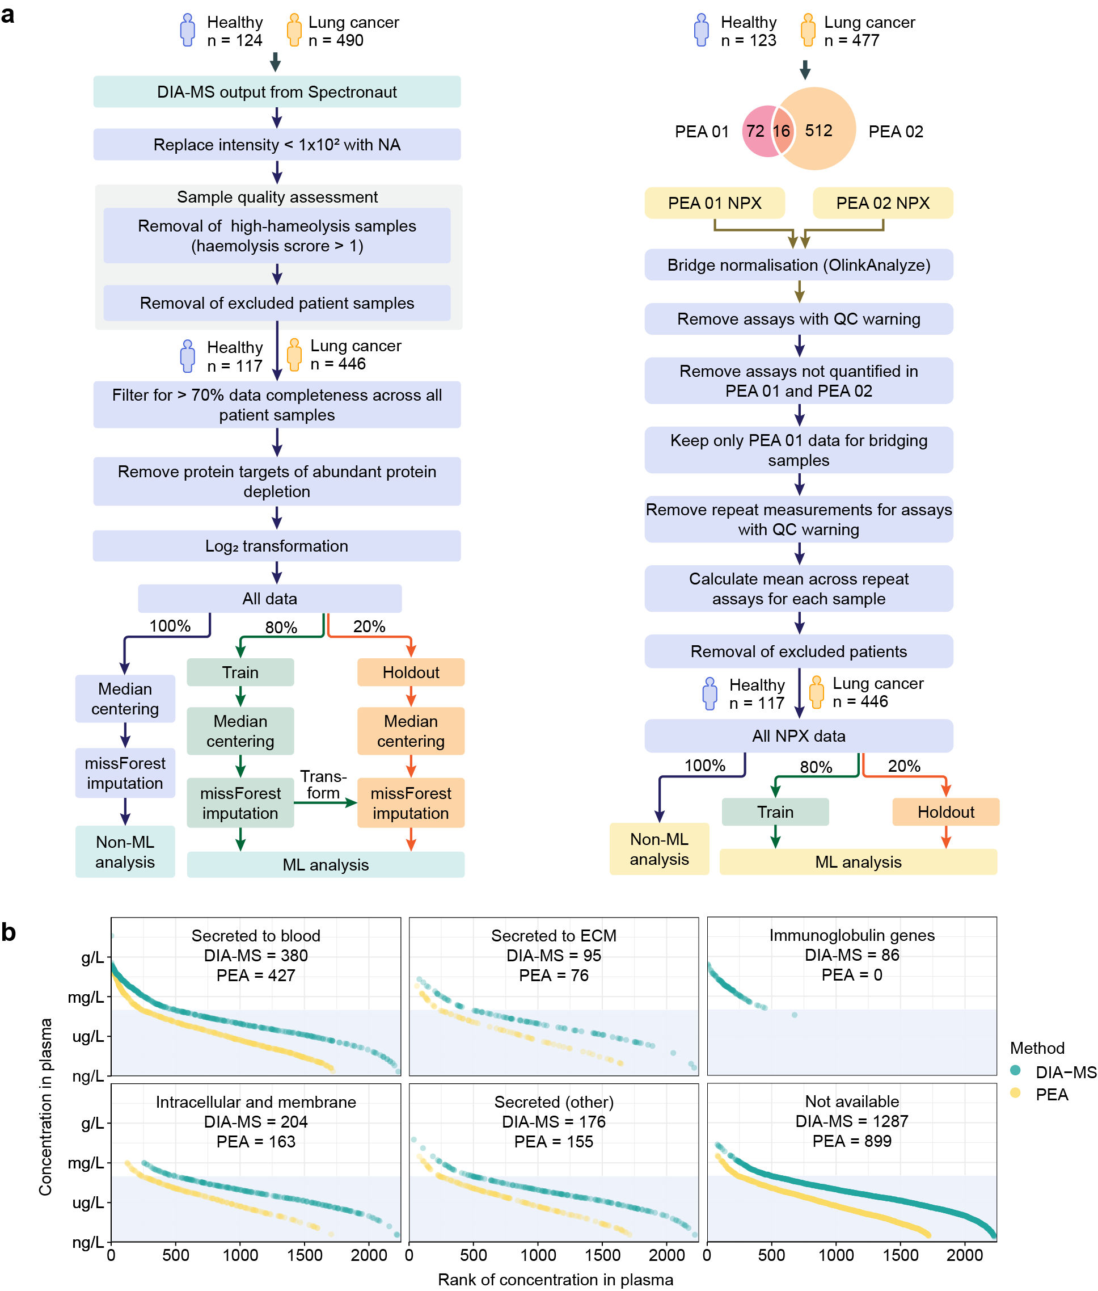

Extended Data Fig. 1 | Multi-dimensional proteomics data processing workflow and secretome location. a, Workflow for pre-processing of DIA-MS (LHS) and PEA data (RHS) for downstream univariate and ML analysis. NPX, Normalised protein expression. b, Concentration of proteins attributed to different secretome location in the Human Protein Atlas (HPA). Ranked according to known concentration in HPA for proteins quantified by DIA-MS (turquoise) and PEA (yellow). Secreted (other) corresponds to protein secreted to digestive system, unknown location, in brain, female reproductive system, male reproductive system and in other tissues. ECM, Extracellular matrix.
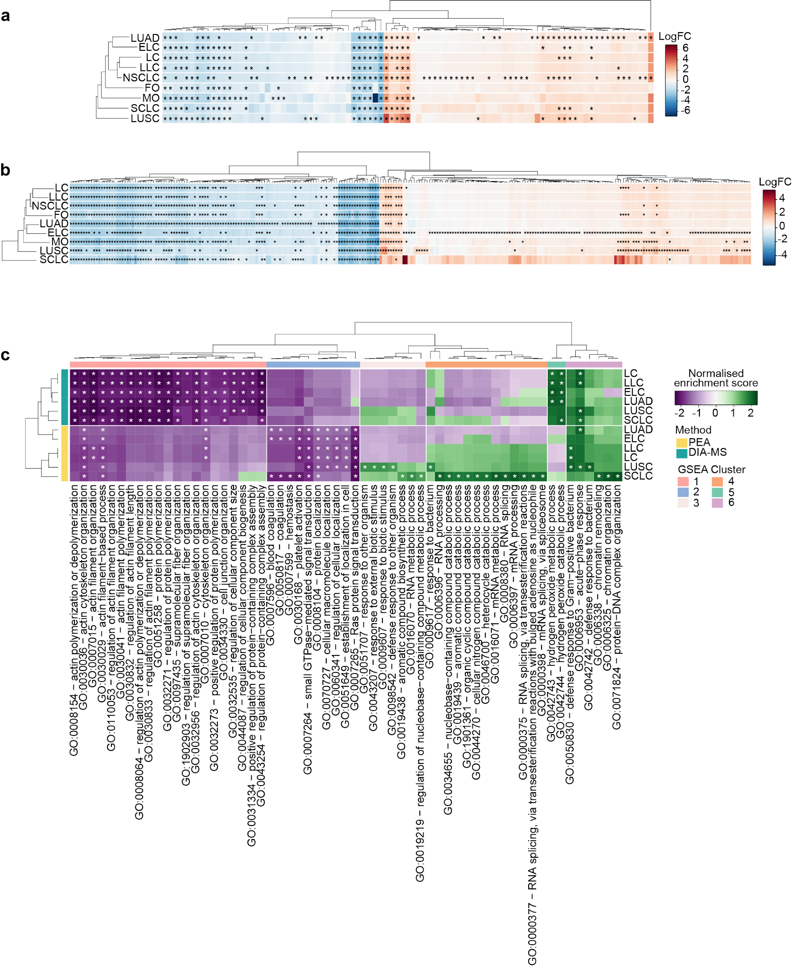
Extended Data Fig. 2 | Variation in proteins and pathways across subcohorts. Hierarchical clustering (Manhattan average) of all proteins differentially abundant according to ANOVA (p-value < 0.05 and Log₂FC > 1) in DIA-MS (a) and PEA (b) across different sub-cohorts. * indicates differential abundance in sub-cohort, coloured according to Log₂FC with respect to healthy controls. c, Hierarchical clustering (Manhattan average) of Gene set enrichment analysis (GSEA) comparing LC, ELC, LLC, LUAD, LUSC and SCLC to healthy controls. Clustered according to normalized enrichment score. Terms with adjusted p-value < 0.01 are shown. * indicates adjusted p-value < 0.05.

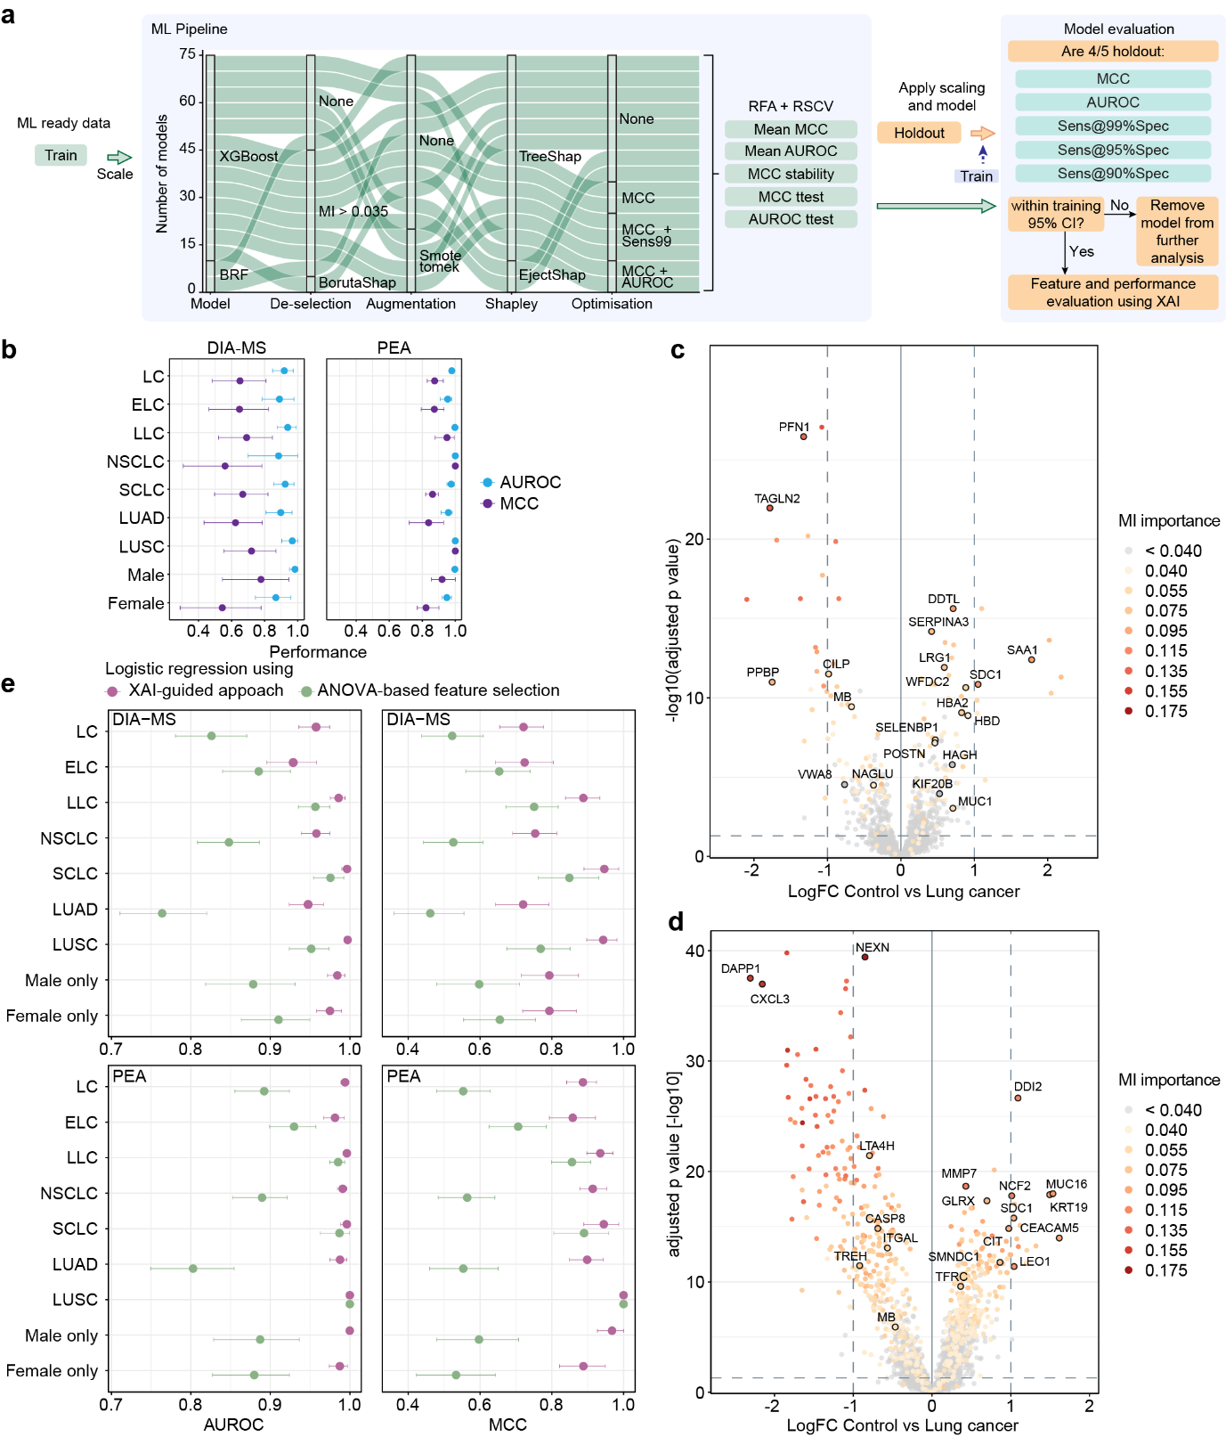
Extended Data Fig. 3 | ML workflow and interpretation. a, ML workflow for evaluating feature selection and generalisability across 75 ML models. b, Mean AUROC (blue) and MCC (purple) for a DIA-MS (left) vs PEA (right) model trained on lung cancer predicting on sub-cohorts. Error bars correspond to 95% CI. Volcano plot showing differential expression of proteins in DIA-MS (c) and PEA (d) coloured according to mutual information (MI) with target (lung cancer). Twenty highest features according to rank of Shapley values across generalisable models of control vs lung cancer are labelled. e, Comparison of model performances using multivariate (XAI-guided approach) vs univariate (ANOVA) selection of features. Feature selection from a representative control vs lung cancer model. The model AUROC (left) and MCC (right) are compared across a logistic regression using top 20 Shapley ranked features (purple) and a logistic regression using features selected using an ANOVA (green). Error bars correspond to 95% CI.

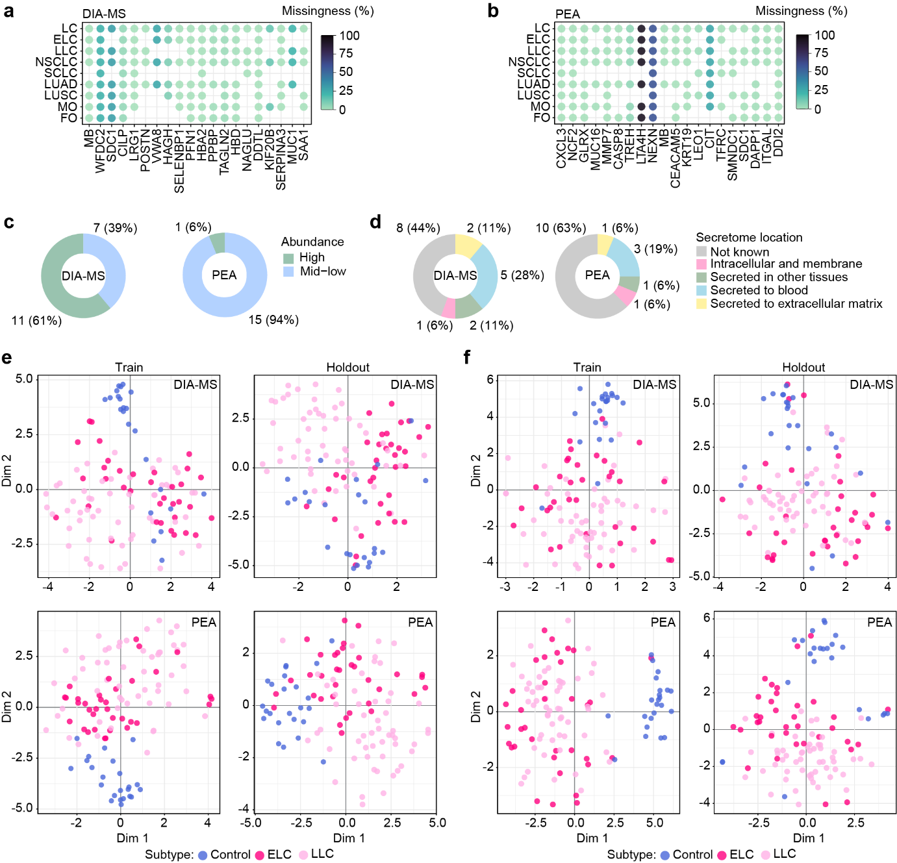
Extended Data Fig. 4 | Feature selection evaluation. Missingness of features from Shapley ranking across DIA-MS (a) and PEA (b). Order of features from left to right according to Shapley rank in control vs Lung cancer models. Absence of point indicates feature was never used by a sub-cohort. c, Pie chart showing number of top 20 high importance lung cancer features considered high-abundance (concentration ≥ 0.1 mg/L) and mid-low abundance (< 0.1 mg/L). d, Pie chart showing secretome location (if known) of top 20 high importance lung cancer features with available data in HPA. e, T-distributed stochastic neighbourhood embedding (t-SNE) visualisation of patient samples in train (LHS) vs holdout (RHS) based on protein quantification from the representative for DIA-MS (top) vs PEA (bottom). Coloured according to cancer status: Control, early lung cancer (ELC) and late lung cancer (LLC). f, t-SNE based on Shapley values of features from representative models for patient from train (LHS) vs holdout (RHS) in DIA-MS (top) vs PEA (bottom).
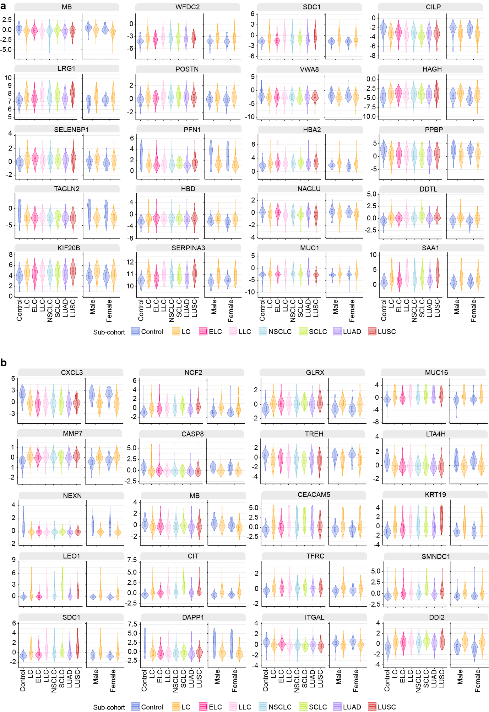
Extended Data Fig. 5 | Sub-cohort feature quantification. Violin plot showing quantification of top 20 Shapley value lung cancer ML features across all sub-cohorts evaluated in DIA-MS (a) and PEA (b).
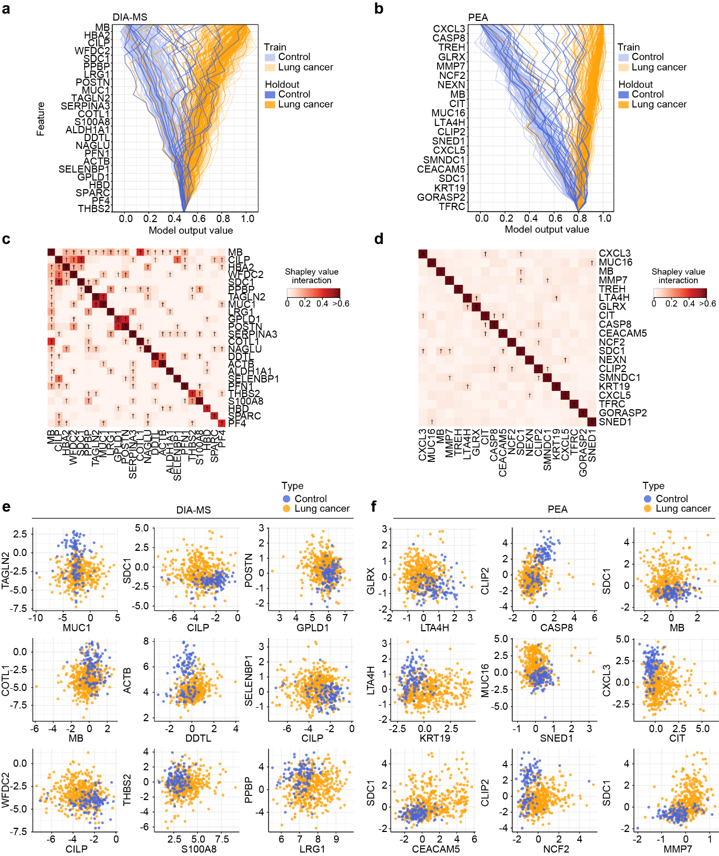
Extended Data Fig. 6 | Shapley value decision analysis. Shapley value decision plots for a representative control vs lung cancer XGBoost model from DIA-MS (a) or PEA (b) trained on training data and evaluated on the complete cohort (train + holdout) to understand differences between train and holdout performance. Each line represents a patient (blue = control, yellow = lung cancer) from training data (pale blue/yellow) or holdout (bright blue/yellow). The order of features from top to bottom is from high importance to low importance as assessed by mean absolute Shapley value for each feature from the complete cohort. X-axis corresponds to model output value (likelihoods) and are centered on the target expected value. This is different for the models as DIA-MS was an augmented (balanced) model and PEA was without augmentation and represents that proportion of lung cancer patients. Moving upwards from the bottom plot, it can be seen how each feature contributes to the model output value for a given patient. The end point indicates the final model output value for a given patient. Heatmap of Shapley value interactions from representative control vs lung cancer DIA-MS (c) or PEA (d) model. Colour scale from low (white) to high (red) Shapley value interaction scaled to show differences between feature interactions; values > 0.6 (feature self-interactions) have same dark red colour for visualisation purposes. † = Interaction > 5% of mean Shapley value. Quantification of features from highest nine Shapley value interactions in DIA-MS (e) vs PEA (f). Each point is a patient from the complete cohort (train and holdout) coloured according to cancer status: control (blue) vs lung cancer (yellow).

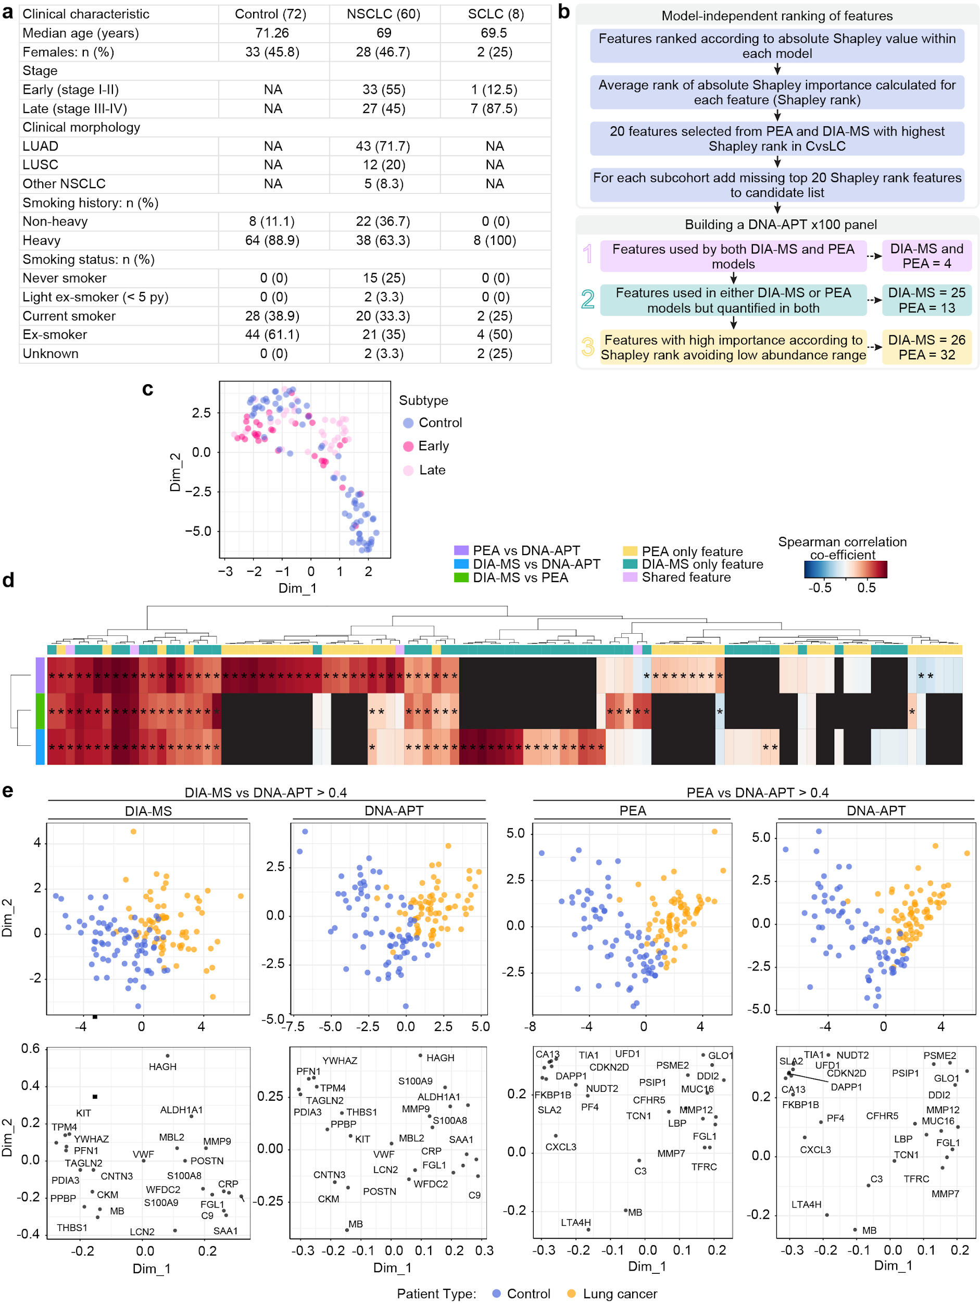
Extended Data Fig. 7 | Clinical characteristics of concordance cohort, workflow, analysis and ML interpretation. a, Clinical characteristics of a subset of the original patient cohort taken forward for DNA-APT validation. Non-heavy smokers have a pack-year (py) history less than 20 years, heavy smokers have a pack-year smoking history greater than/equal to 20 pack-year. NA, not applicable. b, Workflow for selecting 100 features for validation on a third, DNA-aptamer (DNA-APT) platform. c, Uniform manifold approximation and projection (UMAP) visualization of patients according to DNA-APT quantification of 100 features, coloured according to cancer status: control (blue), early (dark pink) or late lung cancer (light pink). d, Spearman correlation co-efficient of all 100 features quantified across DIA-MS, PEA and DNA-APT. * corresponds to FDR-adjusted p-value < 0.05 for correlation. e, PLS plots (upper) and corresponding PLS-loadings (lower) trained with features with concordance > 0.4 spearman correlation coefficient across all two platforms, using data from DNA-APT and DIA-MS (left) or DNA-APT and PEA > 0.4 (right). PLS plots show separability between control samples (blue) (n = 70) and lung cancer samples (orange) (n = 69). Loadings are labelled with gene names.

Supplementary Data

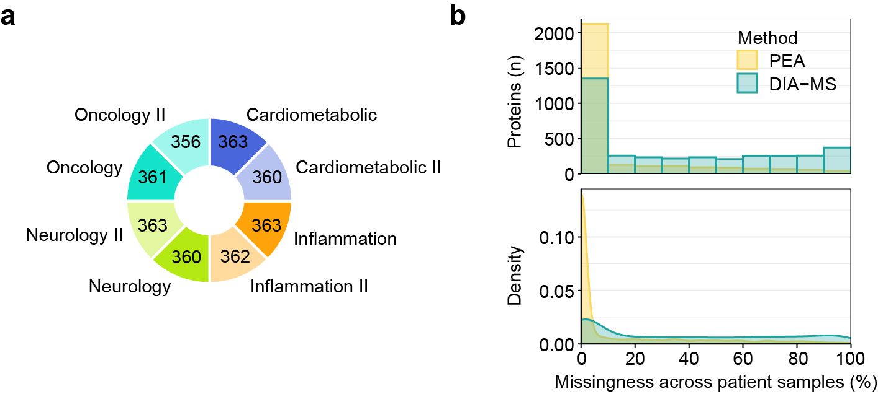
Supplementary Fig. 1 | Quality assessment of multi-dimensional proteomics data. a, Pie chart showing number of proteins from Olink Explore 3072 panels that passed QC and pre-processing. b, Histogram and density plot of missingness of protein quantification across the 600 vs 614 patient samples in PEA (yellow) vs DIA-MS (turquoise), respectively.

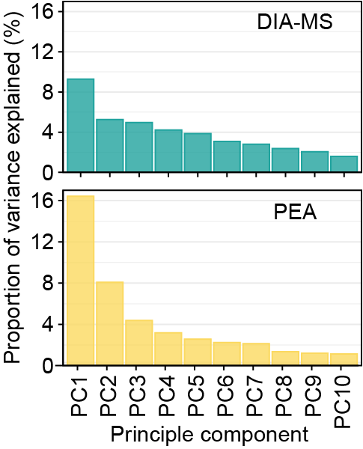

Supplementary Fig. 2 | Principal components. Proportion (%) of variance explained in the first ten principal components (PC) in principal component analysis of DIA-MS (top) and PEA (bottom).

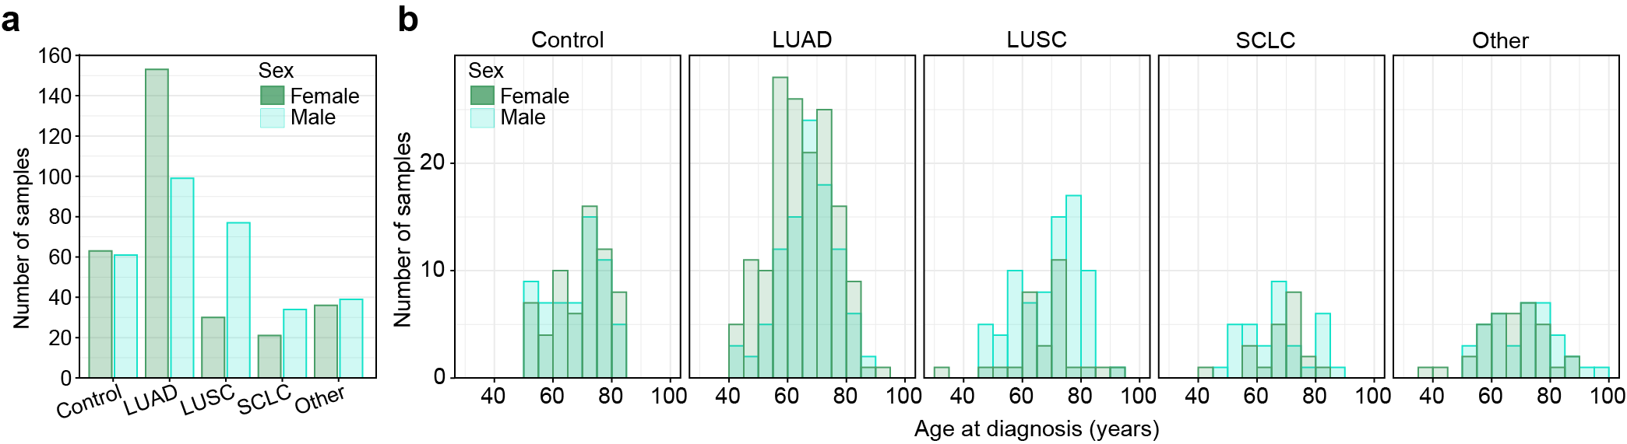
Supplementary Fig. 3 | Clinical and demographic characteristics across sexes. a, Distribution of clinical subtypes of lung cancer across males (turquoise) and females (green). LUAD: Lung adenocarcinoma; LUSC Lung squamous cell carcinoma; SCLC: small cell lung cancer; Other includes other non-small cell lung cancer types. b, Histogram of age ranges across clinical subtypes comparing males (turquoise) with females (green).

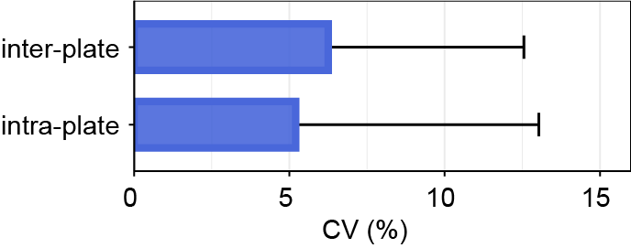

Supplementary Fig. 4 | Coefficient of variation (CV) in DNA-APT data. Intra-plate and inter-plate CV for 100 features analysed by DNA-APT using the SomaScan 11K panel. Quantification comes from matrix-matched plate controls run on each plate. Error bars = + 1SD.

