Automating Epidemiology Report Generation from the MIMIC-IV Clinical Database using SNOMED CT and SQL
Houcemeddine Turki¹*, Naveed A. Pasha, MD MSc², Abdullah Altammami, DMD^{3,4}
Anas H. Alzahrani, MD PhD MPH^{5,6}*

¹ Department of Computer Science, University of the People, Pasadena, California, USA
² South City Hospital, Jinnah Sindh Medical University, Karachi, Pakistan
³ Health Informatics, Rutgers University, New Brunswick, USA
⁴ Public Health and Health Informatics, King Saud Bin Abdulaziz University for Health Sciences, Riyadh, Saudi Arabia
⁵ Department of Community Medicine, Faculty of Medicine, King Abdulaziz University, Jeddah, Saudi Arabia
⁶ King Abdulaziz University Hospital, King Abdulaziz University, Jeddah, Saudi Arabia

* Houcemeddine Turki and Anas H. Alzahrani contributed equally

Supplementary Material

Appendix A

Aortic Aneurysm usecae
S1. Supplementary Figure S1 (Prompt template for SQL condition)
S2. Supplementary Figure S2 (Co-occurrence network)
S1. Supplementary Table S1 (ICD-10 diagnoses mapped from SNOMED-CT
S2. Supplementary Table S2 (SQL conditions)
S3. Supplementary Table S3 (Discharge by sex)
S4. Supplementary Table S4 (Logistic regression coefficients)
S5. Supplementary Table S5 (Prior studies using MIMIC
Appendix B
Upper Respiratory Tract Infection usecase
N1. Supplementary Figure N1 (Sample data visualizations for cohort: admissions, LOS distribution, LOS by admission type)
N2. Supplementary Figure N2 (Network of SNOMED-CT concept co-occurrence in chest radiology reports)
N1. Supplementary Table N1 (SNOMED-CT terms extracted from radiology and clinical notes)
N2. Supplementary Table N2 (ICD-10 diagnoses mapped from SNOMED-CT for upper respiratory tract infection)
N3. Supplementary Table N3 (SQL conditions for identifying ICD-10 codes related to upper respiratory tract infection)
N4. Supplementary Table N4 (Cohort retrieval by SQL condition)
N5. Supplementary Table N5 (Summary of upper respiratory tract infection cohort)
N6. Supplementary Table N6 (Procedures performed and associations with duration of stay, mortality, and age)
N7. Supplementary Table N7 (Cross-table of discharge location by gender)
N8. Supplementary Table N8 (Logistic regression coefficients predicting safe discharge home)
Appendix C
Python code for the pipline

Appendix A

You are given a medical coding table named icd with columns: icd.code, icd.version, and icd.long_title. This table contains ICD-9 and ICD-10 diagnosis descriptions.
Your task is to identify which diagnosis descriptions refer only to the disease: {disease}.
Return a single SQL WHERE condition that matches relevant entries using icd.long_title and LIKE patterns.
Only include diagnoses that cause {disease}.
Use OR, AND, and parentheses to connect LIKE clauses as needed.
Return only the final SQL condition as a single line of text. No explanation.
Please formulate the SQL condition in a way that it includes all the icd.long_title entries below:
{SNOMED-CT names}
Supplementary Figure S1 Prompt template for generating a single SQL WHERE condition over icd.long_title for ICD-9/10 diagnoses using SNOMED-derived labels and constrained Boolean patterns.

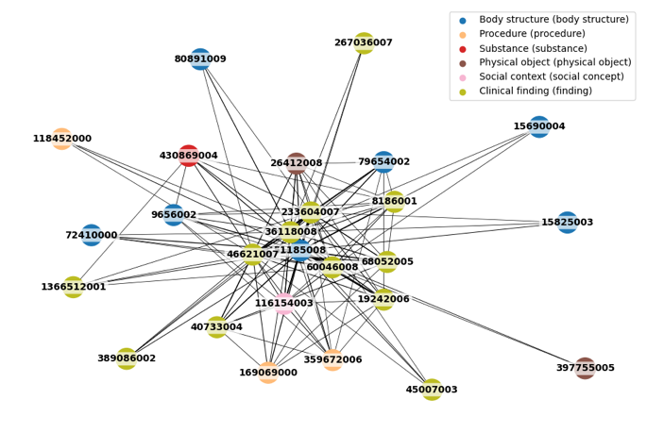
SNOMED-CT ID | Concept Name
80891009 | Heart
116154003 | Patient
79654002 | Edema
40733004 | Infection
169069000 | Chest CT
267036007 | Dyspnea
46621007 | Atelectasis
45007003 | Hypotension
118452000 | Enlargement
60046008 | Pleural effusion
51185008 | Chest
15825003 | Aorta
233604007 | Pneumonia
1366512001 | Right pleural effusion
72410000 | Mediastinum
36118008 | Pneumothorax
389086002 | Hypoxia
19242006 | Pulmonary edema
8186001 | Cardiomegaly
68052005 | Aspiration
430869004 | Effusion
9656002 | Consolidation
26412008 | Endotracheal tube
359672006 | Median sternotomy
15690004 | Tortuosity
397755005 | Swan-Ganz catheter
Supplementary Figure S2 SNOMED-CT concept co-occurrence network from portable AP chest radiology reports; nodes are mapped SNOMED concepts; edges weighted by co-mentions; layout via a force-directed algorithm.

Supplementary Table S1 (SNOMED-CT terms extracted from radiology and clinical notes)
Medical Condition | Hospitalizations (n)
Aortic aneurysm, unspecified site (without rupture) | 111
Congenital aneurysm of aorta | 71
Other congenital malformations of cardiac chambers and connections | 3
Other congenital malformations of aorta | 3
Aortic aneurysm, unspecified site (ruptured) | 2

Supplementary Table S1 (ICD-10 diagnoses mapped from SNOMED-CT
Method | Try | Description | SQL Condition
With SNOMED-CT | A1 | Broad match using “aorta” + “aneurysm/dilatation/ectasia/tunnel” + Valsalva clause | (icd.long_title LIKE '%aorta%' OR icd.long_title LIKE '%aortic%') AND (icd.long_title LIKE '%aneurysm%' OR icd.long_title LIKE '%dilatation%' OR icd.long_title LIKE '%ectasia%' OR icd.long_title LIKE '%tunnel%') OR (icd.long_title LIKE '%Valsalva%' AND icd.long_title LIKE '%aneurysm%')
With SNOMED-CT | A2 | Targeted phrases including “aortic aneurysm,” “Valsalva,” “annuloaortic ectasia” | (icd.long_title LIKE '%aortic aneurysm%' OR icd.long_title LIKE '%aneurysm of aorta%' OR icd.long_title LIKE '%sinus of Valsalva aneurysm%' OR icd.long_title LIKE '%Annuloaortic ectasia%' OR icd.long_title LIKE '%Syphilitic dilatation of aorta%' OR icd.long_title LIKE '%aortico-left ventricular tunnel%')
With SNOMED-CT | A3 | Strict matching on “aortic aneurysm” and variants | (icd.long_title LIKE '%aortic aneurysm%') OR (icd.long_title LIKE '%aneurysm of %aorta%') OR (icd.long_title LIKE '%Valsalva aneurysm%') OR (icd.long_title LIKE '%annuloaortic ectasia%') OR (icd.long_title LIKE '%syphilitic dilatation of aorta%') OR (icd.long_title LIKE '%aortic left ventricular tunnel%')
Without SNOMED-CT | B1 | Broad pattern: “aorta/aortic” + “aneurysm/pseudoaneurysm” | ((icd.long_title LIKE '%aorta%' OR icd.long_title LIKE '%aortic%') AND (icd.long_title LIKE '%aneurysm%' OR icd.long_title LIKE '%pseudoaneurysm%'))
Without SNOMED-CT | B2 | Targeted phrases including “aortic aneurysm,” “aneurysm of aorta” | (icd.long_title LIKE '%aortic aneurysm%' OR icd.long_title LIKE '%aneurysm of aorta%' OR icd.long_title LIKE '%aneurysm, aorta%' OR icd.long_title LIKE '%aorta aneurysm%')
Without SNOMED-CT | B3 | Extended list including pseudoaneurysm variants | (icd.long_title LIKE '%aortic aneurysm%' OR icd.long_title LIKE '%aneurysm of aorta%' OR icd.long_title LIKE '%aneurysm, aorta%' OR icd.long_title LIKE '%aorta aneurysm%' OR icd.long_title LIKE '%aortic pseudoaneurysm%' OR icd.long_title LIKE '%pseudoaneurysm of aorta%')

Supplementary Table S2 (SQL conditions)
Primary Diagnosis | SQL Condition(s) | Hospitalizations (n)
Abdominal aortic aneurysm, without rupture | A1, A2, A3, B1, B2, B3 | 2,075
Thoracic aortic aneurysm, without rupture | A1, A2, A3, B1, B2, B3 | 1,284
Thoracic aortic ectasia | A1 | 418
Thoracoabdominal aortic aneurysm, without rupture | A1, A2, A3, B1, B2, B3 | 89
Abdominal aortic ectasia | A1 | 82
Abdominal aortic aneurysm, ruptured | A1, A2, A3, B1, B2, B3 | 57
Congenital aneurysm of aorta | A1, A2, A3, B1, B2, B3 | 55
Thoracic aortic aneurysm, ruptured | A1, A2, A3, B1, B2, B3 | 22
Thoracoabdominal aortic ectasia | A1 | 13
Thoracoabdominal aortic aneurysm, ruptured | A1, A2, A3, B1, B2, B3 | 10

Supplementary Table S3 (Discharge by sex)
Discharge Location | Male (n) | Female (n)
Acute hospital | 18 | 5
Against medical advice | 11 | 3
Assisted living | 3 | 0
Chronic / long-term acute care | 42 | 25
Died (in-hospital) | 104 | 50
Home | 735 | 276
Home health care | 928 | 446
Hospice | 46 | 21
Other facility | 2 | 1
Psychiatric facility | 3 | 0
Rehabilitation facility | 103 | 33
Skilled nursing facility | 353 | 270

Cross-Table of discharge locations in function of gender (Chi2: 55.67, p-value: 5.83e-08, Degrees of Freedom: 11).

Supplementary Table S4 (Logistic regression coefficients)
Feature | Coefficient
Positive predictors (↑ Increased likelihood of discharge home)
Race: Hispanic/Latino – Guatemalan | +1.05
Admission type: Surgical same-day | +0.98
Admission type: Direct emergency | +0.86
Admission type: Emergency ward | +0.83
Race: Asian – Asian Indian | +0.82
Negative predictors (↓ Decreased likelihood of discharge home)
Race: Black / Caribbean Island | -1.06
Race: Unable to obtain | -1.06
Admission location: Transfer from skilled nursing | -1.53
Admission type: Direct observation | -1.71
Admission type: EU observation | -2.06

Regression coefficients of the logistic regression model predicting safe patient discharge home (Accuracy = 0.75).

Supplementary Table S5 (Prior studies using MIMIC)
Study / Year | Database | Cohort Selection Method | ICD Codes Used
Huang et al., 2021 * | MIMIC-III | Diagnosis + procedure codes to capture AA and surgeries | ICD-9: 441.1, 441.2, 441.3, 441.4, 441.6, 441.7; Procedures: 38.44, 38.45, 39.73, 39.71
Wang et al., 2024 ** | MIMIC-IV | ICD-9 and ICD-10 diagnosed AA admissions, with exclusion filters | ICD-9 & ICD-10 (not specified)
Other studies | MIMIC-III / IV | Likely ICD-based selection (details not disclosed) | Not reported
* Huang K, Shen R, Peng S, et al. Development of SAB model for predicting mortality in intensive care unit after aortic aneurysm surgery. Ann Palliat Med. 2021;10(10):10147-10159. doi:10.21037/apm-21-1660
**Wang, H., Wu, S., Pan, D. et al. Comparison of different intensive care scoring systems and Glasgow Aneurysm score for aortic aneurysm in predicting 28-day mortality: a retrospective cohort study from MIMIC-IV database. BMC Cardiovasc Disord 24, 513 (2024). https://doi.org/10.1186/s12872-024-04184-4

Appendix B
A
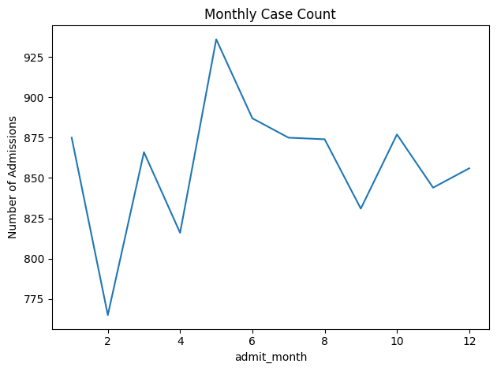
B
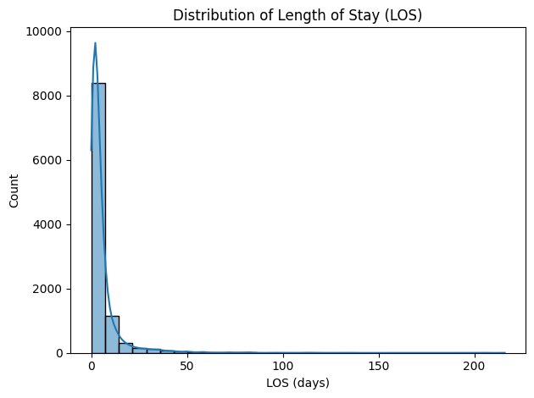
C
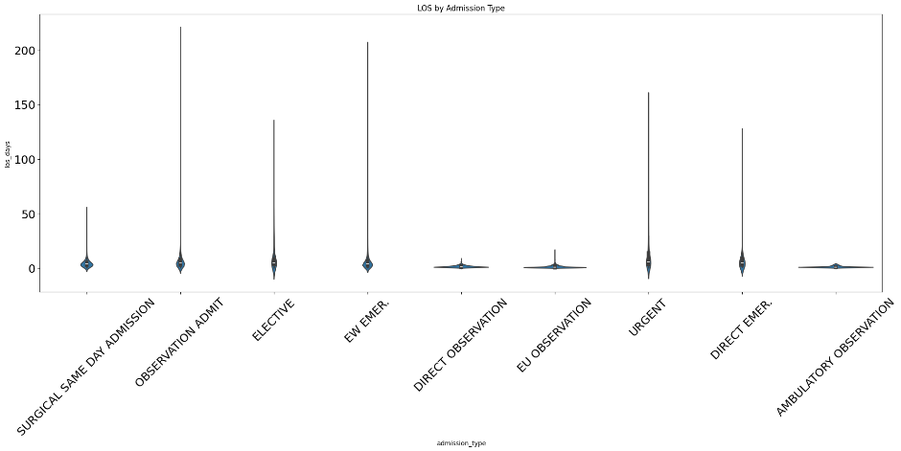
Supplementary Figure N1 Sample Data Visualizations for the Cohort: (A) Number of Admissions in function of the month of the year, (B) Distribution of hospitalizations per length of stay (LOS), (C) Violin plot for LOS per admission type.

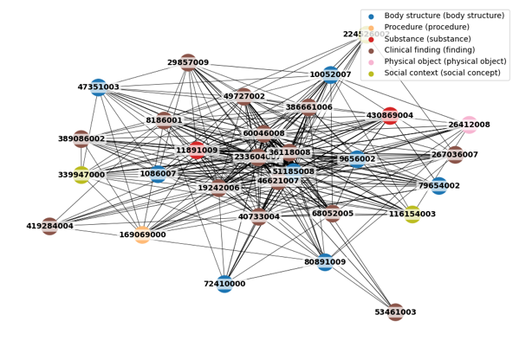
SNOMED-CT ID | Concept Name
224526002 | Woman
386661006 | Fever
1086007 | Female
49727002 | Cough
8186001 | Cardiomegaly
389086002 | Hypoxia
116154003 | Patient
10052007 | Male
169069000 | Chest CT
40733004 | Infection
53461003 | Normal size
430869004 | Effusion
11891009 | Breath
60046008 | Pleural effusion
19242006 | Pulmonary edema
29857009 | Chest pain
36118008 | Pneumothorax
339947000 | Man
233604007 | Pneumonia
72410000 | Mediastinum
9656002 | Consolidation
51185008 | Chest
80891009 | Heart
419284004 | Altered mental status
79654002 | Edema
68052005 | Aspiration
47351003 | Infiltrate
267036007 | Dyspnea
46621007 | Atelectasis
26412008 | Endotracheal tube
Supplementary Table N1. Network of SNOMED-CT concept co-occurrence in Chest (Portable AP) radiology reports.

Supplementary Table N1 (SNOMED-CT terms extracted from radiology and clinical notes)
Medical Condition | Hospitalizations
Other specified bacterial agents as the cause of diseases classified elsewhere | 3486
Candidal stomatitis | 1618
Human immunodeficiency virus [HIV] disease | 1468
Acute upper respiratory infection, unspecified | 1159
Viral infection, unspecified | 673
Chronic sinusitis, unspecified | 598
Acute pharyngitis, unspecified | 587
Influenza due to unidentified influenza virus with other respiratory manifestations | 427
Other sites of candidiasis | 360
Influenza due to other identified influenza virus with other respiratory manifestations | 320
Other viral agents as the cause of diseases classified elsewhere | 282
Other specified disorders of nose and nasal sinuses | 207
Unspecified staphylococcus as the cause of diseases classified elsewhere | 195
Chronic rhinitis | 181
Unspecified mycosis | 154
Streptococcal pharyngitis | 105
Acute sinusitis, unspecified | 93
Acute tonsillitis, unspecified | 83
Respiratory syncytial virus as the cause of diseases classified elsewhere | 78
Other diseases of larynx | 75
Herpesviral gingivostomatitis and pharyngotonsillitis | 72
Streptococcus pneumoniae as the cause of diseases classified elsewhere | 53
Hemophilus influenzae [H. influenzae] as the cause of diseases classified elsewhere | 51
Acute laryngitis | 43
Acute pharyngitis due to other specified organisms | 33
Abscess, furuncle and carbuncle of nose | 22
Acute epiglottitis without obstruction | 20
Other forms of aspergillosis | 19
Acute nasopharyngitis [common cold] | 17
Influenza due to other identified influenza virus with other manifestations | 13
Other specified bacterial diseases | 12
Mycoplasma pneumoniae [M. pneumoniae] as the cause of diseases classified elsewhere | 11
Chronic laryngitis | 10
Other specified infestations | 8
Bacterial infection, unspecified | 8
Adenovirus as the cause of diseases classified elsewhere | 6
Acute bronchitis due to respiratory syncytial virus | 6
Other specified viral infections characterized by skin and mucous membrane lesions | 5
Other secondary syphilis of skin | 4
Acute bronchitis due to parainfluenza virus | 4
Papillomavirus as the cause of diseases classified elsewhere | 3
Rhinocerebral mucormycosis | 2
Other respiratory tuberculosis | 2
Enteroviral vesicular pharyngitis | 2
Gonococcal pharyngitis | 1
Pneumonia due to SARS-associated coronavirus | 1
Acute bronchitis due to Hemophilus influenzae | 1
Other Vincent's infections | 1
Acute recurrent streptococcal tonsillitis | 1

Supplementary Table N2 (ICD-10 diagnoses mapped from SNOMED-CT for upper respiratory tract infection)

SQL Condition
(icd.long_title LIKE '%upper respiratory%infection%' OR icd.long_title LIKE '%URI%' OR icd.long_title LIKE '%URTI%' OR icd.long_title LIKE '%upper respiratory symptoms%' OR icd.long_title LIKE '%severe acute respiratory syndrome of upper respiratory tract%' OR icd.long_title LIKE '%common cold%' OR icd.long_title LIKE '%acute coryza%' OR icd.long_title LIKE '%head cold%' OR icd.long_title = 'Cold' OR icd.long_title = 'Cold (disorder)' OR icd.long_title LIKE '%laryngitis%' OR icd.long_title LIKE '%epiglottitis%' OR icd.long_title LIKE '%laryngotrache%' OR icd.long_title LIKE '%croup%' OR icd.long_title LIKE '%laryngeal diphtheria%' OR (icd.long_title LIKE '%larynx%' AND (icd.long_title LIKE '%infection%' OR icd.long_title LIKE '%inflammation%' OR icd.long_title LIKE '%tuberculosis%' OR icd.long_title LIKE '%myiasis%')) OR (icd.long_title LIKE '%glottis%' AND icd.long_title LIKE '%tuberculosis%') OR (icd.long_title LIKE '%vocal cord%' AND icd.long_title LIKE '%papilloma%virus%infection%') OR icd.long_title LIKE '%pharyngitis%' OR icd.long_title LIKE '%tonsillitis%' OR icd.long_title LIKE '%adenoiditis%' OR icd.long_title LIKE '%pharyngoconjunctivitis%' OR icd.long_title LIKE '%pharyngoconjunctival fever%' OR icd.long_title LIKE '%herpangina%' OR icd.long_title LIKE '%sore throat%' OR icd.long_title LIKE '%vincent%s angina%' OR icd.long_title LIKE '%vincent angina%' OR icd.long_title LIKE '%fusospirochetal pharyngitis%' OR icd.long_title LIKE '%fusobacterial necrotizing tonsillitis%' OR icd.long_title LIKE '%nasopharyngeal diphtheria%' OR (icd.long_title LIKE '%nasopharyngeal%' AND (icd.long_title LIKE '%tuberculosis%' OR icd.long_title LIKE '%myiasis%' OR icd.long_title LIKE '%fascioliasis%' OR icd.long_title LIKE '%lingu%')) OR icd.long_title LIKE '%rhinopharyngitis%' OR (icd.long_title LIKE '%pharynx%' AND (icd.long_title LIKE '%diphtheria%' OR icd.long_title LIKE '%syphilis%' OR icd.long_title LIKE '%tuberculosis%' OR icd.long_title LIKE '%gonorrhea%' OR icd.long_title LIKE '%candidiasis%' OR icd.long_title LIKE '%actinomycosis%' OR icd.long_title LIKE '%inflammation%' OR icd.long_title LIKE '%infection%')) OR (icd.long_title LIKE '%tonsil%' AND (icd.long_title LIKE '%actinomycosis%' OR icd.long_title LIKE '%syphilis%' OR icd.long_title LIKE '%tuberculosis%' OR icd.long_title LIKE '%aspergillosis%' OR icd.long_title LIKE '%remnant%infection%')) OR icd.long_title LIKE '%rhinitis%' OR icd.long_title LIKE '%sinusitis%' OR icd.long_title LIKE '%rhinoscleroma%' OR icd.long_title LIKE '%scleroma%' OR icd.long_title = 'Scleroma (disorder)' OR icd.long_title LIKE '%nasal diphtheria%' OR icd.long_title LIKE '%nasal syphilis%' OR icd.long_title LIKE '%congenital syphilitic rhinitis%' OR icd.long_title LIKE '%congenital syphilitic chronic coryza%' OR (icd.long_title LIKE '%nasal%' AND (icd.long_title LIKE '%gangosa%' OR icd.long_title LIKE '%yaws%' OR icd.long_title LIKE '%tuberculosis%' OR icd.long_title LIKE '%furuncle%' OR icd.long_title LIKE '%boil%' OR icd.long_title LIKE '%carbuncle%' OR icd.long_title LIKE '%mucous cyst%' OR icd.long_title LIKE '%mucopyocele%' OR icd.long_title LIKE '%candidiasis%' OR icd.long_title LIKE '%ulceration%histoplasmosis%')) OR icd.long_title = 'Gangosa' OR icd.long_title = 'Gangosa (disorder)' OR (icd.long_title LIKE '%nasal sinus%' AND (icd.long_title LIKE '%tuberculosis%' OR icd.long_title LIKE '%mucous cyst%' OR icd.long_title LIKE '%mucopyocele%' OR icd.long_title LIKE '%aspergillosis%')) OR (icd.long_title LIKE '%rhinocerebral%' AND (icd.long_title LIKE '%mucormycosis%' OR icd.long_title LIKE '%phycomycosis%')) OR icd.long_title LIKE '%purulent rhinitis%' OR icd.long_title LIKE '%paracoccidioidomycosis%' OR icd.long_title = 'Halzoun' OR icd.long_title = 'Halzoun (disorder)' OR icd.long_title = 'Marrara' OR icd.long_title = 'Marrara (disorder)' OR icd.long_title LIKE 'Marrara syndrome%' OR icd.long_title = 'Bull nose' OR icd.long_title = 'Bull nose (disorder)')

Supplementary Table N3 (SQL conditions for identifying ICD-10 codes related to upper respiratory tract infection)
Primary Diagnosis | Hospitalizations
Acute upper respiratory infections of unspecified site | 1518
Acute upper respiratory infection, unspecified | 1269
Allergic rhinitis, unspecified | 973
Allergic rhinitis, cause unspecified | 843
Unspecified sinusitis (chronic) | 801
Other seasonal allergic rhinitis | 760
Chronic sinusitis, unspecified | 650
Acute pharyngitis, unspecified | 627
Acute pharyngitis | 591
Chronic rhinitis | 296
Acute sinusitis, unspecified | 279
Chronic maxillary sinusitis | 172
Other chronic sinusitis | 155
Streptococcal sore throat | 144
Allergic rhinitis due to pollen | 112
Streptococcal pharyngitis | 105
Acute tonsillitis | 101
Allergic rhinitis due to other allergen | 87
Acute tonsillitis, unspecified | 85
Herpesviral gingivostomatitis and pharyngotonsillitis | 80
Acute laryngitis | 55
Other acute sinusitis | 51
Chronic sphenoidal sinusitis | 48
Acute pharyngitis due to other specified organisms | 47
Acute laryngitis without mention of obstruction | 44
Acute nasopharyngitis [common cold] | 38
Acute maxillary sinusitis | 37
Other allergic rhinitis | 35
Chronic pansinusitis | 32
Acute maxillary sinusitis, unspecified | 27
Acute epiglottitis without obstruction | 26
Chronic tonsillitis | 22
Acute upper respiratory infections of other multiple sites | 21
Acute epiglottitis without mention of obstruction | 20
Chronic laryngitis | 15
Acute recurrent tonsillitis, unspecified | 12
Chronic frontal sinusitis | 12
Chronic ethmoidal sinusitis | 11
Acute sphenoidal sinusitis | 11
Acute pansinusitis, unspecified | 8
Acute sphenoidal sinusitis, unspecified | 7
Acute recurrent sinusitis, unspecified | 7
Chronic pharyngitis | 7
Acute frontal sinusitis | 5
Acute streptococcal tonsillitis, unspecified | 5
Acute epiglottitis with obstruction | 5
Acute frontal sinusitis, unspecified | 5
Acute ethmoidal sinusitis | 4
Vasomotor rhinitis | 4
Chronic laryngotracheitis | 4
Acute ethmoidal sinusitis, unspecified | 3
Allergic rhinitis due to animal (cat) (dog) hair and dander | 3
Chronic tonsillitis and adenoiditis | 3
Acute laryngopharyngitis | 3
Acute laryngotracheitis | 3
Enteroviral vesicular pharyngitis | 2
Acute tonsillitis due to other specified organisms | 2
Chronic adenoiditis | 2
Acute recurrent pansinusitis | 1
Gonococcal pharyngitis | 1
Poisoning by anti-common cold drugs | 1
Acute recurrent streptococcal tonsillitis | 1
Chronic nasopharyngitis | 1
Other acute recurrent sinusitis | 1
Acute laryngotracheitis with obstruction | 1
Gonococcal infection of pharynx | 1

Supplementary Table N5 (Summary of upper respiratory tract infection cohort)
Finding | Criteria | Hospitalizations
Common Primary Diagnoses | Acute upper respiratory infections of unspecified site | 1518
Common Primary Diagnoses | Acute upper respiratory infection, unspecified | 1269
Common Primary Diagnoses | Allergic rhinitis, unspecified | 973
Common Comorbidities | Unspecified essential hypertension | 220
Common Comorbidities | Essential (primary) hypertension | 201
Common Comorbidities | Hyperlipidemia, unspecified | 158
Patients with any abnormal labs |  | 961 (9.3%)
Most common abnormal labs | Red Blood Cells (Reduced) | 704
Most common abnormal labs | Hemoglobin (Reduced) | 680
Most common abnormal labs | Hematocrit (Reduced) | 647
Most common abnormal labs | Glucose (Elevated) | 577
Most common abnormal labs | Platelet Count (Reduced) | 242
Mean BMI (if available) |  | 50.9
Mean Blood Pressure at Admission | Systolic | 98.9
Mean Blood Pressure at Admission | Diastolic | 63.5
Mean Length of Stay (days) |  | 5.76 (95% CI: 5.56 – 5.97)
Hospitalization Outcome | Discharged Home | 4313 (41.9%, 95% CI: 40.9% – 42.8%)
Hospitalization Outcome | Discharged to Rehab/Nursing | 938 (9.1%, 95% CI: 8.5% – 9.7%)
Hospitalization Outcome | In-Hospital Deaths | 127 (1.2%, 95% CI: 1.0% – 1.4%)

Supplementary Table N6 (Procedures performed and associations with duration of stay, mortality, and age)
Procedure (shortened) | Count | Mean DOS (days, 95% CI) | DOS SSMD | Mortality % (95% CI) | p-value | Mortality vs Population | Mean Age (95% CI) | Age SSMD
Infusion device → SVC (percutaneous) | 318 | 24.37 (21.52–27.23) | 0.700 | 11.0 (7.6–14.4) | 0.000 | Higher | 58.2 (56.5–60.0) | 0.142
Venous catheterization (NEC) | 234 | 16.29 (13.91–18.68) | 0.510 | 3.8 (1.4–6.3) | 0.001 | Higher | 57.7 (55.6–59.7) | 0.116
Respiratory measurement (nonoperative) | 223 | 0.74 (0.67–0.81) | -0.480 | 0.0 (0.0–0.0) | 0.119 | Lower | 44.8 (42.0–47.5) | -0.372
Enteral infusion (nutritional substances) | 197 | 21.85 (19.01–24.68) | 0.727 | 9.6 (5.5–13.8) | 0.000 | Higher | 56.0 (53.8–58.2) | 0.045
Nutritional substance → Upper GI (natural/artificial) | 189 | 28.14 (24.51–31.77) | 0.842 | 15.3 (10.2–20.5) | 0.000 | Higher | 57.8 (55.7–59.9) | 0.123
Antineoplastic infusion → Central vein (percutaneous) | 182 | 21.22 (17.92–24.53) | 0.636 | 6.0 (2.6–9.5) | 0.000 | Higher | 57.2 (55.1–59.3) | 0.101

Supplementary Table N7 (Cross-table of discharge location by gender)
Discharge Location | Male | Female | Total
Acute hospital | 29 | 20 | 49
Against advice (self-discharge) | 27 | 11 | 38
Assisted living | 4 | 5 | 9
Chronic / long-term acute care | 57 | 57 | 114
Died (in-hospital deaths) | 72 | 55 | 127
Healthcare facility | 1 | 0 | 1
Home (independent discharge) | 1,943 | 2,370 | 4,313
Home with health care support | 747 | 1,161 | 1,908
Hospice | 29 | 27 | 56
Other facility | 16 | 10 | 26
Psychiatric facility | 27 | 31 | 58
Rehabilitation facility | 87 | 82 | 169
Skilled nursing facility | 277 | 492 | 769

Table A7. Supplementary Table N8 (Logistic regression coefficients predicting safe discharge home)
Feature | Coefficient
Positive predictors (↑ likelihood of discharge home)
Direct Emergency Admission | 1.540
Elective Admission | 1.524
Emergency Ward Admission | 1.324
Urgent Admission | 1.318
Observation Admission | 1.298
Negative predictors (↓ likelihood of discharge home)
Admission Location: Information Not Available | -1.113
Transfer from Skilled Nursing Facility | -1.715
Ambulatory Observation Admission | -1.990
Direct Observation Admission | -2.583
EU Observation Admission | -4.053

Appendix C

"""
RealEpi Pipeline: Automated Epidemiology Report Generation from MIMIC-IV
"""

import pandas as pd
from rdflib import Graph, URIRef
from google.cloud import bigquery
import google.generativeai as genai
import spacy
from scipy import stats
import numpy as np

# 1. ONTOLOGY EXPANSION - Extract SNOMED-CT descendants for target disease
def expand_snomed_concept(g, root_concept="233985008"): # Aortic aneurysm
"""Traverse SNOMED hierarchy to harvest all descendant labels"""
query = f"""
PREFIX rdfs: <http://www.w3.org/2000/01/rdf-schema#>
PREFIX owl: <http://www.w3.org/2002/07/owl#>
PREFIX sn: <http://snomed.info/id/>
PREFIX st: <http://snomed.info/field/>
SELECT DISTINCT ?subject ?label WHERE {{
VALUES ?prop {{st:Description.term.en-us.preferred st:Description.term.en-us.synonym}}
?subject (rdfs:subClassOf*|owl:equivalentClass/owl:intersectionOf/rdf:rest*/rdf:first)* sn:{root_concept} .
?subject ?prop ?label .
}}"""
return pd.DataFrame([(str(r[0]), str(r[1])) for r in g.query(query)],
columns=['ConceptID', 'Label'])

# 2. LLM-ASSISTED SQL SYNTHESIS - Generate ICD WHERE clause from SNOMED labels
def generate_sql_condition(labels_df, disease_name, llm_key):
genai.configure(api_key=llm_key)
model = genai.GenerativeModel("models/gemini-2.5-flash")
prompt = f"""Generate SQL WHERE condition for '{disease_name}' using LIKE patterns.
Include ONLY diagnoses from: {labels_df['Label'].tolist()}
Return single line: icd.long_title LIKE '%pattern1%' OR icd.long_title LIKE '%pattern2%'"""
return model.generate_content(prompt).text.strip('`')

# 3. COHORT EXTRACTION - Query MIMIC-IV with generated SQL
def extract_cohort(client, sql_condition):
query = f"""
WITH cohort AS (
SELECT DISTINCT a.subject_id, a.hadm_id, icd.long_title as diagnosis,
a.admittime, a.dischtime, a.hospital_expire_flag,
p.gender, p.anchor_age, a.admission_type, a.discharge_location
FROM `physionet-data.mimiciv_hosp.admissions` a
JOIN `physionet-data.mimiciv_hosp.diagnoses_icd` d ON a.hadm_id = d.hadm_id
JOIN `physionet-data.mimiciv_hosp.d_icd_diagnoses` icd
ON d.icd_code = icd.icd_code AND d.icd_version = icd.icd_version
JOIN `physionet-data.mimiciv_hosp.patients` p ON a.subject_id = p.subject_id
WHERE {sql_condition} AND d.seq_num = 1
),
labs AS (
SELECT c.hadm_id, dl.label,
AVG(le.valuenum) as avg_val, ANY_VALUE(le.ref_range_upper) as ref_upper
FROM cohort c
JOIN `physionet-data.mimiciv_hosp.labevents` le ON c.hadm_id = le.hadm_id
JOIN `physionet-data.mimiciv_hosp.d_labitems` dl ON le.itemid = dl.itemid
WHERE DATETIME_DIFF(le.charttime, c.admittime, HOUR) BETWEEN 0 AND 48
GROUP BY c.hadm_id, dl.label
)
SELECT c.*, STRING_AGG(CASE WHEN l.avg_val > l.ref_upper
THEN CONCAT(l.label, ' (Elevated)') END, '; ') as abnormal_labs
FROM cohort c LEFT JOIN labs l ON c.hadm_id = l.hadm_id
GROUP BY ALL"""
return client.query(query).to_dataframe()

# 4. CLINICAL NOTES NER - Extract SNOMED entities from narratives
def extract_note_entities(df, snomed_labels, nlp):
"""Map clinical text to SNOMED concepts via NER + string matching"""
entity_index = {label.lower(): cid for cid, label in snomed_labels.values}

def process_note(text):
if pd.isna(text): return []
doc = nlp(text)
entities = []
for chunk in doc.noun_chunks:
if chunk.text.lower() in entity_index:
entities.append(entity_index[chunk.text.lower()])
return entities

df['note_concepts'] = df['discharge_text'].apply(process_note)
return df

# 5. STATISTICAL ANALYSIS - Generate epidemiology metrics
def generate_statistics(df):
"""Compute key epidemiological metrics with 95% CI"""
df['los_days'] = (pd.to_datetime(df['dischtime']) -
pd.to_datetime(df['admittime'])).dt.total_seconds() / 86400

# Proportions with Wilson CI
n = len(df)
mortality_rate = df['hospital_expire_flag'].sum() / n
mort_ci = stats.binom.wilson_confint(df['hospital_expire_flag'].sum(), n)

# Continuous variables
los_mean = df['los_days'].mean()
los_ci = stats.t.interval(0.95, n-1, los_mean, df['los_days'].std()/np.sqrt(n))

return {
'N': n,
'Mortality': f"{mortality_rate:.1%} (95% CI: {mort_ci[0]:.1%}-{mort_ci[1]:.1%})",
'Mean_LOS': f"{los_mean:.1f} days (95% CI: {los_ci[0]:.1f}-{los_ci[1]:.1f})",
'Abnormal_Labs': df['abnormal_labs'].notna().sum()
}

# MAIN PIPELINE EXECUTION
if __name__ == "__main__":
# Load SNOMED graph
g = Graph()
g.parse("snomed_20250701.ttl", format="ttl")

# Step 1: Expand disease concept
labels = expand_snomed_concept(g, "233985008") # Aortic aneurysm

# Step 2: Generate SQL
condition = generate_sql_condition(labels, "aortic aneurysm", "YOUR_API_KEY")

# Step 3: Extract cohort
client = bigquery.Client(project="your-project")
cohort_df = extract_cohort(client, condition)

# Step 4: Process notes (if discharge summaries included)
nlp = spacy.load("en_core_web_sm")
cohort_df = extract_note_entities(cohort_df, labels, nlp)

# Step 5: Generate report
stats = generate_statistics(cohort_df)
print(f"Cohort Statistics: {stats}")
cohort_df.to_csv("cohort_output.csv", index=False)

