Supporting Information
Supplementary Figures：
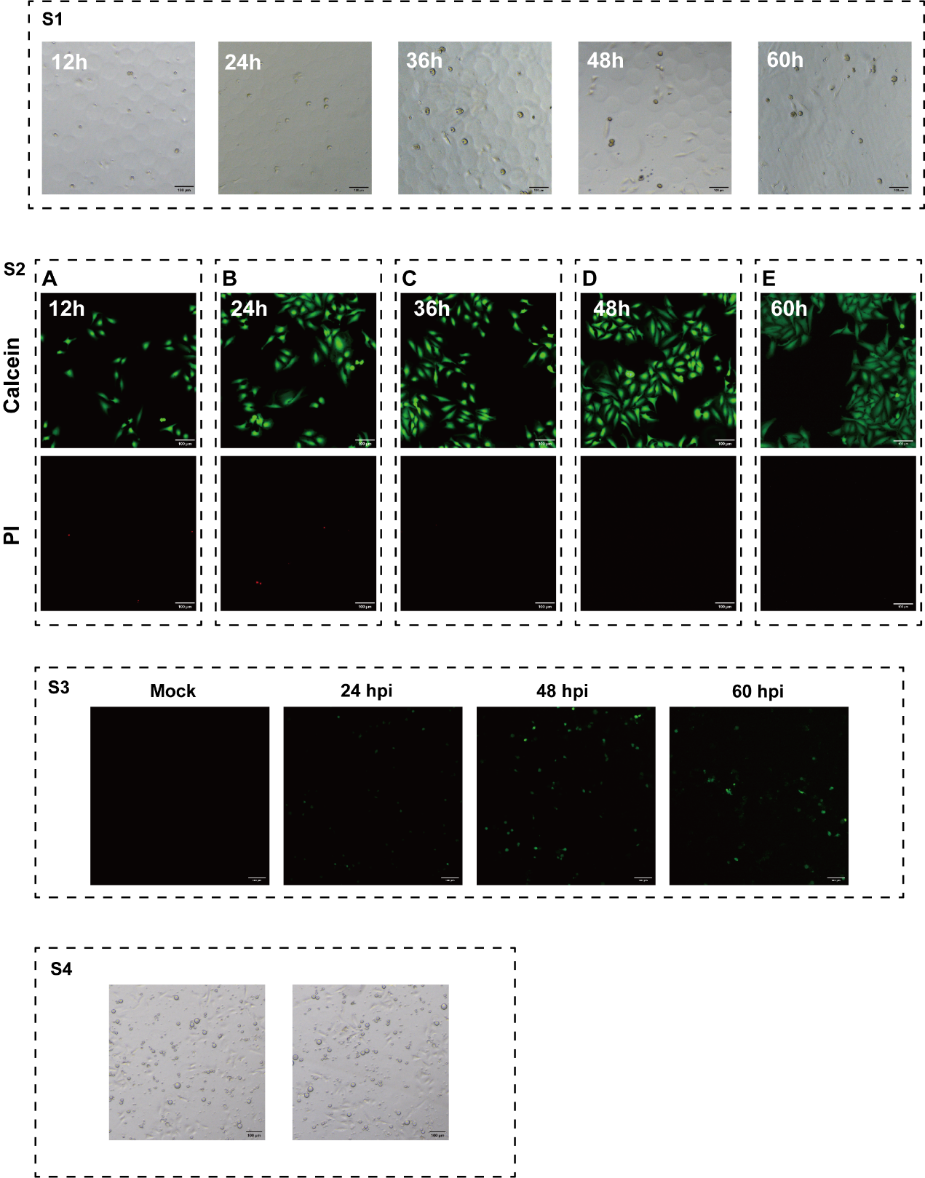
S1 Growth of HeLa cells in 3D culture.
Bright-field image of cell-cultivation within 60h. Scale bar = 100 μm
S2 Conventional plate-based HeLa cell culture
Green fluorescence indicates live cells, and red fluorescence indicates dead cells. Scale bar = 100 μm.
S3 CVB3-eGFP infection to HeLa cells cultivated by conventional plate.
Images of CVB3-eGFP infection to HeLa cells. Scale bar = 100 μm.
S4 3D culture of HeLa cells using 0.4% alginate.
Bright-field image of cell-cultivation within 12h. Scale bar = 100 μm

Full uncropped Blots images
