Three-dimensional reconstruction of biliary system in bioengineered liver using decellularized scaffold
Hiroshi Horie¹, Ken Fukumitsu^{1, 2}, Yusuke Hanabata¹, Takuma Karasuyama¹, Kentaro Iwaki¹, Fumiaki Munekage¹, Kenta Makino¹, Takashi Ito¹, Katsuhiro Tomofuji¹, Hidenobu Kojima¹, Satoshi Ogiso¹, Elena Yukie Uebayashi¹, Hiroyuki Uematsu³ Roberto Coppo³ , Kunishige Onuma³, Masahiro Inoue³, Takamichi Ishii¹, Etsuro Hatano¹

¹ Division of Hepato-Biliary-Pancreatic Surgery and Transplantation, Department of Surgery, Graduate School of Medicine, Kyoto University, 54 Shogo-in Kawahara-cho, Sakyo-ku, Kyoto, 606-8507, JAPAN.
² Department of Surgery, Kyoto Katsura Hospital, 17 Yamadahirao-cho, Nisigyo-ku, Kyoto, 615-8256, JAPAN
³ Department of Clinical Bio-resource Research and Development, Graduate School of Medicine, Kyoto University, 46-29 Yosida-shimo-adachi-cho, Sakyo-ku, Kyoto, 606-8501 Japan

Supplementary Materials

Reagent | Company | Final concentration
Advanced DMEM | Gibco | 1 | x
Penicillin-Streptomycin | Gibco | 1 | %
Glutamax | Gibco | 1 | %
HEPES | Wako | 10 | mM
B27 supplement (50x), minus vitamin A | Gibco | 1 | x
N-Acetyl-L-cysteine | Wako | 1 | mM
RSPO1 conditioned medium | In house | 5 | %
Nicotinamide | Sigma | 10 | mM
[Leu15]-Gastrin I human, >=95% (HPLC) | Sigma | 10 | nM
EGF, Mouse, Recombinant, Carrier-free | R&D | 50 | ng/ml
Animal-Free Recombinant Human FGF-10 | Pepro Tech | 50 | ng/ml
Recombinant Human HGF (HEK293 derived) | Pepro Tech | 25 | ng/ml
Y-27632, Dihydrochloride Salt, >99%  Table S1. Compositions of organoid expansion medium | LC Laboratories | 10 | μM

Reagent | Company | Final concentration
Advanced DMEM | Gibco | 1 | x
Penicillin-Streptomycin | Gibco | 1 | %
Glutamax | Gibco | 1 | %
HEPES | Wako | 10 | mM
B27 supplement (50x), minus vitamin A | Gibco | 1 | x
N-Acetyl-L-cysteine | Wako | 1 | mM
RSPO1 conditioned medium | In house | 5 | %
Nicotinamide | Sigma | 10 | mM
[Leu15]-Gastrin I human, >=95% (HPLC) | Sigma | 10 | nM
EGF, Mouse, Recombinant, Carrier-free | R&D | 50 | ng/ml
Animal-Free Recombinant Human FGF-10 | Pepro Tech | 50 | ng/ml
Recombinant Human HGF (HEK293 derived) | Pepro Tech | 25 | ng/ml
Y-27632, Dihydrochloride Salt, >99% | LC Laboratories | 10 | μM
Dexamethazone (1mM) | Sigma | 0.1 | μM
ITS-G (100x) | Gibco | 1 | x
FBS  Table S2. Compositions of co-culture medium for hepatocytes and liver ductal organoids | Gibco | 10 | %

Antibody | Ig Species | Company | Product code | Dilution
KRT19 | Rabbit | Abcam | ab52625 | 1:400
ALB | Sheep | Bethyl Laboratories | A110-134A | 1:400
SOX9 | Rabbit | Merck Millipore | AB5535 | 1:400
HNF4a | Rabbit | Abcam | ab201460 | 1:400
GFP | Goat | Abcam | ab6673 | 1:1000
MRP2 | Mouse | Abcam | ab3373 | 1:50
ZO-1 | Rabbit | Invitrogen | 61-7300 | 1:200
Primary antibody list

Secondary antibody list
Antibody | Company | Product code | Dilution
IgG Goat anti-Rabbit, Alexa Fluor 555 | Invitrogen | A-21428 | 1:1000
IgG Goat anti-Mouse, Alexa Fluor 488 | Invitrogen | A-11001 | 1:1000
IgG Donkey anti-Goat, Alexa Fluor 488 | Invitrogen | A-11055 | 1:1000
IgG Donley anti-Sheep, Alexa Fluor 594 | Abcam | ab150180 | 1:1000
Table S3. Primary and secondary antibody list for immunofluorescence staining.

Bile canaliculi (-) (n = 5)
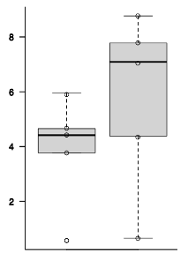
Figure S1. Comparison of total bile acid concentrations between bile duct discharge and culture medium, with histological correlation. Samples were collected from the cases lacking MRP2-positive bile canaliculi adjacent to the KRT19-positive bile ducts (n = 5, p = 0.310). Scale bars = 50 μm.

KRT19 / MRP2 / DAPI
Total Bile Acids (nmol/10^6 cells)
Bile discharge
Culture medium
p = 0.310
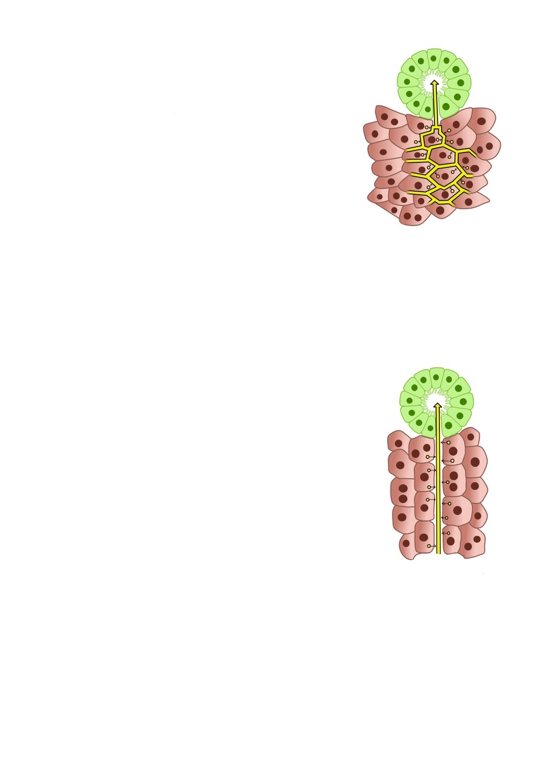
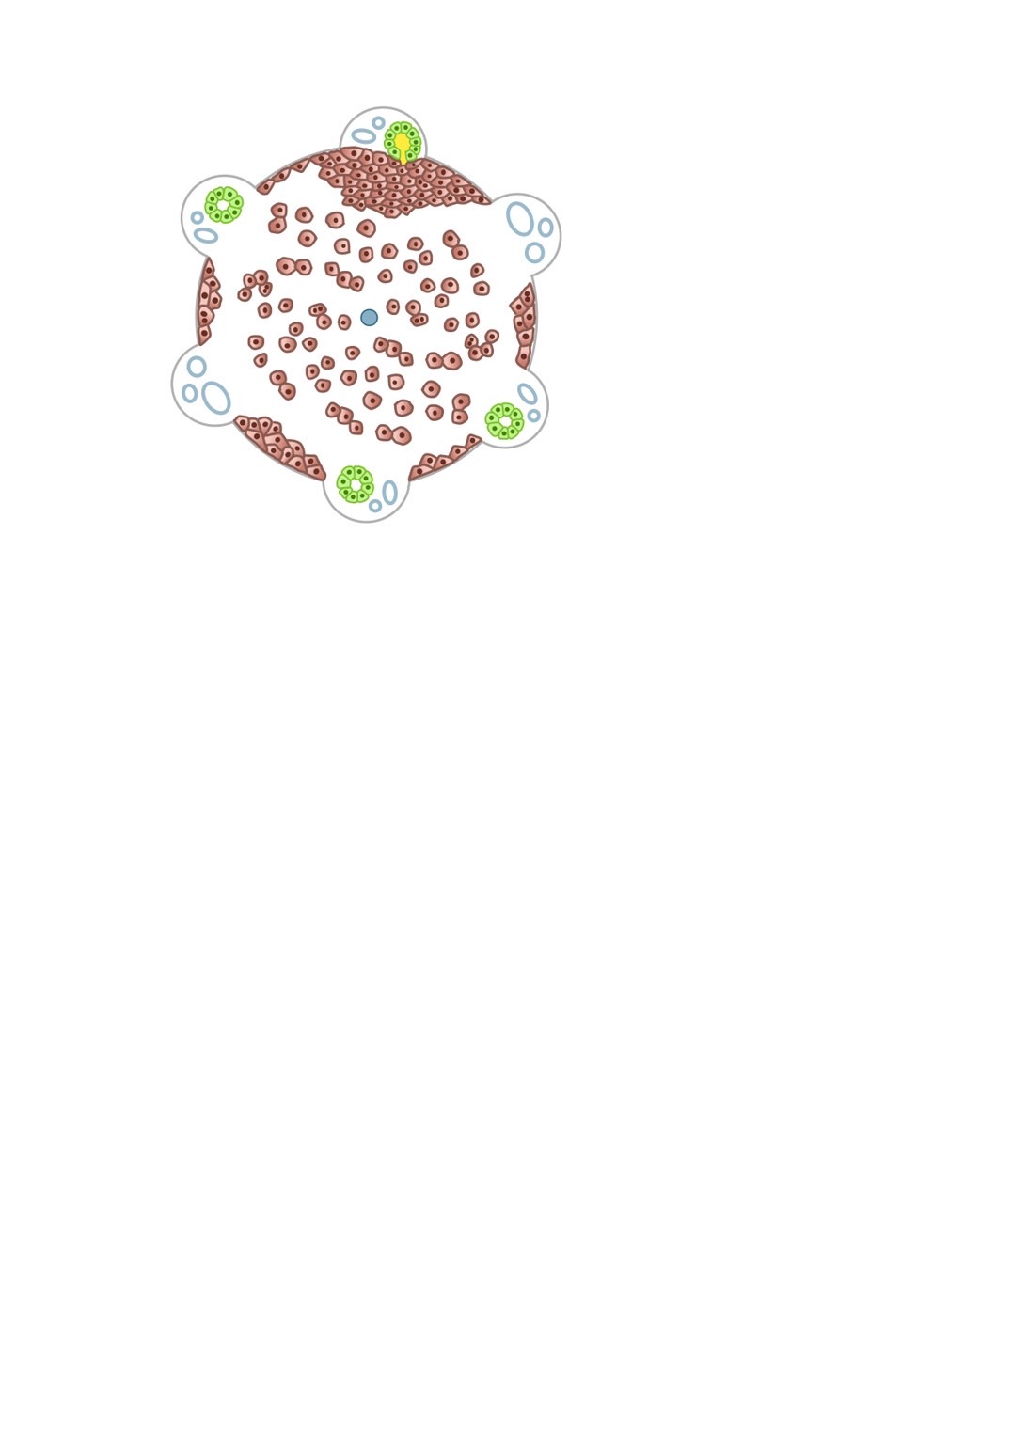
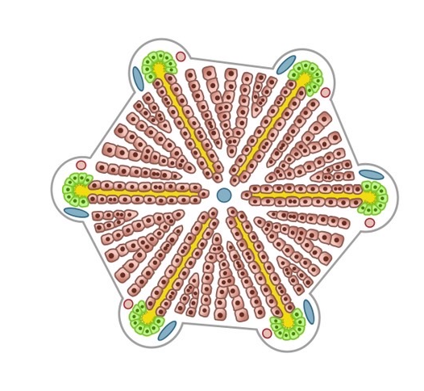
Figure S2. The expected schematic diagram of the reconstructed bile excretion system in the recellularized liver. The upper row illustrated the reconstructed hepatic lobule structure in the recellularized liver. In native liver, hepatocytes were arranged in a regular cord-like structure within the parenchymal space, with bile canaliculi connecting to the bile ducts. In the recellularized liver, hepatocytes were expected to engraft in a stacked manner along the ECM at the margins of the parenchymal space, with some connecting to the recellularized bile ducts. The lower row illustrated the anticipated mechanism of bile excretion in the recellularized liver, where bile produced by hepatocytes was transported from the bile canaliculi to the bile ducts, in comparison to the native liver.

Recellularized liver
Native liver

