Sponge-Derived Streptomyces variabilis Modulates Gene Expression and Immunity in Caenorhabditis elegans: Insights Into Protection From Vibrio parahaemolyticus

Journal Name
Current Microbiology

Author Names
Owen Brylle Acosta^{a*}, Rosanna Ramosª, Francis Reuben Paul Padayao^{b}, Carl Raymond Consuegraª, Norman Quilantangª, Reyna Marie Therese Sanchez^{a,c}, Mary Hannah Rose Padayao^{d}, Kenji Arakawa^{d}, and Jonie Yee^{a*}

Affiliations
ªApplied Microbiology and Molecular Biology Laboratory, Department of Biology, University of San Carlos, Cebu City 6000, Philippines

^{b}Department of Mathematics and Natural Sciences - Biology, Cebu Institute of Technology - University, Cebu City 6000, Philippines

^{c}Department of Science and Technology, Science Education Institute, Taguig City, Metro Manila 1631, Philippines

^{d}Program of Biotechnology, Graduate School of Integrated Sciences for Life, Hiroshima University, Higashi-Hiroshima 739-8526, Japan

*Corresponding authors: jcyee@usc.edu.ph
owenbrylleacosta@gmail.com

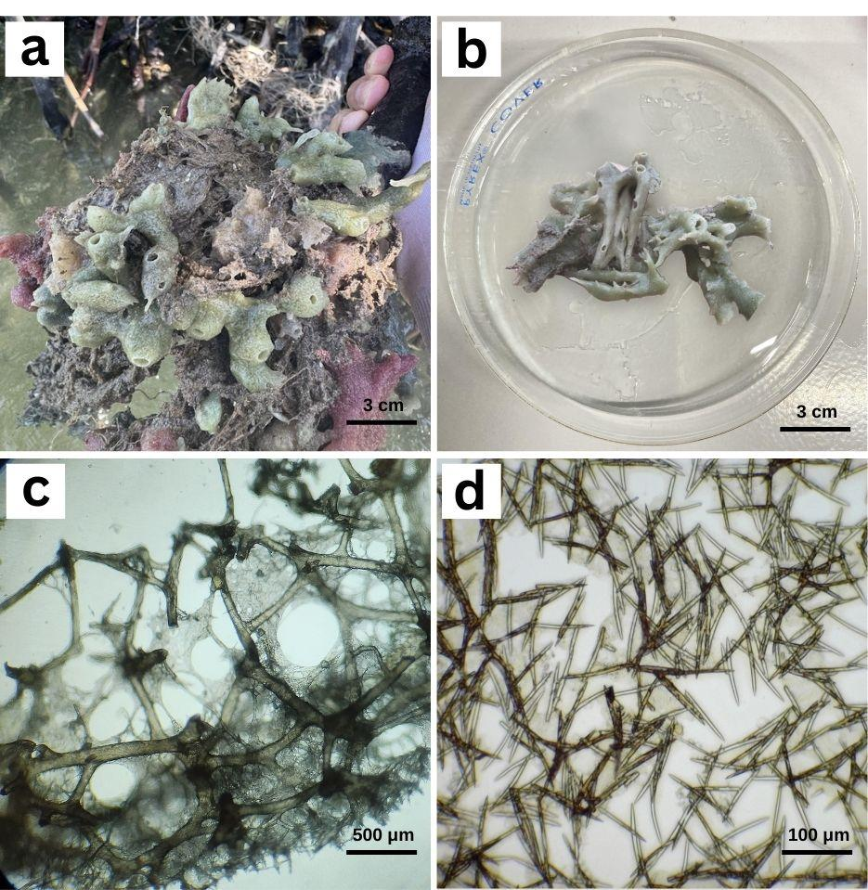
Figure S1 The sponge Haliclona sp. in the mangrove ecosystem of Sta. Fe, Bantayan Island, Cebu, Philippines (a); collected sample for bacterial isolation (b); details of spongin fibers (c); spicules (d)

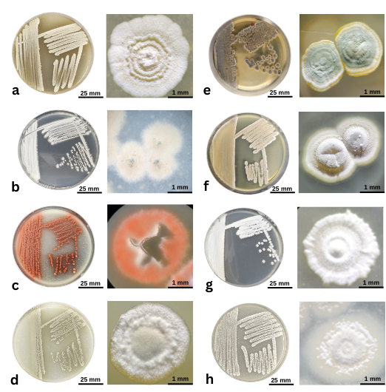
Figure S2 Colony morphology of mangrove sponge-associated actinomycete species (MSAS): Streptomyces champavatii (MSAS1) (a), Nocardiopsis synnemataformans (MSAS3) (b), S. wuyuanensis (MSAS4) (c), S. guorgerotti (MSAS5) (d), S. griseorubens (MSAS6) (e), S. variabilis (MSAS7) (f), N. alborubida (MSAS9) (g), and S. carpaticus (MSAS12) (h)

Table S1. Morphological characterization of presumptive actinomycete species isolated from the mangrove sponge Halicona sp.
Isolate Code | Colony Morphology |  |  | Mycelium Color |  | Diffusible Pigments | Spore Morphology
Isolate Code | Shape | Margin | Elevation | Aerial | Substrate | Diffusible Pigments | Spore Morphology
MSAS1 | Round | Filamentous | Raised | White | Yellowish brown | Negative | Rectiflexibiles
MSAS3 | Round | Entire | Convex | White | Yellow | Negative | Straight
MSAS4 | Round | Entire | Convex | White | Red | Reddish brown | Spiral
MSAS5 | Round | Filamentous | Raised | White | Dark brown | Brown | Rectiflexibiles
MSAS6 | Irregular | Filamentous | Raised | Grey | Yellow | Negative | Spiral
MSAS7 | Rounds | Entire | Convex | Grey | Brown | Negative | Spiral
MSAS9 | Curled | Filamentous | Umbonate | White | Brown | Negative | Straight
MSAS12 | Round | Entire | Raised | Grey | Dark brown | Brown | Spiral

