Supplementary Materials for
A dynamically resolved single-cell architecture of radiation pneumonitis provides insights into acute lung injury
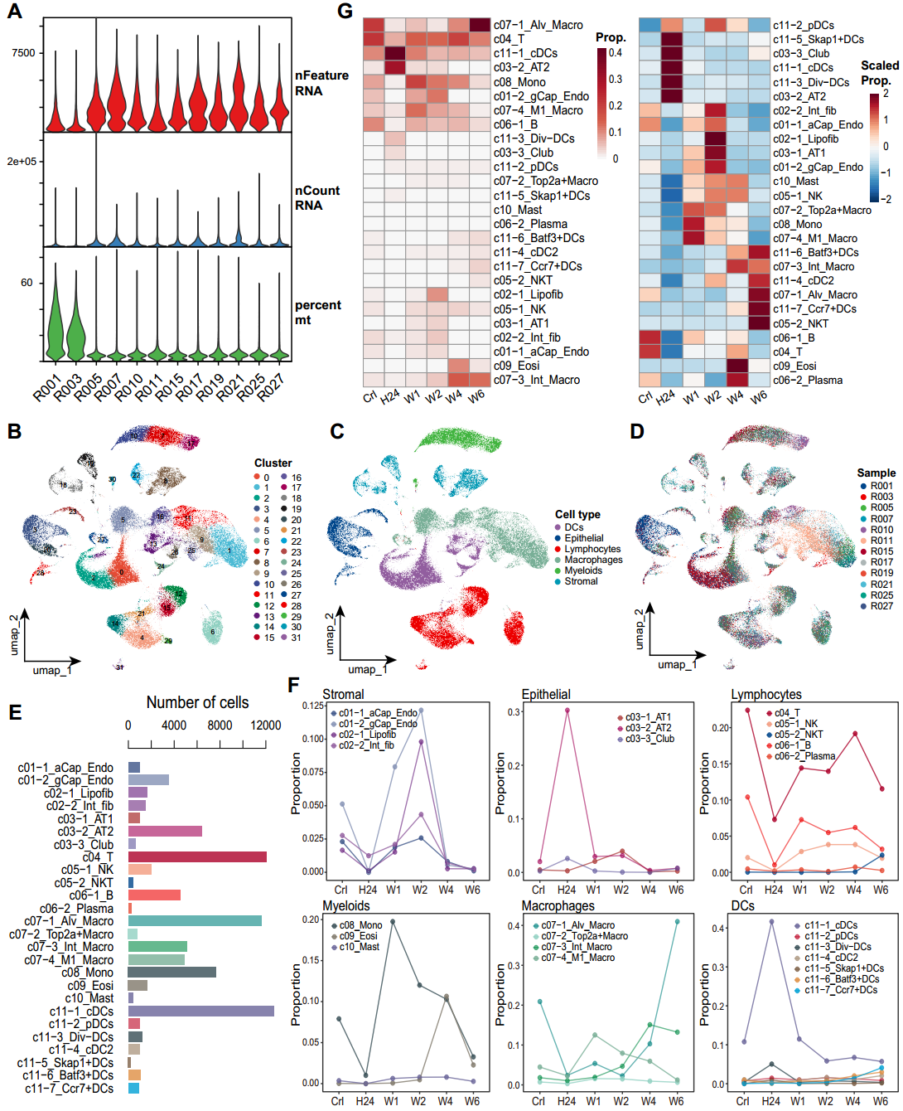
Fig. S1. Single-cell global landscape after irradiation in rats. (A) The number of genes detected, the total number of unique molecular identifiers (UMIs), and the proportion of mitochondrial (mt) genes in each sample during quality control. (B-D) UMAP visualization of 84,865 high-quality single cells showing the cell cluster (B), major cell type (C), and rat samples (D). (E) The histogram shows the number of cells detected in each subpopulation. (F) The dynamics of cell subpopulation in each major cell type across the control (Crl) and irradiation (IR) conditions at different time points. (G) The heat map shows the dynamics of cell subsets.
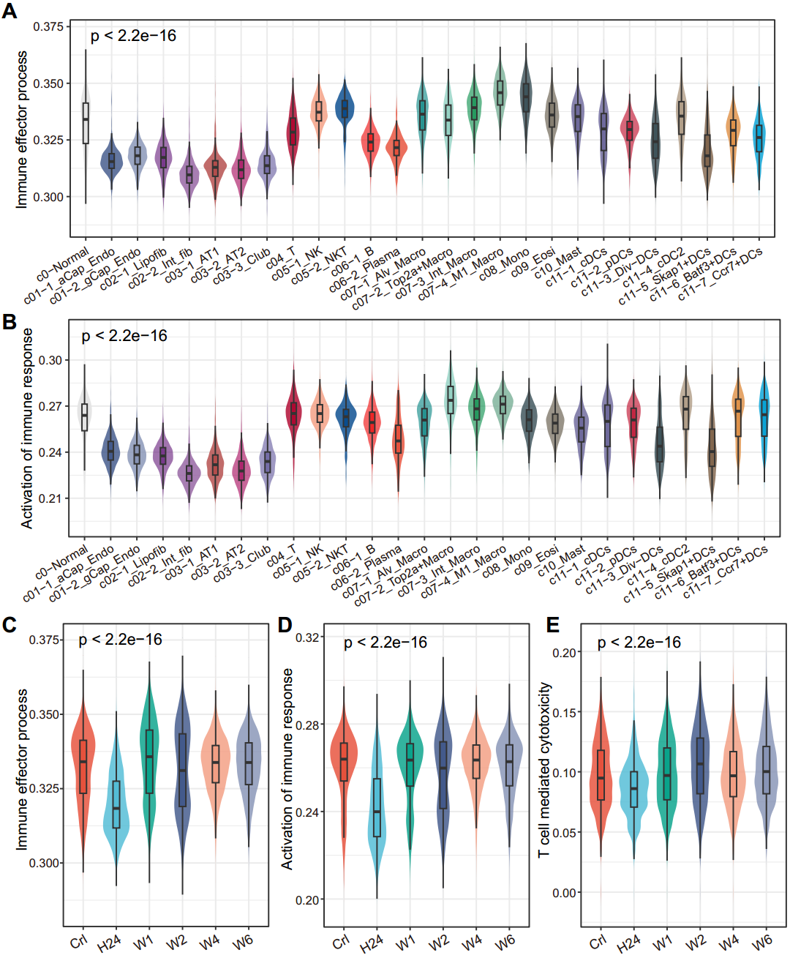
Fig. S2. The inflammatory response and immune effect distribution in different cell subsets and different time points. (A-E) Violin diagram of the immune effector process, activation of immune response, and T cell-mediated cytotoxicity in different cell subsets (A-B) and different time points (C-E). P-values were calculated using the Kruskal-Wallis statistical test.
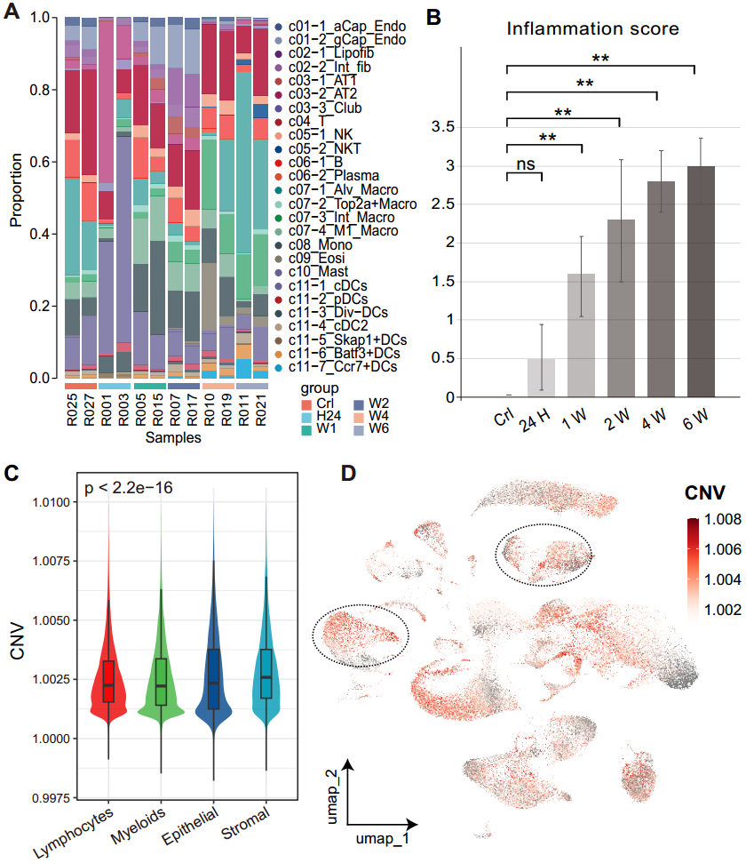
Fig. S3. Single-cell global landscape after irradiation in rats. (A) Dynamics in cell proportions of the cell subsets across the Crl and IR conditions at different time points in 12 rat samples. (B) Statistical analysis of the lung inflammation score in the control and IR groups from different time points (24H, 1W, 2W, 4W, 6W) after IR 20Gy. *, P < 0.05; **, P < 0.01; ***, P < 0.001; and ns indicates not signiﬁcant. (C-D) The sorted score (C) and UMAP visualization (D) of inferred CNV.
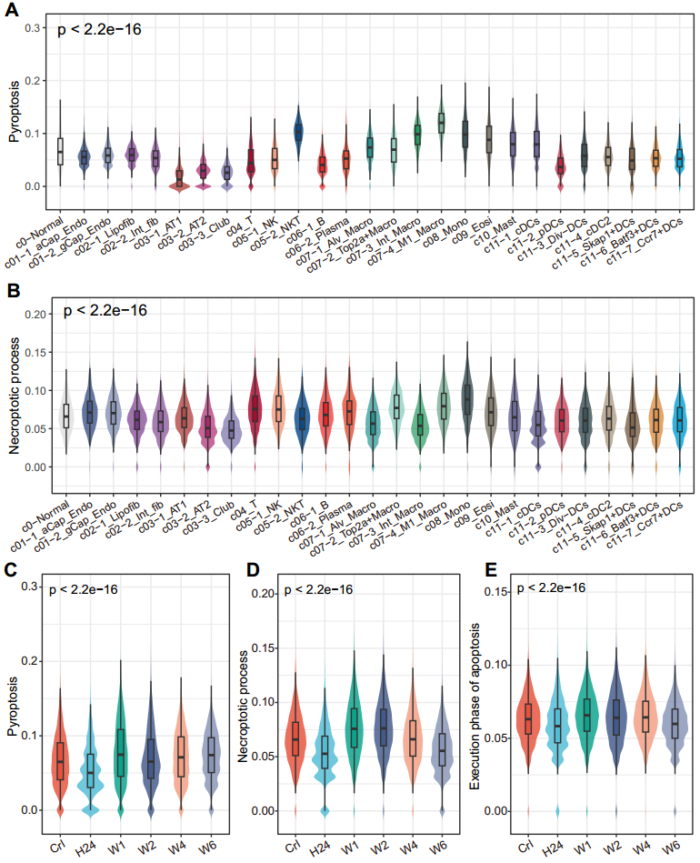
Fig. S4. The cell death effect distribution in different cell subsets and different time points. (A-E) Violin diagram of the pyroptosis, necroptotic process, and regulation of execution phase of apoptosis in different cell subsets (A-B) and groups (C-E). P-values were calculated using the Kruskal-Wallis statistical test.
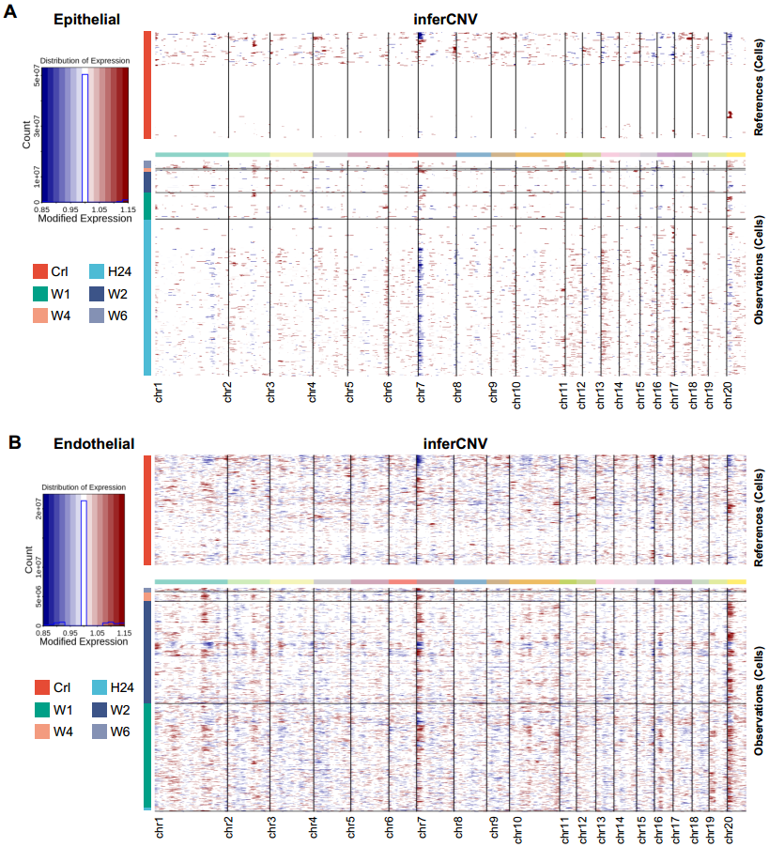
Fig. S5. Inferred CNVs at control and different time points after IR. (A-B) The inferred CNV in epithelial cells (A) and endothelial cells (B) across the control and IR conditions at different time points.
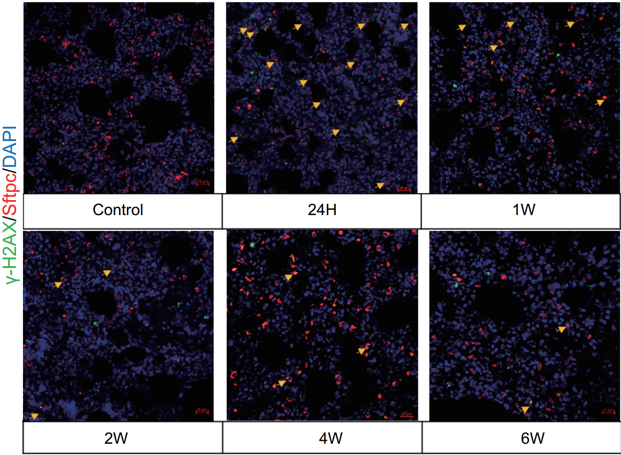
Fig. S6. DNA damage occurs in alveolar epithelial cells at 24 hours after IR. Multiplex immunofluorescence (mIF) staining for Sftpc (red), γ-H2AX (green), and DAPI (blue) in rat lung sections from the control and radiation groups (24H, 1W, 2W, 4W, and 6W). Arrowheads indicate the colocalization of Sftpc and γ-H2AX. Scale bars, 20 µm.
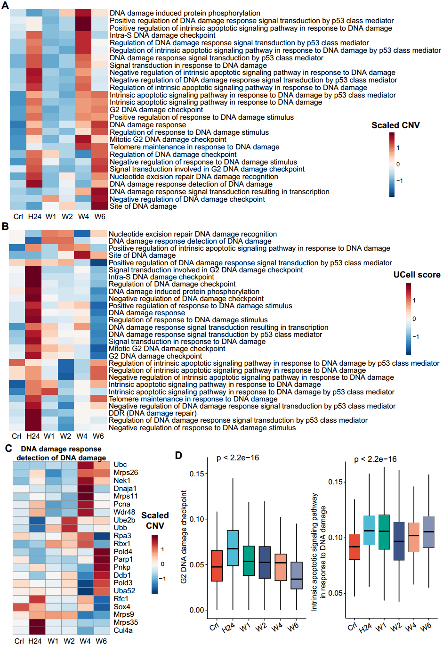
Fig. S7. DNA damage-related pathways respond to irradiation in epithelial cells. (A) Heatmaps show the average CNVs of pathways associated with DNA damage from MSigDB (mouse collection M5) database across the control and IR conditions at the different time points. (B) Enrichment scores (UCell score) for the DNA damage-related pathways (including DNA damage repair, DDR) across the control and IR conditions. (C) The CNVs of gene level from the representative pathway, DNA damage response detection of DNA damage. (D) Box plot shows the enrichment scores contribution of representative pathways (G2 DNA damage checkpoint and intrinsic apoptotic signaling pathway in response to DNA damage) across the control and IR conditions. P-values were calculated using the Kruskal-Wallis statistical test.
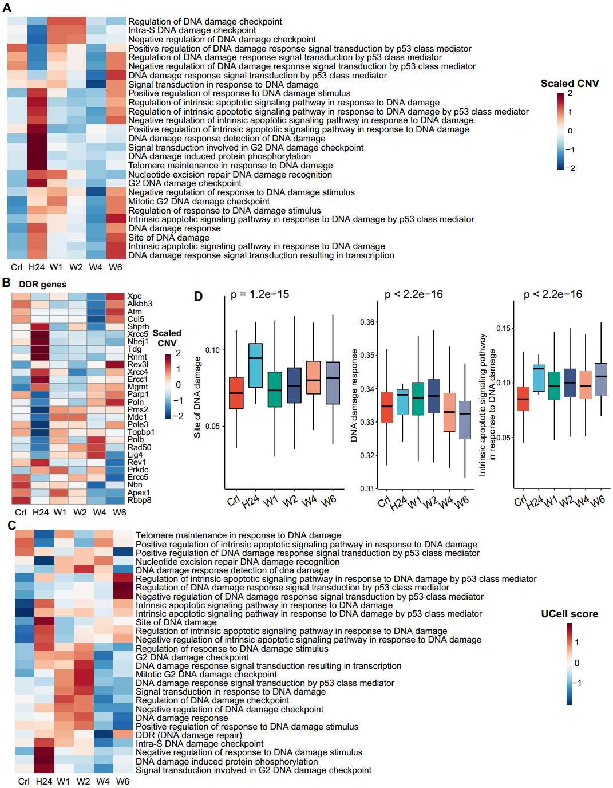
Fig. S8. DNA damage-related pathways respond to irradiation in endothelial cells. (A) Heatmaps show the average CNVs of pathways associated with DNA damage across the control and IR conditions at different time points. (B) The CNVs of gene level from representative pathways, DNA damage repair (DDR). (C) Enrichment scores for the DNA damage-related pathways (including DDR) across the control and IR conditions. (D) Box plot shows the enrichment scores contribution of representative pathways across the control and IR conditions. P-values were calculated using the Kruskal-Wallis statistical test.
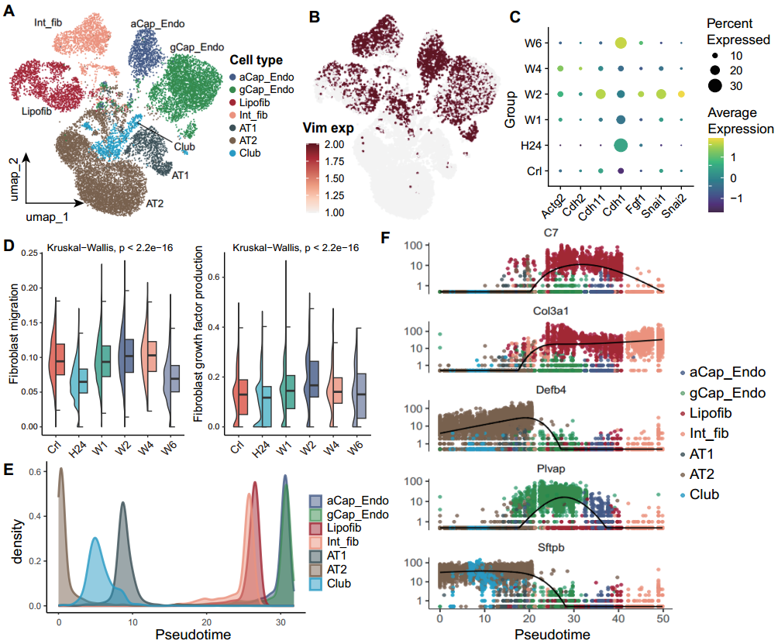
Fig. S9. Epithelial cells undergo mesenchymal transitions after IR. (A-B) UMAP visualization of epithelial-stromal cell subsets (A) and Vim expression (B). (C) Proportions and average expression (scaled) of representative EMT marker genes. (D) The signature analyses of fibroblast migration and fibroblast growth factor production. Signature score was calculated using the UCell package. (E) The density curve shows the pseudotime of each cell subset. (F) The expression dynamics of representative differentiation potential genes in epithelial and stromal cells.
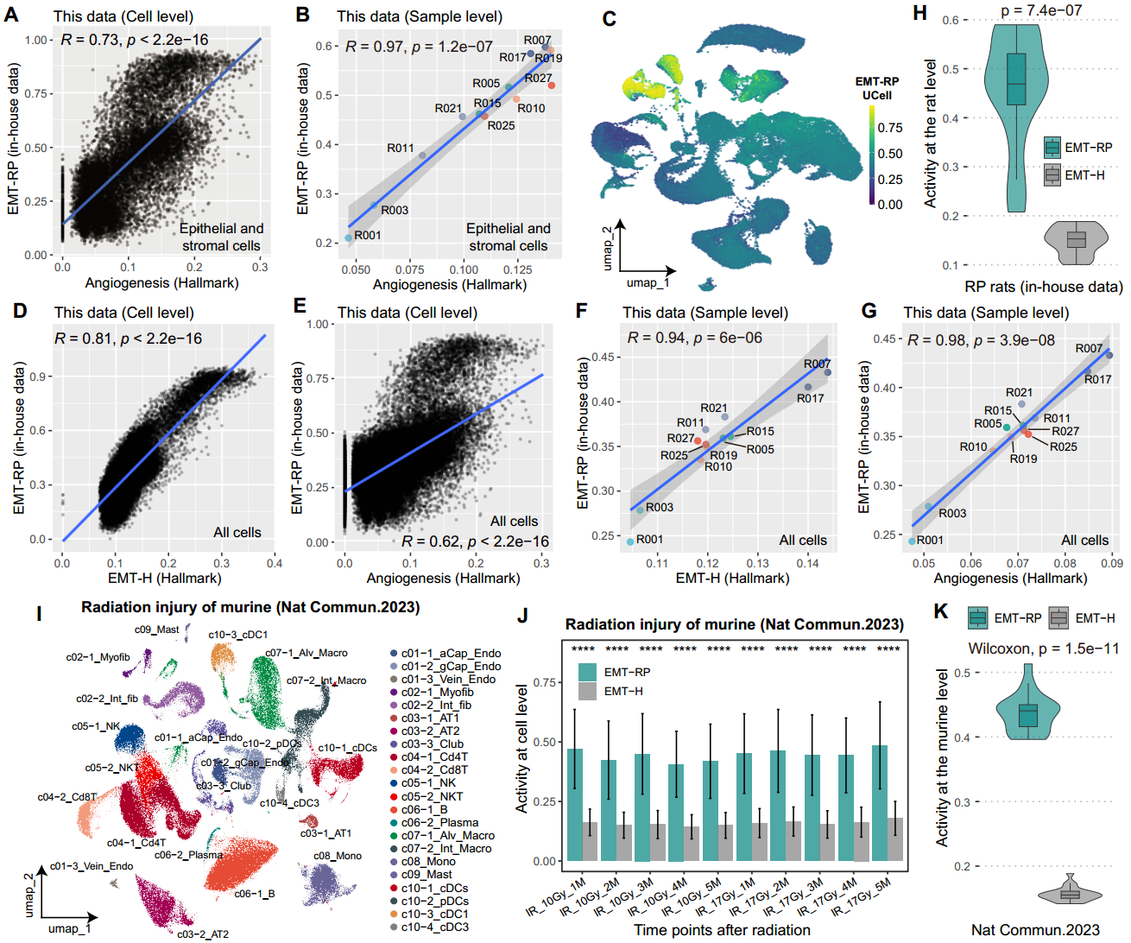
Fig. S10. The radiation-induced EMT signature was correlated with hallmark EMT. (A-B) Correlation analysis of the radiation-induced EMT (EMT-RP) signature with hallmark angiogenesis at the single-cell level (A) and rat sample level (B) in epithelial and stromal cells. (C) UMAP visualization of EMT-RP signature score in all cell types. (D, E) Correlation analysis of EMT-RP signature with hallmark EMT (EMT-H, D) and angiogenesis (E) at the single-cell level (all cell types). (F, G) At the rat sample level, like (D) and (E). Correlation coefficients (R) and P values ​​were calculated using the Pearson method. (H, K) Comparison of EMT-RP signature score and EMT-H signature score at the rat (H) and mice (K) sample level after IR. (I) UMAP visualization of 108,948 high-quality cells from 20 mice (including 5 non-IR mice as control, 5 mice after 10 Gy thorax IR and 10 mice after 17 Gy thorax IR). (J) Comparison of EMT-RP signature score and EMT-H signature score at the single-cell level of IR mice.
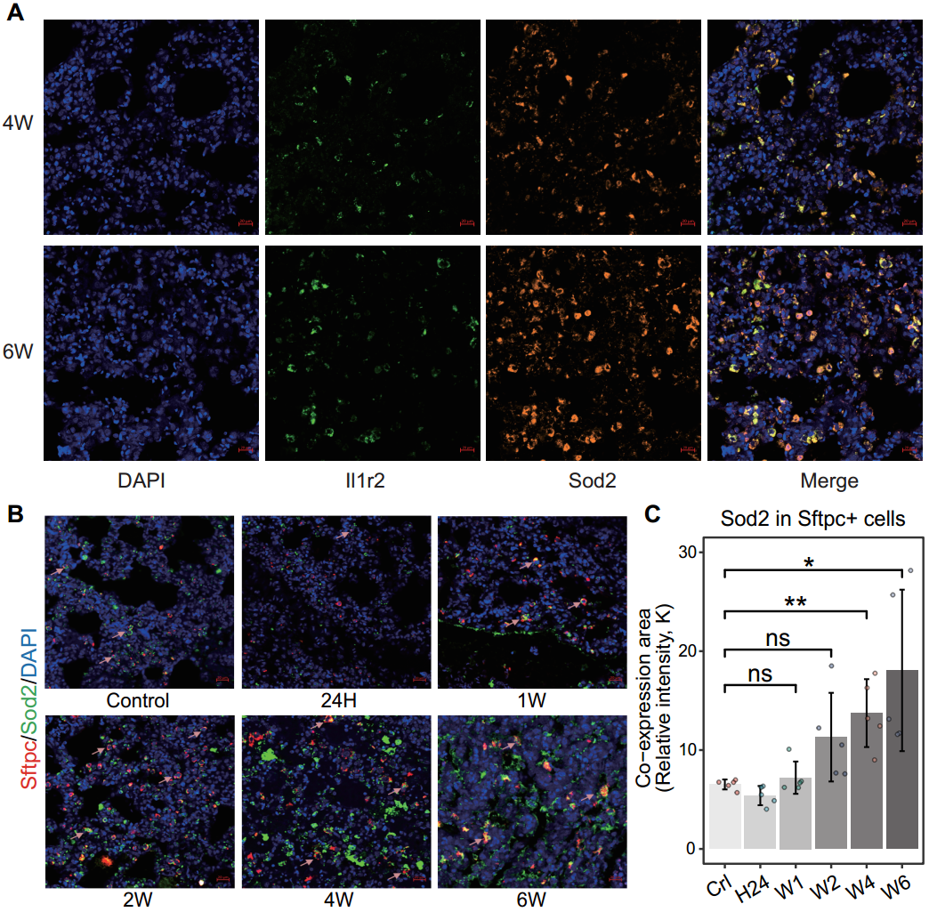
Fig. S11. The mIF staining before and after IR. (A) The mIF staining for Sod2 (brown), Il1r2 (green), and DAPI (blue) in rat lung sections from the control and radiation groups (4W and 6W). Scale bars, 20 µm. (B) The mIF staining of Sftpc (red), Sod2 (greed), and DAPI (blue) in lung sections from control and IR rats (24H,1W, 2W, 4W, 6W). Arrowheads indicate the colocalization of Sftpc and Sod2. Scale bars, 20 μm. (C) Statistical analysis of the relative intensity of Sod2 in Sftpc+ cells. *, P < 0.05; **, P < 0.01; ***, P < 0.001, and ns indicates not signiﬁcant.
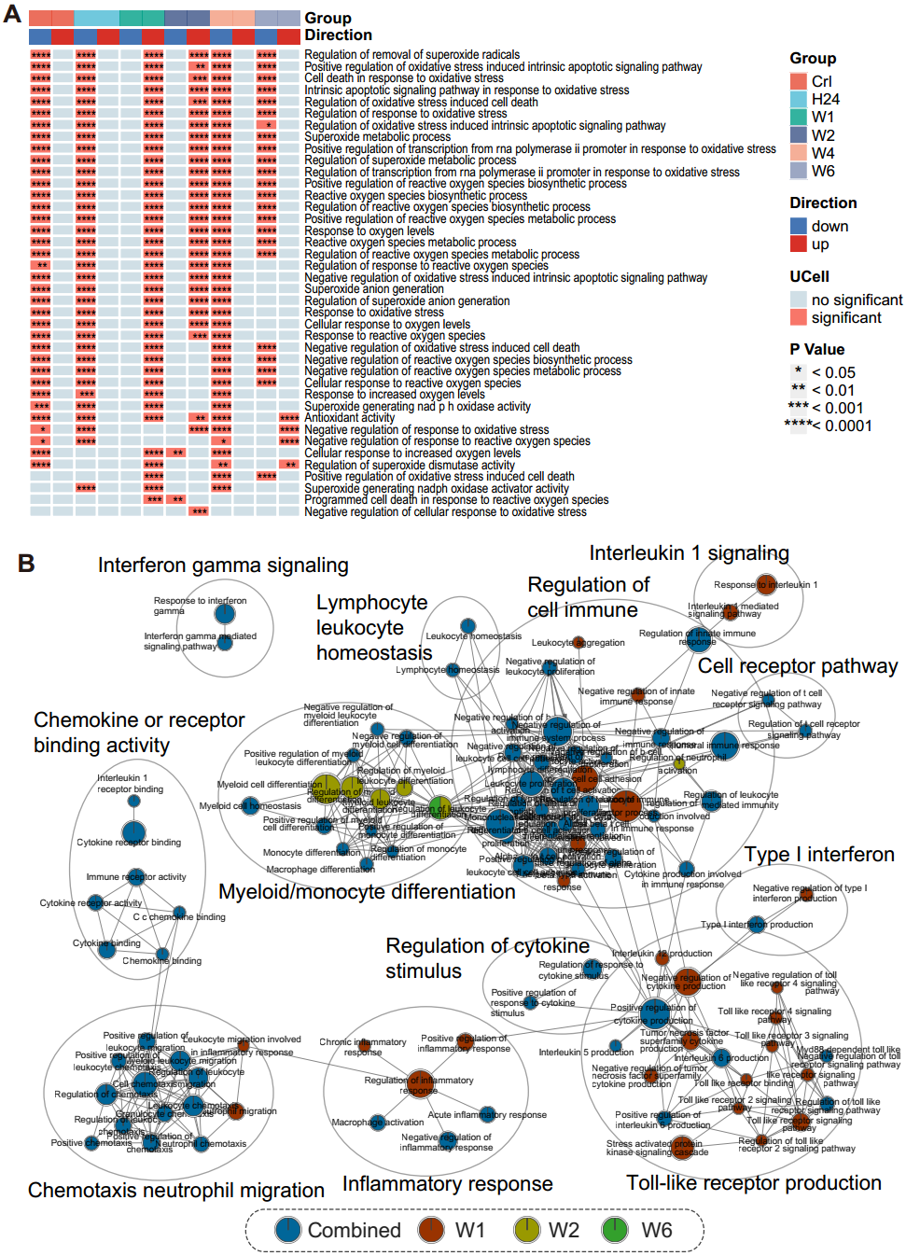
Fig. S12. Oxidative stress response in monocyte cells. (A) Heat map shows the significance of UCell scores for the oxidative stress gene sets in each group relative to the others. Red (blue) indicates up (down)-regulation. P-values were calculated using two-sided Wilcoxon rank-sum test. (B) Enrichment map of top 100 DEGs from per IR group compared with control in monocyte cells (exclude oxidative stress-related terms). The result of enrichment was combined based on Fisher’s combined probability test, which means that it is enriched by multiple IR groups (excluding Crl group).
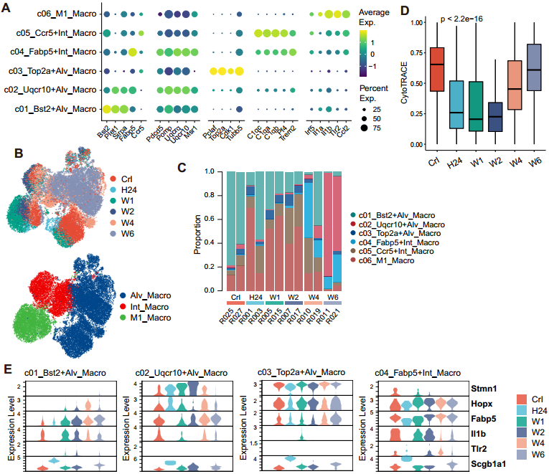
Fig. S13. Irradiation enhances the pro-inflammatory phenotype of macrophages. (A) Bubble plot shows the expression of the markers used for macrophage component identification. (B) UMAP visualization of rat groups and macrophage components. (C) Dynamics in cell proportions of macrophage components among rat samples. (D) The CytoTRACE score in rat groups. P-values were calculated using Kruskal-Wallis statistical test. (E) The expression of proliferation, differentiation, and pro-inflammatory-related genes in Crl and IR groups for macrophage components.
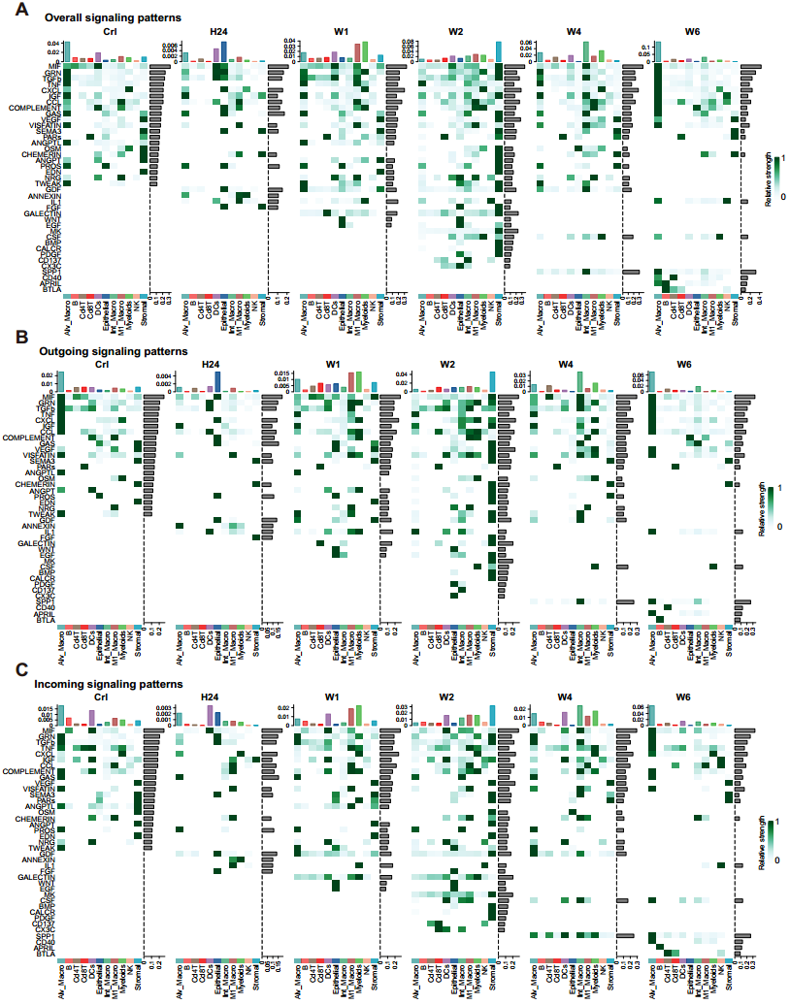
Fig. S14. Comparison of cell signaling patterns across control and IR groups. (A) Overall signaling pattern comparison, including cell types as sender and receiver. (B) Outgoing signaling pattern comparison, including only cell types as sender. (C) Incoming signaling pattern comparison, including only cell types as receiver.
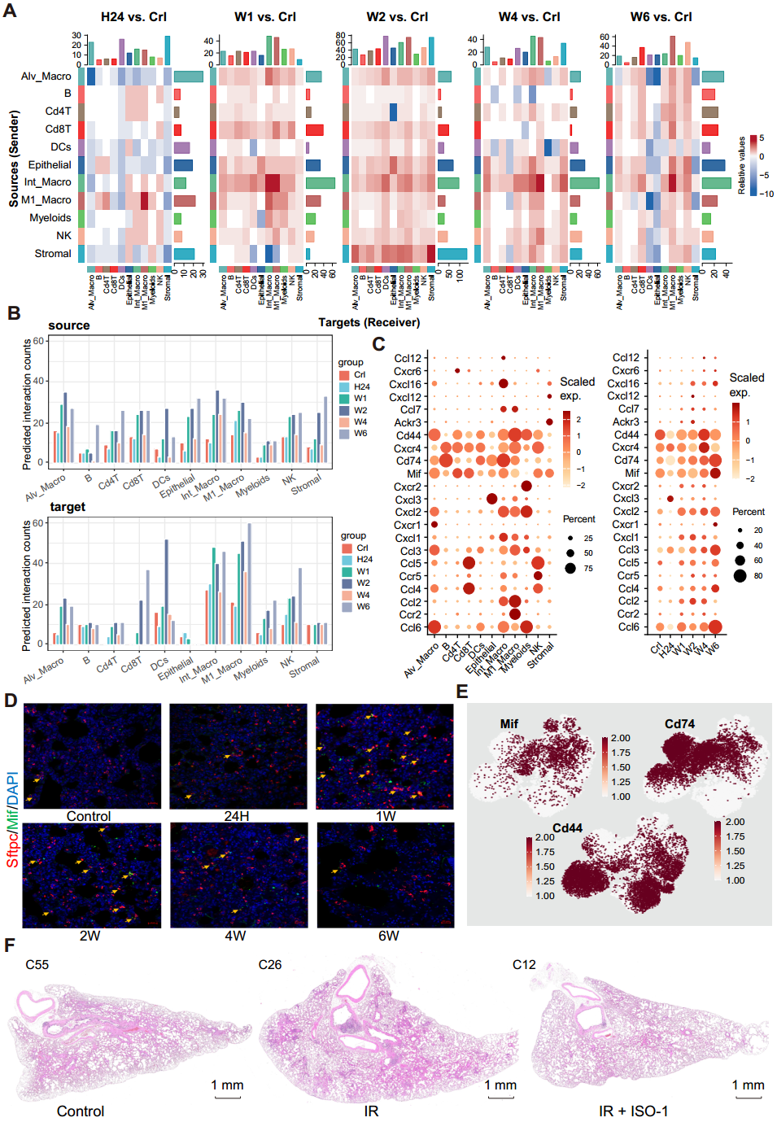
Fig. S15. Cell-cell communication based on signaling pathway ligand-receptor interaction. (A) Differences of cell interaction number in the group of IR conditions at the different time points relative to the control group. (B) The count of ligand-receptor pairs among cell types was identified by scanning molecular interaction with the CellChat pipeline. The count include source (top, sender) and target (bottom, receiver). (C) Expression of ligands and receptors of MIF, CCL, and CXCL signaling pathways of interaction in cell types and rat groups. (D) The mIF staining for Sftpc (red), Mif (green), and DAPI (blue) in rat lung sections across control and IR groups. Arrowheads indicate the colocalization of Sftpc and Mif. Scale bars, 20 µm. (E) UMAP visualization of MIF signaling genes Mif, and its receptor Cd74 and Cd44 in macrophages. (F) H&E staining of lung sections at control, IR (20 Gy), and IR + MIF inhibitor ISO-1 rat groups.
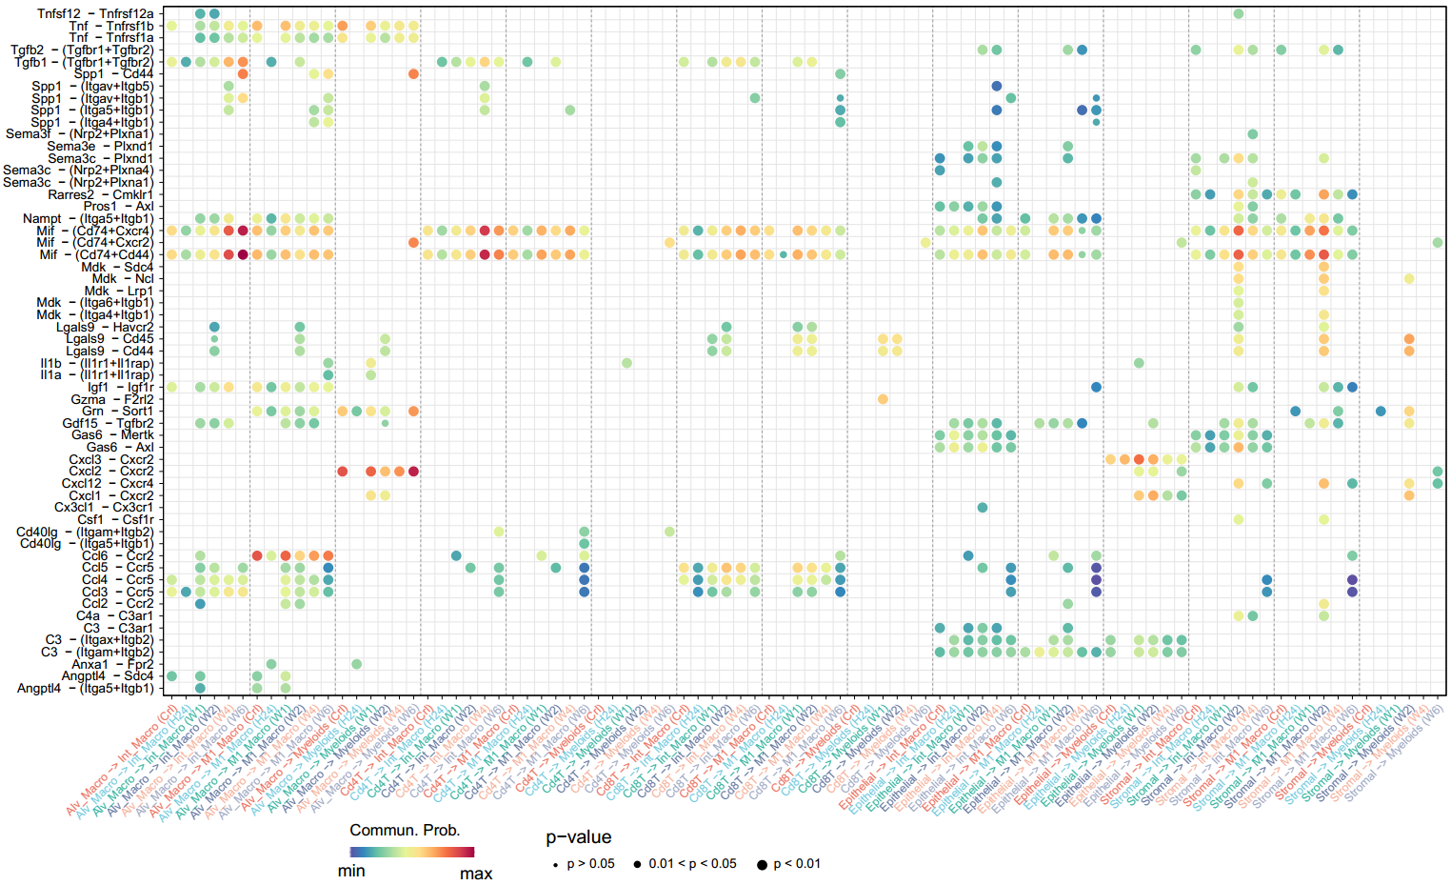
Fig. S16. Change cell interactions in the IR group relative to the control. Bubble plot shows the differences of all ligand-receptor pairs across the control and IR conditions at the different time points. Colors indicate communication probability. The dot size indicates the significance of the interaction. P-values were calculated using a permutation test by randomly permuting the group labels of cells.
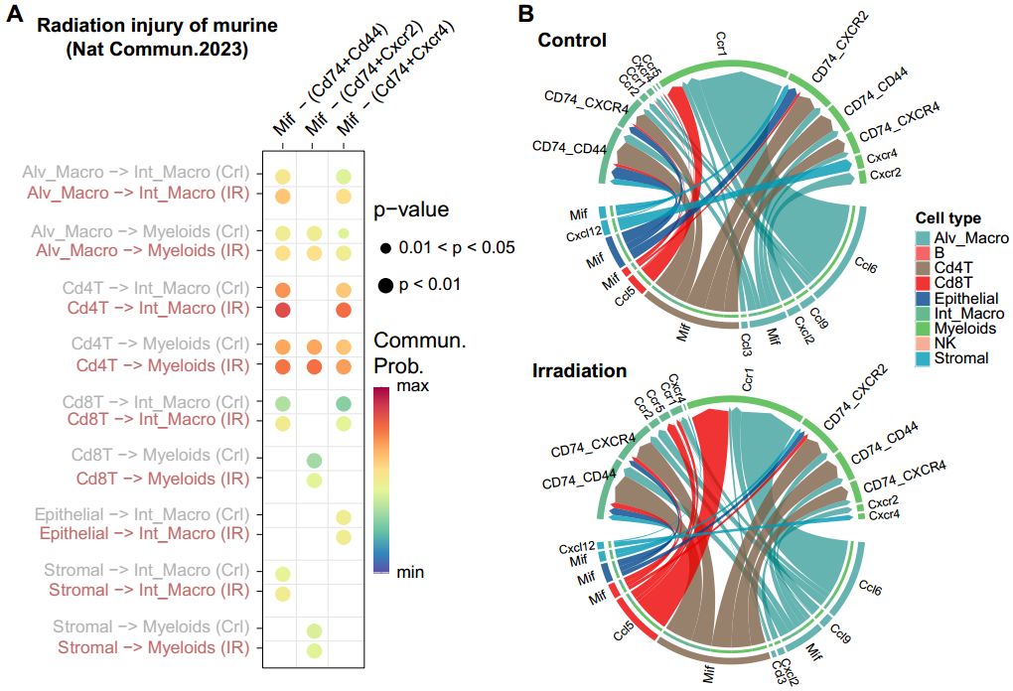
Fig. S17. Change cell interactions in the IR group relative to the control from mice radiation injury data set. (A) Bubble plot shows the changes in communication probability of MIF signaling across the control and IR mice. (B) Chord diagrams show the cell-cell communications based on MIF, CCL, and CXCL signaling across the control and IR mice.

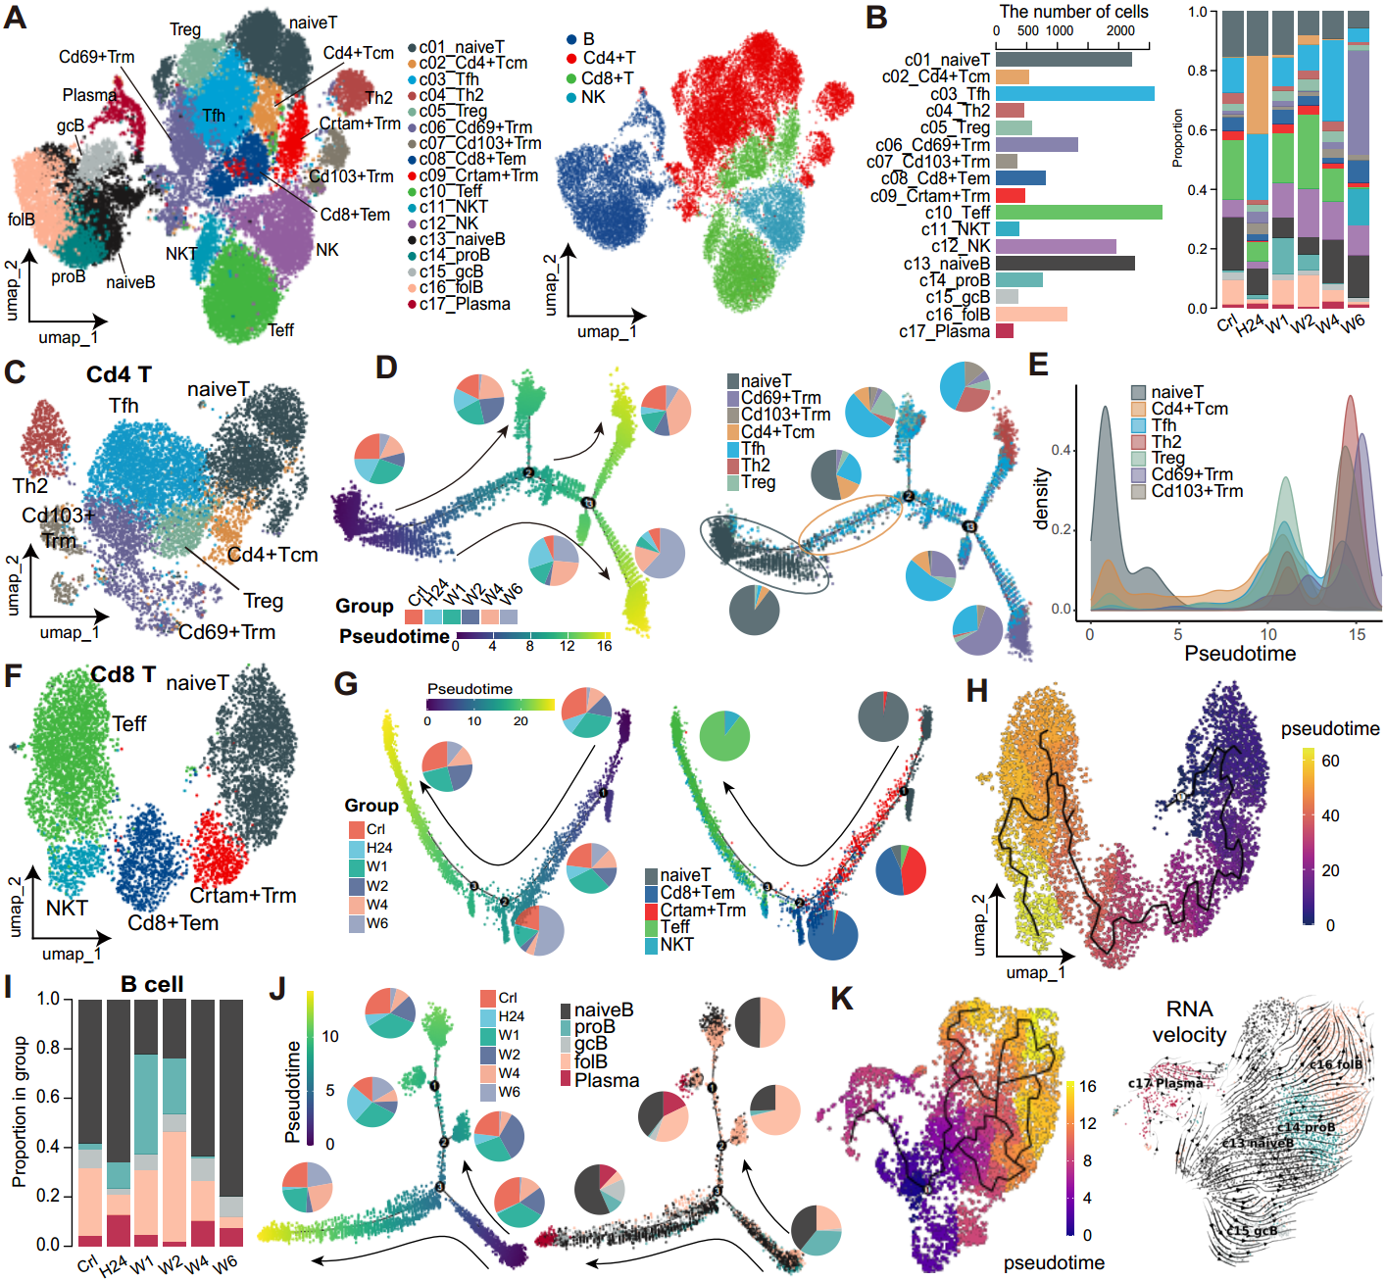
Fig. S18. Lymphocyte dynamics during radiation lung injury. (A) UMAP of cell subsets (left) and major cell type (right) in lymphocytes. (B) Numbers (left) and proportions (right) of lymphocyte subsets. (C, F) UMAP of Cd4+ T (C) and Cd8+ T (F) subsets. (D, G) Pseudotime analysis of Cd4+ (D) and Cd8+ (G) T cells by Monocle 2. The branched trajectory was colored by pseudotime (left) and cell subsets (right). The pie chart shows the proportion of rat groups (left) and cell subsets (right) in each branch. (E) Density curve shows the pseudotime of each Cd4+ T subset. (H) Pseudotime analysis of Cd8+ T cells by Monocle 3. (I) Dynamics of B subset proportions. (J) Pseudotime analysis of B cells. (K) UMAP of pseudotime (left) and RNA velocity (right) in B cells. Tcm, central memory T cells. Tfh, follicular helper T cells. Th2, T-helper 2 cells. Treg, regulatory T cells. Trm, tissue-resident memory T cells. Teff, effector T cells. Tem, effector memory T cells. NK, natural killer cells. NKT, NK-like T cells. proB, proliferating B cells. gcB, germinal center B cells. folB, follicular B cells.
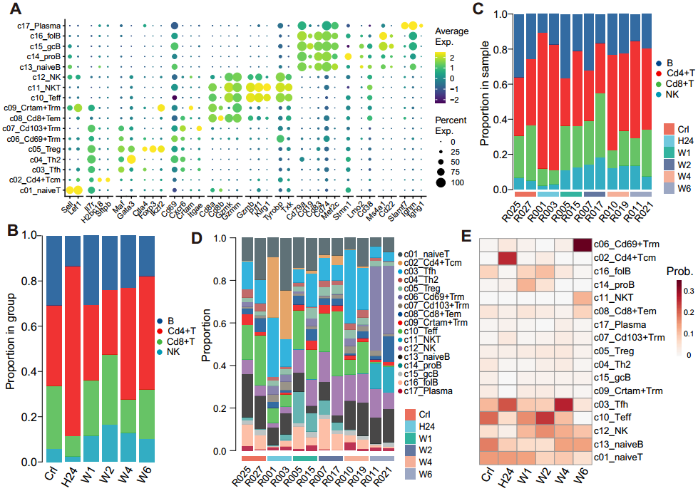
Fig. S19. Lymphocyte dynamic changes after irradiation. (A) Bubble plot shows the expression of the markers used for lymphocyte identification. (B-C) Dynamics in cell proportions of the B cells, NK cells, Cd8+ T, and Cd4+ T cells in rat groups (B) and rat samples (C). (D-E) Dynamics of lymphocyte subset proportions in rat samples (D) and rat groups (E).
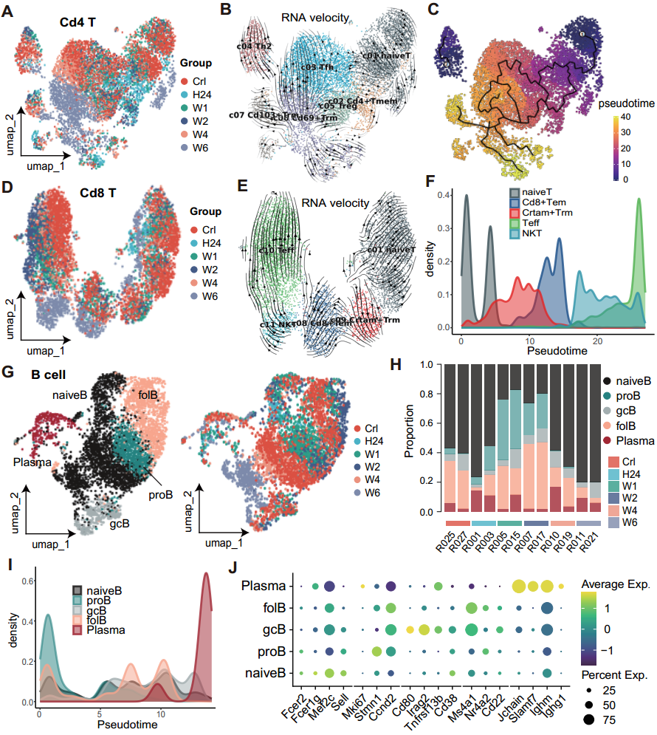
Fig. S20. Pseudotime and differentiation potential analysis for Cd4+ T and Cd8+ T cells. (A-C) UMAP of rat groups (A), RNA velocity (B) and pseudotime (C) in Cd4+ T cells. (D-E) UMAP of rat groups (D) and RNA velocity (E) in Cd8+ T cells. (F, I) Density curve shows the pseudotime of Cd8+ T (F) and B lymphocyte (I) subsets. (G) UMAP of cell subsets (left) and rat groups (right) in B lymphocytes. (H) Dynamics of B subset proportions in rat samples. (J) Bubble plot shows the expression of the markers used for B lymphocyte subsets identification.

