Supplementary information

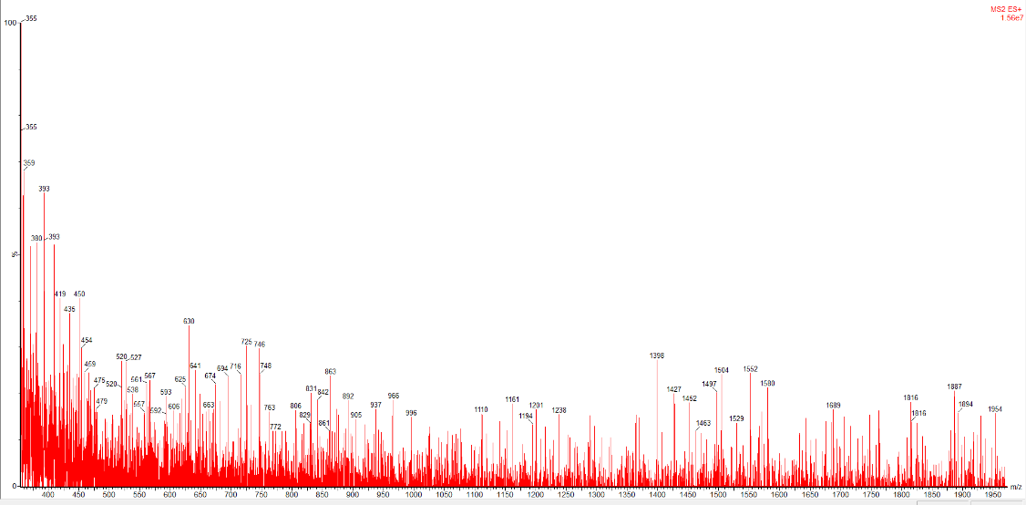

Fig. 1 Total ion spectrum of cheese coded 0H in LC-MS/MS

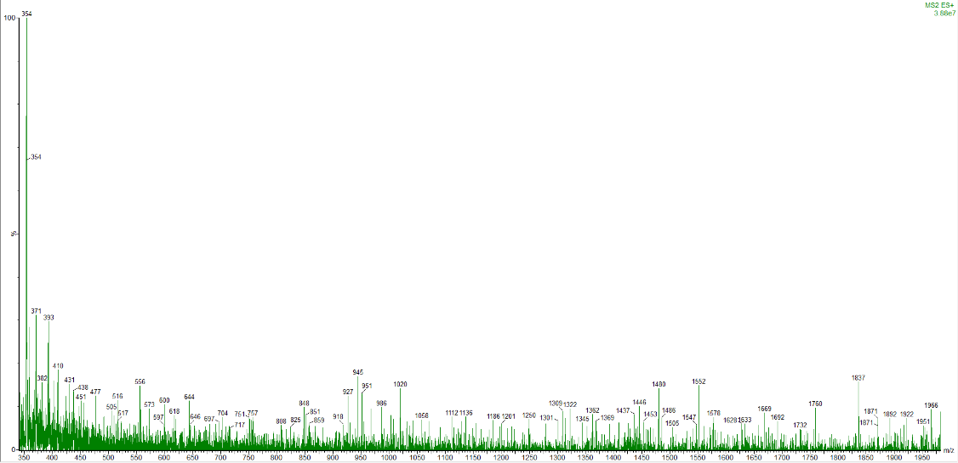

Fig. 2 Total ion spectrum of cheese coded 0A in LC-MS/MS

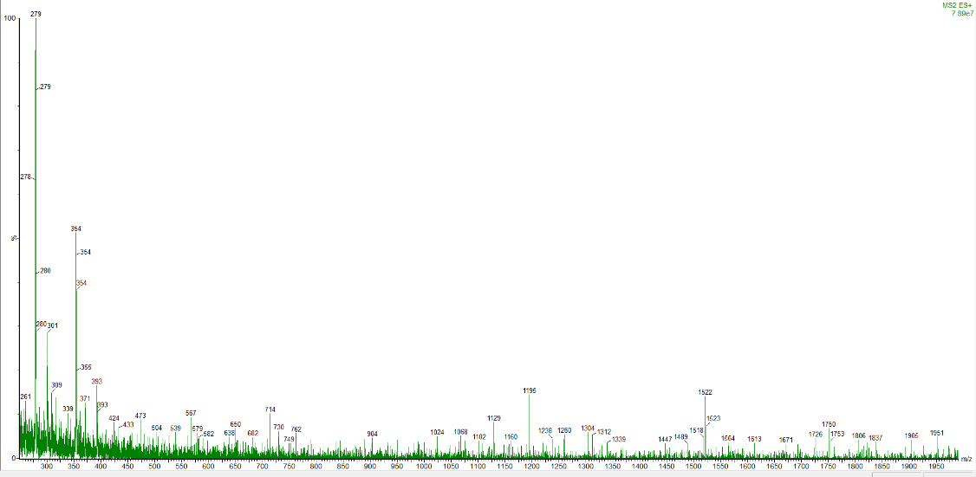

Fig. 3 Total ion spectrum of cheese coded 13H in LC-MS/MS

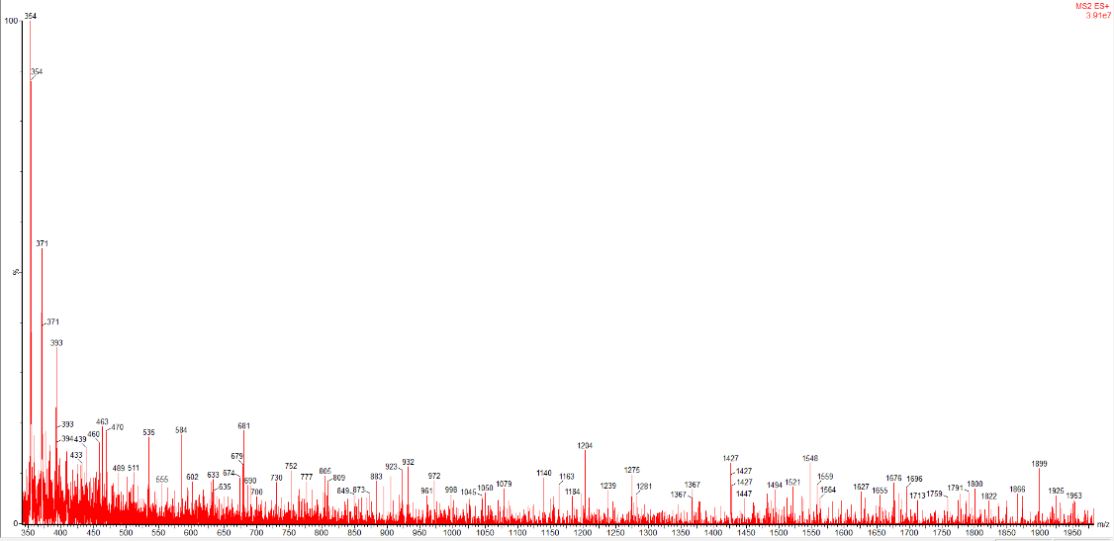

Fig. 4 Total ion spectrum of cheese coded 13A in LC-MS/MS

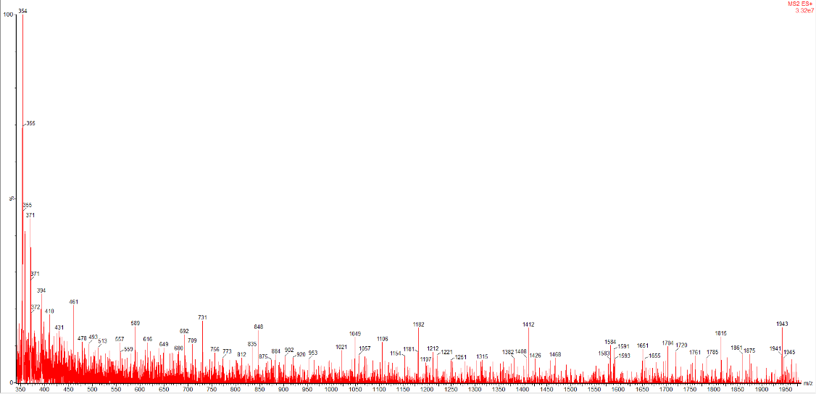

Fig. 5 Total ion spectrum of cheese coded 26H in LC-MS/MS

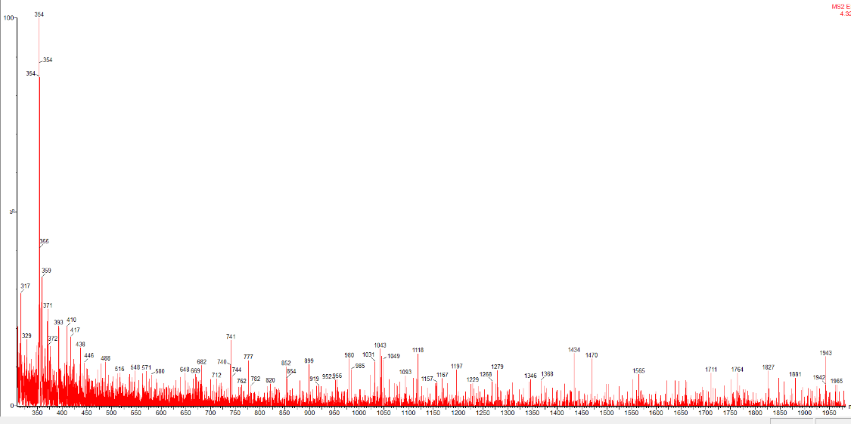

Fig. 6 Total ion spectrum of cheese coded 26A in LC-MS/MS

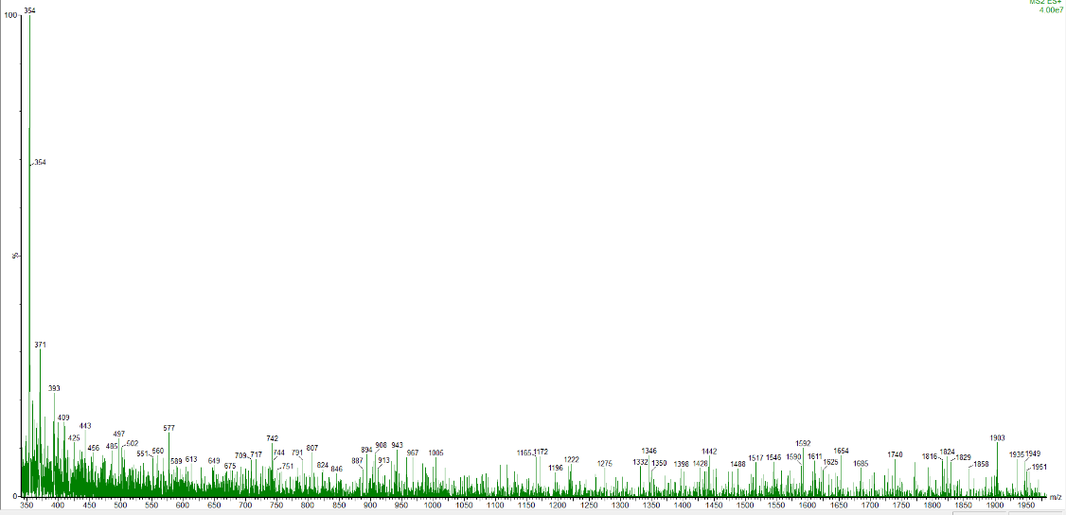

Fig. 7 Total ion spectrum of cheese coded 39H in LC-MS/MS

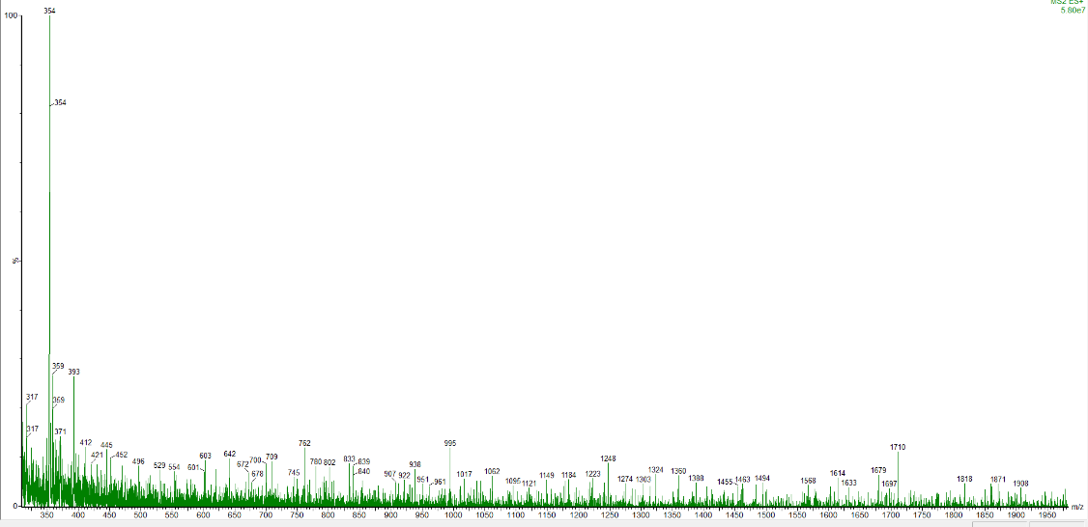

Fig. 8 Total ion spectrum of cheese coded 39A in LC-MS/MS

