Supplementary Information
on
A Super-Resolution Framework for Downscaling Machine Learning Weather Prediction toward 1-km air temperature

Hyebin Park¹, Seonyoung Park^{1*}, Daehyun Kang^{2*}, Jeong-Hwan Kim²

¹Department of Applied Artificial Intelligence, Seoul National University of Science and Technology, Seoul, South Korea
²Center for Climate and Carbon Cycle Research, Korea Institute of Science and Technology, Seoul, South Korea

*Corresponding authors: Seonyoung Park (sypark@seoultech.ac.kr) and Daehyun Kang(dkang@kist.re.kr)

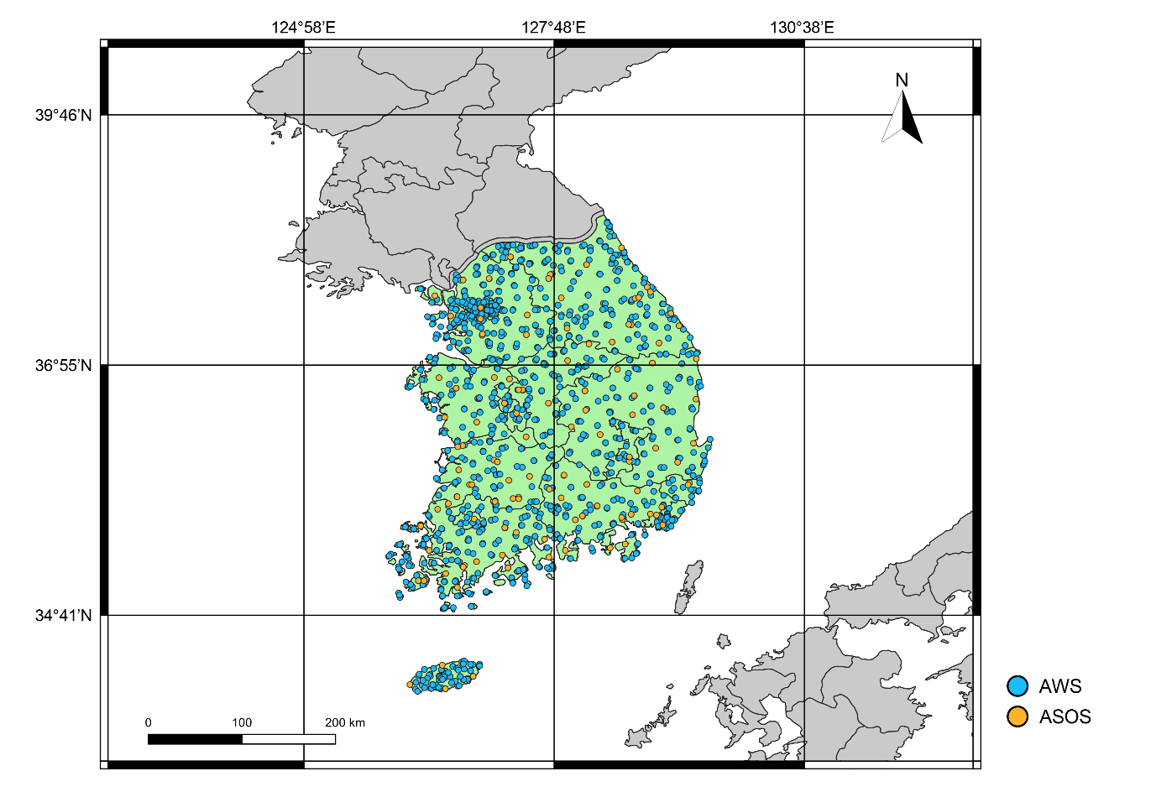
Supplementary Figure S1. South Korea is highlighted as the focus region, with blue circles indicating Automated Weather Stations (AWS) and orange circles indicating Automated Synoptic Observing System (ASOS) sites used for model evaluation.

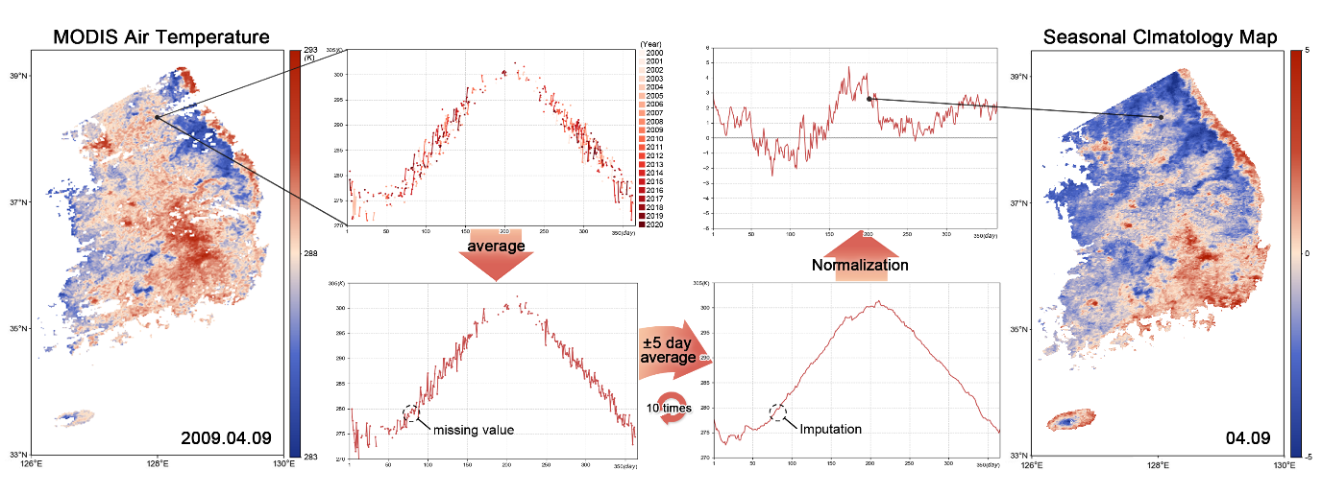
Supplementary Figure S2. Workflow for constructing the Seasonal Climatology Map (SCM). Daily MODIS-derived air temperature data (e.g., that for April 9th shown as an example) are averaged across multiple years to generate the seasonal climatology. Missing values are corrected using a ±5-day moving average and 10 iterations of imputation. The resulting climatological fields are then normalized to produce the SCM, with the right panel showing an example for April 9th.

