Supplementary Information for

Accumulation of zinc during E. coli biofilm mineralization: within or surrounding the hydroxyapatite?
Leona J. Bauer^{1,3*}, Laura Zorzetto^{2*}, Ernesto Scoppola², Yannick Wagener¹, Ioanna Mantouvalou^{1,3†} and Cécile M. Bidan^{2†}
¹ Institute for Physics and Astronomy, Technische Universität Berlin, Hardenbergstrasse 36, 10623 Berlin, Germany.
² Max Planck Institute of Colloids and Interfaces, Department of Biomaterials, 14476 Potsdam, Germany.
³ SyncLab, Helmholtz-Zentrum Berlin für Materialien und Energie, Albert-Einstein-Str. 15, 12489 Berlin, Germany.
* equal contributions
† corresponding authors
Corresponding authors: Cecile.Bidan@mpikg.mpg.de, ioanna.mantouvalou@helmholtz-berlin.de

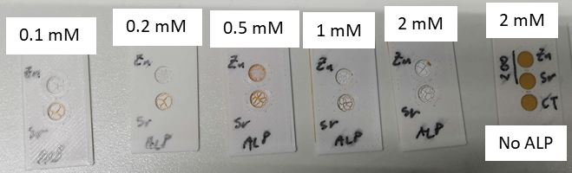
Figure S1: Sample holders containing enzymatically precipitated hydroxyapatite with different ZnCl₂ and SrCl₂ concentrations. Control samples with No ALP were also measured, although no precipitate was visible.
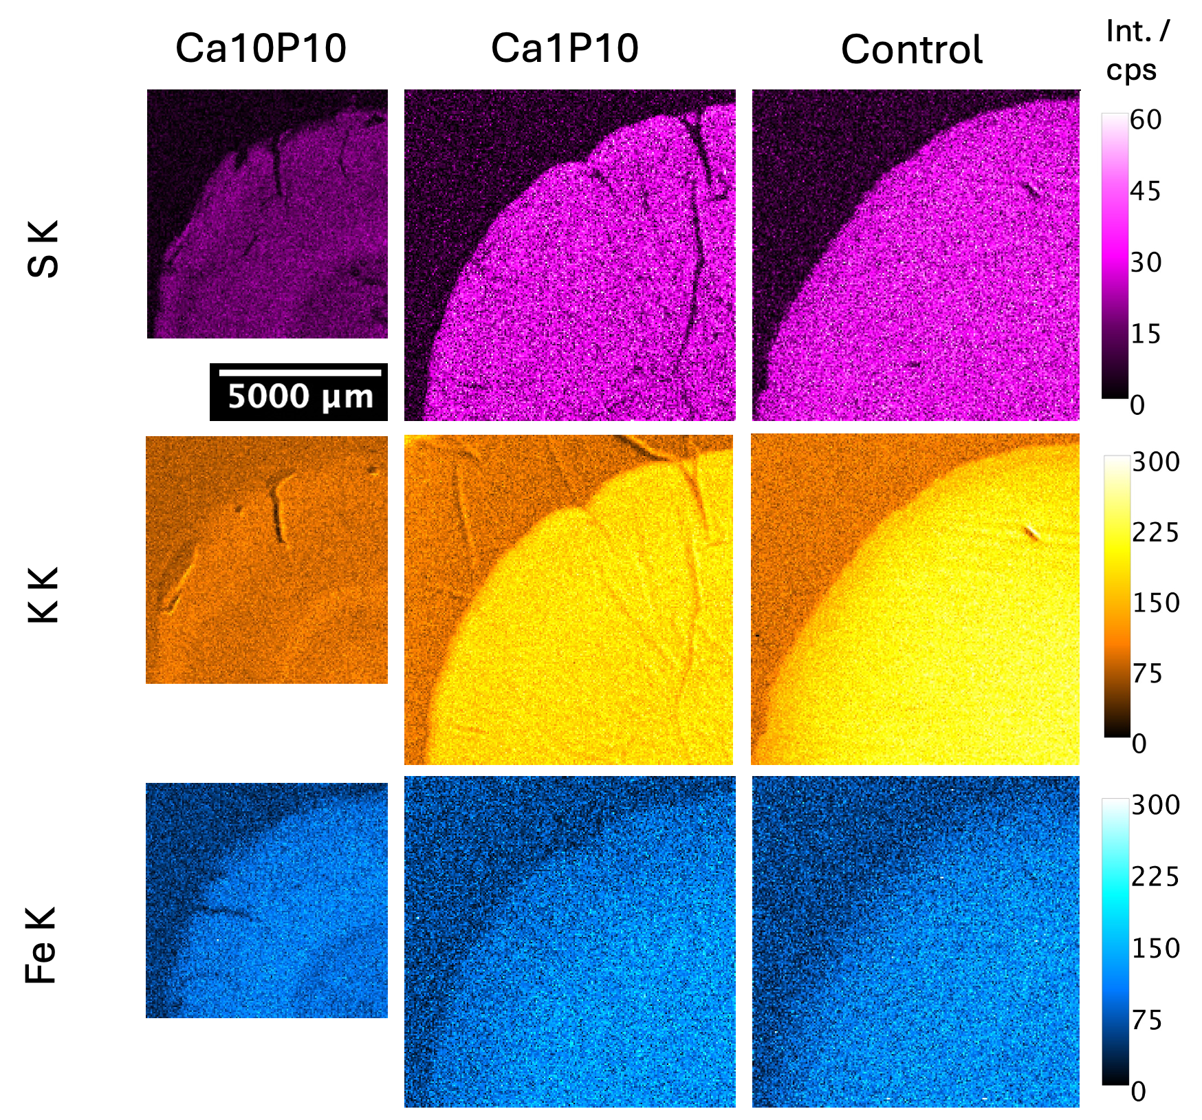
Figure S2: Additional elemental distributions obtained from MXRF measurements on three biofilms grown for 10 days under different mineralization conditions (Ca10P10, Ca1P10, Control). The step size is 50 µm and the measurement times are 1.75 s, 0.85 s, 0.85 s (25 ms, 70 cycles and 35 cycles). The color scales show the X-ray fluorescence net peak intensities in counts per second (cps). The length scale is the same for all three measurements.
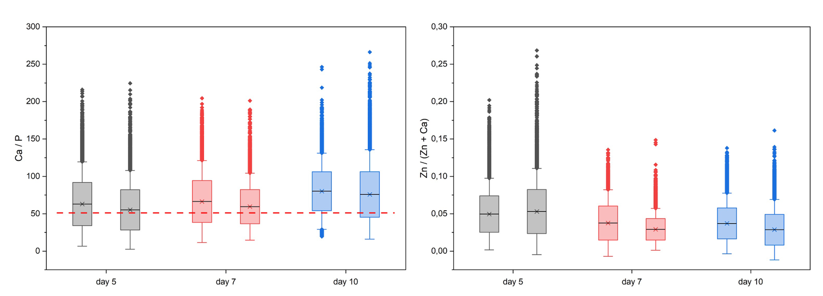
Figure S3: Ca/P (left) and Zn/(Zn+Ca) (right) ratio of the biofilms grown for 5, 7 and 10 days. The boxplot shows the mean value, standard deviation and outliers of the ratios derived from the net peak intensities derived from 2D maps on the biofilms grown for 5, 7 and 10 days (Figure 2). The values cannot be compared with values reported in literature, because the setup specific sensitivity, which differs for Ca and P plays a role. Ratios can only be compared, when measured with the same setup and same measurement conditions. The red dotted line shows the Ca/P ratio derived from the measurement on a HAp pellet using the same setup.

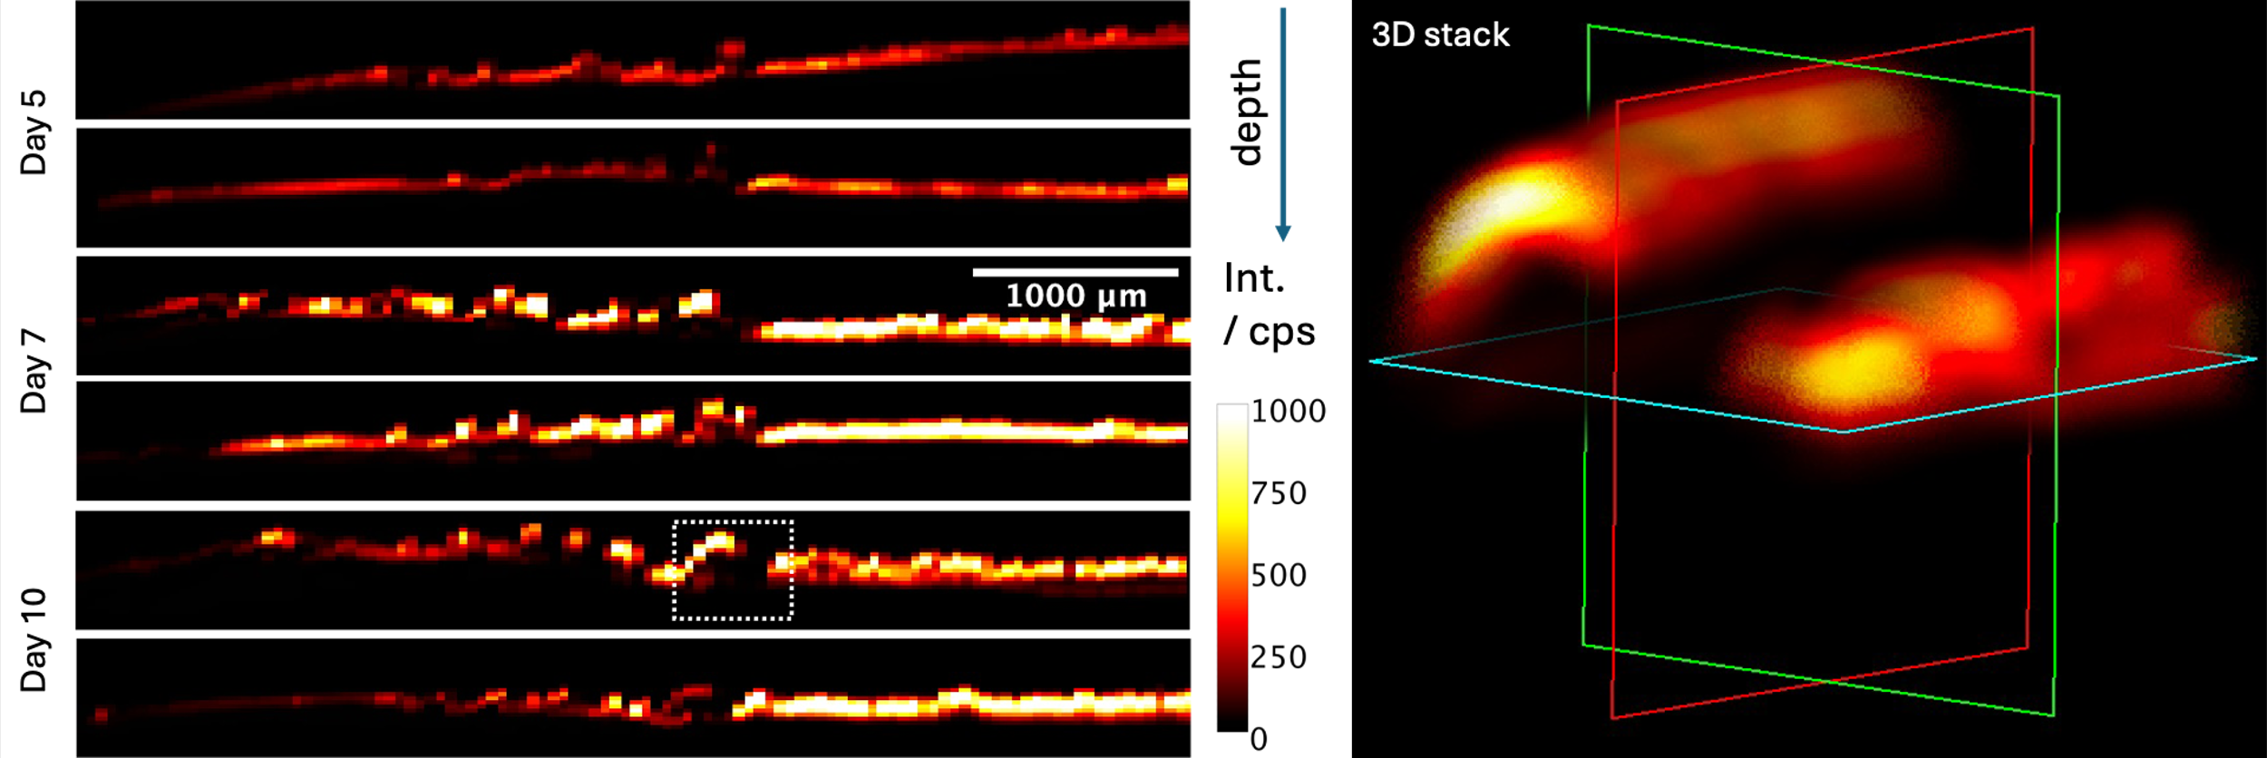
Figure S4: Left: Ca K distributions of virtual slices into the depth for all biofilms in Fig. 3 along the white dotted line measured by CMXRF with a step size of 20 µm into the depth, 50 µm lateral step size and a measurement time of 51 s. Right: 3D Ca K distribution of a detail of a biofilm grown for 10 days (marked with the white rectangle, 20 µm x 20 µm x 20 µm step size, 18.5 s measuring time.

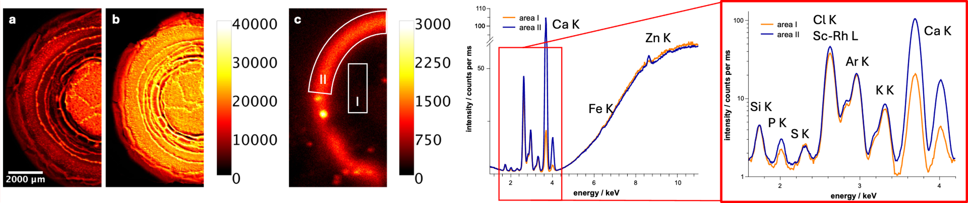
Figure S5: (Left) Ca Kα distribution of a MXRF measurement on a a biofilm on agar substrate, b biofilm removed from agar substrate, c agar substrate after removal of the biofilm. Mineral accumulation also happens in the agar. The step size was 50 µm and the measuring time 200 ms. (Right) Summed spectra with respective fluorescence lines of areas I and II marked in white in c. A rhodium (Rh) tube is used for excitation, thus, the characteristic Rh scattering peaks (elastic and inelastic, Sc-Rh L) are seen. Argon (Ar) fluorescence is emitted from the air.

Table S1: Assumptions for the dark matrix for quantification of pellets
 | information | dark matrix approximation
agar | 70 % agarose: C₁₂H₁₈O₉  30 % agaropectin:  cellulose: C₁₂H₂₀O₁₀ | 99.25 % (C₁₂H₁₈0₉)
yeast  on C-tape | >8 % N,  yeast | 52 % (CH₁₅₈N₂₈O₃₀)  40 % (C₆H₁₂O₆)  (proteins + carbs)
tryptone  on C-tape | >10 % N,  tryptophan rich: C₁₁H₁₂N₂O₂ | 94.5 % (C₁₁H₁₂N₂O₂)
E. coli  on C-tape | E. coli  70 % H20, 15 % proteine, 13 % (DNA, RNA, carbs, small molecules), 2 % phospholipids | 95 % (CH₁₅₈N₂₈O₃₀)  (proteins)
biofilm  Ca10P10  on C-tape | HA: Ca₅(PO₄)₃OH  + 1.8 % E. coli  + 1 % tryptone  + 0.5 % yeast  + CaCl + Sodium ß-glycerophosphate  40 % mineral, 60 % bacteria | 87 % (C₁₂H₁₇₀N₃₀O₃₂)  (tryptone + E.coli)
biofilm  control | + 1.8 % E. coli  + 1 % tryptone  + 0.5 % yeast | 95 % (C₁₂H₁₇₀N₃₀O₃₂)  (tryptone + E.coli)

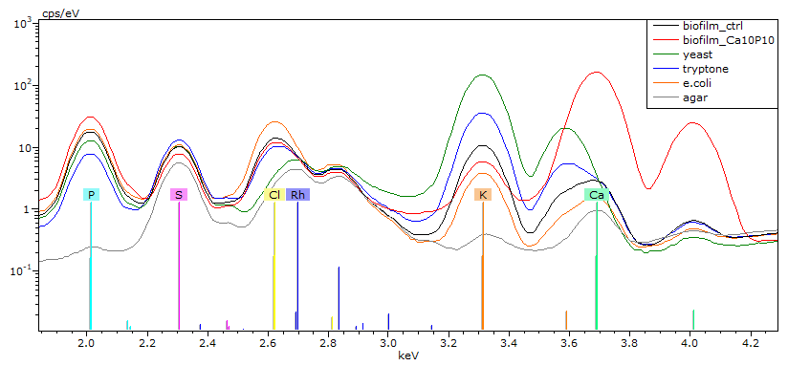
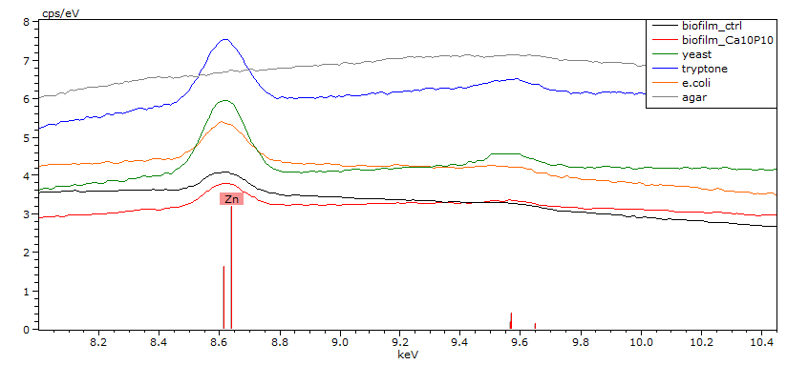
Figure S6: Sum spectra with respective fluorescence lines obtained on pressed pellets from the powders. A Rh tube is used for excitation, thus, the characteristic Rh scattering peaks (elastic and inelastic) are seen. Top: main elements, bottom: Zn K fluorescence lines.

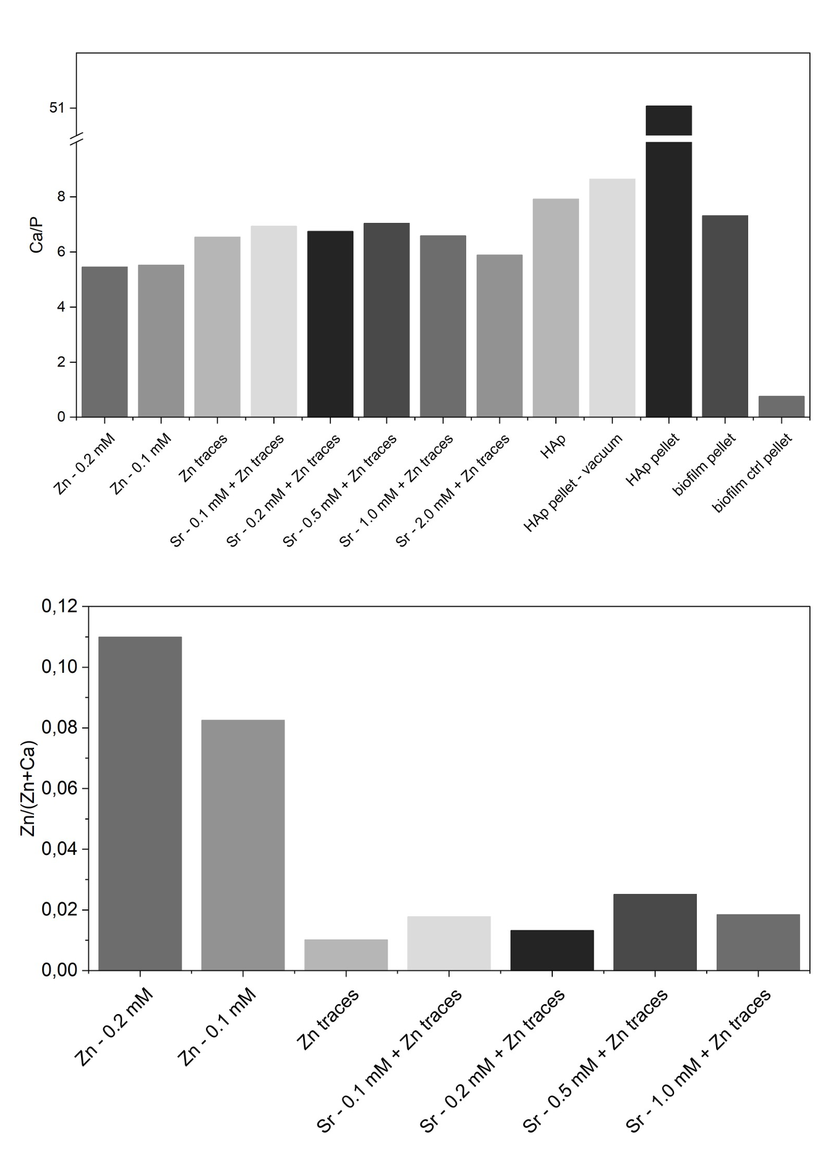
Figure S7: Ca/P (top) and Zn/(Zn+Ca) (bottom) ratios of the abiotic samples, HAp and biofilm pellets derived from MXRF measurements. The samples were measured in vacuum, which prevents a direct comparison to the ratios shown in Figure S3. Due to that we added the Ca/P ratios of two measurements on the HAp pellet – one measured in vacuum (20 mbar) and one measured under ambient pressure. This allows to assume a shift of the values derived from the abiotic system to higher values. For the Zn/(Zn+Ca) ratios one would expect a shift to lower values, due to the better sensitivity for Ca K under 20 mbar, while Zn K is not so much effected.

