Linking smoking and caffeine biomarkers to socioeconomic and health outcomes through wastewater-based epidemiology: a tool for hypothesis generation
Barbara Kasprzyk-Hordern^{1,2}*, Kishore Jagadeesan^{1,2}, Natalie Sims¹, Davey Jones^{3,4}, Matthew J. Wade^{2,5}
¹Department of Chemistry, University of Bath, Claverton Down, Bath, BA2 7AY, UK
²Centre of Excellence in Water Based Early Warning Systems for Health Protection, Bath, BA2 7AY, UK
³School of Environmental and Natural Sciences, Bangor University, Bangor, Gwynedd, LL57 2UW, UK
⁴Verily Life Sciences LLC., Dallas, Texas 75019, United States
⁵Chief Data Officer Group, UK Health Security Agency, London, E14 4PU, UK
*Author for correspondence: B.Kasprzyk-Hordern@bath.ac.uk
Inter-WBE_{CI} associations: Smoking-WBE_{CI}s correlate with multi-disease WBE_{CI}s confirming smoking as a multi-disease risk factor
Nicotine and cotinine were used as smoking-WBE_{CI}s (Kasprzyk-Hordern et al., 2025). As expected, nicotine and cotinine showed statistically significant strong/moderate positive correlations with each other (r_{p/s} = 0.53/0.60, P-Pearson, S-Spearman). Smoking is a risk factor for several diseases, including Type 2 diabetes, asthma/allergies and cardiovascular diseases, as well as being associated with increased pharmaceutical consumption such as painkillers or antibiotics. Indeed, smoking WBE_{CI}s correlated with wide-ranging groups of pharmaceuticals, consistent with the role of smoking as a risk factor for a multiple diseases (Fig. 2).
Smoking and CVDs: The significant correlations observed between nicotine/cotinine and atenolol (rₚ/ₛ = 0.44–0.57) are consistent with the established role of smoking as a risk factor for cardiovascular disease, including hypertension, for which atenolol is commonly prescribed. Moderate positive correlations were also seen between nicotine/cotinine and atorvastatin (used to lower cholesterol; r_{p/s}= 0.32-0.48) and weaker, but still statistically significant, correlations were seen with bezafibrate (used primarily to treat high blood lipid levels). No correlations were observed with irbesartan or lisinopril.
Smoking and asthma: Positive correlations were also observed with antihistamines (rₚ/ₛ = 0.29–0.47), consistent with evidence that smoking is associated with respiratory conditions and allergic diseases for which antihistamines may be prescribed. This is supported by a previous study reporting a strong positive relationship between cetirizine/fexofenadine and cotinine in wastewater (Thai et al. 2023).
Smoking and Type 2 diabetes: Moderate positive correlations between cotinine and metformin (r_{p/s}=0.55/0.47) (Fig. 2) were observed, in line with other reports (Shao, Cong et al. 2021), consistent with evidence that smoking is a risk factor for Type 2 diabetes. Interestingly, no correlations were observed with sitagliptin. The correlations between cotinine and metformin may reflect the fact that nicotine from cigarette smoking reduces cellular insulin sensitivity, leading to elevated blood sugar levels (Maddatu, Anderson-Baucum et al. 2017). While both drugs aim to improve glycaemic control, the potential for metformin to attenuate smoking-related cardiovascular risks might be a distinguishing factor in this difference (Paul, Klein et al. 2016).
Smoking and pain management: Nicotine and its main metabolite cotinine showed strong/moderate positive correlations with several pain management WBE_{CI}s, including analgesics and NSAiDs (paracetamol, codeine/dihydrocodeine, naproxen/O-desmethylnaproxen, diclofenac, ibuprofen (r_{p/s} ≤ 0.71)) and stimulants (amphetamine (r_{p/s} ≤ 0.46)). Stronger correlations were seen with cotinine, which has a mainly human metabolic origin compared with nicotine which has more heterogenous sources. Interestingly, weak/no correlations were seen with the chronic pain management pregabalin/N-methylpregabalin, or the anaesthetic ketamine/norketamine.
Nicotine/cotinine showed strong positive correlations with opioids, e.g. cotinine and tramadol (r_{p/s} = 0.65/0.65), codeine (cotinine: r_{p/s} = 0.70/0.71) and dihydrocodeine (cotinine: r_{p/s} = 0.62/0.68). This association has also been reported in the context of pain perception and pain management using opioids (Etcheson, Gwam et al. 2018).
Smoking and infectious disease: Significant correlations of nicotine/cotinine with several antibiotics (e.g. sulfapyridine/N-acetylsulfapyridine, sulfamethoxazole, trimethoprim; r_{p/s} ≤ 0.50) were also observed. Indeed, tobacco smoking is a risk factor for increased antibiotic prescription (Steinberg, Akincigil et al. 2016).
Smoking and depression: Only two WBE_{CI}s were tested: venlafaxine and desmethylvenlafaxine. No statistically significant correlations were observed.
Smoking and other lifestyle chemicals: Interestingly no correlations were found between nicotine/cotinine and caffeine/dimethylxanthine despite being reported elsewhere (Shao, Cong et al. 2021). Weak/no correlations were observed between nicotine and illicit drugs, e.g. cocaine (r_{p/s} = 0.45/0.41) and amphetamine (r_{p/s}= 0.46/0.41).
Smoking and other CIs: Interestingly, no correlations were observed with HNE-MA (4-hydroxynonenal-mercapturic acid), an oxidative stress marker, or creatinine, a marker of kidney function. Weak to moderate positive correlations were observed with methotrexate, a pharmaceutical used in cancer and autoimmune conditions (r_{p/s} = 0.27-0.30).

(A) Pearson and Spearman Correlation  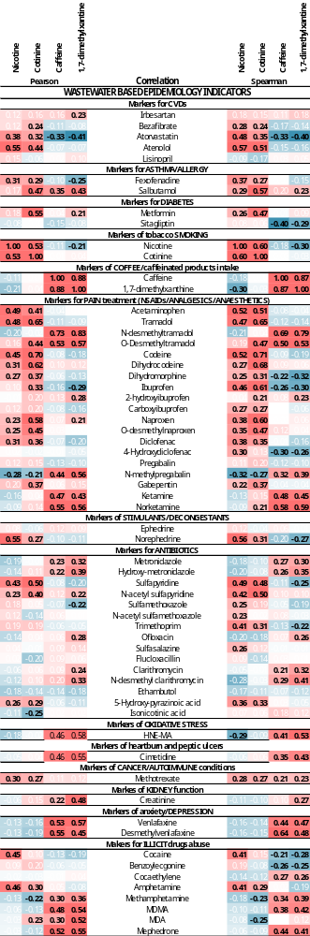 | (B) Hierarchical Cluster Analysis  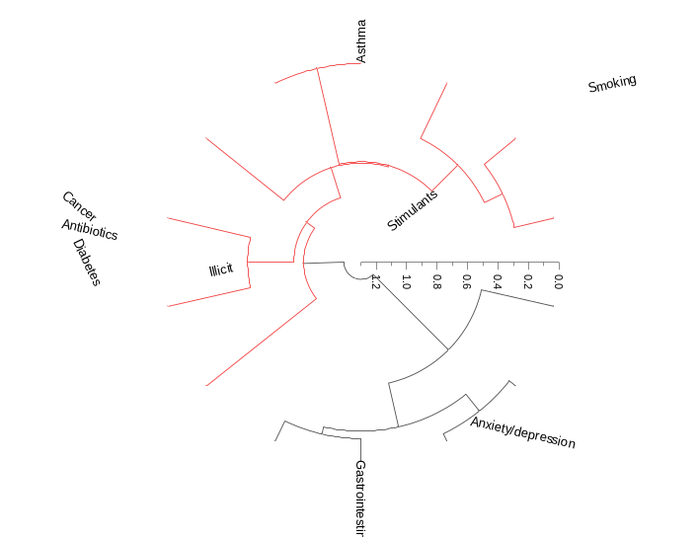
(C) Principal Component Analysis

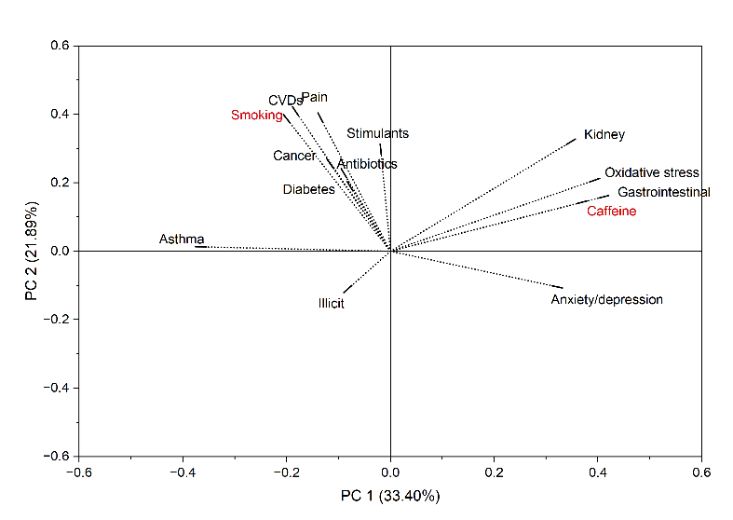

Figure S1. (A) Pearson and Spearman correlation (significant correlations in black font), (B) HCA and (C) PCA showing associations between smoking-WBE_{CI}s (nicotine/cotinine) and pharma-WBE_{CI}s, proxies for disease (city index description: LD-low deprivation, ≤45%, MD-medium deprivation, 46-54%, HD-high deprivation, ≥55%)

Table S1: PCA loadings for Fig 2 and Fig. S1: PCA showing associations between smoking-WBE_{CI}s (nicotine/cotinine) and pharma-WBE_{CI}s, proxies for disease.
PC 1 | PC 2
33.40% | 21.89%
Loading Plot | Loading Plot | Loading Plot
-0.20609 | 0.39939 | Smoking
-0.1885 | 0.42193 | CVDs
-0.37546 | 0.01339 | Asthma
-0.08353 | 0.20411 | Diabetes
0.38057 | 0.1477 | Caffeine
-0.13981 | 0.40447 | Pain
-0.01955 | 0.3135 | Stimulants
-0.09495 | 0.24158 | Antibiotics
0.40338 | 0.21289 | Oxidative stress
0.42099 | 0.1629 | Gastrointestinal
-0.12298 | 0.27072 | Cancer
0.35666 | 0.32774 | Kidney
0.33154 | -0.10723 | Anxiety/depression
-0.08984 | -0.12047 | Illicit

Caffeine-WBE_{CI}s show weak correlations with other WBE_{CI}s and ONS_{SEDI} indicators
We also assessed caffeine, another lifestyle chemical, as a comparator. As a common, low-harm (if consumed in moderate quantities) lifestyle marker, caffeine was selected to explore the further future potential of WBE in risk factor analysis and to determine whether its associations with health and socioeconomic/demographic indicators differ from those observed for smoking.
Relatively few statistically significant correlations were seen between caffeine-WBE_{CI}s and pharmaceutical-WBE_{CIs}. Caffeine and 1,7-DMX showed strong positive correlations with each other (r_{p/s} = 0.87-0.88) (Fig. S1). Significant positive correlations were seen between caffeine-WBE_{CI}s and metabolites of tramadol (r_{p/s}=0.50 - 0.83), and antibiotics/metabolites (e.g. metronidazole/hydroxymetronidazole, r_{p/s} < 0.40) with stronger correlations seen for 1,7-DMX. Strong correlations were also observed between caffeine/1,7-DMX and illicit amphetamines (mephedrone (r_{p/s} = 0.41-0.56), MDMA (r_{p/s} = 0.38-54)) and ketamine/norketamine (r_{p/s} = 0.43-0.59)). The stimulating effect of caffeine intensifying the effects of amphetamines, for example when administered as caffeinated energy-containing drinks, is widely reported. A positive correlation between caffeine-WBE_{CIs} and venlafaxine/desmethylvenlafaxine (r_{p/s} = 0.44-0.64) was also seen. Caffeine has been considered a risk factor for increased risk of anxiety and depression (Liu, Wang et al. 2024).
There are conflicting results regarding coffee consumption and health outcomes. However, recent findings from large studies indicate potential beneficial effects of drinking coffee on risk of death from all causes, especially for circulatory diseases, and digestive diseases, including a more favourable liver function profile and immune response (Gunter, Murphy et al. 2017). Indeed, in this study we found moderate negative associations with atorvastatin (caffeine: r_{p/s}= -0.33 and 1,7-DMX: r_{p/s}= -0.41/-0.40), a statin used to lower cholesterol and prevent heart disease, including heart attacks and strokes (Fig. S1). Interestingly, though, caffeine-WBE_{CI}s showed positive correlations with HNE-MA (r_{p/s} = 0.41-0.58). As discussed earlier, there is a lack of clarity in the literature about whether caffeine (known to have antioxidant properties) can decrease oxidative stress. Some studies have indicated a beneficial effect (Vargas-Pozada, Ramos-Tovar et al. 2023), however, this study shows positive correlations suggesting the need for further work, especially in expanding the range of oxidative stress biomarkers tested.
A moderate to strong positive association between caffeine-WBE_{CI}s and cimetidine (r_{p/s}=0.35-0.55) was also observed (Fig. S1). While caffeine stimulates gastric acid production (Nehlig 2022), it can also exacerbate gastric irritation in patients with ulcers, the stomach lining and increase acid production in patients with stomach ulcers. The observed association my reflect increased use of H₂-receptor antagonists among populations with higher caffeine consumption.

Table S2: PCA loadings and city scores for Fig 3: A) Pearson and Spearman correlation (significant correlations in black font), (B) HCA and (C) PCA showing associations between smoking-WBE_{CIs} (nicotine and cotinine), caffeine-WBE_{CIs} (caffeine and 1,7-DMX) and ONS_{SEDI} (city index description: LD-low deprivation, ≤45%, MD-medium deprivation, 46-54%, HD-high deprivation, ≥55%).
PC 1 | PC 2
65.26% | 17.95%
Loading Plot | Loading Plot | Loading Plot
0.17097 | 0.20908 | Smoking
-0.0387 | -0.19658 | Caffeine
-0.22752 | -0.20303 | GH: V.good to fair health
0.22752 | 0.20303 | GH: Bad to very bad health
-0.23114 | 0.18032 | EG: Asian
-0.20452 | 0.24698 | EG: Black
-0.24376 | 0.07179 | EG: Mixed
0.23236 | -0.19645 | EG: White
-0.22385 | 0.22774 | EG: Other
0.24761 | 0.0052 | D: Disabled
0.23732 | 0.14917 | D: Disabled: limited a lot
0.22711 | -0.17365 | D: Disabled: limited a little
-0.24732 | -0.00552 | D: Not disabled
0.10343 | -0.42711 | D: Not disabled with long-term physical/mental health cond.
-0.24068 | 0.10873 | D: Not disabled/no long-term physical/mental health cond.
-0.15148 | -0.36542 | HD: Not deprived
0.17705 | 0.14262 | HD: Deprived in >1d
0.18603 | 0.31351 | Q: No qualification
0.20045 | 0.13612 | Q: Level 1
0.22527 | 0.03431 | Q: Level 2
0.2343 | 0.00745 | Q: Apprenticeship
0.13113 | -0.35283 | Q: Level 3
-0.23675 | -0.05444 | Q: Level 4

Table S3: MLR parameters.
Parameters
 |  |  |  |  |  | Value |  |  |  | Standard Error |  |  |  | t-Value |  |  |  | Prob>|t| |  |  |  | 95% LCL |  |  | 95% UCL |  |  |  | CI Half-Width |  |  |  | VIF
CVDs |  | Intercept |  |  |  | 1212.43304 |  |  |  | 489.8148 |  |  |  | 2.47529 |  |  |  | 0.01523 |  |  |  | 239.02906 |  |  | 2185.83702 |  |  |  | 973.40398
 |  | "Smoking" |  |  |  | 0.66865 |  |  |  | 0.12139 |  |  |  | 5.50819 |  |  |  | 3.55144E-7 |  |  |  | 0.42741 |  |  | 0.9099 |  |  |  | 0.24124 |  |  |  | 1.89089
 |  | "D: Disabled" |  |  |  | -2.38304 |  |  |  | 1.3726 |  |  |  | -1.73616 |  |  |  | 0.08604 |  |  |  | -5.11079 |  |  | 0.3447 |  |  |  | 2.72775 |  |  |  | 2.34941
 |  | "Age: >40 years" |  |  |  | 1.25891 |  |  |  | 0.93169 |  |  |  | 1.35121 |  |  |  | 0.18009 |  |  |  | -0.59263 |  |  | 3.11045 |  |  |  | 1.85154 |  |  |  | 2.57049
 |  | "HD: Deprivation in at leat 1 dimension" |  |  |  | -2.09423 |  |  |  | 1.02338 |  |  |  | -2.04639 |  |  |  | 0.0437 |  |  |  | -4.12797 |  |  | -0.06048 |  |  |  | 2.03375 |  |  |  | 1.80434
Standard Error was scaled with square root of reduced Chi-Sqr.
Parameters
 |  |  |  | Value |  |  |  | Standard Error |  |  |  |  | t-Value |  |  | Prob>|t| |  |  |  |  | 95% LCL |  |  | 95% UCL |  |  |  |  |  | CI Half-Width |  |  |  |  | VIF
Pain | Intercept |  |  | 77965.96333 |  |  |  | 41014.63663 |  |  |  |  | 1.90093 |  |  | 0.06058 |  |  |  |  | -3542.00836 |  |  | 159473.93501 |  |  |  |  |  | 81507.97168
Pain | "Smoking" |  |  | 49.64475 |  |  |  | 10.16482 |  |  |  |  | 4.88398 |  |  | 4.61767E-6 |  |  |  |  | 29.4443 |  |  | 69.8452 |  |  |  |  |  | 20.20045 |  |  |  |  | 1.89089
Pain | "D: Disabled" |  |  | 251.61357 |  |  |  | 114.93437 |  |  |  |  | 2.18919 |  |  | 0.03123 |  |  |  |  | 23.20566 |  |  | 480.02148 |  |  |  |  |  | 228.40791 |  |  |  |  | 2.34941
Pain | "Age: >40 years" |  |  | 73.69899 |  |  |  | 78.01502 |  |  |  |  | 0.94468 |  |  | 0.34741 |  |  |  |  | -81.33948 |  |  | 228.73745 |  |  |  |  |  | 155.03846 |  |  |  |  | 2.57049
Pain | "HD: Deprivation in at leat 1 dimension" |  |  | -258.57642 |  |  |  | 85.69241 |  |  |  |  | -3.01749 |  |  | 0.00333 |  |  |  |  | -428.87209 |  |  | -88.28076 |  |  |  |  |  | 170.29567 |  |  |  |  | 1.80434
Standard Error was scaled with square root of reduced Chi-Sqr.

Parameters
 |  | Value | Standard Error | t-Value | Prob>|t| | 95% LCL | 95% UCL | CI Half-Width | VIF
Asthma | Intercept | 965.76794 | 247.37875 | 3.90401 | 1.8498E-4 | 474.15465 | 1457.38123 | 491.61329
Asthma | "Smoking" | 0.27213 | 0.06131 | 4.43862 | 2.61468E-5 | 0.15029 | 0.39397 | 0.12184 | 1.89089
Asthma | "D: Disabled" | 1.06688 | 0.69322 | 1.53901 | 0.12739 | -0.31076 | 2.44451 | 1.37764 | 2.34941
Asthma | "Age: >40 years" | -0.78626 | 0.47055 | -1.67095 | 0.09828 | -1.72137 | 0.14885 | 0.93511 | 2.57049
Asthma | "HD: Deprivation in at leat 1 dimension" | -1.18804 | 0.51685 | -2.29861 | 0.0239 | -2.21518 | -0.16091 | 1.02713 | 1.80434
Standard Error was scaled with square root of reduced Chi-Sqr.

Parameters
 |  |  |  |  |  |  |  |  | Value |  |  | Standard Error |  |  |  |  | t-Value |  |  | Prob>|t| |  |  | 95% LCL |  |  |  | 95% UCL |  |  |  | CI Half-Width |  |  | VIF
Anxiety/depression |  |  |  |  | Intercept |  |  |  | 181.46717 |  |  | 113.24516 |  |  |  |  | 1.60243 |  |  | 0.11264 |  |  | -43.58379 |  |  |  | 406.51813 |  |  |  | 225.05096
 |  |  |  |  | "Caffeine consumption" |  |  |  | 0.00674 |  |  | 9.68903E-4 |  |  |  |  | 6.95875 |  |  | 5.84823E-10 |  |  | 0.00482 |  |  |  | 0.00867 |  |  |  | 0.00193 |  |  | 1.09367
 |  |  |  |  | "D: Disabled" |  |  |  | 1.57082 |  |  | 0.34695 |  |  |  |  | 4.52749 |  |  | 1.86315E-5 |  |  | 0.88133 |  |  |  | 2.26032 |  |  |  | 0.6895 |  |  | 2.42699
 |  |  |  |  | "Age: >40 years" |  |  |  | -0.76092 |  |  | 0.21733 |  |  |  |  | -3.50121 |  |  | 7.2965E-4 |  |  | -1.19282 |  |  |  | -0.32902 |  |  |  | 0.4319 |  |  | 2.26138
 |  |  |  |  | "HD: Deprivation in at leat 1 dimension" |  |  |  | -0.15264 |  |  | 0.24283 |  |  |  |  | -0.6286 |  |  | 0.53124 |  |  | -0.63522 |  |  |  | 0.32993 |  |  |  | 0.48258 |  |  | 1.64253
Standard Error was scaled with square root of reduced Chi-Sqr.

Parameters
 |  |  |  |  |  |  | Value |  |  |  | Standard Error |  |  |  | t-Value |  |  |  | Prob>|t| |  |  | 95% LCL |  |  |  | 95% UCL |  | CI Half-Width |  |  |  | VIF
Oxidative stress |  |  | Intercept |  |  |  | 38.16561 |  |  |  | 29.02813 |  |  |  | 1.31478 |  |  |  | 0.192 |  |  | -19.5217 |  |  |  | 95.85292 |  | 57.68731
 |  |  | "Caffeine consumption" |  |  |  | 0.00144 |  |  |  | 2.48359E-4 |  |  |  | 5.81752 |  |  |  | 9.4794E-8 |  |  | 9.51273E-4 |  |  |  | 0.00194 |  | 4.93561E-4 |  |  |  | 1.09367
 |  |  | "D: Disabled" |  |  |  | -0.03697 |  |  |  | 0.08893 |  |  |  | -0.41573 |  |  |  | 0.67862 |  |  | -0.21371 |  |  |  | 0.13977 |  | 0.17674 |  |  |  | 2.42699
 |  |  | "Age: >40 years" |  |  |  | 0.07205 |  |  |  | 0.05571 |  |  |  | 1.29342 |  |  |  | 0.19925 |  |  | -0.03865 |  |  |  | 0.18276 |  | 0.11071 |  |  |  | 2.26138
 |  |  | "HD: Deprivation in at leat 1 dimension" |  |  |  | -0.0972 |  |  |  | 0.06225 |  |  |  | -1.56161 |  |  |  | 0.12197 |  |  | -0.2209 |  |  |  | 0.0265 |  | 0.1237 |  |  |  | 1.64253
Standard Error was scaled with square root of reduced Chi-Sqr.

Table S4: PCA loadings and city scores for Fig 4: PCA and HCA showing associations between WBE_{CI}s and ONS_{SEDI}s.
Principal Component Number | Eigenvalues | PC 1 | PC 2
 |  | 47.00% | 17.99%
Eigenvalue | Eigenvalue | Loading Plot | Loading Plot | Loading Plot
1 | 19.26854 | 0.1595 | -0.16154 | Smoking
2 | 7.37563 | 0.06443 | -0.1219 | CVDs
3 | 5.12173 | 0.04294 | -0.04323 | Asthma
4 | 3.31948 | 0.01946 | -0.20981 | Diabetes
5 | 1.73071 | -0.03601 | 0.17905 | Caffeine
6 | 1.28342 | 0.1743 | 0.00726 | Pain
7 | 1.19002 | -0.01904 | -0.17966 | Stimulants
8 | 0.80869 | 0.16073 | -0.02151 | Antibiotics
9 | 0.60951 | -0.02195 | 0.16067 | Oxidative stress
10 | 0.29227 | 0.00836 | 0.17512 | Gastrointestinal
11 | 1.73472E-29 | 0.06391 | 0.03011 | Cancer
 |  | -0.00716 | 0.11346 | Kidney
 |  | 0.02398 | 0.26481 | Anxiety/depression
 |  | 0.09307 | -0.03574 | Illicit
 |  | -0.20355 | 0.12104 | GH: V.good to fair health
 |  | 0.20355 | -0.12104 | GH: Bad to very bad health
 |  | -0.2009 | -0.13501 | EG: Asian
 |  | -0.17674 | -0.18319 | EG: Black
 |  | -0.21357 | -0.05855 | EG: Mixed
 |  | 0.20181 | 0.14747 | EG: White
 |  | -0.19391 | -0.1716 | EG: Other
 |  | 0.21678 | 0.02454 | D: Disabled
 |  | 0.21032 | -0.0803 | D: Disabled: limited a lot
 |  | 0.19568 | 0.15097 | D: Disabled: limited a little
 |  | -0.21652 | -0.02325 | D: Not disabled
 |  | 0.08506 | 0.29303 | D: Not disabled with phys./mental health
 |  | -0.20925 | -0.0979 | D: Not disabled/no phys./mental health
 |  | -0.13771 | 0.23073 | HD: Not deprived
 |  | 0.15381 | -0.06057 | HD: Deprived in >1d
 |  | 0.16941 | -0.20874 | Q: No qualification
 |  | 0.18174 | -0.11044 | Q: Level 1
 |  | 0.2002 | -0.03488 | Q: Level 2
 |  | 0.20904 | -0.006 | Q: Apprenticeship
 |  | 0.10547 | 0.29326 | Q: Level 3
 |  | -0.20957 | 0.02607 | Q: Level 4
 |  | -0.11896 | 0.2183 | EA: active incl students
 |  | 0.1749 | 0.1269 | EAs: inactive
 |  | 0.21184 | 0.01624 | EA: inactive: Retired
 |  | -0.12717 | 0.24339 | EA: inactive: Student
 |  | -0.07661 | -0.32099 | EA: inactive: Looking after home or family
 |  | 0.18901 | -0.13486 | EA: inactive: Long-term sick or disabled

PC 1 | PC 2
47.00% | 17.99%
Scores | Scores | Scores Labels
1.39043 | -0.60533 | City 7 (HD)
-0.05517 | 1.96832 | City 4 (MD)
0.35282 | 0.50311 | City 1 (MD)
0.1094 | 0.31157 | City 8 (MD)
-1.31627 | 1.35134 | City 5 (LD)
-1.45007 | -1.14007 | City 10a (MD)
-1.50868 | -1.19038 | City 10b (MD)
0.37095 | -0.10328 | City 9 (MD)
1.06633 | -0.60378 | City 3 (HD)
0.52722 | 0.18449 | City 2 (MD)
0.51304 | -0.676 | City 6 (HD)
Table S5 Principal Component Loadings for Census and WBE Indices, and city scores for Figure 5: (a) Hierarchical PCA biplot showing relationships between cities and sociodemographic, health and wastewater biomarker indeces (b) Hierarchical cluster analysis of cities based on standardised sociodemographic, health and wastewater biomarker variables.
Principal Component Number | Eigenvalues | PC 1 | PC 2 | PC 1 | PC 2
 |  | 51.59% | 24.68% | 51.59% | 24.68%
Eigenvalue | Eigenvalue | Loading Plot | Loading Plot | Loading Plot | Loading Plot | Loading Plot
1 | 4.64305 | 0 | 0 | 0.29188 | 0.35164 | DEPRIVATION index
2 | 2.22139 | 0 | 0 | -0.38883 | 0.32872 | ETHNIC DIVERSITY index
3 | 1.09116 | 0 | 0 | -0.44223 | 0.01041 | HEALTH index
4 | 0.57853 | 0 | 0 | 0.42295 | -0.15154 | DISABILITY index
5 | 0.18646 | 0 | 0 | 0.36952 | 0.06967 | PHARMA index
6 | 0.15577 | 0 | 0 | -0.2915 | 0.40795 | Population
7 | 0.07851 | 0 | 0 | 0.35386 | 0.09444 | Smoking
8 | 0.02785 | 0 | 0 | -0.15781 | -0.51096 | Caffeine
9 | 0.01728 | 0 | 0 | -0.1324 | -0.55131 | Oxidative stress

PC 1 | PC 2
51.59% | 24.68%
Scores | Scores | Scores Labels
2.83934 | 0.46421 | City 7 (HD)
-0.82098 | -1.53467 | City 4 (MD)
-0.42936 | -3.10332 | City 1 (MD)
0.83605 | -0.40382 | City 8 (MD)
-2.42877 | -0.91535 | City 5 (LD)
-3.14511 | 1.52637 | City 10a (MD)
-3.12138 | 1.8073 | City 10b (MD)
1.28182 | 0.11178 | City 9 (HD)
2.12674 | 0.31464 | City 3 (HD)
0.71774 | -0.08294 | City 2 (MD)
2.14392 | 1.8158 | City 6 (HD)

Estimation of Socioeconomic and Demographic Indicators (ONS_{SEDIs}) for WWTP Catchments
Demographic and socioeconomic indicators (ONS_{SEDIs}) for each wastewater treatment plant (WWTP) catchment were estimated using 2021 Census data from the UK Office for National Statistics (ONS), provided at the Output Area (OA) level¹. OAs are the smallest geographical units for which census statistics are published, designed to have similar population sizes. They typically encompass between 40 to 250 households and accommodate a resident population ranging from 100 to 625 individuals. Geospatial shapefiles for OAs are publicly accessible from the ONS, while WWTP catchment maps were provided by the partner water companies.
The core of the methodology involved a spatial overlay procedure performed in R² to map the census data from the standard OA boundaries to the bespoke WWTP catchment boundaries. For each OA, the proportion of its geographical area that overlapped with the WWTP catchment (Overlap%) was calculated. The count for each census variable within an OA was then weighted by this percentage:
- If an OA was fully contained within a catchment (Overlap% = 100%), its entire count for a given variable was included.
- For OAs that were only partially overlapping with a catchment, the count for each variable was scaled by its Overlap%. For example, if an OA with 200 residents was 50% inside the catchment boundary, a count of 100 residents was allocated to the catchment from that OA.
All resulting fractional counts were rounded to the nearest integer before being aggregated with data from all other overlapping OAs to produce a final, catchment-level estimate for each variable. This spatial weighting method, which assumes a uniform distribution of characteristics within an OA, is a robust and widely-used approach for estimating population characteristics in bespoke geographical areas like WWTP catchments where direct census data is unavailable³.
This methodology was applied to all >70 ONS_{SEDI} variables used in the main analysis, covering domains of Demography, Education, Ethnic and cultural identity, Health and care, and Housing. A primary output of this process was the Population Estimate from Census data (PE_{CEN}), which was used to calculate population-normalised loads for the wastewater chemical indicators.
References
1. ONS Census 2021 Bulk - Nomis - Official Census and labour market statistics. https://www.nomisweb.co.uk/sources/census_2021_bulk (20/01/2025),
2. Ihaka, R.; Gentleman, R., R: a language for data analysis and graphics. Journal of computational and graphical statistics 1996, 5, (3), 299-314.
3. Kasprzyk-Hordern, B.; Jagadeesan, K.; Sims, N.; Farkas, K.; Proctor, K.; Bagnall, J.; Robertson, M.; Jones, D. L.; Wade, M. J., Multi-biomarker approach for estimating population size in a national-scale wastewater-based epidemiology study. Water Res. 2025, 268, 122527.

