Supplementary materials

S1 - Sample characteristics
Table 1
Study 1 sample characteristics in full sample and by condition
 | DACCS  (N = 264) |  | Electricity Trading  (N = 267) |  | Flexible EV Charging  (N =268) |  | Flexible Heating  (N = 257) |  | Full Sample  (N = 1056)
Age | M | SD | M | SD | M | SD | M | SD | M | SD
 | 45.1 | 14.3 | 43.3 | 14.8 | 44.0 | 13.5 | 44.2 | 14.5 | 44.14 | 14.26
Gender | N | % | N | % | N | %t | N | % | N | %
Female | 143 | 13.5 | 127 | 12.0 | 133 | 12.6 | 130 | 12.3 | 533 | 50.47
Male | 118 | 11.2 | 130 | 12.3 | 134 | 12.7 | 136 | 12.9 | 518 | 49.05
Other | 3 | 0.284 | 0 | 0 | 0 | 0 | 2 | 0.189 | 5 | 0.4735
Income
0-5000 CHF | 125 | 11.8 | 124 | 11.7 | 121 | 11.5 | 125 | 11.8 | 495 | 46.88
5001-8000 CHF | 74 | 7.01 | 93 | 8.81 | 88 | 8.33 | 83 | 7.86 | 338 | 32.01
8001-20.000 CHF | 44 | 4.17 | 29 | 2.75 | 37 | 3.50 | 42 | 3.98 | 152 | 14.39
> 20.000 CHF | 4 | 0.379 | 1 | 0.0947 | 1 | 0.0947 | 4 | 0.379 | 10 | 0.95
Prefer not to answer | 17 | 1.61 | 10 | 0.947 | 20 | 1.89 | 14 | 1.33 | 61 | 5.78
Education
Obligatory School | 19 | 1.8 | 16 | 1.52 | 23 | 2.18 | 16 |  | 74 | 7.01
Secondary School | 134 | 12.7 | 119 | 11.3 | 122 | 11.6 | 124 | 11.7 | 499 | 47.25
Tertiary Degree | 111 | 10.5 | 122 | 11.6 | 122 | 11.6 | 127 | 12.0 | 482 | 45.64
Prefer not to answer | 0 | 0 | 0 | 0 | 0 | 0 | 1 | 0.0947 | 1 | 0.09
Language Area
German | 178 | 16.9 | 156 | 14.8 | 165 | 15.6 | 155 | 14.7 | 654 | 61.93
French | 86 | 8.14 | 101 | 9.56 | 102 | 9.66 | 113 | 10.7 | 402 | 38.07
Living Area
Urban | 113 | 10.7 | 108 | 10.2 | 129 | 12.2 | 134 | 12.7 | 484 | 45.83
Rural | 151 | 14.3 | 149 | 14.1 | 138 | 13.1 | 134 | 12.7 | 572 | 54.17

Table 2
Sample characteristics in Study 2 (N = 765)
Age | M | SD
 | 47.1 | 16.2
Gender | N | Percent
Female | 376 | 49.15
Male | 386 | 50.46
Other | 3 | 0.39
Income
0-5000 CHF | 376 | 49.2
5001-8000 CHF | 242 | 31.6
8001-18.000 CHF | 86 | 11.2
> 18.000 CHF | 3 | 0.392
Prefer not to answer | 58 | 7.58
Education
Obligatory School | 65 | 8.5
Secondary School | 411 | 53.7
Tertiary Degree | 286 | 37.4
Prefer not to answer | 3 | 0.392
Language Area
German | 565 | 73.9
French | 200 | 26.1
Living Area
Urban | 336 | 43.9
Rural | 429 | 56.1

Table 3
Study 3 - Sample characteristics by country
 | France  (N = 572) |  | Germany  (N = 559) |  | Italy  (N = 573) |  | Netherlands  (N = 523) |  | Poland  (N = 562) |  | Spain  (N = 566) |  | Full sample  (N = 3355)
Age | M | SD | M | SD | M | SD | M | SD | M | SD | M | SD | M | SD
 | 48.2 | 16.9 | 49.3 | 16.1 | 48.2 | 15.9 | 47.4 | 16.8 | 44.8 | 15.2 | 46.2 | 14.9 | 47.4 | 16.1
Gender | N | % | N | % | N | %t | N | % | N | % | N | % | N | %
Female | 295 | 51.6 | 283 | 50.6 | 289 | 50.4 | 276 | 52.8 | 299 | 53.2 | 292 | 51.6 | 1734 | 51.7
Male | 277 | 48.4 | 276 | 49.4 | 283 | 49.4 | 247 | 47.2 | 262 | 46.6 | 274 | 48.4 | 1619 | 48.3
Other | 0 | 0 | 0 | 0 | 1 | 0.2 | 0 | 0 | 1 | 0.2 | 0 | 0 | 2 | 0.06
Income | N | % | N | % | N | % | N | % | N | % | N | % | N | %
0-3000 € | 126 | 22.0 | 210 | 37.7 | 222 | 38.7 | 108 | 20.7 | 107 | 19.0 | 166 | 29.3 | 939 | 28.0
3001-6000 € | 227 | 39.7 | 156 | 27.9 | 221 | 38.6 | 172 | 32.9 | 198 | 35.2 | 233 | 41.2 | 1207 | 36.0
6001-16.000 € | 127 | 22.2 | 103 | 18.4 | 49 | 8.6 | 163 | 31.2 | 211 | 37.5 | 108 | 19.1 | 761 | 22.7
> 16.000 € | 71 | 12.4 | 62 | 11.1 | 40 | 7.0 | 40 | 7.6 | 21 | 3.7 | 41 | 7.2 | 275 | 8.2
Prefer not to answer | 21 | 3.7 | 28 | 5.0 | 41 | 7.2 | 40 | 7.6 | 25 | 4.5 | 18 | 3.2 | 173 | 5.1
Education | N | % | N | % | N | % | N | % | N | % | N | % | N | %
Obligatory School | 58 | 10.1 | 123 | 22.0 | 105 | 18.3 | 11 | 2.1 | 21 | 3.7 | 138 | 24.4 | 456 | 13.6
Secondary School | 266 | 46.5 | 264 | 47.2 | 302 | 52.7 | 255 | 48.8 | 344 | 61.2 | 183 | 32.3 | 1614 | 48.1
Tertiary Degree | 245 | 42.8 | 170 | 30.4 | 164 | 28.6 | 256 | 48.9 | 195 | 34.7 | 244 | 43.1 | 1274 | 38.0
Prefer not to answer | 3 | 0.5 | 2 | 0.4 | 2 | 0.4 | 1 | 0.2 | 2 | 0.4 | 1 | 0.2 | 11 | 0.3
Mitigation measure | N | % | N | % | N | % | N | % | N | % | N | % | N | %
BECCS | 133 | 23.3 | 133 | 23.8 | 139 | 24.3 | 118 | 22.6 | 138 | 24.6 | 135 | 23.9 | 796 | 23.7
Green hydrogen | 145 | 25.3 | 141 | 25.2 | 144 | 25.1 | 138 | 26.4 | 144 | 25.6 | 140 | 24.7 | 852 | 25.7
Afforestation & Reforestation | 145 | 25.3 | 144 | 25.8 | 144 | 25.1 | 140 | 26.8 | 141 | 25.1 | 149 | 26.3 | 863 | 25.4
Transition to sustainable diets | 149 | 26.1 | 141 | 25.2 | 146 | 25.5 | 127 | 24.3 | 139 | 24.7 | 142 | 25.1 | 844 | 25.2

Table 4
Sample characteristics by mitigation measure in Study 3
 | BECCS  (N = 796) |  | Green Hydrogen  (N = 852) |  | Afforestation & Reforestation  (N = 863) |  | Transition to sustainable diets  (N = 844)
Age | M | SD | M | SD | M | SD | M | SD
 | 47.4 | 16.1 | 47.2 | 16.5 | 46.8 | 15.9 | 48.0 | 15.6
Gender | N | % | N | % | N | %t | N | %
Female | 394 | 49.5 | 434 | 50.9 | 456 | 52.8 | 450 | 53.3
Male | 402 | 50.5 | 417 | 48.9 | 406 | 47.1 | 394 | 46.7
Other | 0 | 0 | 1 | 0.1 | 1 | 0.1 | 0 | 0
Income | N | % | N | % | N | % | N | %
0-3000 € | 205 | 25.8 | 240 | 28.2 | 247 | 28.6 | 247 | 29.3
3001-6000 € | 306 | 38.4 | 305 | 35.8 | 300 | 34.8 | 296 | 35.1
6001-16.000 € | 182 | 22.9 | 196 | 23.0 | 198 | 22.9 | 185 | 21.9
> 16.000 € | 59 | 7.4 | 69 | 8.1 | 75 | 8.7 | 72 | 8.5
Prefer not to answer | 44 | 5.5 | 42 | 4.9 | 43 | 5.0 | 44 | 5.2
Education | N | % | N | % | N | % | N | %
Obligatory School | 97 | 12.2 | 118 | 13.9 | 124 | 14.4 | 117 | 13.9
Secondary School | 356 | 44.7 | 418 | 49.1 | 423 | 49.0 | 417 | 49.4
Tertiary Degree | 342 | 43.0 | 311 | 36.5 | 315 | 36.5 | 306 | 36.3
Prefer not to answer | 1 | 0.1 | 5 | 0.5 | 1 | 0.1 | 4 | 0.4

S2 – Study 1 model results and included variables
Table 5
Model-identified strongest predictors of energy policy support
Predictor | Regression Random Forest |  | Ridge Regression
 | Rank | Mean RMSE-Loss  (Range) | Rank | Mean Standardized Regression Coefficient  (Range)
Affective responses
Affect | 1 | 0.854  (0.839; 0.871) | 1 | 0.163  (0.146; 0.179)
Hope | 3 | 0.815  (0.809; 0.820) | 3 | 0.097  (0.092; 0.100)
Pride | 4 | 0.813  (0.808; 0.822) | 5 | 0.084  (0.080; 0.087)
Worry | 10 | 0.798  (0.788; 0.804) | 7 | -0.076  (-0.072; -0.079)
Anger | 12 | 0.798  (0.792; 0.804) | 11 | -0.067  (-0.065; -0.068)
Policy-impact-beliefs
Perceived Societal Impacts | 2 | 0.819  (0.815; 0.827) | 2 | 0.107  (0.101; 0.113)
Perceived Environmental Impacts | 5 | 0.810  (0.806; 0.817) | 4 | 0.086  (0.083; 0.088)
Perceived Impact on personal wellbeing | 9 | 0.799  (0.795; 0.803) | - | -
Perceived impact on personal finances | 11 | 0.798  (0.793; 0.802) | - | -
Perceived Fairness
Personal Fairness | 6 | 0.806  (0.800; 0.812) | 8 | 0.074  (0.072; 0.075)
Fairness towards Swiss Citizens | 7 | 0.804  (0.800; 0.809) | 9 | 0.0725  (0.071; 0.073)
Fairness towards people in other countries | - | - | 10 | 0.072  (0.067; 0.075)
Fairness towards low-income earners | - | - | 12 | 0.0584  (0.0579; 0.0585)
Perceived Social Consensus
Perceived Dynamic Norms | 8 | 0.800  (0.794; 0.805) | 6 | 0.077  (0.074; 0.080)

Table 6
Full list of measured variables and importance score by model
Predictor | Regression Random Forest |  | Ridge Regression |  | Literature
Predictor | Rank | Mean RMSE-Loss  (Range) | Rank | Mean Standardized Regression Coefficient  (Range) | Literature
General affect | 1 | 0.854  (0.839; 0.871) | 1 | 0.163  (0.146; 0.179) | Cousse et al. (2020), Hart et al. (2015), Jobin & Siegrist (2018), Jobin et al. (2019), Jones et al. (2021), Spampatti et al. (2022)
Perceived Societal Impacts | 2 | 0.819  (0.815; 0.827) | 2 | 0.107  (0.101; 0.113) | Bergquist et al. (2020), Dasandi et al. (2022), Geiger et al. (2021), Swim & Geiger (2021)
Hope | 3 | 0.815  (0.809; 0.820) | 3 | 0.097  (0.092; 0.100) | Bury et al. (2020), ; Feldman & Hart (2018), Geiger et al. (2023), Marlon et al. (2019), Myers et al., 2024; Nabi et al. (2018), Smith & Leiserowitz, (2014)
Pride | 4 | 0.813  (0.808; 0.822) | 5 | 0.084  (0.080; 0.087) | Bissing-Oloson et al. (2016), Schneider et al. (2017)
Perceived Environmental Impacts | 5 | 0.810  (0.806; 0.817) | 4 | 0.086  (0.083; 0.088) | Geiger et al. (2021), Swim & Geiger (2021)
Personal Fairness | 6 | 0.806  (0.800; 0.812) | 8 | 0.074  (0.072; 0.075) | Bergquist et al. (2022)
Fairness towards Swiss Citizens | 7 | 0.804  (0.800; 0.809) | 9 | 0.0725  (0.071; 0.073) | Bergquist et al. (2022), Huber et al. (2020)
Perceived Dynamic Norms | 8 | 0.800  (0.794; 0.805) | 6 | 0.077  (0.074; 0.080) | Sparkman & Walton (2017, 2019)
Perceived Impact on personal wellbeing | 9 | 0.799  (0.795; 0.803) | 16 | 0.054  (0.054; 0.055) | See note
Worry | 10 | 0.798  (0.788; 0.804) | 7 | -0.076  (-0.072; -0.079) | Bouman et al. (2020); Böhm et al. (2023), Goldberg et al. (2021), Lorteau et al. (2024), Smith & Leiserowitz (2014)
Perceived impact on personal finances | 11 | 0.798  (0.793; 0.802) | 13 | 0.057  (0.057; 0.058) | See note
Anger | 12 | 0.798  (0.792; 0.804) | 11 | -0.067  (-0.065; -0.068) | Feldman & Hart, (2018) Gregersen et al. (2023), Lu & Schuldt, (2015), Myers et al. (2024)
Condition | 13 | 0.797  (0.795; 0.800) | Heating:  24 | 0.0259  (0.0225; 0.0291) | NA
Condition | 13 | 0.797  (0.795; 0.800) | EV:  28 | 0.015  (0.013; 0.017) | NA
Condition | 13 | 0.797  (0.795; 0.800) | Trading:  29 | 0.015  (0.012; 0.017) | NA
Condition | 13 | 0.797  (0.795; 0.800) | DACCS:  In intercept | NA | NA
Fairness towards low-income earners | 14 | 0.797  (0.795; 0.798) | 12 | 0.0584  (0.0579; 0.0585) | Dechezleprêtre et al. (2023)
Descriptive Norms | 15 | 0.796  (0.793; 0.798) | 14 | 0.057  (0.055; 0.058) | Allcott (2011), de Groot & Schuitema (2012)
Fairness towards people in other countries | 16 | 0.796  (0.792; 0.798) | 10 | 0.072  (0.067; 0.075) | Bergquist et al. (2022)
Perceived impact on share of renewables in energy system (Effectiveness) | 17 | 0.794  (0.792; 0.799) | 15 | 0.055  (0.053; 0.055) | Bergquist et al. (2022)
Perceived impact on personal health | 18 | 0.793  (0.790; 0.796) | 20 | 0.035  (0.030; 0.039) | See note
Perceived impact on personal privacy | 19 | 0.793  (0.790; 0.795) | 18 | 0.041  (0.040; 0.042) | See note
Perceived economic impact | 20 | 0.792  (0.789; 0.796) | 17 | 0.049  (0.048; 0.049) | Bergquist et al. (2020), Dechezleprêtre et al. (2023), Geiger et al. (2021), Swim & Geiger (2021)
Perceived impact on personal freedom | 21 | 0.790  (0.786; 0.795) | 21 | -0.034  (-0.034; -0.034) | Contzen et al. (2021), De Groot & Schuitema (2012), Huber et al. (2020), Swim & Geiger (2021), Thaller et al. (2023)
Perceived impact on flexibility of the energy system  (Effectiveness) | 22 | 0.788  (0.785; 0.790) | 23 | 0.029  (0.027; 0.030) | Bergquist et al. (2022)
Perceived impact on reliability of the energy system  (Effectiveness) | 23 | 0.787  (0.784; 0.790) | 30 | 0.015  (0.011; 0.019) | Bergquist et al. (2022)
Subjective knowledge | 24 | 0.787  (0.785; 0.790) | 19 | 0.037  (0.034; 0.039) | Bergquist et al. (2022), Spampatti et al. (2022)
Climate Change Worry | 25 | 0.785  (0.783; 0.787) | 43 | 0.008  (0.007; 0.009) | Bouman et al. (2020); Böhm et al. (2023), Goldberg et al. (2021), Lorteau et al. (2024), Smith & Leiserowitz (2014)
Trust in political institutions | 26 | 0.784  (0.783; 0.787) | 38 | 0.009  (0.007; 0.012) | Bergquist et al. (2022), Boyd et al. (2017), Fairbrother et al. (2019), Harring & Jagers (2013), Kitt et al. (2021), Liu et al. (2022), Rhodes et al. (2017)
Personal responsibility to mitigate climate change | 27 | 0.784  (0.783; 0.786) | 61 | 0.0000021  (-0.0025; 0.0027) | Syropoulos & Markowitz (2022)
Belief in negative consequences of climate change | 28 | 0.784  (0.782; 0.786) | 44 | 0.007  (0.006; 0.007) | Ding et al. (2011), van Valkengoed et al. (2021)
Belief in the reality of climate change | 29 | 0.783  (0.782; 0.784) | 35 | 0.009  (0.009; 0.010) | Ding et al. (2011), van Valkengoed et al. (2021)
Belief in spatial proximity of climate change effects | 30 | 0.783  (0.781; 0.785) | 42 | 0.008  (0.008; 0.009) | van Valkengoed et al. (2021)
Biospheric values | 31 | 0.783  (0.781; 0.784) | 33 | -0.01  (-0.012; -0.008) | Bergquist et al. (2022); Nilsson et al. (2016); Perlviciute & Steg (2015); Perlaviciute, Steg & Sovacool (2021);  Perlaviciute et al. (2021)
Objective knowledge | 32 | 0.783  (0.782; 0.783) | 54 | -0.002  (-0.0027; -0.0003) | Bruine de Bruin & Wong-Parodi (2014), Brunsting et al. (2013), Dubois et al. (2019), Rhodes et al. (2014), Spampatti et al. (2022), Volken et al. (2018)
Perceived impact on energy independence  (Effectiveness) | 33 | 0.782  (0.782; 0.783) | 36 | 0.009  (0.009; 0.010) | Bergquist et al. (2022)
Belief in the human causes of climate change | 34 | 0.782  (0.779; 0.785) | 37 | 0.009  (0.008; 0.010) | Ding et al. (2011), van Valkengoed et al. (2021)
Techno-fix attitudes | 35 | 0.782  (0.780; 0.783) | 49 | 0.005  (0.003; 0.006) | Cologna et al. (2024)
Egoistic values | 36 | 0.782  (0.781; 0.782) | 40 | 0.009  (0.008; 0.009) | Bergquist et al. (2022); Nilsson et al. (2016); Perlviciute & Steg (2015); Perlaviciute, Steg & Sovacool (2021);  Perlaviciute et al. (2021)
Age | 37 | 0.782  (0.780; 0.782) | 32 | -0.0111  (-0.0114; -0.0107) | Bergquist et al. (2022), Steel et al. (2015)
Altruistic values | 38 | 0.782  (0.780; 0.782) | 57 | 0.001  (0.001; 0.002) | Bergquist et al. (2022); Nilsson et al. (2016); Perlviciute & Steg (2015); Perlaviciute, Steg & Sovacool (2021);  Perlaviciute et al. (2021)
Income | 39 | 0.782  (0.781; 0.782) | 0-5000CHF:  In intercept | NA | Bergquist et al. (2022)
Income | 39 | 0.782  (0.781; 0.782) | 5001-8000CHF:  56 | -0.001  (-0.002; -0.001) | Bergquist et al. (2022)
Income | 39 | 0.782  (0.781; 0.782) | 8001-20.000CHF:  34 | -0.0102  (-0.0121; -0.0082) | Bergquist et al. (2022)
Income | 39 | 0.782  (0.781; 0.782) | > 20.000CHF:  55 | -0.001  (-0.002; -0.001) | Bergquist et al. (2022)
Income | 39 | 0.782  (0.781; 0.782) | Prefer not to answer:  45 | -0.005  (-0.006; -0.004) | Bergquist et al. (2022)
Living area (Rural/Urban) | 40 | 0.781  (0.780; 0.784) | Rural:  27 | -0.0152  (-0.0168; -0.0135) | none
Living area (Rural/Urban) | 40 | 0.781  (0.780; 0.784) | Urban: in intercept | NA | none
Techno-optimism | 41 | 0.781  (0.779; 0.783) | 31 | 0.012  (0.011; 0.013) | Cologna et al. (2024)
Belief in the temporal distance of climate change | 42 | 0.781  (0.780; 0.782) | 58 | -0.001  (-0.001; -0.0003) | Ding et al. (2011), van Valkengoed et al. (2021)
Subjective financial scarcity | 43 | 0.781  (0.780; 0.781) | 26 | 0.017  (0.014; 0.020) | Berthold et al. (2023)
Political affiliation | 44 | 0.781  (0.780; 0.782) | 22 | -0.031  (-0.035; -0.028) | Bergquist et al. (2022), Bolsen et al. (2014), Goldberg et al. (2019), Hahnel et al. (2020), Jobin et al. (2019), Olson-Hazboun et al. (2018)
Education | 45 | 0.781  (0.780; 0.782) | Obligatory school:  In intercept | NA | Olson-Hazboun et al. (2018), Steel et al. (2015)
Education | 45 | 0.781  (0.780; 0.782) | Secondary school:  41 | -0.00867  (-0.00950; -0.00780) | Olson-Hazboun et al. (2018), Steel et al. (2015)
Education | 45 | 0.781  (0.780; 0.782) | Tertiary Degree:  47 | 0.00497  (0.00481; 0.00509) | Olson-Hazboun et al. (2018), Steel et al. (2015)
Education | 45 | 0.781  (0.780; 0.782) | Prefer not to answer:  60 | 0.000106  (0.0000954; 0.000115) | Olson-Hazboun et al. (2018), Steel et al. (2015)
Randomly created variable with normal distribution | 46 | 0.781  (0.780; 0.781) | 51 | -0.00287  (-0.00289; -0.00285) | NA
Randomly created variable with binomial distribution | 47 | 0.780  (0.780; 0.781) | 46 | 0.00497  (0.00496; 0.00499) | NA
Political affiliation (prefer not to answer) | 48 | 0.780  (0.780; 0.781) | 52 | -0.00187  (-0.00228; -0.00148) | NA
Randomly created variable with uniform distribution | 49 | 0.780  (0.779; 0.781) | 25 | -0.0203  (-0.0233; -0.0172) | NA
Hedonic values | 50 | 0.780  (0.779; 0.781) | 53 | -0.00176  (-0.00262;  -0.000767) | Bergquist et al. (2022); Nilsson et al. (2016); Perlviciute & Steg (2015); Perlaviciute, Steg & Sovacool (2021);  Perlaviciute et al. (2021)
Gender | 51 | 0.780  (0.779; 0.781) | Female:  In intercept | NA | Clulow et al. (2021), Olson-Hazboun et al. (2018)c
Gender | 51 | 0.780  (0.779; 0.781) | Male:  50 | -0.00323  (-0.00499; -0.00153) | Clulow et al. (2021), Olson-Hazboun et al. (2018)c
Gender | 51 | 0.780  (0.779; 0.781) | Other:  59 | -0.000202  (-0.000206; -0.000195) | Clulow et al. (2021), Olson-Hazboun et al. (2018)c
Techno-pessimism | 52 | 0.780  (0.779; 0.780) | 39 | 0.009  (0.007; 0.011) | Cologna et al. (2024)
Language Area | 53 | 0.780  (0.779; 0.780) | German:  In intercept | NA | none
Language Area | 53 | 0.780  (0.779; 0.780) | French:  48 | 0.00475  (0.00444; 0.00493) | none
Note. The variables measuring perceived personal effects (impact on wellbeing, finances, health, privacy) were added as these topics were explicitly discussed in the policy factsheets and because appraisals of impacts in these dimensions are likely related to perceived personal fairness and perceived coerciveness of the policy.

S3 – Model performance in Studies 1, 2 and 3
Figure 1
Model prediction accuracy in Studies 1 and 2
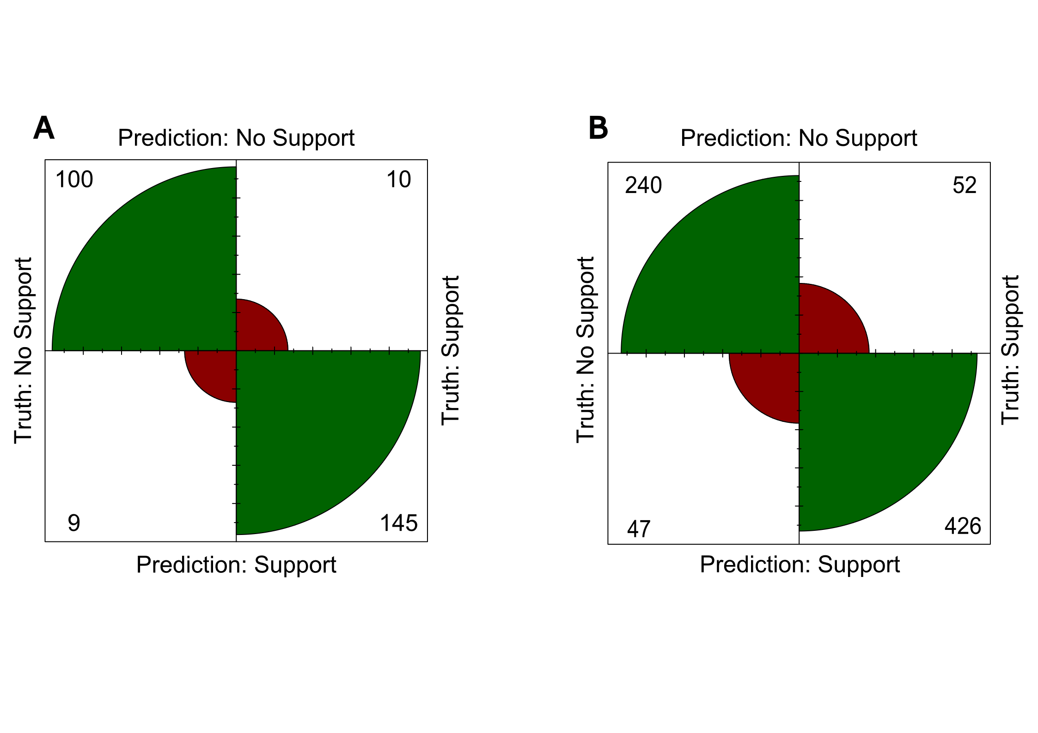
Note. The two Fourfold-plots, A and B, depict the model performance of our model on test data in Studies 1 and 2. The upper left and lower right quadrants of each plot show observations correctly classified as “no support” (upper left) and “support” (lower right), whereas the upper right and lower left quadrant depict the number of observations incorrectly classified as “no support” (upper right) and “support” (lower left), respectively. A depicts model performance on data from Study 1. Here, the model was trained on 75% of the data collected in Study 1 (i.e. 792 observations) and model performance was then tested on 25% of the data (i.e. 264 observations). B depicts model performance on data from Study 2. Here, the model was trained on 100% of observations collected in Study 1 (i.e. 1056 observations) and tested on 100% of observations collected in Study 2 (i.e. 765 observations).

Figure 2
Correlation of model prediction accuracy with mean mitigation measure support in Study 3
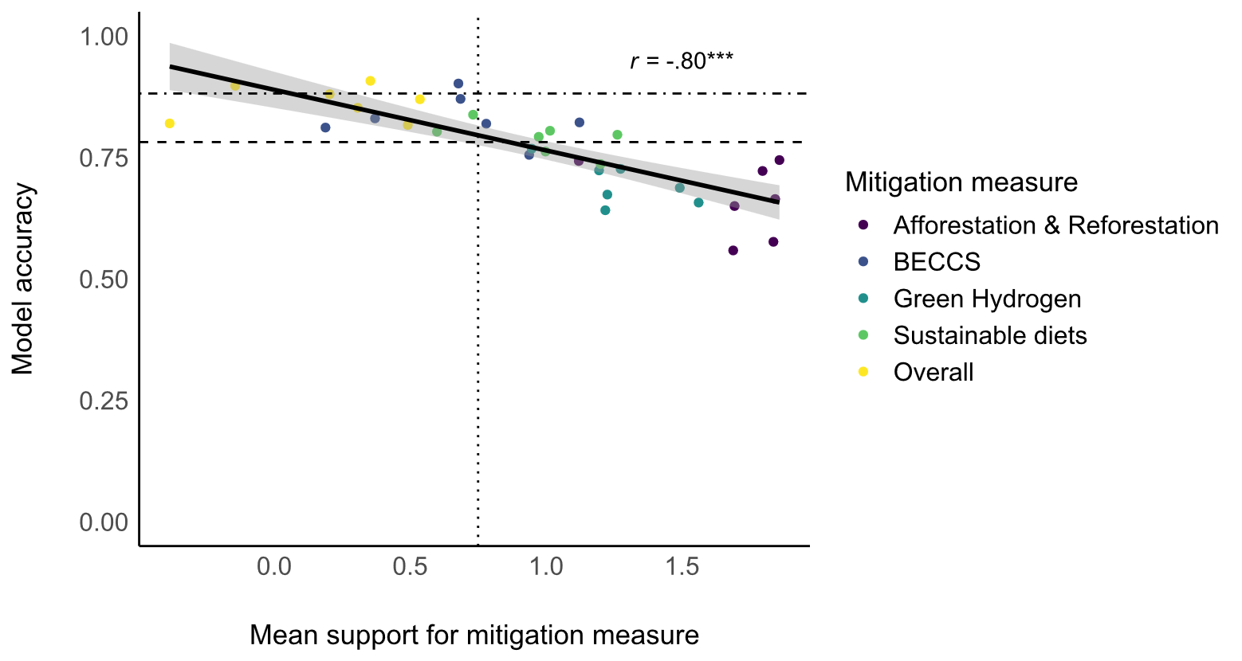
Note. The dotdashed (upper) horizontal line shows our pre-registered cut-off for model performance generalising ((an accuracy of at least 88.2%). The dashed horizontal line shows our pre-registered cut-off for reasonable model performance (an accuracy of at least 78.2%). The dotted vertical line shows the highest reported mean policy support (0.75) in our training data (Study 1). Policy support was measured on a scale of -3 to +3. Coloured dots (n =35) represent individual subsamples in which model performance was tested.
S3 – Information Materials (English)
Study 1
Note: The translated versions (German and French) can be found on the OSF- (https://doi.org/10.17605/OSF.IO/ZN72G).
Supply-side Policies
Fossil fuels with Direct Air Carbon Capture and Storage (DACCS) – 913 words
One option to ensure sufficient flexibility in electricity supply to meet the required demand is to rely on flexible fossil fuel-based electricity plants. These plants can be pictured as a few power plants using natural gas or oil. These plants can run anytime during the year, but they are actually used relatively rarely, only if renewable technologies do not supply enough electricity and can quickly react to fluctuations in electricity demand. As burning fossil fuels contributes to climate change, Switzerland would need to invest into the construction of direct air carbon capture and storage (DACCS) systems to compensate emitted CO₂. DACCS essentially extracts CO₂ molecules from the outside air, hence reducing CO₂ concentrations in the atmosphere and therefore compensating CO₂ emissions from these fossil fuel-based plants. The extracted CO₂ would be transported and stored in long-term geological storage sites in the deep underground abroad, e.g. in Norway. Using DACCS could make it possible to use fossil fuel-based plants to provide flexibility in electricity supply while ensuring that no additional CO₂ is added to the atmosphere. DACCS, which requires large amounts of electricity, in turn could be operated during hours when plentiful renewable electricity is available.
Impact on the environment
- CO₂ emissions
  - Even if emissions from burning fossil fuel could be compensated by DACCS, the DACCS need a large amount of energy and, depending on where DACCS are operated, more or less CO₂ would be emitted during the operation or life cycle of DACCS. For example, in Switzerland, it is expected that for every 1 ton of captured CO₂, 0.15 t of CO₂ might still be emitted.
- Health
  - Using fossil fuels for flexible electricity generation would negatively impact air quality, especially if oil is used (coal use is unlikely in Switzerland). Additionally, the sites of geological CO₂ storage abroad can experience induced earthquakes, but generally these earthquakes are too small to cause any injuries.
- Infrastructure
  - On top of the environmental impacts from fossil fuel plants, additional impacts would occur from manufacturing, constructing and operating DACCS, including the infrastructure for extracting CO₂, for transporting it to the site of geological storage (potentially by grids and ships), and for geological storage in the deep underground. At the same time, Switzerland might require less of other technologies, e.g. batteries, to ensure the supply-side flexibility.
Impact on energy sector
- Renewable generation integration
  - Using fossil fuel plants as back-up plants means the share of renewable electricity would be lower than in the case that flexibility is provided by storage, low-carbon electricity generation or by electricity import. Additionally, the process of extracting produced CO₂ from the outside air and storing it is highly energy-intensive though therefore inefficient.
- Electricity supply reliability
  - Fossil fuel-based back-up plants are very flexible and are already commonly used as reliable back-ups in the electricity system. They can react fast to provide the needed electricity to the grid, independent of season or weather.
- Energy independence
  - Fossil fuels for such plants would be imported from abroad. Hence, compared to other flexibility options, a small degree of energy dependence would remain. Additionally, it is very likely that Switzerland will need to store the captured CO₂ in geological storage sites abroad due to limited storage potential in Switzerland.
Economic impacts
- Costs
  - Costs of producing electricity from fossil fuel plants are known to fluctuate a lot from low to high, depending on the geopolitical context. On top of that, DACCS is currently very expensive. It is however expected that DACCS could become cheaper over time as the technology is more widely deployed and becomes more efficient.
- Economic inequalities
  - Financial benefits or burdens of this policy would be most likely reflected in the overall price of electricity. Low-income households could yet be more sensitive to any potential increase in price.
- Jobs
  - Constructing and operating DACCS plants in Switzerland and abroad will lead to an increase in new jobs in Switzerland. This will also aid the innovation sector of Switzerland as currently a Swiss company is one of the frontrunners of this technology.
Societal impacts
- Comfort
  - If fossil fuel-based electricity plants are used in combination with DACCS to increase flexibility of electricity supply in Switzerland, no involvement or behaviour change is required by the Swiss citizens to provide flexibility by fossil fuel plants with DACCS.
- Privacy
  - Supply-side flexibility measures, such as this one, do not require sharing personal data and hence do not pose or increase any privacy risks.
- Distributional impacts
  - Using fossil fuel-based plants as back-ups with DACCS have different impacts on the Swiss citizens and populations abroad. For example, the mining of fossil fuels as well as most of the geological storage of CO₂ would take place abroad, affecting the Swiss population less.
Electricity trading for increased flexibility – 809 words
One option to ensure sufficient flexibility of electricity supply is to rely on electricity trading (i.e. importing and exporting electricity) with Switzerland’s neighbours. Already today, Switzerland faces a seasonal challenge when during winter electricity demand is higher than in summer (e.g. due to heating), but the domestic electricity generation from hydropower plants is lower because less water is available. Due to its advantageous location in Europe, Switzerland benefits from the ability to trade electricity with neighbouring countries (France, Germany, Austria, Italy) depending on the electricity demand and required flexibility in the system. This policy would entail increasing electricity trading to match electricity supply to electricity demand.
Impact on the environment
- CO₂ emissions
  - Currently, electricity imports mostly come from Germany with comparatively high CO₂ emissions due to coal and gas plants or from France with very low CO₂ emissions due to nuclear power. Assuming that neighbouring countries keep their current commitments to transition to carbon neutrality, trading electricity would not increase CO₂ emissions in the long run.
- Health
  - Health impacts from imported electricity occur where this electricity is produced. Especially in the case of electricity plants from coal and other fossil fuels, there are negative impacts on air pollution and health, e.g. in Germany.
- Infrastructure
  - If electricity imports from neighbouring countries are used to increase flexibility, less infrastructure would be needed to be built in Switzerland. The overall impacts from manufacturing and construction though would vary depending on the type of technology used to generate electricity.
Impact on the energy sector
- Renewable generation integration
  - Assuming that both Switzerland and its neighbouring countries transition to a net-zero energy system, the share of renewables in the Swiss system would stay the same.
- Electricity supply reliability
  - In general, electricity trading is reliable and therefore suitable to provide flexibility based on the needs of the Swiss electricity system.
- Energy independence
  - Trading with neighbouring countries also means Switzerland would continue relying on the situation, strategic decisions and energy policy decisions of these countries and the European Union. The choice of electricity sources, e.g. fossil fuels or renewables, could also be limited.
Economic impacts
- Cost
  - Costs of importing electricity from abroad are uncertain as they depend on the situations and electricity generation mixes in the neighbouring countries. Overall, sufficient interconnection with neighbouring countries for trading allows to benefit from siting renewable generation in best locations and from prioritizing the lowest price electricity across the countries, leading to the lowest overall costs.
- Economic inequalities
If there are any changes in the overall price of electricity, these changes will be similar for comparable types of households. Although low-income households could be more sensitive to potential increase in price, the price is primarily expected to decrease.
- Jobs
  - Relying on trading for flexibility means that less jobs would be created in Switzerland for other flexibility measures, such as storage, demand side flexibility or back-up plants.
Societal impacts
- Comfort
  - If trading is used as the source of flexibility in the Swiss electricity system, no involvement or behaviour change is required by the Swiss citizens to provide flexibility by electricity trading.
- Privacy
  - Supply-side flexibility measures, such as this one, does not require sharing personal data and hence do not pose or increase any privacy risks.
- Distributional impacts
  - Using trading would mean having different impacts on the Swiss citizens and populations abroad. For example, the electricity generation and its negative environmental or health impacts would take place abroad, affecting the Swiss population less.
Flexible EV charging (infrastructure) policy – 805 words
To increase flexibility of the electricity demand, Switzerland could introduce national incentives for smart EV charging infrastructure. This means that the Swiss Confederation would financially support the construction of smart charging stations for EVs, for example, at workplaces, public parking or at residential buildings. These smart charging stations are different from the conventional charging stations in that they can receive signals about the current balance of electricity supply and demand in the grid. Based on this information, the smart charging station can slow down charging temporarily if needed for the grid and shift it within the same session to times with lower grid stress.
Impacts on the environment
- CO₂ emissions
  - Controlling charging times of EVs makes it possible to consume renewable electricity when it is available. This makes it possible to consume more renewable and less non-renewable electricity. It also reduces the need for imported electricity that has higher CO₂ emissions due to the use of fossil fuels abroad as well as the use of fossil fuel back-up plants in Switzerland. This means smart charging leads to CO₂ emissions reductions.
- Health
  - Consuming more renewable electricity by allowing controlled charging times allows for being less dependent on domestic back-up plants that rely on (fossil) fuels whose combustion emissions generate air pollution which can have negative health impacts. Likewise, controlling charging times of EVs makes it possible to avoid consuming imported electricity from fossil fuels, which contributes to air pollution and therefore has negative health impacts abroad.
- Infrastructure
  - Controlling EV charging times reduces the need for additional infrastructure, such as electricity storage (e.g. batteries) and transmission grid extension. This means that overall environmental and health impacts from manufacturing and construction of infrastructures could be lowered, even if smart charging requires slightly more materials than conventional charging.
Impacts on the energy sector
- Renewable generation integration
  - Allowing smart EV charging means that more renewable electricity can be used to power EVs and can be better integrated in the electricity grid overall.
- Electricity supply reliability
  - Smart EV charging generally improves electricity supply reliability because EV charging can be postponed to times when enough supply, especially renewable generation, is available. Hence, smart charging can decrease stress on the electricity grid. Smart EV charging relies more on digital technologies which, however, could increase supply reliability risks.
- Energy independence
  - Allowing smart EV charging means being less dependent on supply-side flexibility options such as electricity trading or being less dependent on domestic back-up plants that rely on imported (fossil) fuels.
Economic impacts
- Costs
  - Smart EV charging would be cheaper for EV owners than conventional charging due to financial support from the confederation and because charging would often be shifted to periods of cheaper electricity price. The amount of cost reductions would depend on the extent of flexible charging allowed. More broadly, the overall costs of the electricity system would be also lower, e.g. due to avoided investment in new grid infrastructure, such as additional storage.
- Economic inequalities
  - Households that own EVs or can afford EVs can financially profit more from this policy: the policy directly decreases the costs of driving the car and the confederation’s financial support also benefits the EV owners. Households that do not own or cannot afford EVs would not directly benefit but could still profit indirectly from the overall lower electricity prices.
- Jobs
  - Smart charging stations and their operation will create additional jobs related to the installation and maintenance of infrastructures and related software, e.g. for software engineers, data analysts, and cybersecurity experts.
Societal impacts
- Comfort
  - Smart charging depends on information about the driver’s departure time and requires more planning. If the driver decides to leave earlier than planned, with smart charging their car may not be fully charged yet. Smart charging could typically prolong charging time from 30 minutes to 3 hours. The driver could restrict or disable smart charging if wanted, but then the financial benefit would be lower or absent.
- Privacy
  - To allow efficient smart charging, grid operators and utility companies need reliable data on charging behaviour. This means individuals will need to share data on their charging behaviour, including when, where and how long they charge their EVs. The data would be protected and anonymized.
- Distributional impacts
  - Using smart charging requires some extent of digital literacy and familiarity with digital devices. Citizens who are less adept at using digital devices might not be able to profit from smart charging infrastructure as much.
Flexible Heating Policy – 831 words
To increase flexibility in residential heating, Switzerland could introduce national incentives for flexible operation of heat pumps. Heat pumps are devices that produce heat for space heating or hot water using electricity, but much more efficiently than conventional electric heating. Heat pumps can be designed to communicate with a smart meter which informs them about the current electricity demand and supply in the grid. Based on this information these heat pumps can be automatically turned down or turned off for a limited amount of time, if needed for the grid. The Swiss Confederation could financially support the flexible operation of heat pumps in residential and public buildings.
Impacts on the environment
- CO₂ emissions
  - Controlling heat pump use makes it possible to consume renewable electricity when it is available. This makes it possible to consume more renewable and less non-renewable electricity. It also reduces the need for imported electricity that has higher CO₂ emissions due to fossil fuels abroad as well as the use of fossil fuel back-up plants in Switzerland. This means smart heating leads to CO₂ emissions reductions.
- Health
  - Consuming more renewable electricity by allowing smart heating allows for being less dependent on domestic back-up power plants that rely on (fossil) fuels for heating. Their combustion emissions generate air pollution which can have negative health impacts. Likewise, smart heating makes it possible to avoid consuming imported electricity from fossil fuels, which contributes to air pollution and therefore has negative health impacts abroad.
- Infrastructure
  - Smart heating reduces the need for additional infrastructure, such as electricity storage (e.g. batteries) and transmission grid extension. This means that overall environmental and health impacts from manufacturing and construction of infrastructures could be lowered, even if smart heating requires slightly more materials than conventional heating.
Impacts on the energy sector
- Renewable generation integration
  - Allowing smart heat pump operation means that more renewable electricity can be used for heating and can be integrated in the electricity grid overall.
- Electricity supply reliability
  - Smart use of heat pumps generally improves electricity supply reliability because heating can be postponed to times when enough supply, especially renewable generation, is available. Hence, smart use of heat pumps can decrease stress on the electricity grid. Smart meters for smart heating rely on digital technologies which, however, could increase reliability risks.
- Energy independence
  - Allowing smart operation of heat pumps means being less dependent on supply-side flexibility options such as electricity trading with neighbouring countries or being less dependent on domestic back-up plants that rely on imported (fossil) fuels.
Economic impacts
- Costs
  - Smart heating would be cheaper for heat pump owners than conventional operation of heat pumps due to financial support from the confederation and because heating would often be shifted to periods of cheaper electricity price. The amount would depend on the extent of flexibility that is allowed. The overall costs of the electricity system would also be lower, e.g. due to avoided investment in new grid infrastructure, such as additional storage.
- Economic inequalities
  - Financial benefits of this policy would reach the households that have a heat pump or can afford to install a heat pump. This is because flexible heating enables heating at times of lower electricity price on top of the confederation’s financial support. Also, not all buildings are suitable for heat pumps so it is not possible for every household to install them.
- Jobs
  - Smart operation of heat pumps requires smart meters, whose installation and operation will create additional jobs, e.g. for technicians, electricians, software engineers, data analysts, and cybersecurity experts.
Societal impacts
- Comfort
  - Allowing smart heating means that heat pump activity will be reduced or turned off at certain times leading to slightly lower room temperature, e.g. typically for 90 minutes at any time during the day. Smart heating can be restricted or disabled if wanted, but then the financial benefit would be lower or absent.
- Privacy
  - To allow smart heating, heat pumps require households to share personal data with grid operators and utility companies via smart meters. This would include data on when and how many individuals are at home, room temperatures, or information on open windows. The data would be protected and anonymized.
- Distributional impacts
  - Using smart heating requires some extent of digital literacy and familiarity with digital devices. Citizens who are less adept at using digital devices might not be able to profit from smart meters for heating as much.
Study 2 – Information on referendum contents provided to participants
Referendum on the Federal Act on a Secure Electricity Supply from Renewable Energy Sources
On 9 June, Switzerland faces an important decision: the vote on the Federal Act on a Secure Electricity Supply from Renewable Energy Sources. This law aims to expand renewable energy systems (solar, wind and hydropower) in order to reduce dependence on foreign electricity and improve security of supply. However, the debate is controversial and both supporters and opponents have strong arguments to put forward.
Arguments of the referendum committee:
The referendum committee warns of the potential consequences of the law. It emphasises that the law threatens nature by facilitating the clearing of forests and disfiguring landscapes. The sovereignty of the people, cantons and municipalities could be restricted by the law, as local decisions on projects could potentially be undermined. The focus on gigantic solar parks in scenic areas is seen as irreparable damage to the country. Instead, alternatives are proposed, such as the increased use of solar installations on existing buildings and infrastructure.
Arguments of the Federal Council and the government:
The Federal Council and the government argue that the law is necessary to drive forward the expansion of domestic electricity production while at the same time showing consideration for nature and the landscape. They emphasise the importance of rapid expansion for the security of the electricity supply and the reduction of dependence on energy imports. The construction of large plants is carried out with consideration for the environment and nature, and areas that are particularly worthy of protection remain largely free of new plants. In addition, the proposal concentrates on selected areas for wind and solar power plants in order to protect the landscape and nature. The bill also includes democratic co-determination options for the population, and financial incentives should enable expansion without additional burdens for consumers. Ultimately, the law is seen as an important step towards achieving climate neutrality by 2050.
Study 3
Bioenergy with carbon capture and storage (BECCS) as a climate change mitigation measure
Please read this text carefully
The Intergovernmental Panel on Climate Change (IPCC), an international body of scientists, warns that if human activities continue at the current rate, global temperature will rise to unsafe levels before 2100. The main drivers of global warming are greenhouse gases—gases in the atmosphere that trap heat, such as carbon dioxide and methane—released by human activities. Currently, the world emits about 60 gigatons of greenhouse gases per year, measured as carbon dioxide equivalent (CO₂eq). To limit temperature rise, we must achieve net-zero greenhouse gas emissions by 2050. This requires using various mitigation measures, including bioenergy with carbon capture and storage (BECCS for its acronym in English BioEnergy with Carbon Capture and Storage).
BECCS involves growing plants, such as grains and sugarcane, that capture large amounts of carbon dioxide (CO₂) from the atmosphere. These plants are then burned to produce energy. However, during combustion, the CO₂ inside the plants would not be emitted into the atmosphere but would be technically captured and deposited underground in the deep rocks, hence reducing the amount of CO₂ in the atmosphere.
The IPCC has calculated the global mitigation potential of BECCS, that is, the amount of greenhouse gases emissions (CO₂eq) that BECCS could avoid and removed from the atmosphere if implemented worldwide. According to the IPCC, BECCS could globally reduce 6 gigatons of CO₂eq per year from 2020 to 2050, as shown in the following graph. 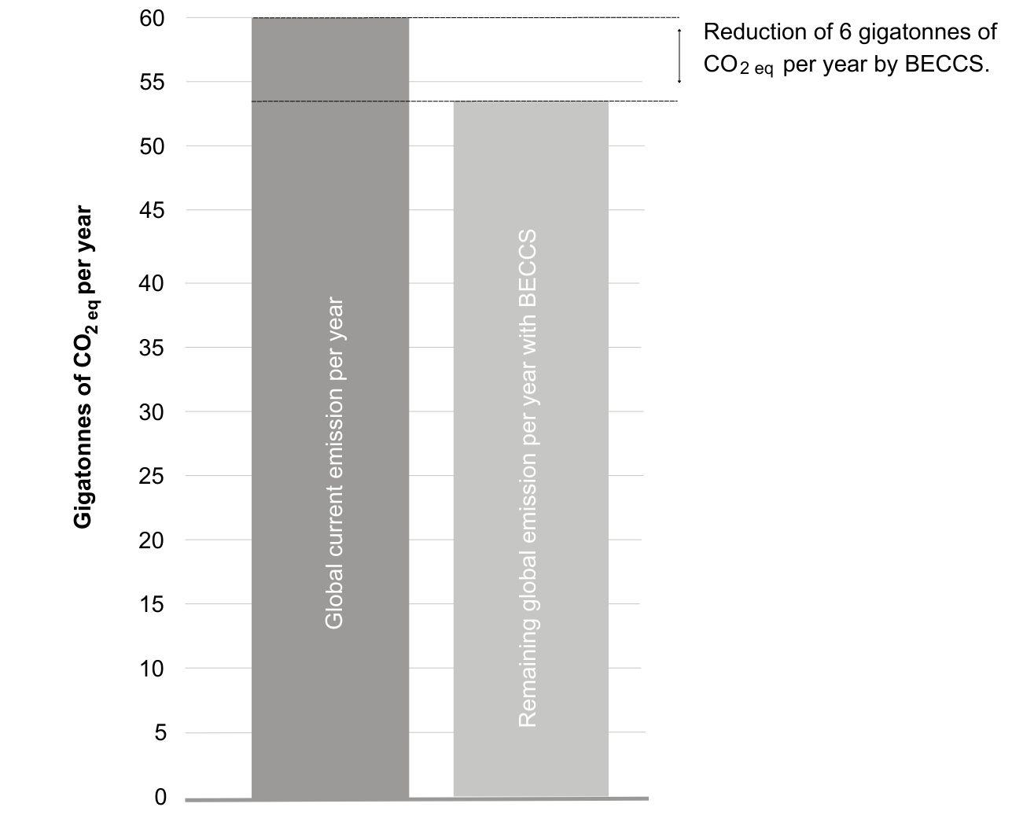
Green hydrogen as a climate change mitigation measure
Please read this text carefully
The Intergovernmental Panel on Climate Change (IPCC), an international body of scientists, warns that if human activities continue at the current rate, global temperature will rise to unsafe levels before 2100. The main drivers of global warming are greenhouse gases—gases in the atmosphere that trap heat, such as carbon dioxide and methane—released by human activities. Currently, the world emits about 60 gigatons of greenhouse gases per year, measured as carbon dioxide equivalent (CO₂eq). To limit temperature rise, we must achieve net-zero greenhouse gas emissions by 2050. This requires using various mitigation measures, including green hydrogen.
Green hydrogen consists of splitting water (H₂O) into oxygen (O) and hydrogen (H) using electricity generated from renewable sources like wind or solar power. Therefore, green hydrogen production does not result in carbon dioxide (CO₂) emissions. Hydrogen can then be used as a fuel to store and provide energy to sectors that are difficult to decarbonise through electrification, such as industry, buildings, and transportation.
The IPCC has calculated the global mitigation potential of green hydrogen, that is, the amount of greenhouse gases emissions (CO₂eq) that green hydrogen could avoid if implemented worldwide. According to the IPCC, green hydrogen could globally reduce 3 gigatons of CO₂eq per year from 2020 to 2050, as shown in the following graph.
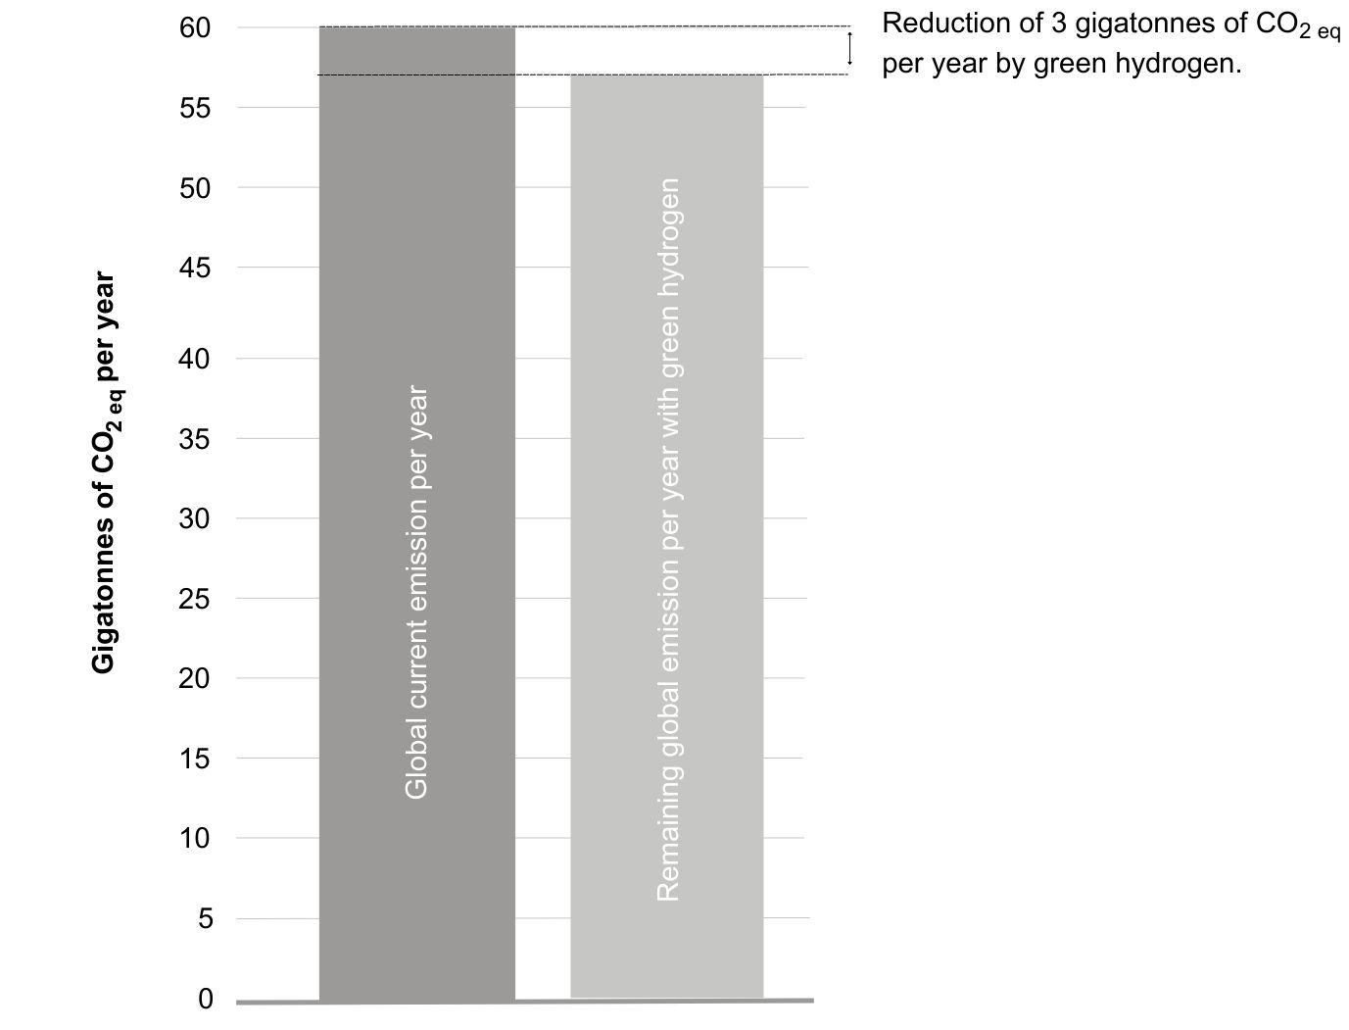

Afforestation and reforestation as a climate change mitigation measure
Please read this text carefully
The Intergovernmental Panel on Climate Change (IPCC), an international body of scientists, warns that if human activities continue at the current rate, global temperature will rise to unsafe levels before 2100. The main drivers of global warming are greenhouse gases—gases in the atmosphere that trap heat, such as carbon dioxide and methane—released by human activities. Currently, the world emits about 60 gigatons of greenhouse gases per year, measured as carbon dioxide equivalent (CO₂eq). To limit temperature rise, we must achieve net-zero greenhouse gas emissions by 2050. This requires using various mitigation measures, including afforestation and reforestation.
Afforestation involves planting trees in areas that do not have natural forest. Reforestation involves planting trees in areas where forests have been depleted or degraded. Both these processes help capture carbon dioxide (CO₂) from the atmosphere as trees naturally absorb CO₂ during photosynthesis, storing carbon in their biomass and the soil.
The IPCC has calculated the global mitigation potential of afforestation and reforestation, that is, the amount of greenhouse gases emissions (CO₂eq) that afforestation and reforestation could remove from the atmosphere if implemented worldwide. According to the IPCC, afforestation and reforestation could globally remove 5 gigatons of CO₂eq emissions per year from 2020 to 2050, as shown in the following graph.
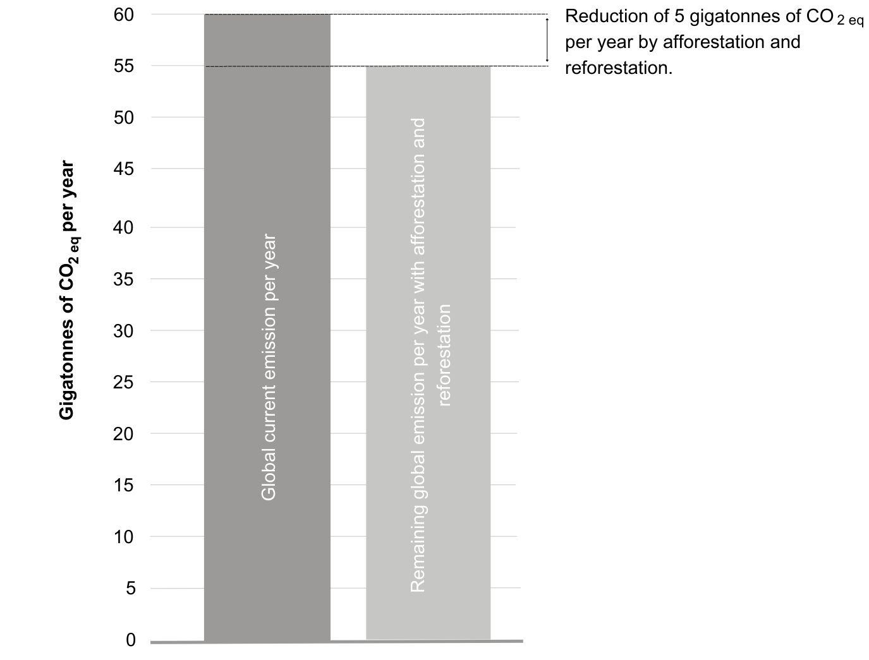

Shifting towards sustainable diets as a climate change mitigation measure
Please read this text carefully
The Intergovernmental Panel on Climate Change (IPCC), an international body of scientists, warns that if human activities continue at the current rate, global temperature will rise to unsafe levels before 2100. The main drivers of global warming are greenhouse gases—gases in the atmosphere that trap heat, such as carbon dioxide and methane—released by human activities. Currently, the world emits about 60 gigatons of greenhouse gases per year, measured as carbon dioxide equivalent (CO₂eq). To limit temperature rise, we must achieve net-zero greenhouse gas emissions by 2050. This requires using various mitigation measures, including shifting towards sustainable diets.
Sustainable diets consist of eating more protein from plants than from animals. Shifting towards diets with more plant-based proteins and fewer animal products, particularly red meat, can reduce carbon dioxide (CO₂) and other greenhouse gas emissions. This is because plant-based diets require much less land than animal products, lowering CO₂ emissions from the conversion of forests to agricultural land for livestock feed and grazing. Additionally, cattle naturally produce large amounts of methane (another greenhouse gas) during digestion, which cannot be significantly reduced by farming practices alone.
The IPCC has calculated the global mitigation potential of shifting towards sustainable diets, that is, the amount of greenhouse gases emissions (CO₂eq) that shifting towards sustainable diets could avoid if implemented worldwide. According to the IPCC, shifting towards sustainable diets could globally reduce 3.5 gigatons of CO₂eq emissions per year from 2020 to 2050,as shown in the following graph.
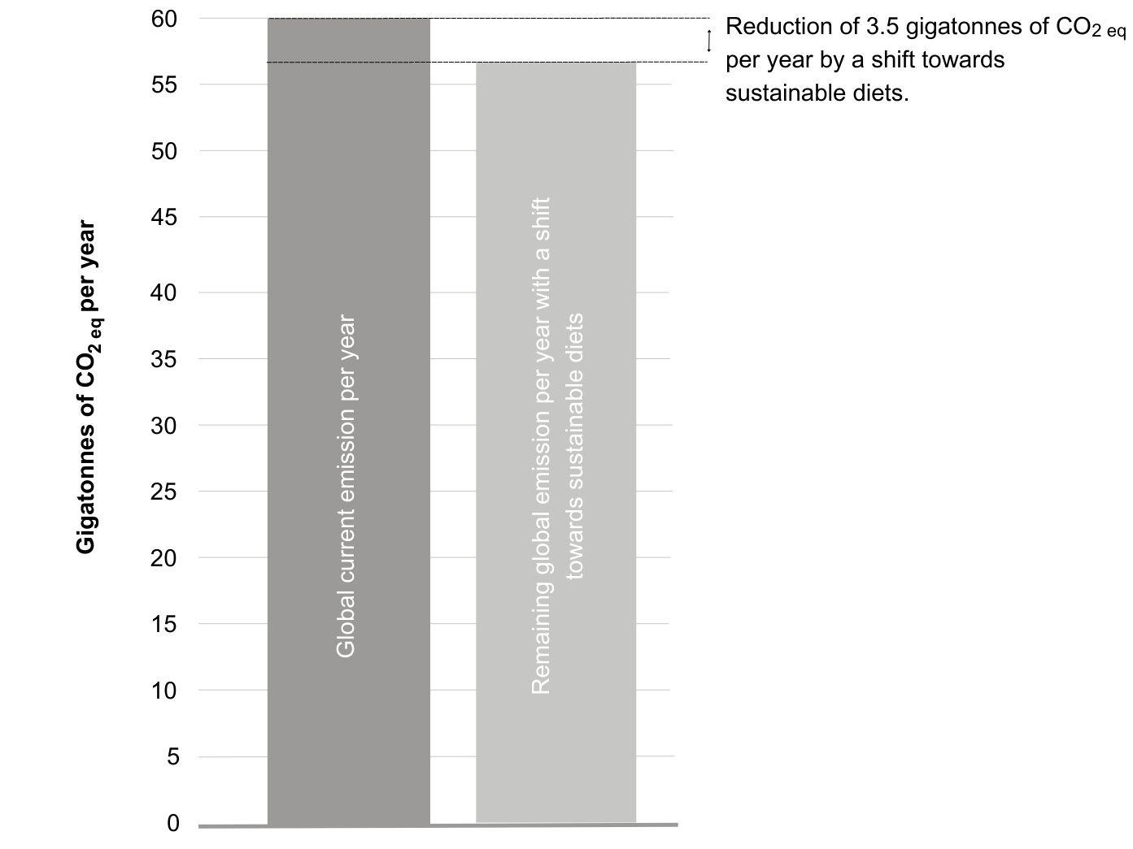
S4 – Additional analyses
Study 1:
Models with N = 1096
We ran the same models without excluding participants with potentially low data quality. The regression random forest using hyperparameters recommended by Pargent et al. (2023) performed with a root mean squared error (RMSE) of 0.62 and explained 80.10 % of variance in policy support (R² = 0.8010). The model using adapted hyperparameter settings performed with a root mean squared error (RMSE) of 0.78 and explained 71.08 percent (%) of variance in policy support (R² = 0.6829). The ridge regression model performed with a mean RMSE of 0.68202 and, on average, explained 77.44 % of variance in policy support (R² = 0.7744).
Table 7
Results of machine learning models without data exclusions
Predictor | Regression Random Forest |  | Ridge Regression
Predictor | Rank | Mean RMSE-Loss  (Range) | Rank | Mean Standardized Regression Coefficient  (Range)
General affect | 1 | 0.8527  (0.8455; 0.8602) | 1 | 0.160  (0.139; 0.176)
Hope | 2 | 0.8175  (0.8118; 0.8236) | 3 | 0.0978  (0.0909; 0.102)
Pride | 3 | 0.8139  (0.8077; 0.8226) | 5 | 0.0847  (0.0792; 0.0879)
Perceived Societal Impacts | 4 | 0.8102  (0.8046; 0.8143) | 2 | 0.105  (0.0969; 0.111)
Perceived Environmental Impacts | 5 | 0.8043  (0.7981; 0.8087) | 4 | 0.0877  (0.0828; 0.0904)
Fairness towards Swiss Citizens | 6 | 0.8043  (0.7993; 0.8121) | 8 | 0.0716  (0.0698; 0.0722)
Personal Fairness | 7 | 0.8028  (0.7975; 0.8075) | 7 | 0.0746  (0.0717; 0.0763)
Perceived Dynamic Norms | 8 | 0.8009  (0.7977; 0.8048) | 6 | 0.0800  (0.0744; 0.0836)
Anger | 9 | 0.8001  (0.7970; 0.8063) | 11 | -0.0654  (-0.0665; -0.0627)
Worry | 10 | 0.7986  (0.7939; 0.8042) | 9 | -0.0715  (-0.0741; -0.0670)
Perceived impact on personal wellbeing | 11 | 0.7971  (0.7922; 0.8035) | 16 | 0.0503  (0.0490: 0.0515)
Fairness towards people in other countries | 12 | 0.7969  (0.7933; 0.8000) | 10 | 0.0673  (0.0625; 0.0703)
Perceived Impact on personal finances | 13 | 0.7962  (0.7911; 0.8016) | 12 | 00585  (0.0581; 0.0585)
Perceived impact on share of renewables in energy system (Effectiveness) | 14 | 0.7932  (0.7909; 0.7992) | 15 | 0.0522  (0.0510; 0.0527)
Condition | 15 | 0.7931  (0.7909; 0.7980) | Heating:  24 | 0.0245  (0.0204; 0.0276)
Condition | 15 | 0.7931  (0.7909; 0.7980) | EV:  28 | 0.0155  (0.0126; 0.0178)
Condition | 15 | 0.7931  (0.7909; 0.7980) | Trading:  25 | 0.0178  (0.0128; 0.0221)
Condition | 15 | 0.7931  (0.7909; 0.7980) | DACCS:  In intercept
Perceived impact on personal privacy | 16 | 0.7931  (0.7815; 0.7947) | 18 | 0.0404  (0.0391; 0.0417)
Fairness towards low-income earners | 17 | 0.7929  (0.7878; 0.7983) | 13 | 0.0584  (0.0575; 0.0585)
Descriptive Norms | 18 | 0.7922  (0.7898; 0.7971) | 14 | 0.0561  (0.0540; 0.0570)
Perceived economic impact | 19 | 0.7921  (0.7902; 0.7946) | 17 | 0.0458  (0.0453; 0.0459)
Perceived impact on personal health | 20 | 0.7921  (0.7894; 0.7951) | 19 | 0.0365  (0.0325; 0.0408)
Perceived impact on flexibility of the energy system  (Effectiveness) | 21 | 0.7883  (0.7865; 0.7903) | 22 | 0.0301  (0.0289; 0.0317)
Subjective knowledge | 22 | 0.7875  (0.7850; 0.7893) | 20 | 0.0354  (0.0321; 0.0378)
Perceived impact on personal freedom | 23 | 0.7875  (0.7832; 0.7899) | 21 | -0.0315  (-0.0315; -0.0313)
Perceived impact on reliability of the energy system  (Effectiveness) | 24 | 0.7870  (0.7844; 0.7901) | 27 | 0.0165  (0.0129; 0.0211)
Climate Change Worry | 25 | 0.7836  (0.7803; 0.7861) | 37 | 0.0105  (0.0099; 0.0115)
Belief in negative consequences of climate change | 26 | 0.7835  (0.7803; 0.7861) | 46 | 0.0055  (0.0047; 0.0069)
Personal responsibility to mitigate climate change | 27 | 0.7834  (0.7822; 0.7851) | 53 | 0.0017  (-0.0007; 0.0048)
Biospheric values | 28 | 0.7833  (0.7821; 0.7844) | 34 | -0.0115  (-0.0135; -0.0085)
Objective knowledge | 29 | 0.7831  (0.7821; 0.7844) | 51 | -0.0025  (-0.0035; -0.0009)
Perceived impact on energy independence  (Effectiveness) | 30 | 0.7828  (0.7811; 0.7840) | 32 | 0.0127  (0.0121; 0.0133)
Belief in spatial proximity of climate change effects | 31 | 0.7828  (0.7815; 0.7847) | 41 | 0.0073  (0.0068; 0.0082)
Techno-optimism | 32 | 0.7827  (0.7808; 0.7842) | 31 | 0.0127  (0.0120; 0.0138)
Altruistic values | 33 | 0.7826  (0.7819; 0.7836) | 55 | -0.0015  (-0.0020; -0.0055)
Belief in the human causes of climate change | 34 | 0.7823  (0.7800; 0.7837) | 39 | 0.0087  (0.0079; 0.0099)
Techno-fix attitudes | 35 | 0.7822  (0.7806; 0.7835) | 49 | 0.0044  (0.0025; 0.0069)
Belief in the temporal distance of climate change | 36 | 0.7818  (0.7808; 0.7825) | 56 | -0.0014  (-0.0014; -0.0013)
Egoistic values | 37 | 0.7818  (0.7808; 0.7827) | 33 | 0.0116  (0.0114; 0.0119)
Age | 38 | 0.7818  (0.7790; 0.7839) | 30 | -0.0142  (-0.0148; -0.0132)
Trust in political institutions | 39 | 0.7817  (0.7777; 0.7840) | 38 | 0.0100  (0.0075; 0.0134)
Belief in the reality of climate change | 40 | 0.7816  (0.7796; 0.7840) | 45 | 0.0058  (0.0050; 0.0072)
Randomly created variable with binomial distribution | 41 | 0.7814  (0.7809; 0.7820) | 47 | 0.00483  (0.00482; 0.00484)
Gender | 42 | 0.7813  (0.7809; 0.7816) | Female:  In intercept | NA
Gender | 42 | 0.7813  (0.7809; 0.7816) | Male:  58 | 0.0004  (-0.0008; 0.0017)
Gender | 42 | 0.7813  (0.7809; 0.7816) | Other:  59 | -0.000158  (-0.000171; -0.000143)
Income | 43 | 0.7812  (0.7801; 0.7822) | 0-5000 CHF:  In intercept | NA
Income | 43 | 0.7812  (0.7801; 0.7822) | 5001-8000 CHF:  61 | 0.000054  (-0.000514; 0.000691)
Income | 43 | 0.7812  (0.7801; 0.7822) | 8001-20.000 CHF:  36 | -0.0110  (-0.0133; -0.0081)
Income | 43 | 0.7812  (0.7801; 0.7822) | > 20.000 CHF:  54 | -0.0016  (-0.0020; -0.0011)
Income | 43 | 0.7812  (0.7801; 0.7822) | Prefer not to answer:  48 | -0.0049  (-0.0057; -0.0031)
Political affiliation (prefer not to answer) | 44 | 0.7811  (0.7801; 0.7822) | 52 | -0.0022  (-0.0027; -0.0016)
Subjective financial scarcity | 45 | 0.7810  (0.7802; 0.7814) | 26 | 0.0173  (0.0126; 0.0206)
Political Affiliation | 46 | 0.7809  (0.7791; 0.7821) | 23 | -0.0288;  (-0.0320; -0.0244)
Randomly created variable with normal distribution | 47 | 0.7810  (0.7804; 0.7816) | 35 | -0.0110  (-0.0120; -0.0095)
Living area (Rural/Urban) | 48 | 0.7808  (0.7793; 0.7829) | Rural:  29 | -0.0145  (-0.0161; -0.0124)
Living area (Rural/Urban) | 48 | 0.7808  (0.7793; 0.7829) | Urban:  In intercept | NA
Hedonic values | 49 | 0.7809  (0.7798; 0.7817) | 57 | -0.0009  (-0.0016; -0.0002)
Language Area | 50 | 0.7807  (0.7801; 0.7813) | German:  In intercept | NA
Language Area | 50 | 0.7807  (0.7801; 0.7813) | French:  43 | 0.0063  (0.0054; 0.0069)
Education | 51 | 0.7807  (0.7801; 0.7819) | Obligatory school: | NA
Education | 51 | 0.7807  (0.7801; 0.7819) | Secondary school: | -0.0079  (-0.0087; -0.0069)
Education | 51 | 0.7807  (0.7801; 0.7819) | Tertiary degree: | 0.0062  (0.0056; 0.0067)
Education | 51 | 0.7807  (0.7801; 0.7819) | Prefer not to answer: | 0.000102  (0.0000892; 0.000111)
Randomly created variable with uniform distribution | 52 | 0.7805  (0.7798; 0.7812) | 50 | 0.0040  (0.0036; 0.0042)
Techno-pessimism | 53 | 0.7801  (0.7797; 0.7809) | 42 | 0.0072  (0.045; 0.0092)

Table 8
Means and Standard Deviations (SDs; in parentheses) of subjective and objective knowledge as well as policy support before (pre) and after (post) information provision
 | DACCS |  | Trading |  | EV |  | Heating
 | Pre | Post | Pre | Post | Pre | Post | Pre | Post
Subjective Knowledge | 3.06  (1.22) | 3.65  (1.31) | 3.34  (1.27) | 3.80  (1.32) | 3.53  (1.31) | 4.22  (1.29) | 3.53  (1.37) | 4.25  (1.35)
Objective Knowledge | 0.55  (1.66) | 2.45  (1.98) | 0.47  (1.91) | 1.28  (2.04) | 1.40  (1.83) | 2.72  (2.02 | 2.21  (2.00) | 2.81  (2.02)
Policy Support | 0.07  (1.14) | -0.55  (1.23) | 0.65  (1.07) | 0.29  (1.21) | 0.49  (1.44) | 0.53  (1.48) | 0.68  (1.24) | 0.75  (1.33)

Study 2:
Model performance in subsamples
Apart from the model performance measures calculated based on the whole sample (N = 765) in Study 2, we additionally checked model performance individually for the following subsamples:
- Participants who intended to vote (N = 326)
The model performed excellently for this subsample: Prediction accuracy = 88.34 %; False-negative rate = 0.1712; False-positive rate = 0.0884; Negative predictive value 0.9116; Positive predictive value = 0.8288; True-negative rate = 0.9116; True-positive rate = 0.8288; Area under the curve = 0.9464.
- Participants who indicated they voted by mail (N = 332)
The model performed excellently for this subsample: Prediction accuracy = 89.16 %; False-negative rate = 0.1032; False-positive rate = 0.1117; Negative predictive value 0.9337; Positive predictive value = 0.8309; True-negative rate = 0.8883; True-positive rate = 0.8968; Area under the curve = 0.9558.
- Participants who do not intend to vote (N = 107)
The model performed considerably worse for this subsample, compared to subsamples of participants who intended to vote or indicated they had already voted by mail: Prediction accuracy = 76.64 %; False-negative rate = 0.3000; False-positive rate = 0.1754; Negative predictive value 0.7581; Positive predictive value = 0.7778; True-negative rate = 0.8246; True-positive rate = 0.7000; Area under the curve = 0.8642.
Forecast for the result of the referendum on the Federal Act on Renewable Energy:
We used the predictions obtained from our model to provide a forecast for the results of the Swiss general referendum on the Federal Act on Renewable Energy on June 9th 2024. According to our model, we forecasted a majority vote in favour of the Federal Act on Renewable Energy with 61.83% of voters voting in favour and 38.17% of voters voting against it. This forecast was closely aligned with self-reported, dichotomized policy support in our sample (62.48% in favour; 37.52% against) and generally in line with Swiss-wide polls conducted about four to three weeks before the referendum (Freiburghaus et al., 2024; Mousson, 2024). The referendum indeed resulted in a majority vote in favour of the Federal Act on Renewable Energy, with 68.7% of voters voting in favour and 31.3% voting against it. Our model thus allowed to correctly forecast the referendum result, while also explaining what the public cares about when forming a decision of whether to vote in favour or against a policy.
S5 – Pilot study
We conducted a pilot study with N = 65 participants (33 French-speaking and 32 German speaking). Participants were randomly assigned to receive informational materials on either both demand-side policies (Flexible EV charging and Flexible Heating; n = 16 German speaking, n = 17 French speaking) or both supply-side policies (DACCS and Electricity Trading; n = 16 German speaking, n = 16 French speaking). Participants rated the understandability of each part of the text (description, environmental, societal, economic and energy sector impacts) individually as well as the trustworthiness of the information on the level of individual policies. Both understandability and trustworthiness were measured with a single item on a 6-point likert scale from 1 (not at all understandable/trustworthy) to 6 (completely understandable/trustworthy). In case a participant rated any of the texts with a four or less regarding its’ understandability (a four representing “rather understandable”) we followed up with an open question asking the participant what part of the text was not understandable and presented the text on the same page as this question.
To investigate whether texts were perceived as comparably understandable and trustworthy, we ran linear mixed models in which we used the categorical variables “Survey language” (French vs. German) and “policy” (DACCS vs. Electricity Trading vs. Flexible EV charging vs. Flexible Heating) as well as an interaction between the two and a random intercept to account for repeated measures. None of these models showed a significant effect of either Survey language or policy on understandability and trustworthiness. For detailed results see Tables 9 and 10 below.
Table 9
Raw means and SDs (in parentheses) for understandability and trustworthiness ratings by Policy and Language
Understandability | Survey Language |  | Policy
Understandability | German | French | DACCS | Trading | EV | Heating
Description | 5.05  (0.785) | 5.14  (0.782) | 4.88 (0.833) | 5.28  (0.581) | 5.09  (0.765) | 5.12  (0.893)
Environmental impacts | 4.95  (0.765) | 5.23  (0.780) | 4.97  (0.740) | 5.22  (0.659) | 5.09  (0.947) | 5.09  (0.782)
Societal impacts | 5.09  (0.635) | 5.15  (0.749) | 5.03  (0.740) | 5.03  (0.647) | 5.21  (0.696) | 5.21  (0.696)
Economic impacts | 5.20  (0.596) | 5.25  (0.686) | 5.16  (0.628) | 5.25  (0.622) | 5.27  (0.674) | 5.24  (0.663)
Energy sector impacts | 5.09  (0.750) | 5.18  (0.742) | 5.00  (0.622) | 5.19  (0.693) | 5.18  (0.983) | 5.14  (0.745)
Trustworthiness | 4.58  (0.887) | 4.62  (1.078) | 4.59  (0.756) | 4.66  (0.787) | 4.61  (1.17) | 4.55  (1.18)

Table 10
Results of linear mixed models for understandability and trustworthiness ratings
Comparison | Survey Language |  |  | Policy type |  |  | Interaction
Comparison | F-value (DF) | p-value | Partial Eta²  [95 % CI] | F-value  (DF) | p-value | Partial Eta²  [95 % CI] | F-value  (DF) | p-value | Partial Eta²  [95 % CI]
Description | 0.346  (1, 61) | 0.559 | 0.003  [0.00, 1.00] | 1.859  (3, 91.177) | 0.142 | 0.053  [0.00, 1.00] | 0.166  (3, 91.177) | 0.919 | 0.005  [0.00, 1.00]
Environmental impacts | 2.938  (1, 61) | 0.092 | 0.031  [0.00, 1.00] | 0.896  (3, 86.581) | 0.446 | 0.028  [0.00, 1.00] | 0.609  (3, 86.581) | 0.611 | 0.019  [0.00, 1.00]
Societal impacts | 0.127  (1, 61) | 0.723 | 0.002  [0.00, 0.08] | 0.464  (3, 80.197) | 0.709 | 0.017  [0.00, 0.07] | 0.211  (3, 80.197) | 0.889 | 0.008  [0.00, 0.04]
Economic impacts | 0.167  (1, 61) | 0.684 | 0.002  [0.00, 1.00] | 0.233  (3, 89.257) | 0.873 | 0.007  [0.00, 1.00] | 0.064  (3, 89.257) | 0.979 | 0.002  [0.00, 1.00]
Energy sector impacts | 0.255  (1, 61) | 0.615 | 0.003  [0.00, 1.00] | 1.048  (3, 72.221) | 0.377 | 0.041  [0.00, 1.00] | 0.970  (3, 72.221) | 0.412 | 0.038  [0.00, 1.00]
Trustworthiness | 0.031  (1, 61) | 0.862 | >0.001  [0.00, 0.05] | 0.308  (3, 64.55) | 0.820 | 0.014  [0.00, 0.07] | 0.211  (3, 64.55) | 0.888 | 0.010  [0.00, 0.05]

This information was originally written in German and translated to French. An English translation is provided to make materials more accessible.
Note though, that our forecast for the result of the referendum is based on the full sample of N = 765 participants.
We opted to use both correctly and incorrectly classified predictions, since the value of a predictive model such as ours lies in its’ ability to provide an accurate forecast even in cases where we cannot test whether predictions were classified correctly or not.

