Supplementary materials

Climate-driven upward spread of forest fires in European mountain regions
Mirela Beloiu Schwenke¹ᵃ*, Tomoki Loeillot¹ᵃ, Verena C. Griess^{1,} Dimitris Poursanidis², Fanny Petibon¹ᵃ*
ᵃAuthors contributed equally.
*Corresponding author:
Mirela Beloiu Schwenke: mirela.beloiu@usys.ethz.ch
Fanny Petibon: fanny.petibon@usys.ethz.ch

Descriptive statistics: fire distribution

Figure S1. Illustration of fire selection based on the 90th percentile of the elevation distribution. The histogram represents the elevation distribution of fires above 800 m. The dashed line represents the elevation at the 90th percentile of the fire elevation distribution (Z₉₀). Light blue bars represent the counts of fires below the Z₉₀ threshold and darker blue bars represent fires above it.

Table S1. Distribution of burned area and number of fires across European mountain regions from 2000 to 2022. The table reports annual burned area (in hectares), total number of fires, and their breakdown by fire regime classification and specific mountain regions. Fire regimes are categorized as: High and persistent (Apennines, Iberian Mountains, Balkans/Southeast Europe), Moderate and reoccurring (Pyrenees, Turkey), Low and emerging (Alps, Carpathians, French/Swiss middle mountains).
Year | Burned area (ha) | No. fires | High and persistent | Low and emerging | Moderate and reoccurring | Carpa-thians | Alps | French/ Swiss middle mts | Pyrenees | Turkey | Balkans/ Southeast Europe | Apennines | Iberian mountains
2000 | 9,169 | 24 | 23 | 1 | 0 | 1 | 0 | 0 | 0 | 0 | 23 | 0 | 0
2001 | 39,878 | 68 | 32 | 2 | 34 | 1 | 1 | 0 | 2 | 32 | 7 | 13 | 12
2002 | 16,474 | 40 | 11 | 2 | 27 | 2 | 0 | 0 | 8 | 19 | 2 | 0 | 9
2003 | 30,497 | 140 | 93 | 23 | 24 | 2 | 10 | 11 | 6 | 18 | 72 | 3 | 18
2004 | 6,974 | 53 | 34 | 2 | 17 | 0 | 2 | 0 | 11 | 6 | 1 | 1 | 32
2005 | 20,061 | 74 | 39 | 3 | 32 | 1 | 2 | 0 | 10 | 22 | 10 | 0 | 29
2006 | 35,098 | 63 | 61 | 0 | 2 | 0 | 0 | 0 | 0 | 2 | 1 | 5 | 55
2007 | 188,888 | 293 | 291 | 2 | 0 | 0 | 2 | 0 | 0 | 0 | 175 | 87 | 29
2008 | 30,234 | 51 | 46 | 0 | 5 | 0 | 0 | 0 | 0 | 5 | 34 | 10 | 2
2009 | 19,487 | 48 | 48 | 0 | 0 | 0 | 0 | 0 | 0 | 0 | 2 | 4 | 42
2010 | 20,224 | 37 | 37 | 0 | 0 | 0 | 0 | 0 | 0 | 0 | 8 | 3 | 26
2011 | 29,611 | 104 | 103 | 1 | 0 | 0 | 1 | 0 | 0 | 0 | 55 | 9 | 39
2012 | 124,589 | 296 | 286 | 3 | 7 | 3 | 0 | 0 | 3 | 4 | 211 | 34 | 41
2013 | 37,442 | 57 | 49 | 5 | 3 | 3 | 2 | 0 | 0 | 3 | 12 | 1 | 36
2014 | 5,702 | 11 | 8 | 0 | 3 | 0 | 0 | 0 | 0 | 3 | 2 | 0 | 6
2015 | 30,081 | 93 | 62 | 1 | 30 | 0 | 1 | 0 | 0 | 30 | 32 | 2 | 28
2016 | 102,385 | 167 | 76 | 0 | 91 | 0 | 0 | 0 | 2 | 89 | 38 | 6 | 32
2017 | 268,532 | 435 | 372 | 18 | 45 | 2 | 15 | 1 | 2 | 43 | 205 | 123 | 44
2018 | 64,785 | 151 | 57 | 8 | 86 | 5 | 3 | 0 | 3 | 83 | 37 | 4 | 16
2019 | 163,149 | 933 | 577 | 50 | 306 | 11 | 20 | 19 | 169 | 137 | 326 | 30 | 221
2020 | 157,807 | 569 | 420 | 21 | 128 | 11 | 6 | 4 | 6 | 122 | 369 | 32 | 19
2021 | 349,751 | 454 | 327 | 9 | 118 | 1 | 6 | 2 | 5 | 113 | 236 | 63 | 28
2022 | 243,833 | 746 | 535 | 103 | 108 | 43 | 36 | 24 | 80 | 28 | 290 | 54 | 191
Total | 1994651 | 4,907 | 3,587 | 254 | 1,066 | 86 | 107 | 61 | 307 | 759 | 2,148 | 484 | 955

Table S2a. Aggregate fire distribution by elevation class across all European mountain regions (2000–2022).
Elevation class (m) | Fire number
800-1000 | 1375
1000-1200 | 1261
1200-1400 | 906
1400-1600 | 597
1600-1800 | 375
1800-2000 | 239
2000-2200 | 102
>2200 | 52

Table S2b. Distribution of fire events by mountain region and elevation class (2000–2022).
Mountain | Elevation class (m) | Fire number
Alps | 800-1000 | 12
Alps | 1000-1200 | 30
Alps | 1200-1400 | 15
Alps | 1400-1600 | 20
Alps | 1600-1800 | 13
Alps | 1800-2000 | 8
Alps | 2000-2200 | 6
Alps | >2200 | 3
Apennines | 800-1000 | 227
Apennines | 1000-1200 | 169
Apennines | 1200-1400 | 53
Apennines | 1400-1600 | 32
Apennines | 1600-1800 | 1
Apennines | 1800-2000 | 2
Balkans/Southeast Europe | 800-1000 | 499
Balkans/Southeast Europe | 1000-1200 | 593
Balkans/Southeast Europe | 1200-1400 | 447
Balkans/Southeast Europe | 1400-1600 | 283
Balkans/Southeast Europe | 1600-1800 | 165
Balkans/Southeast Europe | 1800-2000 | 107
Balkans/Southeast Europe | 2000-2200 | 32
Balkans/Southeast Europe | >2200 | 22
Carpathians | 800-1000 | 45
Carpathians | 1000-1200 | 23
Carpathians | 1200-1400 | 10
Carpathians | 1400-1600 | 2
Carpathians | 1600-1800 | 4
Carpathians | 1800-2000 | 2
French/Swiss middle mts. | 800-1000 | 20
French/Swiss middle mts. | 1000-1200 | 19
French/Swiss middle mts. | 1200-1400 | 17
French/Swiss middle mts. | 1400-1600 | 5
Iberian mts. | 800-1000 | 406
Iberian mts. | 1000-1200 | 231
Iberian mts. | 1200-1400 | 156
Iberian mts. | 1400-1600 | 86
Iberian mts. | 1600-1800 | 50
Iberian mts. | 1800-2000 | 21
Iberian mts. | 2000-2200 | 4
Iberian mts. | >2200 | 1
Pyrenees | 800-1000 | 84
Pyrenees | 1000-1200 | 82
Pyrenees | 1200-1400 | 73
Pyrenees | 1400-1600 | 40
Pyrenees | 1600-1800 | 15
Pyrenees | 1800-2000 | 8
Pyrenees | 2000-2200 | 2
Pyrenees | >2200 | 3
Turkey | 800-1000 | 82
Turkey | 1000-1200 | 114
Turkey | 1200-1400 | 135
Turkey | 1400-1600 | 129
Turkey | 1600-1800 | 127
Turkey | 1800-2000 | 91
Turkey | 2000-2200 | 58
Turkey | >2200 | 23

Burned area distributions and vegetation composition across fire region types in European mountains
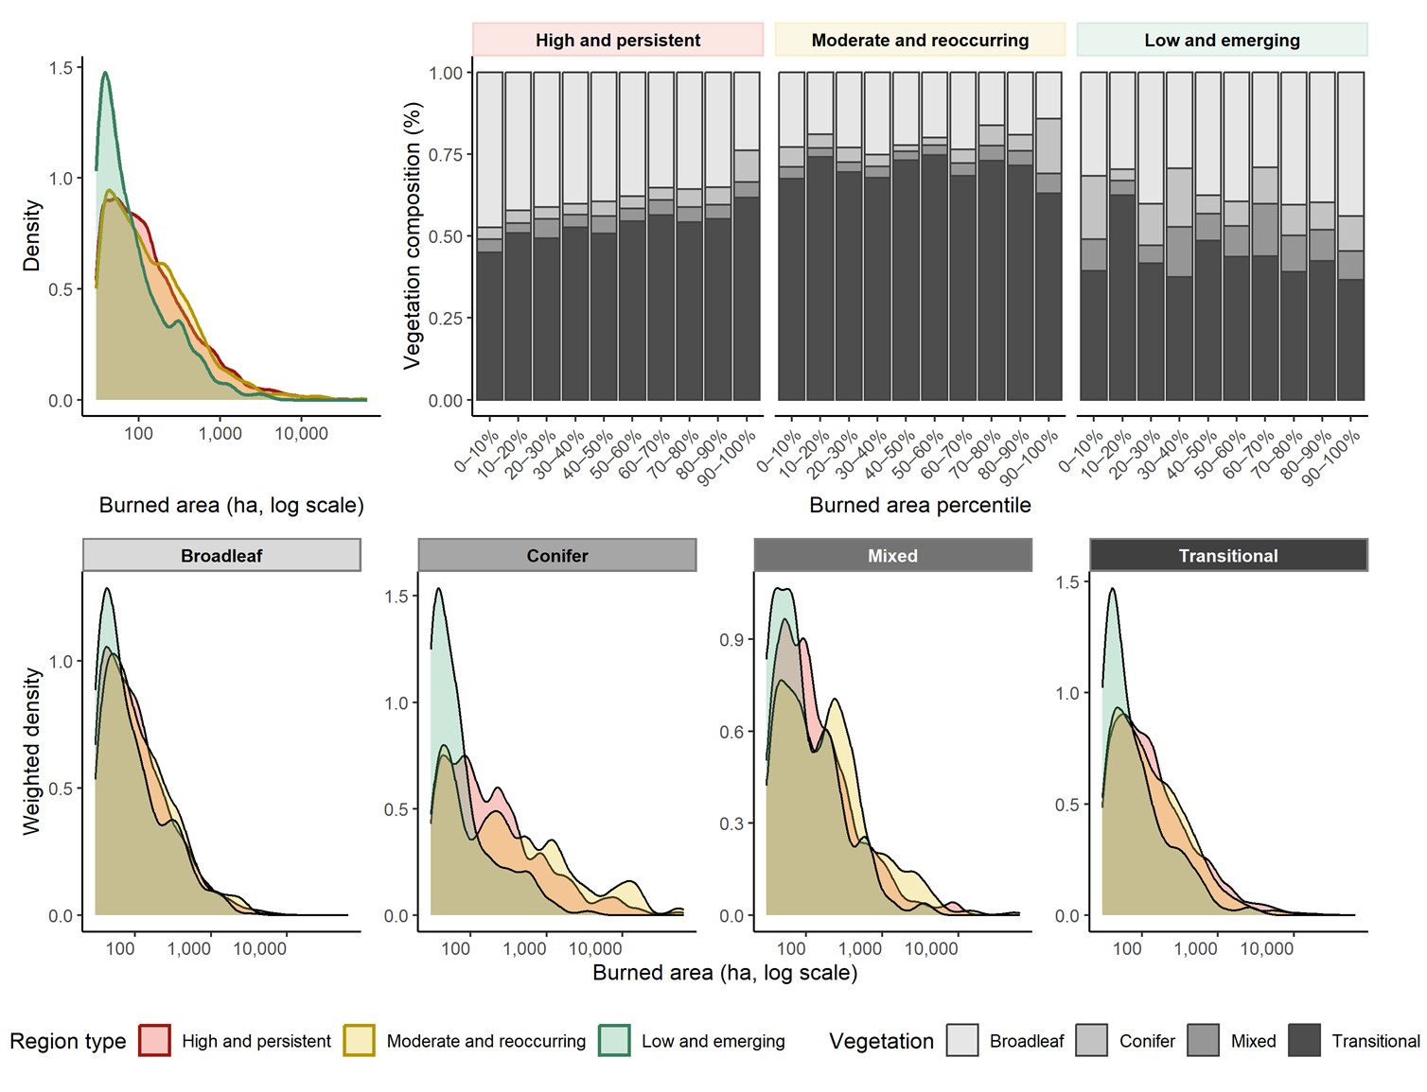
Figure S2. Burned area distributions and vegetation composition across region types. (a) Probability density of burned area (log scale) for high and persistent (red), moderate and reoccurring (yellow), and low and emerging (green) fire region types. (b) Vegetation composition of burned areas across burned area percentiles (0–10% to 90–100%) separated by region type, showing proportional contributions of broadleaf, conifer, mixed, and transitional forests. (c–f) Weighted density of burned area (log scale) for each vegetation type (broadleaf, conifer, mixed, transitional), stratified by region type. Overall, burned area distributions are right-skewed with large fires occurring across all region types, but the contribution of vegetation classes varies: transitional forests dominate across percentiles, while broadleaf and conifer contributions differ by region type and fire regime intensity.

Table S3. Summary of generalized linear mixed models of the temporal trends in fire occurrence with elevation classes as a random effect. AIC = Akaike’s Information Criterion.
Model |  | Fire occurrence
Formula |  | Fire occurrence ~ Year + (Year|Elevation class)
Estimate ± Standard error | Intercept | 2.64 ± 0.33
 | Slope | 0.84 ± 0.05
P-value | Intercept | 9.61 x 10⁻¹⁶
 | Slope | < 2 x 10⁻¹⁶
Number of observations |  | 161
Degrees of freedom |  | 156
AIC |  | 3,016.7
Marginal R-squared (R²m) |  | 0.45
Conditional R-squared (R²c) |  | 0.99

Table S4. Temporal trends of forest fire occurrence before and after 2015
 | before 2015 |  |  | after 2015
Elevation class (m) |  | Mean | SD | Slope | R²
800 – 1’000 | 27.67 |  | 23.59 | 26.36 | 0.514
1’000 – 1’200 | 22.93 |  | 23.56 | 24.75 | 0.495
1’200 – 1’400 | 15.53 |  | 16.55 | 16.04 | 0.458
1’400 – 1’600 | 12.23 |  | 11.49 | 9.38 | 0.458
1’600 – 1’800 | 7.27 |  | 7.31 | 4.92 | 0.591
1’800 – 2’000 | 5.21 |  | 7.52 | 1.98 | 0.085
2’000 – 2’200 | 2.28 |  | 2.56 | 1.05 | 0.067
> 2’200 | 3.33 |  | 1.15 | 1.12 | 0.189

