Supporting information file

Secondary nucleation of α-Synuclein drives Mitochondria dysfunctions and Lewy body formation in Parkinson’s Disease
Emily E. Prescott^{1,2}, Jiapeng Wei³, Emma F. Garland^{1,2}, Agnieszka Urbanek^{1,2}, Francesco Capriglia^{1,2}, Willem H. Molenkamp⁴, David P Rhodes^{1,2}, Louise Heywood^{1,2}, Aurelie Schwartzentruber^{1,2}, Elezabeth Stephen^{1,2}, Rachel Hughes^{1,2}, Oliver Bandmann^{1,2}, Mark O. Collins⁵, Sara Linse⁶, Axel Abelein⁴, Jan Johansson⁴, Michele Vendruscolo³, J Robin Highly^{1,2}, Tuomas P.J. Knowles^{3,7,*}, Heather Mortiboys^{1,2,*}, Suman De^{1,2,8*}

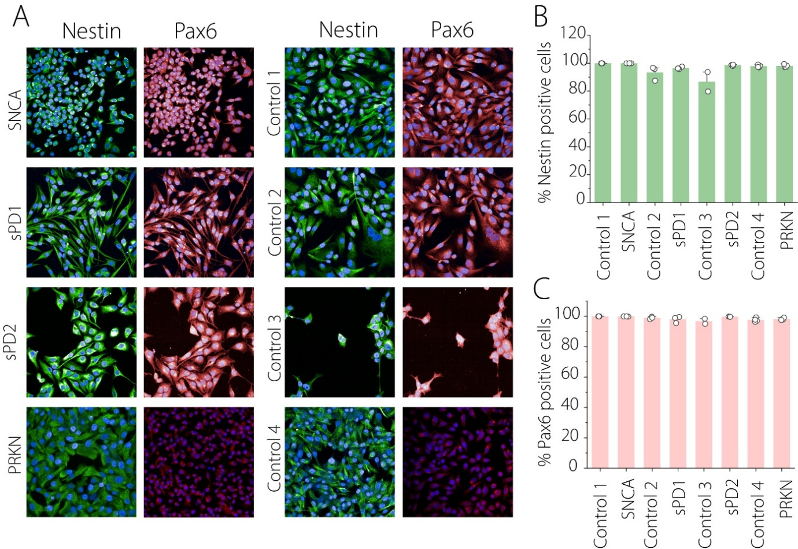
Figure S1. (A) Immunofluorescence staining of iNPCs for markers: Nestin and Pax6 in patient and NHC lines (B-C) Quantification of marker-positive cells as a percentage of total nuclei (Hoechst) with Nestin (B) and Pax6 (C)

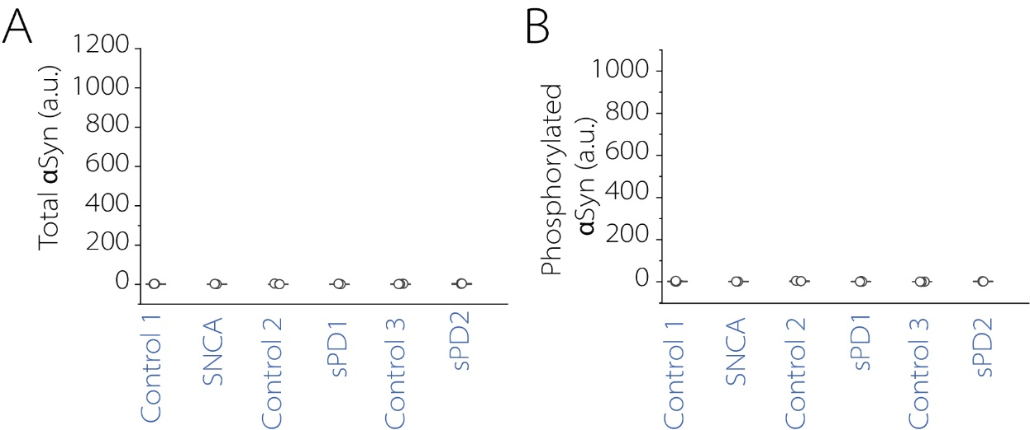

Figure S2. (A -B) Quantification of total αSyn(A), phosphorylated αSyn (pS129) (B), in fibroblast lysate across cell lines using an MSD assay.
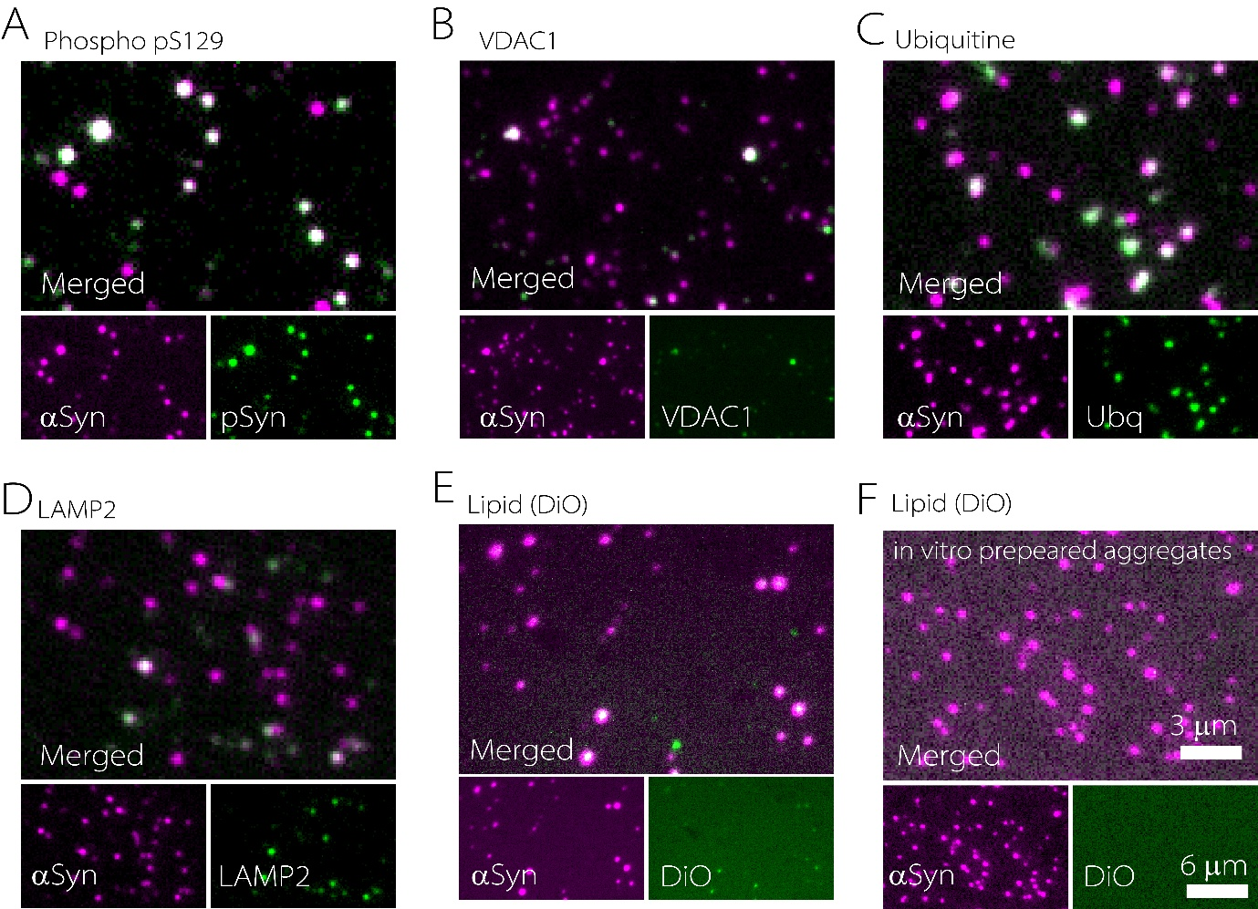
Figure S3. (A-E) Representative SiMPull images showing colocalization of αSyn aggregates with phosphorylated αSyn (pS129) (A), VDAC1 (B), Ubiquitin (C), LAMP2 (D), and Lipid (E) in iNL lysate. (F) Colocalization of recombinant αSyn aggregates with lipid marker DiO.

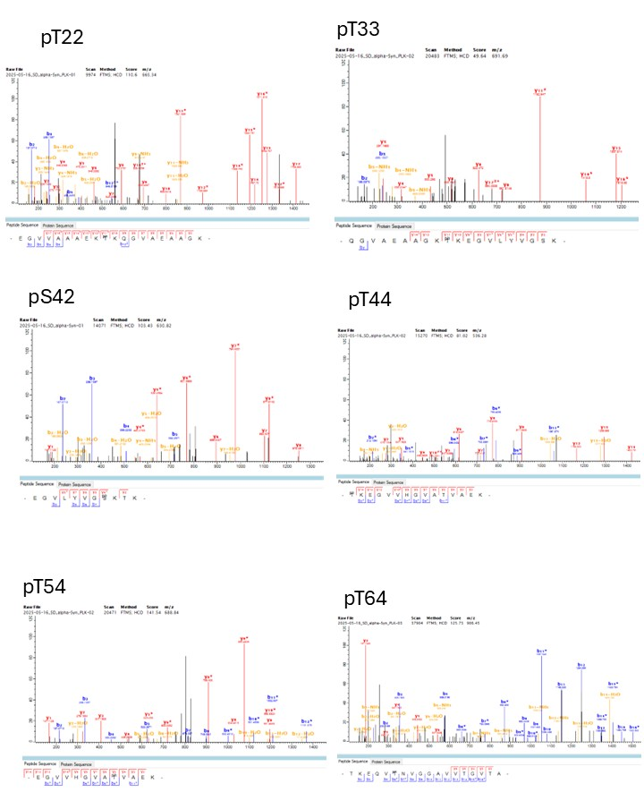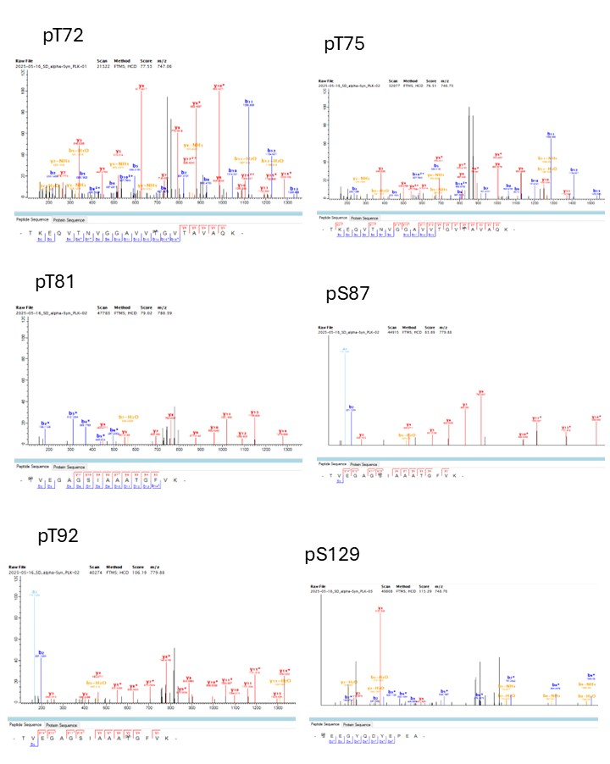
Figure S4. Identification of phosphorylation sites using mass spectrometry.

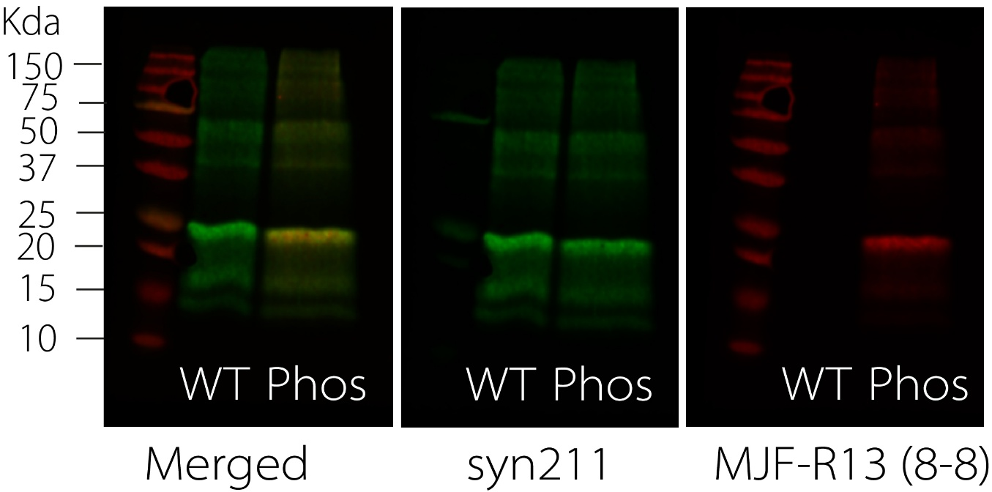
Figure S5 Western blot confirming phosphorylation of AF488 labelled recombinant αSyn. WT αSyn was detected using Syn211 antibodies, and phosphorylated αSyn was detected using the phospho-specific MJF-R13 (8-8) antibody.

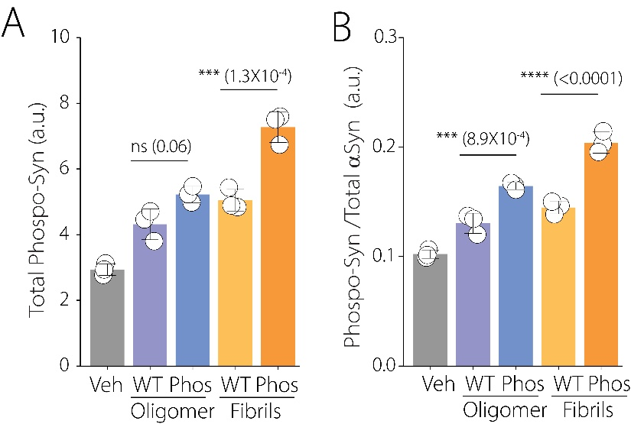

Figure S6 Quantification of phosphorylated αSyn(A), and the ratio of phosphorylated αSyn and total αSyn (B) in lysate across cell lines using an MSD assay following different seed treatment.

