Supplementary data:
Micro-architectural analysis of cortical bone using Micro-CT: Micro-CT analysis of the femoral mid-diaphyseal cortical bone revealed no significant alterations in total cross-sectional area (Tt. Ar), cortical bone area (Ct. Ar), cortical thickness (Cortical.Th), or bone mineral density (BMD) across the different treatment groups. These results suggest that VCD-induced ovarian failure, as well as subsequent treatment with abaloparatide, zoledronate, or their combination, did not significantly affect cortical bone microarchitecture at the femoral midshaft in this model. (figure 1 and figure 2)
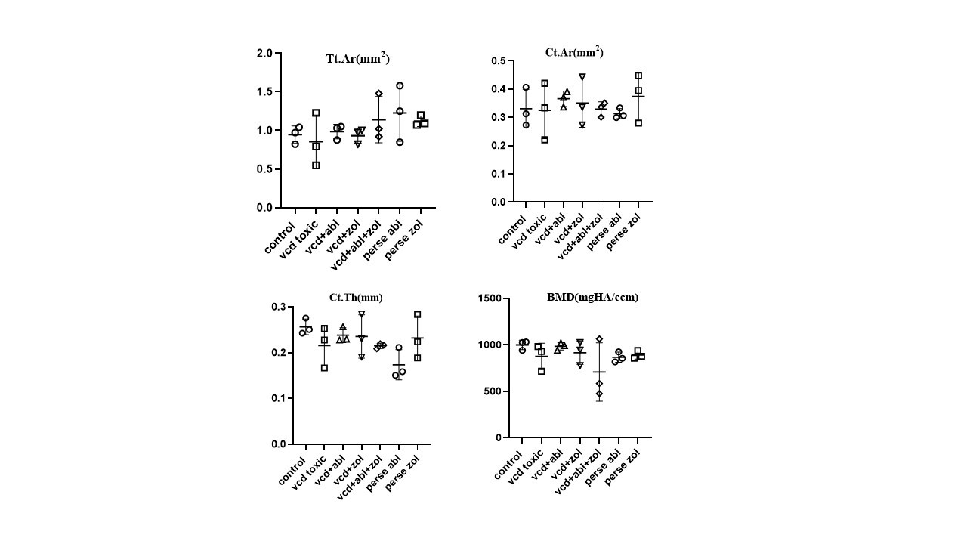
Figure S1: Effect of abaloparatide, zoledronate, and their combination on the VCD-induced alterations in femur cortical bone using microcomputed tomography analysis. Total cross-sectional tissue area (Tt. Ar), Cortical Bone area (Ct. Ar), Cortical Thickness (Cortical.Th), and bone mineral density (BMD mgHA/ccm) were measured in the mid-diaphyseal cortical region. One-way ANOVA and Tukey’s multiple comparison test were used for analysis, and values are expressed as mean±SD (n=8). The significance is determined as p>0.05 vs Control, p>0.05 vs VCD.

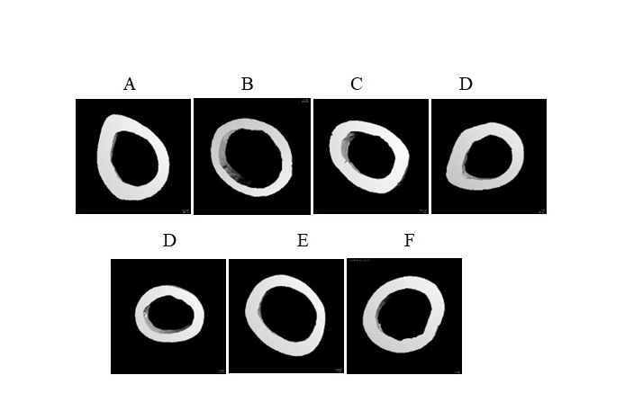

Figure S2: The three-dimensional images of the mid-diaphysis cortical region of the femur bone are shown in the figure. (A) control (B) vcd (C) vcd+abl (D) vcd+zol (E) vcd+abl+zol (F) abl per se (G) zol per se

