Supplementary Material

Sediment Properties

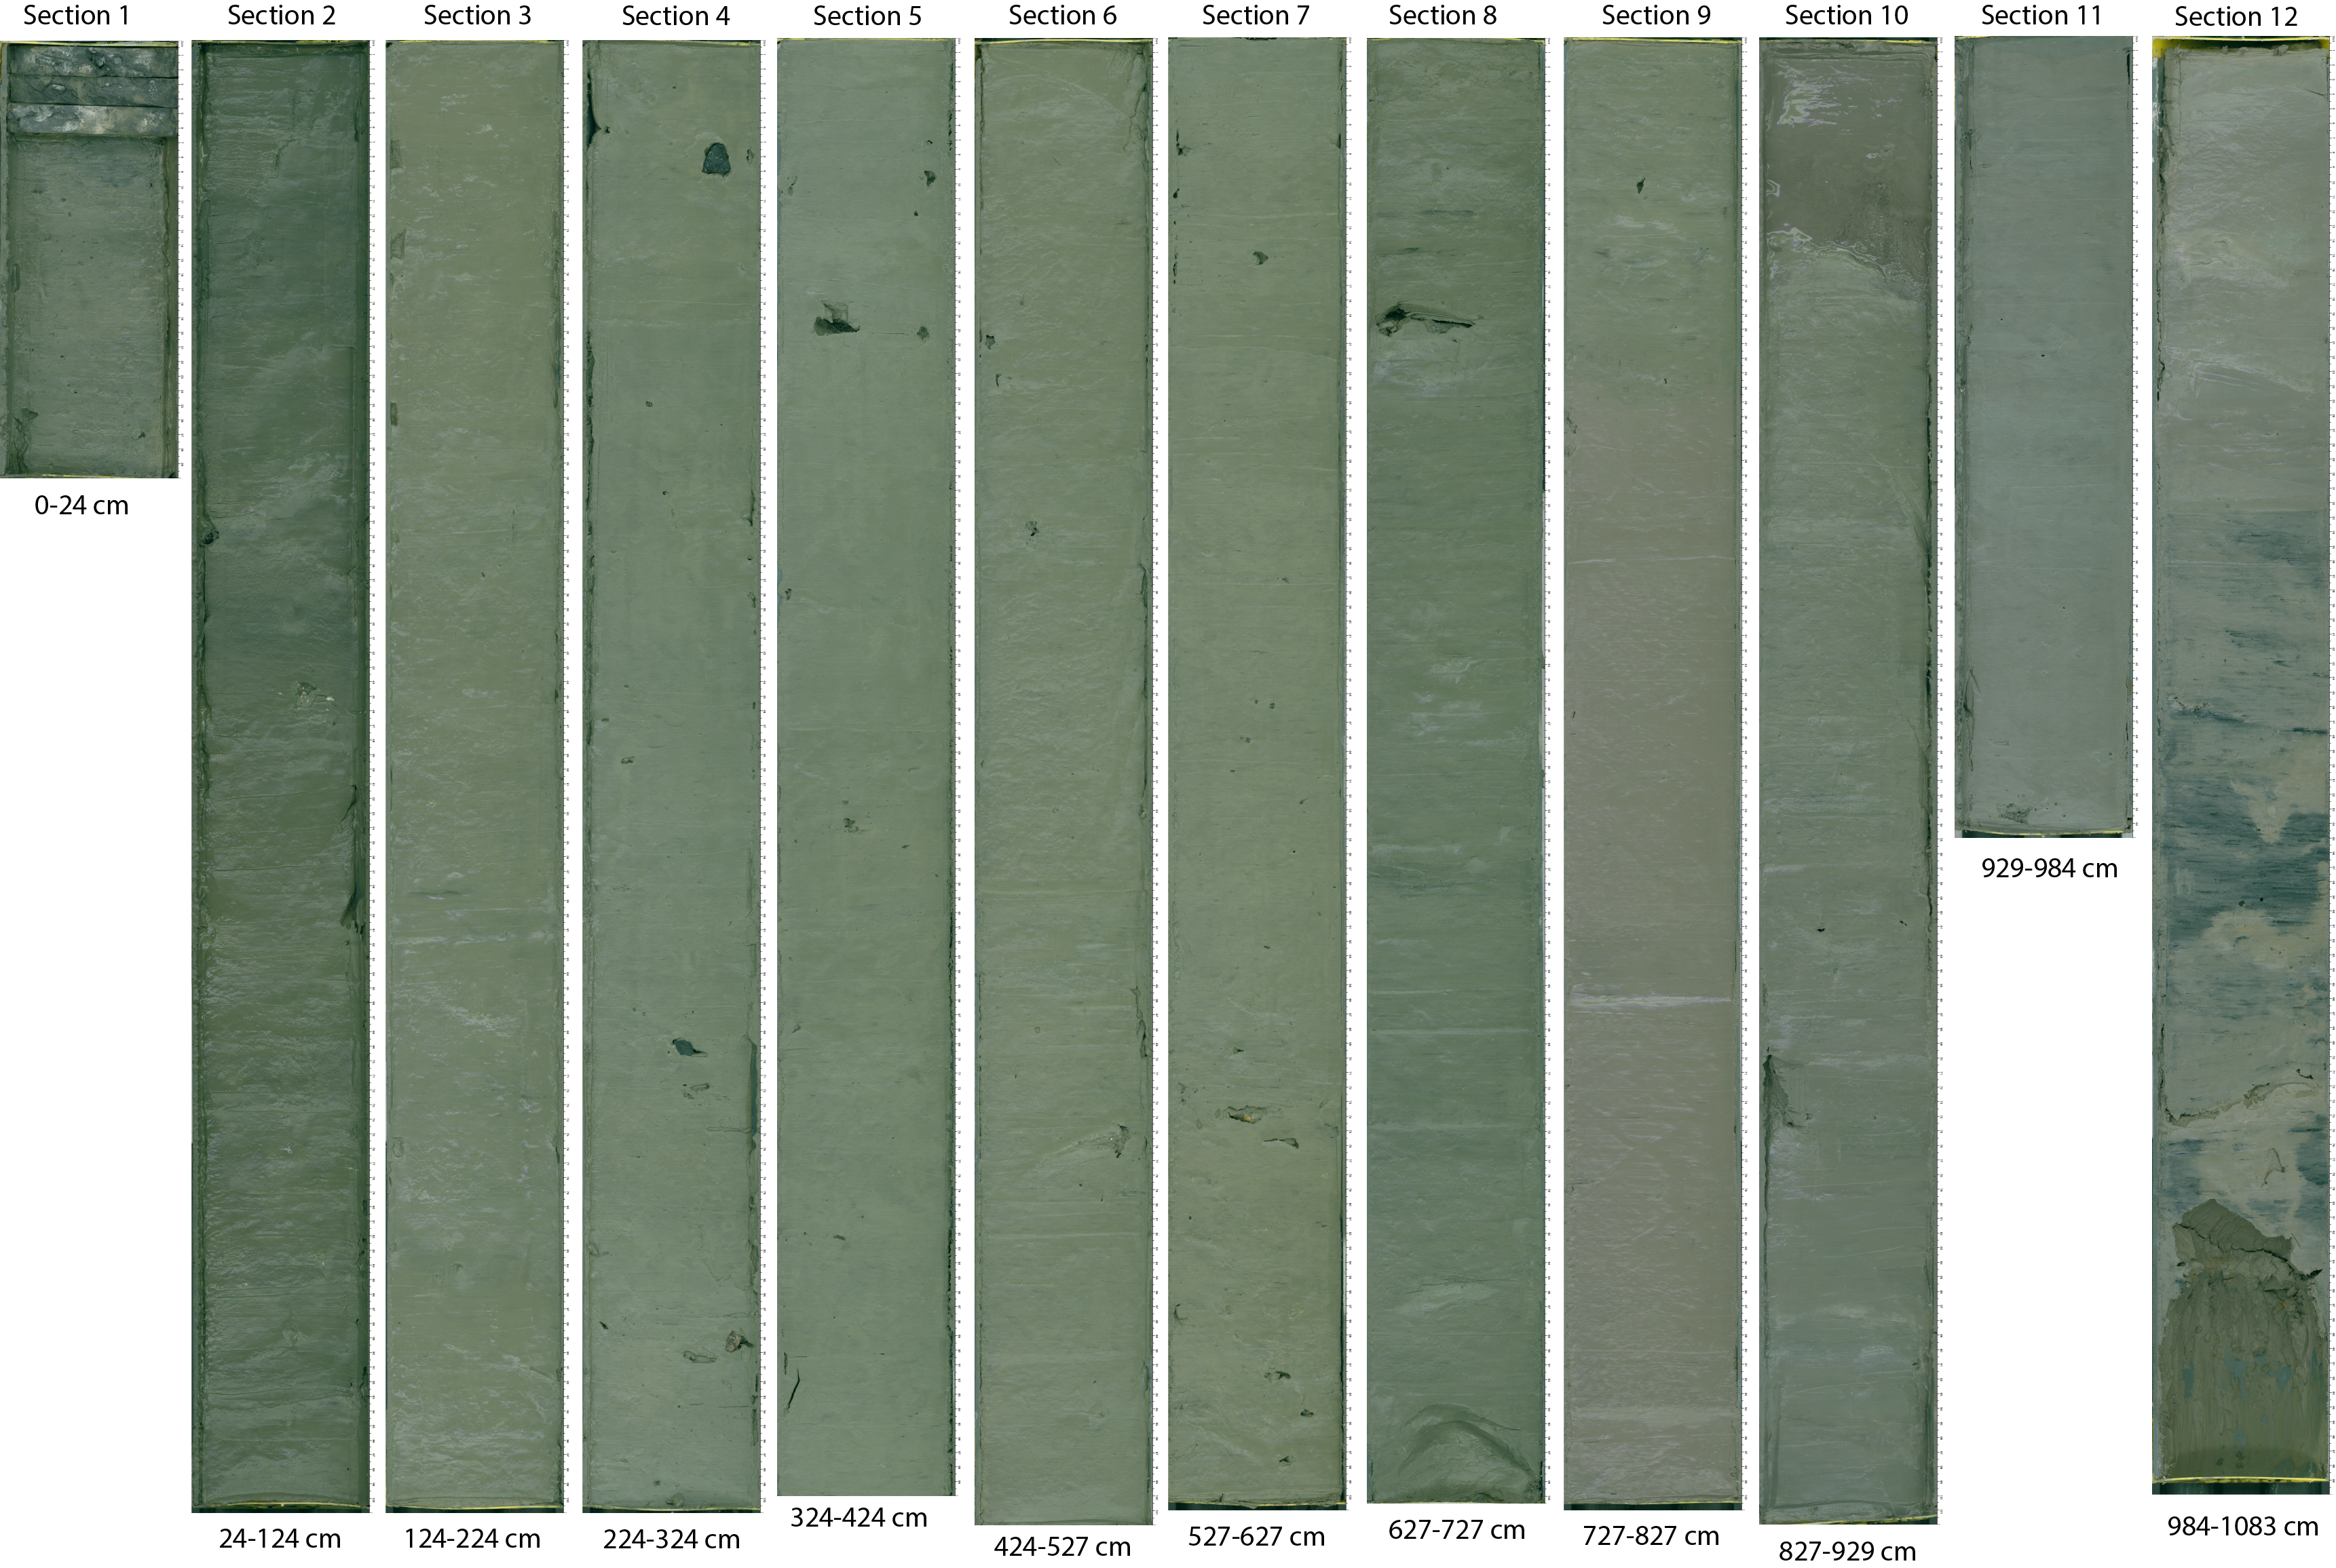
Figure S1: Sediment core GeoB25206-2 color images. The visual inspection of the gravity core GeoB25206-2 shows that the majority of the core, from top to about 750 cm, consists of compact olive-grey fine-grained mud. From 750 cm GeoB25206-2 shows a transitional colour change from olive-grey to pinkish grey. This interval is intercepted at 827 cm by a about 13 cm thick water rich olive-grey sand layer which is cut off at about 840 cm by a layer of olive-grey fine-grained mud with a downcore colour change to pale red. The grey sediment with a reddish hue is present until the end of the core and large dark-grey patches appear from 1017 cm downcore. Visual core description and high-resolution sediment core line scanner images of the sediment core GeoB25206-2 are available on PANGEA:
https://www.pangaea.de/tok/e1a54ed3fe826d6a02f8f5121ab279f809d25dd6

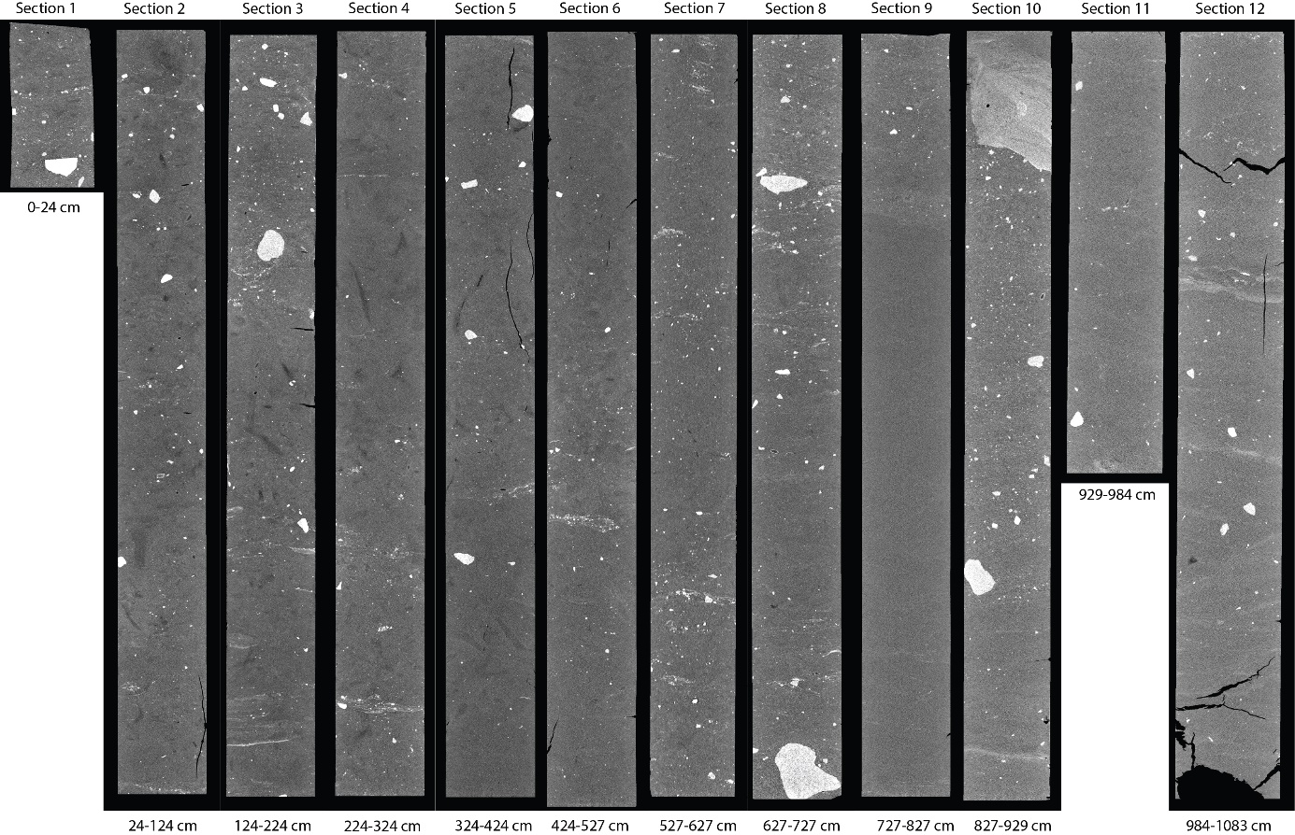
a)
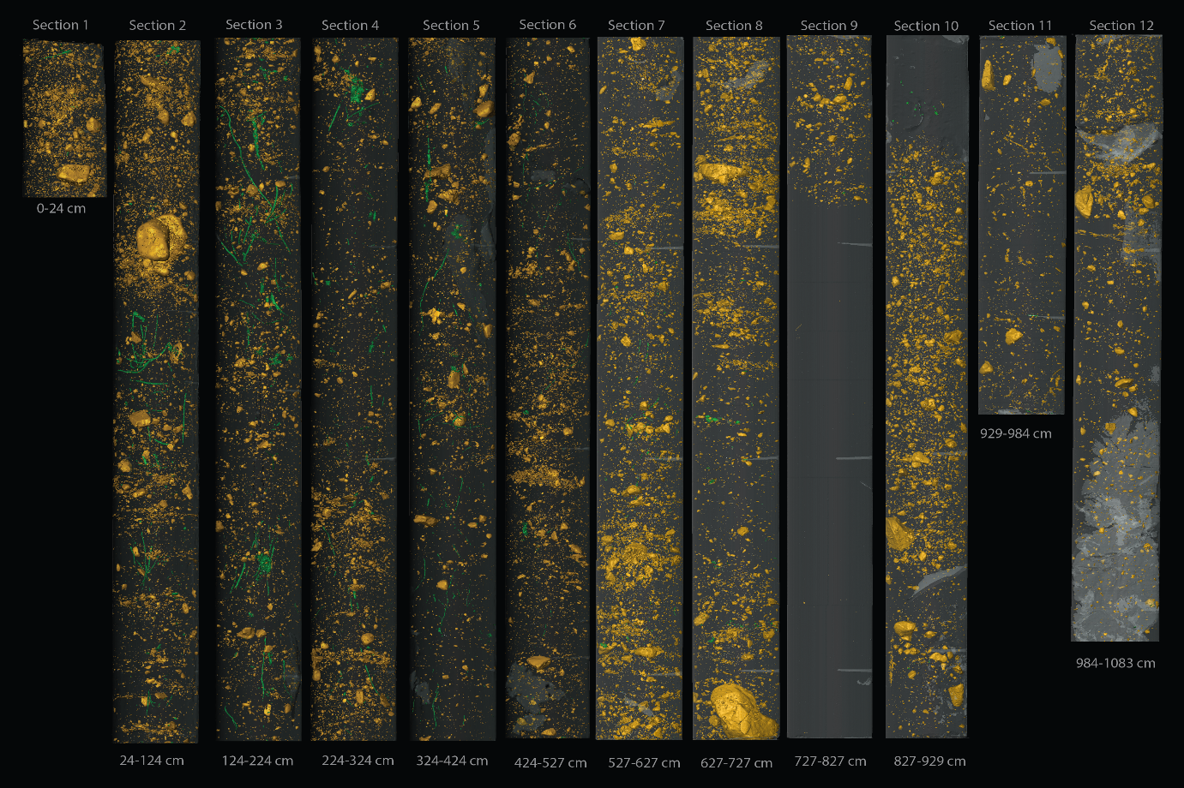
b)
Figure S2: Sediment core GeoB25206-2 CT scan grey scale images (a) and 3D reconstructions of IRD grains (yellow) and bioturbation (green) (b). CT raw data (DICOM format) of sediment core GeoB25206-2 are available on PANGEA: https://www.pangaea.de/tok/5b8016e0cb58841c1a4c04bb3e4315c099e41f79
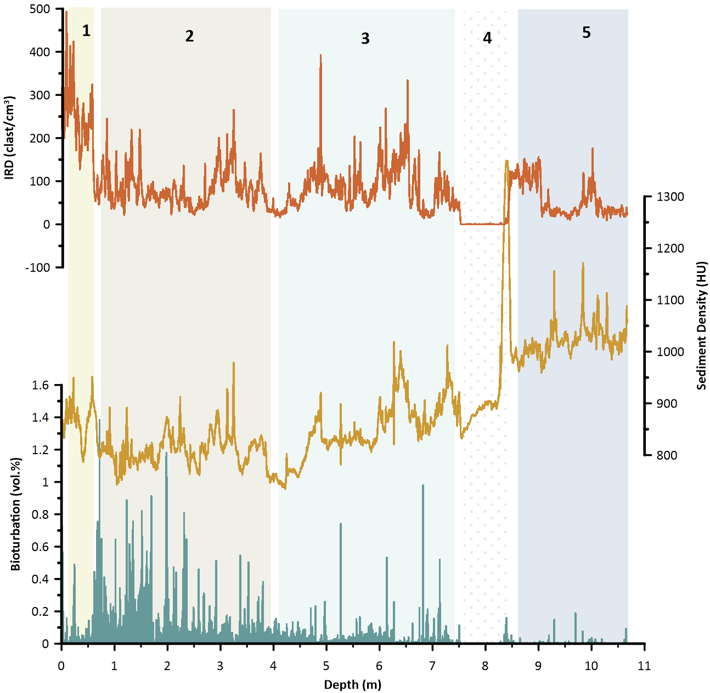
Figure S3: In comparison to the superficial visual core description, CT scanning reveals detailed information about the sediment core's internal structure, helping to determine the genesis of the sediment record. The GeoB25206-2 CT scan record shows a larger number of IRD grains, a minor disturbance due to bioturbation and a detailed estimation of sediment density. Throughout the core, the amount of IRDs range between 0-493 clasts/cm³ with an average of 80 clasts/cm³. Highest IRD numbers (126-493 clasts/cm³) and low bioturbation occur at the top of the core, between 0-60 cm. At about 60 cm, the number of IRD grains drops sharply and the bioturbation intensity increases. Bioturbation stays high until about 250 cm and decreases down to <0.2 vol% at about 400 cm. Besides slightly higher values around 320 cm, IRD numbers are relatively low between 60-400 cm. From 400 cm IRDs show an increasing trend until about 650 cm from where the number of IRD grains decrease again until about 750 cm. The sediment layer between 750 cm and 840 cm shows no bioturbation and no IRDs. Bioturbation stays very low until the end of the core while the IRD record shows two layers (between 840-910 cm and 980-1010 cm) with more than 100 IRD clasts/cm³.
Sediment density varies in accordance with the IRD record until about 650 cm. From 650-827 cm sediment density increases and stays relatively high until the end of the core. A pronounced density peak is found at about 835 cm at the position of a water rich sand layer (see Fig. S2).
Chronology

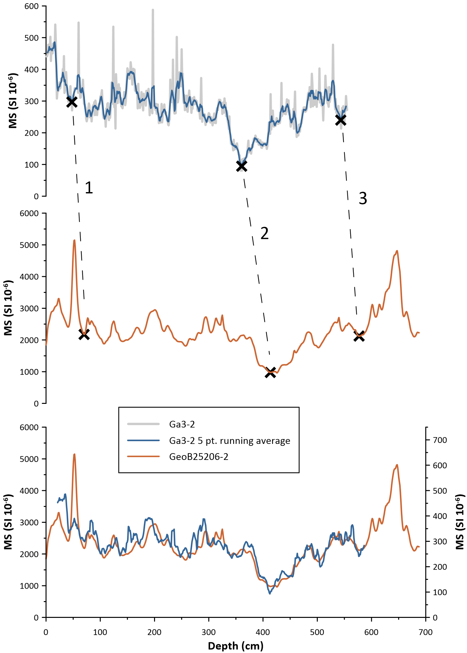
Figure S4: Magnetic susceptibility (MS) record of the of Ga3-2 (Nørgaard-Pedersen and Mikkelsen, 2009) with a 5pt. running average overlay compared to MS record (first 700 cm) of the GeoB25206-2. Based on the Ga3-2 age model sedimentation rate is almost linear below ~600 cm. Therefore, only three anchor points (marked by black crosses) were used to achieve alignment. Both depicted MS record refer to the sediment sequence and therefore largely coincide in relative terms. The deviant scaling of MS logs is therefore believed to have technical and not sedimentological reasons. Magnetic susceptibility data of sediment core GeoB25206-2 are available on PANGEA: https://doi.org/10.1594/PANGAEA.983992

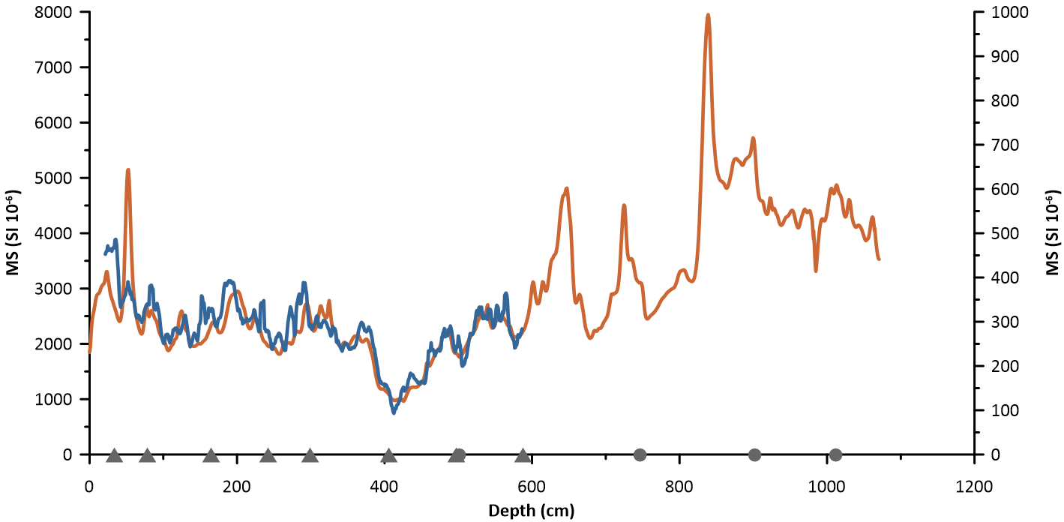
Figure S5: Depth alignment of the Ga3-2 magnetic susceptibility record (5 pt. running average) (Nørgaard-Pedersen and Mikkelsen, 2009) and the entire GeoB25206-2 record. Depth of the AMS radiocarbon dates used for the GeoB25206-2 age-depth model (Table S1, Figure S6) are denoted by grey triangles (Ga3-2) and grey dots (GeoB25206-2).

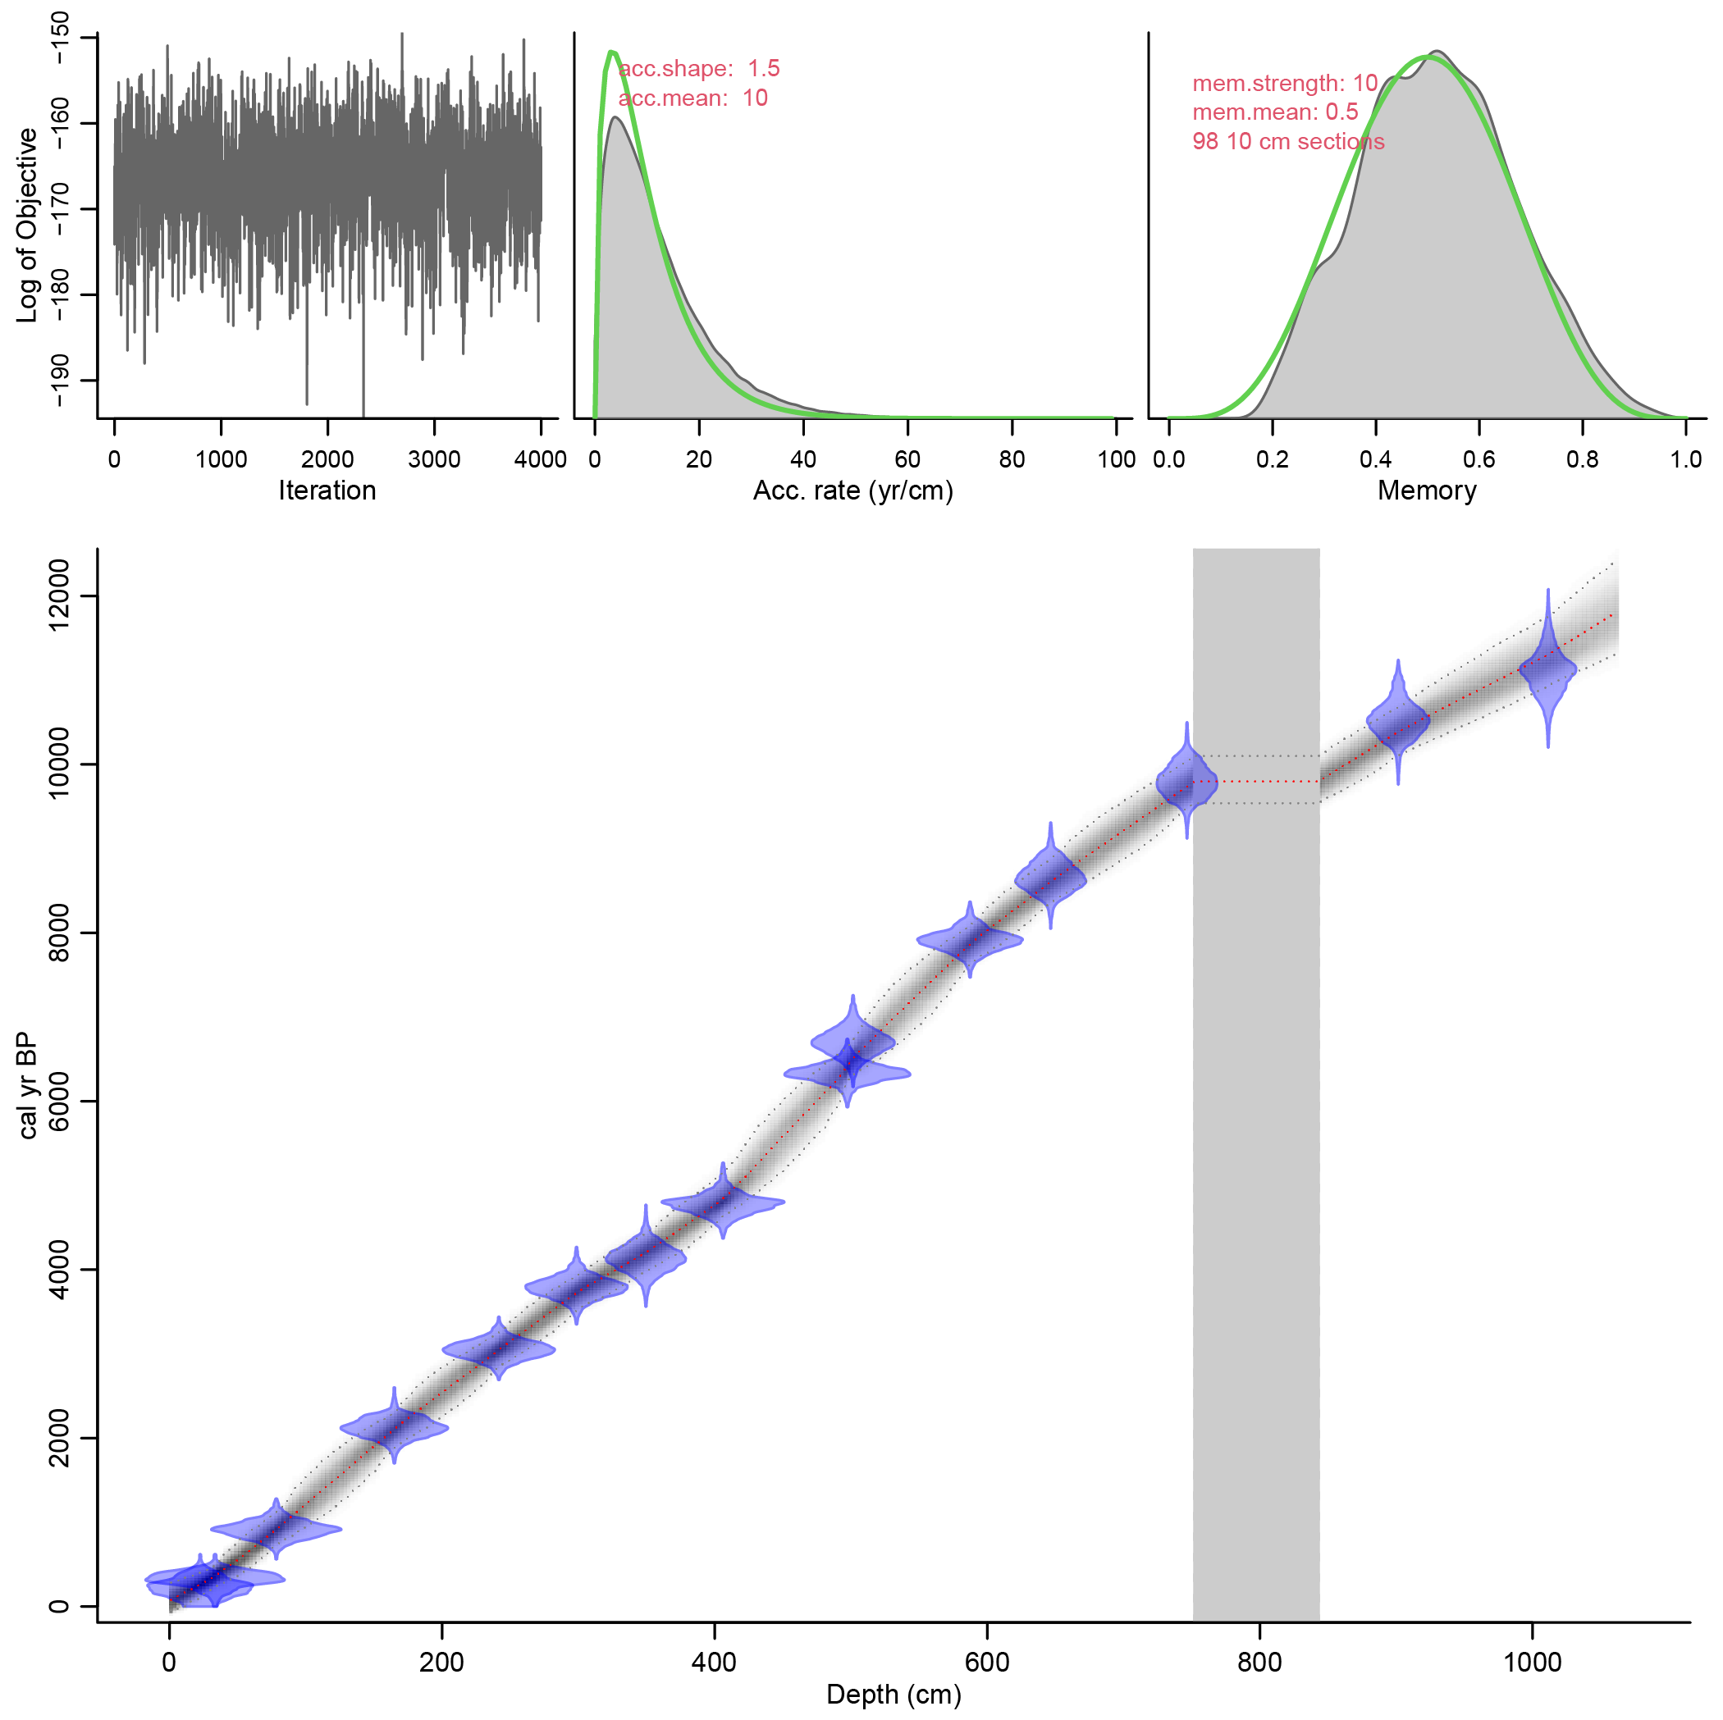
Figure S6: The age-depth model of GeoB25206-2, Bacon output (Blaauw, 2010). AMS Radiocarbon ages were calibrated using the MARINE20 curve with reservoir correction of -74 ±24 years (Pearce et al., 2023). The upper panels depict the Markov Chain Monte Carlo (MCMC) iterations (left; good runs show a stationary distribution with little structure among neighboring iterations), the prior (green curves) and posterior (grey histograms) distributions for the accumulation rate (middle panel) and memory (right panel). The bottom panel shows the calibrated ¹⁴C dates (transparent blue) and the age-depth model (darker greys indicate more likely calendar ages; grey stippled lines show 95% confidence intervals; the red curve shows a single 'best' model based on the mean age for each depth).
The age-depth model indicates that the base of the sediment core GeoB25206-2 extends back to almost 12 ka cal. BP. Moreover, sedimentation rate is relatively constant, about 90 cm/ka, until ~4.9 ka (416 cm). From this point, sedimentation rate decreases slightly to an average of about 69 cm/ka until 9.7 ka (752 cm). The sediment unit from 752-843 cm (vertical grey shadow), which shows no bioturbation, no IRDs and which is partly sandy, water rich and shows high density values (Figs. S2-S4) is interpreted as a turbiditic event. Therefore, this depth interval is assumed to be deposited in less than a year. With an average of 107 cm/ka, highest sedimentation occurs below the mass-wasting deposit (>9715 cal yr BP) until the end of the core.

Numerical Modelling

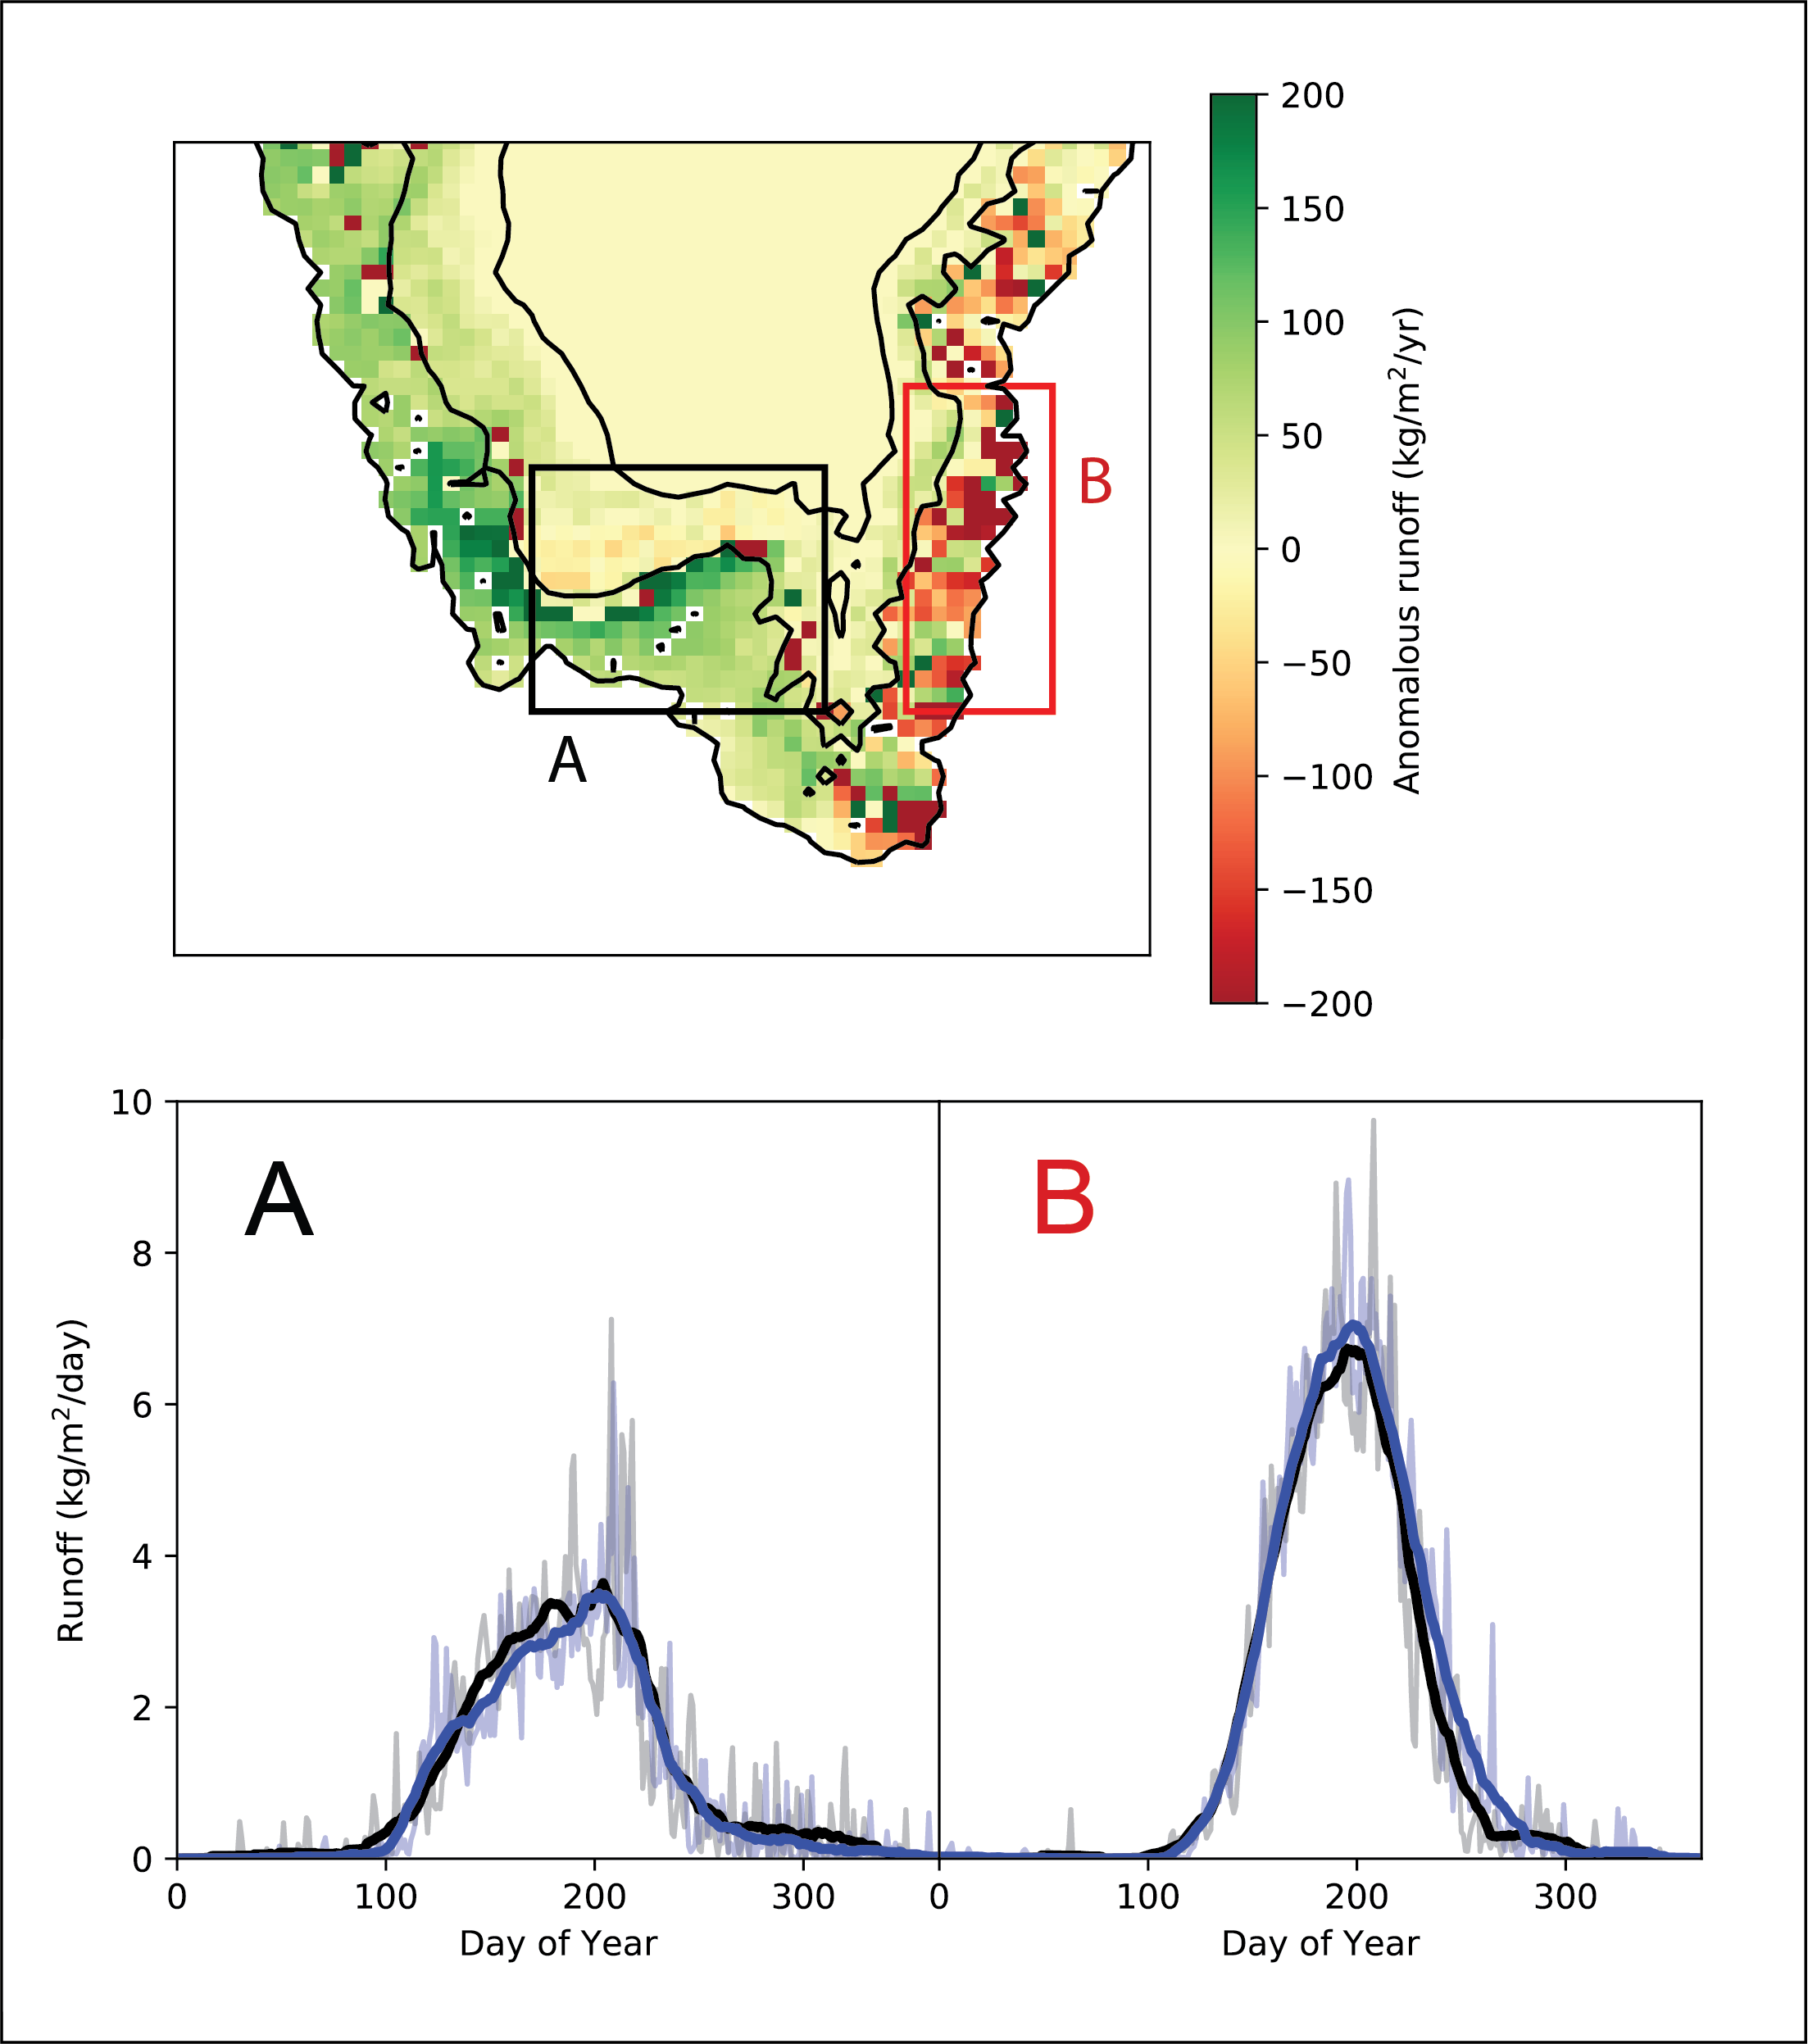
Figure S7: Upper figure: South Greenland regional anomalous runoff 'NAO+ minus NAO-' as calculated by BESSI (Born et al., 2019; Zolles and Born, 2021).Lower figure: Average runoff from region A and B (upper figure), for NAO+ (black) and NAO- (blue).

References
Blaauw, M., 2010, Methods and code for 'classical' age-modelling of radiocarbon sequences: Quaternary Geochronology, v. 5, no. 5, p. 512-518.
Born, A., Imhof, M. A., and Stocker, T. F., 2019, An efficient surface energy–mass balance model for snow and ice: The Cryosphere, v. 13, no. 5, p. 1529-1546.
Nørgaard-Pedersen, N., and Mikkelsen, N., 2009, 8000 year marine record of climate variability and fjord dynamics from Southern Greenland: Marine Geology, v. 264, no. 3-4, p. 177-189.
Pearce, C., Özdemir, K. S., Forchhammer Mathiasen, R., Detlef, H., and Olsen, J., 2023, The marine reservoir age of Greenland coastal waters: Geochronology, v. 5, no. 2, p. 451-465.
Zolles, T., and Born, A., 2021, Sensitivity of the Greenland surface mass and energy balance to uncertainties in key model parameters: The Cryosphere, v. 15, no. 6, p. 2917-2938.

