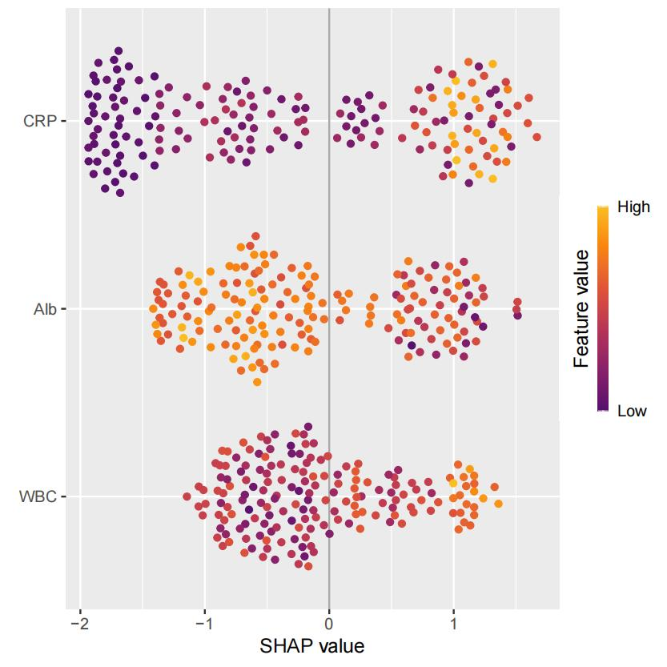
Figure. SHAP Summary Plot of the Training Set.

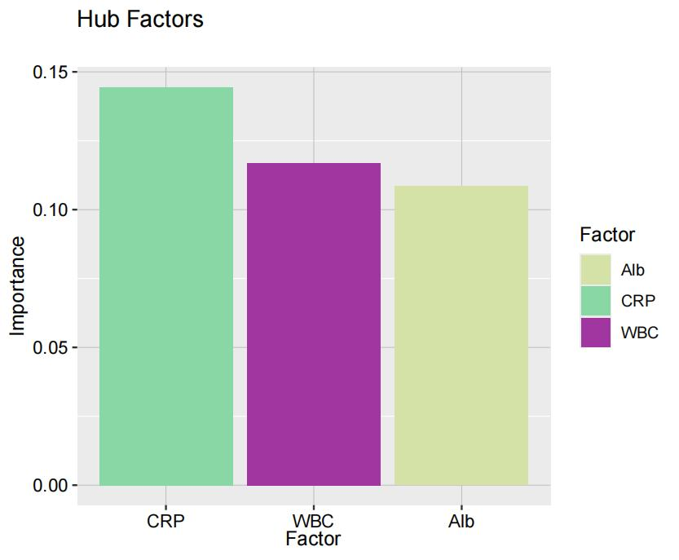
Figure. Feature Importance Ranking of the SVM Model.

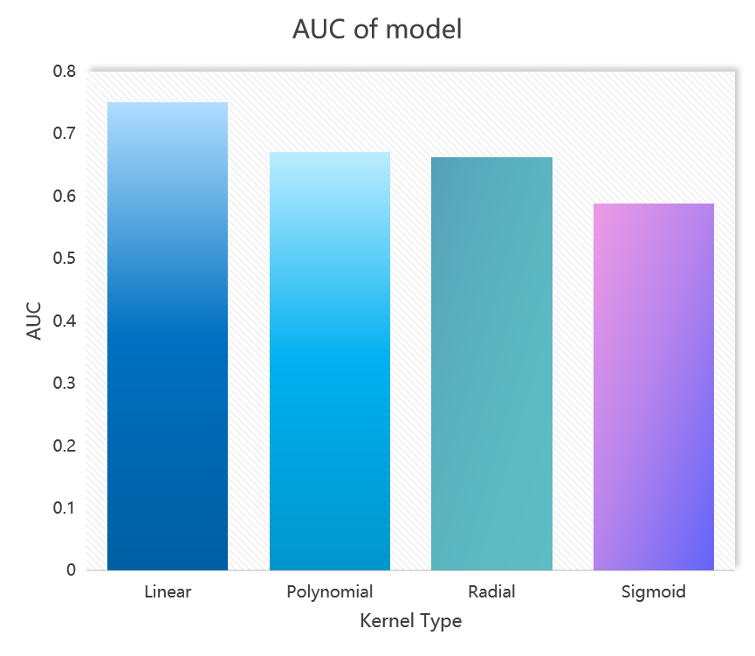
Figure. AUCs of Four SVM Kernel Functions.

