Engineering surgical stitches to prevent bacterial infection

Daniela Vieira, Samuel N. Angel, Yazan Honjol, Maude Masse, Samantha Gruenheid, Edward J. Harvey, Geraldine Merle

Supplementary data

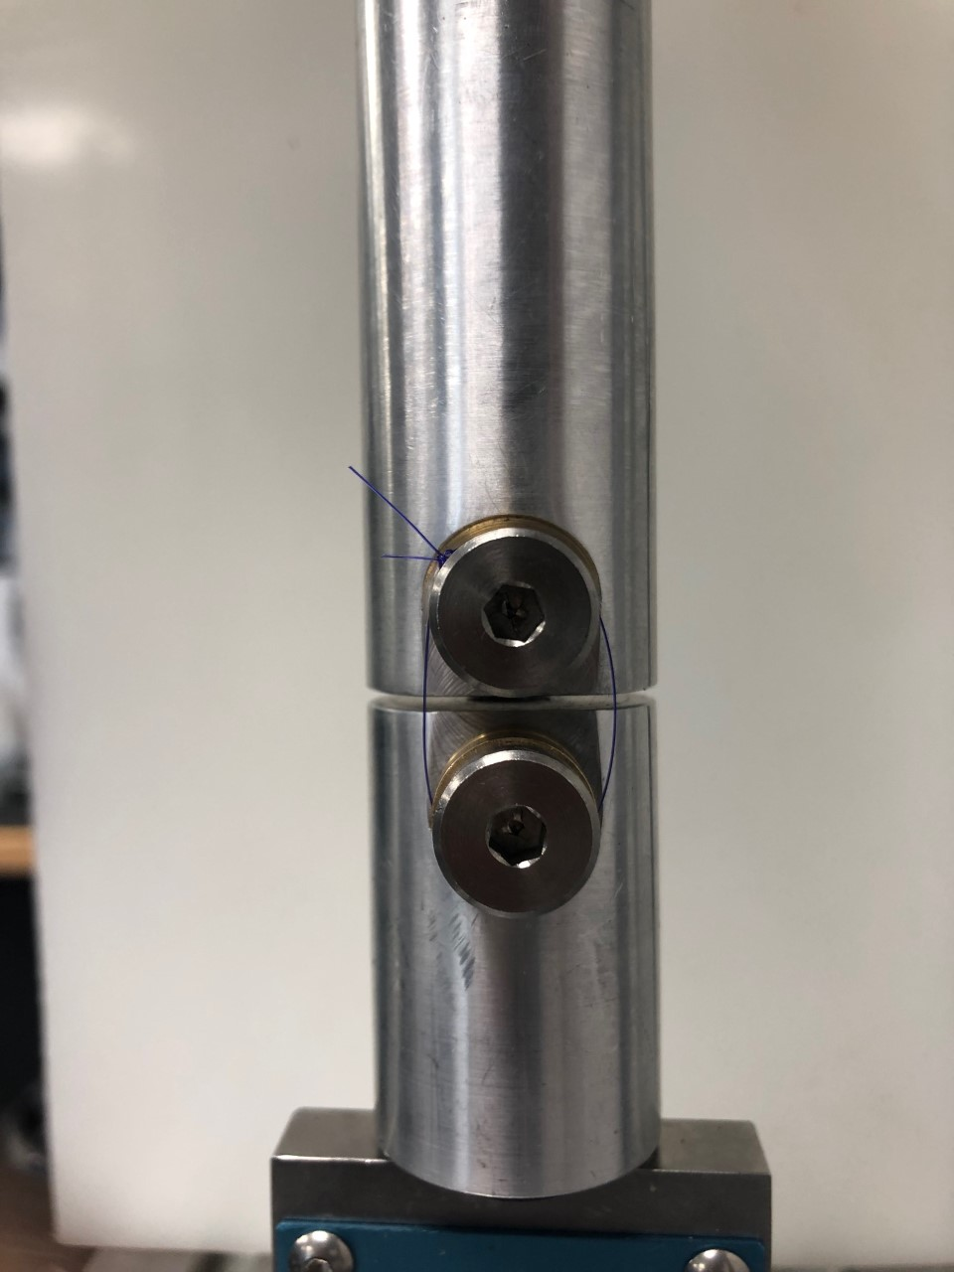
Figure S1 - The loop model applied in the mechanical tensile test. Suture loop (70 mm diameter) was held in the support and a separation rate of 0.7 mm/sec was applied.

Table S1 – Uncoated and coated sutures diameters
Suture coating | Diameter (µm) | Standard deviation
Control (PDS II)^{(a)} | 224.15 | 0.81
TiO^{(a)} | 236.88 | 1.77
ZnO^{(a)} | 227.89 | 0.43
CuO^{(a)} | 241.17 | 1.59
Cu^{(a)} | 243.34 | 1.16
Fe2O3^{(a)} | 233.40 | 0.84
MgO^{(a)} | 231.88 | 0.54
^{(a)}ANOVA test p<0.05 – significant difference

Table S2 - Stress and strain values for suture conditions. All values represent stress and strain exerted on the suture at the moment of fracture indicating the maximum stress and strain.
Suture | Strain (%) | Stress (GPa)
PDS II | 12.7 ± 1.73 | 1.61 ± 0.07
Silk | 11.34 ± 2.65 | 1.44 ± 0.54
TiO | 7.52 ± 0.57 | 1.72 ± 0.38
ZnO | ^{(a)}5.31 ± 1.84 | 1.71 ± 0.06
CuO | 10.25 ± 2.26 | 1.86 ± 0.07
Cu | ^{(a)}5.49 ± 1.28 | 1.78 ± 0.12
Fe2O3 | 13.11 ± 1.24 | 2.02 ± 0.08
MgO | ^{(a)}6.55 ± 1.14 | 2.06 ± 0.09
^{(a)}ANOVA test p<0.05 – significant difference, n=5

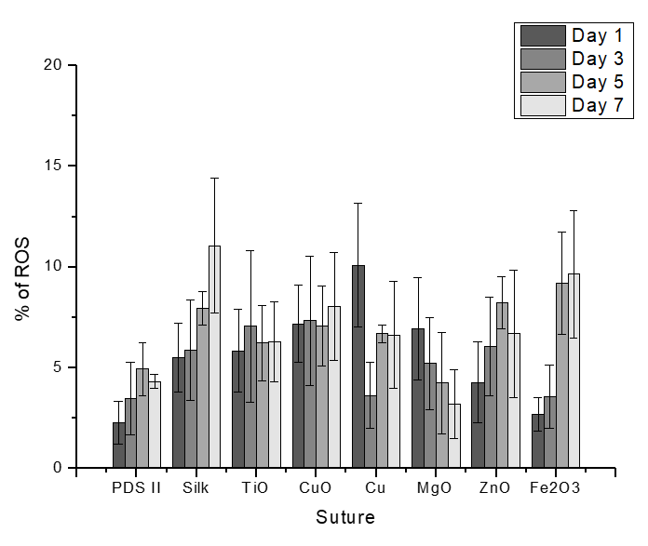
Figure S2. ROS production represented by % of ROS in the aqueous suture testing environment at each timepoint (1, 3, 5, 7 days) (n= 3). ANOVA and Tukey tests were performed with the weight differences in coated sutures against weight differences in the uncoated PDS II samples.

