Bone-strengthening activity of pinocembrin and the exploration of the mechanism by proteomics analysis
Ayaka Tsuchiya ¹, Maki Suzuki ², Reiko Murakami ⁴, Kazuki Nakajima ⁴, Tohru Mitsunaga ¹, Kosei Yamauchi ^{1,2,3,5 *}
¹ The United Graduate School of Agricultural Science, Gifu University, 1-1 Yanagido, Gifu-shi, Gifu, 501-1193, Japan
² Graduate School of Natural Science and Technology, Gifu University, 1-1 Yanagido, Gifu-shi, Gifu, 501-1193, Japan
³ Center for One Medicine Innovative Translational Research (COMIT), Institute for Advanced Study, Gifu University, Gifu, Japan
⁴ Institute for Glyco-core Research (iGCORE), Gifu University, Gifu, Gifu 501-1193, Japan
⁵ Faculty of Applied Biological Sciences, Gifu University, 1-1 Yanagido, Gifu-shi, Gifu, 501-1193, Japan
Corresponding author
* Corresponding author: Kosei Yamauchi Kosei Yamauchi : yamauchi.kosei.p2@f.gifu-u.ac.jp

Contents
Scheme 1. Synthesis scheme of pinocembrin. 3
Scheme 2. Ethylamination of pinocembrin using correlation transfer catalysis. 3
Table S1. ¹H-NMR data of 7-O-ethylamino pinocembrin (Pino-EA) and 7-O-Boc-ethylamino pinocembrin (Pino-EA-Boc). 4
Fig. S1. ¹H-NMR of 7-O-Boc-ethylamino pinocembrin (in ClCD₃, 600 MHz) 5
Fig. S2 ¹H-NMR of 7-O-ethylamino pinocembrin（in MeOD, 600 MHz） 5
Fig. S3. Results of preliminary breeding test. 6
Fig. S4. Representative vertical cut images of femur bone. 6
Table S2. Detected proteins as target protein of (±)-pinocembrin using CETSA 7
Table S3. Proteins combined with pinocembrin beads by pull down assay. 8
Fig. S5. Result of actin polymerization assay. 10

Scheme 1. Synthesis scheme of pinocembrin. (a) 2,4,6-trihydroxy acetophenone (5.95 mmol), MOM-Cl (894 µl), dichloromethane (15 ml), DIPEA (2.38 ml), 0℃ rise to room temperature. (b) benzealdehyde (6.28 mmol), EtOH/H₂O (26 ml, 4:1 v/v), KOH (25 mmol), 0℃ rise to room temperature. (c) methanol (10 ml), 6N HCl-MeOH (4.4 ml), reflux. (d) MeOH (100 ml), excess sodium acetate anhydrate, reflux.

Scheme 2. Ethylamination of pinocembrin using correlation transfer catalysis.

Table S1. ¹H-NMR data of 7-O-ethylamino pinocembrin (Pino-EA) and 7-O-Boc-ethylamino pinocembrin (Pino-EA-Boc).

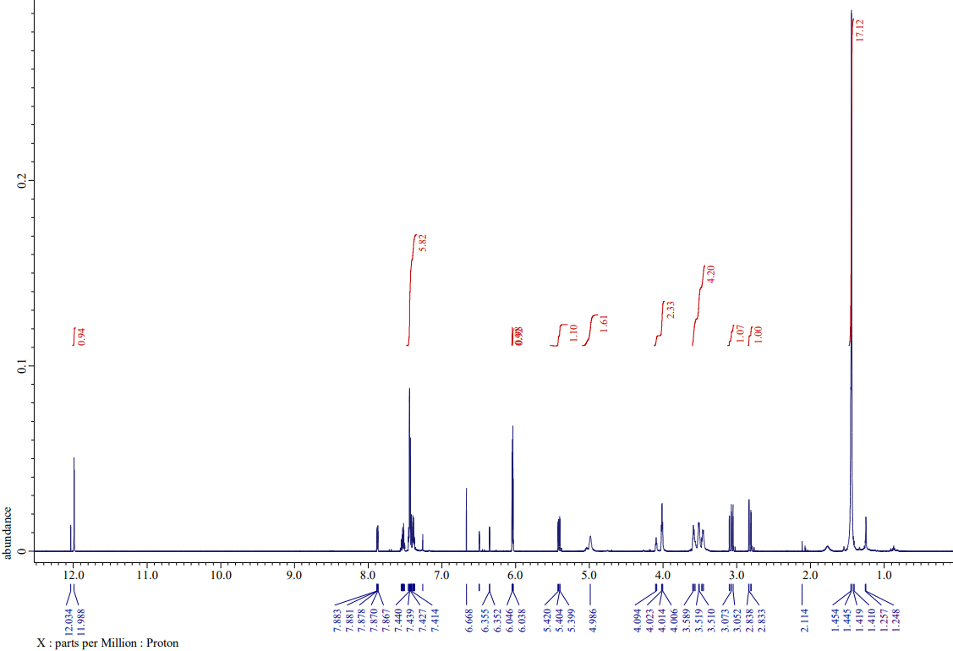

Fig. S1. ¹H-NMR of 7-O-Boc-ethylamino pinocembrin (in ClCD₃, 600 MHz)
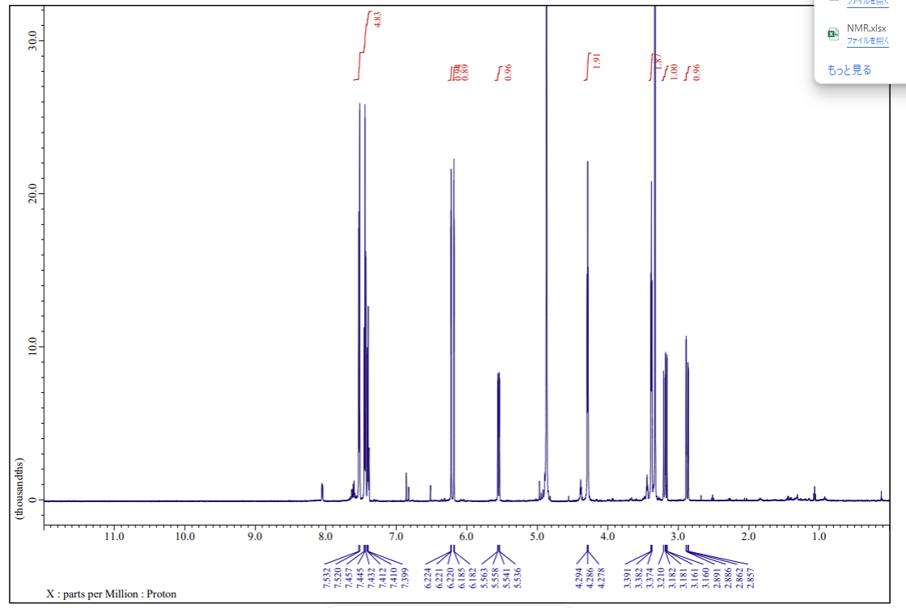

Fig. S2 ¹H-NMR of 7-O-ethylamino pinocembrin（in MeOD, 600 MHz）

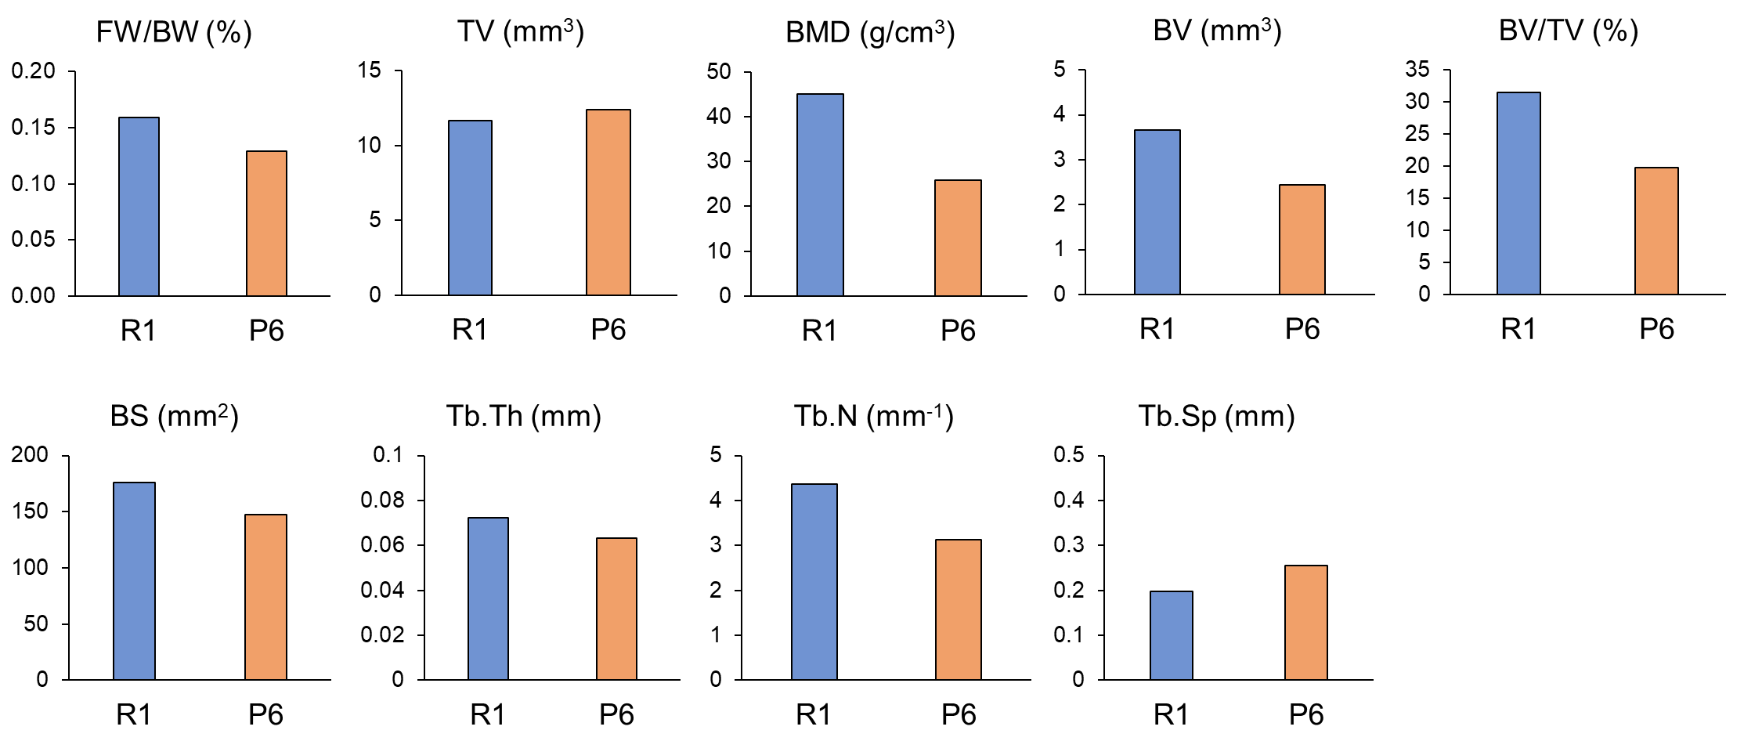
Fig. S3. Results of preliminary breeding test. Blue bar: 3-month-old SAMR1 mouse, Orange bar: 3-month-old SAMP6 mouse. FW/BW: Femur Weight/Body Weight, TV: Tissue Volume, BMD: Bone Mineral Density, BV: Bone Volume, BS: Bone Surface, Tb.Th: Trabecular Thickness, Tb.N: Trabecular Number, Tb.Sp: Trabecular Separation. BMD was calculated with 2 mm BMD phantoms as standard (0.25 and 0.75 g/cm³).

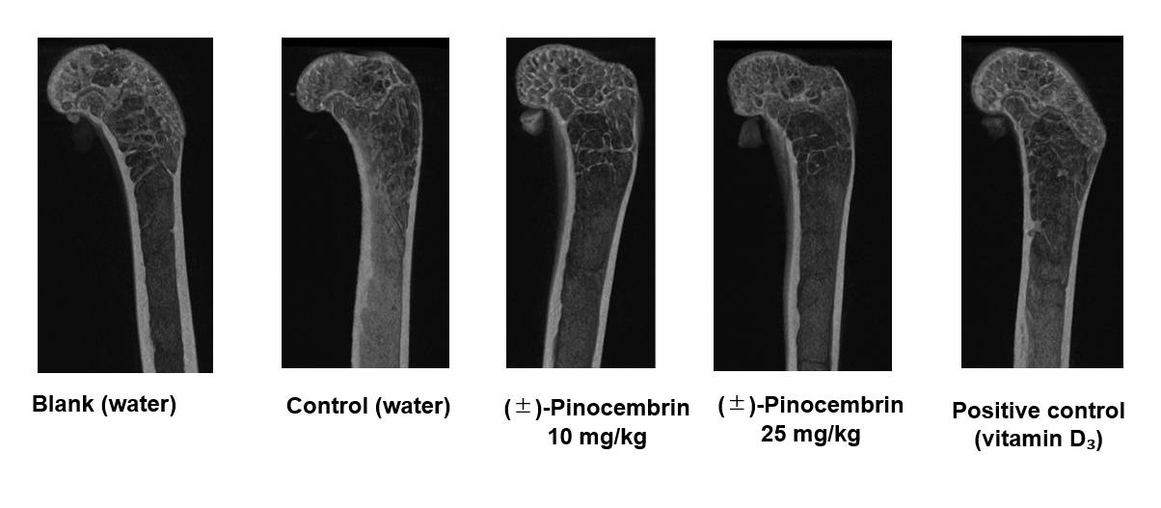
Fig. S4. Representative vertical cut images of femur bone. Mice left femur bones were dried completely and subjected to micro-CT scanning at 50 kV and 200 µA with 0.5 mm of aluminum filter. 3D reconstruction was performed using NRecon V1.7 software.

Table S2. Detected proteins as target protein of (±)-pinocembrin using CETSA
Proteins
Alpha-actinin-4
Glucose-6-phosphate 1-dehydrogenase X
Aldehyde dehydrogenase, mitochondrial
Transportin-1
TAR DNA-binding protein 43
Activator of 90 kDa heat shock protein ATPase homolog 1
Dolichyl-diphosphooligosaccharide--protein glycosyltransferase subunit
Superoxide dismutase [Mn], mitochondrial
Neutrophil cytosol factor 1
Ataxin-10
Integrin alpha-4
Thioredoxin
Nicastrin
Single-stranded DNA-binding protein, mitochondrial
Microtubule-associated protein 1S
Tubulin alpha chain-like 3
Derlin-1
Patatin-like phospholipase domain-containing protein 6
Mitochondrial pyruvate carrier 2
Calmodulin-2

Table S3. Proteins combined with pinocembrin beads by pull down assay. The proteins were analyzed by LCMS proteomics.

proteins
SNW domain-containing protein 1
Nuclear fragile X mental retardation-interacting protein 2
RNA-binding protein 10
Retroviral-like aspartic protease 1
Centromere protein V, W
Coiled-coil domain-containing protein 47
nuclear pore complex protein Nup98-Nup96
Pre-mRNA-splicing factor ATP-dependent RNA helicase PRP16
Immunoglobulin lambda-like polypeptide 5
Regulator of chromosome condensation
nuclear pore complex protein nup155
Pleiotropic regulator 1
RNA-binding motif protein, X-linked 2
General transcription factor IIF subunit 2
Gamma-glutamyl hydrolase
RING1 and YY1-binding protein
BUD13 homolog
pre-mRNA 3' end processing protein WDR33
Nebulin-related-anchoring protein
RB1-inducible coiled-coil protein 1
Protein NipSnap homolog 2
G2/mitotic-specific cyclin-B2
DNA-directed RNA polymerase II subunit RPB2
metal transporter CNNM4
Keratin, type II cytoskeletal 2 oral
Small acidic protein
transcription factor BTF3 homolog 4
40S ribosomal protein S27-like
gamma-glutamylcyclotransferase
Elongin-A
puromycin-sensitive aminopeptidase
Salivary acidic proline-rich phosphoprotein 1/2
Cold-inducible RNA-binding protein
Succinyl-CoA:3-ketoacid coenzyme A transferase 2, mitochondrial
Histone-arginine methyltransferase CARM1
DNA-directed RNA polymerase II subunit RPB1
Zinc finger CCCH domain-containing protein 4
Mucin-like protein 1
Probable ribosome biogenesis protein RLP24
Ribosomal RNA small subunit methyltransferase Nep1
lipoprotein lipase
Leucine-rich repeat-containing protein 40
Cathepsin L2
Long-chain-fatty-acid--CoA ligase 5
Protein NipSnap homolog 1
39S ribosomal protein L34, mitochondrial
alpha-N-acetylgalactosaminide alpha-2,6-sialyltransferase 5
Pyridoxal kinase
Kinesin-like protein KIF2A
Receptor-type tyrosine-protein phosphatase beta
tRNA-dihydrouridine(20) synthase [NAD(P)+]-like
Shugoshin 2
Cathepsin B [OS=Homo sapiens]

Fig. S5. Result of actin polymerization assay. Fluorescence was measured for 1h at Ex/Em= 365/410 nm. Orange line: control, Gray line: 25 µM of (±)-pinocembrin, Yellow line: 100 µM of (±)-pinocembrin.

