Supplementary Table 1. Disk diffusion interpretive criteria for antibiotic susceptibility testing
Antimicrobial Agent | Disk Content (μg) | Zone Diameter (mm)
 |  | Breakpoints
Ampicillin (AMP)ª | 10 | Inherently resistant¹
Tetracycline (TE)^{b} | 30 | ≥ 20
Sulphamethoxazole/trimethoprim (SXT)ª | 25 | ≥ 15
Oxytetracycline (OT)ª | 30 | ≥ 23
Florfenicol (FFC)ª | 30 | ≥ 26
Oxolinic Acid (OA)ª | 2 | ≥ 13
Flumequine (UB)^{b} | 30 | ≥19
a: based on the Ampicillin, Oxytetracycline, Florfenicol and Οxolinic Acid breakpoints established by Yun-Jin Lim et.al for V. harveyi ¹. b: based on the Τetracycline and Flumequine breakpoints established by (EUCAST) ².

Supplementary Figure 1. Adsorption of Vibrio phage Virtus against V. harveyi VH2.

Supplementary Figure 2. Growth of phage-resistant mutants (red line) compared to the wild type strain Vibrio harveyi VH2 (black line) as indicated by the absorbance (OD₆₀₀) measurements. The curves represent the growth trajectories over time, highlighting the differences in growth dynamics between the mutants and wild type. SE bars are included for the mean of n=3, but since variation was very low they are not visible in the graph.

Supplementary Table 2. Antibiotic susceptibility test of the phage-resistant mutants and wild type V. harveyi VH2. Zone diameters are noted in millimeters (mm).
Bacterial Strains | Antibiotics
 | AMP | OA | SXT | UB | FFC | TE | OT
V.harveyi VH2 | 5.9 ± 1.1 | 15.7 ± 0.2 | 17.0 ± 0.7 | 21.4 ± 0.8 | 25.6 ± 0.3 | 19.6 ± 0.7 | 20.3 ± 1.6
R1D4 | 5.4 ± 0.4 | 14.0 ± 0.2 | 14.9 ± 0.6 | 21.0 ± 1.3 | 26.1 ± 0.1 | 18.6 ± 0.8 | 19.4 ± 0.3
R2D4 | 5.3 ± 0.7 | 14.0 ± 0.3 | 12.6 ± 0.8 | 18.9 ± 0.8 | 25.9 ± 0.5 | 18.5 ± 0.5 | 18.0 ± 0.8
R3D4 | 5.7 ± 0.7 | 14.7 ± 0.6 | 14.8 ± 1.4 | 22.3 ± 0.8 | 25.7 ± 1.6 | 20.7 ± 0.5 | 18.7 ± 0.3
R4D4 | 6.1 ± 0.7 | 9.6 ± 0.2 | 13.8 ± 0.9 | 18.9 ± 0.3 | 25.4 ± 0.5 | 17.0 ± 0.5 | 17.1 ± 0.2
R5D4 | 6.3 ± 0.3 | 16.4 ± 0.7 | 17.7 ± 0.4 | 21.5 ± 0.5 | 25.6 ± 0.6 | 19.4 ± 1.0 | 19.9 ± 0.9
R7D4 | 5.9 ± 0.6 | 16.9 ± 0.9 | 17.0 ± 1.3 | 22.7 ± 0.4 | 27.6 ± 0.7 | 19.5 ± 0.3 | 18.1 ± 0.1
R8D4 | 5.9 ± 0.9 | 14.2 ± 0.8 | 16.3 ± 1.1 | 21.5 ± 0.3 | 25.9 ± 0.8 | 18.2 ± 0.6 | 19.3 ± 1.2
R9D4 | 5.9 ± 0.8 | 15.9 ± 0.5 | 16.1 ± 1.0 | 19.9 ± 0.7 | 26.8 ± 1.2 | 18.2 ± 0.3 | 17.6 ± 0.5
R10D4 | 5.6 ± 1.0 | 15.5 ± 0.6 | 16.0 ± 0.8 | 22.9 ± 0.7 | 23.9 ± 0.8 | 19.3 ± 0.2 | 20.4 ± 1.5
R11D4 | 6.0 ± 0.5 | 15.5 ± 0.8 | 15.3 ± 0.4 | 21.5 ± 1.4 | 21.2 ± 0.6 | 19.5 ± 0.1 | 18.2 ± 0.4
R12D4 | 5.8 ± 0.4 | 12.1 ± 0.6 | 12.5 ± 0.1 | 17.0 ± 1.0 | 12.4 ± 0.1 | 15.4 ± 1.2 | 9.9 ± 0.9

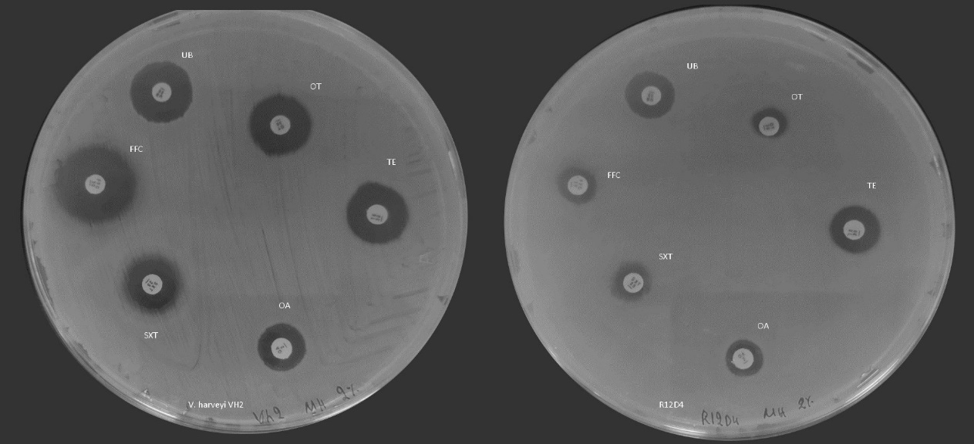
Supplementary Figure 3. Antibiotic Susceptibility test of V. harveyi VH2 (left) and R12D4 (right). Phage-resistance development led to a multi-drug resistant phenotype of R12D4, as it is resistant to all antibiotics tested.
Supplementary Figure 4. Scatter plot of the variant fraction for each mutation in the phage-resistant mutants. The variant fraction represents the proportion of sequences containing a particular mutation, providing insights into the prevalence of each mutation within the population.

Supplementary Figure 5. Scatter plot of the variant coverage for each mutation in the phage-resistant mutants. The variant coverage indicates the depth of sequencing for each mutation, reflecting the reliability and frequency of mutation detection across the samples.

Supplementary Table 3. Summary of Sequencing Results and Variant Detection Across Libraries. The table presents key metrics from each read library, including total reads, properly mapped reads, median and mean base coverage, number of bases with zero and low coverage, as well as the number of raw and high-quality variants identified using FreeBayes. Libraries are labeled as R1D4 to R12D4, representing different sequencing datasets which represent phage-resistant mutants.
Library | Total Reads | Properly Mapped Reads | Total Reference Bases | Median Base Coverage | Mean Base Coverage | Bases with Zero Coverage | Bases with <=10 Coverage | Raw FreeBayes Variants | High Quality Variants
R1D4 | 12319781 | 12281123 | 5836044 | 201 | 206.9 | 13 | 136 | 102 | 4
R2D4 | 12269501 | 12246627 | 5836044 | 200 | 205.9 | 6 | 113 | 221 | 2
R3D4 | 12289804 | 11913909 | 5836044 | 197 | 200.3 | 12 | 152 | 192 | 5
R4D4 | 12281783 | 12268689 | 5836044 | 203 | 206 | 10 | 144 | 220 | 3
R5D4 | 12288775 | 12223356 | 5836044 | 201 | 205.6 | 17 | 148 | 228 | 4
R7D4 | 12123678 | 12063315 | 5836044 | 191 | 202.4 | 17 | 123 | 318 | 58
R8D4 | 12261448 | 12166715 | 5836044 | 198 | 204.2 | 15 | 123 | 199 | 5
R9D4 | 14603787 | 14598171 | 5836044 | 276 | 318.2 | 1319 | 35052 | 651 | 77
R10D4 | 12291615 | 12197910 | 5836044 | 197 | 205.2 | 10 | 125 | 361 | 86
R11D4 | 12326765 | 12304460 | 5836044 | 203 | 207.2 | 11 | 136 | 102 | 3
R12D4 | 12268634 | 12198077 | 5836044 | 201 | 204.9 | 11 | 132 | 202 | 4
VH2-C | 8059551 | 8058096 | 5836044 | 192 | 194.3 | 37423 | 46949 | 150 | 1

Supplementary Table 4. Hemagglutination (ΗΑ) activity of Vibrio harveyi VH2 wild type and phage-resistant mutants with gilthead seabream erythrocytes.
Category | Bacterial Strain | HA_Titer
Hypermutator | R10D4 | 1: 2⁰
Hypermutator | R7D4 | 1: 2⁰
Hypermutator | R9D4 | 1: 2⁰
MSHA mutant | R11D4 | 1: 2²
MSHA mutant | R2D4 | 1: 2²
MSHA mutant | R4D4 | 1: 2²
PilT mutant | R12D4 | No HA
PilT mutant | R1D4 | No HA
PilT mutant | R3D4 | No HA
PilT mutant | R5D4 | No HA
PilT mutant | R8D4 | No HA
Wild type | VH2 Mock Treated | 1:2²
Wild type | VH2 WT | 1:2²

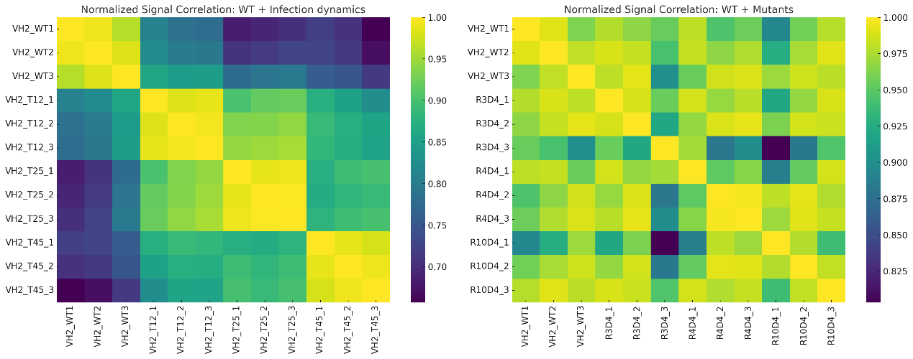

Supplementary Figure 6. Pairwise sample correlation heatmaps of transcriptomic profiles based on normalized signal values. (Left) V. harveyi VH2 wild-type (WT) and infection dynamics at 12 (VH2_T12), 25 (VH2_T25), and 45 (VH2_T45) minutes post-phage challenge. Replicates at each timepoint cluster tightly (average intra-replicate correlation ≥0.98), confirming high reproducibility and revealing a temporal gradient of divergence from the WT control. (Right) WT compared with phage-resistant mutants R3D4 (PilT), R4D4 (MSHA), and R10D4 (hypermutator). Replicates within each mutant group also cluster closely (≥0.95 correlation), validating dataset robustness. While PilT and MSHA mutants remain transcriptionally closer to WT, the hypermutator shows a more divergent correlation profile, consistent with broad transcriptional remodeling.

References
1. Lim, Y.-J. et al. Epidemiological cut-off values for disc diffusion data generated by standard test protocols from Edwardsiella tarda and Vibrio harveyi. Aquaculture International 24, 1153–1161 (2016).
2. The European Committee on Antimicrobial Susceptibility Testing. Breakpoint Tables for Interpretation of MICs and Zone Diameters. Version 14.0. http://www.eucast.org.

.

