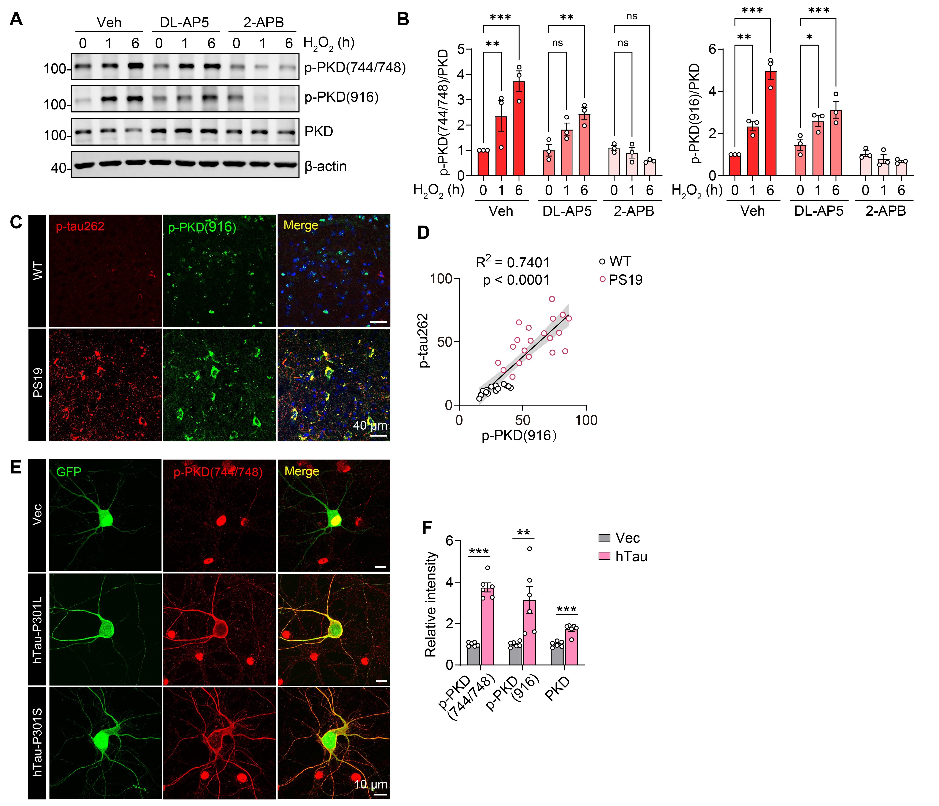
Supplementary Figure 1 PKD1 activity in human tau-carrying neurons.
(A) Representative blots of p-PKD (Ser744/748), p-PKD (Ser916), and PKD in primary cultured P301S tau-carrying neurons pretreated for 1 h with the NMDAR antagonist DL-AP5 (200 μM), or the store-operated calcium channel inhibitor 2-APB (10 μM), and stimulated with H₂O₂ (100 μM) for 1 or 6 h. (B) Quantification of p-PKD(Ser744/748) and p-PKD(Ser916) signals relative to total PKD in A. n = 3 independent experiments. (C) Representative immunostaining images of p-tau (Ser262) and p-PKD (Ser916) in the cortex of 9-month-old WT and PS19 mice. (D) Correlation analysis between p-PKD (Ser916) and p-tau (Ser262) in WT and PS19 mice. (E) Representative immunostaining images of p-PKD (Ser744/748) in primary cultured cortical neurons transfected with hTau-P301L, hTau-P301S, or control GFP plasmids. (F) Quantification of p-PKD (Ser744/748), p-PKD (Ser916) and PKD blots in Fig. 1L. n = 6 per group. Statistical significance was determined by unpaired Student’s t test (F) or two-way ANOVA with Dunnett’s post hoc analysis (B). Data are shown as mean ± SEM, *p < 0.05, **p < 0.01, ***p < 0.001, n. s, not significant.

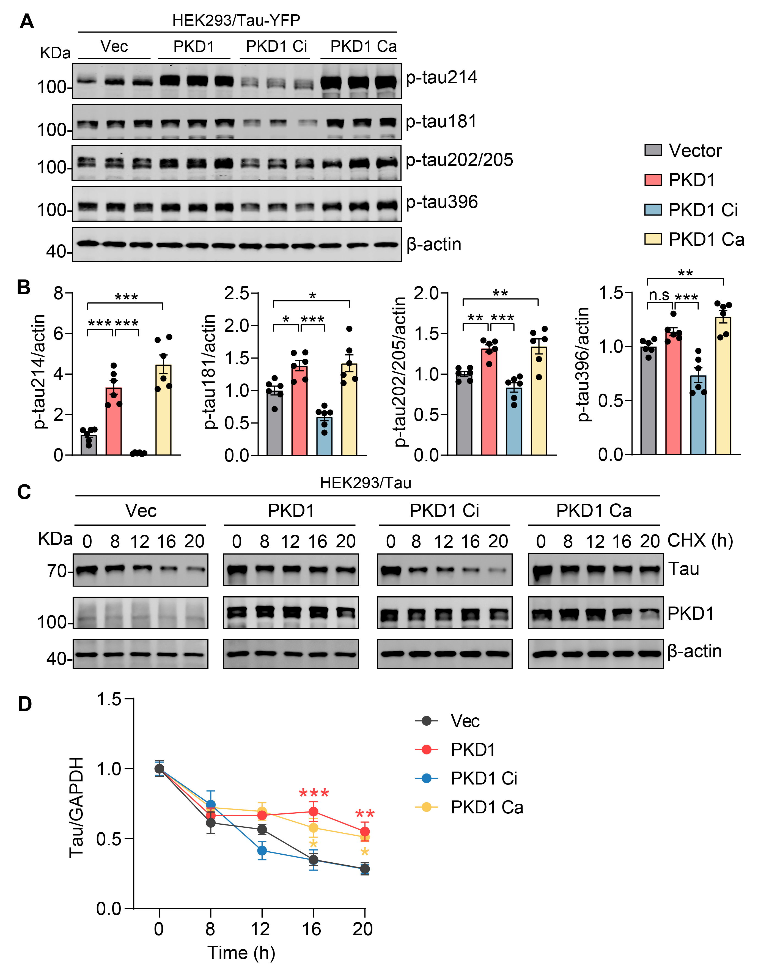
Supplementary Figure 2 PKD1 regulates tau phosphorylation and tau stabilization.
(A and B) Representative blots and quantifications of phosphorylated tau (p-Ser214, p-Thr181, p-Ser202/Thr205, p-Ser396) in total lysates from HEK293/tau-YFP cells transfected with control vector, PKD1, PKD1 Ci mutant, or PKD1 Ca mutant. n = 6 from 2 independent experiments. (C and D) Representative blots and quantifications of tau levels of lysates from HEK293/Tau cell lines overexpressed with control vector, PKD1, PKD1 Ci mutant, or PKD1 Ca mutant, and then treated with cycloheximide (CHX) for indicated periods of time. n = 4 per group. Statistical significance was determined by two-way ANOVA with Dunnett’s post hoc analysis. *p < 0.05, **p < 0.01, ***p < 0.001, n. s, not significant.

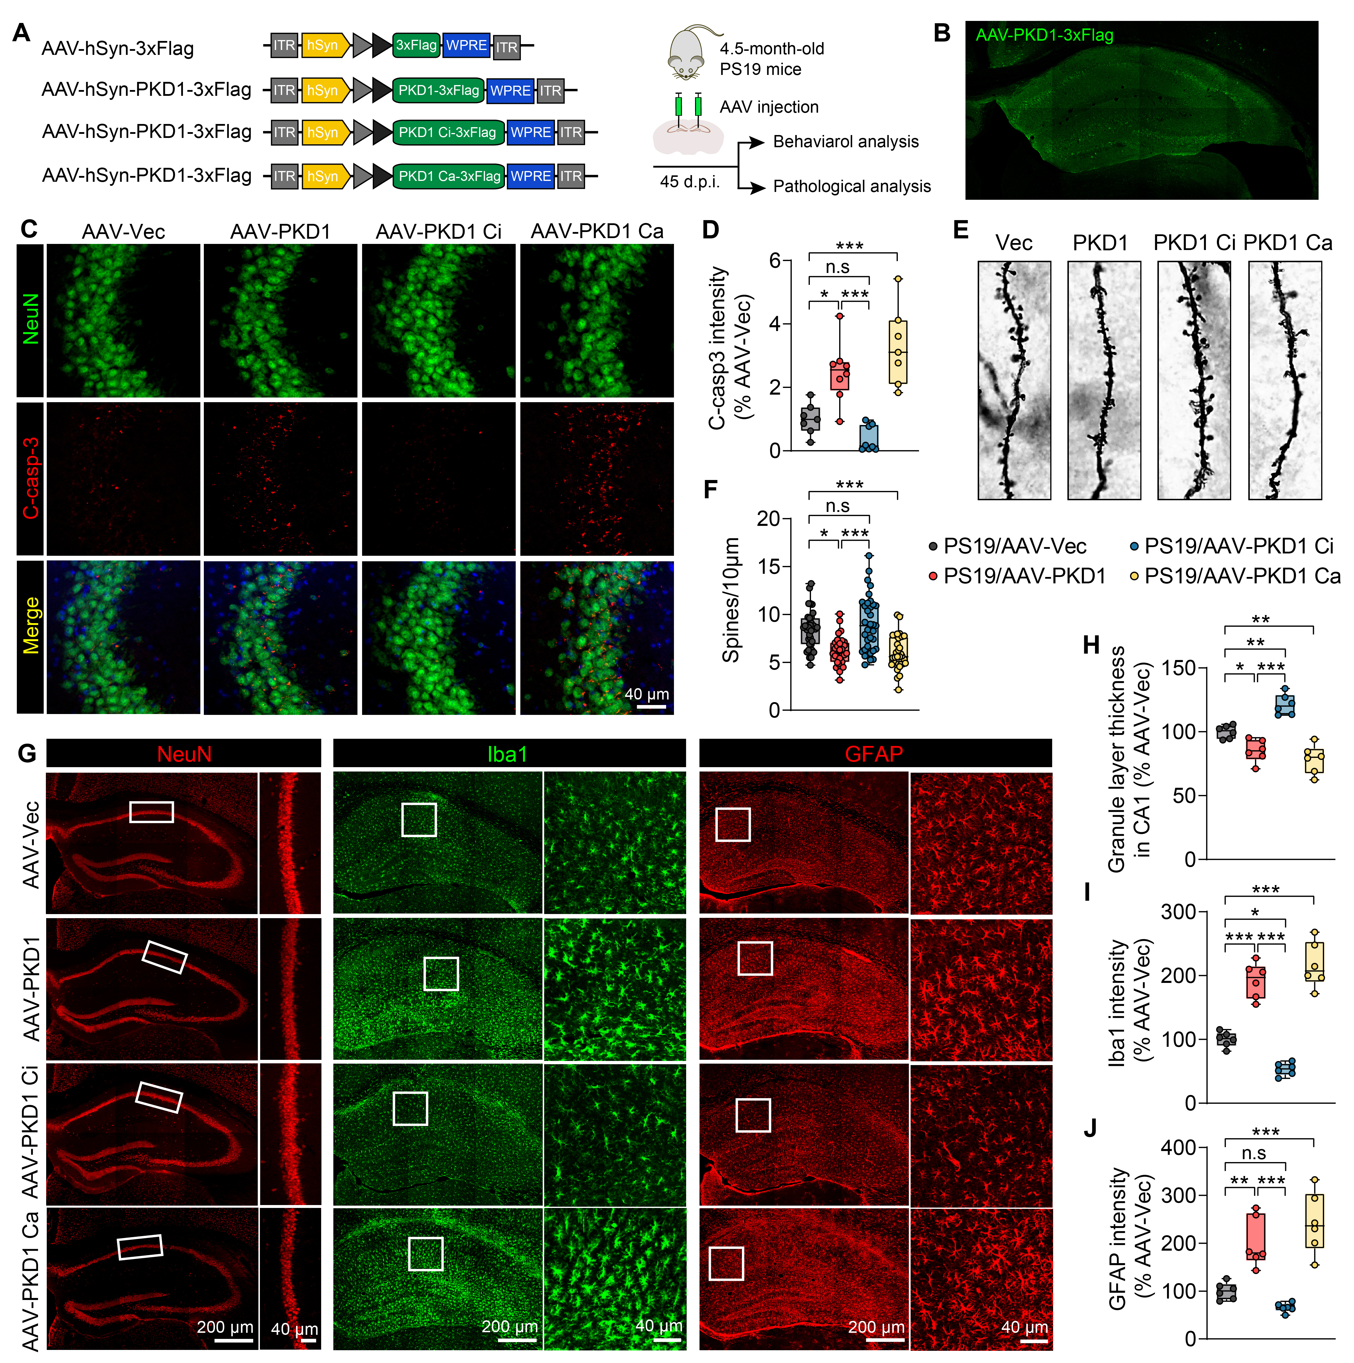
Supplementary Figure 3 Overexpression of PKD1 exacerbates neuronal loss and gliosis in young PS19 mice.
(A) Schematic illustration of AAVs constructed with PKD1 or PKD1 mutant and the in vivo experimental timeline. (B) Representative immunostaining images of Flag showing the expression of AAV in the hippocampus of PS19 mice. (C and D) Immunofluorescence staining analysis of cleaved Caspase-3 and neuronal nuclear antigen (NeuN) in the hippocampal CA3 of of 6-month-old PS19 mice after AAV injection. (E and F) Golgi staining analysis of dendritic spines from apical dendritic layer of the CA1 region. (G-J) Immunofluorescence staining analysis of NeuN, Glial fibrillary acidic protein (GFAP), and Ionized calcium binding adapter molecule 1 (Iba1) in the hippocampus of AAV-injected PS19mice. Statistical significance was determined by one-way ANOVA with Dunnett’s post hoc analysis. Data are shown as mean ± SEM, *p < 0.05, **p < 0.01, ***p < 0.001, n. s, not significant.

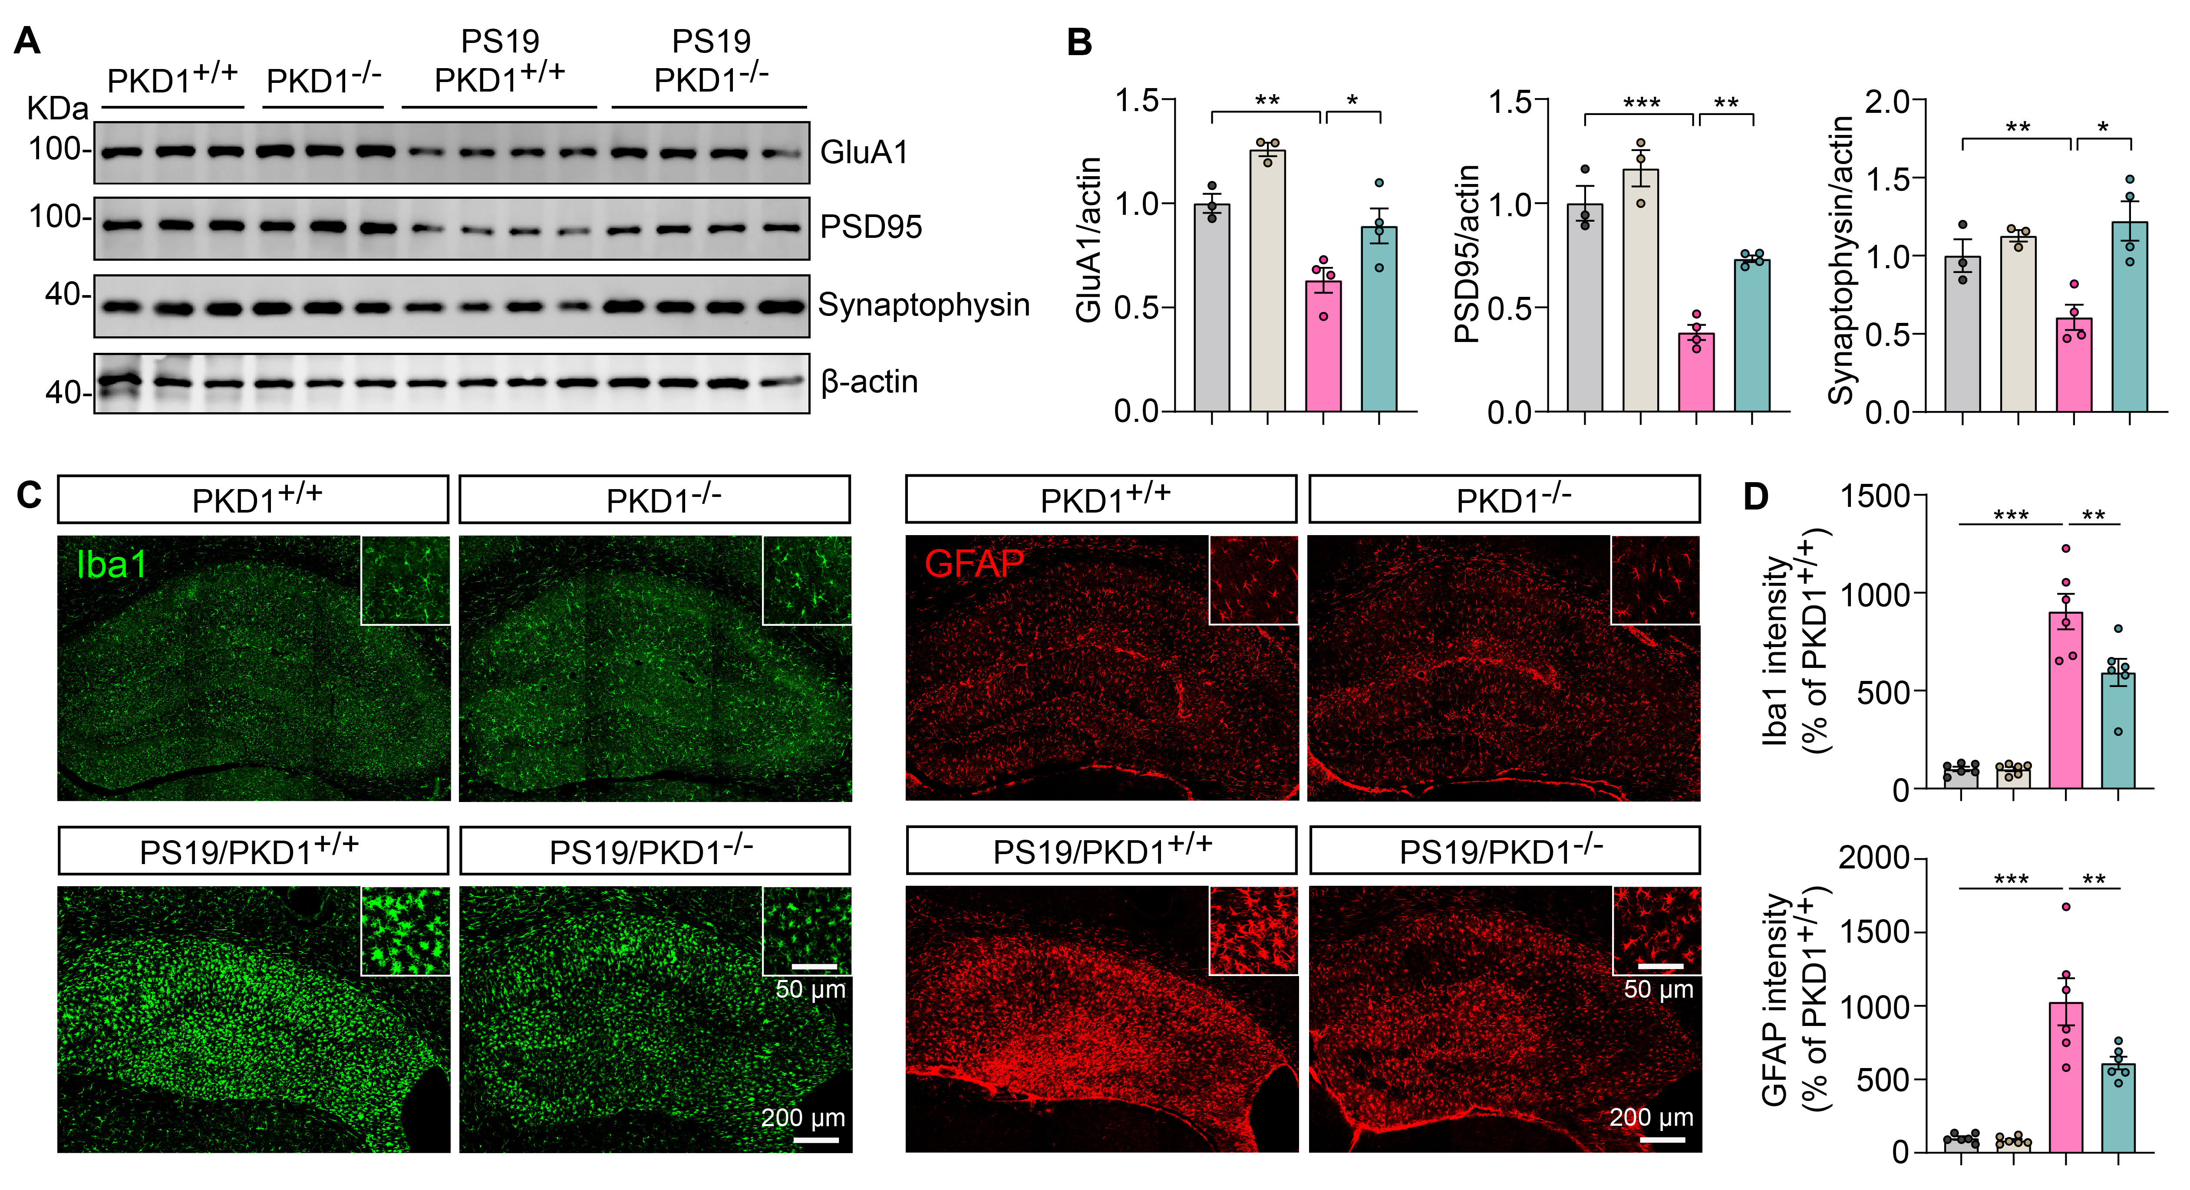
Supplementary Figure 4 PKD1 deletion ameliorates synaptic protein loss and glial cell activation in PS19 mice.
(A and B) Immunoblotting analysis of GluA1, PSD95 and synaptophysin protein in the hippocampal tissues from PKD1^{+/+}, PS19/PKD1^{+/+} and PS19/PKD1^{-/-} mice. n = 3-4 mice per group. (C and D) Immunofluorescence staining analysis of Iba1 and GFAP in the hippocampus of PKD1^{+/+}, PS19/PKD1^{+/+} and PS19/PKD1^{-/-} mice. n = 6 mice per group. Statistical significance was determined by one-way ANOVA with Dunnett’s post hoc analysis. Data are shown as mean ± SEM, *p < 0.05, **p < 0.01, ***p < 0.001, n. s, not significant.

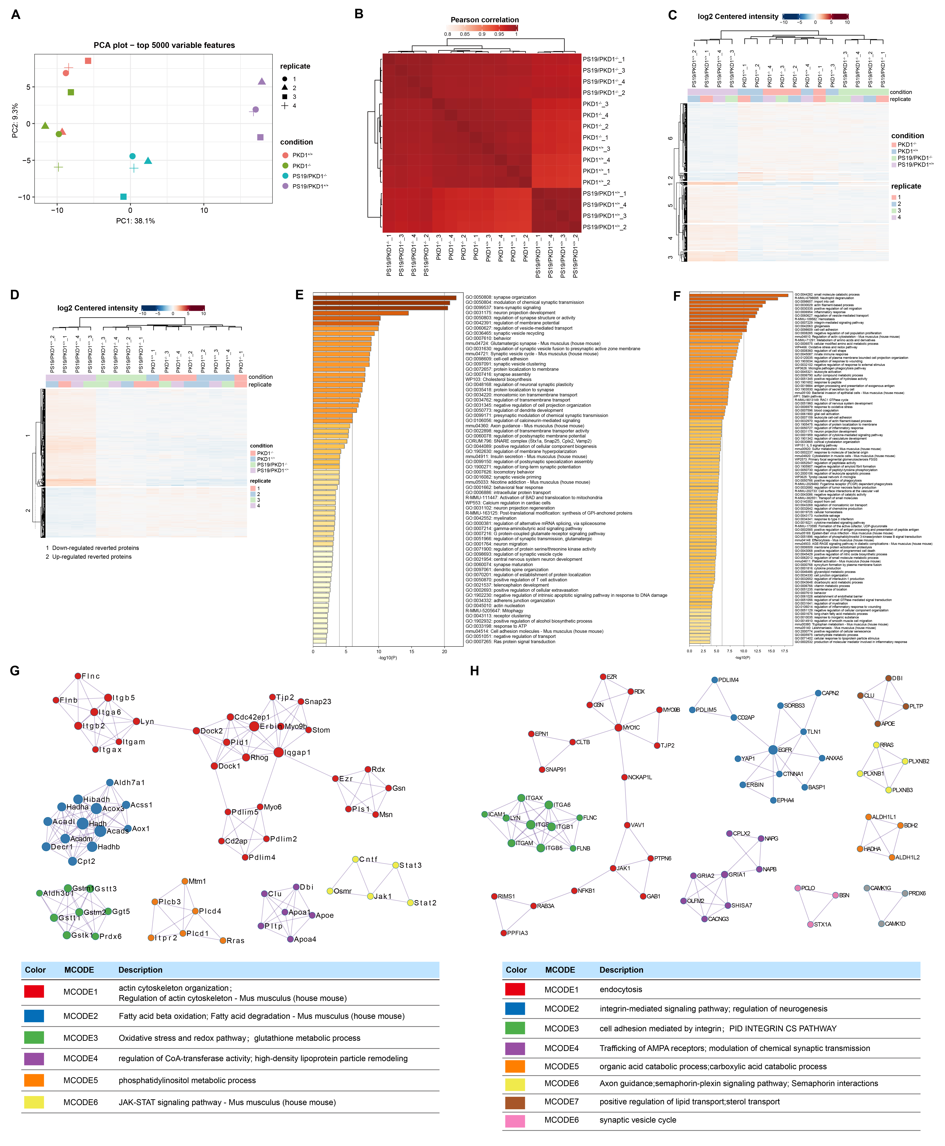
Supplementary Figure 5 PKD1 deletion ameliorates protein dyshomeostasis in PS19 mice.
(A) Principal component analysis (PCA) plot displays all samples based on the top 5000 variable proteins, utilizing the first two components: PC1, which accounts for 38.1% of the variance, and PC2, which accounts for 9.3% of the variance. (B) Heatmap showing visual correlations among different samples. (C) Heatmap illustrating the expression levels of all significantly differentially proteins (DEPs) identified across the four groups of mice. (D) Heatmap illustrating the expression levels of proteins with reversed expression patterns across all groups. The color bar represents the log2-centered expression intensity, where shades of red denote higher expression levels and shades of blue indicate lower protein levels. Clustering of columns suggests a closer association of samples, while clustering of rows indicates proteins with similar expression patterns. (E) Heatmap showing the top 100 enriched functional terms for up-regulated proteins with reversed expression due to PKD1 deletion in PS19 mice. (F) Heatmap showing the top 100 enriched functional terms for down-regulated proteins with reversed expression resulting from PKD1 deletion in PS19 mice. (G) Protein clusters identified by MCODE analysis of the protein-protein interaction network of down-regulated proteins with reversed expression pattern by PKD1 deletion. (H) Protein clusters identified by MCODE analysis of the 272 orthologous DEPs from the human AD-DEP dataset.

