Supplementary Material
Searching for visuomotor matches vs mismatches biases confidence and visual sampling strategies, but not performance
Jonathan Yi, Zhenyu Wang, Peng Wang, and Jakub Limanowski

Supplementary Table 1. Summary of a generalized mixed effects model of main effects and interactions with Correct Response as the dependent variable.
Fixed effects | B (Odds ratios) | Std. Error | 95 % CI | p
(Intercept) | 1.90 | 0.24 | 1.48 – 2.45 | <0.001
Search Instruction | 0.83 | 0.17 | 0.56 – 1.23 | 0.347
Delay Discrepancy | 10.22 | 2.13 | 6.80 – 15.38 | <0.001
Log Response Time | 0.74 | 0.05 | 0.65 – 0.85 | <0.001
Confidence Rating | 1.31 | 0.05 | 1.20 – 1.41 | <0.001
Search Instruction × Delay Discrepancy | 5.25 | 1.69 | 2.79 – 9.88 | <0.001
Search Instruction × log Response Time | 1.38 | 0.16 | 1.11 – 1.72 | 0.004
Delay Discrepancy × log Response Time | 0.33 | 0.04 | 0.27 – 0.42 | <0.001
Search Instruction × Delay Discrepancy × log Response Time | 0.79 | 0.15 | 0.55 – 1.14 | 0.214

Supplementary Table 2. Pairwise post hoc comparisons for Correct Responses.
Pairwise Comparison | Δ Probability | SE | z | 95 % CI Lower | 95 % CI Upper |  | p
FSLD – FSHD | +1.31 | 0.171 | 2.09 | 0.93 | 1.85 |  | 0.300
FSLD – FDLD | +1.26 | 0.135 | 2.13 | 0.95 | 1.67 |  | 0.300
FSLD – FDHD | –0.48 | 0.046 | –7.63 | 0.37 | 0.62 |  | 3.7 × 10⁻¹³
FSHD – FDHD | –0.36 | 0.045 | –8.20 | 0.26 | 0.50 |  | 8.5 × 10⁻¹⁵
FDLD – FSHD | +1.05 | 0.182 | 0.25 | 0.66 | 1.65 |  | 0.800
FDLD – FDHD | –0.38 | 0.046 | –8.02 | 0.28 | 0.52 |  | 2.6 × 10⁻¹⁴
Note. FSLD = Find Similar, Low Discrepancy; FSHD = Find Similar, High Discrepancy; FDLD = Find Different, Low Discrepancy; FDHD = Find Different, High Discrepancy. All p-values are Holm-adjusted (Holm, 1979).

Supplementary Table 3. Summary of a linear mixed effects model of main effects and interactions with Log Response Time as the dependent variable.
Fixed effects | Estimate | Std. Error | 95 % CI | p
(Intercept) | 1.56 | 0.07 | 1.42 – 1.70 | < 0.001
Search Instruction | 0.09 | 0.05 | –0.01 – 0.20 | 0.099
Delay Discrepancy | –0.08 | 0.02 | –0.11 – –0.04 | < 0.001
Correct Response | –0.07 | 0.01 | –0.09 – –0.04 | < 0.001
Confidence Rating | –0.32 | 0.01 | –0.33 – –0.30 | < 0.001
Search Instruction × Delay Discrepancy | 0.11 | 0.03 | 0.06 – 0.17 | < 0.001
Search Instruction × Correct Response | 0.07 | 0.03 | 0.02 – 0.13 | 0.008
Delay Discrepancy × Correct Response | –0.21 | 0.03 | –0.26 – –0.16 | < 0.001
Search Instruction × Delay Discrepancy × Correct Response | 0.00 | 0.05 | –0.10 – 0.11 | 0.952

Supplementary Table 4. Pairwise post hoc comparisons for Response Times.
Pairwise Comparison | Δ logRT | SE | t | df | 95 % CI Lower | 95 % CI Upper | p
FSLD – FSHD | +0.136 | 0.022 | 6.18 | 60.8 | 0.076 | 0.196 | 2.11 × 10⁻⁶
FSLD – FDLD | –0.037 | 0.056 | –0.66 | 27.0 | –0.198 | 0.123 | 1.00
FSLD – FDHD | –0.016 | 0.055 | –0.28 | 24.5 | –0.174 | 0.143 | 1.00
FSHD – FDHD | –0.151 | 0.057 | –2.66 | 27.7 | –0.312 | 0.010 | 0.204
FDLD – FSHD | +0.173 | 0.060 | 2.88 | 24.4 | 0.001 | 0.346 | 0.204
FDLD – FDHD | +0.022 | 0.023 | 0.98 | 67.2 | –0.039 | 0.083 | 1.00
Note. FSLD = Find Similar, Low Discrepancy; FSHD = Find Similar, High Discrepancy; FDLD = Find Different, Low Discrepancy; FDHD = Find Different, High Discrepancy. Degrees of freedom were estimated using Satterthwaite approximation (Kuznetsova et al., 2017). All p-values are Holm-adjusted (Holm, 1979).

Supplementary Table 5. Summary of a linear mixed effects model of main effects and interactions with Confidence Rating as the dependent variable.
Fixed effects | Estimate | Std. Error | 95% CI | p
(Intercept) | 1.01 | 0.02 | 0.96 – 1.05 | <0.001
Search Instruction | -0.06 | 0.02 | -0.10 – -0.02 | 0.004
Delay Discrepancy | 0.02 | 0.01 | 0.00 – 0.04 | 0.032
Correct Response | 0.04 | 0.01 | 0.02 – 0.05 | <0.001
Log Response Time | -0.23 | 0.01 | -0.24 – -0.22 | <0.001
Search Instruction × Delay Discrepancy | -0.02 | 0.01 | -0.04 – 0.01 | 0.167

Supplementary Table 6. Pairwise post hoc comparisons for Confidence Ratings.
Pairwise Comparison | Δ CFR | SE | t | df | 95 % CI Lower | 95 % CI Upper | p (Holm)
FSLD – FSHD | –0.031 | 0.012 | –2.55 | 41.9 | –0.065 | 0.003 | 0.058
FSLD – FDLD | 0.052 | 0.022 | 2.38 | 27.9 | –0.010 | 0.114 | 0.073
FSLD – FDHD | 0.037 | 0.024 | 1.52 | 24.1 | –0.033 | 0.107 | 0.281
FSHD – FDHD | –0.068 | 0.022 | –3.12 | 28.2 | 0.006 | 0.130 | 0.021
FDLD – FSHD | –0.083 | 0.023 | –3.65 | 24.4 | –0.148 | –0.018 | 0.008
FDLD – FDHD | –0.015 | 0.012 | –1.21 | 42.3 | –0.048 | 0.019 | 0.281
Note. FSLD = Find Similar, Low Discrepancy; FSHD = Find Similar, High Discrepancy; FDLD = Find Different, Low Discrepancy; FDHD = Find Different, High Discrepancy. Degrees of freedom were estimated using Satterthwaite approximation (Kuznetsova et al., 2017). All p-values are Holm-adjusted (Holm, 1979).

Supplementary Table 7. Summary of a linear mixed effects model where for every gaze sample, the dependent variable, namely, Gaze Bias, was computed for each eye-tracking sample as that sample’s share of the trial duration spent looking at the Center ROI plus the VH ROIs (outside ROI data points were excluded). Summing these signed values across all samples in a trial yields a net bias that ranges from –100 % (gaze exclusively on the VH ROIs of the entire duration of a trial looking at the Center ROI + VH ROIs) to +100 % (gaze exclusively on the Center ROI of the entire duration of a trial looking at the Center ROI + VH ROIs). We introduced Within Trial Progression (WTP: 0 – 100 % of elapsed progression within a single trial) as a new fixed effect.
Fixed effects | Estimate | Std. Error | 95% CI | p
(Intercept) | 0.032 | 0.017 | -0.003 – 0.068 | 0.075
Within Trial Progression | -0.012 | 0.001 | -0.013 – -0.011 | <0.001
Search Instruction | -0.023 | 0.009 | -0.041 – -0.005 | 0.014
Delay Discrepancy | 0.004 | 0.007 | -0.009 – 0.018 | 0.509
Within Trial Progression x  Search Instruction | 0.010 | 0.001 | 0.008 – 0.012 | <0.001
Within Trial Progression ×  Delay Discrepancy | -0.008 | 0.001 | -0.011 – -0.006 | <0.001
Search Instruction ×  Delay Discrepancy | -0.012 | 0.002 | -0.016 – -0.008 | <0.001
Within Trial Progression ×  Search Instruction ×  Delay Discrepancy | 0.003 | 0.002 | -0.002 – 0.007 | 0.227

Supplementary Table 8 Pairwise post hoc comparisons for Center vs. VHs Gaze Bias for the Search Instruction x Delay Discrepancy interaction effect.
Pairwise Comparison (FS/FD × LD/HD) | Δ Gaze Bias | SE | t | df | 95% CI Lower | 95% CI Upper | P (Holm)
FSLD – FDLD | −0.013 | 0.007 | −1.780 | 24.6 | −0.034 | 0.008 | 0.351
FSLD – FSHD | 0.008 | 0.006 | 1.330 | 25.3 | −0.009 | 0.024 | 0.513
FSLD – FDHD | −0.014 | 0.010 | −1.410 | 23.8 | −0.044 | 0.015 | 0.513
FDLD – FSHD | 0.021 | 0.008 | 2.540 | 23.9 | −0.003 | 0.044 | 0.089
FDLD – FDHD | −0.001 | 0.006 | −0.249 | 24.6 | −0.018 | 0.015 | 0.806
FSHD – FDHD | −0.022 | 0.007 | −3.030 | 24.9 | −0.043 | −0.001 | 0.034
Note. Entries are pairwise differences in predicted Gaze Bias between Search Instruction × Delay Discrepancy, evaluated at the mean of the z-transformed Within-Trial Progression = 0. Positive Δ Gaze Bias indicates more center-ward bias in the left cell minus the right cell (e.g., FSLD – FDLD). Degrees of freedom were estimated using Satterthwaite approximation (Kuznetsova et al., 2017). FSLD = Find Similar, Low Discrepancy; FSHD = Find Similar, High Discrepancy; FDLD = Find Different, Low Discrepancy; FDHD = Find Different, High Discrepancy. All p-values are Holm-adjusted (Holm, 1979).

Supplementary Table 9. Pairwise post hoc comparisons for Center vs. VHs Gaze Bias for interaction effects using Within Trial Progression.
Contrast (Factor) | Δ Slope (Within Trial Progression) | SE | t | df | 95% CI Lower | 95% CI Upper | P (Holm)
Search Instruction: FS vs FD | 0.010 | 0.001 | 9.12 | 1,942,581.0 | 0.008 | 0.012 | < 0.001
Delay Discrepancy: LD vs HD | −0.008 | 0.001 | −7.80 | 1,942,575.0 | −0.006 | −0.006 | < 0.001
Note. Within-Trial Progression (z-scored time within a trial; larger values = later in the trial). Entries report differences in simple slopes of predicted Gaze Bias (positive = more center-ward, negative = more hand-ward) with respect to Within Trial Progression between factor levels of Search Instruction and Delay Discrepancy. Thus, a Δ Slope of 0.010 means the per-SD increase in predicted Gaze Bias across the trial is 0.010 units larger in the first condition than in the second. Degrees of freedom were estimated using Satterthwaite approximation (Kuznetsova et al., 2017). FS = Find Similar; FD = Find Different; LD = Low Discrepancy; HD = High Discrepancy. All p-values are (Holm, 1979).

Correct responses as a function of Center Gaze Percentage and Hand Correctness
In this supplementary eye-tracking analysis we investigated once again using a mixed effects model if participants were more likely to perform better (higher CR) as a function of looking more at the Center ROI vs. looking more at the VH ROIs on a trial-by-trial basis as measured by the new fixed effects Center Gaze Percentage (CGP) and Hand Correctness (HC) throughout the entire experimental manipulation. Since the dependent variable was CR for this analysis, we used a generalized mixed effects model (Gelman & Hill, 2006). The new fixed effect called CGP summarized gaze toward the center with Center vs. the VHs, i.e. the proportion that the eyes gazed within the Center ROI, computed by summing the time-weighted samples on the Center and dividing by total trial time spent looking at the Center ROI plus the VH ROIs (once again, eye gaze samples Outside the Center and VH ROIs were excluded for this analysis since we wanted to compare peripheral vs. serial sampling of visual information). To clarify, if a participant looked exclusively at the Center during a trial while never looking at any of the VH ROIs, a GCP score of 100 was given while conversely, a CGP score of 0 was assigned if participants only gazed at the VH ROIs within a trial. GCP was subsequently z-transformed and standardized when used as a fixed effect in our mixed effects model (Schielzeth, 2010). Because CR was logged once per trial, the fixed effect CGP also consisted of only one value per trial. CGP provided that single number per trial in contrast to the Gaze Bias dependent variable in the previous model which consisted of multiple data points per trial. Adding multiple GCP values per trial into the current model would break the assumption of independence in generalized mixed effects models (Bolker et al., 2009). Hence we chose CGP instead for this particular mixed effects model. Furthermore, regarding the second new fixed effect of this model, for every trial we derived one HC score which was the time-weighted average hand rank score (1 = most “Correct” VH, 4 = least “Correct” VH) of the participants gaze allocation across the VHs within individual trials. Accordingly, lower HC values reflect larger proportion of individual trial times spent gazing on the more “Correct” VH, whereas higher values signal larger proportion of trial times looking at the more “Incorrect” VHs in individual trials (e.g., 1 = exclusive fixation on the VHs; 2.5 = uniform gaze across all four VHs; 4 = exclusive fixation on the VH, although these values were z-transformed (Schielzeth, 2010), see Methods). So to clarify, HC was a continuous variable and not a discrete one for distinct ranks of hand correctness. The HC values was contingent on Search Instruction since it determined which VHs was “Correct” or “Incorrect” as a function of Find Similar and Find Different. Since each of the VHs had a distinct delay at each given trial, HC could be determined as a function of Search Instruction; in Find Similar trials, the VH with the least delay was given a HC of 1 and the VH with the highest delay was given a HC of 4 and vice versa for Find Different trials. We did not observe a main effect of CGP (B = 1.019, SE = 0.037, p = 0.611) thus, participants’ CR did not increase as a function of gazing more at the Center vs. the four VHs on a trial-by-trial basis. On the other hand, we observed a main effect of HC (B = 0.908, SE = 0.028, p = 0.002), revealing that participants’ CR increased as a function allocating increasing proportions of individual trial times gazing more on the “Correct” VHs as a gradient of HC (Supplementary Figure 2). Interestingly, we also observed an interaction effect between CGP x HC (B = 0.940, SE = 0.027, p = 0.033) whereby, participants’ CRs increased the more they looked at the Center (higher CGP) as HC scores improved (as mentioned above, the lower the HC, the more “Correct”) while conversely, higher GCP predicted lower CRs as HC scores worsened. Hence, increased visual allocation toward the Center was only beneficial in terms of CR in individual trials when participants’ spent increasingly larger proportions of the same trials’ time looking at the more “Correct” VHs and vice versa for looking the most the less “Correct” VHs on a trial-by-trial basis as well.
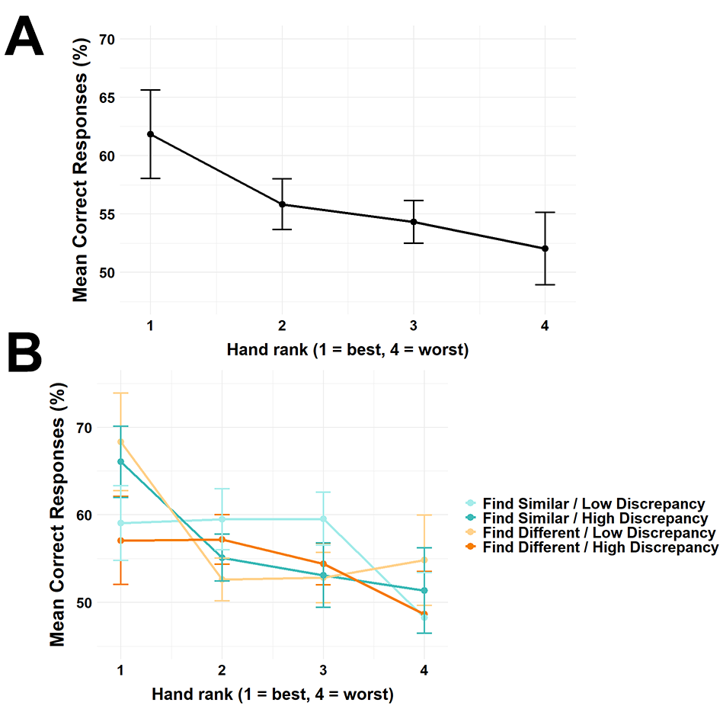
Supplementary Figure 1 | Participants CR were enhanced as a function of HC. A: This figure illustrates the mean CR on the y-axis as a function of where participants looked the most at each VH as a function of HC across all trials. Participants performed better as a function of allocating their gazes as a function of HC. To clarify, “1” in the x-axis refers to trials where participants looked the most at the most “correct” VH compared to all the other VHs in the same trial as a function of Search Instruction. Inversely, “4” on the x-axis refers to trials where participants’ spent most of their visual attention on the most “incorrect” VH relative to the other VHs in the same trial. B: This panel shows the same data as panel A that has further been subdivided into Search Instruction x Delay Discrepancy. Note. Error bars represent Cousineau-Morey corrected standard errors (SE) of participant means (Cousineau, 2005; Morey, 2008). The presented data in this figures consist of raw data and not a model fit.

Supplementary Table 10. Summary of a generalized mixed effects model of main effects and interactions with Correct Response as the dependent variable. This analysis was used to assess if increased gaze allocation toward the Center ROI vs. the four VH ROIs during trials resulted on average in enhanced CRs across the experiment. This fixed effect is referred to as Center Gaze Percentage in this table. Moreover, we investigated if HC predicted higher CRs as well.
Fixed effects | B (Odds ratios) | Std. Error | 95% CI | p
(Intercept) | 1.249 | 0.092 | 1.081 – 1.444 | 0.003
Center Gaze Percentage | 1.019 | 0.037 | 0.949 – 1.094 | 0.611
Hand Correctness | 0.908 | 0.028 | 0.854 – 0.964 | 0.002
Search Instruction | 1.090 | 0.067 | 0.966 – 1.231 | 0.163
Delay Discrepancy | 1.921 | 0.119 | 1.702 – 2.168 | <0.001
Center Gaze Percentage x Hand Correctness | 0.940 | 0.027 | 0.889 – 0.995 | 0.033
Search Instruction x Delay Discrepancy | 2.433 | 0.300 | 1.910 – 3.099 | <0.001

Shapiro Wilk testing for STAI-T, CR, RT, CFR and Spearman and Pearson Correlation analyses pertaining to STAI-T.
Shapiro–Wilk tests showed that the participant-level means of STAI-T, RT, and CFR did not depart significantly from normality (W = 0.94 – 0.97, p ≥ .175). In contrast, the participant level mean of CR was modestly non-normal (W = 0.91, p = .028). The Shapiro–Wilk results are summarized in Supplementary Table8. Because CR violated normality, its association with STAI-T was assessed with Spearman’s ρ; the other two variables were analyzed with Pearson’s r. No significant correlation reached conventional significance (all p > .05). The largest (though still non‑significant) effect was the negative correlation between STAI‑T and CFR (r = −0.34, p = .092).

Supplementary Table 11. Summary of Shapiro-Wilk Normality checks for STAI-T, CR, log RT and CFR.
Variable | W | p
STAI-T | 0.94 | .175
Correct Response | 0.91 | .028
Log Response Time | 0.96 | .360
Confidence Rating | 0.97 | .595

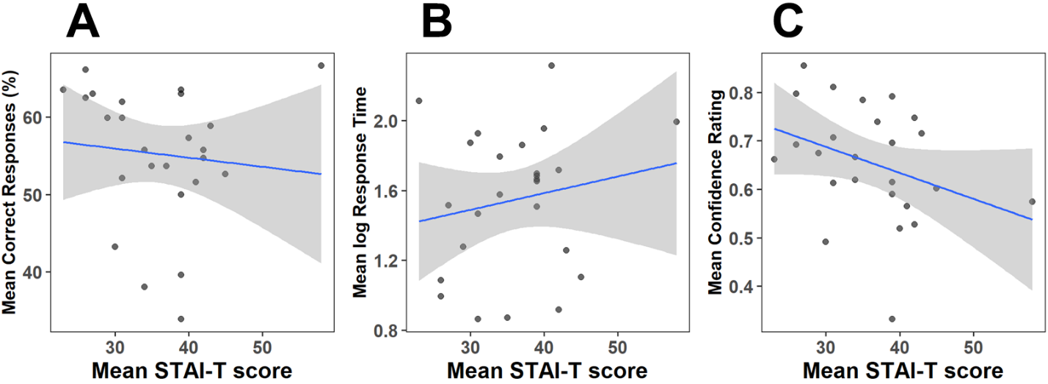
Supplementary Figure 2 | Participant-level means of STAI-T scores correlated with participant-level means of CR RT and CFR. None of these correlations reached significance. The largest (though still non‑significant) effect was the negative correlation between STAI‑T and CFR (r = −0.34, p = .092). a, Since the participant level mean of CR was not normally distributed, we ran a Spearman correlation. b-c, For RT and CFR Pearson correlations were performed since they together with STAI-T were are normally distributed at the participant-mean levels.
Supplementary Table 12. Summary of participant-level mean correlation between STAI-T, CR, log RT and CFR.
Correlation pair | Test | r / ρ | 95 % CI | p
STAI-T × Correct Response | Spearman ρ | −0.23 | — | .265
STAI-T × log Response Time | Pearson r | 0.18 | −0.23 – 0.54 | .394
STAI-T × Confidence Rating | Pearson r | −0.34 | −0.65 – 0.06 | .092

