Supplementary data
Synergistic Role of Micropore Structure and N/O Dual Functional Groups in Enhancing Low-Temperature NH₃-SCR Denitration over Activated Carbon Catalysts: Structural Evolution and Mechanistic Insights
Jihui Yang¹, Minghao Shi¹, Jiahao Zheng¹, Shule Zhang*¹, and Qin Zhong¹
1. School of Chemistry and Chemical Engineering, Nanjing University of Science and Technology, Nanjing 210094, PR China.
* Corresponding author, Tel.: +86 25 84315517
* E-mail: shulezhang@163.com (Shule Zhang).

1. Experimental methods
1.1 Material Characterizations
The X-ray diffraction (XRD) patterns of the samples were carried out using a D2 PHASER (Bruker, Germany) equipped with a Cu Kα radiation. The data were collected between 5-80° with a step size of 0.02°. The morphology was studied by field emission scanning transmission microscopy (FESEM, JEOL, JSM-7800F PRIME, Japan). The Brunauer-Emmett-Teller (BET) specific surface area measurements were determined on an automatic aperture analyzer (Micromeritics, ASAP 2460). The chemical compositions of the samples were determined by X-ray photoelectron spectroscopy (XPS, Perkin Elmer, PHI-5000C ESCA system, America) with Al Kα radiation (hν = 1486.6 eV), and all the data were corrected by the C 1s adventitious located at 284.4 eV.
Ammonia temperature-programmed desorption and Mass Spectrometry (NH₃-TPD&MS), Nitrogen monoxide temperature-programmed desorption and Mass Spectrometry (NH3-TPD&MS) were performed on an automated catalyst characterization system (Micromeritics, AutoChem II 2920, America) equipped with a thermal conductivity detector (TCD) and mass spectrometry (HPR-20 EGA, Hiden Analytical, U. K.).
In situ FTIR experiments were carried out by a Nicolet IZ10 FTIR spectrometer, equipped with a liquid-nitrogen cooled MCT detector. Prior to each experiment, background was taken by recording the IR spectrum of KBr in a N₂ stream at 300 °C, and had been deducted for each spectrum. During the experiment, 32 scans were averaged for each IR spectra, which were recorded at a resolution of 4 cm⁻¹; each catalyst was preheated at 240 °C for 60 min under at a flow of 40 mL min⁻¹ before experiments; the total flow rate of gas was 40 mL min⁻¹; the concentration of NO, NH₃, and O₂ in mixture gas were 500 ppm, 500 ppm, and 10 vol%, respectively. In the NH₃ or NO + O₂ adsorption experiment, the catalysts were heated to 120 °C at a rate of 10 °C min⁻¹, and the background spectra of catalysts were respectively recorded. The adsorption of NH₃ (NO + O₂) was conducted at 120 °C, and the spectra of catalyst were recorded as a function of time. For the reaction of pre-absorbed NH₃ (NO + O₂) with NO + O₂ (NH₃), the catalysts were heated to 120 °C in a rate of 10 °C min⁻¹, the NO + O₂ (NH₃) introduced after NH₃ (NO + O₂) pre-absorbed for 60 min, the spectra of catalyst recorded as a function of time.
1.2 Catalytic tests
Evaluate the NH₃-SCR activity of the catalyst using a fixed-bed quartz tube reactor filled with 1ml and 2ml of catalyst. The reaction conditions were set to maintain a total flow rate of 150 mL min⁻¹, equivalent to a GHSV of 9000 h⁻¹ and 4500 h⁻¹, with the following concentrations: 500 ppm NH₃, 500 ppm NO, 10% O₂, balanced with N₂. The reaction was carried out from 120 to 240 °C, and each measuring point of the powder catalyst was insulated for 50 min to obtain stable sampling data, and then the product gas was analyzed by a Thermo NO_{x} analyzer.

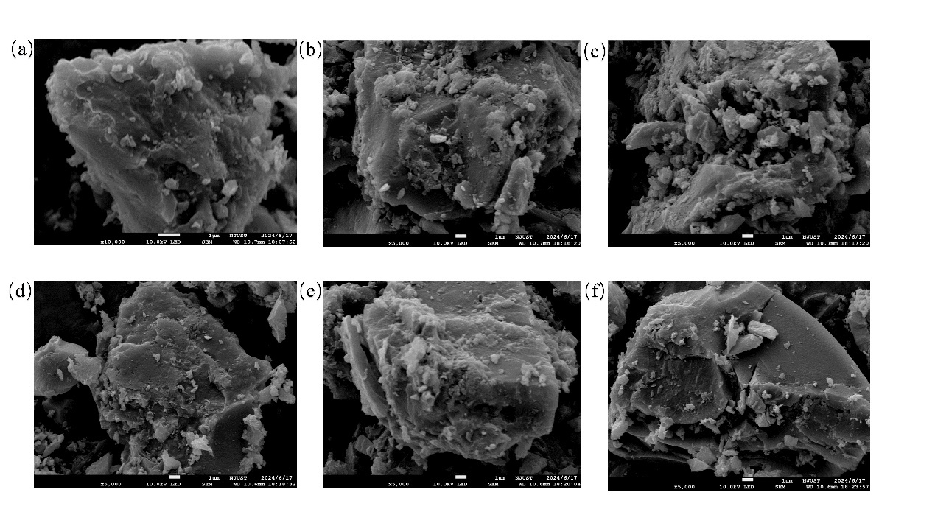
Fig. S1 The SEM images of (a)OAC, and (b) NOAC-400 and (c) NOAC-500 and (d) NOAC-700 and (e) NOAC-800 and (f) NOAC-900.
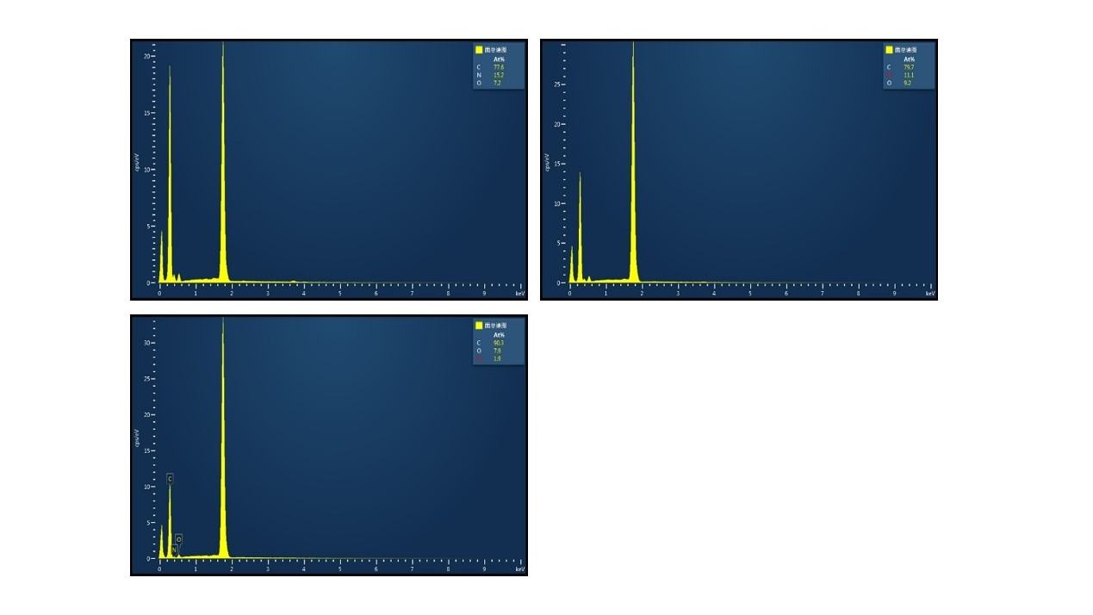
Fig. S2 The EDS images of NOAC-400, NOAC-600 and NOAC-800.
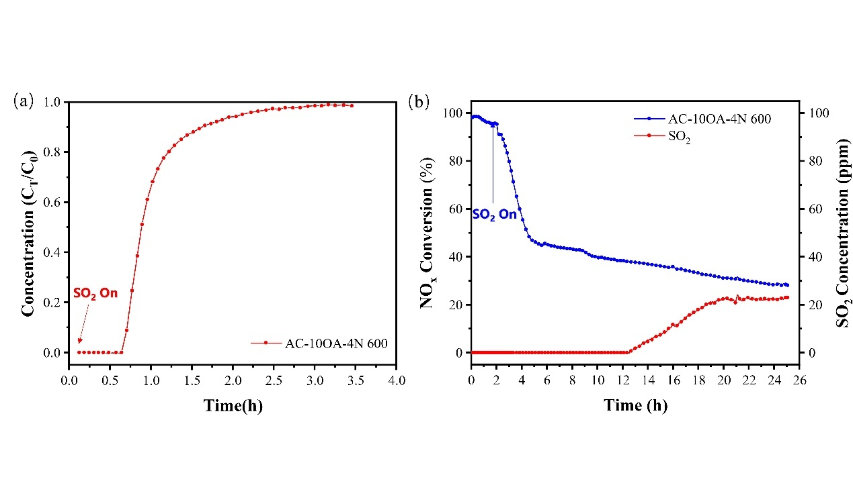
Fig. S3 (a)SO₂ Breakthrough Curve of NOAC-600 and (b) SO₂ tolerance tests of NOAC-60.

