Supplemental Material

Table S1. Life table model for the total cohort by categories of daily step counts.
Age (years) | Steps/d
Age (years) | <4000  (reference group) | 4000-5999 | 6000-7999 | 8000-9999 | 10000-11999 | ≥12000
40 | 33.3 | 38.7 | 42.3 | 45.2 | 46.9 | 48.1
41 | 32.4 | 37.8 | 41.4 | 44.3 | 46.0 | 47.2
42 | 31.6 | 36.9 | 40.5 | 43.3 | 45.0 | 46.2
43 | 30.8 | 36.1 | 39.6 | 42.4 | 44.1 | 45.3
44 | 29.9 | 35.2 | 38.7 | 41.5 | 43.2 | 44.4
45 | 29.1 | 34.3 | 37.8 | 40.6 | 42.3 | 43.5
46 | 28.3 | 33.5 | 37.0 | 39.7 | 41.4 | 42.5
47 | 27.5 | 32.6 | 36.1 | 38.8 | 40.5 | 41.6
48 | 26.8 | 31.8 | 35.2 | 37.9 | 39.6 | 40.7
49 | 26.0 | 31.0 | 34.4 | 37.1 | 38.7 | 39.8
50 | 25.2 | 30.2 | 33.5 | 36.2 | 37.8 | 38.9
51 | 24.5 | 29.4 | 32.7 | 35.3 | 36.9 | 38.0
52 | 23.8 | 28.6 | 31.9 | 34.5 | 36.0 | 37.1
53 | 23.0 | 27.8 | 31.0 | 33.6 | 35.2 | 36.3
54 | 22.3 | 27.0 | 30.2 | 32.8 | 34.3 | 35.4
55 | 21.7 | 26.3 | 29.4 | 31.9 | 33.5 | 34.5
56 | 21.0 | 25.5 | 28.6 | 31.1 | 32.6 | 33.7
57 | 20.3 | 24.8 | 27.9 | 30.3 | 31.8 | 32.8
58 | 19.7 | 24.1 | 27.1 | 29.5 | 31.0 | 32.0
59 | 19.1 | 23.4 | 26.4 | 28.7 | 30.2 | 31.2
60 | 18.5 | 22.7 | 25.6 | 27.9 | 29.4 | 30.4
61 | 17.9 | 22.0 | 24.9 | 27.2 | 28.5 | 29.5
62 | 17.3 | 21.3 | 24.1 | 26.4 | 27.7 | 28.7
63 | 16.7 | 20.6 | 23.4 | 25.6 | 26.9 | 27.9
64 | 16.1 | 19.9 | 22.6 | 24.8 | 26.1 | 27.1
65 | 15.5 | 19.3 | 21.9 | 24.0 | 25.3 | 26.3
66 | 14.9 | 18.6 | 21.2 | 23.3 | 24.6 | 25.5
67 | 14.4 | 18.0 | 20.5 | 22.5 | 23.8 | 24.7
68 | 13.8 | 17.3 | 19.8 | 21.8 | 23.0 | 23.9
69 | 13.3 | 16.7 | 19.1 | 21.1 | 22.3 | 23.1
70 | 12.8 | 16.1 | 18.5 | 20.4 | 21.5 | 22.4
71 | 12.2 | 15.4 | 17.7 | 19.6 | 20.7 | 21.6
72 | 11.6 | 14.8 | 17.0 | 18.8 | 20.0 | 20.8
73 | 11.1 | 14.1 | 16.3 | 18.1 | 19.2 | 20.0
74 | 10.5 | 13.5 | 15.6 | 17.4 | 18.4 | 19.2
75 | 10.0 | 12.9 | 14.9 | 16.6 | 17.7 | 18.4
76 | 9.5 | 12.3 | 14.3 | 15.9 | 17.0 | 17.7
77 | 9.0 | 11.7 | 13.7 | 15.3 | 16.2 | 16.9
78 | 8.6 | 11.1 | 13.0 | 14.6 | 15.5 | 16.2
79 | 8.1 | 10.6 | 12.4 | 13.9 | 14.9 | 15.5
80 | 7.7 | 10.1 | 11.9 | 13.3 | 14.2 | 14.8
81 | 7.2 | 9.5 | 11.2 | 12.6 | 13.5 | 14.1
82 | 6.7 | 8.9 | 10.6 | 11.9 | 12.8 | 13.3
83 | 6.3 | 8.4 | 10.0 | 11.3 | 12.1 | 12.6
84 | 5.8 | 7.9 | 9.4 | 10.6 | 11.4 | 11.9
85 | 5.4 | 7.3 | 8.8 | 10.0 | 10.7 | 11.2
86 | 5.0 | 6.9 | 8.3 | 9.4 | 10.1 | 10.6
87 | 4.6 | 6.4 | 7.7 | 8.8 | 9.5 | 9.9
88 | 4.2 | 5.9 | 7.2 | 8.2 | 8.8 | 9.3
89 | 3.9 | 5.5 | 6.7 | 7.7 | 8.3 | 8.7
90 | 3.6 | 5.1 | 6.2 | 7.2 | 7.7 | 8.1
91 | 3.3 | 4.8 | 5.8 | 6.6 | 7.1 | 7.5
92 | 3.0 | 4.4 | 5.4 | 6.1 | 6.6 | 6.9
93 | 2.8 | 4.1 | 5.0 | 5.7 | 6.1 | 6.3
94 | 2.6 | 3.8 | 4.6 | 5.2 | 5.5 | 5.8
95 | 2.4 | 3.5 | 4.2 | 4.7 | 5.0 | 5.2
96 | 2.2 | 3.2 | 3.8 | 4.3 | 4.5 | 4.7
97 | 2.1 | 3.0 | 3.5 | 3.8 | 4.0 | 4.1
98 | 2.0 | 2.7 | 3.1 | 3.3 | 3.4 | 3.5
99 | 2.0 | 2.5 | 2.6 | 2.8 | 2.8 | 2.9
100 | 2.2 | 2.2 | 2.2 | 2.2 | 2.2 | 2.2

Figure S1. Diagram of participants selection.

Figure S2. Dose-response association between daily step counts and all-cause mortality.
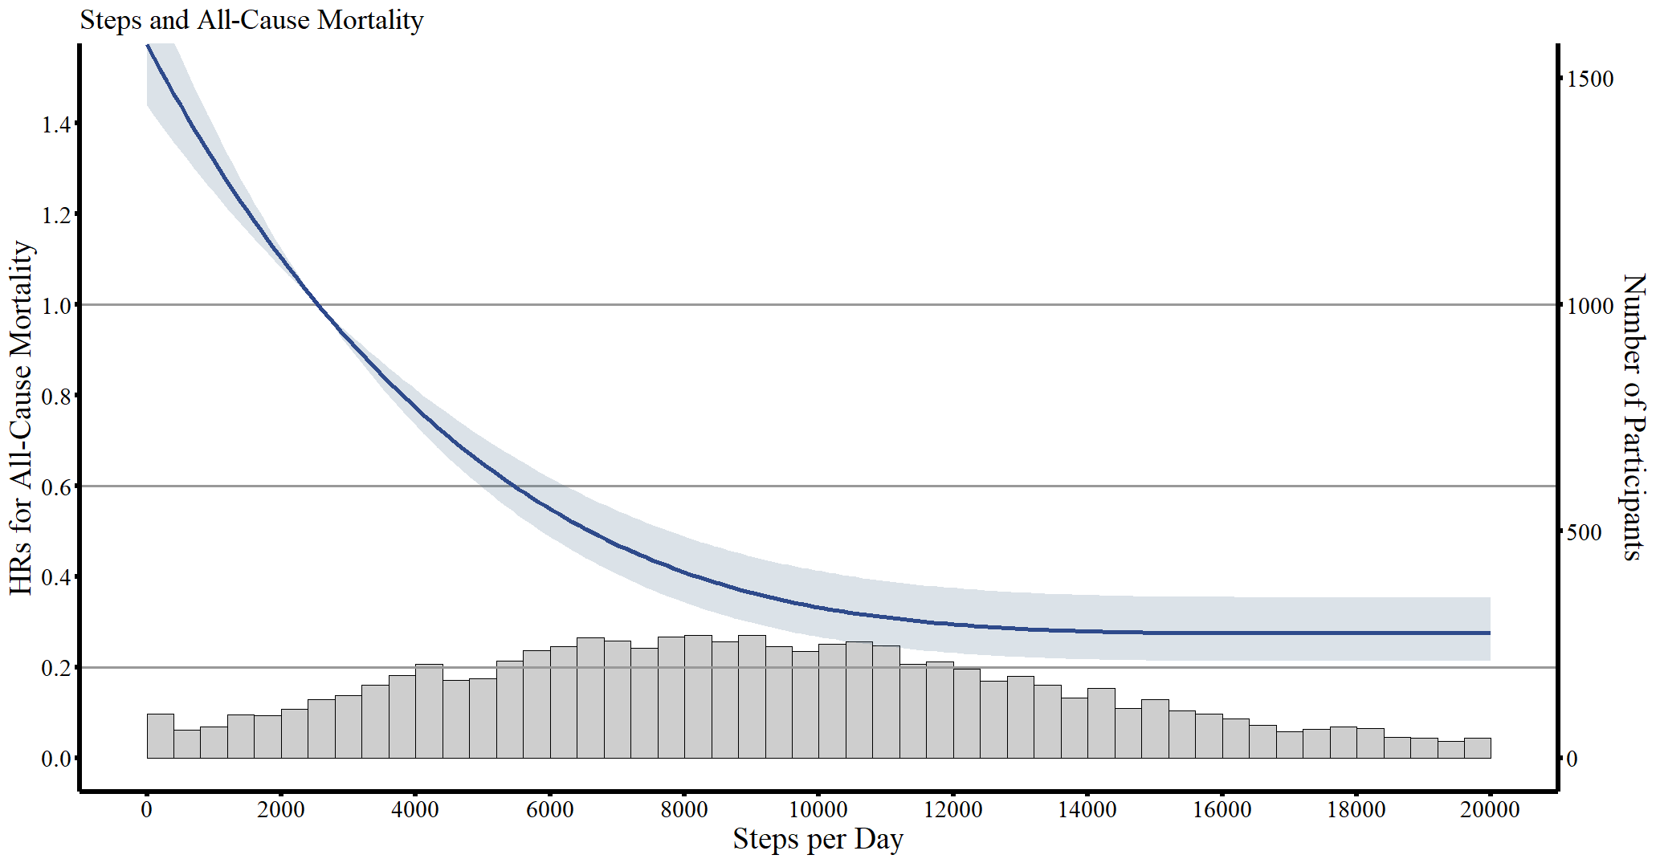

Figure S3. Dose-response association between daily step counts and all-cause mortality by sex (Male/Female).
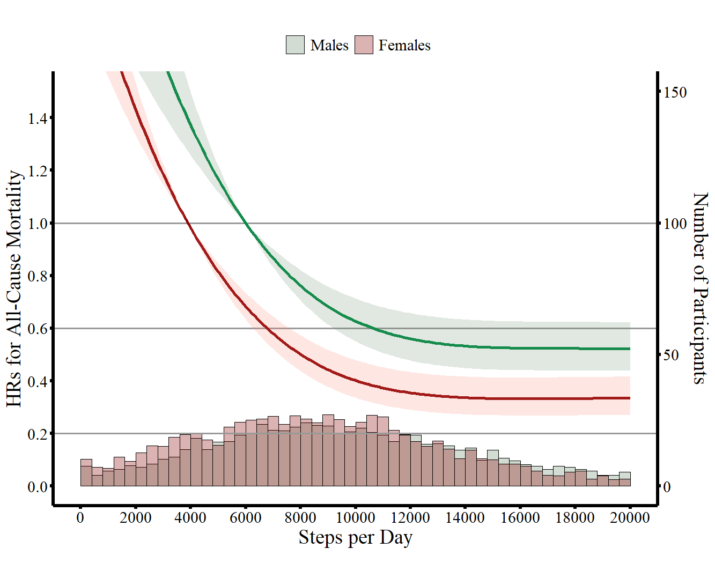

Figure S4. Dose-response association between daily step counts and all-cause mortality by race/ethnicity (Non-Hispanic White/Non-Hispanic Black/Hispanic).
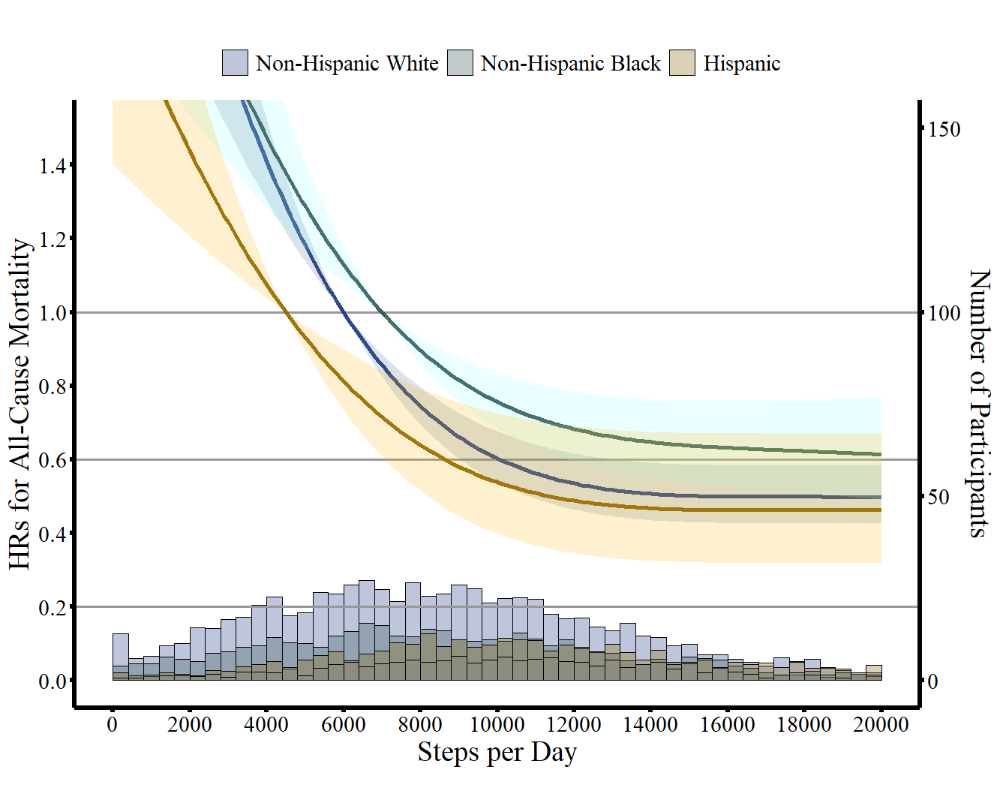

Figure S5. Estimates of life expectancy across age groups stratified by daily step count categories among males aged 40 and over.
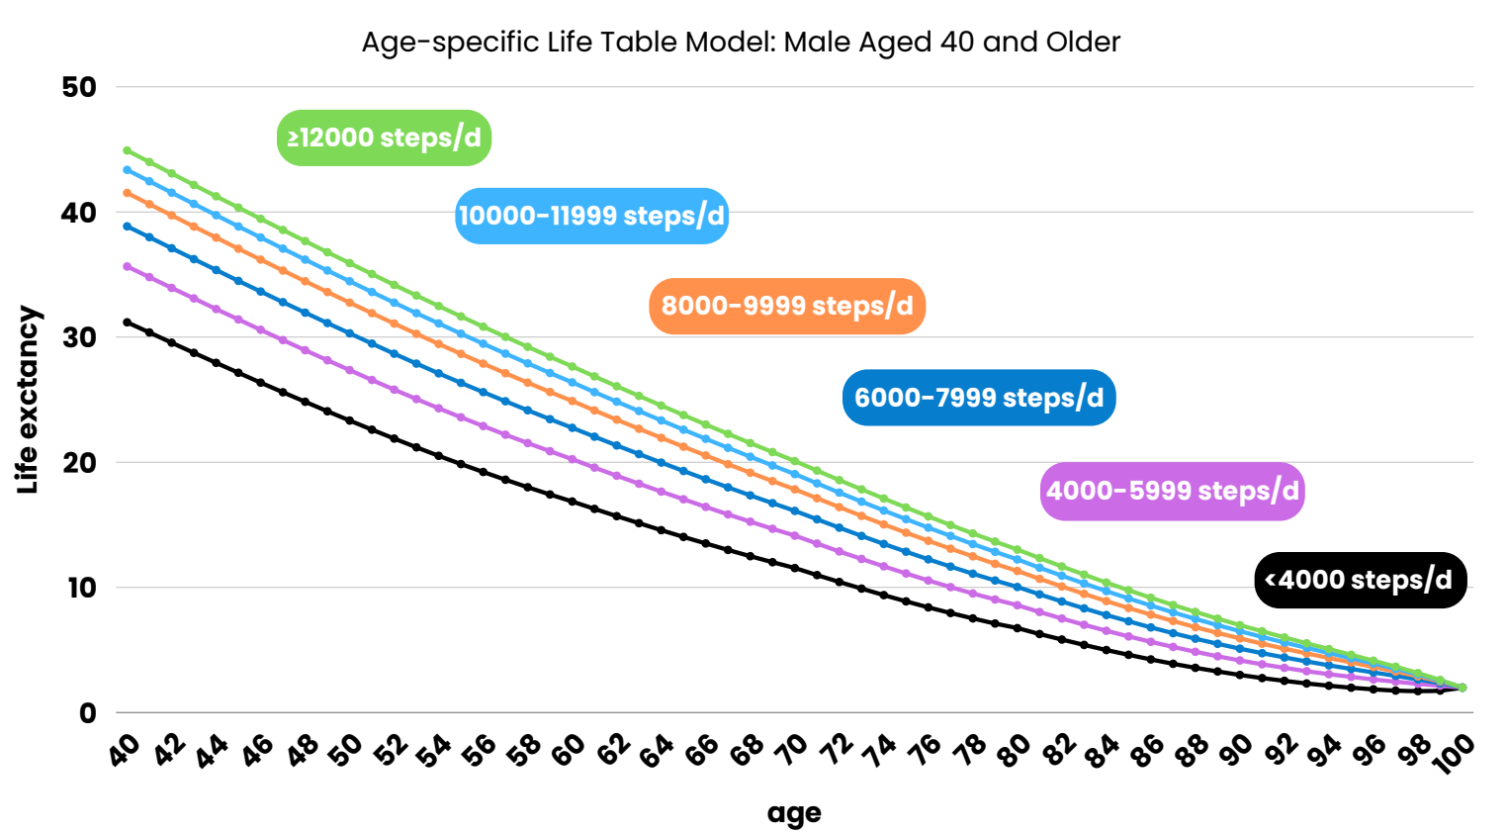

Figure S6. Estimates of life expectancy across age groups stratified by daily step count categories among females aged 40 and over.
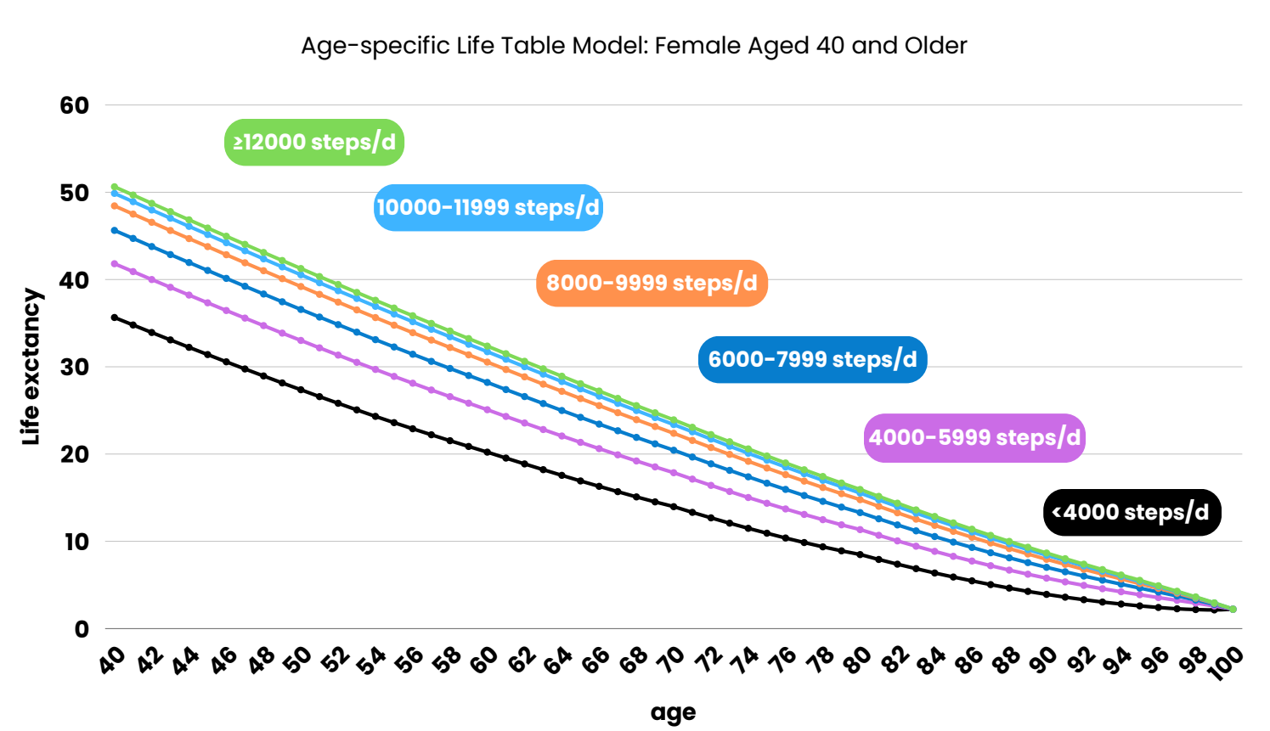

Figure S7. Estimates of life expectancy across age groups stratified by daily step count categories among Non-Hispanic White participants aged 40 and over.
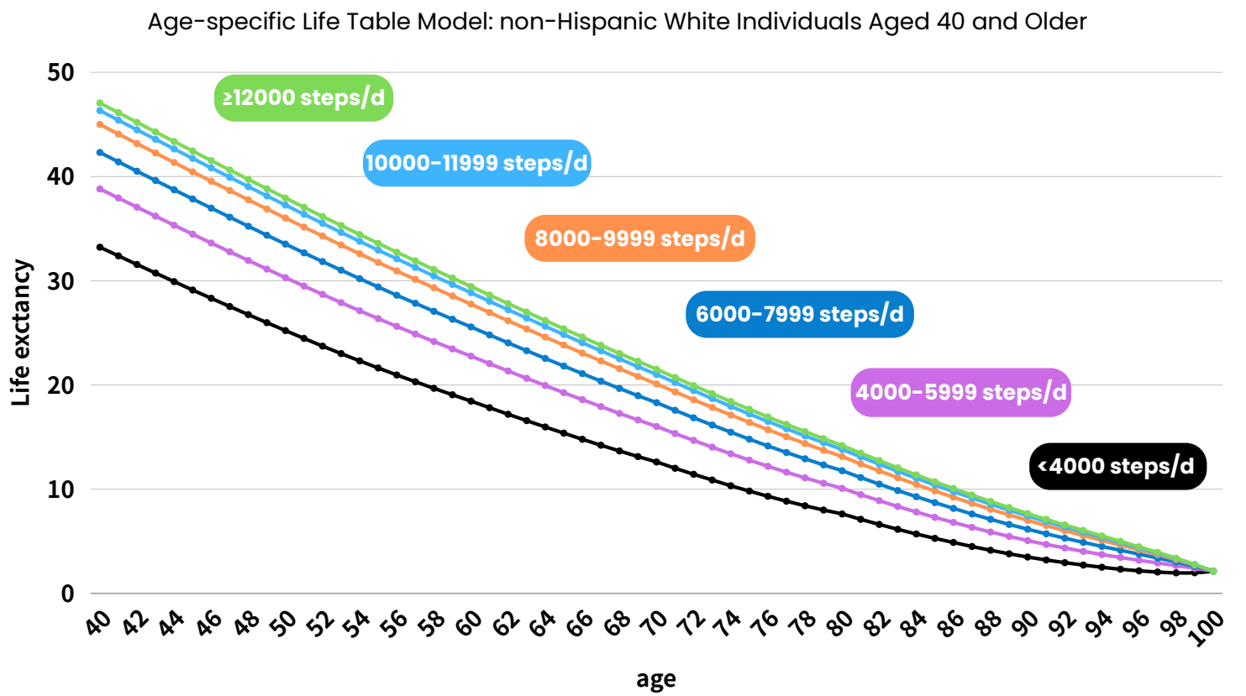

Figure S8. Estimates of life expectancy across age groups stratified by daily step count categories among Non-Hispanic Black participants aged 40 and over.
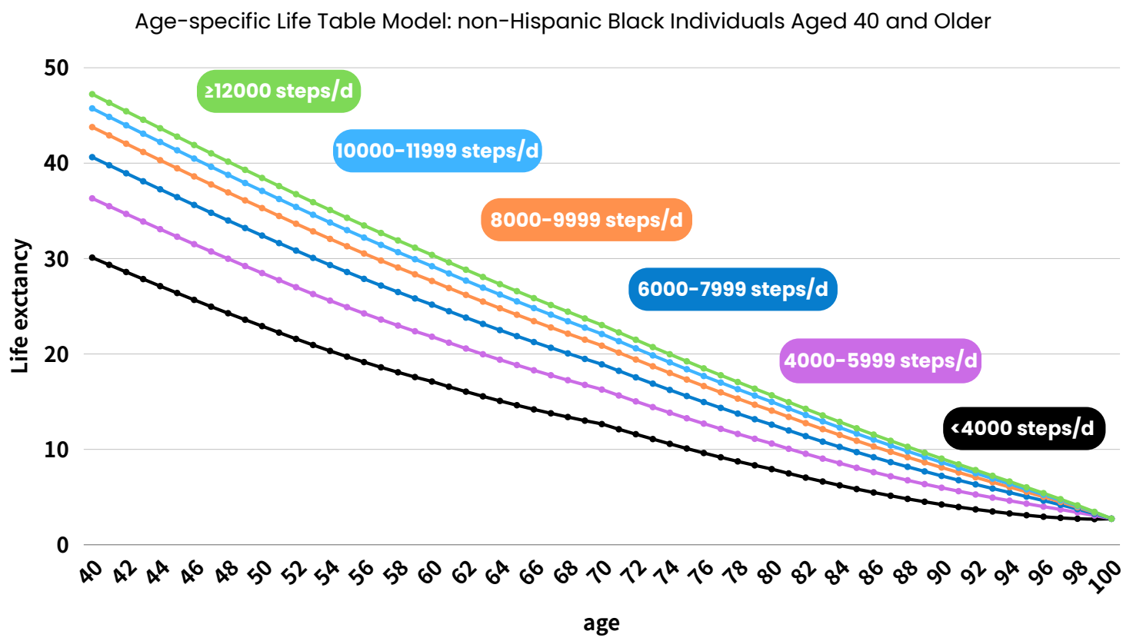

Figure S9. Estimates of life expectancy across age groups stratified by daily step count categories among Hispanic participants aged 40 and over.
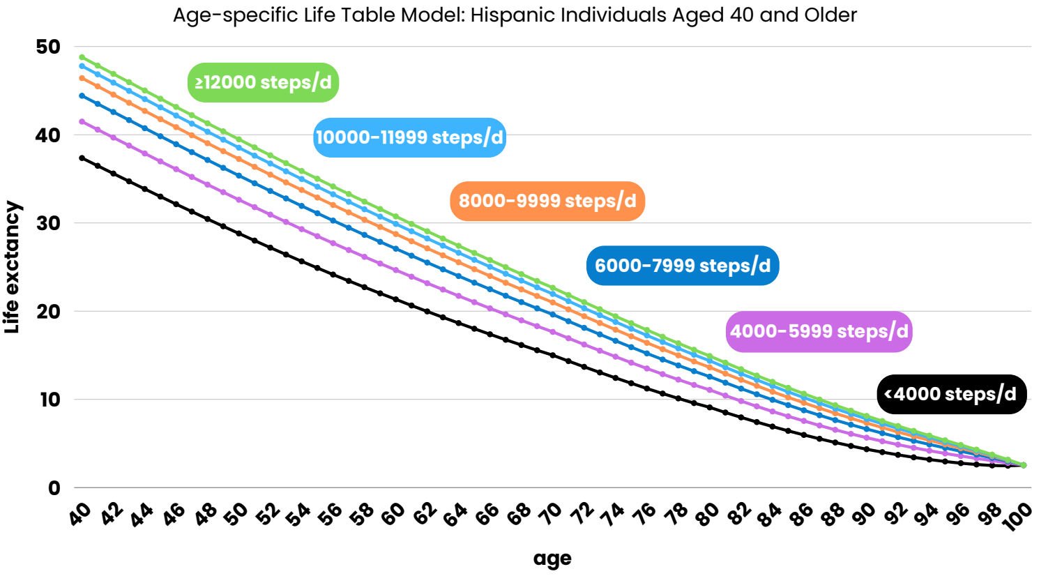

Figure S10. Sensitive analyses 1: Estimates of life expectancy across age groups stratified by daily step count, calculated using the Verisense 2 algorithm, among participants aged 40 and older.
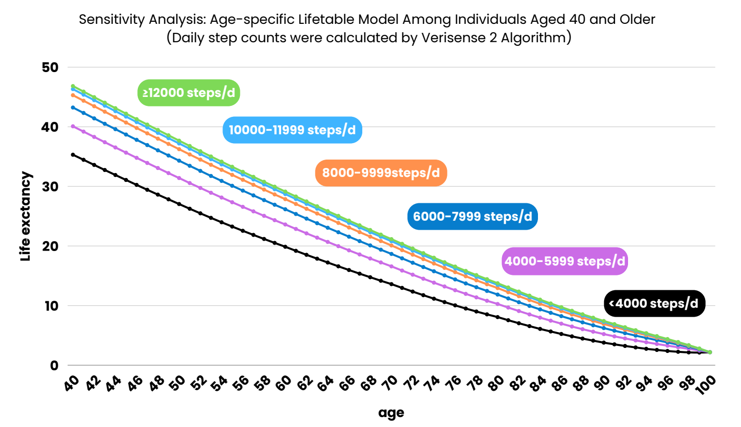

Figure S11. Sensitive analyses 2: Estimates of life expectancy across age groups stratified by daily step count, following Multiple Imputation by Chained Equations (MICE) to address missing covariate data.
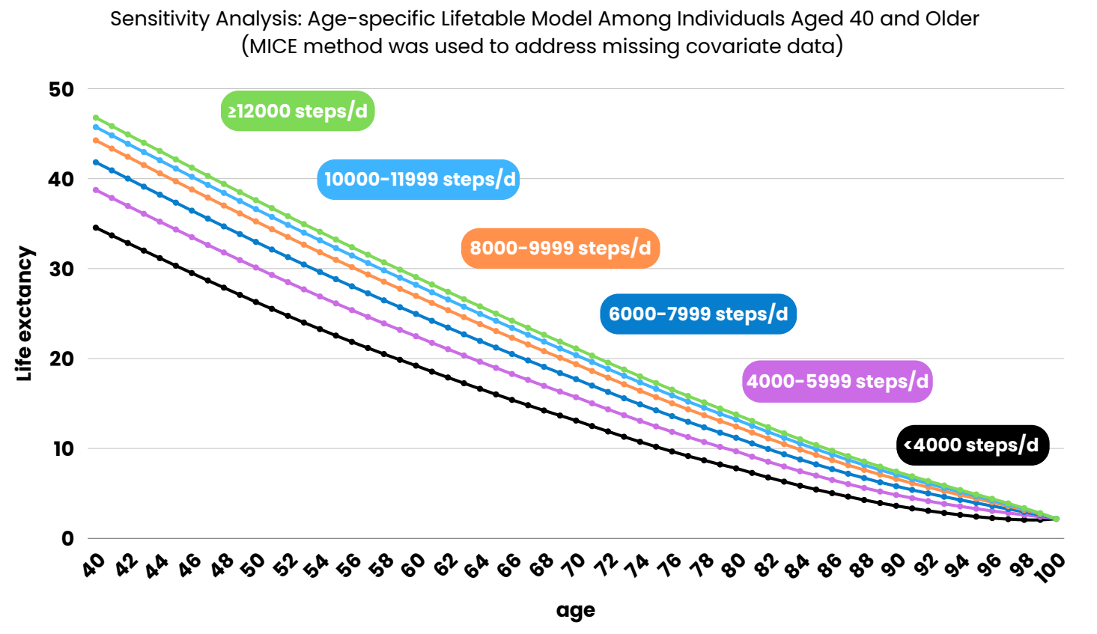

Figure S12. Sensitive analyses 3: Estimates of life expectancy across age groups stratified by daily step count, including only participants with at least four days of valid accelerometer wear time.
