Supplementary

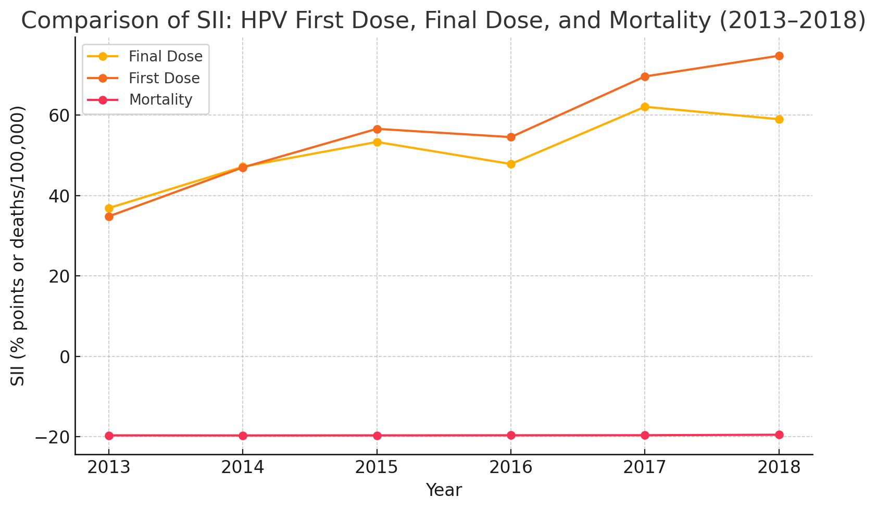
Figure S1. Comparison of SII trends in HPV first-dose coverage, final-dose coverage, and cervical cancer mortality (2013–2018)

