Supplementary File
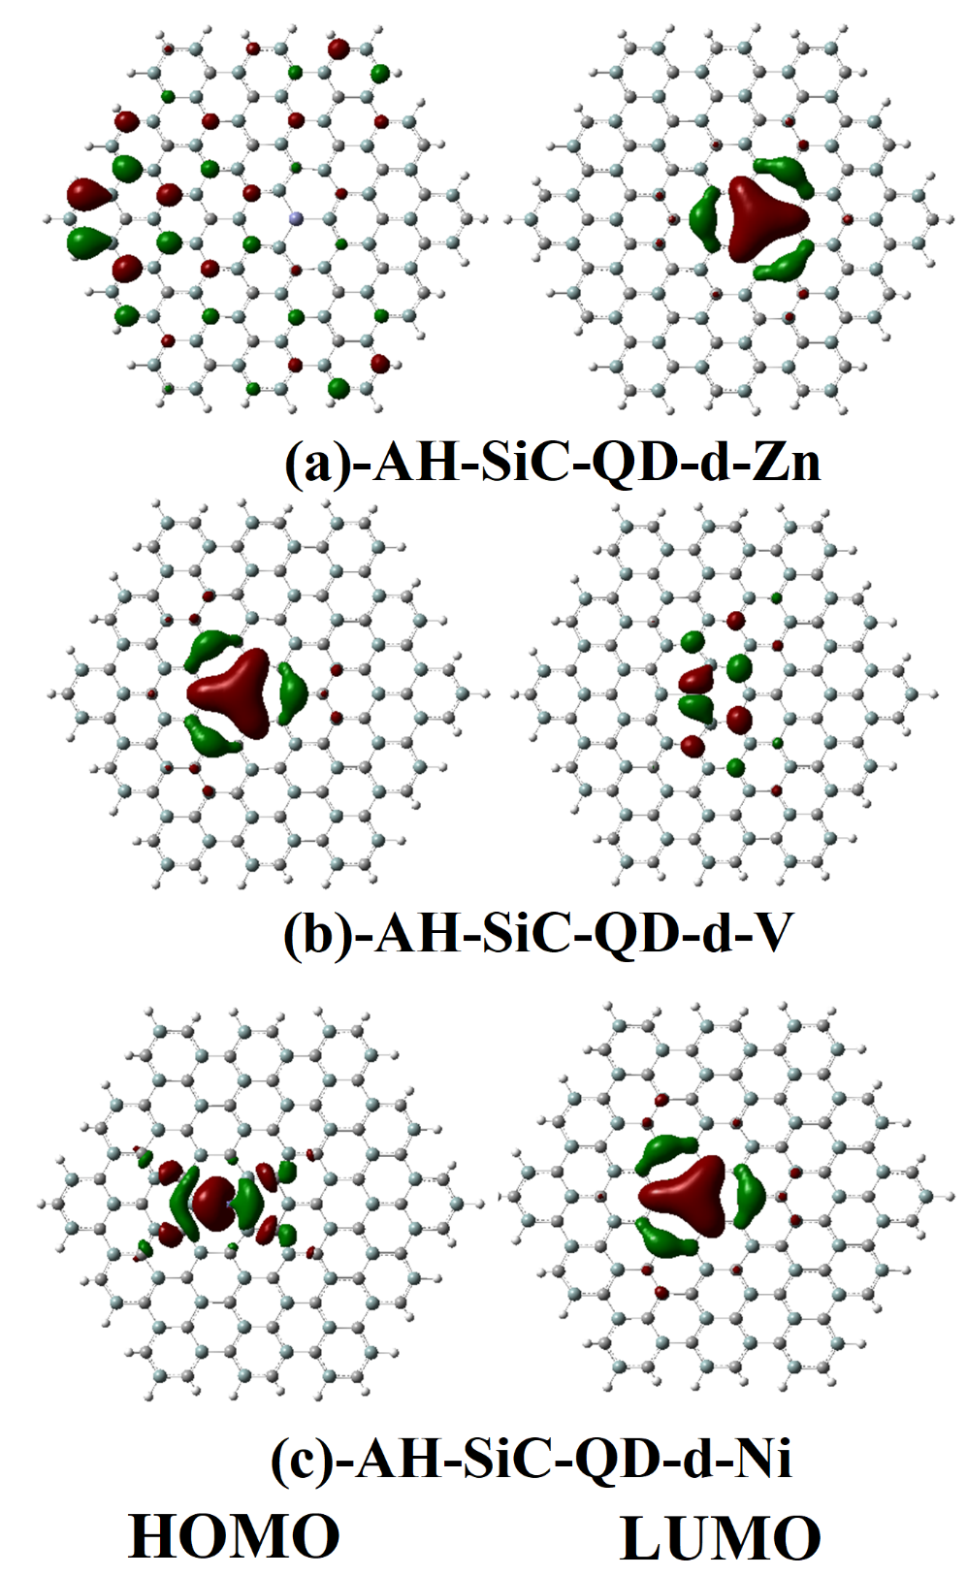
Figure S1. (a–c) HOMO/LUMO distributions of AH-SiC-QD doped with Zn, V, and Ni.

