Supplementary Material
Beyond 1100delC: Distinct CHEK2 Variants and Unique Cancer Phenotypes in Northeast Brazil
Mariana Macambira Noronha, Pedro Robson Costa Passos, Valbert Oliveira Costa Filho, Thais Baccili Cury Megid, Fernanda Teresa de Lima, Danielle Calheiros Campelo Maia
Summary
Figure S1: Flowchart summarizing the cohort included in the study…………………………….2
Figure S2: Geographical distribution of families with the CHEK2 variant in the State of Ceará.. 3

Figure 1. Flowchart summarizing the cohort included in the study.
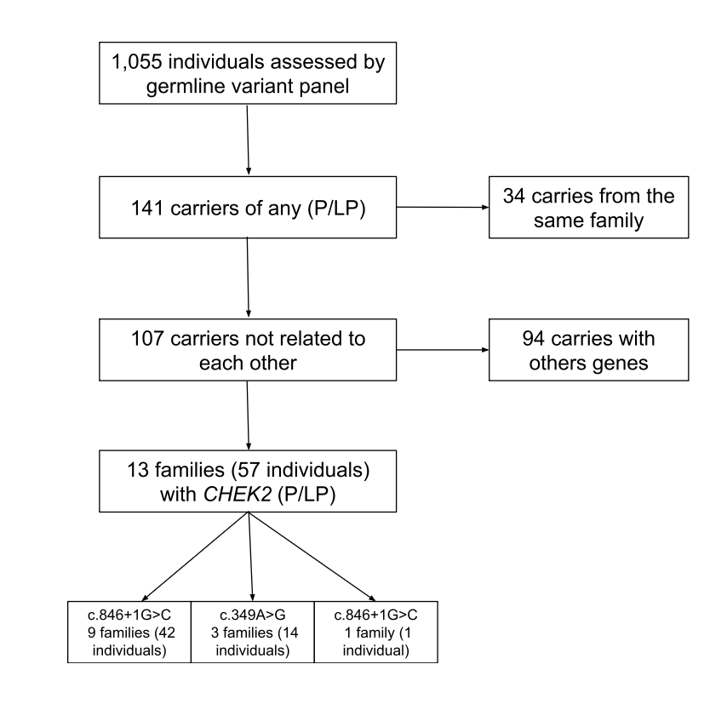

Figure 2. Geographical distribution of families with the CHEK2 variant in the State of Ceará
