Supplementary Data
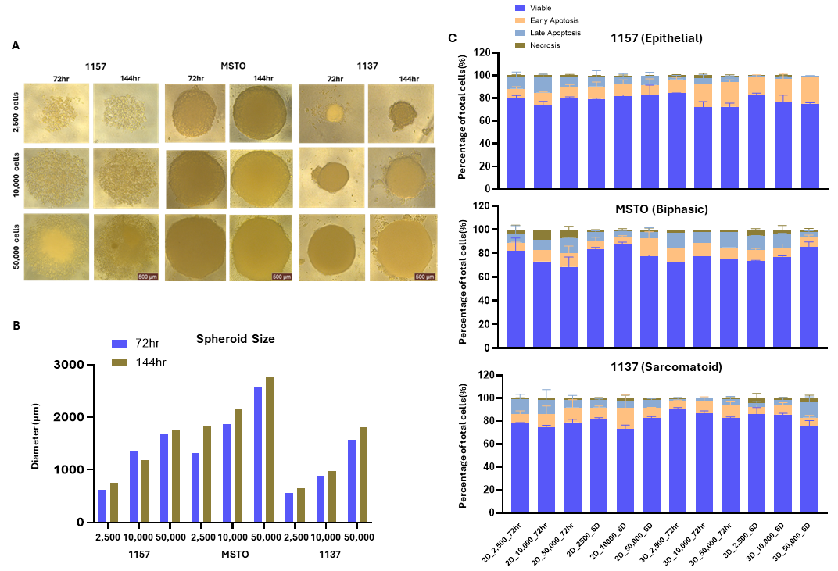

Supplementary Figure 1. Optimising seeding density and treatment time for mesothelioma spheroids. (A). Representative image of mesothelioma spheroids (1157 epithelial, MSTO Biphasic, 1137 sarcomatoid) that were cultured at seeding densities of 2,500, 10,000 and 50,000 cells for 72 and 144 hours. (B). Spheroid size (diameter) was measured to track growth over the 72-hour and 144-hour periods. (C). Spheroids viability and apoptosis rate were measured by annex V/PI flow cytometry. N=2-3 biological replicated. Error bar= SEM.

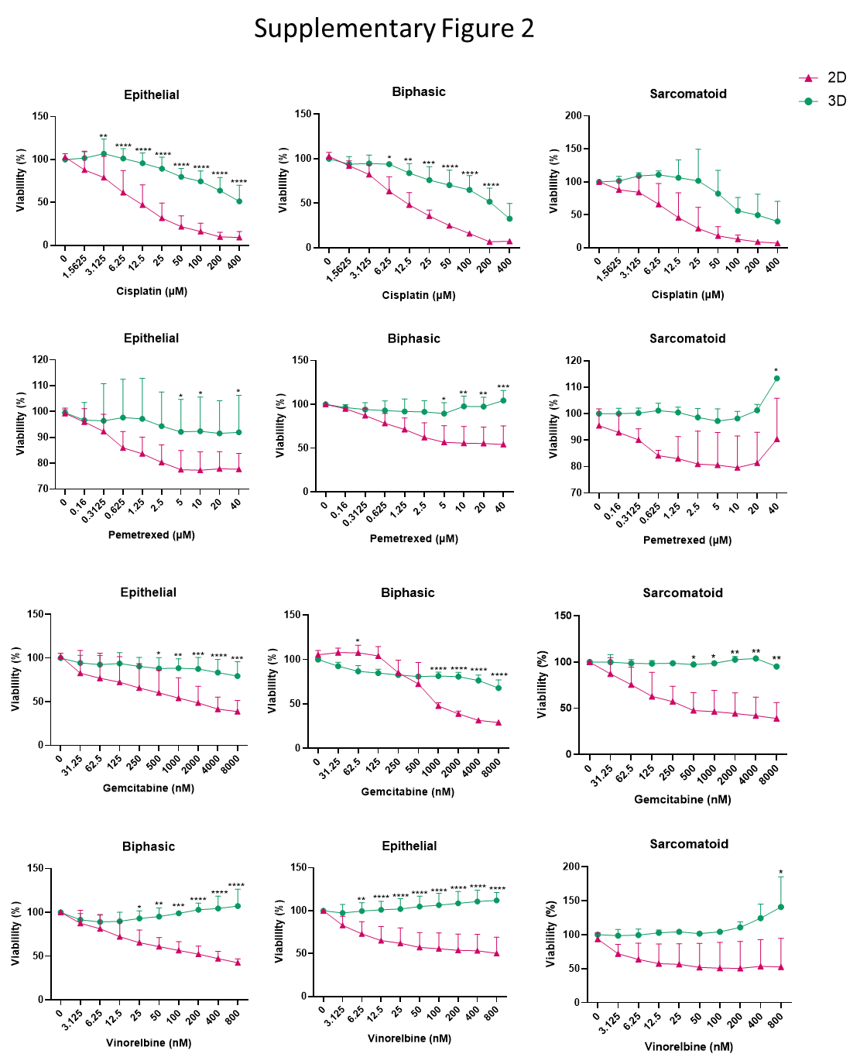

Supplementary Figure 2. 3D spheroids of mesothelioma cells show higher drug resistance to chemotherapy when compared to cells cultured in 2D. Cell viability for the remaining panel of mesothelioma cells post drug treatment in 2D and 3D spheroid models are shown. Each bar represents an average of n = 2 or 3 biological experiments. Error bars represents SEM. * p < 0.05, ** p < 0.01, *** p < 0.001, **** p < 0.0001.

Supplementary Table 1. List of miRNA qRT-PCR primer probes

microRNA | Sequence | Manufacturer
hsa-miR-RNU6B | CGCAAGGATGACACGCAAATTCGTGAAGCGTTCCATATTTTT | Thermo Fisher Scientific
hsa-miR-16 | UAGCAGCACGUAAAUAUUGGCG | Thermo Fisher Scientific
hsa-miR-21 | UAGCUUAUCAGACUGAUGUUGA | Thermo Fisher Scientific
hsa-miR-23a | AUCACAUUGCCAGGGAUUUCC | Thermo Fisher Scientific
hsa-miR-30e | UGUAAACAUCCUUGACUGGAAG | Thermo Fisher Scientific
hsa-miR-31* | UGCUAUGCCAACAUAUUGCCAU | Thermo Fisher Scientific
hsa-miR-221 | AGCUACAUUGUCUGCUGGGUUUC | Thermo Fisher Scientific
hsa-miR-222 | AGCUACAUCUGGCUACUGGGU | Thermo Fisher Scientific
Fold changes relative to untreated control

Supplementary Figure 3. Summary of miRNA expression in 13 mesothelioma cell lines cultured in 2D and 3D spheroids, treated with cisplatin and pemetrexed for 72 hours. N=3 biological replicates, * P<0.05.
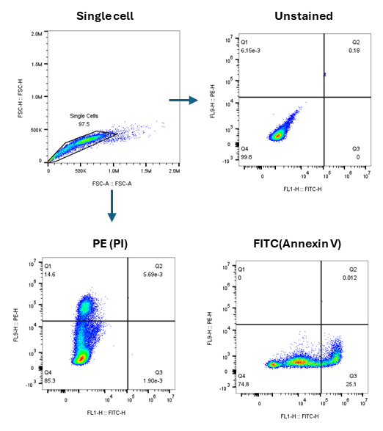

Supplementary Figure 4. Gating strategies for Annexin V (FITC) and PI (PE) co-staining for flow cytometry analysis.

Animal ID | Apoptosis/Necrosis % | Immune cell infitration% | CD8 positive cells | Fibrosis (Masson) | Chemotherapy Response
1 | ~ 10% apoptosis, 50% necrosis | ~5% Lymphocytes | 0 | 0 | Intermediate (50% necrosis/no fibrosis)
2 | ~ 10% apoptosis, 55% necrosis | ~10% Lymphocytes | 0 | 0 | Intermediate (55% necrosis/no fibrosis)
3 | ~ 5% apoptosis, 50% necrosis | ~5% Lymphocytes | low TILs (1+) | 0 | Intermediate (50% necrosis/no fibrosis)
4 | ~ 5% apoptosis, 45% necrosis | ~10% Lymphocytes | 0 | 0 | Intermediate (45% necrosis/no fibrosis)
5 | ~ 5% apoptosis, 40% necrosis | ~5% Lymphocytes | 0 | 0 | Intermediate (40% necrosis/no fibrosis)
6 | ~ 5% apoptosis,50% necrosis | Less than 5% (~1-2%) | low TILs (1+) | 0 | Intermediate (40% necrosis/no fibrosis)
7 | ~ 5% apoptosis,10% necrosis | ~15% Lymphocytes | low TILs (1+) | Mild fibrosis | Poor (10% necrosis/mild fibrosis)
8 | ~ less 5% apoptosis (~1%), 35% necrosis | ~5% Lymphocytes | 0 | 0 | Intermediate (35% necrosis/mild fibrosis)
9 | ~ 5% apoptosis, 0% necrosis | ~5% Lymphocytes, mainly at edge | 0 | Mild fibrosis | Poor (0% necrosis/no fibrosis)
10 | ~ 5% apoptosis, 40% necrosis | Less than 5% (~0%) | No slide | 0 | Intermediate (40% necrosis/no fibrosis)
11 | ~ 5% focal apoptosis, 40% necrosis | ~5% Lymphocytes | low TILs (1+) | 0 | Intermediate (40% necrosis/no fibrosis)
12 | ~ 5% focal apoptosis, 50% necrosis | ~10% Lymphocytes | No slide | No slide | Intermediate (50% necrosis/no fibrosis)
13 | ~ 5% focal apoptosis, 10% necrosis | Less than 5% (~1%) | low TILs (1+) | Mild fibrosis | Poor (10% necrosis/no fibrosis)
14 | ~ 10% apoptosis, 50% necrosis | ~5% Lymphocytes, mainly at edge | 0 | Mild fibrosis | Intermediate (50% necrosis/no fibrosis)
15 | ~ 5% apoptosis, 35% necrosis | Less than 5% (~2-3%) | 0 | Mild fibrosis | Intermediate (35% necrosis/mild fibrosis)
16 | ~ 10% focal apoptosis, 35% necrosis | ~5% Lymphocytes, mainly at edge | 0 | Mild fibrosis | Intermediate (35% necrosis/mild fibrosis)
17 | ~ 5% focal apoptosis, 30% necrosis | Less than 5% (~0%) | 0 | Mild fibrosis | Poor (30% necrosis/no fibrosis)
18 | ~ 5% focal apoptosis, 1% necrosis (very focal necrosis) | ~5% Lymphocytes | low TILs (1+) | Mild fibrosis | Poor (1% necrosis/no fibrosis)
19 | ~ 5% focal apoptosis, 5% necrosis | Less than 5% (~0%) | 0 | Mild fibrosis | Poor (5% necrosis/no fibrosis)
20 | ~ 5% focal apoptosis, 0% necrosis | Less than 5% (~0%) | 0 | Moderate Fibrosis | Absent
21 | ~ 5% focal apoptosis, 10% necrosis | Less than 5% (~0%) | 0 | Moderate Fibrosis | Poor (10% necrosis/miminal fibrosis)
22 | ~ 5% focal apoptosis, 0% necrosis | Less than 5% (~0%) | 0 | Mild fibrosis | Absent

Supplementary Table 2. Histological assessment of chemotherapy response of tumour growth from 2D and 3D cultured mesothelioma cells in pleural mesothelioma mice model.

Analyte | 2D tumour | 2D tumour Cis/Pem | 3D tumour | 3D tumour Cis/Pem
a-Fetoprotein | 7576.50 | 12959.00 | 17190.50 | 12549.50
Amphiregulin | 5978.00 | 10615.50 | 11504.00 | 11266.00
Angiopoietin-1 | 2936.50 | 6399.50 | 5629.50 | 4264.00
Angiopoietin-like4 | 8279.00 | 11223.00 | 10397.50 | 9210.50
ENPP-2/Autotaxin | 18780.00 | 13572.00 | 19504.00 | 18395.00
Axl | 19746.50 | 18248.00 | 26891.50 | 22931.00
BCL-x | 7298.00 | 5402.50 | 11365.00 | 14717.14
CA125/MUC16 | 3435.00 | 5480.00 | 6260.00 | 7575.00
E-Cadherin | 6120.00 | 10616.00 | 5555.50 | 9533.50
VE-Cadherin | 20505.00 | 15691.50 | 12600.00 | 18930.00
CapG | 23599.00 | 33630.50 | 35877.00 | 27533.00
Carbonic Anhydrase IX | 6812.00 | 11751.50 | 13703.00 | 9936.00
Cathepsin B | 5993.00 | 10925.50 | 11420.00 | 7988.00
Cathepsin D | 25767.00 | 33110.00 | 29758.50 | 22668.00
Cathepsin S | 12699.50 | 17484.50 | 17377.00 | 17121.00
CEACAM-5 | 6333.00 | 8576.00 | 8450.50 | 10547.50
Decorin | 6047.00 | 8336.00 | 6743.50 | 13463.50
Dkk-1 | 22296.50 | 23790.50 | 21833.50 | 30147.50
DLL1 | 7775.00 | 11139.00 | 5962.00 | 15076.50
EGF R/ErbB1 | 29272.50 | 35475.50 | 19006.50 | 39487.50
Endoglin | 18741.50 | 23698.50 | 35388.00 | 24476.00
Endostain | 6428.50 | 7886.50 | 11119.00 | 14427.00
Enolase 2 | 26056.00 | 27236.00 | 34157.00 | 22392.00
eNOS | 6359.50 | 6292.00 | 10890.00 | 7342.00
EpCAM/TROP1 | 10860.00 | 9933.00 | 15145.00 | 11556.00
Era/NR3A1 | 6952.50 | 8110.50 | 8643.50 | 8139.00
ErbB2 | 20302.50 | 19971.00 | 20636.00 | 18962.50
ErbB3/Her3 | 7623.50 | 12531.50 | 7773.00 | 13721.50
ErbB4 | 5277.50 | 6896.00 | 4363.50 | 8133.50
FGF basic | 36289.50 | 43223.50 | 27032.00 | 46974.00
FoxC2 | 6340.00 | 10756.50 | 12301.50 | 10286.50
Fox01/FKHR | 7281.00 | 9538.50 | 12574.50 | 9232.50
Gaectin-3 | 38973.50 | 46458.50 | 52408.00 | 43188.00
GM-CSF | 9086.50 | 12288.50 | 14941.50 | 10071.50
CG a/b (HCG) | 7567.00 | 6748.50 | 13292.50 | 9073.00
HGF R/c-Met | 7096.00 | 6855.00 | 12768.50 | 9668.50
HIF-1a | 12342.00 | 7768.50 | 13915.50 | 12113.00
NHF-3b | 8412.00 | 5976.00 | 8740.00 | 10446.00
HO-1/HMOX1 | 10936.00 | 8486.00 | 11381.50 | 14429.00
ICAM-1/CD54 | 7137.00 | 6181.50 | 6954.00 | 7549.00
IL-2 Ra | 9480.50 | 7859.50 | 8587.00 | 13156.00
IL-6 | 10003.00 | 7864.50 | 4453.50 | 13644.50

Analyte | 2D tumour | 2D tumour Cis/Pem | 3D tumour | 3D tumour Cis/Pem
CXCL8/IL-8 | 8113.50 | 11981.50 | 14384.00 | 11319.50
IL-18 Bpa | 5620.50 | 7314.00 | 8950.00 | 7154.50
Kallikrein 3/PSA | 7042.00 | 8252.50 | 11171.00 | 9019.50
Kallikrein 5 | 1990.00 | 5000.00 | 5328.50 | 3130.00
Kallikrein 6 | 5236.50 | 6637.50 | 8118.00 | 6056.00
Leptin | 4398.50 | 4758.00 | 6695.50 | 3631.50
Lumican | 3029.50 | 3026.50 | 4821.50 | 4506.50
CCL2/MCP-1 | 3619.00 | 4130.00 | 4552.00 | 5589.50
CCL8/MCP-2 | 8539.50 | 7508.50 | 9202.00 | 11187.00
CCL7/MCP-3 | 3999.00 | 3026.00 | 4815.00 | 5623.50
M-CSF | 8888.50 | 7458.50 | 8616.50 | 11932.00
Mesothelin | 8676.50 | 9021.00 | 4480.00 | 7999.00
CCL3/MIP-1a | 5076.00 | 7993.50 | 4651.00 | 7207.50
CCL20/MIP=3a | 9155.00 | 10712.00 | 12872.00 | 10584.00
MMP-2 | 15733.00 | 16986.50 | 26062.50 | 17124.00
MMP-3 | 22803.50 | 21894.50 | 28207.00 | 17788.00
MMP-9 | 3861.00 | 7548.50 | 7796.00 | 5057.00
MSP/MST1 | 6717.50 | 8982.00 | 10277.50 | 7781.00
MUC-1 | 3284.00 | 5096.00 | 4425.00 | 4133.00
Nectin-4 | 7634.00 | 8733.00 | 8545.50 | 10414.00
Osteopontin | 14150.00 | 17183.00 | 15993.00 | 17586.50
p27/Kip1 | 9238.00 | 8538.50 | 8588.50 | 6877.00
p53 | 19264.50 | 16006.00 | 15868.50 | 25341.50
PDGF-AA | 9181.00 | 10632.50 | 5493.00 | 8488.00
CD31/PECAM-1 | 8642.00 | 11255.50 | 14155.50 | 11159.00
Progesterone R | 11577.50 | 12505.50 | 14919.00 | 12202.50
Progranulin | 27983.00 | 35676.50 | 33902.00 | 27752.00
Prolactin | 10499.50 | 12777.00 | 12606.50 | 7462.50
Prostasin | 5468.00 | 9749.50 | 9961.50 | 7004.00
E-Selectin | 4295.50 | 6818.50 | 6418.00 | 4335.50
Serpin B5 | 15260.50 | 18273.50 | 18712.50 | 18281.50
Serpin E1 | 20374.00 | 25940.50 | 21084.00 | 22528.00
Snail | 13211.50 | 16515.50 | 14753.00 | 11952.00
SPARC | 14365.50 | 17070.00 | 12143.50 | 11008.00
Survivin | 19406.00 | 18470.00 | 13113.00 | 17326.50
Tenascin C | 6476.00 | 7209.00 | 3197.50 | 4013.00
Thrombospondin-1 | 5446.00 | 14928.00 | 7397.50 | 6619.50
Tie-2 | 7821.50 | 11375.00 | 10750.00 | 8951.50
u-Plasminogen Activator | 9282.00 | 10961.00 | 10671.50 | 8729.00
VCAM-1 | 6211.00 | 5728.00 | 6773.50 | 5618.50
VEGF | 7066.50 | 9507.50 | 10611.00 | 8680.00
Vimentin | 9523.50 | 8888.00 | 14761.50 | 8220.50

Supplementary Table 3. Protein expression levels of cancer-related human genes in 2D and 3D spheroids derived tumour pre- and post-cisplatin and pemetrexed treatment. The raw data is expressed as pixel density measured using imageJ.

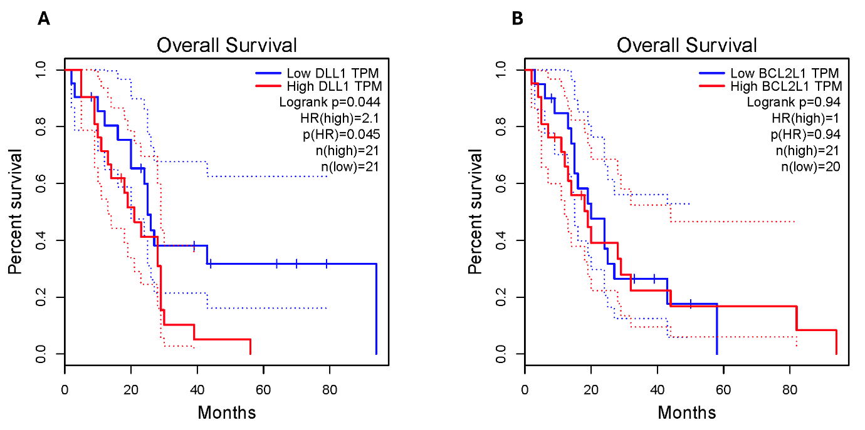
Supplementary Figure 5. High expression levels of DLL1 (P < 0.05) and BCL-XL (BCL2L1) are associated with poor overall survival in patients with pleural mesothelioma, based on data accessed and analysed from the TCGA database.

