Supplementary Materials and Methods

DSS-induced UC model and TNBS-induced colitis model
Acute UC was induced by feeding mice 2.5% dextran sodium sulphate solution (DSS, Millipore, Billerica, MA, USA) dissolved in physiological saline.¹ Seven days later, the mice were allowed to recover with normal drinking water for 3 days. From day 3 of modelling, the mice were intravenously injected with genetic circuits or inﬂiximab once a day for seven times until they were euthanized on day 10.
For the DSS-induced chronic UC model, BALB/c mice were allowed to rhythmically drink 2.5% DSS for 1 week and normal water for 2 weeks, and the cycle was repeated 3 times.² Four days after each DSS drinking, the mice were intravenously injected with PBS or genetic circuits for a total of 3 times, once every 2 days. One day after the final injection on day 52, the mice were euthanized and analysed.
For the AAV-based strategy, BALB/c mice were intravenously injected with 25, 50 or 100 μL AAV-CMV-siR^{TNF-α} or AAV-CMV-siR^{T+B+I} (10¹² V. g/ml) coexpressing a luciferase reporter. Luciferase activity was monitored at weeks 1, 3 and 10 by noninvasive in vivo bioluminescence imaging. At week 3, the mice were rhythmically administered DSS to establish a chronic UC model, and the therapeutic effects were evaluated at week 10.
A TNBS-induced acute colitis model was established by intracolonic administration of 2.5% TNBS solution.¹ Briefly, BALB/c mice were fasted for 48 hours with free access to drinking water to remove as much stool as possible and then anaesthetized with pentobarbital sodium. A polyethylene catheter (2 mm in outer diameter) was inserted rectally until the splenic flexure (5-8 cm from the anus). Mice were rectally administered 2.0-2.5 mg of TNBS (Sigma-Aldrich) dissolved in 50% ethanol through the catheter and then held in a headfirst position for at least 10 minutes. For the TNBS-induced chronic colitis model, mice were intracolonically administered 2.5% TNBS for 4 times, once a week.²

Exosome isolation
Venous blood samples of mice (~ 1 mL) were collected and placed in a plasma separator tube. The plasma was separated by centrifugation at room temperature for 10 minutes at 800 × g. To remove cell debris, the plasma was centrifuged at room temperature for 15 minutes at 10000 × g. Then, a Total Exosome Isolation (from plasma) kit (4484450, Invitrogen, USA) was used for exosome isolation from the plasma according to the manufacturer’s instructions.

Electron microscopy
Exosomes were suspended in 1 × PBS and fixed in 2% paraformaldehyde. The fixed sample was absorbed by a copper mesh coated with formaldehyde in a dry environment for 20 minutes. The sample was fixed in 1% glutaraldehyde for 5 minutes. After rinsing in distilled water, the sample was dyed with uranyl oxalate for 5 minutes and then with uranyl acetate for 10 minutes on ice. Excess liquid was removed from the mesh with filter paper, and the mesh was stored at room temperature until imaging. Imaging was performed using a Zhongkekeyi KYKY-EM3200 microscope.

Nanoparticle tracking analysis
Separated exosomes were analysed using a NanosightLM10 system equipped with a blue laser (405 nm). The nanoparticle is illuminated with a laser, and its Brownian motion is captured for 60 seconds. At least 3 videos were collected from each individual sample to provide representative concentration measurements. The size distribution curves obtained from the NTA system were averaged within each sample in the video repetition and then averaged between samples to provide a representative size distribution. These profiles were then normalized to the total nanoparticle concentration or final cell count.

Quantitative RT-PCR assay
TRIzol Reagent (Invitrogen, Carlsbad, CA) was used to extract total RNA from cultured cells or mouse tissues according to the manufacturer’s instructions. SiRNAs were quantified using customized TaqMan miRNA probes (Applied Biosystems, CA, USA) according to the manufacturer’s instructions. Briefly, 1 µg of total RNA was reverse-transcribed into cDNA using AMV reverse transcriptase (TaKaRa, Dalian, China) and a stem-loop RT primer (Applied Biosystems). The following reaction conditions were used: 16°C for 30 minutes, 42°C for 30 minutes, and 85°C for 5 minutes. Real-time PCR was performed using a TaqMan™ MicroRNA Assay (Applied Biosystems, 4440887, CA, USA) and a LightCycler 96 System (Roche, IN, USA). The reactions were incubated in a 96-well optical plate at 95°C for 10 minutes followed by 40 cycles at 95°C for 15 seconds and 60°C for 1 minute.
For quantification of the absolute levels of TNF-α siRNA, synthetic single-stranded TNF-α siRNA was serially diluted and assessed using quantitative RT-PCR to generate a standard curve, and a no-template control was assessed simultaneously to determine the specificity of the primer set. By referring to the standard curve, the concentration of TNF-α siRNA in various tissues was calculated and presented as the absolute amounts of TNF-α siRNA in 1 g of total RNA isolated from each mouse tissue (pmol/g total RNA). For quantification of the relative amounts of siRNA, the siRNA levels in the cells and tissues were normalized to U6 snRNA, while in plasma and exosomes, the siRNA levels were normalized to endogenous miR-16.
For quantification of mRNAs, 1 μg of total RNA was reverse transcribed into cDNA using oligo(dT). Then, specific forward primers and reverse primers were used to amplify TNF-α mRNA, integrin α4 mRNA, B7-1 mRNA and GAPDH mRNA. Real-time PCR was incubated in a 96-well optical plate at 95°C for 5 minutes, followed by 40 cycles of 95°C for 30 seconds, 60°C for 30 seconds and 72°C for 1 minute.
All reactions were run in triplicate. After the reactions were complete, the cycle threshold (CT) values were determined using fixed threshold settings. All sequences of the primers can be found in Supplementary Table. 3.

Western blot analysis
After treatment with Cell Extraction Buffer (Invitrogen, FNN0011), 30 μg total protein of exosomes was used for electrophoresis and transferred to PVDF membranes. The membranes were blocked with skim milk before antibody incubation at room temperature for 1 hour. The antibodies used in the experiments were as follows: CD63 antibody (Proteitech, 25682-1-AP), CD9 antibody (Proteitech, 20597-1-AP), TSG101 antibody (Proteitech, 28283-1-AP). The primary antibody was incubated at 4°C overnight, and the secondary antibody was incubated at 37°C for 1 hour before detection. The blot was visualized with the enhanced chemiluminescence (ECL) method.

In situ hybridization of siRNA
In situ hybridizations were performed using 15-μm cryosections from formaldehyde-fixed mouse tissues.³ Sections were prehybridized in hybridization solution (50% formamide, 5 × SSC, 0.5 mg/mL yeast tRNA, 1 × Denhardt’s solution) at 25°C below the predicted Tm value of the LNA probe for 30 minutes. Probes (3 pmol) (miRCURY LNA miRNA detection probe; Qiagen) were DIG-labelled and hybridized to the sections for 10 hours at the same temperature as in the prehybridization. The slides were washed in 0.1 × SSC 3 times at 60°C once for 5 minutes in 2 × SSC at room temperature with agitation. After blocking, anti-digoxigenin (Roche, 11207741910) was added to the section slides. After washing again, the slides were mounted in Prolong Gold containing DAPI (ProLong™ Gold Antifade Mountant with DAPI; Invitrogen).

DAI
The DAI used to evaluate intestinal inflammation was based on a previously published grading system.² The scores ranged from 0 to 4 based on the following parameters: weight loss (0, <1%; 1, 1-5%; 2, 6-10%; 3, 11-18%; and 4, >18%), stool consistency (0, normal; 1, soft but still formed; 2, soft; 3, very soft and wet; and 4, watery diarrhoea) and blood (0 and 1, negative hemoccult; 2, positive hemoccult; 3, blood traces in stool visible; and 4, gross rectal bleeding) (Nanjing Jiancheng Bioengineering Institute, Urine faecal occult blood test kit, C027-1-1). The combined scores were then averaged to obtain the final DAI score.

Cytokine and MPO analysis
For cytokine determination and MPO activity measurement in the colons, protein extracts were prepared by homogenizing colonic segments (50 mg of tissue per mL) in 50 mmol/L Tris-HCl (pH 7.4)/0.5 mmol/L DTT/10 mg/mL with a Protease Inhibitor Cocktail (Sigma, P8340-1ML, Darmstadt, Germany). Samples were centrifuged at 3,000 × rpm for 20 minutes and stored at -80°C until analysis. The concentrations of TNF-α, IL-6, IL-12p70, IL-17A and IL-23 in colons were evaluated using ELISA kits (Lianke bio, 70-EK282/3-96, 70-EK206/3-96, 70-EK212/3-96, 70-EK217/2-96, 70-EK223-96).⁴ MPO activity was determined using a kit from Jiancheng Biotech (Nanjing, China).

Immunofluorescence staining and H&E staining
Cryosections were fixed with 4% paraformaldehyde and blocked with 5% BSA. They were then incubated with TNF-α (Abcam, ab183218), B7-1 (Abcam, ab254579), integrin α4 (Cell Signalling Technology, 8440S), F4/80 (Abcam, ab60343) or CD4 (Proteintech, CL488-65141) antibodies and then washed and incubated with goat anti-rabbit IgG (H+L) and CoraLite594 conjugate secondary antibodies (Proteintech, SA00013-4). Nuclei were counterstained with DAPI (ProLong™ Gold Antifade Mountant with DAPI; Invitrogen), and samples were analysed by fluorescence confocal microscopy (LSM SP8, Leica).
For histopathological examination, the obtained colonic samples were fixed in Bouis buffer, embedded in paraffin, sectioned and stained with haematoxylin and eosin (H&E). Inflammation of DSS-induced UC was scored in a blinded manner from 0 to 3 as follows: tissue damage (0, no signs of inflammation; 1, isolated focal epithelial damage; 2, mucosal erosions and ulcerations; 3, extensive damage deep into the bowel wall) and lamina propria inflammatory cell infiltration (0, infrequent; 1, increased, some neutrophils; 2, submucosal presence of inflammatory cell clusters; 3, transmural cell infiltrations). The combined scores were then averaged to obtain the final histopathological scores.² Inflammation of TNBS-induced colitis was also scored in a blinded manner from 0 to 4 as follows: 0, no signs of inflammation; 1, low leukocyte infiltration; 2, moderate leukocyte infiltration; 3, high leukocyte infiltration, moderate fibrosis, high vascular density, thickening of the colon wall, moderate goblet cell loss, and focal loss of crypts; and 4, transmural infiltration, massive loss of goblet cells, extensive fibrosis, and diffuse loss of crypts.²

Flow cytometry
Cells were stained with fluorochrome-conjugated antibodies against F4/80 (11-4801-81, Invitrogen), B7-1 (ab93507, Abcam), integrin α4 (ab202969, Abcam) and CD25 (ab86908, Abcam). Isotype-matched antibodies of irrelevant specificity were used to determine the level of nonspecific staining and frequency of cells stained with test antibodies. Cells were analysed by flow cytometry on a FACScan flow cytometer using FlowJo 10 software.

E-Cadherin adhesion assay
Adhesion assays were performed as described previously on glass slides.⁵ Wells were coated with E-cadherin (5 μg/mL, R&D) in 150 mM NaCl with 20 mM HEPES at 37°C overnight, followed by blocking with 5% BSA at 37°C for 2 hours. A total of 50000 purified CD4⁺ cells in adhesion buffer were added for 90 minutes at 37°C. After washing, adherent cells were counterstained with DAPI. Finally, the slides were analysed by fluorescence and confocal microscopy, and adherent cells in at least three high-power fields per condition were counted.

Analyses of serum biochemical indicators and tissue damage
BALB/c mice were intravenously injected with PBS or the 20 mg/kg CMV-scrR, CMV-siR^{TNF-α} or CMV-siR^{T+B+I} circuit every day for a total of 7 times. Twelve hours after the last injection, the mice were euthanized to collect peripheral blood and tissues. Liver and kidney specimens were fixed in 4% PFA for H&E staining to evaluate tissue damage. Fresh peripheral blood was subjected to separation of serum and measurement of representative serum biochemical indicators, including alanine aminotransferase (ALT), aspartate aminotransferase (AST), total bilirubin (TBIL), blood urea nitrogen (BUN), alkaline phosphatase (ALP) and creatinine (CREA).

References
1 Wirtz, S., Neufert, C., Weigmann, B. & Neurath, M. F. Chemically induced mouse models of intestinal inflammation. Nature Protocols 2, 541-546, doi:10.1038/nprot.2007.41 (2007).
2 Wirtz, S. et al. Chemically induced mouse models of acute and chronic intestinal inflammation. Nature Protocols 12, 1295-1309, doi:10.1038/nprot.2017.044 (2017).
3 Nielsen, B. S., Moller, T. & Holmstrom, K. in In Situ Hybridization Protocols, 4th Edition Vol. 1211 Methods in Molecular Biology (ed B. S. Nielsen) 77-84 (2014).
4 Alex, P. et al. Distinct Cytokine Patterns Identified from Multiplex Profiles of Murine DSS and TNBS-induced Colitis. Inflammatory Bowel Diseases 15, 341-352, doi:10.1002/ibd.20753 (2009).
5 Zundler, S. et al. Blockade of alpha E beta 7 integrin suppresses accumulation of CD8(+) and Th9 lymphocytes from patients with IBD in the inflamed gut in vivo. Gut 66, 1936-1948, doi:10.1136/gutjnl-2016-312439 (2017).
Supplementary Table

Supplementary Table. 1 Sequences of the siRNAs designed for silencing of TNF-α, IL-17A, INF-γ, IL-6, integrin α4, ICAM-1, CD3 and B7-1.
Name | siRNA sequences (5’ - 3’)
CMV-siR^{TNF-α} -1 | CCATTTGGGAACTTCTCATCC
CMV-siR^{TNF-α} -2 | AGAAGAGGCTGAGACATAGGC
CMV-siR^{TNF-α} -3 | GAGTAGACAAGGTACAACCC
CMV-siR^{ICAM-1} | TGCATCCCCCAGGCCACCAT
CMV-siR^{B7-1} | AAGAGAAACTAGTAAGAGTCT
CMV-siR^{IL-17A}-1 | AAATAGCTCATATAAATATAG
CMV-siR^{IL-17A}-2 | AATAGATTCATAAATAGCTCA
CMV-siR^{IFN-γ}-1 | TGCTGTTGCTGAAGAAGG
CMV-siR^{IFN-γ}-2 | TCAAAGAGTCTGAGGTAG
CMV-siR^{IL-6} | AGAGCAGAATGAGCTACAGAC
CMV-siR^{CD3} | ATTCAGGCCAGAATACAGGTC
CMV-siR^{Integrin α4}-1 | TGCAGAATCAGATTGAAATGC
CMV-siR^{Integrin α4}-2 | ATCACATGATGCCCAAGGTGG
Supplementary Table. 2 Sequences of siRNA expression cassettes.
Name | Sequences of siRNA expression cassette (5’ - 3’)
CMV-siR^{TNF-α} -1  (sense) | AATTCGCCATTTGGGAACTTCTCATCCGTTTTGGCCACTGACTGACGGATGAGATTCCCAAATGGCA
CMV-siR^{TNF-α} -1  (antisense) | AATTCGCCATTTGGGAACTTCTCATCCGTTTTGGCCACTGACTGACGGATGAGATTCCCAAATGGCA
CMV-siR^{TNF-α} -2  (sense) | AATTCGAGAAGAGGCTGAGACATAGGCGTTTTGGCCACTGACTGACGCCTATGCATCAGCCTCTTCTCA
CMV-siR^{TNF-α} -2  (antisense) | CCGGTGAGAAGAGGCTGACATAGGCGTCAGTCAGTGGCCAAAACGCCTATGTCTCAGCCTCTTCTCG
CMV-siR^{TNF-α} -3  (sense) | AATTCGGAGTAGACAAGGTACAACCCGTTTTGGCCACTGACTGACGGGTTGTATTGTCTACTCCA
CMV-siR^{TNF-α} -3  (antisense) | CCGGTGGAGTAGACAATACAACCCGTCAGTCAGTGGCCAAAACGGGTTGTACCTTGTCTACTCCG
CMV-siR^{ICAM-1}  (sense) | AATTCGTGCATCCCCCAGGCCACCATGTTTTGGCCACTGACTGACATGGTGGCGGGGGATGCACA
CMV-siR^{ICAM-1}  (antisense) | CCGGTGTGCATCCCCCGCCACCATGTCAGTCAGTGGCCAAAACATGGTGGCCTGGGGGATGCACG
CMV-siR^{B7-1}  (sense) | AATTCGAAGAGAAACTAGTAAGAGTCTGTTTTGGCCACTGACTGACAGACTCTTTAGTTTCTCTTCA
CMV-siR^{B7-1}  (antisense) | CCGGTGAAGAGAAACTAAAGAGTCTGTCAGTCAGTGGCCAAAACAGACTCTTACTAGTTTCTCTTCG
CMV-siR^{IL-17A}-1  (sense) | AATTCGAAATAGCTCATATAAATATAGGTTTTGGCCACTGACTGACCTATATTTATGAGCTATTTCA
CMV-siR^{IL-17A}-1  (antisense) | CCGGTGAAATAGCTCATAAATATAGGTCAGTCAGTGGCCAAAACCTATATTTATATGAGCTATTTCG
CMV-siR^{IL-17A}-2  (sense) | AATTCGAATAGATTCATAAATAGCTCAGTTTTGGCCACTGACTGACTGAGCTATATGAATCTATTCA
CMV-siR^{IL-17A}-2  (antisense) | CCGGTGAATAGATTCATATAGCTCAGTCAGTCAGTGGCCAAAACTGAGCTATTTATGAATCTATTCG
CMV-siR^{IFN-γ}-1  (sense) | AATTCGTGCTGTTGCTGAAGAAGGGTTTTGGCCACTGACTGACCCTTCTTCAGCAACAGCACA
CMV-siR^{IFN-γ}-1  (antisense) | CCGGTGTGCTGTTGCTGAAGAAGGGTCAGTCAGTGGCCAAAACCCTTCTTCAGCAACAGCACG
CMV-siR^{IFN-γ}-2  (sense) | AATTCGTCAAAGAGTCTGAGGTAGGTTTTGGCCACTGACTGACCTACCTCAGACTCTTTGACA
CMV-siR^{IFN-γ}-2  (antisense) | CCGGTGTCAAAGAGTCTGAGGTAGGTCAGTCAGTGGCCAAAACCTACCTCAGACTCTTTGACG
CMV-siR^{IL-6}  (sense) | AATTCGAGAGCAGAATGAGCTACAGACGTTTTGGCCACTGACTGACGTCTGTAGCATTCTGCTCTCA
CMV-siR^{IL-6}  (antisense) | CCGGTGAGAGCAGAATGCTACAGACGTCAGTCAGTGGCCAAAACGTCTGTAGCTCATTCTGCTCTCG
CMV-siR^{CD3}  (sense) | AATTCGATTCAGGCCAGAATACAGGTCGTTTTGGCCACTGACTGACGACCTGTACTGGCCTGAATCA
CMV-siR^{CD3}  (anti-sense) | CCGGTGATTCAGGCCAGTACAGGTCGTCAGTCAGTGGCCAAAACGACCTGTATTCTGGCCTGAATCG
CMV-siR^{Integrin α4}-1  (sense) | AATTCGTGCAGAATCAGATTGAAATGCGTTTTGGCCACTGACTGACGCATTTCACTGATTCTGCACA
CMV-siR^{Integrin α4}-1  (anti-sense) | CCGGTGTGCAGAATCAGTGAAATGCGTCAGTCAGTGGCCAAAACGCATTTCAATCTGATTCTGCACG
CMV-siR^{Integrin α4}-2  (sense) | AATTCGATCACATGATGCCCAAGGTGGGTTTTGGCCACTGACTGACCCACCTTGCATCATGTGATCA
CMV-siR^{Integrin α4}-2  (anti-sense) | CCGGTGATCACATGATGCCCAAGGTGGGTTTTGGCCACTGACTGACCCACCTTGCATCATGTGATCG

Supplementary Table. 3 Primer sequences.
Name | Primer sequences (5’ - 3’)
TNF-α (forward) | CAGGCGGTGCCTATGTCTC
TNF-α (reverse) | CGATCACCCCGAAGTTCAGTAG
B7-1 (forward) | TCCTGGGCCTGGTCCTTTCA
B7-1 (reverse) | GGGAAACCCCCGGAAGCAAA
Integrin α4 (forward) | GCCAACCGTCGCATCCTGTG
Integrin α4 (reverse) | TCGGTCTGCACCTCGCTTCC
ICAM-1 (forward) | CTGGCAGCAAGTAGGCAAGGAC
ICAM-1 (reverse) | TGGCTGGCGGCTCAGTATCTC
IFN-γ (forward) | CAGGCCATCAGCAACAACATAAGC
IFN-γ (reverse) | AGCTGGTGGACCACTCGGATG
IL-6 (forward) | AGGAGTGGCTAAGGACCAAGACC
IL-6 (reverse) | CTGACCACAGTGAGGAATGTCCAC
CD3 (forward) | GTCTGCGTCTGGTGCCTTCTTC
CD3 (reverse) | CGGCATCGTCCTGGCAAGTG
IL-17A (forward) | TGATGCTGTTGCTGCTGCTGAG
IL-17A (reverse) | TGGAACGGTTGAGGTAGTCTGAGG
GAPDH (forward) | GATATTGTTGCCATCAATGAC
GAPDH (reverse) | TTGATTTTGGAGGGATCTCG

Supplementary Fig

Supplementary Fig. 1 Characterization of the genetic circuits in vitro. (a) ANA-1 cells were transfected with CMV-scrR or three CMV-siR^{TNF-α} circuits. At 24 hours posttransfection, ANA-1 cells were treated with LPS to stimulate an inflammatory response, and quantitative RT-PCR analysis was performed to measure TNF-α mRNA levels at 48 hours posttransfection (n = 6 in each group). Untreated cells were used as normal controls. (b) Determination of the levels of secretory TNF-α protein in cell culture supernatant by ELISA (n = 6 in each group). Values are presented as the mean ± SEM. Signiﬁcance was determined using one-way ANOVA followed by Dunnett’s multiple comparison. * p < 0.05; ** p < 0.01; *** p < 0.005.
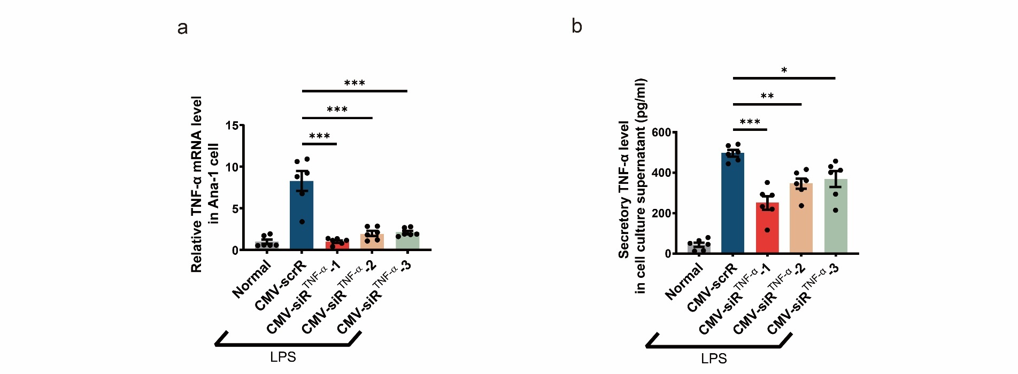

Supplementary Fig. 2 Characterization of the properties of siRNA-encapsulating exosomes. BALB/c mice were intravenously injected with 5 mg/kg CMV-scrR, CMV-siR^{TNF-α} or CMV-siR^{T+B+I} circuit every day for a total of 7 times, and exosomes were then purified from mouse plasma and characterized using NTA and TEM. The enrichment of exosomal markers was analysed by Western blotting. Untreated BALB/c mice were included as normal controls. (a) Size distribution and concentration of purified exosomes determined by NTA. The exosomes purified from mouse plasma had the typical size of exosomes (~100 nm) and were present at a similar concentration (~10⁹ particles/mL). (b) Representative TEM images of purified exosomes (scale bar: 100 nm). The purified exosomes had the characteristic morphology of exosomes. (c) Western blot analysis of specific exosomal markers (TSG101, CD63 and CD9) in whole plasma, purified exosomes and exosome-free plasma. An equal amount of total protein was loaded in each lane. Enrichment of exosomal markers was detected only in purified exosomes but not in exosome-free plasma.
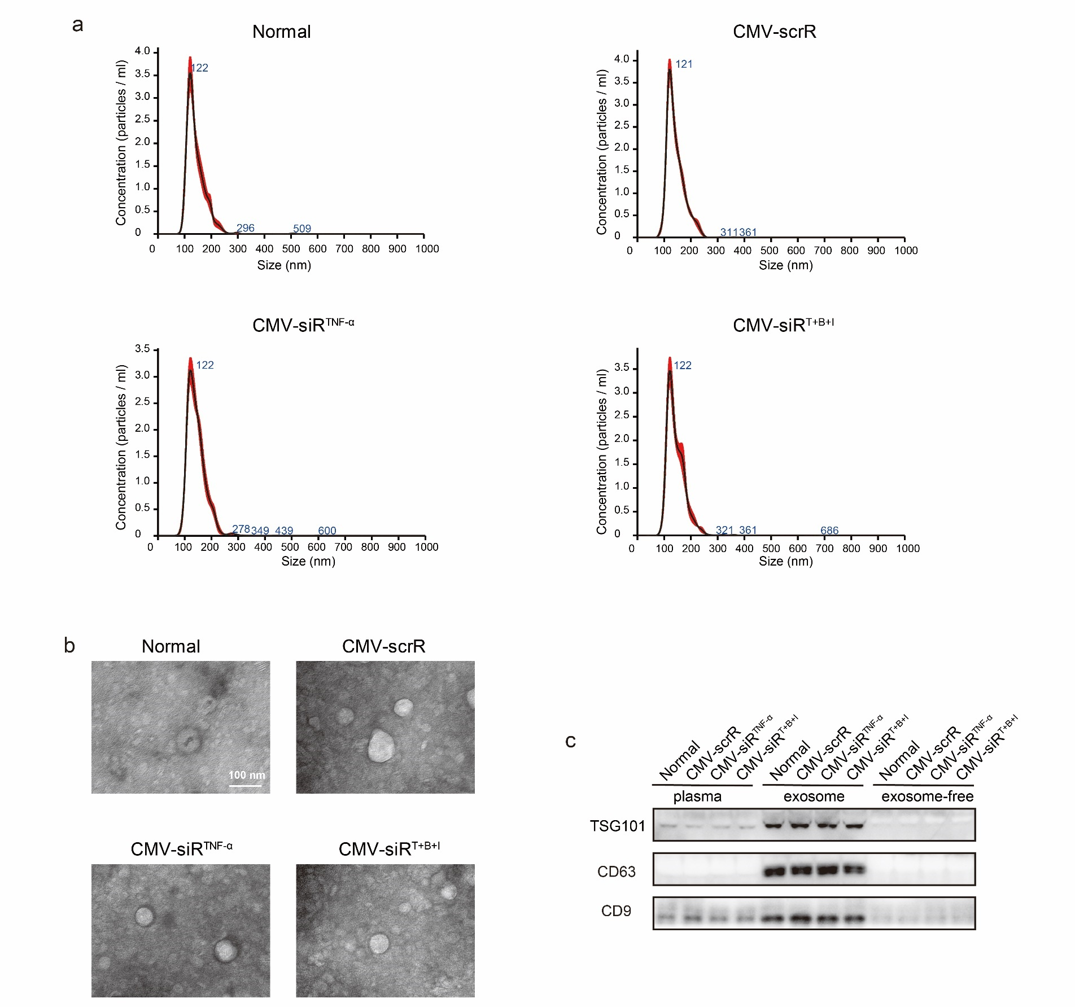

Supplementary Fig. 3 Tracking and visualization of TNF-α siRNA in vivo. (a and b) In situ detection of TNF-α siRNA in liver (a) and colon (b) sections of DSS mice at 0, 6, 12, 24 or 48 hours after injection with the CMV-siR^{TNF-α} circuit. Positive in situ hybridization signals are shown in green, and DAPI-stained nuclei are shown in blue. Scale bar: 50 μm.
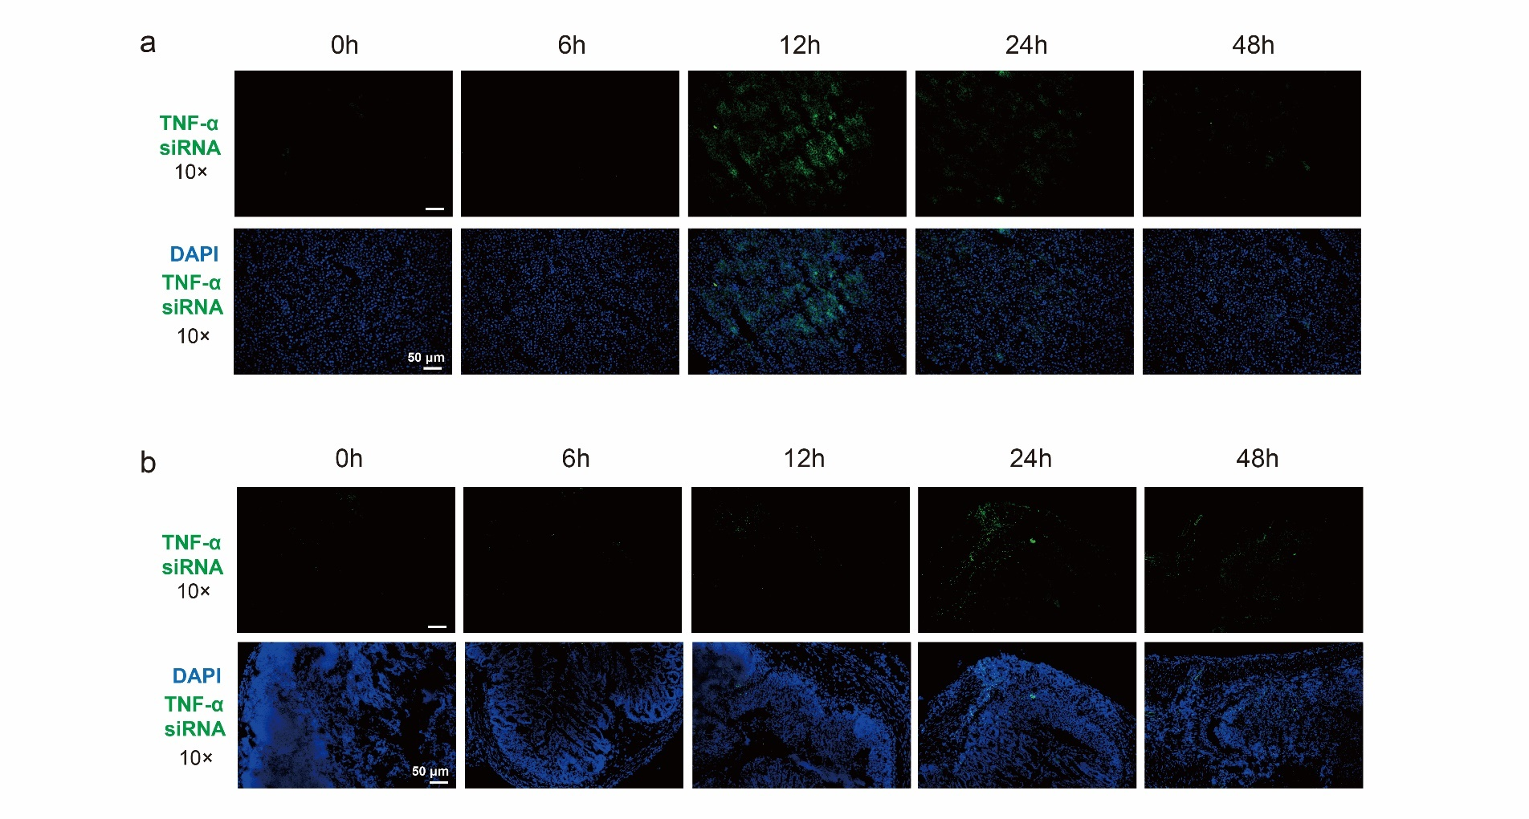

Supplementary Fig. 4 Intravenous injection of the CMV-siR^{TNF-α} circuit protects mice from DSS-induced acute UC. Acute UC was induced in male BALB/c mice by replacing their drinking water with a 2.5% DSS solution for 7 days. From day 3 of modelling, the mice were intravenously injected with 20 mg/kg CMV-scrR or three dosages (0.5, 5 and 20 mg/kg) of CMV-siR^{TNF-α} circuit or 20 mg/kg inﬂiximab (IFX) once a day. After 7 injections on day 10, the mice were euthanized and analysed. Untreated mice were included as normal controls. (a) Mean colon length (n = 5 in each group). (b) Immunofluorescence staining of TNF-α (red) and DAPI (blue) in colon sections. Scale bar: 75 μm (10×) or 25 μm (40×). (c) Determination of serum levels of IL-6, IL-12p70, IL-17A and IL-23 by ELISA (n = 4-5 in each group). (d) Colonic MPO activity (n = 4 in each group). (e) Representative images of H&E staining of colon sections. Scale bar: 100 μm. (f) Histological scores of colon sections (n = 5 in each group). Values are presented as the mean ± SEM. Signiﬁcance was determined using one-way ANOVA followed by Dunnett’s multiple comparison in panels C, E and F. * p < 0.05; *** p < 0.005.
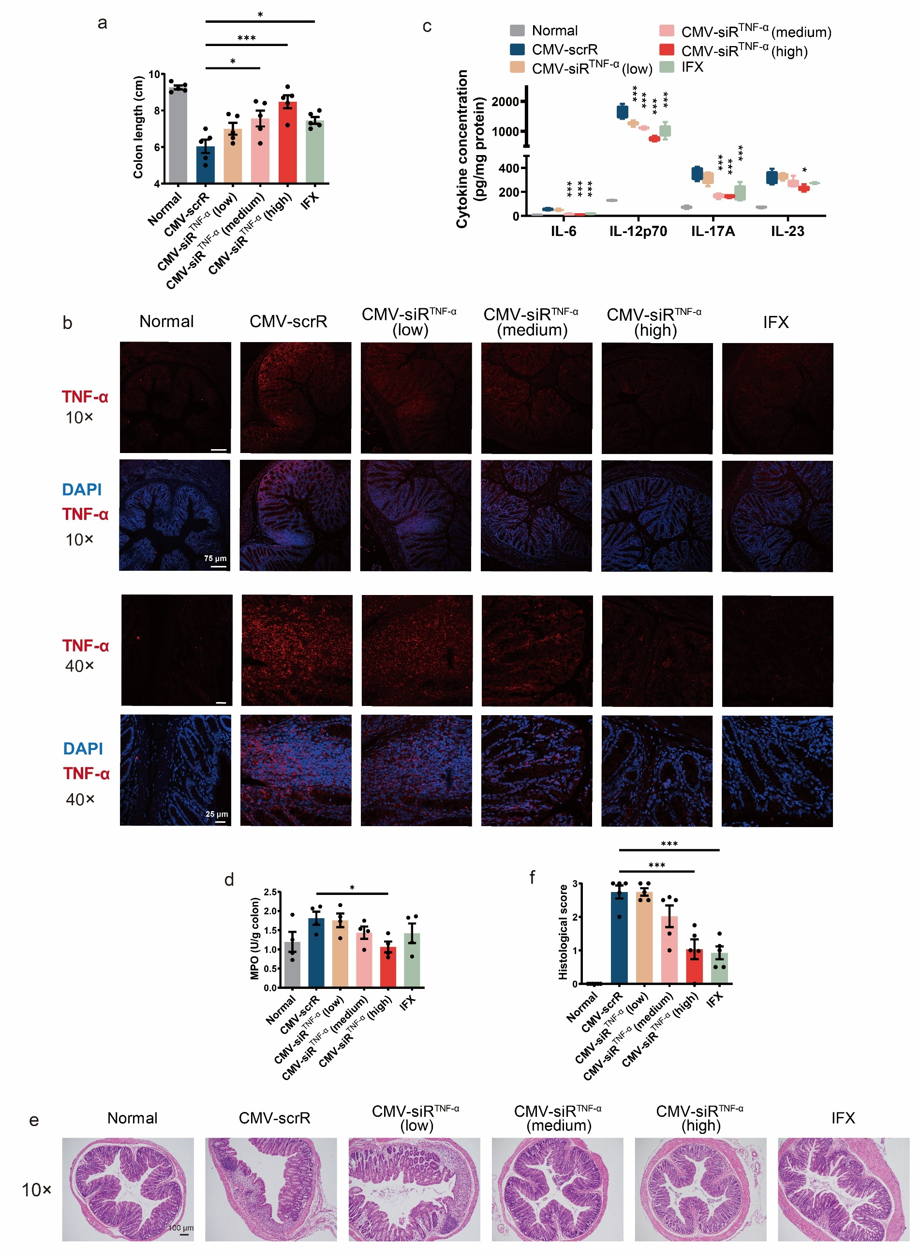

Supplementary Fig. 5 Intravenous injection of the CMV-siR^{TNF-α} circuit protects mice from a TNBS-induced acute colitis model. (a) Flow chart of the experimental design. Acute colitis was induced by intracolonic administration of 2.5% TNBS into BALB/c mice. One day later, mice were intravenously injected with 20 mg/kg CMV-scrR or three dosages (0.5, 5 and 20 mg/kg) of CMV-siR^{TNF-α} circuit or 20 mg/kg inﬂiximab (IFX) once a day. After 7 injections, the mice were euthanized. Body weights were monitored daily, and symptoms and histology were evaluated on day 8. Untreated BALB/c mice were included as normal controls. TNBS mice receiving the CMV-scrR circuit showed typical characteristics of colitis, as manifested by sustained body weight loss, an increased DAI score, a shortened colon length and enhanced colonic TNF-α levels; however, these characteristic symptoms of colitis were significantly alleviated by treatment with the CMV-siR^{TNF-α} circuit. (b) Body weight curves (n = 6 in each group). (c) DAI scores (n = 6 in each group). (d) Representative macroscopic features of colons. Scale bar: 1 cm. (e) Mean colon length (n = 6 in each group). (f) Quantitative RT-PCR analysis of the relative expression levels of TNF-α mRNA in the colon (n = 6 in each group). (g) Determination of the absolute expression levels of TNF-α protein in the colon by ELISA (n = 6 in each group). Values are presented as the mean ± SEM. Signiﬁcance was determined using one-way ANOVA followed by Dunnett’s multiple comparison in panels c, e, f and g or two-way ANOVA followed by Dunnett’s multiple comparison in panel b. * p < 0.05; ** p < 0.01; *** p < 0.005.
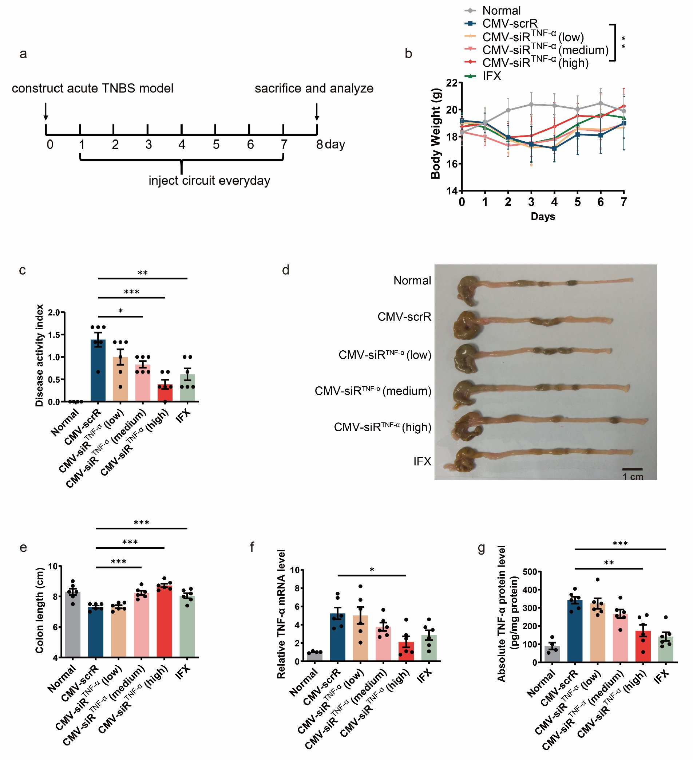

Supplementary Fig. 6 Intravenous injection of the CMV-siR^{TNF-α} circuit protects mice from DSS-induced chronic UC. (a) Flow chart of the experimental design. Chronic UC was induced in male BALB/c mice by rhythmically administering to mice 2.5% DSS for 1 week and water for 2 weeks for 3 cycles. Four days after each DSS drinking, mice were intravenously injected with 20 mg/kg CMV-scrR, 20 mg/kg CMV-siR^{TNF-α} circuit or 20 mg/kg inﬂiximab for a total of 3 times, once every 2 days. One day after the final injection on day 52, the mice were euthanized. Body weights were monitored daily, and symptoms and histology were evaluated on day 52. Untreated BALB/c mice were included as normal controls. (b) Body weight curves (n = 6 in each group). (c) DAI scores (n = 6 in each group). (d) Representative macroscopic features of colons. Scale bar: 1 cm. (e) Mean colon length (n = 6 in each group). (f) Determination of serum levels of IL-6, IL-12p70, IL-17A and IL-23 by ELISA (n = 6 in each group). (g) Colonic MPO activity (n = 4 in each group). (h) Representative images of H&E staining of colon sections. Scale bar: 100 μm. (i) Histological scores of colon sections (n = 6 in each group). (j) Quantitative RT-PCR analysis of the relative expression levels of TNF-α mRNA in the colon (n = 6 in each group). (k) Determination of the absolute expression levels of TNF-α protein in the colon by ELISA (n = 6 in each group). (l) Immunofluorescence staining of TNF-α (red) and DAPI (blue) in colon sections. Scale bar: 50 μm (20×) or 25 μm (40×). Values are presented as the mean ± SEM. Signiﬁcance was determined using one-way ANOVA followed by Dunnett’s multiple comparison in panels c, e, f, g, i, j and k or two-way ANOVA followed by Dunnett’s multiple comparison in panel b. * p < 0.05; ** p < 0.01; *** p < 0.005.
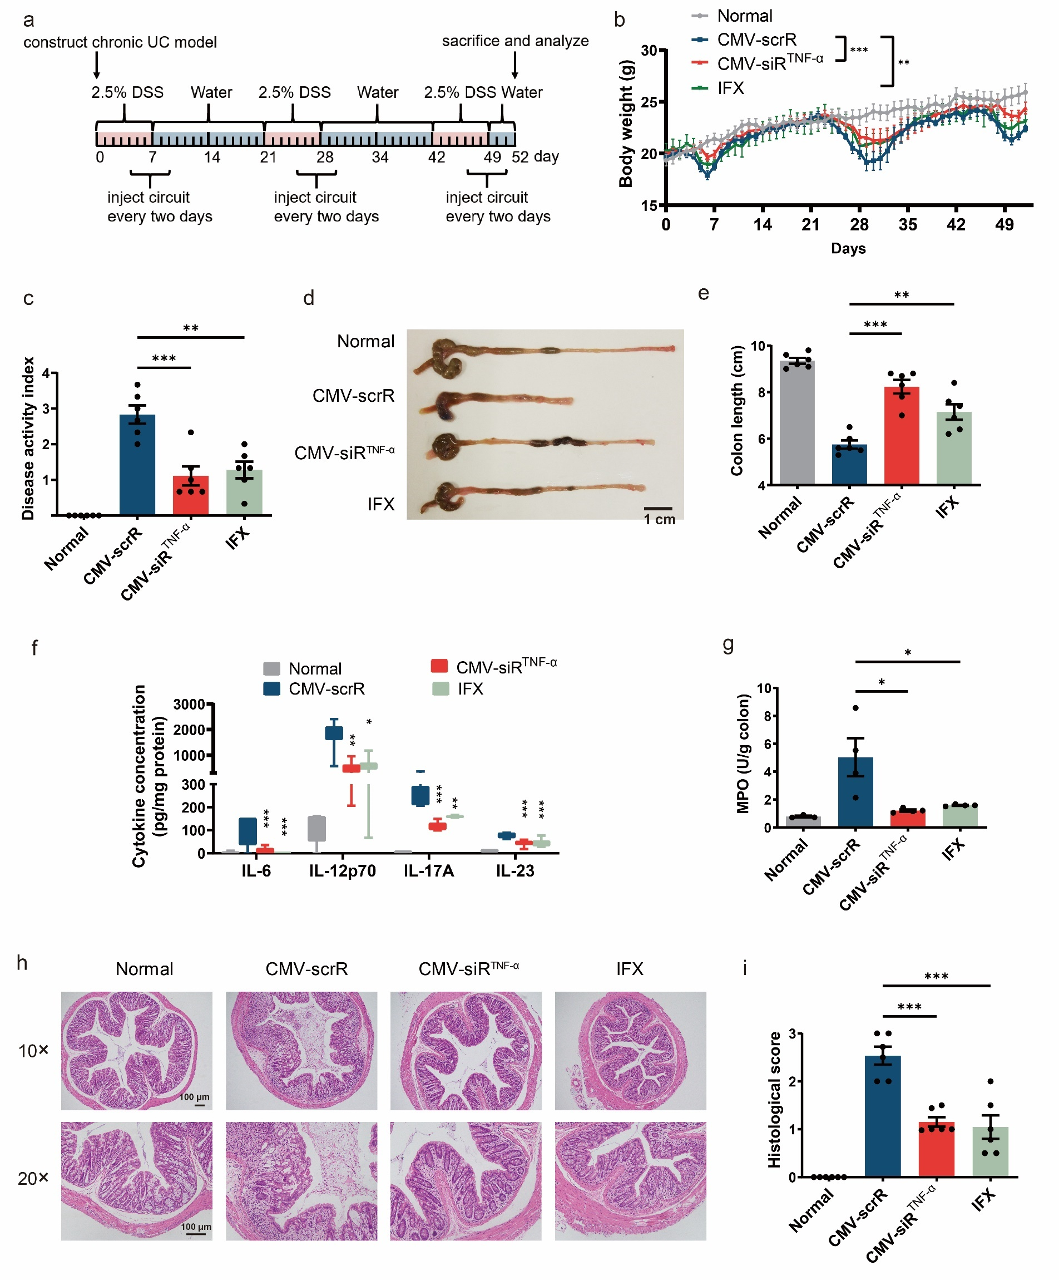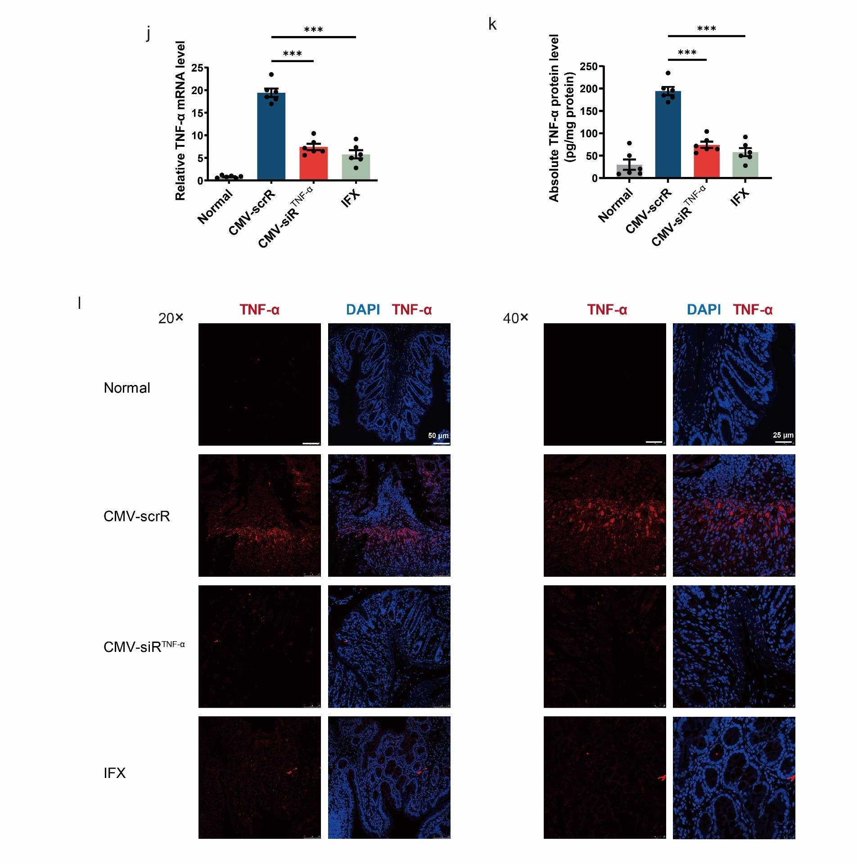

Supplementary Fig. 7 Evaluation of the toxic effects and tissue damage in mice after intravenous injection of the genetic circuits. BALB/c mice were intravenously injected with PBS or 5 mg/kg CMV-scrR, CMV-siR^{TNF-α} or CMV-siR^{T+B+I} circuit every day for a total of 7 times. After the treatment, mice were sacrificed, and blood and tissue samples were collected and analysed for serum biochemical indicators and tissue damage. (a) Histological examination of the liver and kidney of genetic circuit-treated mice. No overt tissue damage was observed in any of the tissues. Scale bar: 100 μm. (b) Measurement of representative serum biochemical indicators, including alanine aminotransferase (ALT), aspartate aminotransferase (AST), total bilirubin (TBIL), blood urea nitrogen (BUN), alkaline phosphatase (ALP) and creatinine (CREA), in the serum of genetic circuit-treated mice. Values are presented as the mean ± SEM. Significance was determined using one-way ANOVA followed by Dunnett’s multiple comparison. NS, not significant.
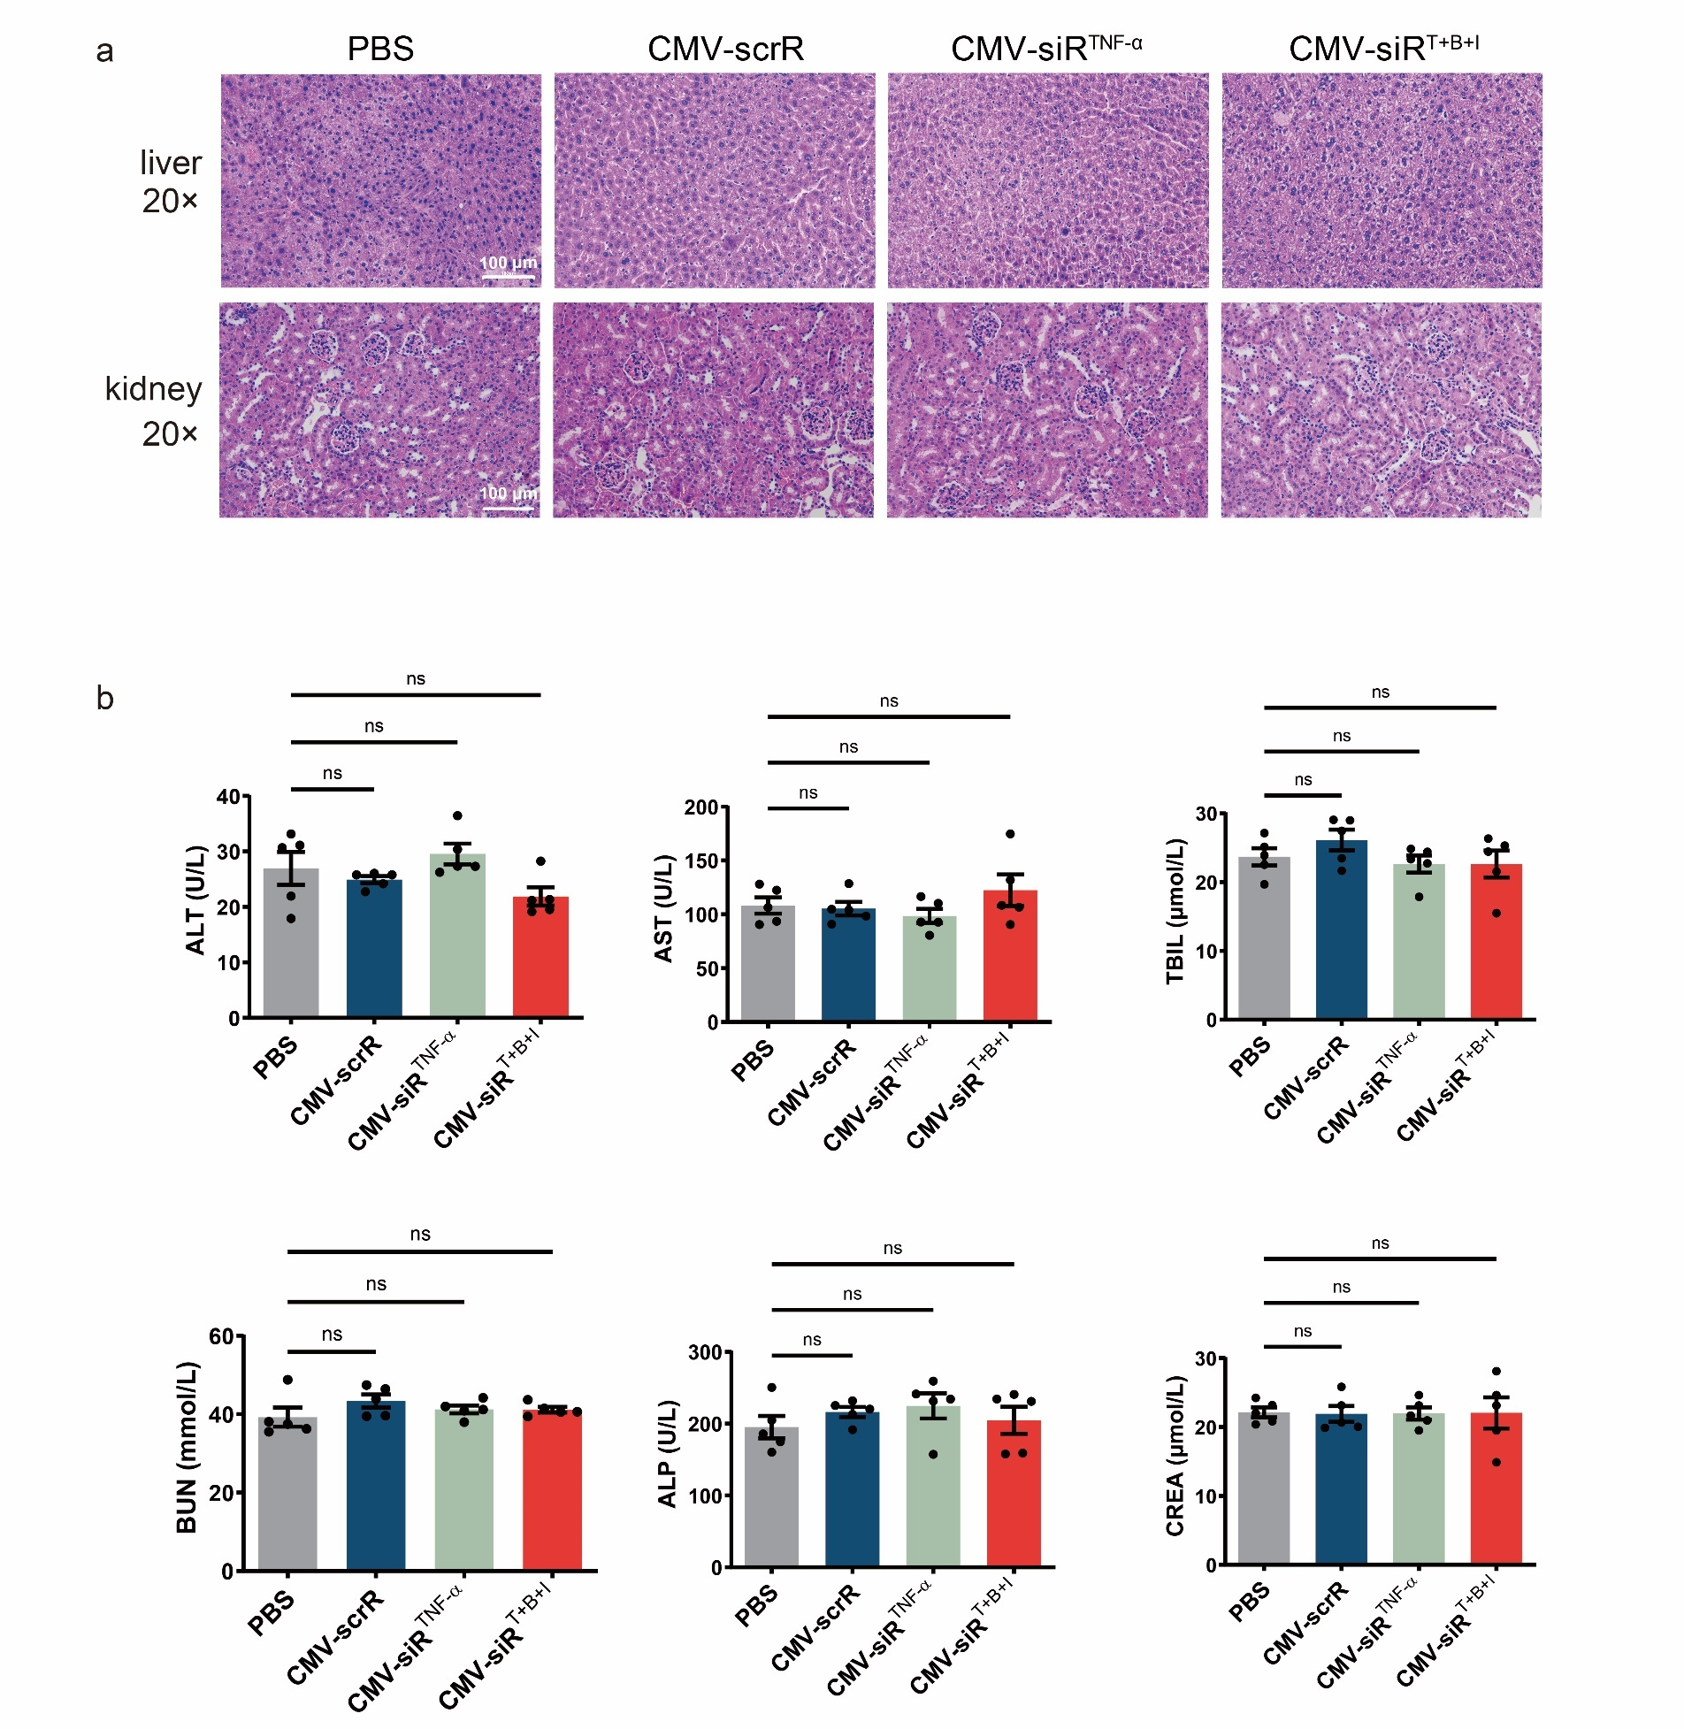

Supplementary Fig. 8 Intravenous injection of the CMV-siR^{TNF-α} circuit protects mice in the TNBS-induced chronic colitis model. (a) Flow chart of the experimental design. Chronic colitis was induced by rhythmic administration (once a week) of 2.5% TNBS into BALB/c mice for 4 times. After each TNBS administration, mice were intravenously injected with 20 mg/kg CMV-scrR, 20 mg/kg CMV-siR^{TNF} circuit or 20 mg/kg infliximab for a total of 4 times over the first 4 days. Body weights were monitored daily, and symptoms and histology were evaluated on day 26. Untreated BALB/c mice were used as normal controls. CMV-siR^{TNF-α} circuit-treated mice rapidly recovered the lost body weight and colon length, experienced a low DAI score and MPO activity, showed a significant decline in TNF-α and inflammatory cytokines, and exhibited an improved colonic histological appearance compared with the mice treated with the CMV-scrR circuit. Additionally, the CMV-siR^{TNF-α} circuit ameliorated the manifestations of chronic colitis to a similar, if not better, extent as infliximab. (b) Body weight curves (n = 6 in each group). (c) DAI scores (n = 6 in each group). (d) Representative macroscopic features of colons. Scale bar: 1 cm. (e) Mean colon length (n = 6 in each group). (f) Determination of serum levels of IL-6, IL-12p70, IL-17A and IL-23 by ELISA (n = 6 in each group). (g) Colonic MPO activity (n = 4 in each group). (h) Representative images of H&E staining of colon sections. Scale bar: 100 μm. (i) Histological scores of colon sections (n = 6 in each group). (j) Quantitative RT-PCR analysis of the relative expression levels of TNF-α mRNA in the colon (n = 6 in each group). (k) Determination of the absolute expression levels of TNF-α protein in the colon by ELISA (n = 6 in each group). Values are presented as the mean ± SEM. Signiﬁcance was determined using one-way ANOVA followed by Dunnett’s multiple comparison in panels c, e, f, g, i, j and k or two-way ANOVA followed by Dunnett’s multiple comparison in panel b. * p < 0.05; ** p < 0.01; *** p < 0.005.
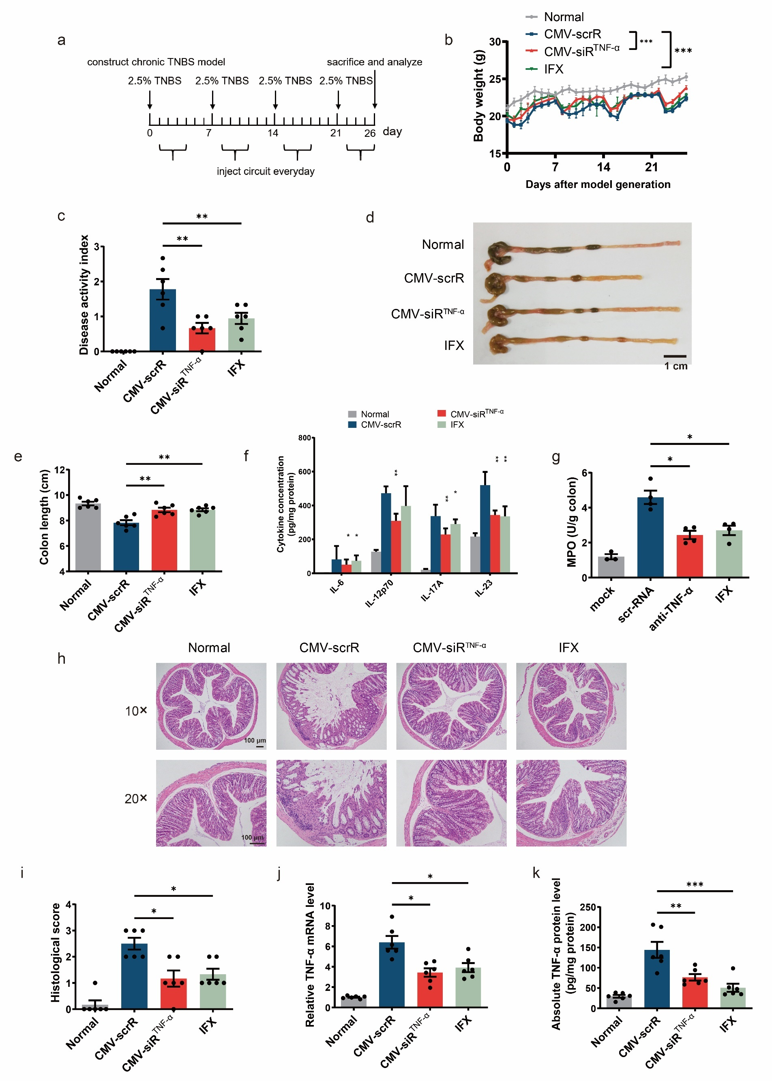

Supplementary Fig. 9 Assessing the therapeutic efficacy of candidate siRNA expression cassettes. Acute UC was induced in male BALB/c mice by replacing their drinking water with a 2.5% DSS solution for 7 days. From day 3 of modelling, the mice were intravenously injected once a day with PBS, CMV-scrR, two types of genetic circuits targeting IL-17A (CMV-siR^{IL-17A}-1 and CMV-siR^{IL-17A}-2), two types of genetic circuits targeting INF-γ (CMV-siR^{INF-γ}-1 and CMV-siR^{INF-γ}-2), a genetic circuit targeting IL-6 (CMV-siR^{IL-6}), two types of genetic circuits targeting integrin α4 (CMV-siR^{Integrin α4}-1 and CMV-siR^{Integrin α4}-2), a genetic circuit targeting ICAM-1 (CMV-siR^{ICAM-1}), a genetic circuit targeting CD3 (CMV-siR^{CD3}) or a genetic circuit targeting B7-1 (CMV-siR^{B7-1}). Each genetic circuit was injected at a dosage of 20 mg/kg. After 7 injections on day 10, the mice were euthanized and analysed. Untreated BALB/c mice were included as normal controls. (a) DAI scores (n = 3 in each group). (b) Representative macroscopic features of colons. Scale bar: 1 cm. (c) Mean colon length (n = 3 in each group). (d) Quantitative RT-PCR analysis of the relative expression levels of IL-17A mRNA in the colon after treatment with CMV-siR^{IL-17A}-1 and CMV-siR^{IL-17A}-2 (n = 3 in each group). (e) Quantitative RT-PCR analysis of the relative expression levels of IFN-γ mRNA in the colon after treatment with CMV-siR^{INF-γ}-1 and CMV-siR^{INF-γ}-2 (n = 3 in each group). (f) Quantitative RT-PCR analysis of the relative expression levels of integrin α4 mRNA in the colon after treatment with CMV-siR^{Integrin α4}-1 and CMV-siR^{Integrin α4}-2 (n = 3 in each group). (g) Quantitative RT-PCR analysis of the relative expression levels of IL-6 mRNA in the colon after treatment with CMV-siR^{IL-6} (n = 3 in each group). (h) Quantitative RT-PCR analysis of the relative expression levels of CD3 mRNA in the colon after treatment with CMV-siR^{CD3} (n = 3 in each group). (i) Quantitative RT-PCR analysis of the relative expression levels of ICAM1 mRNA in the colon after treatment with CMV-siR^{ICAM1} (n = 3 in each group). (j) Quantitative RT-PCR analysis of the relative expression levels of B7-1 mRNA in the colon after treatment with CMV-siR^{B7-1} (n = 3 in each group). Values are presented as the mean ± SEM. Signiﬁcance was determined using one-way ANOVA followed by Dunnett’s multiple comparison. In panels a and b, all groups were compared with CMV-scrR. * p < 0.05; ** p < 0.01; *** p < 0.005.
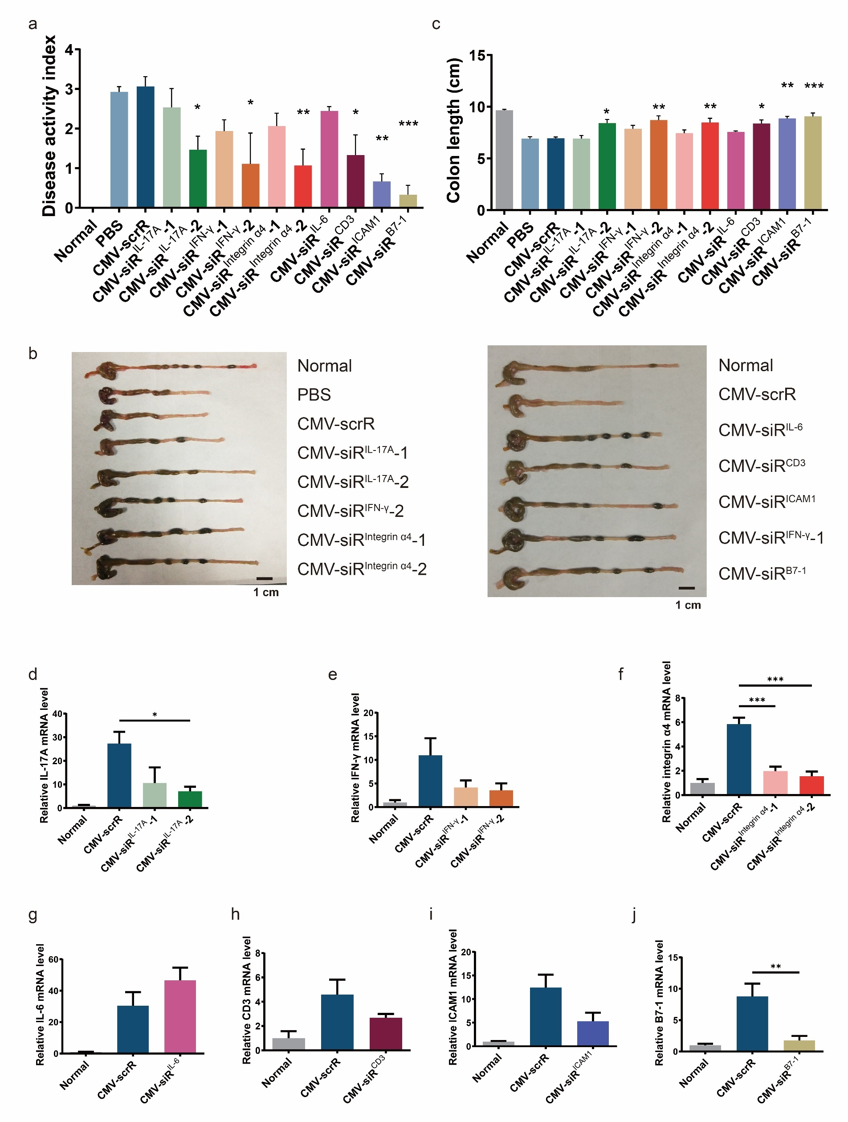
Supplementary Fig. 10 Tracking and visualization of the delivery of self-assembled siRNAs into desired tissues and cells in the DSS-induced acute UC model. Chronic UC was induced in male BALB/c mice by rhythmically administering to mice 2.5% DSS for 1 week and water for 2 weeks for 3 cycles. Four days after each DSS drinking, mice were intravenously injected with PBS, 10 mg/kg CMV-scrR, 10 mg/kg CMV-siR^{TNF-α}, 10 mg/kg CMV-siR^{Integrin α4}, 10 mg/kg CMV-siR^{B7-1} or 10 mg/kg CMV-siR^{T+B+I} circuit for a total of 3 times, once every 2 days. Two days after the final injection on day 52, the mice were euthanized, and the presence of siRNAs in various tissues and cells was evaluated. (a and b) Quantitative RT-PCR analysis of the absolute expression levels of TNF-α siRNA in the plasma (A) and colon (B) (n = 5 in each group). (c) In situ detection of TNF-α siRNA in colonic macrophages extracted from DSS mice. Positive in situ hybridization signals are shown in green, and DAPI-stained nuclei are shown in blue. Scale bar: 50 μm (20×) or 25 μm (40×). (d and e) Quantitative RT-PCR analysis of the absolute expression levels of B7-1 siRNA in the plasma (d) and colon (e) (n = 5 in each group). (f) In situ detection of B7-1 siRNA in colonic macrophages extracted from DSS mice. Positive in situ hybridization signals are shown in green, and DAPI-stained nuclei are shown in blue. Scale bar: 50 μm (20×) or 25 μm (40×). (g and h) Quantitative RT-PCR analysis of the absolute expression levels of integrin α4 siRNA in the plasma (g) and colon (h) (n = 5 in each group). (i) In situ detection of integrin α4 siRNA in peripheral blood CD4⁺ T cells extracted from DSS mice. Positive in situ hybridization signals are shown in green, and DAPI-stained nuclei are shown in blue. Scale bar: 50 μm (20×) or 25 μm (40×). Values are presented as the mean ± SEM. Signiﬁcance was determined using one-way ANOVA followed by Dunnett’s multiple comparison. * p < 0.05; ** p < 0.01; *** p < 0.005.
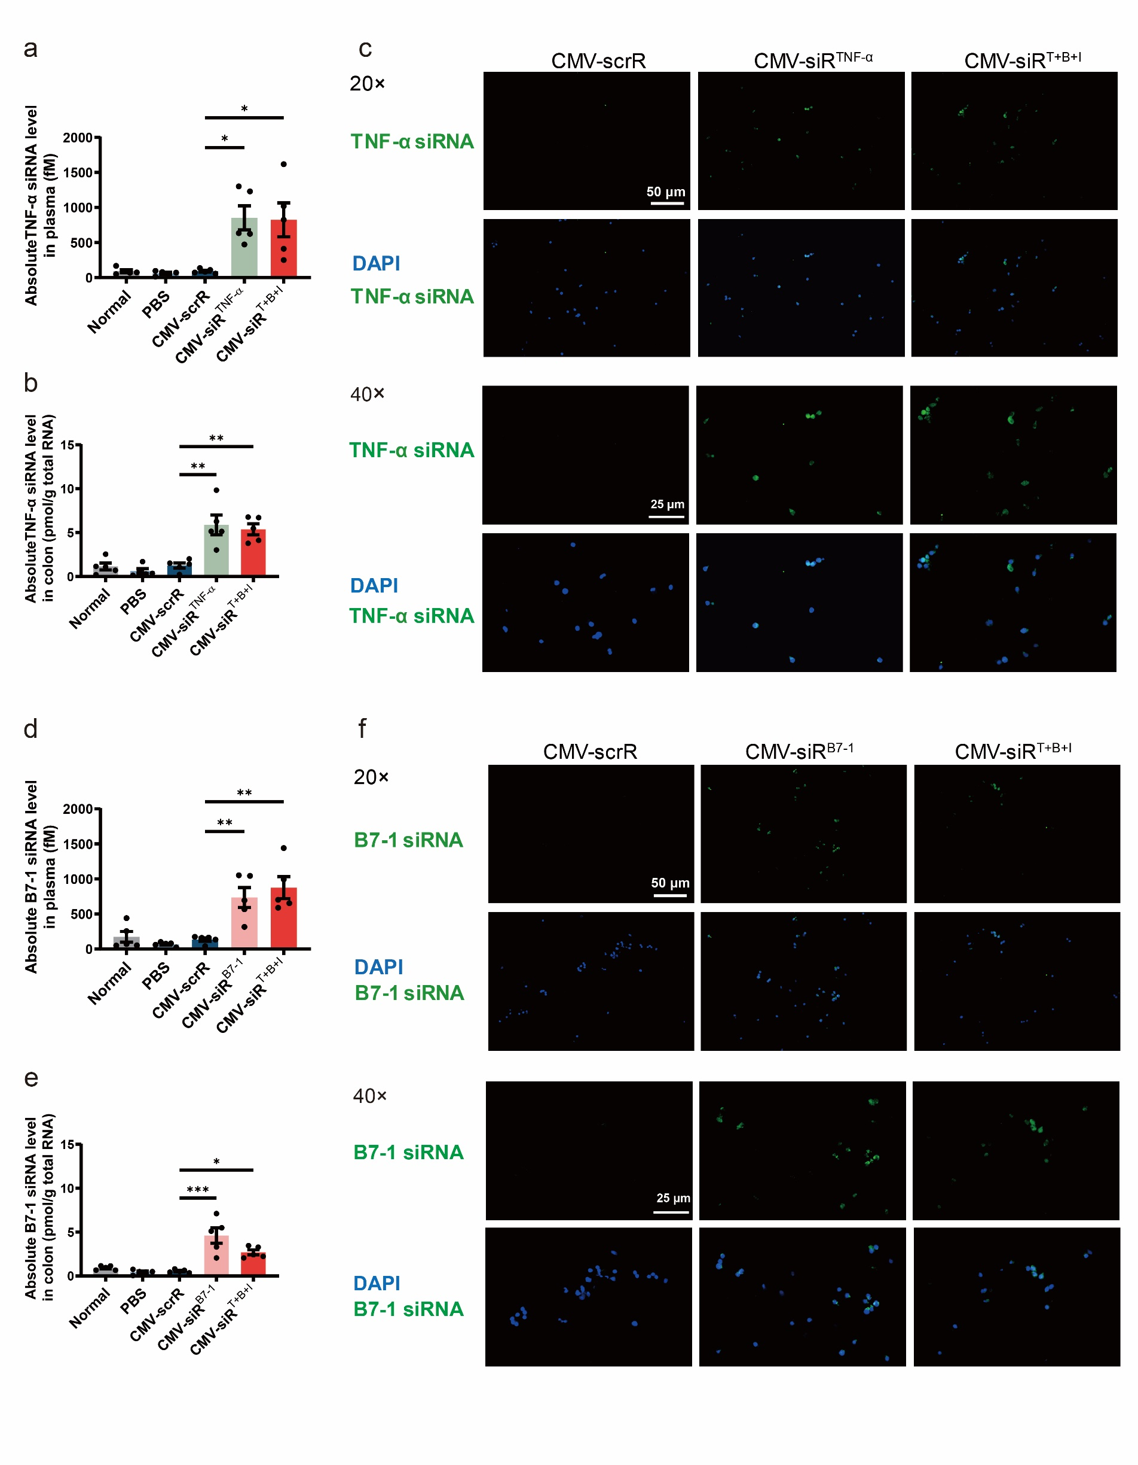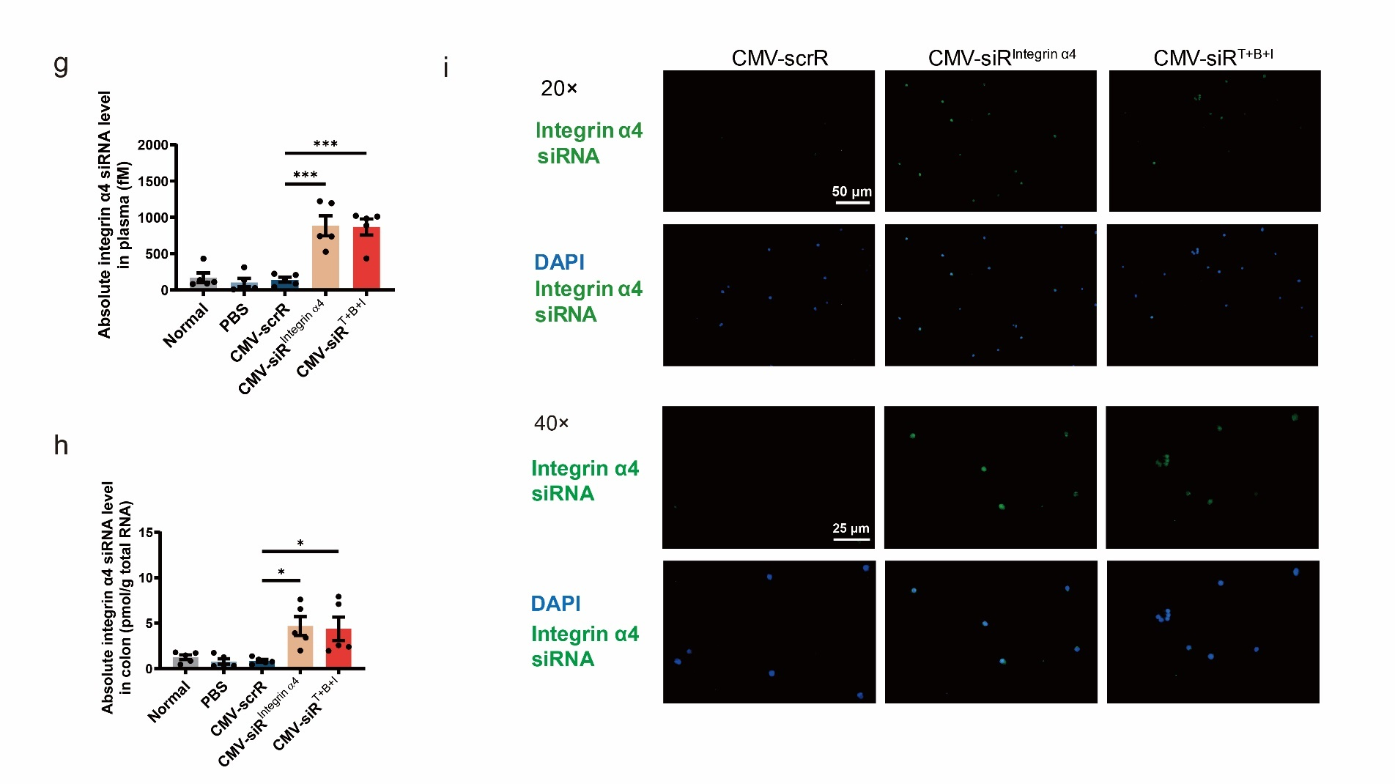

Supplementary Fig. 11 Intravenous injection of the multitargeted CMV-siR^{T+B+I} circuit simultaneously inhibits TNF-α, B7-1 and integrin α4 in target cells and exerts a synergistic therapeutic effect against DSS-induced chronic UC. Chronic UC was induced in male BALB/c mice by rhythmically administering to mice 2.5% DSS for 1 week and water for 2 weeks for 3 cycles. Four days after each DSS drinking, mice were intravenously injected with PBS, 10 mg/kg CMV-scrR, 10 mg/kg CMV-siR^{TNF-α}, 10 mg/kg CMV-siR^{Integrin α4}, 10 mg/kg CMV-siR^{B7-1} or 10 mg/kg CMV-siR^{T+B+I} circuit for a total of 3 times, once every 2 days. Two days after the final injection on day 52, the mice were euthanized and analysed. Untreated BALB/c mice were included as normal controls. (a) Mean colon length (n = 6 in each group). (b) Determination of serum levels of IL-6, IL-12p70 and IL-17A by ELISA (n = 6 in each group). (c) Representative images of H&E staining of colon sections. Scale bar: 100 μm (10× or 20×) or 50 μm (40×). (d) Histological scores of colon sections (n = 6 in each group). Values are presented as the mean ± SEM. Signiﬁcance was determined using one-way ANOVA followed by Dunnett’s multiple comparison. * p < 0.05; ** p < 0.01; *** p < 0.005.
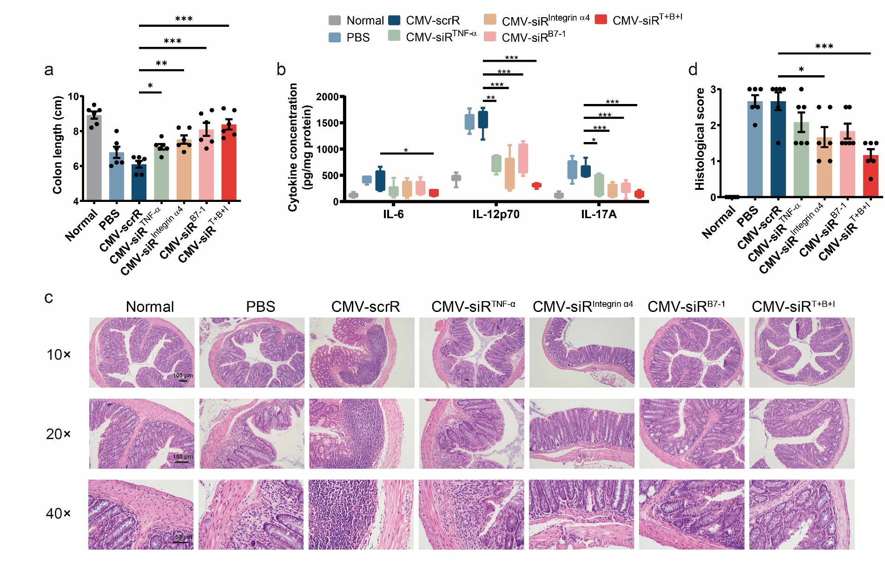

Supplementary Fig. 12 Intravenous injection of the multitargeted CMV-siR^{T+B+I} circuit inhibits TNF-α in macrophages. (a) Immunofluorescence staining of TNF-α (red) and DAPI (blue) in primary macrophages isolated from colonic lamina propria and cultured in conditioned medium for 12 hours. Scale bar: 100 μm. (b) Representative flow cytometric plots of F4/80⁺ on colonic lamina propria macrophages. (c) The population of F4/80⁺ cells in all colonic lamina propria macrophages (n = 3 in each group). Values are presented as the mean ± SEM. Signiﬁcance was determined using one-way ANOVA followed by Dunnett’s multiple comparison.
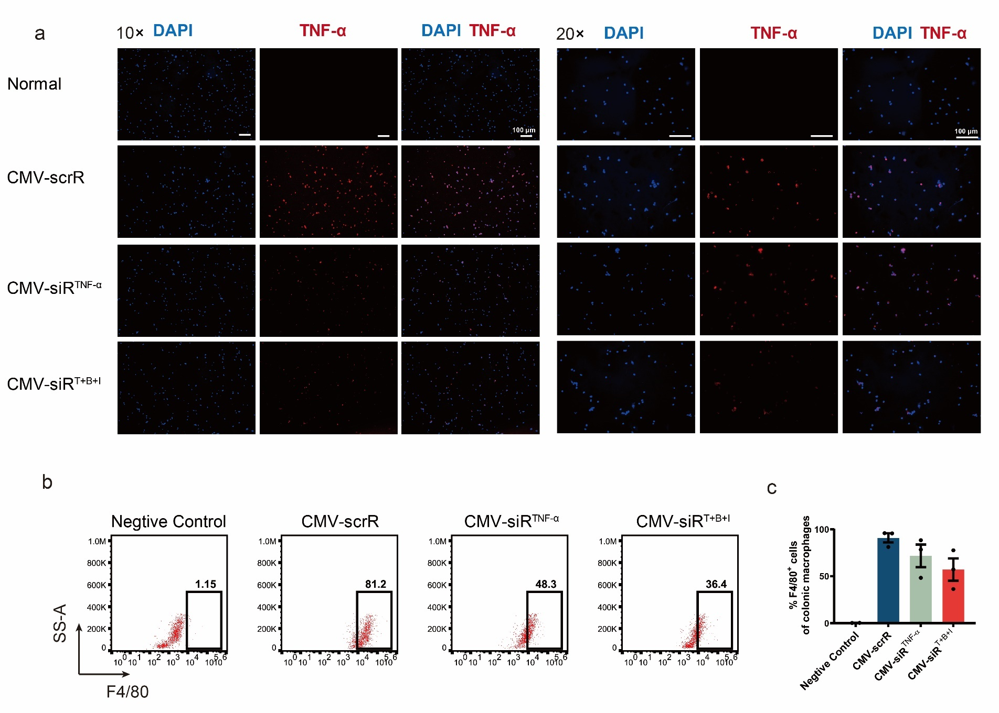

Supplementary Fig. 13 Intravenous injection of the multitargeted CMV-siR^{T+B+I} circuit inhibits B7-1 in macrophages. (a) Representative flow cytometric plots of B7-1 on the surface of peripheral blood mononuclear cells. (b) The population of B7-1⁺ cells in peripheral blood mononuclear cells (n = 4 in each group). (c) Representative flow cytometric plots of B7-1 on the surface of splenic mononuclear cells. (d) The population of B7-1⁺ cells in splenic mononuclear cells (n = 4 in each group). (e) Immunofluorescence staining of B7-1 (red) and DAPI (blue) in primary macrophages isolated from colonic lamina propria and cultured in conditioned medium for 12 hours. Scale bar: 100 μm. (f) Immunofluorescence staining of B7-1 (red), F4/80 (green) and DAPI (blue) in colon sections. Double-positive (red and green) signals indicate B7-1⁺ macrophages. Scale bar: 100 μm. (g) Representative flow cytometric plots of CD25 on colonic lamina propria mononuclear cells. (h) The population of CD25⁺ T cells in total colonic lamina propria mononuclear cells (n = 4 in each group). Values are presented as the mean ± SEM. Signiﬁcance was determined using one-way ANOVA followed by Dunnett’s multiple comparison. * p < 0.05; ** p < 0.01.
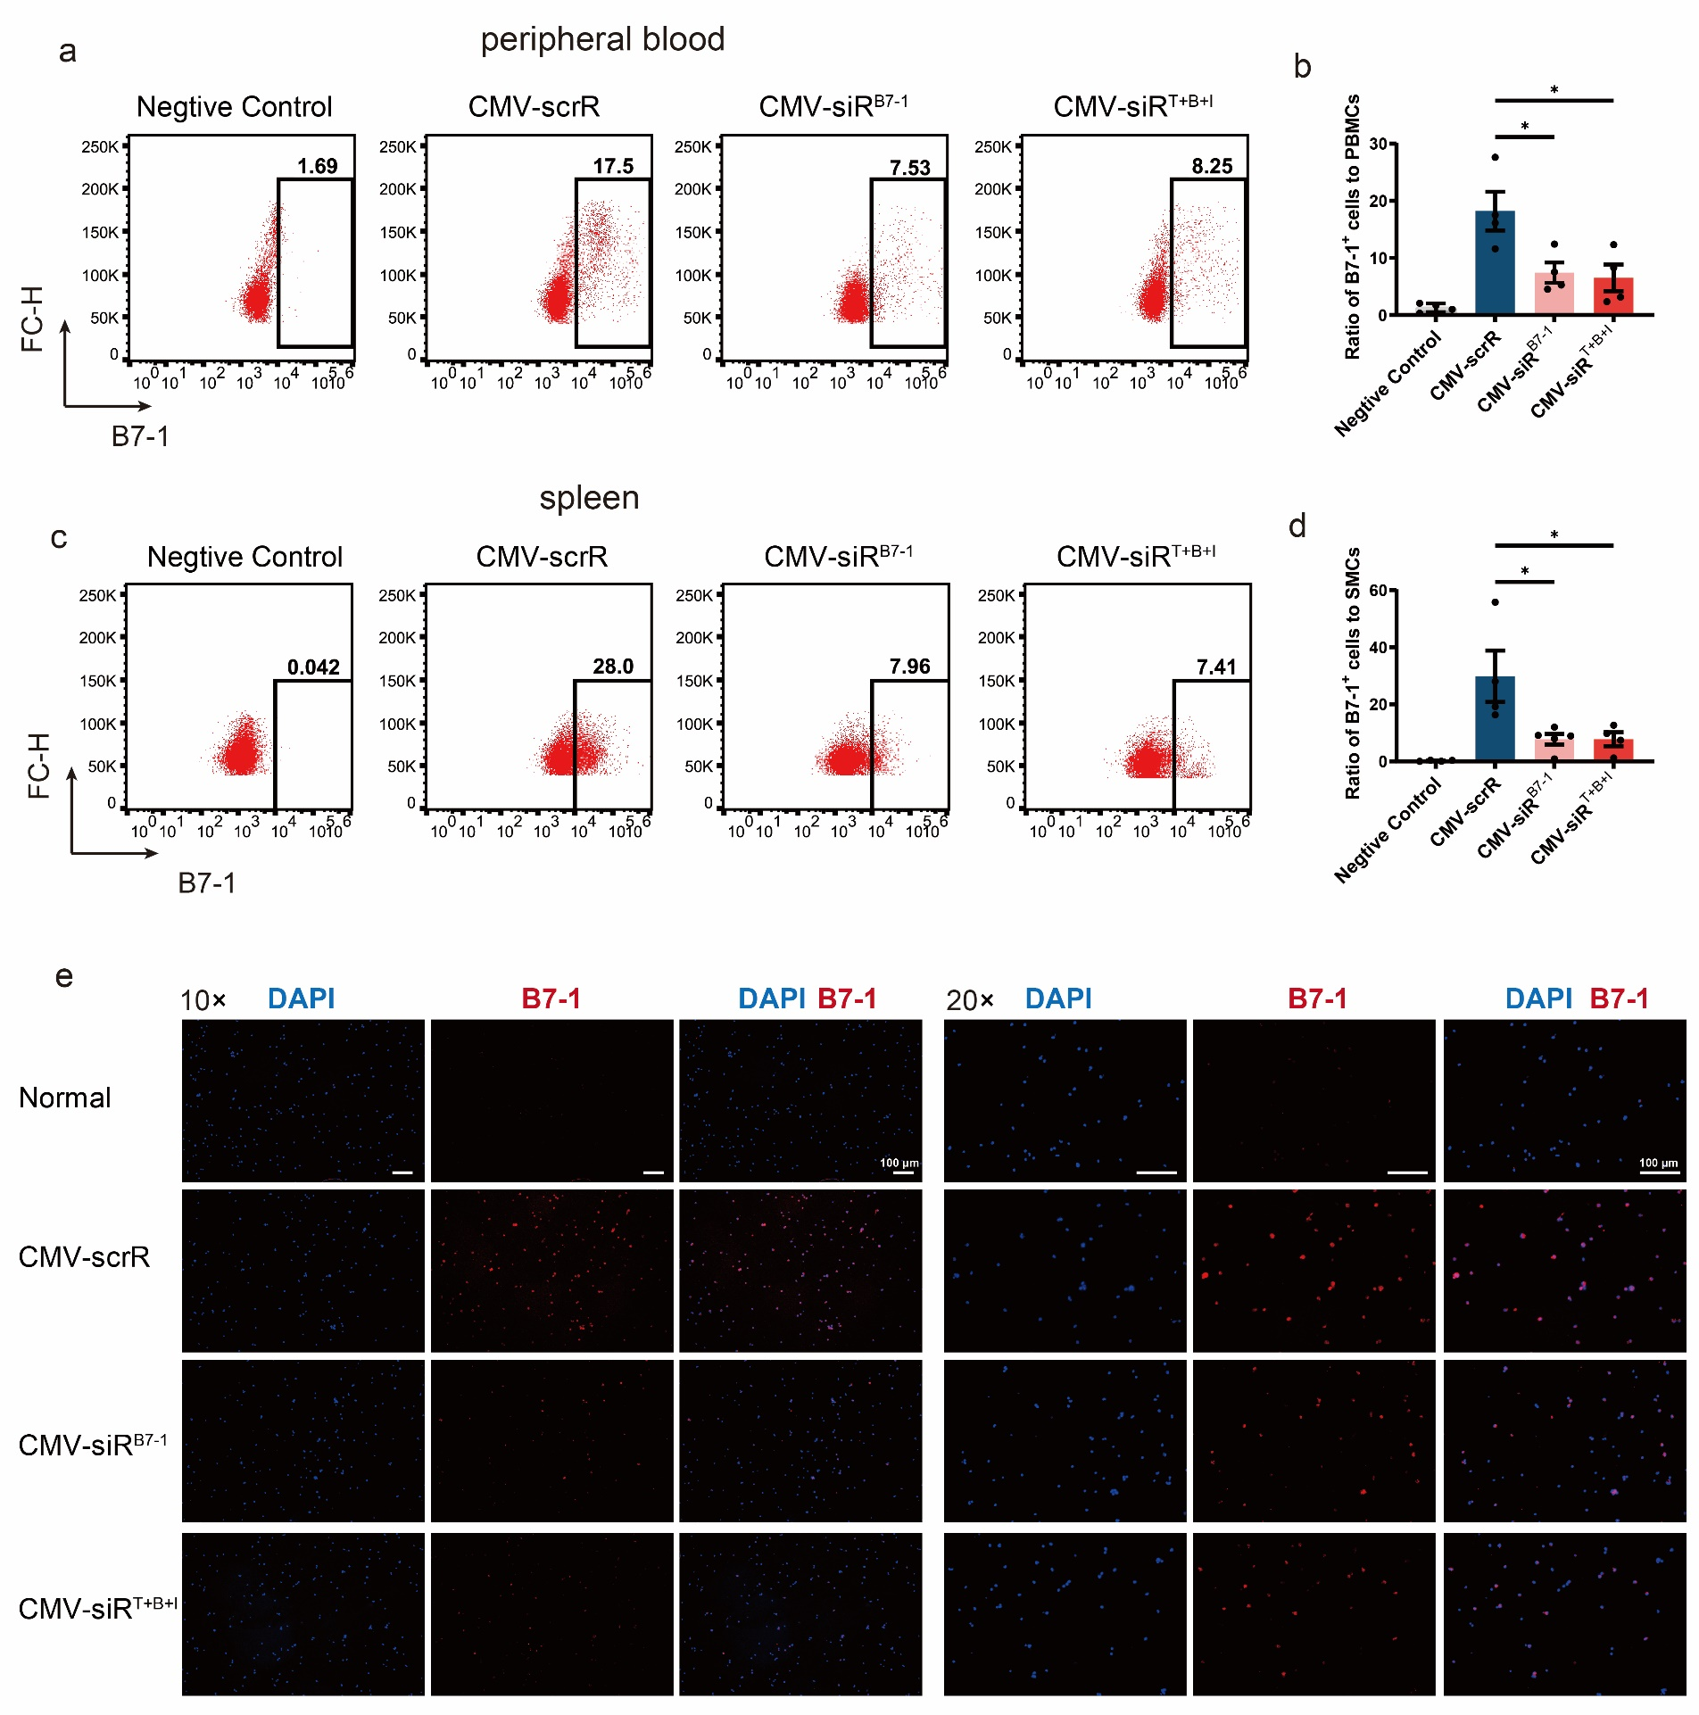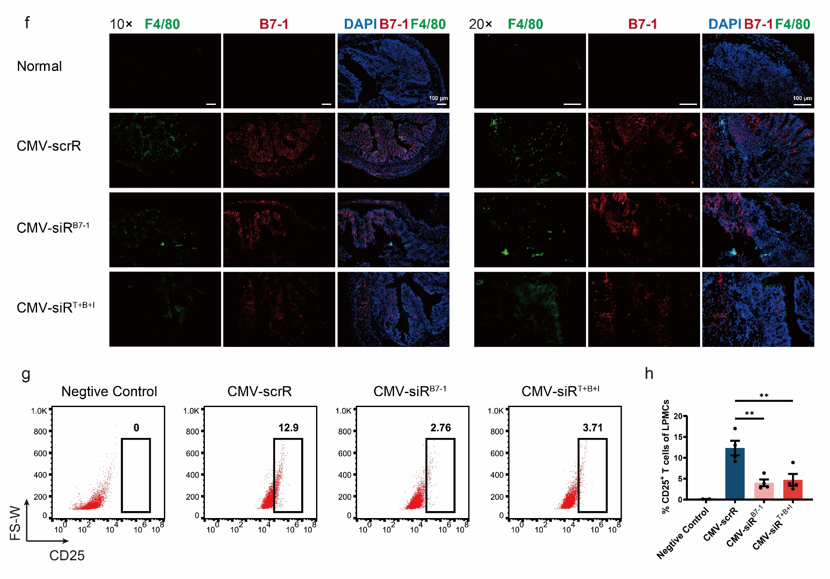

Supplementary Fig. 14 Intravenous injection of the multitargeted CMV-siR^{T+B+I} circuit inhibits integrin α4 in CD4⁺ T cells. (a) Representative flow cytometric plots of integrin α4 on the surface of peripheral blood lymphocytes. (b) The population of integrin α4⁺ cells in peripheral blood lymphocytes (n = 4 in each group). (c) Representative flow cytometric plots of integrin α4 on the surface of splenic lymphocytes. (d) The population of integrin α4⁺ cells in splenic lymphocytes (n = 4 in each group). (e) Immunofluorescence staining of integrin α4 (red), CD4 (green) and DAPI (blue) in colon sections. Double-positive (red and green) signals indicate integrin α4⁺ CD4⁺ cells. Scale bar: 100 μm. (f) Representative images of adhesion assays showing the adhesion of peripheral blood integrin α4⁺ CD4⁺ T cells to plates coated with E-cadherin. Scale bars: 100 μm. (g) Quantitative analysis of the amounts of adherent CD4⁺ T cells (n = 3 in each group). Values are presented as the mean ± SEM. Signiﬁcance was determined using one-way ANOVA followed by Dunnett’s multiple comparison. * p < 0.05; ** p < 0.01; *** p < 0.005.
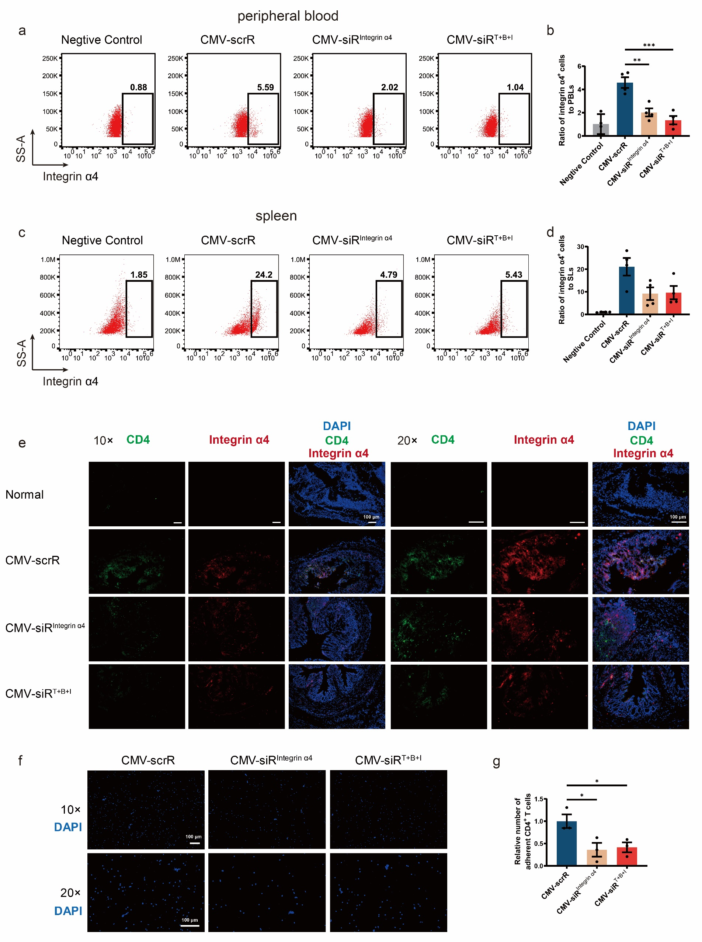

Supplementary Fig. 15 Intravenous injection of the AAV-CMV-siR^{TNF-α} circuit induces a long-term therapeutic effect in the DSS-induced chronic UC model. (a) Flow chart of the experimental design. On week 0, BALB/c mice were intravenously injected with AAV-CMV-scrR (1.0×10¹¹ v.g.) or with three dosages of AAV-CMV-siR^{TNF-α} (2.5×10¹⁰ v.g., 5.0×10¹⁰ v.g. or 1.0×10¹¹ v.g.). Three weeks later, chronic UC was induced by rhythmically administering to mice 2.5% DSS for 1 week and water for 2 weeks. Body weights were monitored every two days, and symptoms and histology were evaluated at week 10. Untreated BALB/c mice were included as normal controls. (b and c) Evaluation of AAV-mediated luciferase expression to reflect coexpressed TNF-α siRNA accumulation in vivo (n = 4-6 in each group). (d) Body weight curves (n = 4-6 in each group). (e) DAI scores (n = 4-6 in each group). (f) Representative macroscopic features of colons. Scale bar: 1 cm. (g) Representative images of H&E staining of colon sections. Scale bar: 100 μm (10× or 20×) or 50 μm (40×). (h) Histological scores of colon sections (n = 4-6 in each group). (i) Determination of serum levels of IL-6, IL-12p70 and IL-23 by ELISA (n = 4-6 in each group). (j) Quantitative RT-PCR analysis of the absolute expression levels of TNF-α siRNA in plasma (n = 4-6 in each group). (k) Quantitative RT-PCR analysis of the relative expression levels of TNF-α mRNA in the colon (n = 4-6 in each group). (l) Determination of the absolute expression levels of TNF-α protein in the colon by ELISA (n = 4-6 in each group). Values are presented as the mean ± SEM. Signiﬁcance was determined using one-way ANOVA followed by Dunnett’s multiple comparison in panels e, h, i, j, k and l or two-way ANOVA followed by Dunnett’s multiple comparison in panel d. * p < 0.05; ** p < 0.01, *** p < 0.005.
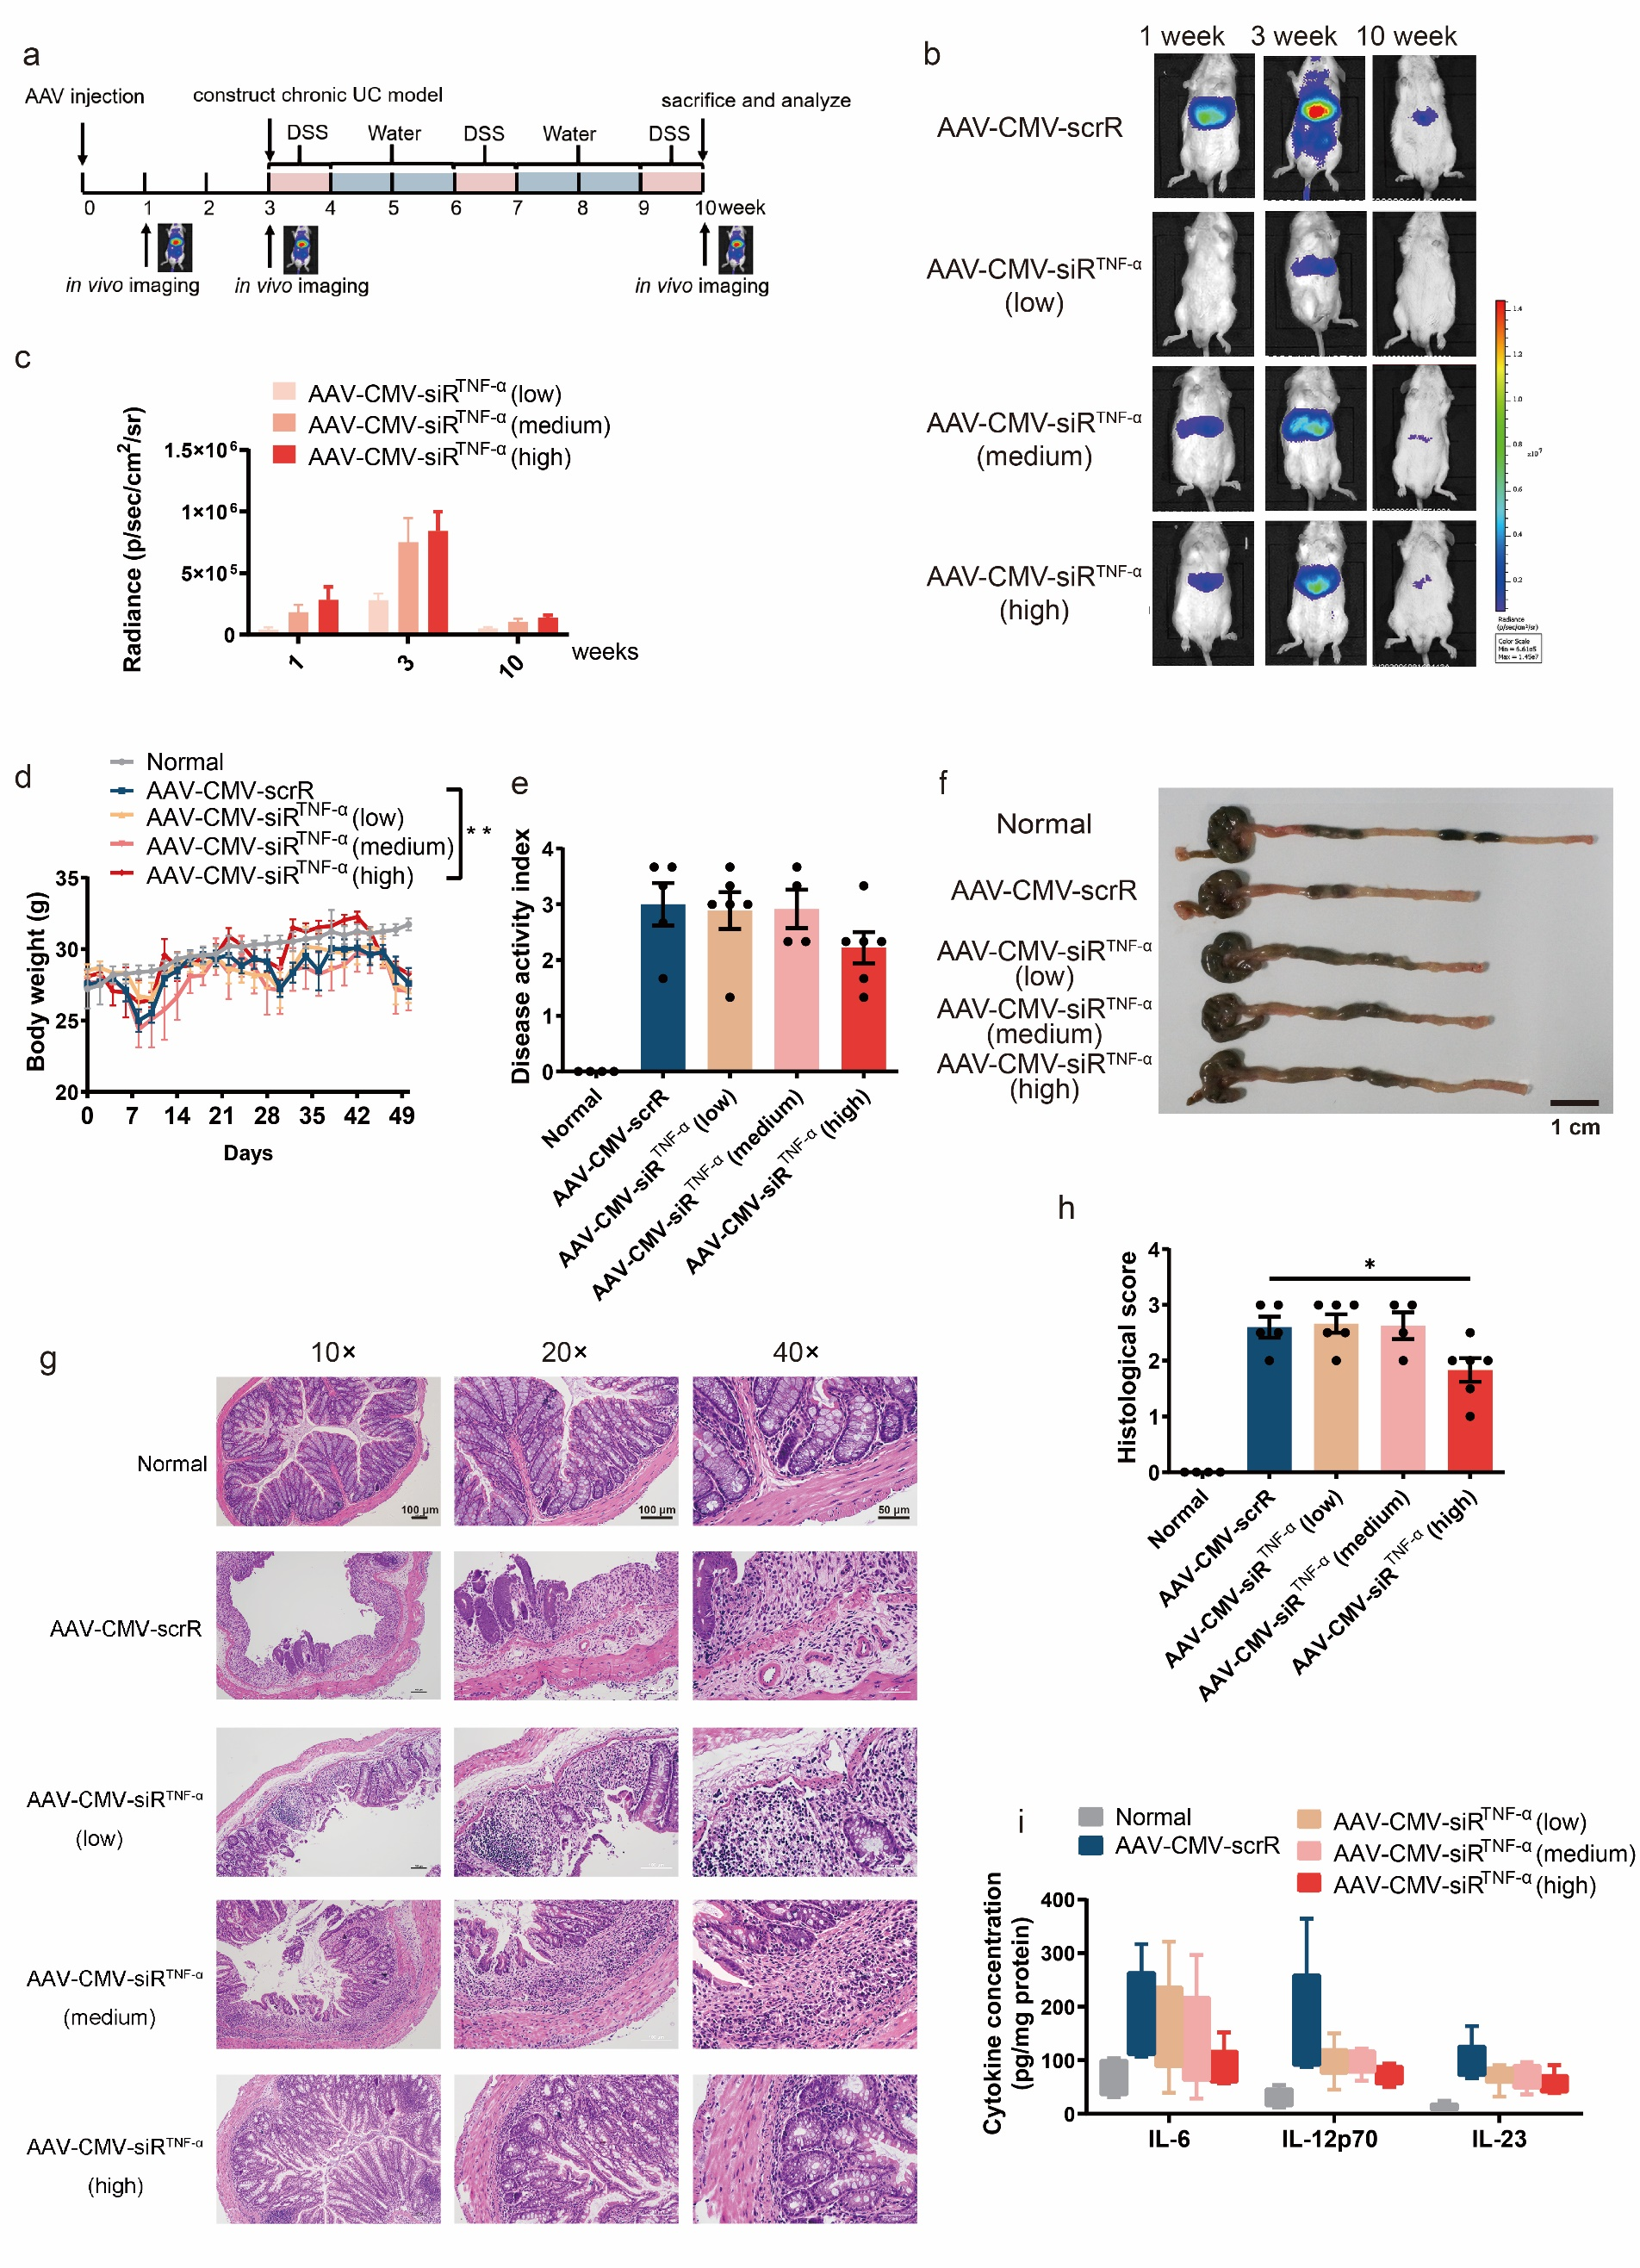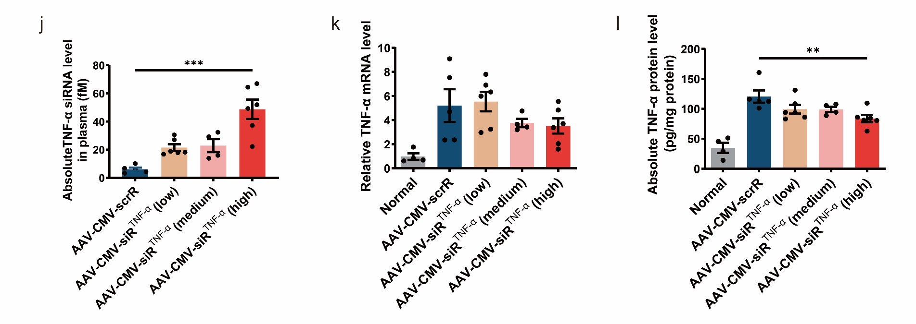

Supplementary Fig. 16 Intravenous injection of the AAV-CMV-siR^{T+B+I} circuit induces long-term combination therapy in the DSS-induced chronic UC model. On week 0, BALB/c mice were intravenously injected with AAV-CMV-scrR (1.0×10¹¹ v.g.) or with three dosages of AAV-CMV-siR^{T+B+I} (2.5×10¹⁰ v.g., 5.0×10¹⁰ v.g. or 1.0×10¹¹ v.g.). Three weeks later, chronic UC was induced by rhythmically administering to mice 2.5% DSS for 1 week and water for 2 weeks. Body weights were monitored every two days, and symptoms and histology were evaluated at week 10. Untreated BALB/c mice were included as normal controls. (a) Mean colon length (n = 4 in each group). (b) Determination of serum levels of IL-6, IL-12p70 and IL-17A by ELISA (n = 4 in each group). (c) Representative images of H&E staining of colon sections. Scale bar: 100 μm (10× or 20×) or 50 μm (40×). (d) Histological scores of colon sections (n = 4 in each group). (e and f) Quantitative RT-PCR analysis of the absolute expression levels of TNF-α siRNA in the liver (e) and plasma (f) (n = 4 in each group). (g and h) Quantitative RT-PCR analysis of the absolute expression levels of B7-1 siRNA in the liver (g) and plasma (h) (n = 4 in each group). (i and j) Quantitative RT-PCR analysis of the absolute expression levels of integrin α4 siRNA in the liver (i) and plasma (j) (n = 4 in each group). Values are presented as the mean ± SEM. Signiﬁcance was determined using one-way ANOVA followed by Dunnett’s multiple comparison. * p < 0.05; ** p < 0.01; *** p < 0.005.
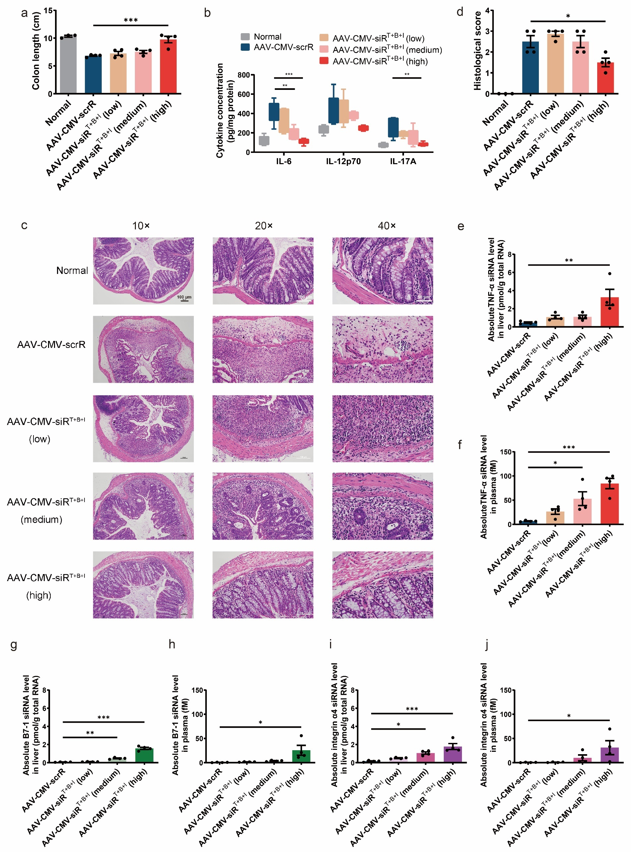

Supplementary Fig. 17 Maps of the plasmids used to express genetic circuits. (a) CMV-siR^{TNF-α} circuit. (b) CMV-siR^{B7-1} circuit. (c) CMV-siR^{Integrin α4} circuit. (d) CMV-siR^{T+B+I} circuit.
