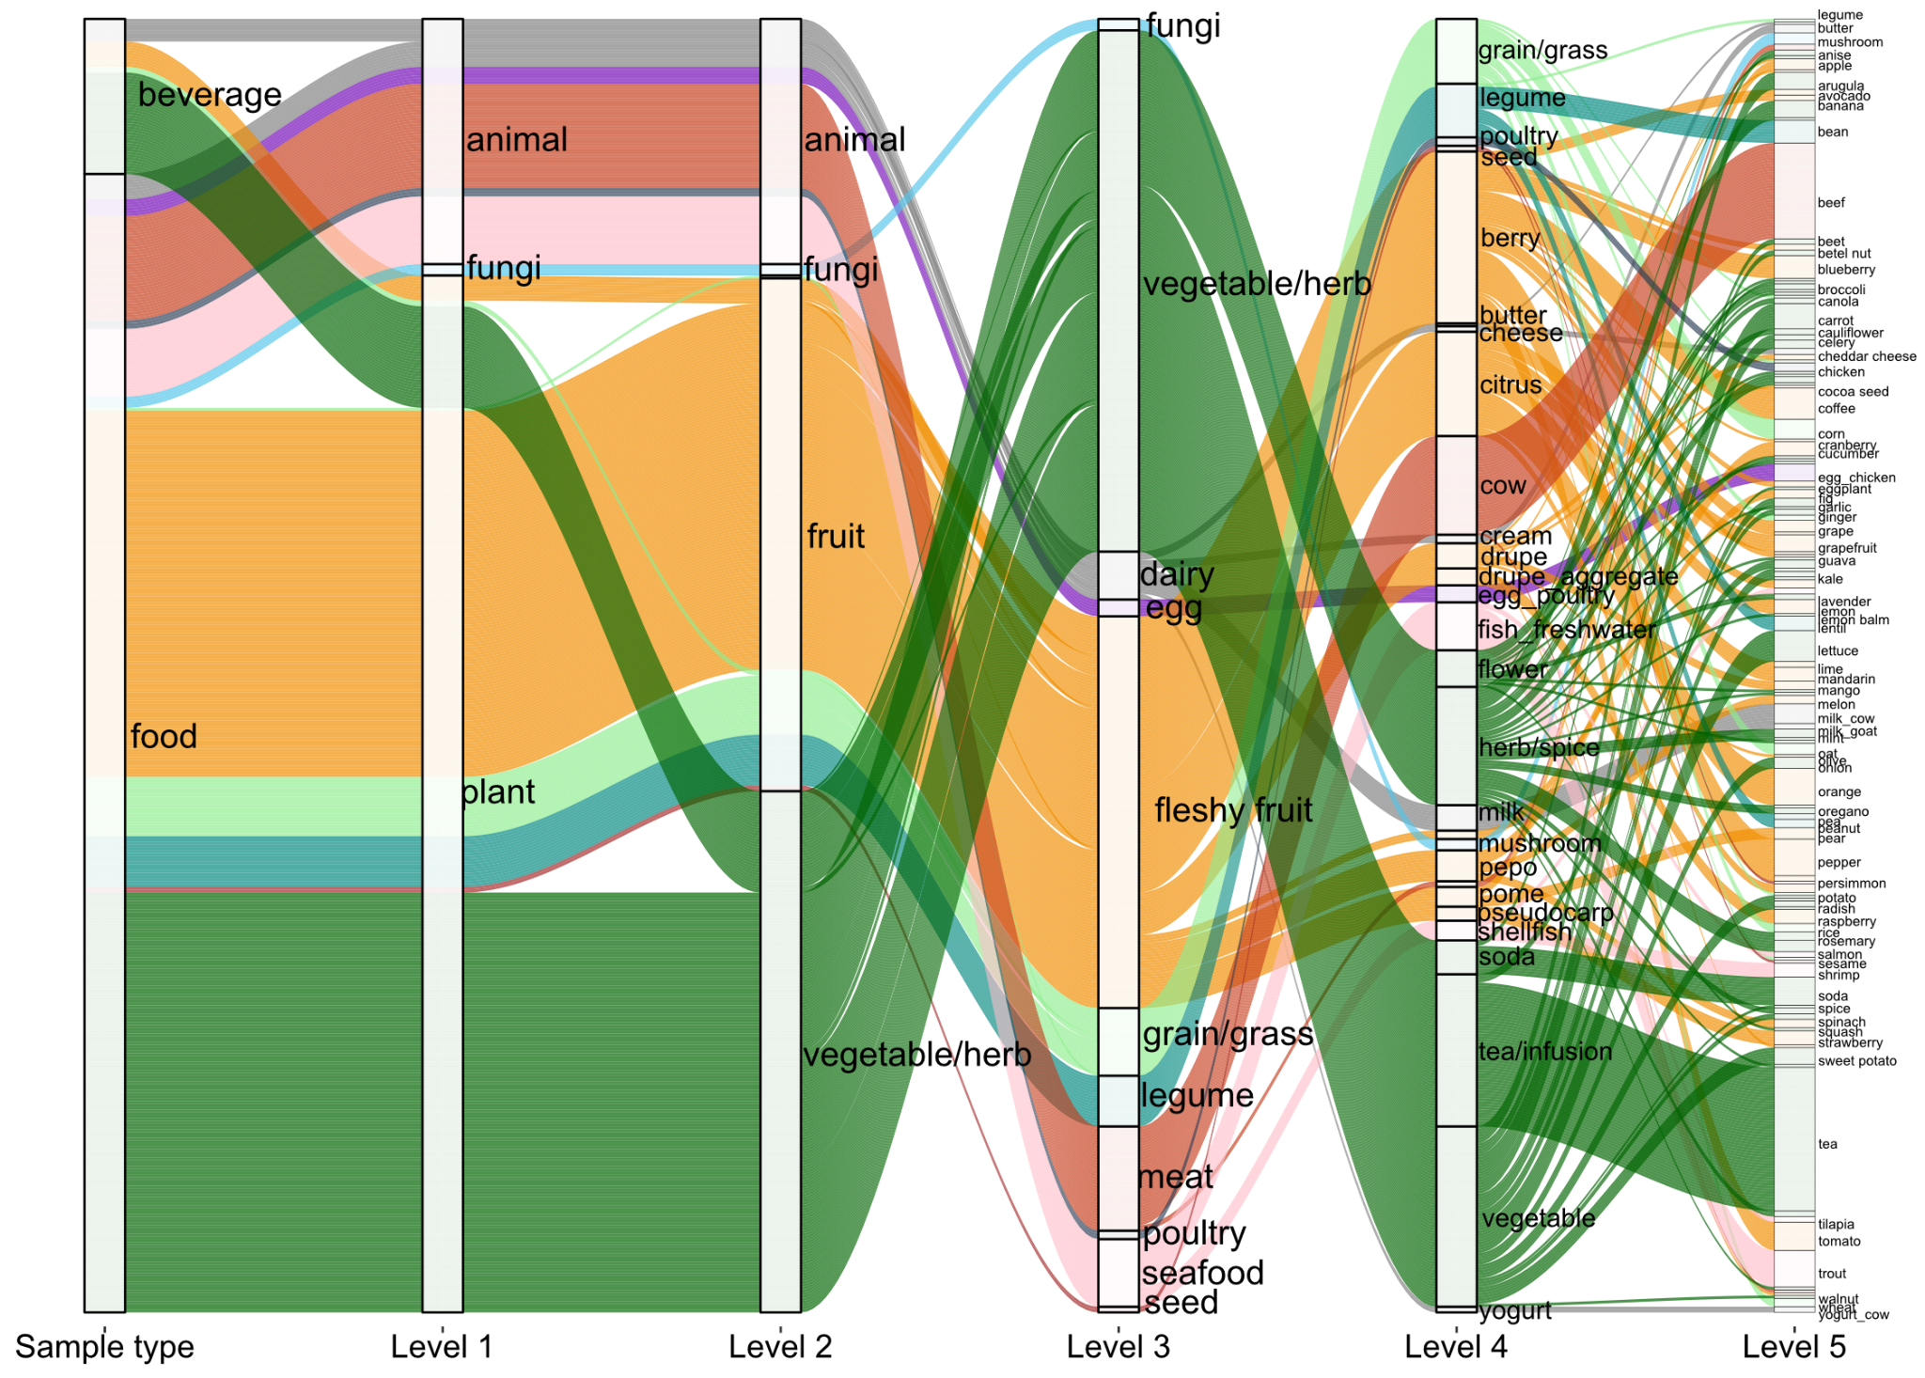

FigureS1:Food ontology of 500 dietary ingredients analysed using the untargeted metabolomics (UHPLC-MS/MS) analysis.
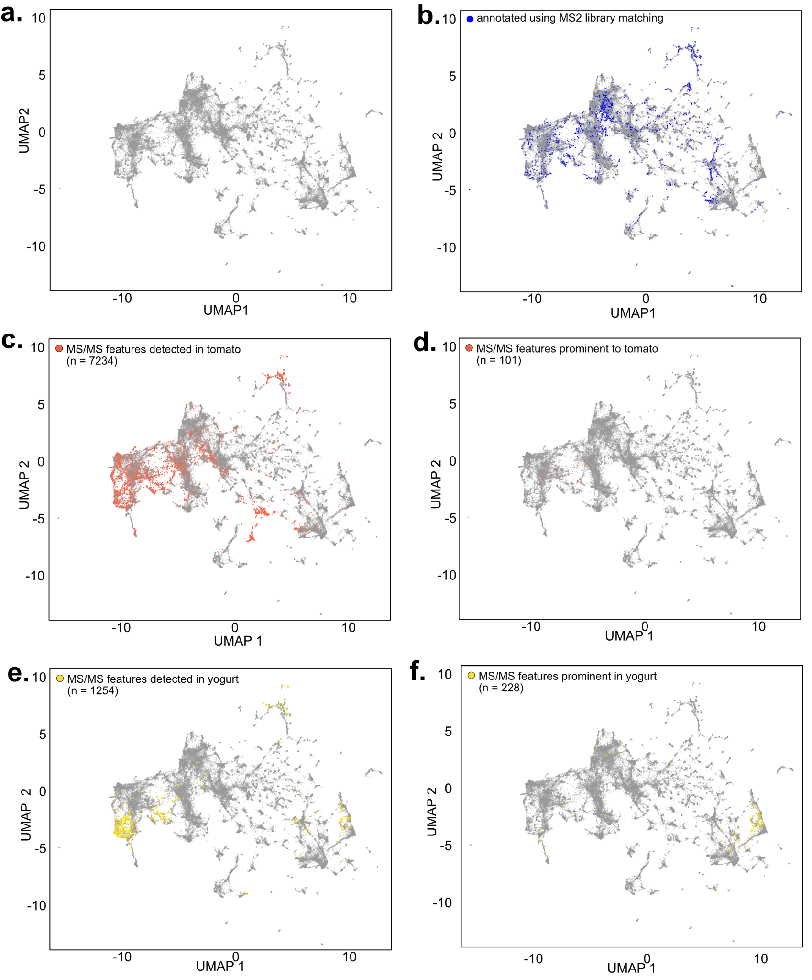
FigureS2: UMAP of dietary metabolites based on their distribution in 500 foods.

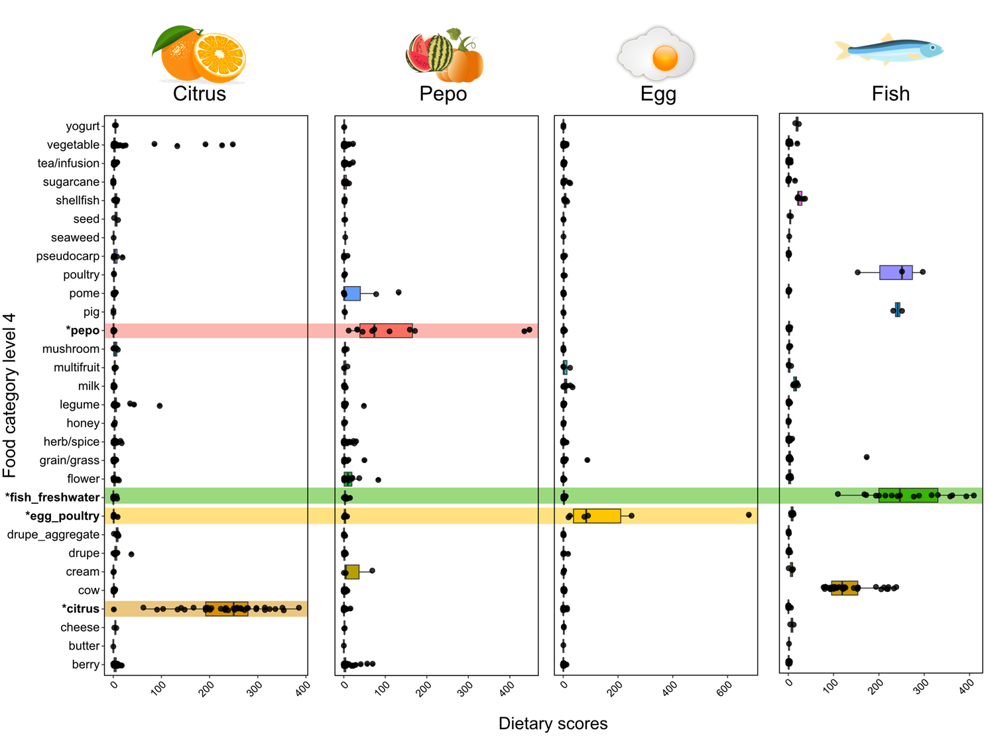
FigureS3: Classification of food categories at level4 ontology using the MS/MS tags developed from the supervised classification model. Dietary scores highlighting the distribution of MS/MS food biomarkers for citrus, pepo fruit, egg and fish food categories are highlighted between different food classes.

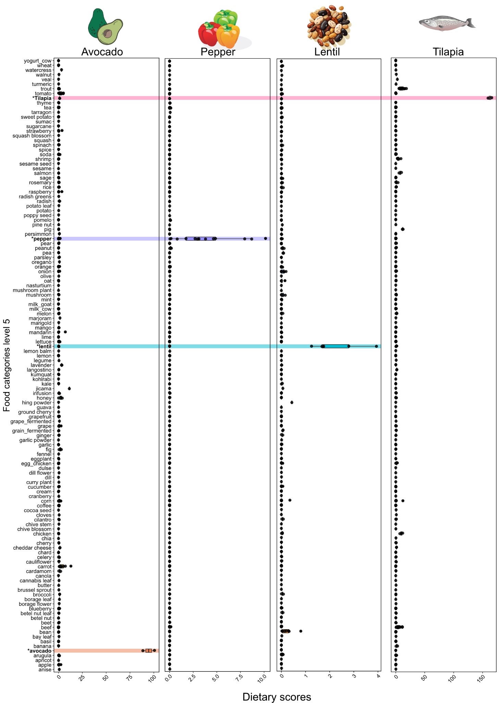
FigureS4: Classification of food categories at level5 ontology using the MS/MS food biomarkers developed from the multilayered classification model. Dietary scores highlighting the distribution MS/MS food biomarkers for avocado, lentil, pepper and tilapia categories are highlighted between different food classes.
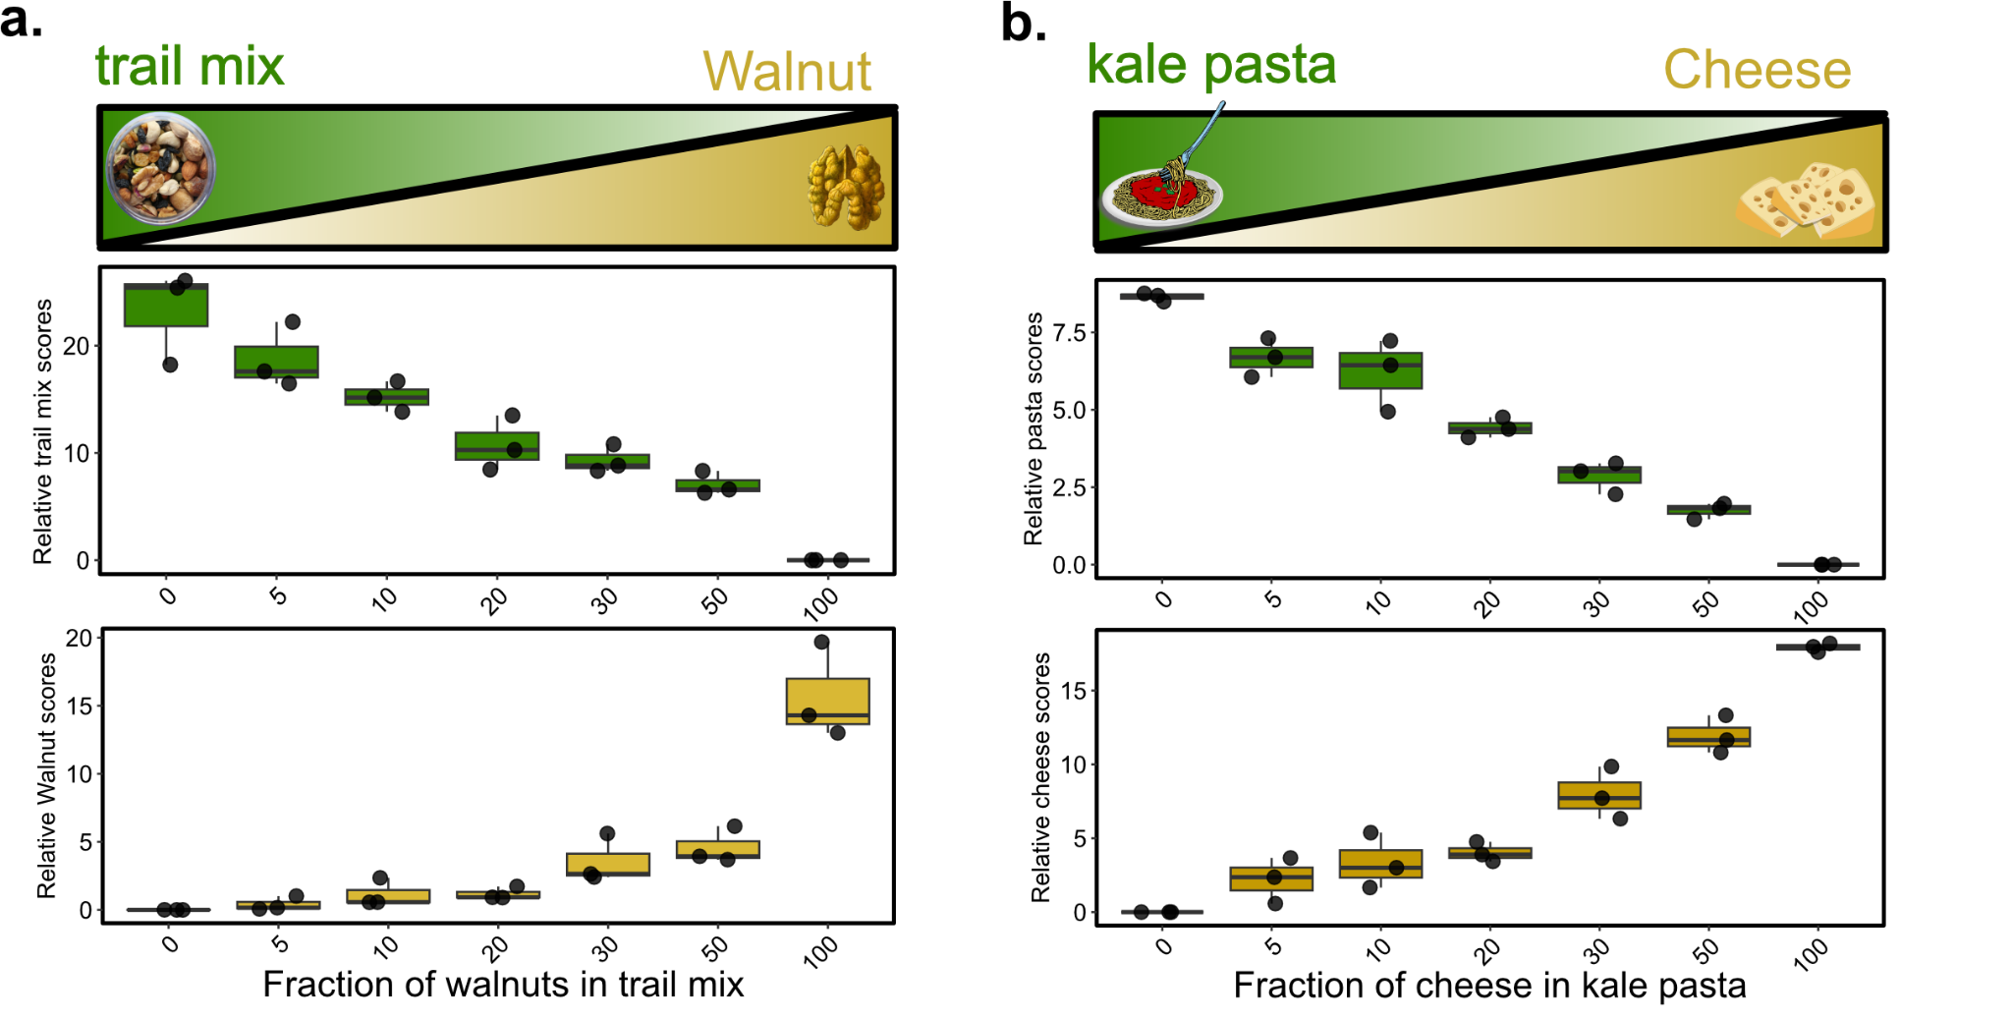
FigureS5:To test relative quantitative sensitivity of metabolomics approach for dietary readout, we used complex foods like trail mix (a) and kale pasta *(b) samples added with different amounts of walnuts and cheese respectively. We observed that the fraction of feta cheese and walnut added to each food well correlated with the dietary scores obtained using the metabolomics approach. Consistently, dietary readout for kale pasta and trail mix respectively decreased with decreasing fraction of that individual foods in the sample.

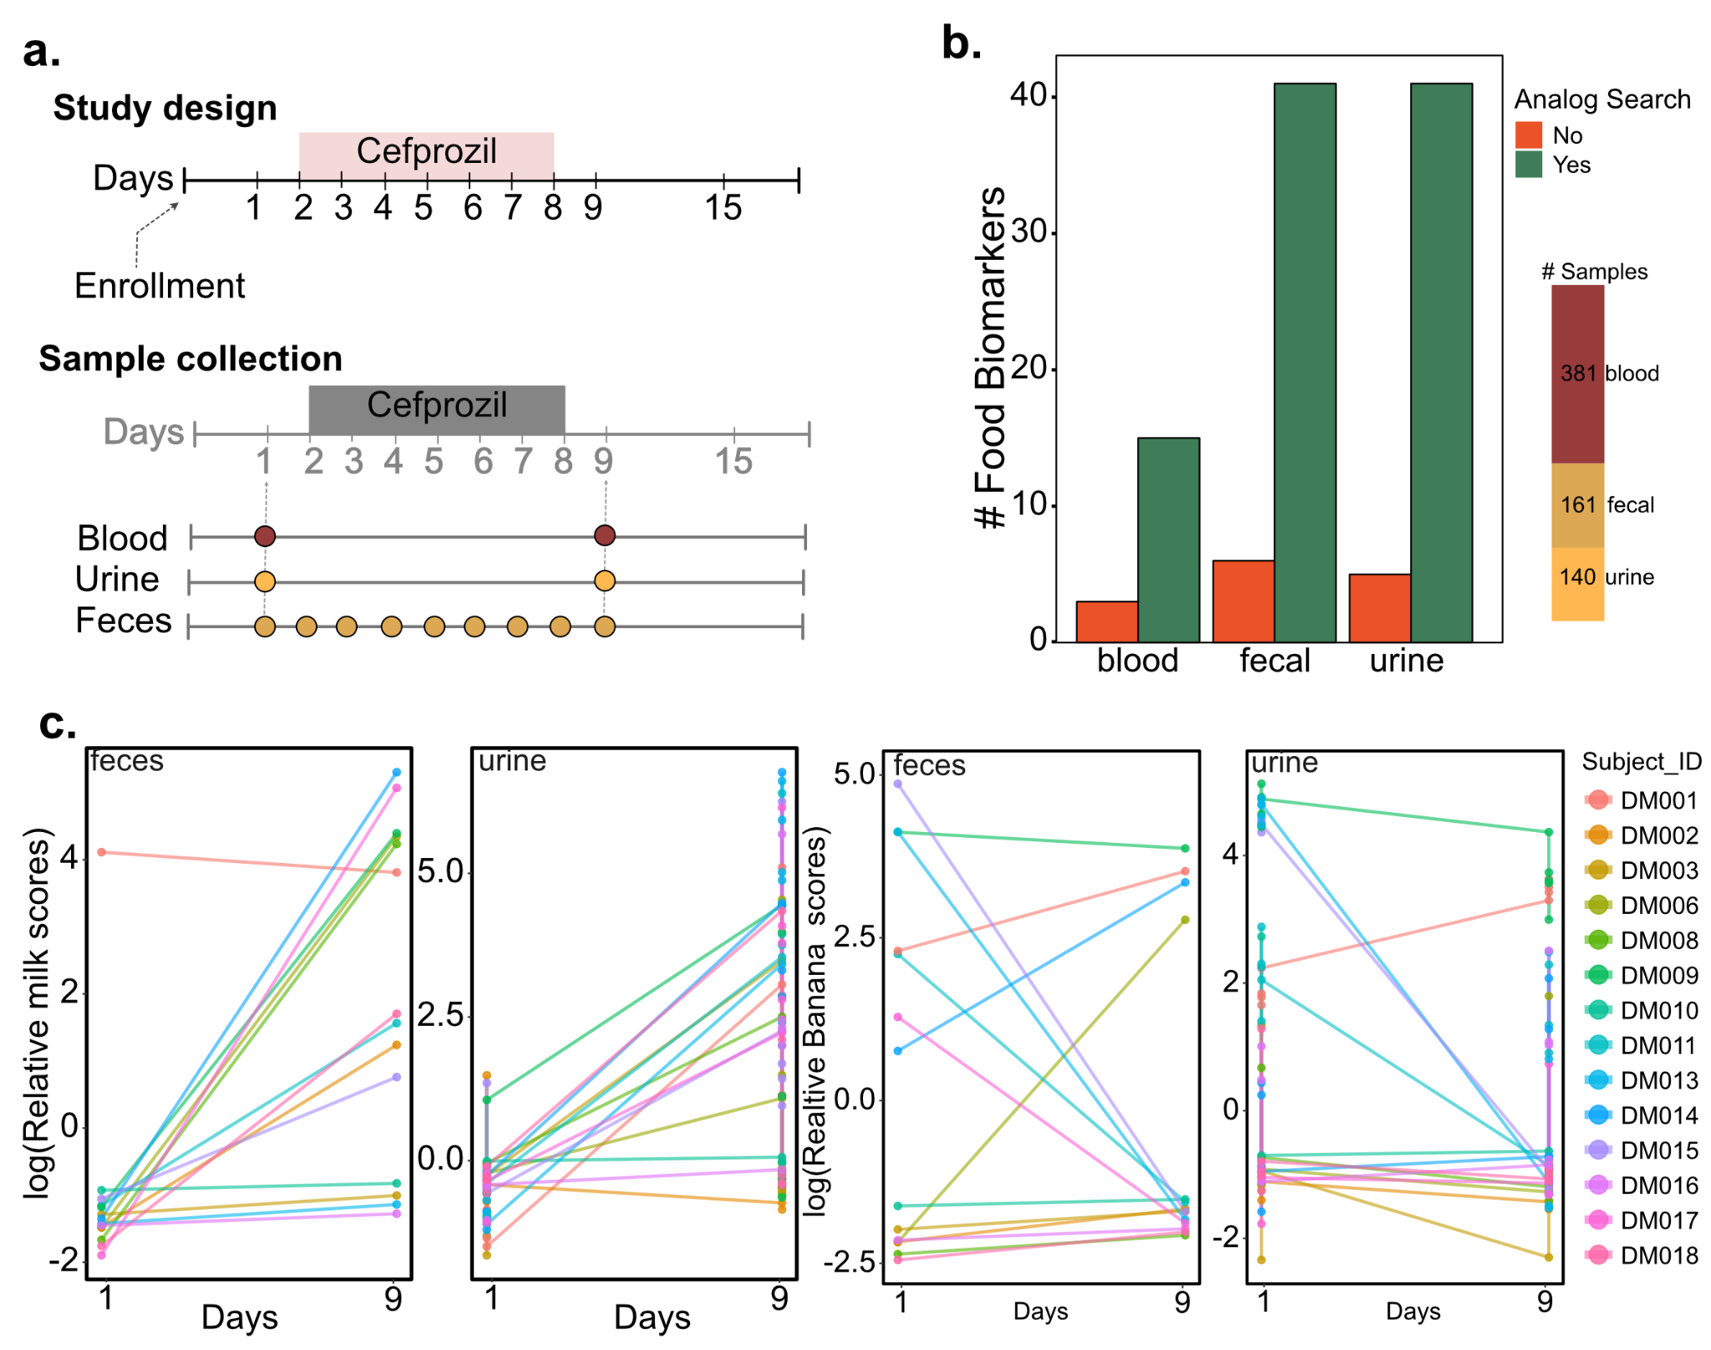
Figure S6: Urine and fecal metabolomics data capture host and microbial modifications of dietary metabolites. (a) In a drug treatment study, biological fluids blood, urine and feces samples were collected before, and after antibiotic Cefprozil treatment. (b)Using modified cosine similarity, the analogs of dietary metabolites were observed in all biological fluids. (c) Dietary scores obtained using the metabolomics approach, showed constant results between fecal and urine metabolomics data for each individual .

