Multi-scale drivers of parasitoid wasp communities in urban gardens: Local vegetation, landscape configuration and heterogeneity
Urban Ecosystems
Sergio Zapata-Martínez;¹ Susana Maza-Villalobos; Diana Ahuatzin; Gabriela Pérez-Lachaud; Miguel Á. Castillo-Santiago.
Corresponding author: sumaza@ecosur.mx
¹ Departamento de Conservación de la Biodiversidad, El Colegio de la Frontera Sur, Periférico Sur s/n, María Auxiliadora, 29290 San Cristóbal de Las Casas, Chiapas.

Table S1. Location and local characteristics found in urban gardens excluded in further analysis
Garden Key | Location |  | Garden Size  (m2) | LLtC  (%) | BrGC  (%) | FlwR  (n spp.)
Garden Key | Latitude | Longitude
CDJ | 16.740204 | -92.636105 | 1100 | 25.9 ± 3.7 | 19.2 ± 2.6 | 1.7 ± 0.2
DLM | 16.699869 | -92.635555 | 325 | 40.6 ± 6.3 | 21.5 ± 2.7 | 1.1 ± 0.2
ECO | 16.706151 | -92.615697 | 200 | 21.3 ± 3.5 | 28.0 ± 2.4 | 1.7 ± 0.2
ENC | 16.733133 | -92.605394 | 1500 | 3.6 ± 1.6 | 29.1 ± 3.9 | 3.5 ± 0.6
EPF | 16.745586 | -92.617475 | 260 | 17.8 ± 3.9 | 23.3 ± 2.0 | 1.0 ± 0.2
FCS | 16.744281 | -92.630577 | 300 | 22.6 ± 3.8 | 25.1 ± 3.8 | 1.3 ± 0.2
HBT | 16.745586 | -92.642808 | 1150 | 5.6 ± 1.2 | 46.4 ± 3.0 | 1.8 ± 0.2
HEW | 16.741044 | -92.661972 | 75 | 16.0 ± 4.5 | 27.2 ± 5.5 | 0.9 ± 0.3
HJK | 16.73453 | -92.62746 | 180 | 16.3 ± 3.2 | 33.3 ± 3.1 | 3.0 ± 0.7
HPS | 16.720322 | -92.659867 | 1000 | 1.7 ± 0.9 | 45.5 ± 4.5 | 2.1 ± 0.3
JMA | 16.743331 | -92.651117 | 20 | 5.0 ± 1.7 | 22.9 ± 3.8 | 1.8 ± 0.2
LET | 16.726195 | -92.680944 | 700 | 0.9 ± 0.6 | 25.5 ± 3.0 | 2.1 ± 0.4
PLM | 16.729305 | -92.705806 | 2200 | 1.3 ± 0.7 | 47.1 ± 3.6 | 1.6 ± 0.2
Abbreviations: LLtC = Leaf litter cover, BrGC = Bare ground cover, FlwR = Flower richness

Table S2. Landscape categories (land use classification) in the city of San Cristóbal, Chiapas, Mexico.
Vegetation classes or land uses | Description
Forest  (550) | Pine-oak forests bordering the city.
Grasslands  (630) | Vegetation community dominated by pasture; may include wasteland or areas used for livestock activities.
Agricultural areas  (600) | Areas primarily used for vegetable production on the city outskirts.
Urban green areas  (1,090) | Non-built-up areas with vegetation, such as parks, community gardens and riparian vegetation.
Urban areas  (1,000) | Human settlements, infrastructure and cement constructions, highways and asphalt roads. Human settlements, infrastructure and cement constructions, highways and asphalt roads.
* numbers in parentheses indicate training points for each type of land use cover.

Table S3. Mantel tests of spatial autocorrelation for parasitoid community response variables.
Variables | r | p
Richness (q0) | -0.211 | 0.908
Shannon (q1) | -0.189 | 0.854
Simpson (q2) | -0.162 | 0.772

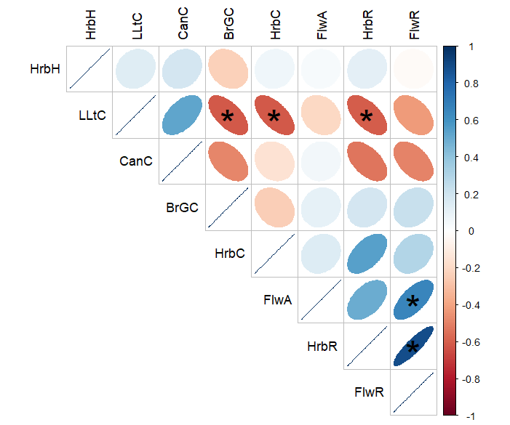
Figure S1. Pearson correlation matrix of local variables recorded in urban gardens of San Cristobal de Las Casas, Chiapas, Mexico. Asterisks indicate significant predictors (p < 0.05). Meaning of abbreviations: HrbH = Herbaceous height, HrbC = Herbaceous cover, LLtC = Leaf litter cover, BrGC = Bare ground cover, HrbR = Herbaceous plant richness, FlwA = Flower abundance, FlwR = Flower richness, CanC = Canopy cover.
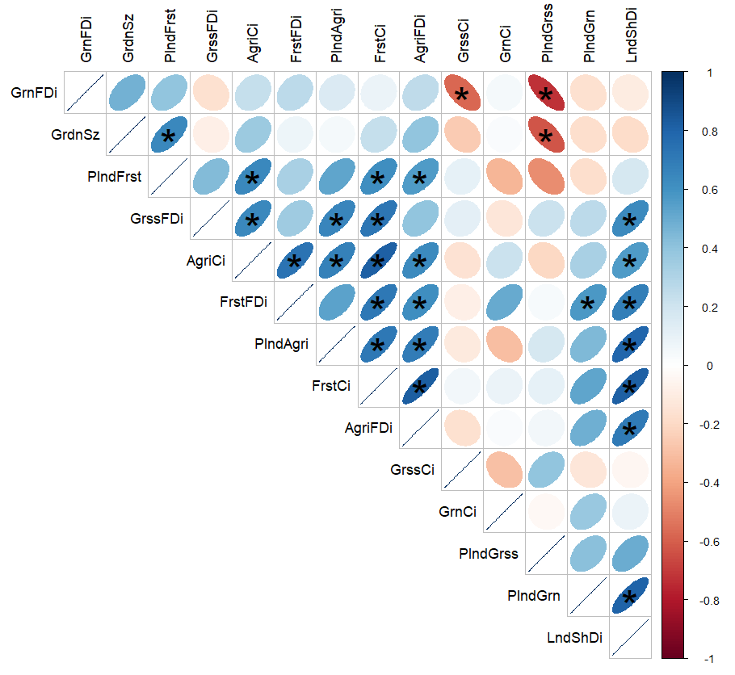Figure S2. Pearson correlation matrix of landscape variables calculated for all land use classes around urban gardens in San Cristóbal de Las Casas, Chiapas, Mexico. Asterisks indicate significant predictors (p < 0.05). Meaning of abbreviations: GrdnSz = Garden size, GrnCi = Urban green área clumpy index, AgriCi = Agriculture area clumpy index, GrssCi = Grassland clumpy index, FrstCi = Forest clumpy index, GrnFDi = Urban green área fractal dimention index, AgriFDi = Agriculture area fractal dimention index, GrssFDi = Grassland fractal dimention index, FrstFDi = Forest fractal dimention index, PlndGrn = Urban green área land proportion, PlndAgri = Agriculture area land proportion, PlndGrss = Grassland land proportion, PlndFrst = forest land proportion, LndShDi = Landscape Shannon diversity index.

Tabla S4. GLMs results of common families of parasitoid in 13 urban gardens in San Cristóbal de Las Casas, Chiapas, Mexico.
Familias | Variables en el modelo | Estimates | Std. Error | p | AIC | R2 | gl
Encyrtidae | GrnAFDi | -1563.12 | 500.993 | 0.002 | 121.82 | 0.64 | 10
 | LndShdi | -77.368 | 23.035 | 0.001
Mymaridae | NULL
Braconidae | NULL
Scelionidae | HrbH | 217.731 | 90.430 | 0.016 | 132.86 | 0.50 | 10
 | LndShdi | 132.799 | 43.438 | 0.002
Diapriidae | NULL
Figitidae | HrbR | 98.868 | 39.318 | 0.012 | 124.55 | 0.37 | 11
Ichneumonidae | FlwA | 47.831 | 15.707 | 0.002 | 119.26 | 0.78 | 10
 | CanC | 69.875 | 14.348 | < 0.001
Platygastridae | NULL
Eulophidae | HrbC | -36.383 | 18.249 | 0.016 | 96.43 | 0.50 | 10
 | PlndFrst | 31.605 | 14.345 | 0.019
Pteromalidae | FlwA | 15.787 | 4.827 | 0.001 | 92.54 | 0.73 | 9
 | CanC | -9.899 | 4.406 | 0.025
 | GrnACi | 51.028 | 13.405 | <0.001
Ceraphronidae | FlwA | 12.584 | 4.327 | 0.004 | 85.60 | 0.67 | 10
 | GrnAFDi | 394.826 | 123.143 | 0.001
Asaphesinae | CanC | 31.514 | 7.277 | <0.001 | 104.41 | 0.90 | 9
 | PlndFrst | 30.271 | 5.723 | <0.001
 | GrnACi | 75.541 | 17.882 | <0.001
 | GrnAFDi | -1398.217 | 214.296 | <0.001
Meaning of abbreviations: HrbH = Herbaceous height, HrbC = Herbaceous cover, HrbR = Herbaceous plant richness, FlwA = Flower abundance, CanC = Canopy cover, PlndFrst = Forest land proportion, GrnACi = Urban green area clumpy index, GrnAFDi = Urban green area fractal dimension index, LndShdi = Landscape heterogeneity index.

Table S5. GLMs results of parasitoid diversity indices (q0, q1 and q2) in 13 urban gardens in San Cristóbal de Las Casas, Chiapas, Mexico.
Index | Predictors | t | SE | p | AIC | R2 | gl
Richness (q0) | FlwA | 4.97 | 0.674 | < 0.001 | 46.422 | 0.91 | 8
 | CanC | 2.109 | 0.686 | 0.002
 | GrnACi | 6.756 | 1.829 | <0.001
 | LndShDi | 5.174 | 1.008 | <0.001
Shannon (q1) | HrbH | -9.750 | 2.002 | <0.001 | 48.986 | 0.876 | 8
 | FlwA | 2.991 | 0.723 | <0.001
 | GrnACi | 8.358 | 2.041 | <0.001
 | GrnAFDi | 56.129 | 21.191 | 0.008
Simpson (q2) | HrbH | -10.39 | 1.95 | < 0.001 | 48.305 | 0.878 | 8
 | FlwA | 2.603 | 0.705 | <0.001
 | GrnACi | 7.919 | 1.989 | <0.001
 | GrnAFDi | 59.963 | 20.642 | 0.004
* Meaning of abbreviations: HrbH = Herbaceous height, FlwA = Flower abundance, CanC = Canopy cover, GrnACi = Urban green area clumpy index, GrnAFDi = Urban green area fractal dimension index, LndShdi = Landscape heterogeneity index.

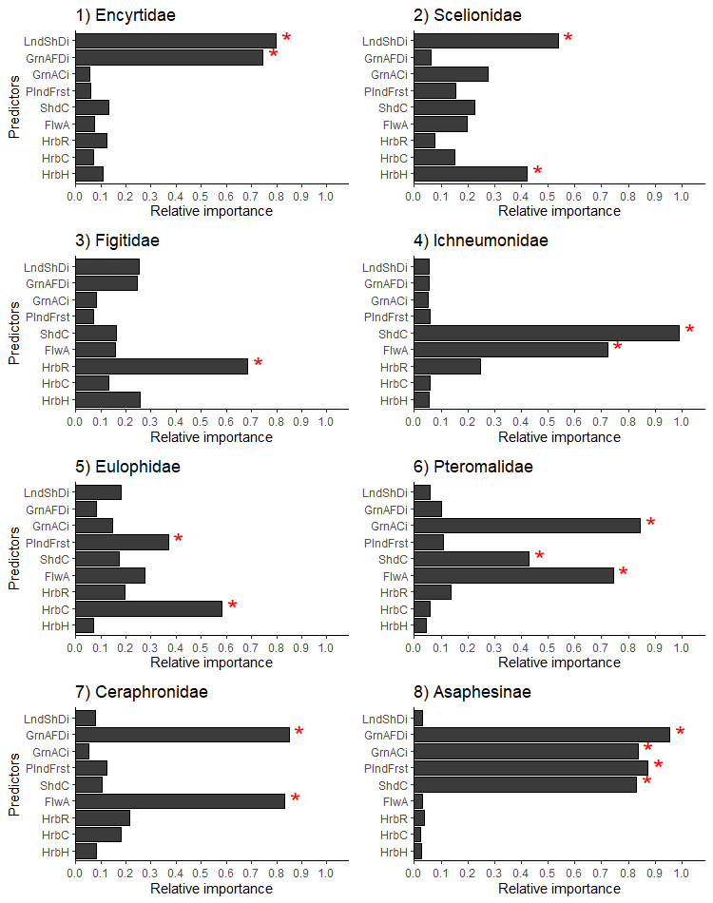
Figure S3. Relative importance of variables for model selection of most abundant parasitoid wasp families collected in urban gardens of San Cristóbal de Las Casas, Chiapas. Asterisks in red indicate significant predictors for the best model. HrbH = Herbaceous height, HrbC = Herbaceous cover, HrbR = Herbaceous plant richness, FlwA = Flower abundance, CanC = Canopy cover, PlndFrst = Forest land proportion, GrnACi = Urban green area clumpy index, GrnAFDi = Urban green area fractal dimension index, LndShDi = Landscape heterogeneity index.
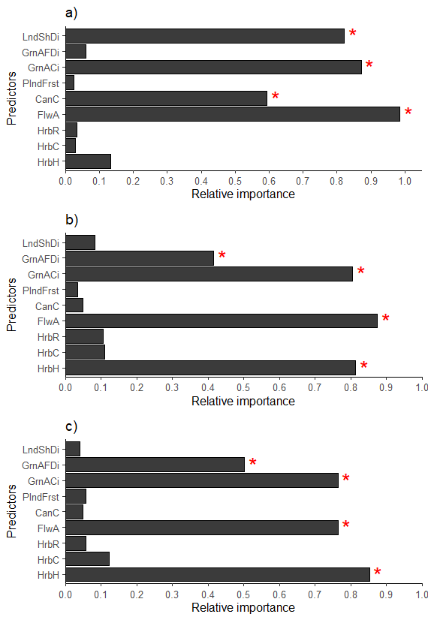
Figure S4. Relative importance of variables in model selection for a) richness (q0), b) Shannon's diversity index (q1) and c) Simpson's index (q2) of parasitoid community wasps collected in urban gardens of San Cristóbal de Las Casas, Chiapas. Asterisks in red indicate significant predictors for the best model. HrbH = Herbaceous height, HrbC = Herbaceous cover, HrbR = Herbaceous plant richness, FlwA = Flower abundance, CanC = Canopy cover, PlndFrst = Forest land proportion, GrnACi = Urban green area clumpy index, GrnAFDi = Urban green area fractal dimension index, LndShDi = Landscape heterogeneity index.

Table S5. Abundances (n), effective numbers of families observed, estimated (Est. ± SE) and sampling coverage (%) of parasitoid family richness for each garden in San Cristobal de Las Casas city, Chiapas, Mexico.
Garden | n | Species richness (q0) |  | Shannon diversity (q1) |  | Simpson Diversity (q2) |  | Coverage (%)
Garden | n | Observed | Est. ± SE | Observed | Est. ± SE | Observed | Est. ± SE | Coverage (%)
CDJ | 591 | 23 | 27.5 ± 4.9 | 13 | 13.3 ± 0.5 | 9.93 | 10.1 ± 0.5 | 83.6
DLM | 360 | 20 | 30 ± 8.1 | 11.9 | 12.4 ± 0.6 | 9.82 | 10.1 ± 0.5 | 66.7
ECO | 573 | 22 | 26 ± 4.6 | 11.6 | 11.9 ± 0.5 | 8.33 | 8.4 ± 0.5 | 84.6
ENC | 537 | 23 | 25.7 ± 5.8 | 12.6 | 12.9 ± 0.4 | 10.2 | 10.4 ± 0.4 | 89.5
EPF | 305 | 22 | 31 ± 10.3 | 13 | 13.7 ± 0.7 | 10.6 | 11 ± 0.6 | 71
FCS | 653 | 22 | 26.5 ± 4.8 | 10.7 | 10.9 ± 0.4 | 8.28 | 8.4 ± 0.3 | 83
HBT | 506 | 21 | 25.5 ± 4.7 | 11.7 | 12 ± 0.5 | 9.22 | 9.4 ± 0.4 | 90.4
HEW | 275 | 23 | 29.2 ± 9.9 | 12.3 | 13 ± 0.9 | 9.26 | 9.6 ± 0.7 | 78.8
HJK | 503 | 22 | 26 ± 4.8 | 12.4 | 12.7 ± 0.5 | 10.1 | 10.3 ± 0.4 | 84.6
HPS | 523 | 24 | 26.7 ± 6.3 | 13.2 | 13.5 ± 0.5 | 10.2 | 10.4 ± 0.6 | 93.9
JMA | 303 | 16 | 16.2 ± 2.2 | 6.6 | 6.8 ± 0.5 | 4.1 | 4.2 ± 0.3 | 98.8
LET | 711 | 21 | 29 ± 6.1 | 10.3 | 10.5 ± 0.4 | 7.6 | 7.7 ± 0.4 | 72.4
PLM | 617 | 22 | 26.5 ± 4.8 | 12.8 | 13.1 ± 0.6 | 10.1 | 10.3 ± 0.5 | 83
Total | 6457 | 34 | 35.0 ± 3.5 | 14.1 | 14.1 ± 0.1 | 11 | 11 ± 0.1 | 97.1

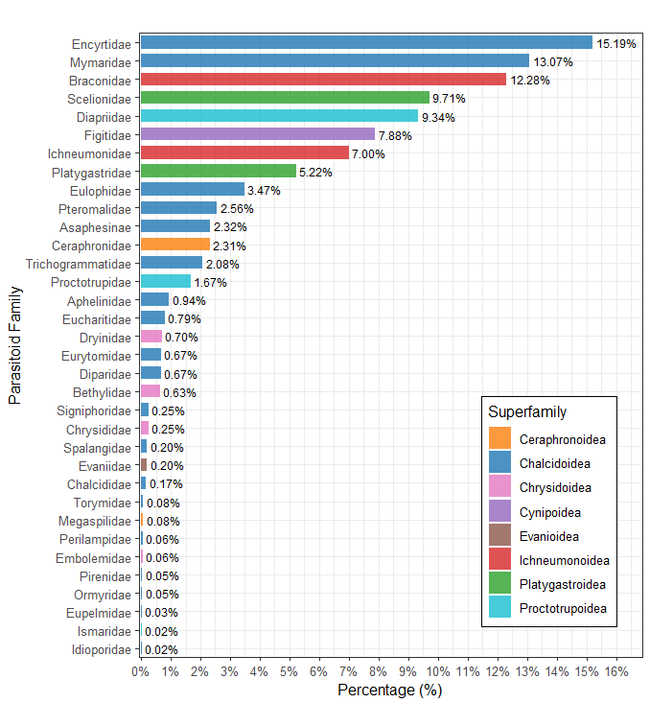
Figure S5. Parasitoid individuals grouped by families collected in 13 gardens in the city of San Cristóbal de Las Casas, Chiapas, Mexico.

