Supplementary Information

S1. Overview of calculated VIs.
Index | Formula |  | Traits | Relevant Studies
Chlorophyll Index - Green (CIG) | $$\left(\frac{R_{NIR}}{R_{G}}\right)-1$$ |  | chlorophyll | [97]
Chlorophyll Vegetation Index (CVI) | $$\frac{(R_{NIR}*R_{R})}{{R_{G}}^{2}}$$ |  | chlorophyll | [97]
Green Leaf Index (GLI) | $$\frac{(2R_{G}-R_{R}-R_{B})}{(2R_{G}+R_{R}+R_{B})}$$ |  | chlorophyll | [98]
Modified Soil Adjusted Vegetation Index 2 (MSAVI2) | ${0.5[2R}_{NIR}+1-\sqrt{{{(2R}_{NIR}+1)}^{2}-8\left(R_{NIR}-R_{R}\right)}$] |  | disease (YR) | [47]
Modified Simple Ratio (MSR) | $$\frac{(\frac{R_{NIR}}{R_{R}}-1)}{\sqrt{(\frac{R_{NIR}}{R_{R}})+1}}$$ |  | disease | [48]
Optimized Soil-Adjusted Vegetation Index (OSAVI) | $$\frac{(R_{NIR}-R_{R})}{(R_{NIR}+R_{R}+0.16)}$$ |  | disease | [48]
Plant Senescence Reflectance Index (PSRI) (only Pleiades-Neo) | $$\frac{(R_{R}-R_{G})}{R_{RE}}$$ |  | chlorophyll, nitrogen, maturity | [99]
Re-normalized Difference Vegetation Index (RDVI) | $$\frac{(R_{NIR}-R_{R})}{\sqrt{(R_{NIR}+R_{R})}}$$ |  | disease (YR) | [37]
Soil Adjusted Vegetation Index (SAVI) | $$\frac{({1+L)*(R}_{NIR}-R_{R})}{(R_{NIR}+R_{R}+L)}$$ | L=0.5 | disease (YR) | [31,37,47]
Triangular Vegetation Index (TVI) | $$0.5[120(R_{NIR}-R_{G})-200(R_{R}-R_{G})]$$ |  | disease (YR), green LAI, chlorophyll, canopy | [31,34,47]
Note: R: measured reflectance at the original wavelength or wavebands specified by the subscript (G: Green; R: Red; NIR: near-infrared).

S2a. Trial 1 – YR visual disease scoring results per plot, showing incidence in percentage, severity in percentage, and host plant reaction (on DAI 0, YR was not observed in the plots).
Plot | Variety | Block¹ | DAI 17 | DAI 30 | DAI 37
1 | Kubsa | UT | 15/5/S | 100/60/S | 100/70/MS-S
2 | Hidase | UT | 0/0/- | 35/20/S | 0/0/-
3 | Danda’a | UT | 0/0/- | 10/5/MR-MS | 0/0/-
4 | Kingbird | UT | 0/0/- | 20/5/MS | 0/0/-
5 | Pavon-76 | UT | 0/0/- | 25/5/MS | 0/0/-
6 | Shorima | UT | 5/2/MS | 10/5/MS | 0/0/-
7 | Danda’a | T | 0/0/- | 0/0/- | 0/0/-
8 | Kubsa | T | 20/5/S | 50/25/MR-MS | 0/0/-
9 | Hidase | T | 10/5/MS | 10/5/MR-MS | 0/0/-
10 | Shorima | T | 0/0/- | 0/0/- | 0/0/-
11 | Pavon-76 | T | 0/0/- | 0/0/- | 0/0/-
12 | Kingbird | T | 0/0/- | 0/0/- | 0/0/-
13 | Shorima | T | 0/0/- | 0/0/- | 0/0/-
14 | Danda’a | T | 0/0/- | 0/0/- | 0/0/-
15 | Kingbird | T | 0/0/- | 0/0/- | 0/0/-
16 | Pavon-76 | T | 6/1/MS | 0/0/- | 0/0/-
17 | Kubsa | T | 0/0/- | 0/0/- | 0/0/-
18 | Hidase | T | 10/5/MS | 0/0/- | 0/0/-
19 | Hidase | UT | 5/1/MS | 30/15/MS-S | 0/0/-
20 | Danda’a | UT | 0/0/- | 10/5/MS | 0/0/-
21 | Kubsa | UT | 30/15/S | 70/25/MS-S | Not scored
22 | Shorima | UT | 0/0/- | 20/5/MS | 0/0/-
23 | Pavon-76 | UT | 0/0/- | 10/5/MS | 0/0/-
24 | Kingbird | UT | 0/0/- | 10/5/MS-S | 0/0/-
25 | Danda’a | UT | 0/0/- | 20/5/MS-S | 0/0/-
26 | Kubsa | UT | 40/15/S | 100/40/MS-S | 100/50/S
27 | Pavon-76 | UT | 0/0/- | 20/5/MS | 0/0/-
28 | Kingbird | UT | 0/0/- | 0/0/- | 0/0/-
29 | Hidase | UT | 5/2/MS | 30/15/S | 0/0/-
30 | Shorima | UT | 0/0/- | 10/5/MS | 0/0/-
31 | Danda’a | T | 5/2/MS | 0/0/- | 0/0/-
32 | Kubsa | T | 25/10/S | 20/10/MR | 0/0/-
33 | Shorima | T | 0/0/- | 0/0/- | 0/0/-
34 | Hidase | T | 15/10/S | 0/0/- | 0/0/-
35 | Kingbird | T | 0/0/- | 0/0/- | 0/0/-
36 | Pavon-76 | T | 0/0/- | 0/0/- | 0/0/-
¹ T: treated, fungicide treatment block; UT: untreated, non-fungicide treatment block;
² S: susceptible; MS-S: moderately susceptible to susceptible; MS: moderately susceptible; MR-MS: moderately resistant to moderately susceptible; MR: moderately resistant [67].

S2b. Trial 2 – YR visual disease scoring results per plot, showing incidence in percentage, severity in percentage, and host plant reaction (on DAI 0, YR was not observed in the plots).
Plot | Variety | Block¹ | DAI 17 | DAI 30 | DAI 37
37 | Kubsa | UT | 25/10/S | 90/40/S | 100/60/S
38 | Hidase | UT | 0/0/- | 20/10/S | 0/0/-
39 | Danda’a | UT | 0/0/- | 0/0/- | 0/0/-
40 | Kingbird | UT | 0/0/- | 0/0/- | 0/0/-
41 | Pavon-76 | UT | 0/0/- | 0/0/- | 50/30/S
42 | Shorima | UT | 6/2/MS | 10/5/S | 0/0/-
43 | Danda’a | T | 0/0/- | 0/0/- | 0/0/-
44 | Kubsa | T | 0/0/- | 0/0/- | 0/0/-
45 | Hidase | T | 20/5/MS | 0/0/- | 0/0/-
46 | Shorima | T | 0/0/- | 0/0/- | 0/0/-
47 | Pavon-76 | T | 0/0/- | 0/0/- | 0/0/-
48 | Kingbird | T | 0/0/- | 0/0/- | 0/0/-
49 | Shorima | T | 0/0/- | 0/0/- | 0/0/-
50 | Danda’a | T | 0/0/- | 0/0/- | 0/0/-
51 | Kingbird | T | 0/0/- | 0/0/- | 0/0/-
52 | Pavon-76 | T | 20/5/MS | 0/0/- | 0/0/-
53 | Kubsa | T | 0/0/- | 10/5/MR | 0/0/-
54 | Hidase | T | 0/0/- | 0/0/- | 0/0/-
55 | Hidase | UT | 0/0/- | 10/5/S | 0/0/-
56 | Danda’a | UT | 10/5/MS-S | 10/5/S | 0/0/-
57 | Kubsa | UT | 0/0/- | 90/50/S | 100/60/S
58 | Shorima | UT | 5/2/MS | 10/5/S | 0/0/-
59 | Pavon-76 | UT | 0/0/- | 15/5/MS | 0/0/-
60 | Kingbird | UT | 0/0/- | 20/15/MS | 0/0/-
61 | Danda’a | UT | 25/10/S | 10/5/S | 0/0/-
62 | Kubsa | UT | 15/5/MS | 100/50/S | 100/100/S
63 | Pavon-76 | UT | 0/0/- | 10/5/S | 40/20/S
64 | Kingbird | UT | 10/2/MS | 0/0/- | 0/0/-
65 | Hidase | UT | 0/0/- | 10/5/S | 40/20/S
66 | Shorima | UT | 0/0/- | 10/5/S | 0/0/-
67 | Danda’a | T | 0/0/- | 0/0/- | 0/0/-
68 | Kubsa | T | 20/5/MS-S | 0/0/- | 0/0/-
69 | Shorima | T | 0/0/- | 0/0/- | 0/0/-
70 | Hidase | T | 0/0/- | 0/0/- | 0/0/-
71 | Kingbird | T | 0/0/- | 0/0/- | 0/0/-
72 | Pavon-76 | T | 0/0/- | 0/0/- | 0/0/-
¹ T: treated, fungicide treatment block; UT: untreated, non-fungicide treatment block;
² S: susceptible; MS-S: moderately susceptible to susceptible; MS: moderately susceptible; MR-MS: moderately resistant to moderately susceptible; MR: moderately resistant [67].

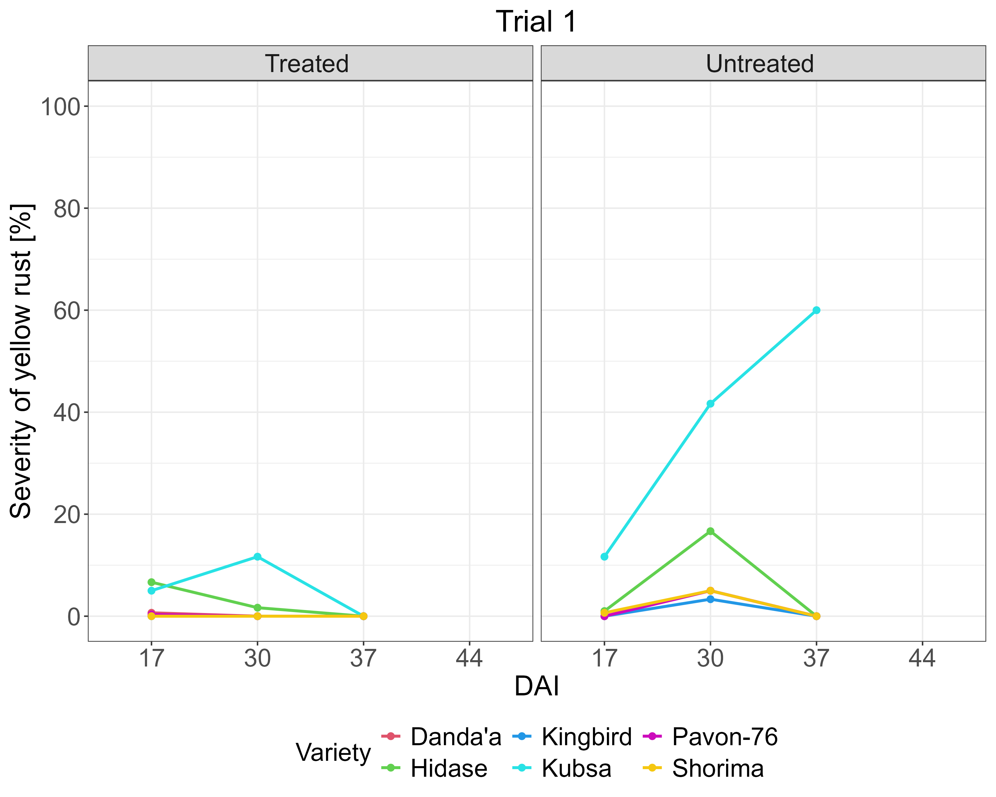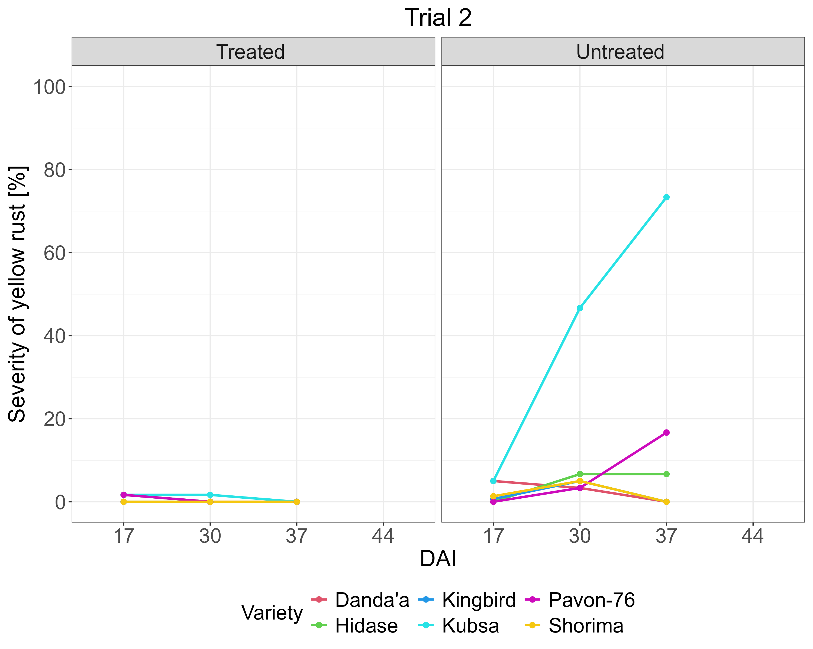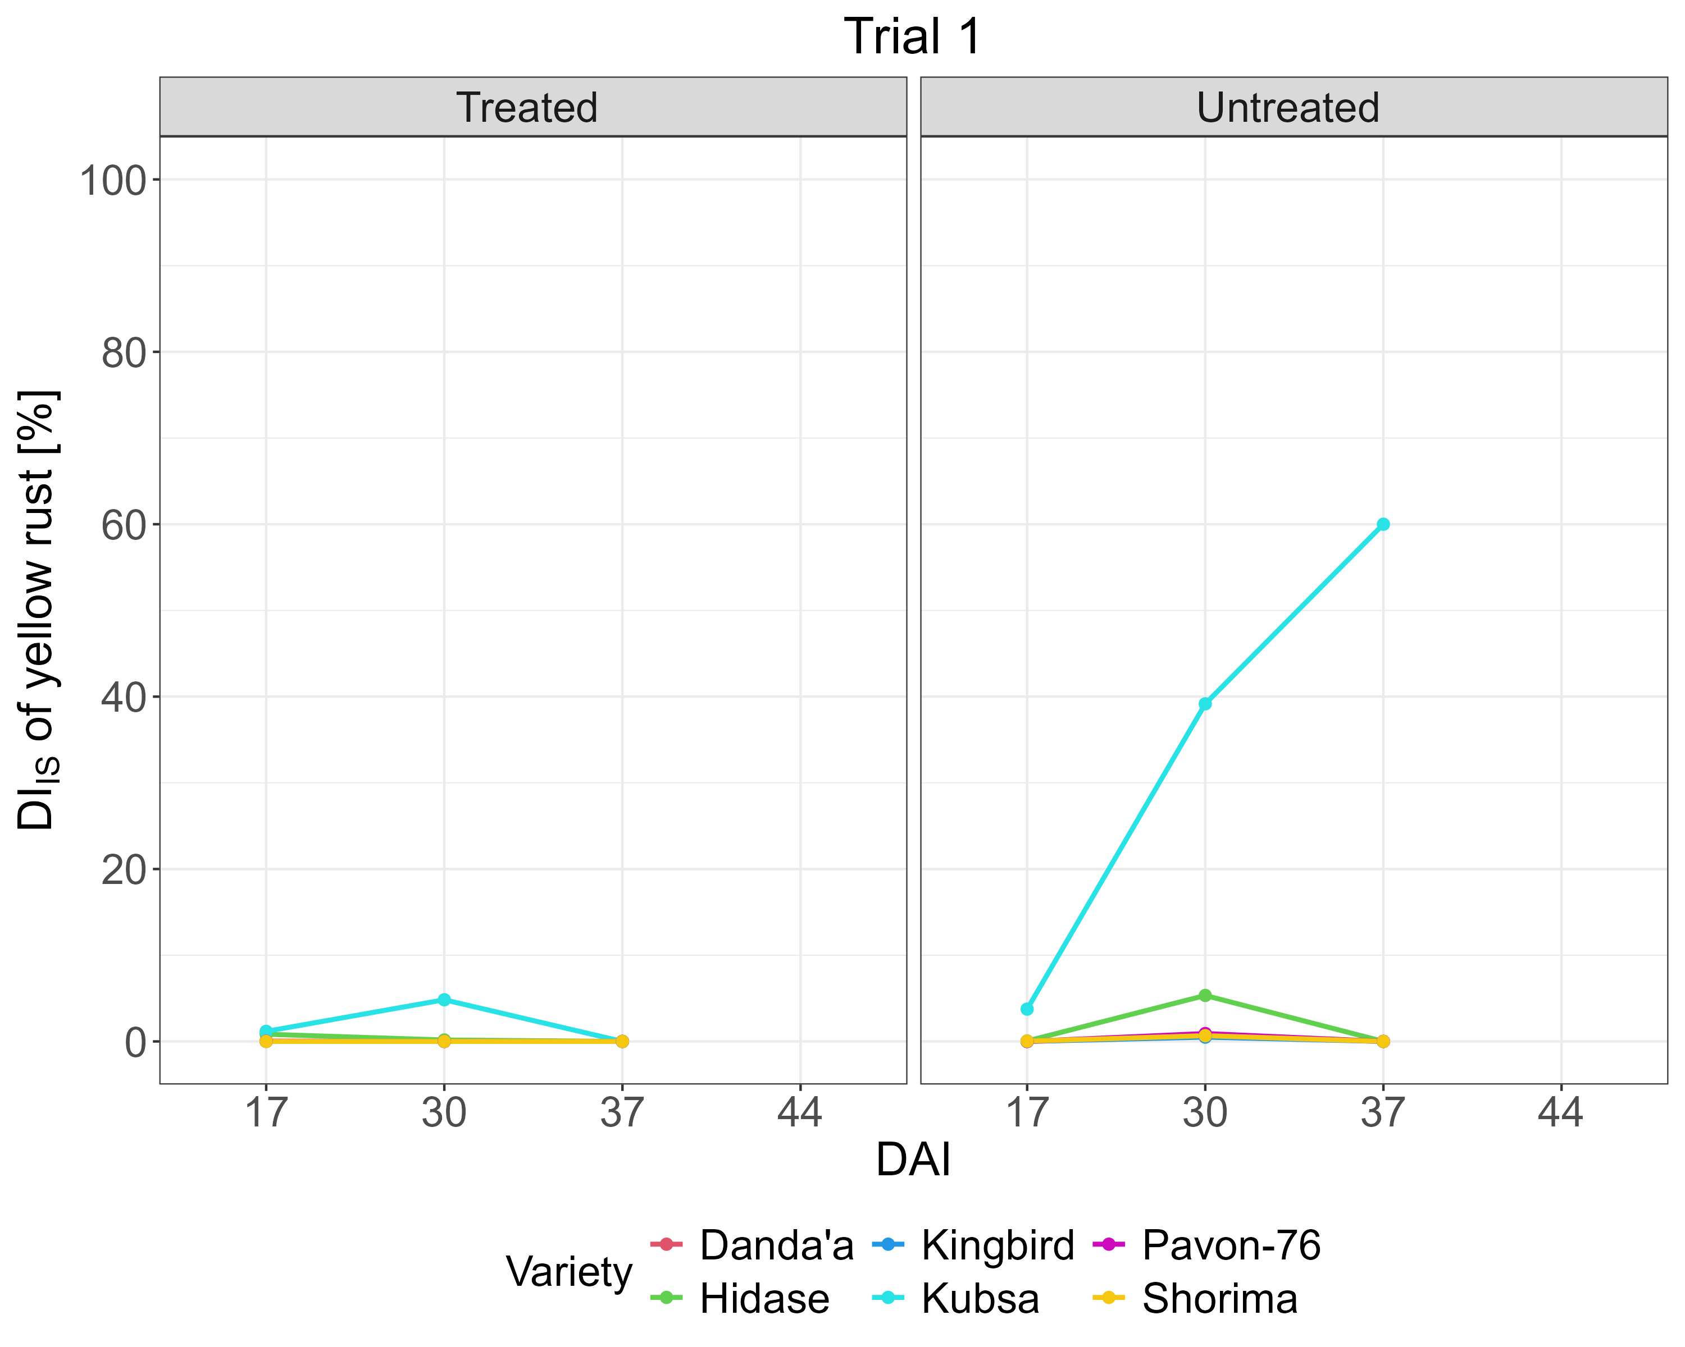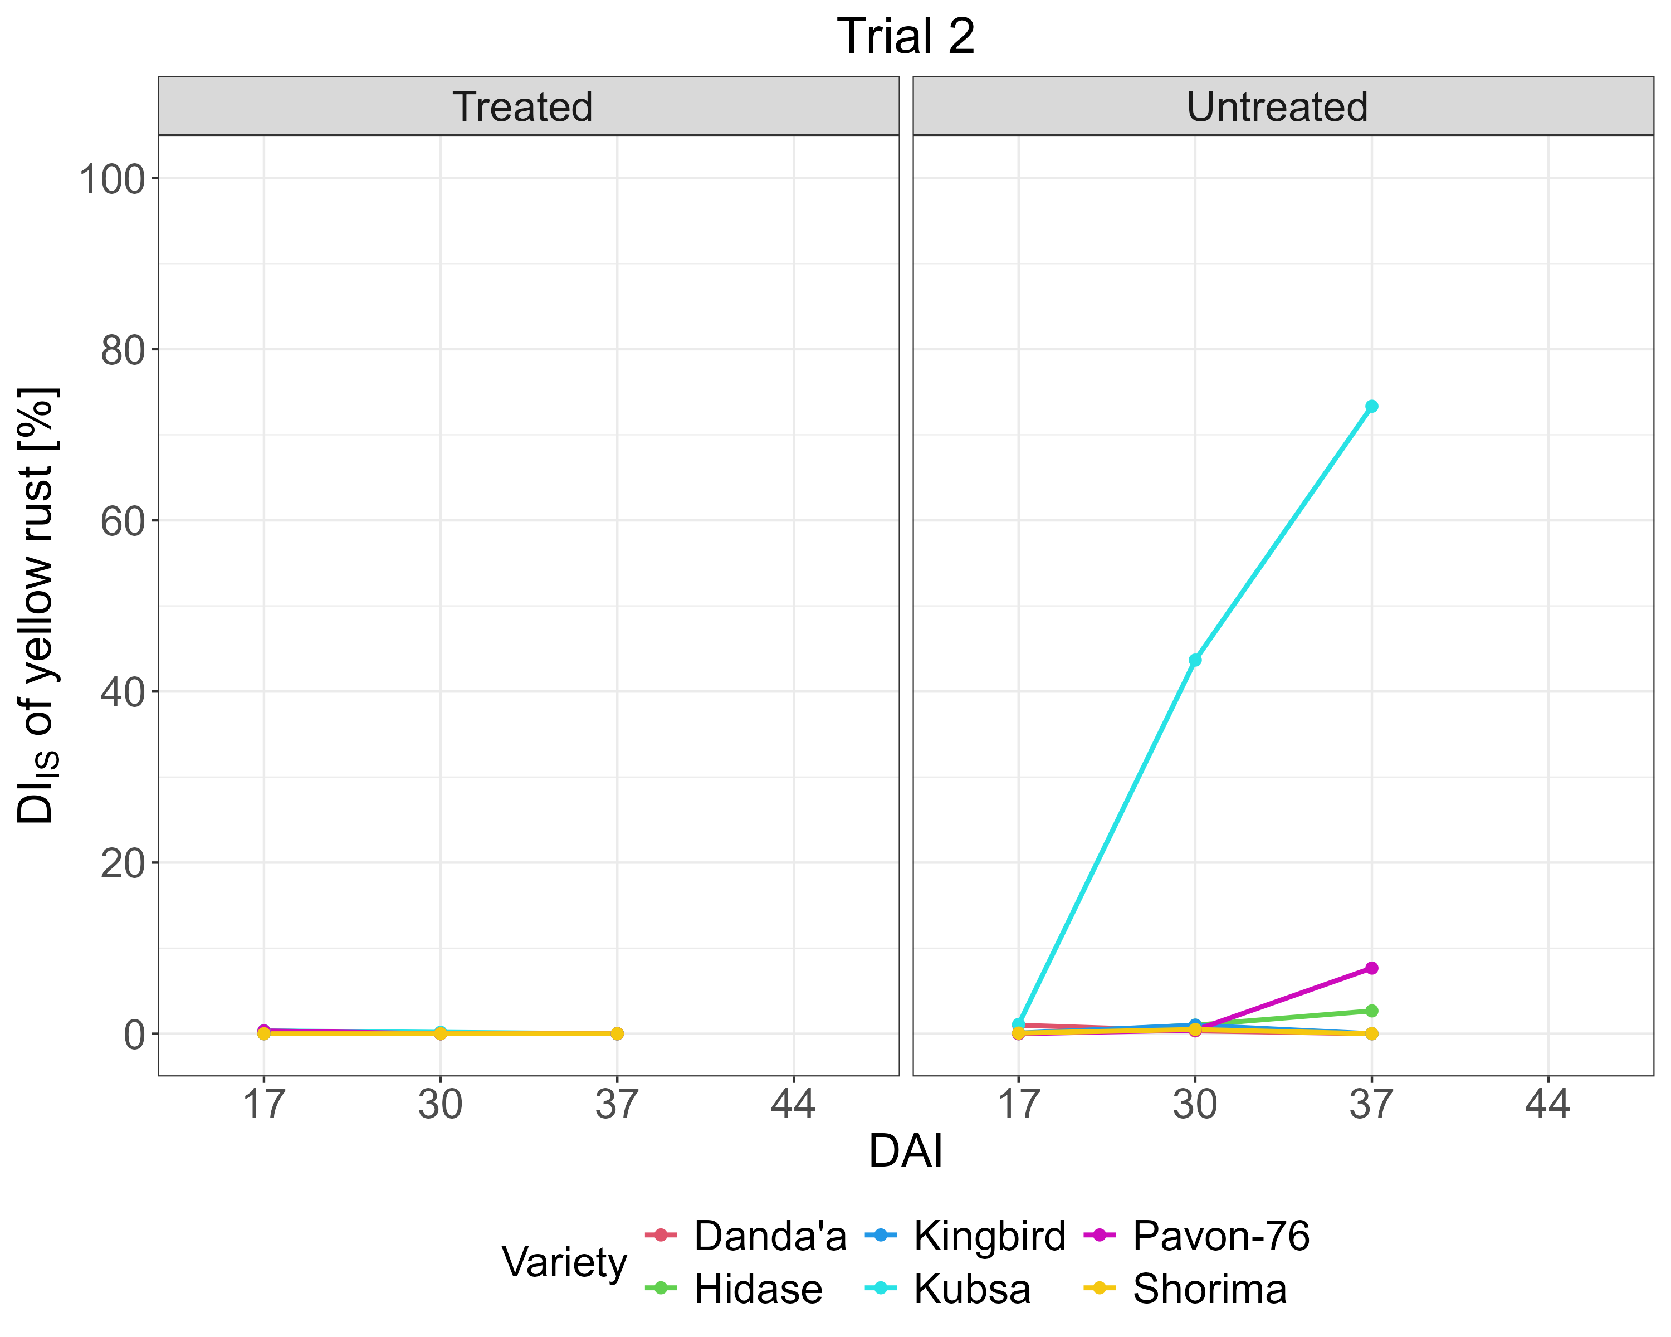
a)
b)
c)
d)
S3. YR disease progression per wheat variety and treatment block for Trials 1 and 2 – severity (a, b) and DI_{IS} (c, d).

S4a. Trial 1 – SR visual disease scoring results per plot, showing incidence in percentage, severity in percentage, and host plant reaction (on DAI 0, SR was not observed in the plots).
Plot | Variety | Block¹ | DAI 17 | DAI 30 | DAI 37 | DAI 44
1 | Kubsa | UT | 5/2/MS | 70/40/MS-S | 100/70/MS-S | 100/80/MS-S
2 | Hidase | UT | 20/10/S | 90/50/MS-S | 100/60/MS-S | 100/80/MS-S
3 | Danda’a | UT | 10/2/MS | 60/35/MS-S | 100/50/MS-S | 100/60/MS-S
4 | Kingbird | UT | 5/2/MS | 60/30/MS-S | 100/40/MS-S | 100/60/MS-S
5 | Pavon-76 | UT | 5/1/MS | 50/30/MS-S | 100/50/MS-S | 100/50/MS
6 | Shorima | UT | 5/1/MS | 20/10/MS-S | 100/30/MS-S | 100/30/MS
7 | Danda’a | T | 10/5/MS-S | 0/0/- | 0/0/- | 0/0/-
8 | Kubsa | T | 5/2/MS | 10/5/MS | 0/0/- | 0/0/-
9 | Hidase | T | 25/10/S | 10/5/MR | 0/0/- | 0/0/-
10 | Shorima | T | 5/2/MS | 0/0/- | 0/0/- | 0/0/-
11 | Pavon-76 | T | 5/1/MS | 0/0/- | 0/0/- | 0/0/-
12 | Kingbird | T | 6/1/MS | 0/0/- | 0/0/- | 0/0/-
13 | Shorima | T | 0/0/- | 0/0/- | 0/0/- | 0/0/-
14 | Danda’a | T | 5/1/MS | 0/0/- | 0/0/- | 0/0/-
15 | Kingbird | T | 0/0/- | 0/0/- | 0/0/- | 0/0/-
16 | Pavon-76 | T | 0/0/- | 10/5/MR-MS | 0/0/- | 0/0/-
17 | Kubsa | T | 5/2/MS | 5/5/MR-MS | 0/0/- | 0/0/-
18 | Hidase | T | 25/10/S | 20/5/MR-MS | 10/5/MR | 0/0/-
19 | Hidase | UT | 20/10/S | 100/40/MS-S | 100/70/MS-S | 100/80/S
20 | Danda’a | UT | 0/0/- | 50/25/MS-S | 80/50/MS-S | 100/60/MS-S
21 | Kubsa | UT | 10/5/MS | 60/35/MS | 100/60/S | 100/70/S
22 | Shorima | UT | 0/0/- | 45/15/MS | 50/30/MS-S | 100/30/MS
23 | Pavon-76 | UT | 5/1/MS | 45/20/MS-S | 60/40/MS-S | 100/50/MS
24 | Kingbird | UT | 10/5/MS | 70/40/MS-S | 80/50/MS-S | 100/50/MS-S
25 | Danda’a | UT | 10/5/MS | 60/30/MS-S | 100/60/S | 100/50/MS-S
26 | Kubsa | UT | 10/5/MS | 65/35/MS-S | 100/50/S | 100/60/S
27 | Pavon-76 | UT | 5/1/MS | 30/20/MS-S | 100/40/MS-S | 100/45/MS
28 | Kingbird | UT | 5/1/MS | 55/30/MS-S | 100/40/MS-S | 100/40/MS-S
29 | Hidase | UT | 40/20/S | 100/45/S | 100/70/S | 100/70/S
30 | Shorima | UT | 0/0/- | 40/20/MS-S | 60/30/MS-S | 100/30/MR-MS
31 | Danda’a | T | 5/2/MS | 10/5/MR | 0/0/- | 0/0/-
32 | Kubsa | T | 5/2/MS | 10/5/MR-MS | 20/10/MR-MS | 0/0/-
33 | Shorima | T | 0/0/- | 10/5/MR-MS | 0/0/- | 0/0/-
34 | Hidase | T | 30/15/S | 10/5/MR-MS | 10/5/MR-MS | 0/0/-
35 | Kingbird | T | 5/1/MS | 10/5/MR-MS | 0/0/- | 0/0/-
36 | Pavon-76 | T | 0/0/- | 0/0/- | 0/0/- | 0/0/-
¹ T: treated, fungicide treatment block; UT: untreated, non-fungicide treatment block;
² S: susceptible; MS-S: moderately susceptible to susceptible; MS: moderately susceptible; MR-MS: moderately resistant to moderately susceptible; MR: moderately resistant [67].

S4b. Trial 2 – SR visual disease scoring results per plot, showing incidence in percentage, severity in percentage, and host plant reaction (on DAI 0, SR was not observed in the plots).
Plot | Variety | Block¹ | DAI 17 | DAI 30 | DAI 37 | DAI 44
37 | Kubsa | UT | 0/0/- | 50/25/MS-S | 100/40/MS-S | 100/45/MS-S
38 | Hidase | UT | 5/2/MS | 100/35/S | 100/50/MS-S | 100/50/MS-S
39 | Danda’a | UT | 5/2/MS | 25/10/MS | 60/40/MS-S | 100/40/MS-S
40 | Kingbird | UT | 0/0/- | 25/15/MS-S | 60/35/MS-S | 100/35/MS-S
41 | Pavon-76 | UT | 0/0/- | 25/5/MS | 30/5/MS-S | 100/20/MS
42 | Shorima | UT | 0/0/- | 30/10/MS | 40/15/MS-S | 100/25/MS
43 | Danda’a | T | 0/0/- | 0/0/- | 0/0/- | 0/0/-
44 | Kubsa | T | 0/0/- | 0/0/- | 0/0/- | 0/0/-
45 | Hidase | T | 5/2/MS | 0/0/- | 0/0/- | 0/0/-
46 | Shorima | T | 0/0/- | 0/0/- | 0/0/- | 0/0/-
47 | Pavon-76 | T | 0/0/- | 0/0/- | 0/0/- | 0/0/-
48 | Kingbird | T | 10/5/MS | 0/0/- | 0/0/- | 0/0/-
49 | Shorima | T | 0/0/- | 0/0/- | 0/0/- | 0/0/-
50 | Danda’a | T | 0/0/- | 0/0/- | 0/0/- | 0/0/-
51 | Kingbird | T | 0/0/- | 0/0/- | 0/0/- | 0/0/-
52 | Pavon-76 | T | 0/0/- | 0/0/- | 0/0/- | 0/0/-
53 | Kubsa | T | 5/1/MS | 0/0/- | 0/0/- | 0/0/-
54 | Hidase | T | 10/5/MS-S | 0/0/- | 0/0/- | 0/0/-
55 | Hidase | UT | 0/0/- | 80/40/S | 100/60/S | 100/70/S
56 | Danda’a | UT | 0/0/- | 20/5/MS-S | 40/25/MS-S | 100/30/MS
57 | Kubsa | UT | 0/0/- | 25/10/MS | 90/45/MS-S | 100/50/MS-S
58 | Shorima | UT | 0/0/- | 20/10/MS | 60/35/MS-S | 100/35/MS
59 | Pavon-76 | UT | 0/0/- | 30/15/MS-S | 90/40/MS-S | 100/40/MS
60 | Kingbird | UT | 15/5/MS | 40/25/MS | 100/40/MS-S | 100/50/MS
61 | Danda’a | UT | 0/0/- | 20/10/MS-S | 100/50/S | 100/40/MS-S
62 | Kubsa | UT | 0/0/- | 20/10/MS | 100/40/MS-S | 100/50/MS-S
63 | Pavon-76 | UT | 0/0/- | 20/10/MS | 60/30/MS-S | 100/30/MS
64 | Kingbird | UT | 10/5/MS-S | 0/0/- | 90/40/MS-S | 100/40/MS
65 | Hidase | UT | 0/0/- | 80/35/MS-S | 100/60/S | 100/60/S
66 | Shorima | UT | 0/0/- | 20/5/MS-S | 30/15/MS-S | 100/30/MS
67 | Danda’a | T | 0/0/- | 0/0/- | 0/0/- | 0/0/-
68 | Kubsa | T | 5/2/MS | 0/0/- | 0/0/- | 0/0/-
69 | Shorima | T | 0/0/- | 0/0/- | 0/0/- | 0/0/-
70 | Hidase | T | 30/15/S | 0/0/- | 0/0/- | 0/0/-
71 | Kingbird | T | 0/0/- | 0/0/- | 0/0/- | 0/0/-
72 | Pavon-76 | T | 0/0/- | 0/0/- | 0/0/- | 0/0/-
¹ T: treated, fungicide treatment block; UT: untreated, non-fungicide treatment block;
² S: susceptible; MS-S: moderately susceptible to susceptible; MS: moderately susceptible; MR-MS: moderately resistant to moderately susceptible; MR: moderately resistant [67].

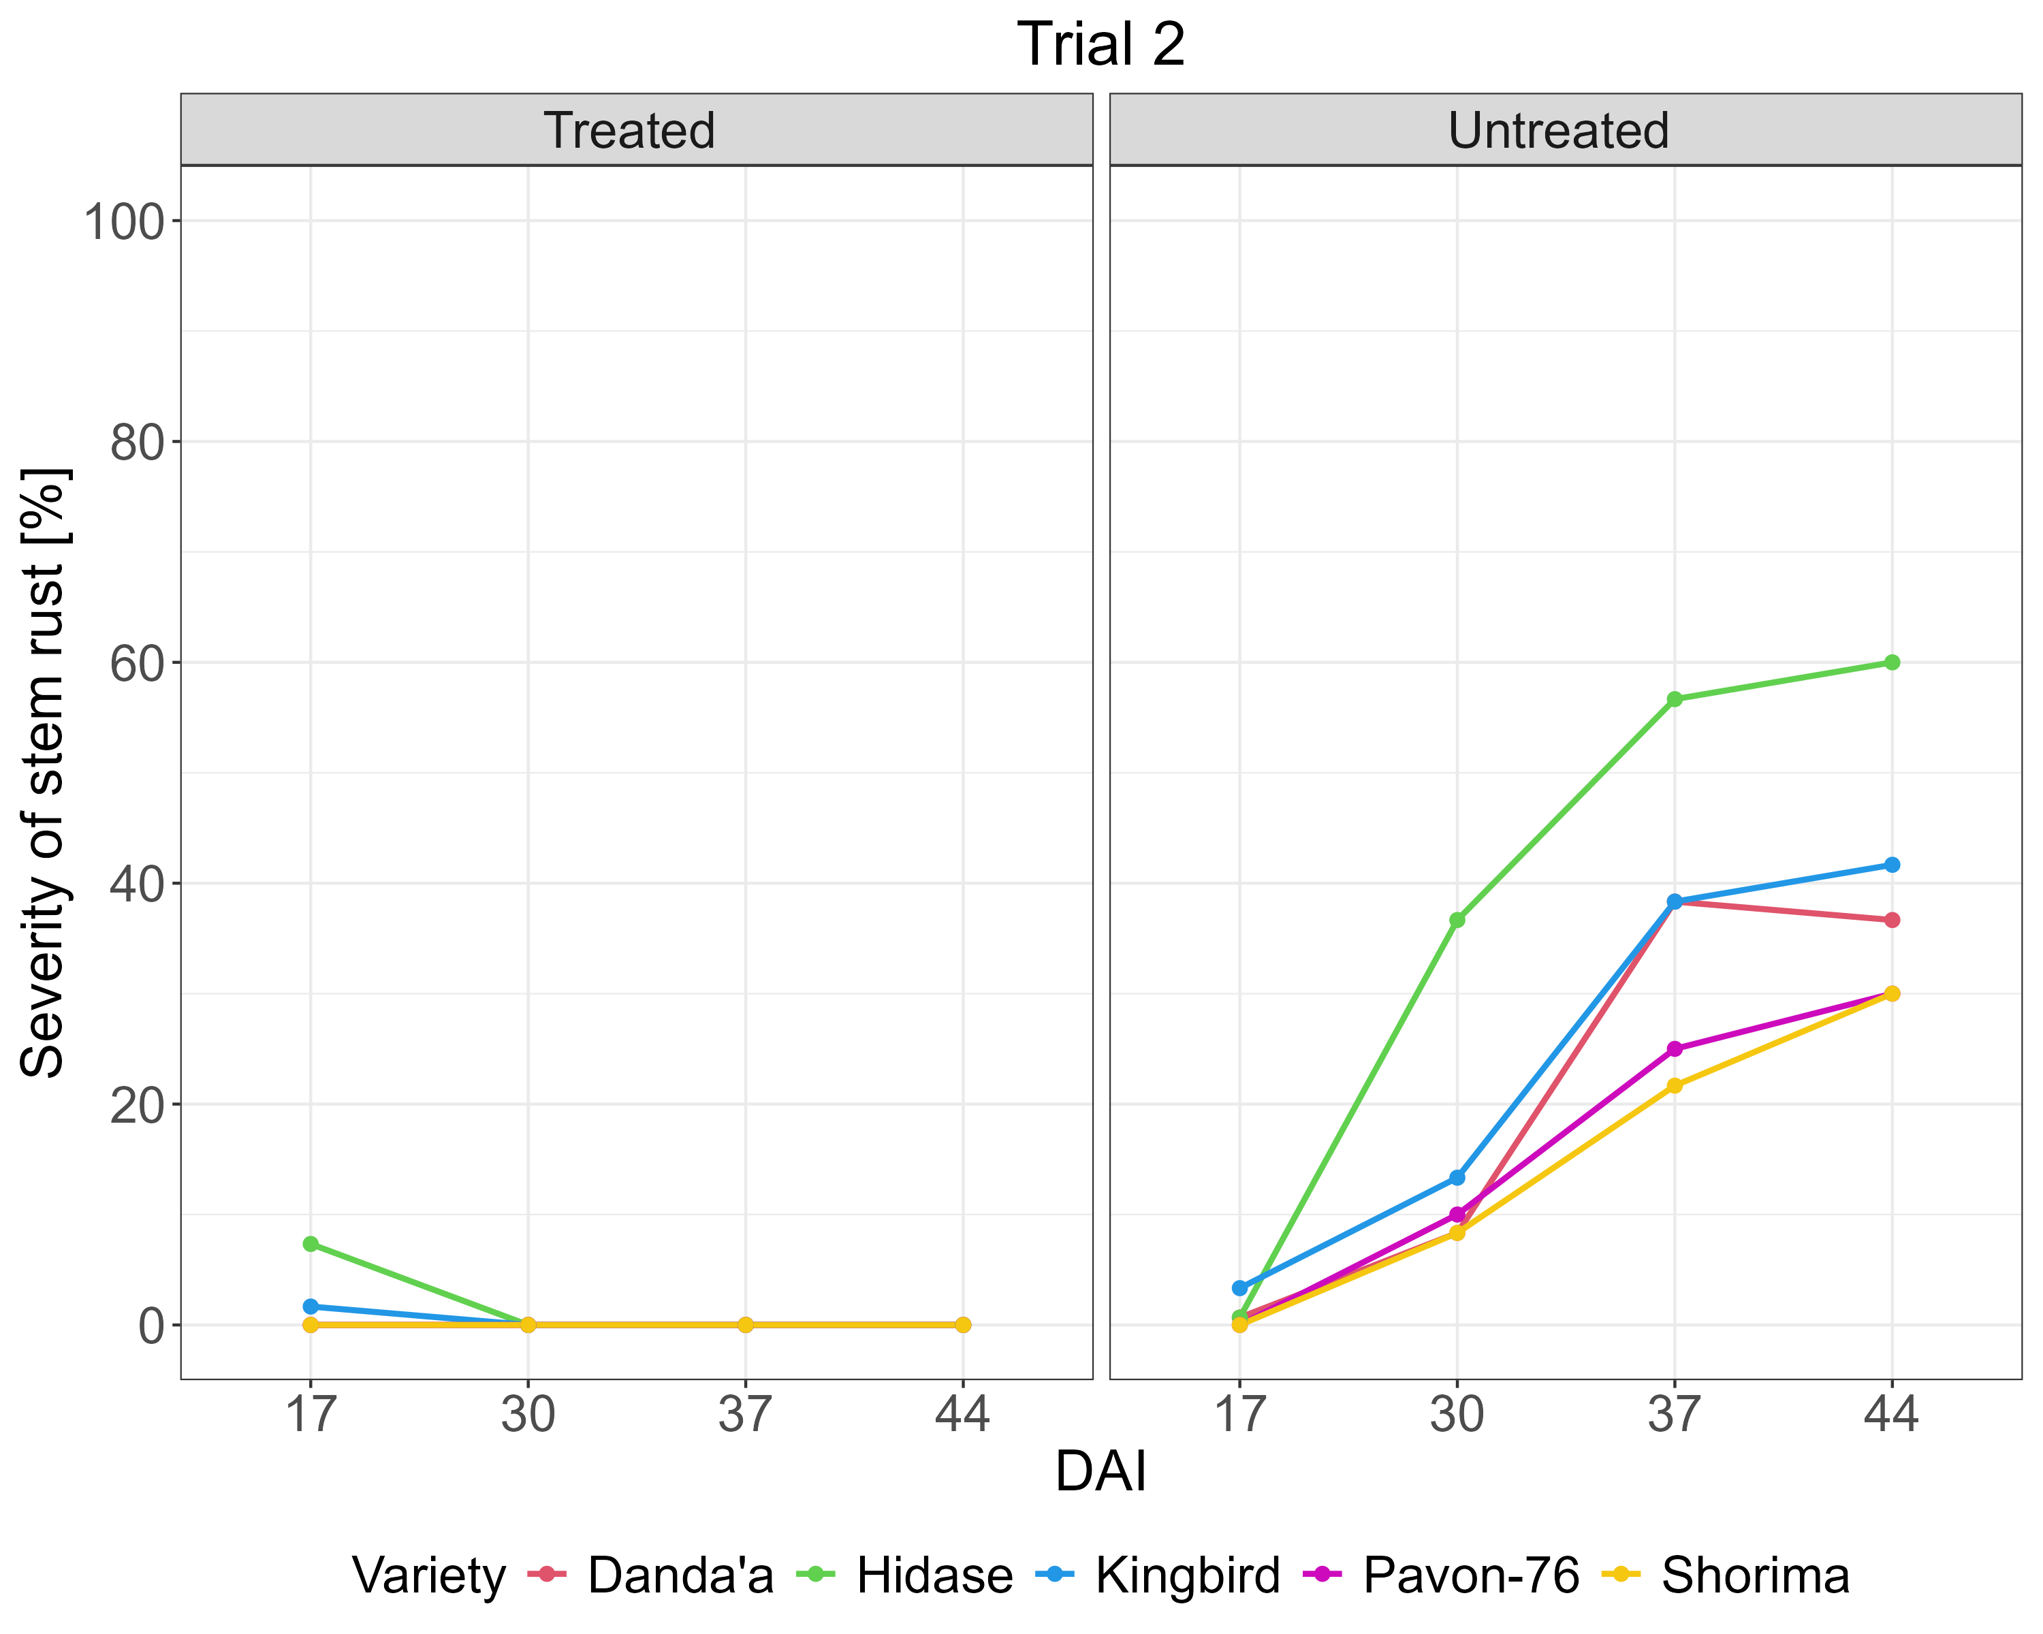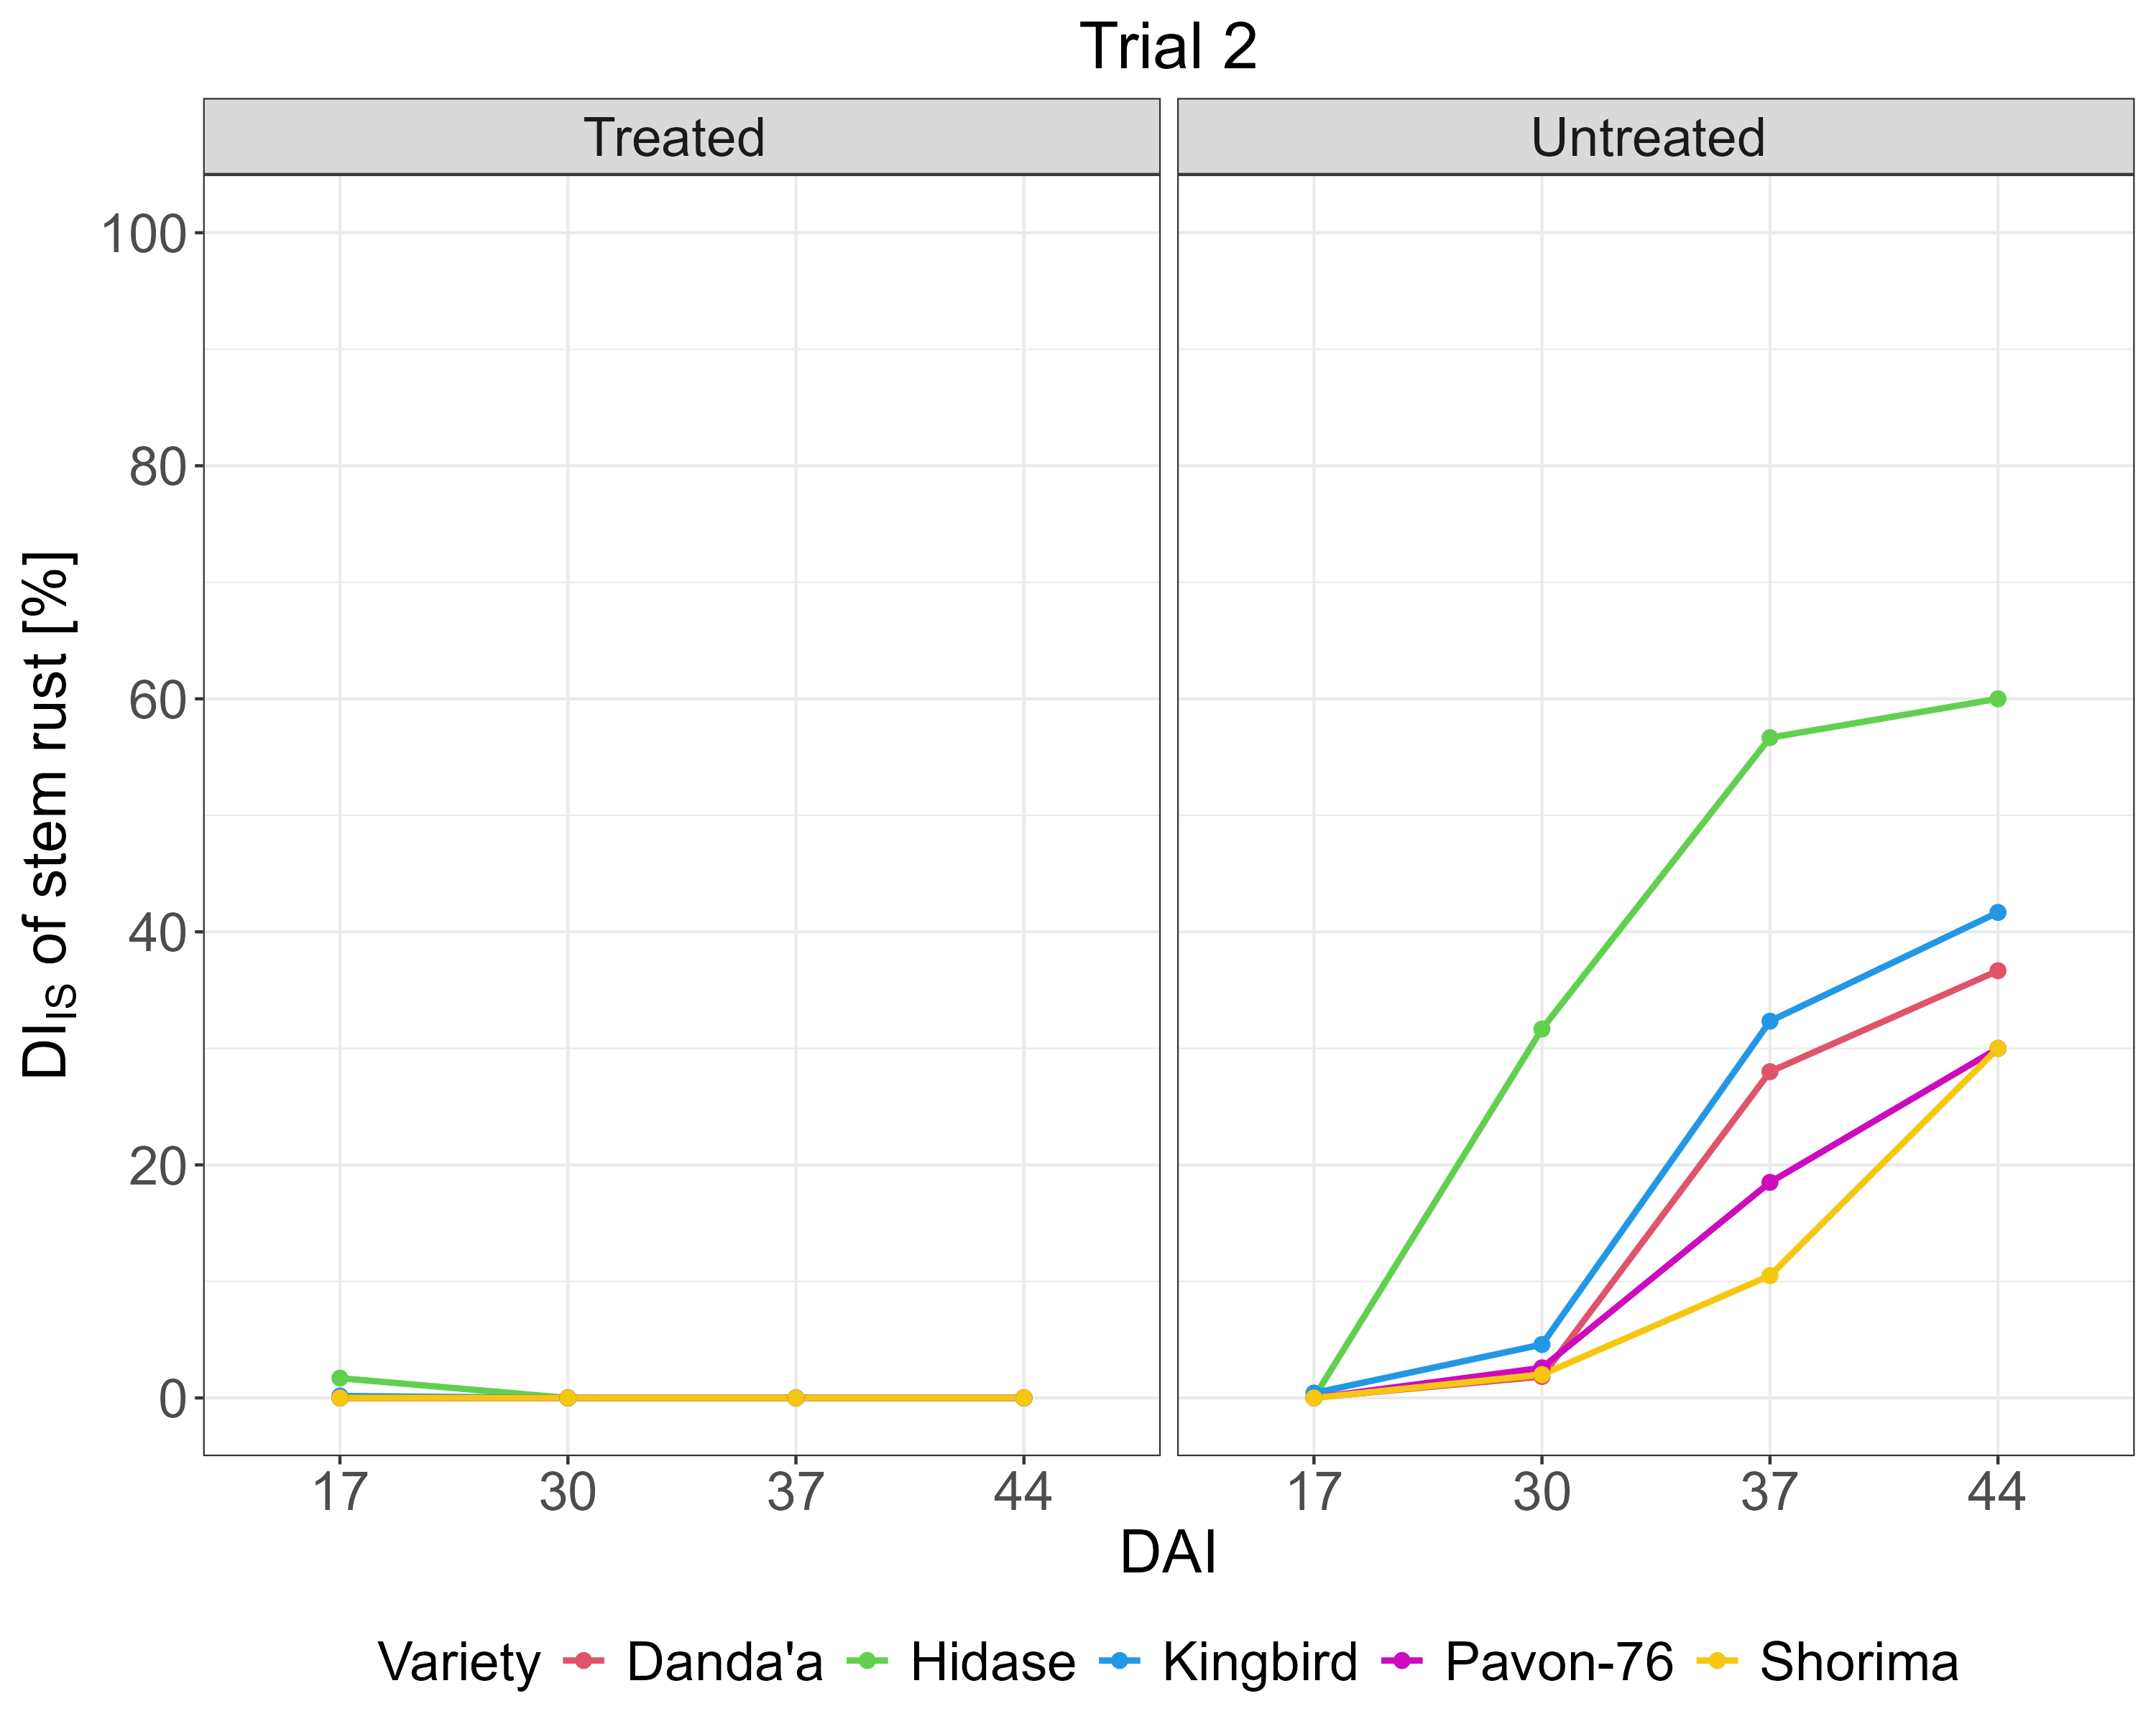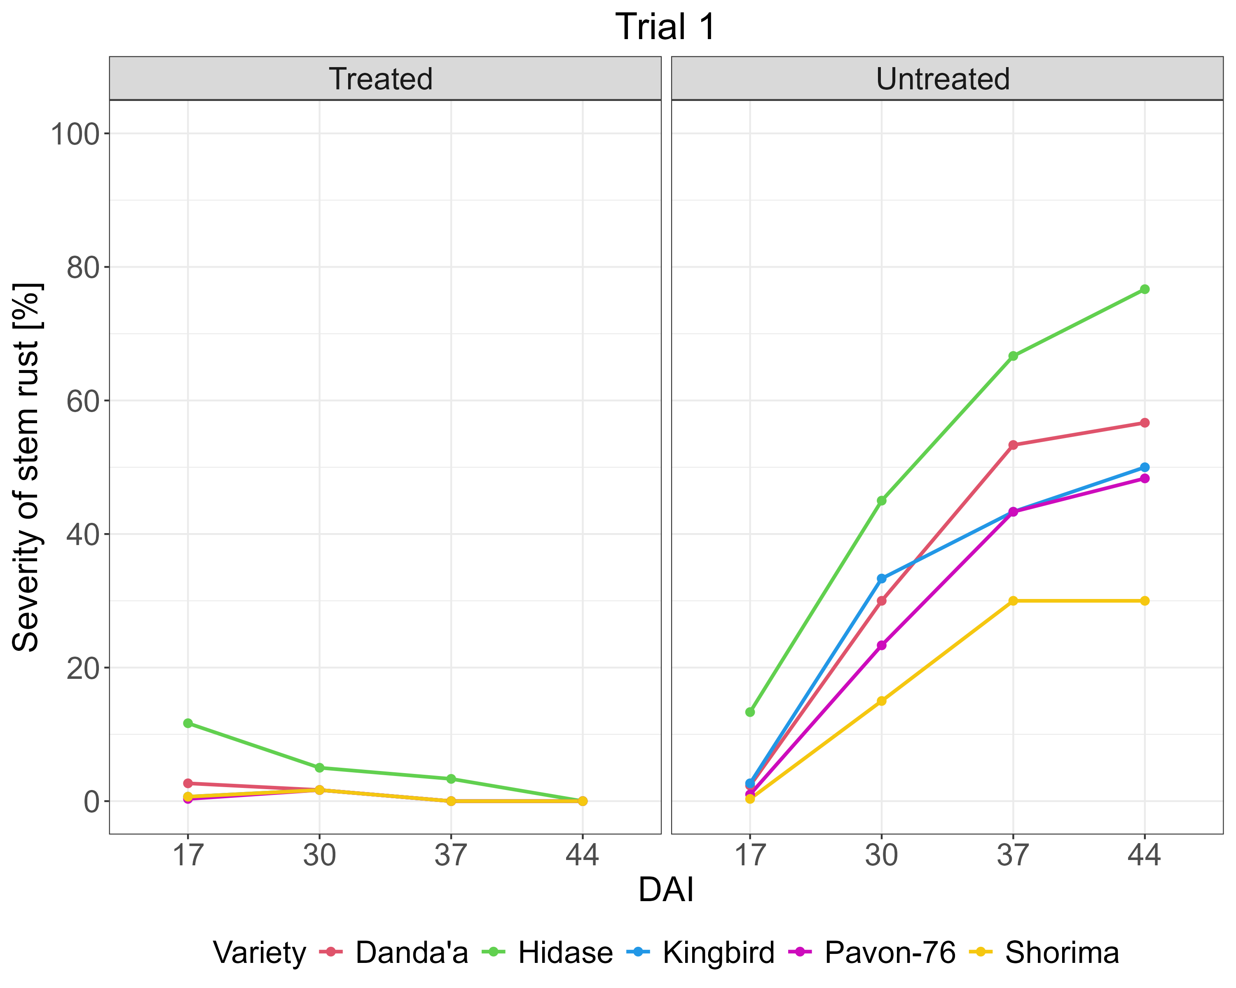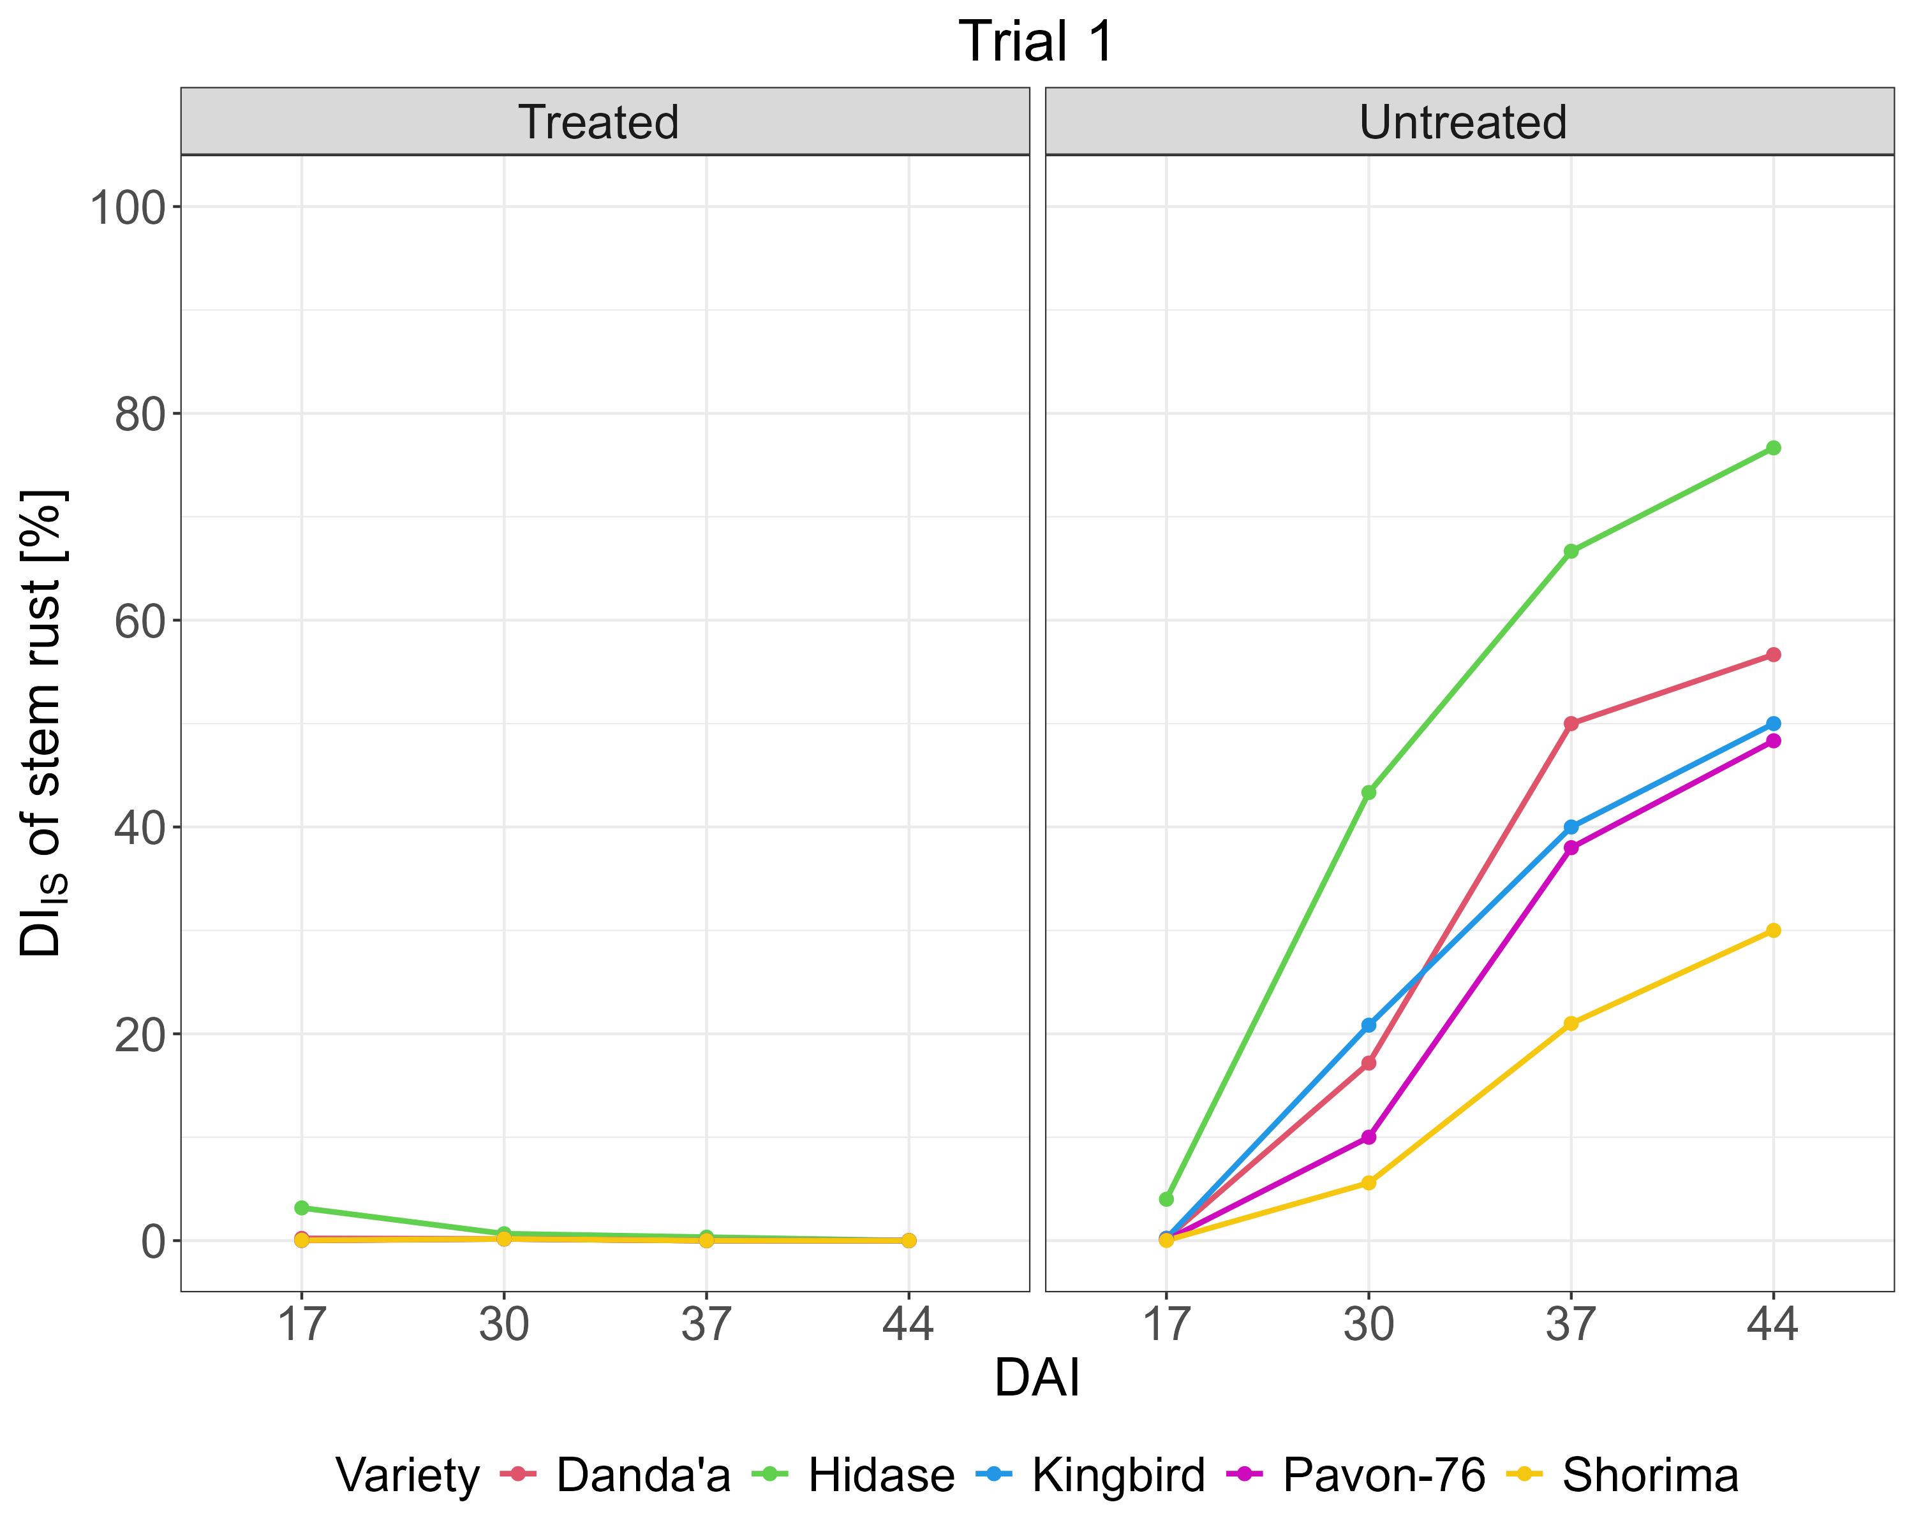
a)
b)
c)
d)
S5. SR disease progression per wheat variety and treatment block for Trials 1 and 2 – severity (a, b) and DI_{IS} (c, d) (note: variety Kubsa was excluded).

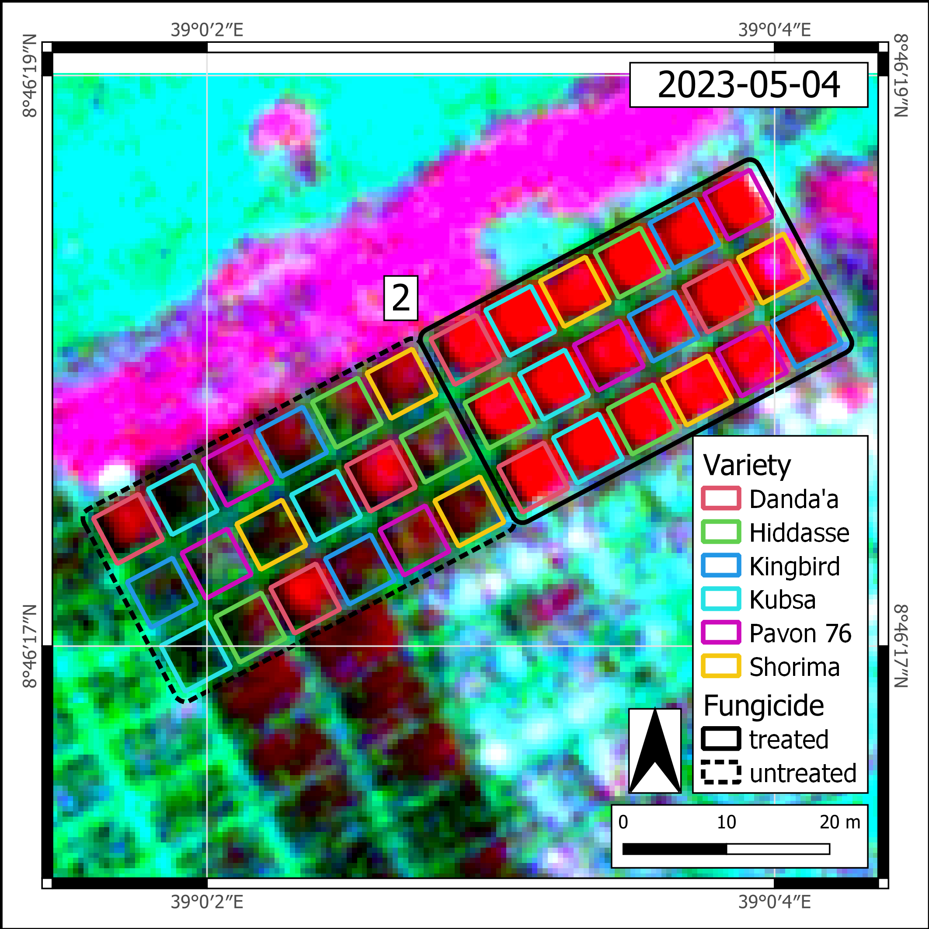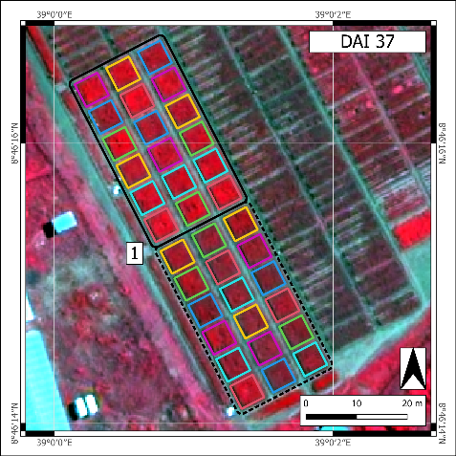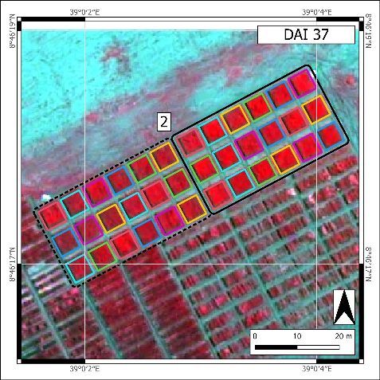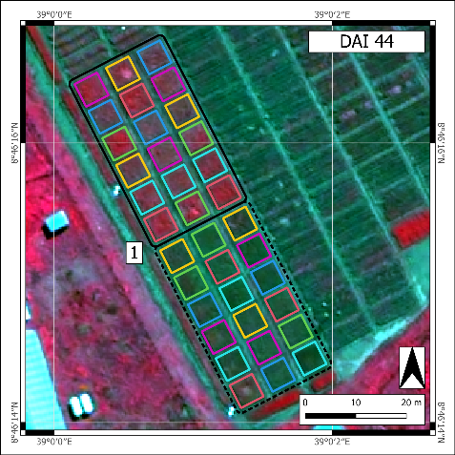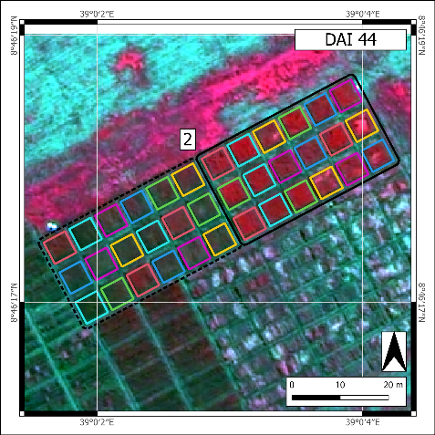
Trial 2
Trial 1
S6. The spectral signal derived from Pleiades-Neo time series reveals wheat canopy changes (Pleiades-Neo false color composites using near-infrared, red, and green bands from corresponding DAIs). Figures prepared using QGIS version 3.28.11-Firenze.

S7a. SkySat – Trial 1 – Pearson correlation analysis between DI_{ISHR} and spectral features at each DAI (untreated block) (P = p-value; *P < 0.05; **P < 0.01).
Spectral feature | SKYSAT
Spectral feature | DAI 17 |  | DAI 30 |  | DAI 37 |  | DAI 44
Spectral feature | Healthy |  | Moderately Diseased |  | Severely Diseased |  | Fully Diseased
Spectral feature | r | P | r | P | r | P | r | P
B | -0.33 | 0.235 | -0.48 | 0.069 | -0.45 | 0.095 | -0.05 | 0.855
G | -0.29 | 0.296 | -0.10 | 0.734 | -0.44 | 0.097 | -0.23 | 0.399
R | -0.47 | 0.076 | -0.28 | 0.304 | -0.10 | 0.731 | 0.33 | 0.235
NIR | 0.35 | 0.198 | 0.01 | 0.966 | 0.12 | 0.674 | -0.23 | 0.419
CIG | 0.40 | 0.136 | 0.06 | 0.844 | 0.32 | 0.240 | -0.14 | 0.619
CVI | 0.25 | 0.363 | -0.06 | 0.828 | 0.58* | 0.023 | 0.19 | 0.493
GLI | 0.38 | 0.164 | 0.6* | 0.019 | -0.33 | 0.228 | -0.51 | 0.052
MSAVI2 | 0.42 | 0.114 | 0.13 | 0.644 | 0.10 | 0.717 | -0.31 | 0.254
MSR | 0.48 | 0.073 | 0.14 | 0.609 | 0.12 | 0.673 | -0.28 | 0.304
OSAVI | 0.43 | 0.110 | 0.13 | 0.638 | 0.11 | 0.709 | -0.30 | 0.269
RDVI | 0.39 | 0.154 | 0.06 | 0.821 | 0.11 | 0.688 | -0.27 | 0.323
SAVI | 0.43 | 0.110 | 0.13 | 0.638 | 0.11 | 0.709 | -0.30 | 0.269
TVI | 0.43 | 0.111 | 0.13 | 0.640 | 0.10 | 0.712 | -0.31 | 0.263
RSI(B,G) | -0.32 | 0.248 | -0.58* | 0.023 | -0.38 | 0.164 | 0.06 | 0.837
RSI(B,R) | -0.31 | 0.263 | -0.38 | 0.163 | -0.38 | 0.161 | -0.22 | 0.438
RSI(B,NIR) | -0.35 | 0.195 | -0.28 | 0.307 | -0.56* | 0.031 | 0.15 | 0.589
RSI(G,B) | 0.41 | 0.130 | 0.63* | 0.012 | 0.54* | 0.037 | -0.07 | 0.802
RSI(G,R) | 0.39 | 0.156 | 0.40 | 0.135 | -0.41 | 0.129 | -0.52* | 0.045
RSI(G,NIR) | -0.38 | 0.159 | -0.04 | 0.891 | -0.30 | 0.273 | 0.15 | 0.597
RSI(R,B) | 0.26 | 0.342 | 0.45 | 0.092 | 0.56* | 0.029 | 0.25 | 0.364
RSI(R,G) | -0.33 | 0.236 | -0.40 | 0.141 | 0.42 | 0.124 | 0.54* | 0.039
RSI(R,NIR) | -0.42 | 0.114 | -0.13 | 0.644 | -0.10 | 0.717 | 0.31 | 0.254
RSI(NIR,B) | 0.56* | 0.031 | 0.34 | 0.217 | 0.6* | 0.019 | -0.14 | 0.610
RSI(NIR,G) | 0.40 | 0.136 | 0.06 | 0.844 | 0.32 | 0.240 | -0.14 | 0.619
RSI(NIR,R) | 0.49 | 0.061 | 0.15 | 0.597 | 0.12 | 0.658 | -0.27 | 0.323
NDSI(B,G) | -0.32 | 0.239 | -0.59* | 0.019 | -0.40 | 0.141 | 0.06 | 0.827
NDSI(B,R) | -0.31 | 0.258 | -0.40 | 0.143 | -0.40 | 0.137 | -0.22 | 0.421
NDSI(B,NIR) | -0.35 | 0.194 | -0.29 | 0.301 | -0.56* | 0.031 | 0.15 | 0.589
NDSI(G,B) | 0.32 | 0.239 | 0.59* | 0.019 | 0.40 | 0.141 | -0.06 | 0.827
NDSI(G,R) | 0.36 | 0.193 | 0.40 | 0.138 | -0.41 | 0.126 | -0.53* | 0.042
NDSI(G,NIR) | -0.38 | 0.157 | -0.04 | 0.886 | -0.31 | 0.269 | 0.15 | 0.600
NDSI(R,B) | 0.31 | 0.258 | 0.40 | 0.143 | 0.40 | 0.137 | 0.22 | 0.421
NDSI(R,G) | -0.36 | 0.193 | -0.40 | 0.138 | 0.41 | 0.126 | 0.53* | 0.042
NDSI(R,NIR) | -0.43 | 0.110 | -0.13 | 0.638 | -0.11 | 0.709 | 0.30 | 0.269
NDSI(NIR,B) | 0.35 | 0.194 | 0.29 | 0.301 | 0.56* | 0.031 | -0.15 | 0.589
NDSI(NIR,G) | 0.38 | 0.157 | 0.04 | 0.886 | 0.31 | 0.269 | -0.15 | 0.600
NDSI(NIR,R) | 0.43 | 0.110 | 0.13 | 0.638 | 0.11 | 0.709 | -0.30 | 0.269
green: healthy (avg. DI_{ISHR} <1%); orange: moderately diseased (avg. DI_{ISHR} 15-29.9%); red: severely diseased (avg. DI_{ISHR} 30-44.9%); and grey: fully damaged (avg. DI_{ISHR} ≥45%).

S7b. SkySat – Trial 2 – Pearson correlation analysis between DI_{ISHR} and spectral features at each DAI (untreated block) (P = p-value; *P < 0.05; **P < 0.01).
Spectral feature | SKYSAT
Spectral feature | DAI 17 |  | DAI 30 |  | DAI 37 |  | DAI 44
Spectral feature | Healthy |  | Mildly Diseased |  | Moderately Diseased |  | Severely Diseased
Spectral feature | r | P | r | P | r | P | r | P
B | -0.03 | 0.918 | -0.50 | 0.060 | -0.58* | 0.025 | -0.10 | 0.729
G | 0.34 | 0.222 | -0.30 | 0.277 | -0.11 | 0.699 | 0.16 | 0.572
R | -0.05 | 0.853 | -0.17 | 0.546 | 0.10 | 0.728 | 0.29 | 0.303
NIR | -0.06 | 0.820 | 0.13 | 0.634 | -0.23 | 0.404 | -0.24 | 0.387
CIG | -0.22 | 0.436 | 0.23 | 0.401 | -0.12 | 0.671 | -0.24 | 0.384
CVI | -0.46 | 0.088 | 0.34 | 0.211 | 0.02 | 0.937 | -0.18 | 0.522
GLI | 0.27 | 0.339 | 0.22 | 0.431 | 0.03 | 0.911 | -0.23 | 0.409
MSAVI2 | 0.03 | 0.927 | 0.18 | 0.532 | -0.18 | 0.522 | -0.28 | 0.313
MSR | -0.03 | 0.908 | 0.16 | 0.568 | -0.19 | 0.487 | -0.27 | 0.324
OSAVI | 0.02 | 0.948 | 0.17 | 0.537 | -0.18 | 0.515 | -0.28 | 0.315
RDVI | -0.03 | 0.902 | 0.15 | 0.583 | -0.21 | 0.444 | -0.26 | 0.343
SAVI | 0.02 | 0.948 | 0.17 | 0.537 | -0.18 | 0.515 | -0.28 | 0.315
TVI | 0.02 | 0.941 | 0.17 | 0.535 | -0.18 | 0.518 | -0.28 | 0.314
RSI(B,G) | -0.02 | 0.947 | -0.51 | 0.050 | -0.68** | 0.006 | -0.16 | 0.568
RSI(B,R) | 0.03 | 0.904 | -0.52* | 0.049 | -0.66** | 0.008 | -0.27 | 0.334
RSI(B,NIR) | -0.05 | 0.867 | -0.40 | 0.137 | -0.44 | 0.097 | 0.14 | 0.608
RSI(G,B) | 0.02 | 0.956 | 0.51 | 0.054 | 0.7** | 0.003 | 0.12 | 0.659
RSI(G,R) | 0.28 | 0.304 | -0.05 | 0.856 | -0.28 | 0.315 | -0.29 | 0.286
RSI(G,NIR) | 0.19 | 0.498 | -0.23 | 0.404 | 0.12 | 0.673 | 0.25 | 0.361
RSI(R,B) | -0.11 | 0.703 | 0.57* | 0.027 | 0.71** | 0.003 | 0.25 | 0.367
RSI(R,G) | -0.28 | 0.303 | 0.04 | 0.891 | 0.28 | 0.319 | 0.30 | 0.272
RSI(R,NIR) | -0.03 | 0.927 | -0.18 | 0.532 | 0.18 | 0.522 | 0.28 | 0.313
RSI(NIR,B) | -0.11 | 0.692 | 0.43 | 0.114 | 0.52* | 0.045 | -0.19 | 0.506
RSI(NIR,G) | -0.22 | 0.436 | 0.23 | 0.401 | -0.12 | 0.671 | -0.24 | 0.384
RSI(NIR,R) | -0.05 | 0.858 | 0.15 | 0.582 | -0.20 | 0.477 | -0.27 | 0.330
NDSI(B,G) | -0.02 | 0.953 | -0.51 | 0.051 | -0.68** | 0.005 | -0.15 | 0.587
NDSI(B,R) | 0.03 | 0.904 | -0.53* | 0.043 | -0.67** | 0.007 | -0.26 | 0.340
NDSI(B,NIR) | -0.05 | 0.870 | -0.40 | 0.135 | -0.45 | 0.096 | 0.15 | 0.601
NDSI(G,B) | 0.02 | 0.953 | 0.51 | 0.051 | 0.68** | 0.005 | 0.15 | 0.587
NDSI(G,R) | 0.28 | 0.304 | -0.05 | 0.872 | -0.28 | 0.317 | -0.30 | 0.280
NDSI(G,NIR) | 0.19 | 0.491 | -0.23 | 0.403 | 0.12 | 0.672 | 0.25 | 0.363
NDSI(R,B) | -0.03 | 0.904 | 0.53* | 0.043 | 0.67** | 0.007 | 0.26 | 0.340
NDSI(R,G) | -0.28 | 0.304 | 0.05 | 0.872 | 0.28 | 0.317 | 0.30 | 0.280
NDSI(R,NIR) | -0.02 | 0.948 | -0.17 | 0.537 | 0.18 | 0.515 | 0.28 | 0.315
NDSI(NIR,B) | 0.05 | 0.870 | 0.40 | 0.135 | 0.45 | 0.096 | -0.15 | 0.601
NDSI(NIR,G) | -0.19 | 0.491 | 0.23 | 0.403 | -0.12 | 0.672 | -0.25 | 0.363
NDSI(NIR,R) | 0.02 | 0.948 | 0.17 | 0.537 | -0.18 | 0.515 | -0.28 | 0.315
green: healthy (avg. DI_{ISHR} <1%); yellow: mildly diseased (avg. DI_{ISHR} 1-14.9%); orange: moderately diseased (avg. DI_{ISHR} 15-29.9%); and red: severely diseased (avg. DI_{ISHR} 30-44.9%).

S8a. SkySat – Trial 1 – Pearson correlation analysis between severity and spectral features at each DAI (untreated block) (P = p-value; *P < 0.05; **P < 0.01).
Spectral feature | SKYSAT
Spectral feature | DAI 17 |  | DAI 30 |  | DAI 37 |  | DAI 44
Spectral feature | Healthy |  | Moderately Diseased |  | Severely Diseased |  | Fully Diseased
Spectral feature | r | P | r | P | r | P | r | P
B | -0.38 | 0.158 | -0.40 | 0.141 | -0.39 | 0.148 | -0.03 | 0.914
G | -0.25 | 0.363 | 0.03 | 0.904 | -0.24 | 0.397 | -0.19 | 0.489
R | -0.51 | 0.050 | -0.17 | 0.544 | 0.08 | 0.769 | 0.38 | 0.163
NIR | 0.39 | 0.152 | -0.06 | 0.835 | 0.00 | 0.997 | -0.26 | 0.352
CIG | 0.41 | 0.131 | -0.05 | 0.851 | 0.13 | 0.636 | -0.19 | 0.492
CVI | 0.21 | 0.457 | -0.17 | 0.550 | 0.38 | 0.160 | 0.13 | 0.647
GLI | 0.51 | 0.053 | 0.58* | 0.024 | -0.39 | 0.154 | -0.53* | 0.042
MSAVI2 | 0.48 | 0.073 | 0.03 | 0.909 | -0.06 | 0.844 | -0.36 | 0.188
MSR | 0.52* | 0.048 | 0.04 | 0.882 | -0.05 | 0.871 | -0.33 | 0.233
OSAVI | 0.48 | 0.070 | 0.03 | 0.904 | -0.05 | 0.848 | -0.35 | 0.201
RDVI | 0.43 | 0.111 | -0.02 | 0.944 | -0.03 | 0.919 | -0.31 | 0.254
SAVI | 0.48 | 0.070 | 0.03 | 0.904 | -0.05 | 0.848 | -0.35 | 0.201
TVI | 0.48 | 0.071 | 0.03 | 0.906 | -0.05 | 0.846 | -0.35 | 0.196
RSI(B,G) | -0.39 | 0.149 | -0.58* | 0.024 | -0.38 | 0.159 | 0.06 | 0.822
RSI(B,R) | -0.37 | 0.172 | -0.38 | 0.164 | -0.40 | 0.144 | -0.22 | 0.424
RSI(B,NIR) | -0.42 | 0.120 | -0.19 | 0.495 | -0.44 | 0.098 | 0.20 | 0.485
RSI(G,B) | 0.56* | 0.031 | 0.61* | 0.017 | 0.53* | 0.043 | -0.09 | 0.752
RSI(G,R) | 0.50 | 0.058 | 0.38 | 0.161 | -0.46 | 0.087 | -0.54* | 0.036
RSI(G,NIR) | -0.39 | 0.153 | 0.06 | 0.820 | -0.11 | 0.685 | 0.20 | 0.466
RSI(R,B) | 0.36 | 0.182 | 0.45 | 0.096 | 0.56* | 0.031 | 0.25 | 0.377
RSI(R,G) | -0.45 | 0.090 | -0.38 | 0.160 | 0.46 | 0.086 | 0.56* | 0.031
RSI(R,NIR) | -0.48 | 0.073 | -0.03 | 0.909 | 0.06 | 0.844 | 0.36 | 0.188
RSI(NIR,B) | 0.66** | 0.008 | 0.24 | 0.393 | 0.52* | 0.047 | -0.19 | 0.486
RSI(NIR,G) | 0.41 | 0.131 | -0.05 | 0.851 | 0.13 | 0.636 | -0.19 | 0.492
RSI(NIR,R) | 0.53* | 0.041 | 0.04 | 0.873 | -0.04 | 0.882 | -0.32 | 0.250
NDSI(B,G) | -0.40 | 0.140 | -0.59* | 0.022 | -0.40 | 0.138 | 0.07 | 0.803
NDSI(B,R) | -0.38 | 0.166 | -0.40 | 0.145 | -0.42 | 0.124 | -0.23 | 0.412
NDSI(B,NIR) | -0.42 | 0.119 | -0.19 | 0.488 | -0.45 | 0.096 | 0.20 | 0.484
NDSI(G,B) | 0.40 | 0.140 | 0.59* | 0.022 | 0.40 | 0.138 | -0.07 | 0.803
NDSI(G,R) | 0.48 | 0.073 | 0.38 | 0.161 | -0.46 | 0.086 | -0.55* | 0.034
NDSI(G,NIR) | -0.39 | 0.151 | 0.06 | 0.824 | -0.12 | 0.679 | 0.20 | 0.470
NDSI(R,B) | 0.38 | 0.166 | 0.40 | 0.145 | 0.42 | 0.124 | 0.23 | 0.412
NDSI(R,G) | -0.48 | 0.073 | -0.38 | 0.161 | 0.46 | 0.086 | 0.55* | 0.034
NDSI(R,NIR) | -0.48 | 0.070 | -0.03 | 0.904 | 0.05 | 0.848 | 0.35 | 0.201
NDSI(NIR,B) | 0.42 | 0.119 | 0.19 | 0.488 | 0.45 | 0.096 | -0.20 | 0.484
NDSI(NIR,G) | 0.39 | 0.151 | -0.06 | 0.824 | 0.12 | 0.679 | -0.20 | 0.470
NDSI(NIR,R) | 0.48 | 0.070 | 0.03 | 0.904 | -0.05 | 0.848 | -0.35 | 0.201
green: healthy (avg. DI_{ISHR} <1%); orange: moderately diseased (avg. DI_{ISHR} 15-29.9%); red: severely diseased (avg. DI_{ISHR} 30-44.9%); and grey: fully damaged (avg. DI_{ISHR} ≥45%).

S8b. SkySat – Trial 2 – Pearson correlation analysis between severity and spectral features at each DAI (untreated block) (P = p-value; *P < 0.05; **P < 0.01).
Spectral feature | SKYSAT
Spectral feature | DAI 17 |  | DAI 30 |  | DAI 37 |  | DAI 44
Spectral feature | Healthy |  | Mildly Diseased |  | Moderately Diseased |  | Severely Diseased
Spectral feature | r | P | r | P | r | P | r | P
B | -0.09 | 0.738 | -0.35 | 0.199 | -0.6* | 0.017 | -0.06 | 0.838
G | 0.17 | 0.541 | -0.22 | 0.433 | -0.18 | 0.526 | 0.20 | 0.475
R | -0.17 | 0.553 | -0.11 | 0.696 | -0.02 | 0.936 | 0.33 | 0.235
NIR | 0.02 | 0.932 | 0.03 | 0.910 | -0.19 | 0.508 | -0.32 | 0.240
CIG | -0.07 | 0.810 | 0.13 | 0.641 | -0.06 | 0.843 | -0.32 | 0.243
CVI | -0.31 | 0.255 | 0.22 | 0.427 | 0.04 | 0.889 | -0.27 | 0.328
GLI | 0.31 | 0.261 | 0.13 | 0.657 | 0.14 | 0.615 | -0.26 | 0.352
MSAVI2 | 0.13 | 0.633 | 0.09 | 0.741 | -0.10 | 0.728 | -0.36 | 0.189
MSR | 0.09 | 0.751 | 0.07 | 0.796 | -0.11 | 0.699 | -0.34 | 0.211
OSAVI | 0.13 | 0.649 | 0.09 | 0.751 | -0.10 | 0.722 | -0.36 | 0.194
RDVI | 0.06 | 0.818 | 0.06 | 0.832 | -0.15 | 0.592 | -0.34 | 0.212
SAVI | 0.13 | 0.649 | 0.09 | 0.751 | -0.10 | 0.722 | -0.36 | 0.194
TVI | 0.13 | 0.643 | 0.09 | 0.748 | -0.10 | 0.724 | -0.36 | 0.192
RSI(B,G) | -0.08 | 0.775 | -0.36 | 0.185 | -0.68** | 0.005 | -0.15 | 0.596
RSI(B,R) | -0.04 | 0.898 | -0.38 | 0.164 | -0.64* | 0.011 | -0.27 | 0.324
RSI(B,NIR) | -0.11 | 0.689 | -0.26 | 0.353 | -0.49 | 0.066 | 0.24 | 0.383
RSI(G,B) | 0.09 | 0.759 | 0.35 | 0.206 | 0.69** | 0.005 | 0.11 | 0.708
RSI(G,R) | 0.32 | 0.239 | -0.08 | 0.783 | -0.17 | 0.535 | -0.32 | 0.247
RSI(G,NIR) | 0.05 | 0.873 | -0.13 | 0.645 | 0.06 | 0.834 | 0.34 | 0.209
RSI(R,B) | -0.05 | 0.872 | 0.42 | 0.121 | 0.68** | 0.006 | 0.24 | 0.379
RSI(R,G) | -0.33 | 0.236 | 0.06 | 0.829 | 0.17 | 0.538 | 0.33 | 0.233
RSI(R,NIR) | -0.13 | 0.633 | -0.09 | 0.741 | 0.10 | 0.728 | 0.36 | 0.189
RSI(NIR,B) | 0.01 | 0.977 | 0.27 | 0.330 | 0.53* | 0.042 | -0.27 | 0.333
RSI(NIR,G) | -0.07 | 0.810 | 0.13 | 0.641 | -0.06 | 0.843 | -0.32 | 0.243
RSI(NIR,R) | 0.08 | 0.787 | 0.07 | 0.814 | -0.11 | 0.693 | -0.34 | 0.219
NDSI(B,G) | -0.08 | 0.773 | -0.36 | 0.191 | -0.68** | 0.005 | -0.14 | 0.621
NDSI(B,R) | -0.04 | 0.892 | -0.39 | 0.152 | -0.64** | 0.010 | -0.27 | 0.335
NDSI(B,NIR) | -0.11 | 0.691 | -0.26 | 0.351 | -0.49 | 0.066 | 0.25 | 0.379
NDSI(G,B) | 0.08 | 0.773 | 0.36 | 0.191 | 0.68** | 0.005 | 0.14 | 0.621
NDSI(G,R) | 0.33 | 0.237 | -0.07 | 0.804 | -0.17 | 0.537 | -0.32 | 0.241
NDSI(G,NIR) | 0.05 | 0.866 | -0.13 | 0.645 | 0.06 | 0.834 | 0.34 | 0.214
NDSI(R,B) | 0.04 | 0.892 | 0.39 | 0.152 | 0.64** | 0.010 | 0.27 | 0.335
NDSI(R,G) | -0.33 | 0.237 | 0.07 | 0.804 | 0.17 | 0.537 | 0.32 | 0.241
NDSI(R,NIR) | -0.13 | 0.649 | -0.09 | 0.751 | 0.10 | 0.722 | 0.36 | 0.194
NDSI(NIR,B) | 0.11 | 0.691 | 0.26 | 0.351 | 0.49 | 0.066 | -0.25 | 0.379
NDSI(NIR,G) | -0.05 | 0.866 | 0.13 | 0.645 | -0.06 | 0.834 | -0.34 | 0.214
NDSI(NIR,R) | 0.13 | 0.649 | 0.09 | 0.751 | -0.10 | 0.722 | -0.36 | 0.194
green: healthy (avg. DI_{ISHR} <1%); yellow: mildly diseased (avg. DI_{ISHR} 1-14.9%); orange: moderately diseased (avg. DI_{ISHR} 15-29.9%); and red: severely diseased (avg. DI_{ISHR} 30-44.9%).

S9a. SkySat – Trial 1 – Pearson correlation analysis between DI_{IS} and spectral features at each DAI (untreated block) (P = p-value; *P < 0.05; **P < 0.01).
Spectral feature | SKYSAT
Spectral feature | DAI 17 |  | DAI 30 |  | DAI 37 |  | DAI 44
Spectral feature | Healthy |  | Moderately Diseased |  | Severely Diseased |  | Fully Diseased
Spectral feature | r | P | r | P | r | P | r | P
B | -0.33 | 0.236 | -0.46 | 0.084 | -0.45 | 0.090 | -0.03 | 0.914
G | -0.29 | 0.302 | -0.05 | 0.856 | -0.41 | 0.134 | -0.19 | 0.489
R | -0.47 | 0.076 | -0.24 | 0.393 | -0.03 | 0.926 | 0.38 | 0.163
NIR | 0.36 | 0.189 | -0.02 | 0.943 | 0.05 | 0.865 | -0.26 | 0.352
CIG | 0.41 | 0.134 | 0.01 | 0.963 | 0.25 | 0.365 | -0.19 | 0.492
CVI | 0.25 | 0.363 | -0.10 | 0.724 | 0.53* | 0.042 | 0.13 | 0.647
GLI | 0.38 | 0.158 | 0.59* | 0.022 | -0.41 | 0.126 | -0.53* | 0.042
MSAVI2 | 0.43 | 0.111 | 0.09 | 0.752 | 0.03 | 0.921 | -0.36 | 0.188
MSR | 0.48 | 0.071 | 0.10 | 0.720 | 0.04 | 0.881 | -0.33 | 0.233
OSAVI | 0.43 | 0.107 | 0.09 | 0.747 | 0.03 | 0.915 | -0.35 | 0.201
RDVI | 0.39 | 0.148 | 0.03 | 0.923 | 0.04 | 0.890 | -0.31 | 0.254
SAVI | 0.43 | 0.107 | 0.09 | 0.747 | 0.03 | 0.915 | -0.35 | 0.201
TVI | 0.43 | 0.108 | 0.09 | 0.749 | 0.03 | 0.917 | -0.35 | 0.196
RSI(B,G) | -0.32 | 0.248 | -0.59* | 0.021 | -0.40 | 0.145 | 0.06 | 0.822
RSI(B,R) | -0.31 | 0.263 | -0.40 | 0.143 | -0.41 | 0.128 | -0.22 | 0.424
RSI(B,NIR) | -0.35 | 0.196 | -0.25 | 0.364 | -0.54* | 0.039 | 0.20 | 0.485
RSI(G,B) | 0.41 | 0.127 | 0.64* | 0.011 | 0.53* | 0.043 | -0.09 | 0.752
RSI(G,R) | 0.39 | 0.150 | 0.38 | 0.158 | -0.48 | 0.071 | -0.54* | 0.036
RSI(G,NIR) | -0.38 | 0.157 | 0.00 | 0.996 | -0.24 | 0.397 | 0.20 | 0.466
RSI(R,B) | 0.26 | 0.341 | 0.47 | 0.079 | 0.56* | 0.029 | 0.25 | 0.377
RSI(R,G) | -0.33 | 0.227 | -0.38 | 0.163 | 0.48 | 0.067 | 0.56* | 0.031
RSI(R,NIR) | -0.43 | 0.111 | -0.09 | 0.752 | -0.03 | 0.921 | 0.36 | 0.188
RSI(NIR,B) | 0.56* | 0.029 | 0.30 | 0.269 | 0.56* | 0.032 | -0.19 | 0.486
RSI(NIR,G) | 0.41 | 0.134 | 0.01 | 0.963 | 0.25 | 0.365 | -0.19 | 0.492
RSI(NIR,R) | 0.50 | 0.059 | 0.11 | 0.709 | 0.05 | 0.868 | -0.32 | 0.250
NDSI(B,G) | -0.32 | 0.239 | -0.6* | 0.018 | -0.41 | 0.125 | 0.07 | 0.803
NDSI(B,R) | -0.31 | 0.258 | -0.41 | 0.125 | -0.43 | 0.109 | -0.23 | 0.412
NDSI(B,NIR) | -0.35 | 0.195 | -0.26 | 0.358 | -0.54* | 0.039 | 0.20 | 0.484
NDSI(G,B) | 0.32 | 0.239 | 0.6* | 0.018 | 0.41 | 0.125 | -0.07 | 0.803
NDSI(G,R) | 0.36 | 0.186 | 0.38 | 0.160 | -0.48 | 0.069 | -0.55* | 0.034
NDSI(G,NIR) | -0.39 | 0.155 | 0.00 | 0.999 | -0.24 | 0.393 | 0.20 | 0.470
NDSI(R,B) | 0.31 | 0.258 | 0.41 | 0.125 | 0.43 | 0.109 | 0.23 | 0.412
NDSI(R,G) | -0.36 | 0.186 | -0.38 | 0.160 | 0.48 | 0.069 | 0.55* | 0.034
NDSI(R,NIR) | -0.43 | 0.107 | -0.09 | 0.747 | -0.03 | 0.915 | 0.35 | 0.201
NDSI(NIR,B) | 0.35 | 0.195 | 0.26 | 0.358 | 0.54* | 0.039 | -0.20 | 0.484
NDSI(NIR,G) | 0.39 | 0.155 | 0.00 | 0.999 | 0.24 | 0.393 | -0.20 | 0.470
NDSI(NIR,R) | 0.43 | 0.107 | 0.09 | 0.747 | 0.03 | 0.915 | -0.35 | 0.201
green: healthy (avg. DI_{ISHR} <1%); orange: moderately diseased (avg. DI_{ISHR} 15-29.9%); red: severely diseased (avg. DI_{ISHR} 30-44.9%); and grey: fully damaged (avg. DI_{ISHR} ≥45%).

S9b. SkySat – Trial 2 – Pearson correlation analysis between DI_{IS} and spectral features at each DAI (untreated block) (P = p-value; *P < 0.05; **P < 0.01).
Spectral feature | SKYSAT
Spectral feature | DAI 17 |  | DAI 30 |  | DAI 37 |  | DAI 44
Spectral feature | Healthy |  | Mildly Diseased |  | Moderately Diseased |  | Severely Diseased
Spectral feature | r | P | r | P | r | P | r | P
B | -0.05 | 0.855 | -0.48 | 0.070 | -0.58* | 0.024 | -0.06 | 0.838
G | 0.33 | 0.228 | -0.29 | 0.300 | -0.09 | 0.736 | 0.20 | 0.475
R | -0.06 | 0.824 | -0.16 | 0.575 | 0.10 | 0.718 | 0.33 | 0.235
NIR | -0.08 | 0.783 | 0.11 | 0.697 | -0.26 | 0.348 | -0.32 | 0.240
CIG | -0.22 | 0.421 | 0.21 | 0.447 | -0.15 | 0.603 | -0.32 | 0.243
CVI | -0.47 | 0.076 | 0.32 | 0.246 | -0.01 | 0.963 | -0.27 | 0.328
GLI | 0.28 | 0.317 | 0.21 | 0.460 | 0.04 | 0.879 | -0.26 | 0.352
MSAVI2 | 0.03 | 0.929 | 0.16 | 0.574 | -0.20 | 0.478 | -0.36 | 0.189
MSR | -0.03 | 0.905 | 0.14 | 0.615 | -0.21 | 0.446 | -0.34 | 0.211
OSAVI | 0.02 | 0.951 | 0.16 | 0.581 | -0.20 | 0.472 | -0.36 | 0.194
RDVI | -0.04 | 0.877 | 0.13 | 0.637 | -0.24 | 0.392 | -0.34 | 0.212
SAVI | 0.02 | 0.951 | 0.16 | 0.581 | -0.20 | 0.472 | -0.36 | 0.194
TVI | 0.02 | 0.943 | 0.16 | 0.579 | -0.20 | 0.474 | -0.36 | 0.192
RSI(B,G) | -0.04 | 0.881 | -0.50 | 0.058 | -0.68** | 0.005 | -0.15 | 0.596
RSI(B,R) | 0.01 | 0.975 | -0.51 | 0.054 | -0.66** | 0.007 | -0.27 | 0.324
RSI(B,NIR) | -0.07 | 0.816 | -0.38 | 0.161 | -0.43 | 0.106 | 0.24 | 0.383
RSI(G,B) | 0.03 | 0.919 | 0.49 | 0.063 | 0.7** | 0.003 | 0.11 | 0.708
RSI(G,R) | 0.30 | 0.285 | -0.06 | 0.830 | -0.27 | 0.328 | -0.32 | 0.247
RSI(G,NIR) | 0.20 | 0.477 | -0.21 | 0.448 | 0.15 | 0.600 | 0.34 | 0.209
RSI(R,B) | -0.09 | 0.737 | 0.56* | 0.030 | 0.71** | 0.003 | 0.24 | 0.379
RSI(R,G) | -0.29 | 0.286 | 0.05 | 0.866 | 0.27 | 0.336 | 0.33 | 0.233
RSI(R,NIR) | -0.03 | 0.929 | -0.16 | 0.574 | 0.20 | 0.478 | 0.36 | 0.189
RSI(NIR,B) | -0.11 | 0.705 | 0.40 | 0.137 | 0.51* | 0.050 | -0.27 | 0.333
RSI(NIR,G) | -0.22 | 0.421 | 0.21 | 0.447 | -0.15 | 0.603 | -0.32 | 0.243
RSI(NIR,R) | -0.05 | 0.855 | 0.14 | 0.630 | -0.22 | 0.438 | -0.34 | 0.219
NDSI(B,G) | -0.04 | 0.888 | -0.50 | 0.059 | -0.68** | 0.005 | -0.14 | 0.621
NDSI(B,R) | 0.01 | 0.972 | -0.52* | 0.047 | -0.67** | 0.006 | -0.27 | 0.335
NDSI(B,NIR) | -0.06 | 0.819 | -0.38 | 0.159 | -0.43 | 0.105 | 0.25 | 0.379
NDSI(G,B) | 0.04 | 0.888 | 0.50 | 0.059 | 0.68** | 0.005 | 0.14 | 0.621
NDSI(G,R) | 0.30 | 0.285 | -0.05 | 0.847 | -0.27 | 0.332 | -0.32 | 0.241
NDSI(G,NIR) | 0.20 | 0.471 | -0.21 | 0.448 | 0.15 | 0.600 | 0.34 | 0.214
NDSI(R,B) | -0.01 | 0.972 | 0.52* | 0.047 | 0.67** | 0.006 | 0.27 | 0.335
NDSI(R,G) | -0.30 | 0.285 | 0.05 | 0.847 | 0.27 | 0.332 | 0.32 | 0.241
NDSI(R,NIR) | -0.02 | 0.951 | -0.16 | 0.581 | 0.20 | 0.472 | 0.36 | 0.194
NDSI(NIR,B) | 0.06 | 0.819 | 0.38 | 0.159 | 0.43 | 0.105 | -0.25 | 0.379
NDSI(NIR,G) | -0.20 | 0.471 | 0.21 | 0.448 | -0.15 | 0.600 | -0.34 | 0.214
NDSI(NIR,R) | 0.02 | 0.951 | 0.16 | 0.581 | -0.20 | 0.472 | -0.36 | 0.194
green: healthy (avg. DI_{ISHR} <1%); yellow: mildly diseased (avg. DI_{ISHR} 1-14.9%); orange: moderately diseased (avg. DI_{ISHR} 15-29.9%); and red: severely diseased (avg. DI_{ISHR} 30-44.9%).

S10. Pleiades-Neo – Pearson correlation analysis between DI_{ISHR} and spectral features at each DAI (untreated block) for Trials 1 and 2 (P = p-value; *P < 0.05; **P < 0.01).
Spectral feature | TRIAL 1 |  |  |  | TRIAL 2
Spectral feature | DAI 37 |  | DAI 44 |  | DAI 37 |  | DAI 44
Spectral feature | Severely Diseased |  | Fully Diseased |  | Moderately Diseased |  | Severely Diseased
Spectral feature | r | P | r | P | r | P | r | P
DB | -0.64* | 0.011 | -0.33 | 0.234 | -0.22 | 0.425 | -0.78*** | 0.001
B | -0.52* | 0.045 | -0.19 | 0.492 | -0.36 | 0.181 | -0.55* | 0.033
G | -0.26 | 0.345 | -0.29 | 0.296 | 0.06 | 0.829 | -0.24 | 0.384
R | -0.30 | 0.275 | 0.51 | 0.050 | 0.12 | 0.661 | 0.06 | 0.843
RE | 0.25 | 0.372 | -0.37 | 0.172 | 0.09 | 0.759 | -0.31 | 0.266
NIR | 0.28 | 0.309 | -0.32 | 0.238 | -0.14 | 0.622 | -0.30 | 0.270
CIG | 0.31 | 0.257 | -0.28 | 0.305 | -0.12 | 0.672 | -0.19 | 0.487
CVI | 0.30 | 0.278 | 0.00 | 0.991 | -0.08 | 0.772 | -0.13 | 0.640
GLI | 0.57* | 0.027 | -0.56* | 0.031 | 0.22 | 0.422 | -0.12 | 0.664
MSAVI2 | 0.29 | 0.293 | -0.46 | 0.088 | -0.14 | 0.606 | -0.24 | 0.379
MSR | 0.31 | 0.264 | -0.41 | 0.126 | -0.14 | 0.629 | -0.22 | 0.422
OSAVI | 0.29 | 0.287 | -0.44 | 0.100 | -0.14 | 0.616 | -0.24 | 0.391
PSRI | -0.23 | 0.416 | 0.63* | 0.013 | 0.23 | 0.400 | 0.29 | 0.299
RDVI | 0.29 | 0.289 | -0.40 | 0.141 | -0.14 | 0.617 | -0.27 | 0.339
SAVI | 0.29 | 0.287 | -0.44 | 0.100 | -0.14 | 0.616 | -0.24 | 0.391
TVI | 0.29 | 0.289 | -0.45 | 0.095 | -0.14 | 0.613 | -0.24 | 0.387
RSI(DB,B) | -0.01 | 0.960 | -0.30 | 0.286 | 0.44 | 0.099 | -0.06 | 0.827
RSI(DB,G) | -0.21 | 0.450 | -0.11 | 0.698 | -0.29 | 0.287 | -0.33 | 0.225
RSI(DB,R) | 0.03 | 0.927 | -0.72** | 0.002 | -0.24 | 0.381 | -0.34 | 0.216
RSI(DB,RE) | -0.62* | 0.013 | 0.24 | 0.394 | -0.20 | 0.482 | -0.08 | 0.768
RSI(DB,NIR) | -0.46 | 0.085 | 0.25 | 0.362 | 0.05 | 0.866 | 0.12 | 0.661
RSI(B,DB) | 0.01 | 0.967 | 0.30 | 0.276 | -0.44 | 0.104 | 0.08 | 0.767
RSI(B,G) | -0.30 | 0.278 | 0.17 | 0.546 | -0.64** | 0.010 | -0.43 | 0.107
RSI(B,R) | 0.04 | 0.892 | -0.67** | 0.006 | -0.44 | 0.103 | -0.42 | 0.123
RSI(B,RE) | -0.6* | 0.019 | 0.32 | 0.245 | -0.31 | 0.255 | -0.05 | 0.871
RSI(B,NIR) | -0.42 | 0.116 | 0.31 | 0.267 | -0.05 | 0.868 | 0.13 | 0.656
RSI(G,DB) | 0.23 | 0.414 | 0.11 | 0.691 | 0.30 | 0.279 | 0.36 | 0.192
RSI(G,B) | 0.31 | 0.260 | -0.18 | 0.531 | 0.66** | 0.008 | 0.45 | 0.091
RSI(G,R) | 0.27 | 0.325 | -0.61* | 0.016 | -0.17 | 0.538 | -0.27 | 0.326
RSI(G,RE) | -0.36 | 0.183 | 0.35 | 0.204 | 0.01 | 0.959 | 0.12 | 0.658
RSI(G,NIR) | -0.29 | 0.291 | 0.32 | 0.247 | 0.12 | 0.662 | 0.21 | 0.450
RSI(R,DB) | -0.01 | 0.980 | 0.74** | 0.002 | 0.25 | 0.360 | 0.37 | 0.177
RSI(R,B) | -0.01 | 0.971 | 0.69** | 0.004 | 0.45 | 0.090 | 0.44 | 0.103
RSI(R,G) | -0.28 | 0.319 | 0.62* | 0.013 | 0.18 | 0.528 | 0.28 | 0.315
RSI(R,RE) | -0.34 | 0.214 | 0.51 | 0.051 | 0.09 | 0.754 | 0.21 | 0.460
RSI(R,NIR) | -0.29 | 0.293 | 0.46 | 0.088 | 0.14 | 0.606 | 0.24 | 0.379
RSI(RE,DB) | 0.64** | 0.010 | -0.23 | 0.407 | 0.23 | 0.416 | 0.10 | 0.736
RSI(RE,B) | 0.61* | 0.016 | -0.30 | 0.274 | 0.34 | 0.214 | 0.05 | 0.863
RSI(RE,G) | 0.38 | 0.167 | -0.33 | 0.234 | -0.01 | 0.982 | -0.12 | 0.666
RSI(RE,R) | 0.35 | 0.199 | -0.47 | 0.076 | -0.08 | 0.785 | -0.19 | 0.487
RSI(RE,NIR) | -0.22 | 0.424 | 0.25 | 0.360 | 0.24 | 0.398 | 0.28 | 0.316
RSI(NIR,DB) | 0.49 | 0.066 | -0.23 | 0.401 | -0.04 | 0.898 | -0.12 | 0.674
RSI(NIR,B) | 0.44 | 0.100 | -0.27 | 0.323 | 0.06 | 0.824 | -0.12 | 0.678
RSI(NIR,G) | 0.31 | 0.257 | -0.28 | 0.305 | -0.12 | 0.672 | -0.19 | 0.487
RSI(NIR,R) | 0.31 | 0.256 | -0.40 | 0.142 | -0.14 | 0.630 | -0.22 | 0.437
RSI(NIR,RE) | 0.23 | 0.403 | -0.24 | 0.386 | -0.23 | 0.405 | -0.26 | 0.343
NDSI(DB,B) | -0.01 | 0.964 | -0.30 | 0.281 | 0.44 | 0.101 | -0.07 | 0.797
NDSI(DB,G) | -0.22 | 0.435 | -0.11 | 0.695 | -0.30 | 0.283 | -0.34 | 0.211
NDSI(DB,R) | 0.02 | 0.952 | -0.73** | 0.002 | -0.25 | 0.371 | -0.35 | 0.199
NDSI(DB,RE) | -0.63* | 0.012 | 0.24 | 0.397 | -0.20 | 0.466 | -0.09 | 0.760
NDSI(DB,NIR) | -0.46 | 0.083 | 0.25 | 0.369 | 0.05 | 0.873 | 0.12 | 0.663
NDSI(B,DB) | 0.01 | 0.964 | 0.30 | 0.281 | -0.44 | 0.101 | 0.07 | 0.797
NDSI(B,G) | -0.30 | 0.270 | 0.17 | 0.539 | -0.65** | 0.009 | -0.44 | 0.100
NDSI(B,R) | 0.03 | 0.929 | -0.68** | 0.005 | -0.44 | 0.097 | -0.43 | 0.114
NDSI(B,RE) | -0.6* | 0.018 | 0.32 | 0.252 | -0.32 | 0.245 | -0.05 | 0.868
NDSI(B,NIR) | -0.43 | 0.114 | 0.30 | 0.277 | -0.05 | 0.859 | 0.12 | 0.660
NDSI(G,DB) | 0.22 | 0.435 | 0.11 | 0.695 | 0.30 | 0.283 | 0.34 | 0.211
NDSI(G,B) | 0.30 | 0.270 | -0.17 | 0.539 | 0.65** | 0.009 | 0.44 | 0.100
NDSI(G,R) | 0.27 | 0.322 | -0.62* | 0.014 | -0.17 | 0.535 | -0.28 | 0.321
NDSI(G,RE) | -0.37 | 0.178 | 0.34 | 0.214 | 0.01 | 0.967 | 0.12 | 0.661
NDSI(G,NIR) | -0.30 | 0.285 | 0.31 | 0.261 | 0.12 | 0.666 | 0.21 | 0.458
NDSI(R,DB) | -0.02 | 0.952 | 0.73** | 0.002 | 0.25 | 0.371 | 0.35 | 0.199
NDSI(R,B) | -0.03 | 0.929 | 0.68** | 0.005 | 0.44 | 0.097 | 0.43 | 0.114
NDSI(R,G) | -0.27 | 0.322 | 0.62* | 0.014 | 0.17 | 0.535 | 0.28 | 0.321
NDSI(R,RE) | -0.34 | 0.210 | 0.50 | 0.058 | 0.08 | 0.768 | 0.20 | 0.468
NDSI(R,NIR) | -0.29 | 0.287 | 0.44 | 0.100 | 0.14 | 0.616 | 0.24 | 0.391
NDSI(RE,DB) | 0.63* | 0.012 | -0.24 | 0.397 | 0.20 | 0.466 | 0.09 | 0.760
NDSI(RE,B) | 0.6* | 0.018 | -0.32 | 0.252 | 0.32 | 0.245 | 0.05 | 0.868
NDSI(RE,G) | 0.37 | 0.178 | -0.34 | 0.214 | -0.01 | 0.967 | -0.12 | 0.661
NDSI(RE,R) | 0.34 | 0.210 | -0.50 | 0.058 | -0.08 | 0.768 | -0.20 | 0.468
NDSI(RE,NIR) | -0.23 | 0.416 | 0.25 | 0.371 | 0.23 | 0.400 | 0.27 | 0.326
NDSI(NIR,DB) | 0.46 | 0.083 | -0.25 | 0.369 | -0.05 | 0.873 | -0.12 | 0.663
NDSI(NIR,B) | 0.43 | 0.114 | -0.30 | 0.277 | 0.05 | 0.859 | -0.12 | 0.660
NDSI(NIR,G) | 0.30 | 0.285 | -0.31 | 0.261 | -0.12 | 0.666 | -0.21 | 0.458
NDSI(NIR,R) | 0.29 | 0.287 | -0.44 | 0.100 | -0.14 | 0.616 | -0.24 | 0.391
NDSI(NIR,RE) | 0.23 | 0.416 | -0.25 | 0.371 | -0.23 | 0.400 | -0.27 | 0.326
orange: moderately diseased (avg. DI_{ISHR} 15-29.9%); red: severely diseased (avg. DI_{ISHR} 30-44.9%); and grey: fully damaged (avg. DI_{ISHR} ≥45%).

S11. Pleiades-Neo – Pearson correlation analysis between severity and spectral features at each DAI (untreated block) for Trials 1 and 2 (P = p-value; *P < 0.05; **P < 0.01).
Spectral feature | TRIAL 1 |  |  |  | TRIAL 2
Spectral feature | DAI 37 |  | DAI 44 |  | DAI 37 |  | DAI 44
Spectral feature | Severely Diseased |  | Fully Diseased |  | Moderately Diseased |  | Severely Diseased
Spectral feature | r | P | r | P | r | P | r | P
DB | -0.50 | 0.056 | -0.30 | 0.273 | -0.26 | 0.340 | -0.77*** | 0.001
B | -0.31 | 0.261 | -0.17 | 0.556 | -0.42 | 0.116 | -0.54* | 0.038
G | 0.02 | 0.945 | -0.29 | 0.292 | -0.05 | 0.866 | -0.25 | 0.366
R | -0.05 | 0.847 | 0.56* | 0.029 | 0.04 | 0.881 | 0.07 | 0.813
RE | 0.31 | 0.262 | -0.40 | 0.134 | 0.03 | 0.923 | -0.38 | 0.161
NIR | 0.16 | 0.575 | -0.36 | 0.186 | -0.11 | 0.695 | -0.38 | 0.165
CIG | 0.11 | 0.701 | -0.33 | 0.237 | -0.05 | 0.850 | -0.26 | 0.352
CVI | 0.08 | 0.782 | -0.03 | 0.927 | -0.01 | 0.961 | -0.21 | 0.445
GLI | 0.55* | 0.033 | -0.6* | 0.018 | 0.22 | 0.421 | -0.16 | 0.578
MSAVI2 | 0.10 | 0.725 | -0.50 | 0.057 | -0.10 | 0.734 | -0.31 | 0.264
MSR | 0.12 | 0.678 | -0.46 | 0.086 | -0.08 | 0.788 | -0.28 | 0.312
OSAVI | 0.10 | 0.716 | -0.49 | 0.066 | -0.09 | 0.747 | -0.30 | 0.278
PSRI | -0.12 | 0.670 | 0.67** | 0.006 | 0.20 | 0.484 | 0.31 | 0.256
RDVI | 0.13 | 0.637 | -0.44 | 0.100 | -0.10 | 0.721 | -0.33 | 0.228
SAVI | 0.10 | 0.716 | -0.49 | 0.066 | -0.09 | 0.747 | -0.30 | 0.278
TVI | 0.10 | 0.719 | -0.49 | 0.063 | -0.09 | 0.743 | -0.30 | 0.273
RSI(DB,B) | -0.23 | 0.404 | -0.29 | 0.299 | 0.50 | 0.056 | -0.06 | 0.823
RSI(DB,G) | -0.44 | 0.097 | -0.07 | 0.796 | -0.19 | 0.503 | -0.31 | 0.257
RSI(DB,R) | -0.18 | 0.516 | -0.75** | 0.001 | -0.16 | 0.561 | -0.35 | 0.206
RSI(DB,RE) | -0.59* | 0.022 | 0.28 | 0.305 | -0.19 | 0.508 | 0.01 | 0.977
RSI(DB,NIR) | -0.30 | 0.271 | 0.30 | 0.278 | 0.02 | 0.945 | 0.21 | 0.444
RSI(B,DB) | 0.23 | 0.407 | 0.29 | 0.287 | -0.49 | 0.061 | 0.09 | 0.761
RSI(B,G) | -0.48 | 0.068 | 0.21 | 0.460 | -0.57* | 0.027 | -0.40 | 0.141
RSI(B,R) | -0.13 | 0.633 | -0.71** | 0.003 | -0.37 | 0.179 | -0.42 | 0.116
RSI(B,RE) | -0.48 | 0.073 | 0.36 | 0.182 | -0.33 | 0.234 | 0.03 | 0.911
RSI(B,NIR) | -0.24 | 0.391 | 0.35 | 0.200 | -0.08 | 0.768 | 0.21 | 0.461
RSI(G,DB) | 0.46 | 0.086 | 0.08 | 0.787 | 0.20 | 0.482 | 0.33 | 0.223
RSI(G,B) | 0.49 | 0.064 | -0.21 | 0.447 | 0.58* | 0.023 | 0.42 | 0.123
RSI(G,R) | 0.14 | 0.616 | -0.66** | 0.008 | -0.13 | 0.657 | -0.30 | 0.285
RSI(G,RE) | -0.17 | 0.544 | 0.39 | 0.151 | -0.03 | 0.903 | 0.19 | 0.490
RSI(G,NIR) | -0.09 | 0.757 | 0.36 | 0.186 | 0.07 | 0.799 | 0.29 | 0.303
RSI(R,DB) | 0.20 | 0.474 | 0.76*** | 0.001 | 0.18 | 0.526 | 0.37 | 0.171
RSI(R,B) | 0.16 | 0.563 | 0.72** | 0.002 | 0.38 | 0.158 | 0.44 | 0.097
RSI(R,G) | -0.14 | 0.608 | 0.67** | 0.006 | 0.13 | 0.641 | 0.30 | 0.273
RSI(R,RE) | -0.16 | 0.560 | 0.56* | 0.031 | 0.04 | 0.883 | 0.26 | 0.353
RSI(R,NIR) | -0.10 | 0.725 | 0.50 | 0.057 | 0.10 | 0.734 | 0.31 | 0.264
RSI(RE,DB) | 0.61* | 0.016 | -0.28 | 0.316 | 0.22 | 0.428 | 0.01 | 0.979
RSI(RE,B) | 0.49 | 0.065 | -0.34 | 0.210 | 0.36 | 0.189 | -0.02 | 0.930
RSI(RE,G) | 0.18 | 0.513 | -0.37 | 0.176 | 0.05 | 0.858 | -0.19 | 0.506
RSI(RE,R) | 0.18 | 0.529 | -0.52* | 0.048 | -0.02 | 0.941 | -0.24 | 0.386
RSI(RE,NIR) | -0.01 | 0.964 | 0.30 | 0.283 | 0.18 | 0.528 | 0.35 | 0.201
RSI(NIR,DB) | 0.33 | 0.223 | -0.28 | 0.313 | 0.00 | 0.987 | -0.20 | 0.479
RSI(NIR,B) | 0.26 | 0.353 | -0.32 | 0.252 | 0.11 | 0.691 | -0.19 | 0.503
RSI(NIR,G) | 0.11 | 0.701 | -0.33 | 0.237 | -0.05 | 0.850 | -0.26 | 0.352
RSI(NIR,R) | 0.12 | 0.663 | -0.44 | 0.098 | -0.07 | 0.800 | -0.27 | 0.330
RSI(NIR,RE) | 0.02 | 0.937 | -0.28 | 0.308 | -0.17 | 0.550 | -0.33 | 0.228
NDSI(DB,B) | -0.23 | 0.406 | -0.29 | 0.293 | 0.50 | 0.058 | -0.07 | 0.792
NDSI(DB,G) | -0.45 | 0.092 | -0.07 | 0.792 | -0.19 | 0.493 | -0.32 | 0.243
NDSI(DB,R) | -0.19 | 0.496 | -0.76** | 0.001 | -0.17 | 0.544 | -0.36 | 0.191
NDSI(DB,RE) | -0.59* | 0.020 | 0.28 | 0.307 | -0.19 | 0.488 | 0.00 | 0.988
NDSI(DB,NIR) | -0.31 | 0.264 | 0.30 | 0.284 | 0.02 | 0.956 | 0.21 | 0.451
NDSI(B,DB) | 0.23 | 0.406 | 0.29 | 0.293 | -0.50 | 0.058 | 0.07 | 0.792
NDSI(B,G) | -0.49 | 0.066 | 0.21 | 0.454 | -0.57* | 0.025 | -0.41 | 0.133
NDSI(B,R) | -0.15 | 0.599 | -0.72** | 0.003 | -0.37 | 0.169 | -0.43 | 0.108
NDSI(B,RE) | -0.48 | 0.071 | 0.36 | 0.189 | -0.33 | 0.223 | 0.03 | 0.916
NDSI(B,NIR) | -0.24 | 0.386 | 0.34 | 0.210 | -0.09 | 0.756 | 0.20 | 0.468
NDSI(G,DB) | 0.45 | 0.092 | 0.07 | 0.792 | 0.19 | 0.493 | 0.32 | 0.243
NDSI(G,B) | 0.49 | 0.066 | -0.21 | 0.454 | 0.57* | 0.025 | 0.41 | 0.133
NDSI(G,R) | 0.14 | 0.613 | -0.66** | 0.007 | -0.13 | 0.650 | -0.30 | 0.279
NDSI(G,RE) | -0.17 | 0.536 | 0.38 | 0.159 | -0.04 | 0.890 | 0.19 | 0.495
NDSI(G,NIR) | -0.09 | 0.747 | 0.35 | 0.198 | 0.07 | 0.808 | 0.28 | 0.313
NDSI(R,DB) | 0.19 | 0.496 | 0.76** | 0.001 | 0.17 | 0.544 | 0.36 | 0.191
NDSI(R,B) | 0.15 | 0.599 | 0.72** | 0.003 | 0.37 | 0.169 | 0.43 | 0.108
NDSI(R,G) | -0.14 | 0.613 | 0.66** | 0.007 | 0.13 | 0.650 | 0.30 | 0.279
NDSI(R,RE) | -0.17 | 0.553 | 0.54* | 0.036 | 0.03 | 0.902 | 0.25 | 0.363
NDSI(R,NIR) | -0.10 | 0.716 | 0.49 | 0.066 | 0.09 | 0.747 | 0.30 | 0.278
NDSI(RE,DB) | 0.59* | 0.020 | -0.28 | 0.307 | 0.19 | 0.488 | 0.00 | 0.988
NDSI(RE,B) | 0.48 | 0.071 | -0.36 | 0.189 | 0.33 | 0.223 | -0.03 | 0.916
NDSI(RE,G) | 0.17 | 0.536 | -0.38 | 0.159 | 0.04 | 0.890 | -0.19 | 0.495
NDSI(RE,R) | 0.17 | 0.553 | -0.54* | 0.036 | -0.03 | 0.902 | -0.25 | 0.363
NDSI(RE,NIR) | -0.02 | 0.954 | 0.29 | 0.293 | 0.17 | 0.535 | 0.34 | 0.211
NDSI(NIR,DB) | 0.31 | 0.264 | -0.30 | 0.284 | -0.02 | 0.956 | -0.21 | 0.451
NDSI(NIR,B) | 0.24 | 0.386 | -0.34 | 0.210 | 0.09 | 0.756 | -0.20 | 0.468
NDSI(NIR,G) | 0.09 | 0.747 | -0.35 | 0.198 | -0.07 | 0.808 | -0.28 | 0.313
NDSI(NIR,R) | 0.10 | 0.716 | -0.49 | 0.066 | -0.09 | 0.747 | -0.30 | 0.278
NDSI(NIR,RE) | 0.02 | 0.954 | -0.29 | 0.293 | -0.17 | 0.535 | -0.34 | 0.211
orange: moderately diseased (avg. DI_{ISHR} 15-29.9%); red: severely diseased (avg. DI_{ISHR} 30-44.9%); and grey: fully damaged (avg. DI_{ISHR} ≥45%).

S12. Pleiades-Neo – Pearson correlation analysis between DI_{IS} and spectral features at each DAI (untreated block) for Trials 1 and 2 (P = p-value; *P < 0.05; **P < 0.01).
Spectral feature | TRIAL 1 |  |  |  | TRIAL 2
Spectral feature | DAI 37 |  | DAI 44 |  | DAI 37 |  | DAI 44
Spectral feature | Severely Diseased |  | Fully Diseased |  | Moderately Diseased |  | Severely Diseased
Spectral feature | r | P | r | P | r | P | r | P
DB | -0.62* | 0.014 | -0.30 | 0.273 | -0.23 | 0.402 | -0.77*** | 0.001
B | -0.50 | 0.057 | -0.17 | 0.556 | -0.37 | 0.179 | -0.54* | 0.038
G | -0.22 | 0.433 | -0.29 | 0.292 | 0.07 | 0.798 | -0.25 | 0.366
R | -0.24 | 0.382 | 0.56* | 0.029 | 0.15 | 0.597 | 0.07 | 0.813
RE | 0.20 | 0.481 | -0.40 | 0.134 | 0.03 | 0.923 | -0.38 | 0.161
NIR | 0.21 | 0.449 | -0.36 | 0.186 | -0.18 | 0.524 | -0.38 | 0.165
CIG | 0.24 | 0.383 | -0.33 | 0.237 | -0.15 | 0.599 | -0.26 | 0.352
CVI | 0.23 | 0.401 | -0.03 | 0.927 | -0.11 | 0.704 | -0.21 | 0.445
GLI | 0.52* | 0.045 | -0.6* | 0.018 | 0.20 | 0.475 | -0.16 | 0.578
MSAVI2 | 0.23 | 0.419 | -0.50 | 0.057 | -0.18 | 0.518 | -0.31 | 0.264
MSR | 0.24 | 0.392 | -0.46 | 0.086 | -0.17 | 0.552 | -0.28 | 0.312
OSAVI | 0.23 | 0.413 | -0.49 | 0.066 | -0.18 | 0.529 | -0.30 | 0.278
PSRI | -0.17 | 0.543 | 0.67** | 0.006 | 0.27 | 0.327 | 0.31 | 0.256
RDVI | 0.22 | 0.422 | -0.44 | 0.100 | -0.18 | 0.524 | -0.33 | 0.228
SAVI | 0.23 | 0.413 | -0.49 | 0.066 | -0.18 | 0.529 | -0.30 | 0.278
TVI | 0.23 | 0.415 | -0.49 | 0.063 | -0.18 | 0.525 | -0.30 | 0.273
RSI(DB,B) | -0.03 | 0.902 | -0.29 | 0.299 | 0.43 | 0.108 | -0.06 | 0.823
RSI(DB,G) | -0.25 | 0.369 | -0.07 | 0.796 | -0.32 | 0.249 | -0.31 | 0.257
RSI(DB,R) | -0.03 | 0.911 | -0.75** | 0.001 | -0.28 | 0.321 | -0.35 | 0.206
RSI(DB,RE) | -0.58* | 0.025 | 0.28 | 0.305 | -0.17 | 0.550 | 0.01 | 0.977
RSI(DB,NIR) | -0.39 | 0.146 | 0.30 | 0.278 | 0.08 | 0.775 | 0.21 | 0.444
RSI(B,DB) | 0.03 | 0.907 | 0.29 | 0.287 | -0.43 | 0.114 | 0.09 | 0.761
RSI(B,G) | -0.34 | 0.213 | 0.21 | 0.460 | -0.66** | 0.007 | -0.40 | 0.141
RSI(B,R) | -0.02 | 0.936 | -0.71** | 0.003 | -0.47 | 0.077 | -0.42 | 0.116
RSI(B,RE) | -0.54* | 0.036 | 0.36 | 0.182 | -0.29 | 0.300 | 0.03 | 0.911
RSI(B,NIR) | -0.36 | 0.187 | 0.35 | 0.200 | -0.02 | 0.957 | 0.21 | 0.461
RSI(G,DB) | 0.27 | 0.336 | 0.08 | 0.787 | 0.32 | 0.240 | 0.33 | 0.223
RSI(G,B) | 0.35 | 0.198 | -0.21 | 0.447 | 0.68** | 0.006 | 0.42 | 0.123
RSI(G,R) | 0.21 | 0.454 | -0.66** | 0.008 | -0.21 | 0.460 | -0.30 | 0.285
RSI(G,RE) | -0.30 | 0.282 | 0.39 | 0.151 | 0.05 | 0.859 | 0.19 | 0.490
RSI(G,NIR) | -0.23 | 0.417 | 0.36 | 0.186 | 0.16 | 0.575 | 0.29 | 0.303
RSI(R,DB) | 0.05 | 0.861 | 0.76*** | 0.001 | 0.29 | 0.297 | 0.37 | 0.171
RSI(R,B) | 0.05 | 0.858 | 0.72** | 0.002 | 0.49 | 0.065 | 0.44 | 0.097
RSI(R,G) | -0.21 | 0.446 | 0.67** | 0.006 | 0.21 | 0.447 | 0.30 | 0.273
RSI(R,RE) | -0.27 | 0.323 | 0.56* | 0.031 | 0.13 | 0.655 | 0.26 | 0.353
RSI(R,NIR) | -0.23 | 0.419 | 0.50 | 0.057 | 0.18 | 0.518 | 0.31 | 0.264
RSI(RE,DB) | 0.59* | 0.020 | -0.28 | 0.316 | 0.20 | 0.475 | 0.01 | 0.979
RSI(RE,B) | 0.55* | 0.033 | -0.34 | 0.210 | 0.32 | 0.251 | -0.02 | 0.930
RSI(RE,G) | 0.31 | 0.267 | -0.37 | 0.176 | -0.04 | 0.892 | -0.19 | 0.506
RSI(RE,R) | 0.28 | 0.311 | -0.52* | 0.048 | -0.11 | 0.698 | -0.24 | 0.386
RSI(RE,NIR) | -0.16 | 0.572 | 0.30 | 0.283 | 0.26 | 0.341 | 0.35 | 0.201
RSI(NIR,DB) | 0.42 | 0.122 | -0.28 | 0.313 | -0.07 | 0.817 | -0.20 | 0.479
RSI(NIR,B) | 0.37 | 0.172 | -0.32 | 0.252 | 0.04 | 0.898 | -0.19 | 0.503
RSI(NIR,G) | 0.24 | 0.383 | -0.33 | 0.237 | -0.15 | 0.599 | -0.26 | 0.352
RSI(NIR,R) | 0.24 | 0.384 | -0.44 | 0.098 | -0.17 | 0.556 | -0.27 | 0.330
RSI(NIR,RE) | 0.17 | 0.551 | -0.28 | 0.308 | -0.26 | 0.351 | -0.33 | 0.228
NDSI(DB,B) | -0.03 | 0.905 | -0.29 | 0.293 | 0.43 | 0.111 | -0.07 | 0.792
NDSI(DB,G) | -0.26 | 0.355 | -0.07 | 0.792 | -0.32 | 0.245 | -0.32 | 0.243
NDSI(DB,R) | -0.04 | 0.887 | -0.76** | 0.001 | -0.28 | 0.309 | -0.36 | 0.191
NDSI(DB,RE) | -0.58* | 0.023 | 0.28 | 0.307 | -0.18 | 0.532 | 0.00 | 0.988
NDSI(DB,NIR) | -0.40 | 0.142 | 0.30 | 0.284 | 0.08 | 0.783 | 0.21 | 0.451
NDSI(B,DB) | 0.03 | 0.905 | 0.29 | 0.293 | -0.43 | 0.111 | 0.07 | 0.792
NDSI(B,G) | -0.35 | 0.207 | 0.21 | 0.454 | -0.67** | 0.007 | -0.41 | 0.133
NDSI(B,R) | -0.04 | 0.899 | -0.72** | 0.003 | -0.48 | 0.071 | -0.43 | 0.108
NDSI(B,RE) | -0.55* | 0.035 | 0.36 | 0.189 | -0.29 | 0.288 | 0.03 | 0.916
NDSI(B,NIR) | -0.36 | 0.185 | 0.34 | 0.210 | -0.02 | 0.947 | 0.20 | 0.468
NDSI(G,DB) | 0.26 | 0.355 | 0.07 | 0.792 | 0.32 | 0.245 | 0.32 | 0.243
NDSI(G,B) | 0.35 | 0.207 | -0.21 | 0.454 | 0.67** | 0.007 | 0.41 | 0.133
NDSI(G,R) | 0.21 | 0.451 | -0.66** | 0.007 | -0.21 | 0.455 | -0.30 | 0.279
NDSI(G,RE) | -0.30 | 0.278 | 0.38 | 0.159 | 0.05 | 0.870 | 0.19 | 0.495
NDSI(G,NIR) | -0.23 | 0.410 | 0.35 | 0.198 | 0.16 | 0.581 | 0.28 | 0.313
NDSI(R,DB) | 0.04 | 0.887 | 0.76** | 0.001 | 0.28 | 0.309 | 0.36 | 0.191
NDSI(R,B) | 0.04 | 0.899 | 0.72** | 0.003 | 0.48 | 0.071 | 0.43 | 0.108
NDSI(R,G) | -0.21 | 0.451 | 0.66** | 0.007 | 0.21 | 0.455 | 0.30 | 0.279
NDSI(R,RE) | -0.28 | 0.320 | 0.54* | 0.036 | 0.12 | 0.671 | 0.25 | 0.363
NDSI(R,NIR) | -0.23 | 0.413 | 0.49 | 0.066 | 0.18 | 0.529 | 0.30 | 0.278
NDSI(RE,DB) | 0.58* | 0.023 | -0.28 | 0.307 | 0.18 | 0.532 | 0.00 | 0.988
NDSI(RE,B) | 0.55* | 0.035 | -0.36 | 0.189 | 0.29 | 0.288 | -0.03 | 0.916
NDSI(RE,G) | 0.30 | 0.278 | -0.38 | 0.159 | -0.05 | 0.870 | -0.19 | 0.495
NDSI(RE,R) | 0.28 | 0.320 | -0.54* | 0.036 | -0.12 | 0.671 | -0.25 | 0.363
NDSI(RE,NIR) | -0.16 | 0.564 | 0.29 | 0.293 | 0.26 | 0.344 | 0.34 | 0.211
NDSI(NIR,DB) | 0.40 | 0.142 | -0.30 | 0.284 | -0.08 | 0.783 | -0.21 | 0.451
NDSI(NIR,B) | 0.36 | 0.185 | -0.34 | 0.210 | 0.02 | 0.947 | -0.20 | 0.468
NDSI(NIR,G) | 0.23 | 0.410 | -0.35 | 0.198 | -0.16 | 0.581 | -0.28 | 0.313
NDSI(NIR,R) | 0.23 | 0.413 | -0.49 | 0.066 | -0.18 | 0.529 | -0.30 | 0.278
NDSI(NIR,RE) | 0.16 | 0.564 | -0.29 | 0.293 | -0.26 | 0.344 | -0.34 | 0.211
orange: moderately diseased (avg. DI_{ISHR} 15-29.9%); red: severely diseased (avg. DI_{ISHR} 30-44.9%); and grey: fully damaged (avg. DI_{ISHR} ≥45%).

S13. Pearson correlation analysis of the AUCs of SkySat spectral features with AUDPC and yield, respectively (untreated block) (P = p-value; *P < 0.05; **P < 0.01).
AUC of spectral feature | AUDPC |  |  |  | YIELD
AUC of spectral feature | Trial 1 |  | Trial 2 |  | Trial 1 |  | Trial 2
AUC of spectral feature | r | P | r | P | r | P | r | P
B-AUC | -0.55* | 0.034 | -0.54* | 0.039 | 0.08 | 0.772 | 0.45 | 0.095
G-AUC | -0.29 | 0.300 | -0.14 | 0.610 | 0.07 | 0.815 | 0.31 | 0.257
R-AUC | -0.22 | 0.431 | -0.05 | 0.869 | 0.03 | 0.910 | 0.30 | 0.273
NIR-AUC | 0.14 | 0.627 | 0.01 | 0.968 | -0.03 | 0.911 | -0.23 | 0.414
CIG-AUC | 0.23 | 0.405 | 0.06 | 0.830 | -0.05 | 0.868 | -0.29 | 0.287
CVI-AUC | 0.17 | 0.550 | 0.05 | 0.871 | 0.01 | 0.973 | -0.25 | 0.376
GLI-AUC | 0.33 | 0.234 | 0.16 | 0.569 | -0.09 | 0.742 | -0.30 | 0.274
MSAVI2-AUC | 0.10 | 0.713 | -0.03 | 0.919 | 0.01 | 0.965 | -0.25 | 0.378
MSR-AUC | 0.24 | 0.385 | 0.04 | 0.875 | -0.07 | 0.797 | -0.28 | 0.308
OSAVI-AUC | 0.13 | 0.648 | -0.01 | 0.963 | 0.00 | 0.990 | -0.25 | 0.364
RDVI-AUC | 0.14 | 0.622 | 0.01 | 0.985 | -0.02 | 0.938 | -0.24 | 0.383
SAVI-AUC | 0.13 | 0.649 | -0.01 | 0.963 | 0.00 | 0.989 | -0.25 | 0.364
TVI-AUC | 0.12 | 0.672 | -0.02 | 0.948 | 0.00 | 0.995 | -0.25 | 0.369
RSI(B,G)-AUC | -0.57* | 0.025 | -0.63* | 0.012 | 0.13 | 0.636 | 0.44 | 0.102
RSI(B,R)-AUC | -0.47 | 0.075 | -0.64** | 0.009 | 0.06 | 0.835 | 0.30 | 0.275
RSI(B,NIR)-AUC | -0.39 | 0.155 | -0.30 | 0.277 | 0.04 | 0.900 | 0.39 | 0.147
RSI(G,B)-AUC | 0.54* | 0.039 | 0.20 | 0.478 | -0.28 | 0.317 | -0.34 | 0.211
RSI(G,R)-AUC | 0.14 | 0.624 | -0.02 | 0.947 | -0.09 | 0.745 | -0.20 | 0.476
RSI(G,NIR)-AUC | -0.17 | 0.536 | -0.01 | 0.984 | 0.03 | 0.919 | 0.25 | 0.376
RSI(R,B)-AUC | 0.32 | 0.243 | 0.12 | 0.683 | -0.14 | 0.607 | -0.30 | 0.270
RSI(R,G)-AUC | -0.05 | 0.854 | 0.02 | 0.939 | 0.01 | 0.958 | 0.20 | 0.475
RSI(R,NIR)-AUC | -0.10 | 0.713 | 0.03 | 0.920 | -0.01 | 0.965 | 0.25 | 0.378
RSI(NIR,B)-AUC | 0.57* | 0.026 | 0.18 | 0.510 | -0.26 | 0.344 | -0.39 | 0.155
RSI(NIR,G)-AUC | 0.23 | 0.405 | 0.06 | 0.830 | -0.05 | 0.868 | -0.29 | 0.287
RSI(NIR,R)-AUC | 0.29 | 0.301 | 0.06 | 0.820 | -0.10 | 0.718 | -0.30 | 0.285
NDSI(B,G)-AUC | -0.6* | 0.018 | -0.67** | 0.006 | 0.16 | 0.574 | 0.50 | 0.058
NDSI(B,R)-AUC | -0.52* | 0.045 | -0.7** | 0.003 | 0.12 | 0.676 | 0.38 | 0.160
NDSI(B,NIR)-AUC | -0.40 | 0.139 | -0.31 | 0.262 | 0.04 | 0.875 | 0.40 | 0.141
NDSI(G,B)-AUC | 0.6* | 0.018 | 0.67** | 0.006 | -0.16 | 0.574 | -0.50 | 0.058
NDSI(G,R)-AUC | 0.10 | 0.732 | -0.02 | 0.943 | -0.06 | 0.845 | -0.20 | 0.477
NDSI(G,NIR)-AUC | -0.18 | 0.521 | -0.01 | 0.958 | 0.03 | 0.914 | 0.25 | 0.364
NDSI(R,B)-AUC | 0.52* | 0.045 | 0.7** | 0.003 | -0.12 | 0.676 | -0.38 | 0.160
NDSI(R,G)-AUC | -0.10 | 0.732 | 0.02 | 0.943 | 0.06 | 0.845 | 0.20 | 0.477
NDSI(R,NIR)-AUC | -0.13 | 0.648 | 0.01 | 0.963 | 0.00 | 0.990 | 0.25 | 0.364
NDSI(NIR,B)-AUC | 0.40 | 0.139 | 0.31 | 0.262 | -0.04 | 0.875 | -0.40 | 0.141
NDSI(NIR,G)-AUC | 0.18 | 0.521 | 0.01 | 0.958 | -0.03 | 0.914 | -0.25 | 0.364
NDSI(NIR,R)-AUC | 0.13 | 0.648 | -0.01 | 0.963 | 0.00 | 0.990 | -0.25 | 0.364

