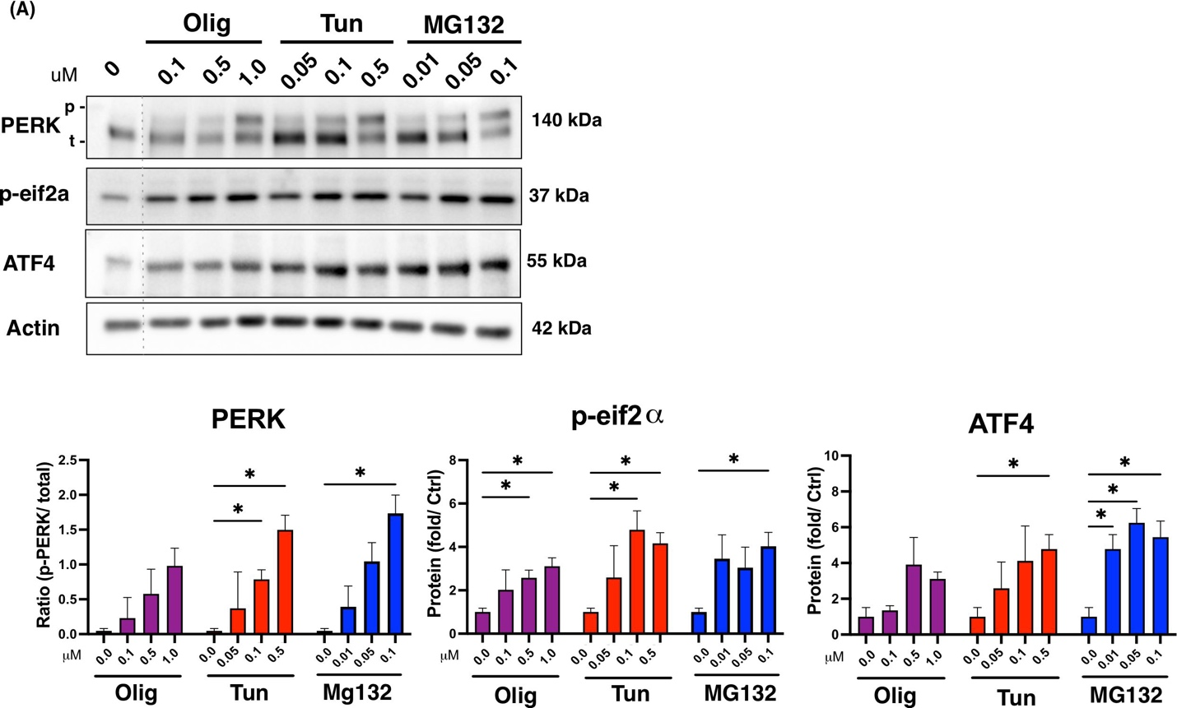
Supplemental Figure 1. Proteostatic toxins induced ISR activation
Primary microglia cultures derived from neonatal (p2-4) wildtype Fischer 344 rats (18 DIV) (a) microglia were treated with increasing concentrations of Oligomycin, Tunicamycin or MG132 for 8 hours and then lysed for protein. Levels of phosphorylated (p-) and unphosphorylated (t-) PERK, ATF4 and phosphorylated eIF2α (p-eIF2α) were assessed by Western blot and protein levels were quantified by densitometry. The dashed line indicates where the image has been spliced. (b) PERK was reported as a phosphorylated to unphosphorylated species ratio. (c) ATF4 and (d) p-eIF2α were reported as a fold increase of the `untreated time point control following normalization to β-actin levels. Data was collected from three independent experiments (n = 3). All graphs are presented as mean ± SEM and analyzed by two-way ANOVA followed by Tukey’s multiple comparisons test (*p < 0.05).
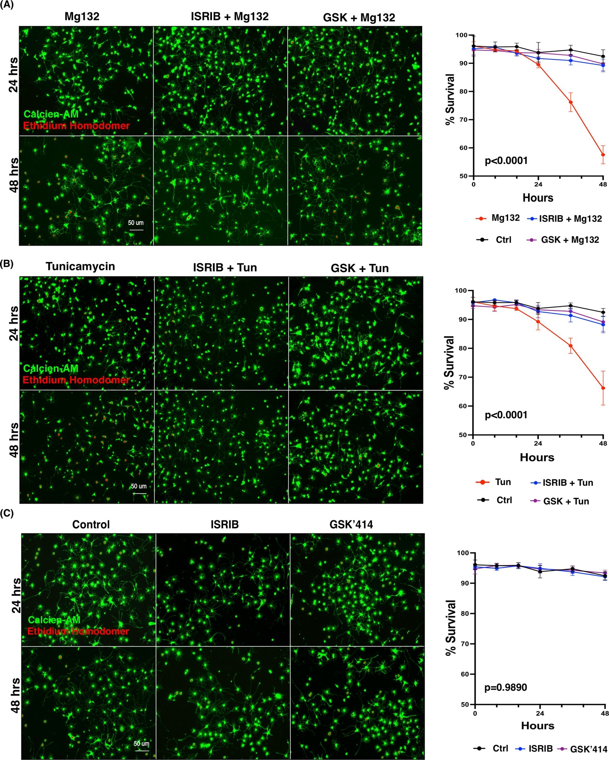
Supplemental Figure 2. ISR inhibition prevents cell death attributed to sustained proteostatic stress in microglia.
Primary microglia cultures derived from wild-type Fischer 344 rats (18 DIV) were treated with either ISRIB (0.1 μM) or GSK’141(0.05 μM) for 2 hours before exposure to MG132 (0.1 μM) or Tun (0.5 μM), and cell viability was assessed by Calcein-AM/Ethidium homodimer staining at the indicated times. Representative images of microglia pre-treated with ISRIB, GSK’141 or vehicle at 24 and 48 hours following (A) MG132, (B) Tun and (C) control cells with live Calcein-AM (green) and dead ethidium homodimer-1 (red). Percent survival was calculated as the fraction of viable cells to the total number of cells within each 10x field and averaged across three technical replicates per biological replicate (n = 4). A mixed-effects analysis, followed by Tukey’s multiple comparisons test, determined the reported interaction effects of treatment and time.

