Table S1. Summary statistics for the regression of logit-transformed biomass production efficiency (BPE) on predictor variables in evergreen species. Environmental factors are growing-season mean temperature (T_{g}, ˚C), mean temperature of the coldest month (MTCO, ˚C) , natural log-transformed stand age (ln age, year), natural log-transformed soil C:N ratio (ln CN), soil pH (pH, unitless) and soil sand content (Sand, % of weight).
Predictor variable | Coefficient | SE | t-value | p-value | R² | df
Intercept | 3.839 | 0.728 | 5.274 | < 0.001
T_{g} (˚C) | $-$0.058 | 0.013 | 2.504 | 0.013
MTCO (˚C) | 0.012 | 0.004 | 2.872 | 0.004
ln age (year) | $-$0.132 | 0.038 | $-$3.468 | < 0.001 | 0.203 | 234
ln CN | $-$0.573 | 0.205 | $-$2.801 | 0.006
pH (unitless) | $-$0.227 | 0.049 | $-$4.628 | < 0.001
Sand (% of weight) | $-$0.005 | 0.003 | $-$2.178 | 0.030

Table S2. Summary statistics for the regression of logit-transformed biomass production efficiency (BPE) on predictor variables in deciduous species. Environmental factors are growing-season mean temperature (T_{g}, ˚C), mean temperature of the coldest month (MTCO, ˚C), natural log-transformed stand age (ln age, year), natural log-transformed soil C:N ratio (ln CN), soil pH (pH, unitless) and soil sand content (Sand, % of weight).
Predictor variable | Coefficient | SE | t-value | p-value | R² | df
Intercept | 2.606 | 1.059 | 2.460 | 0.015
T_{g} (˚C) | $-$0.013 | 0.017 | $-$1.072 | 0.462
MTCO (˚C) | 0.008 | 0.007 | 1.072 | 0. 286
ln age (year) | $-$0.159 | 0.043 | $-$2.376 | < 0.001 | 0.268 | 113
ln CN | $-$0.815 | 0.343 | $-$2.376 | 0.019
pH (unitless) | 0.015 | 0.063 | 0.235 | 0.815
Sand (% of weight) | $-$0.001 | 0.003 | $-$0.267 | 0.790

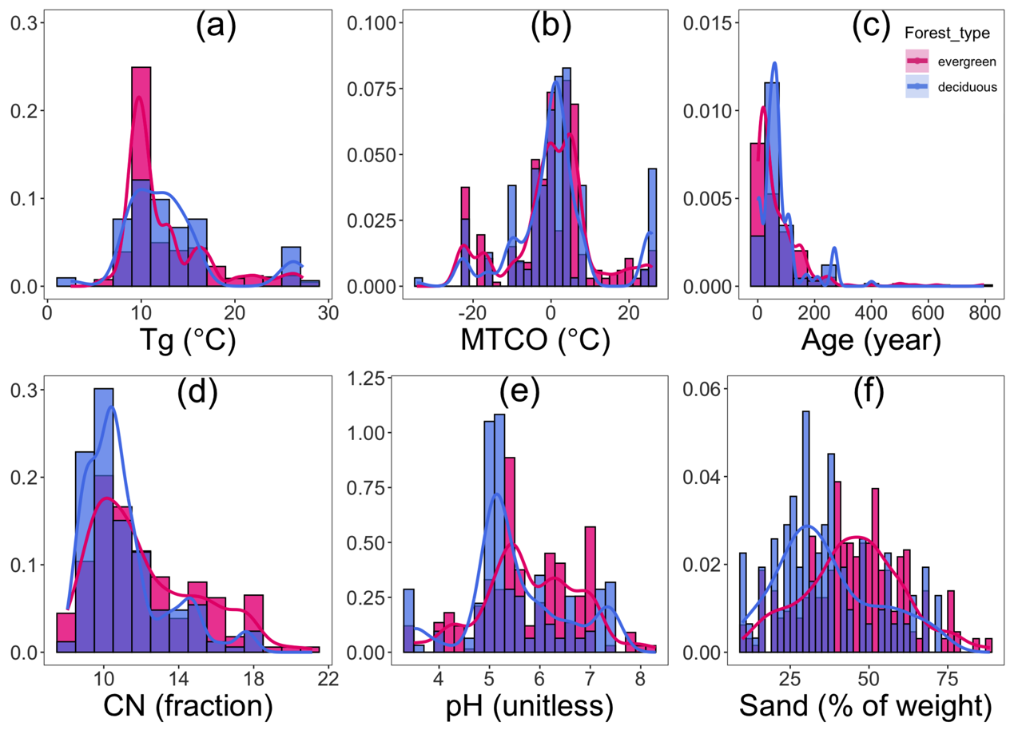

Fig. S1 Distributions of environmental variables in the dataset. Environmental factors are a: growing-season mean temperature (T_{g}, ˚C), b: mean temperature of the coldest month (MTCO, ˚C), c: stand age (ln age, year), d: soil C:N ratio (ln CN), e: soil pH (pH, unitless), f: soil sand content (Sand, % of weight)

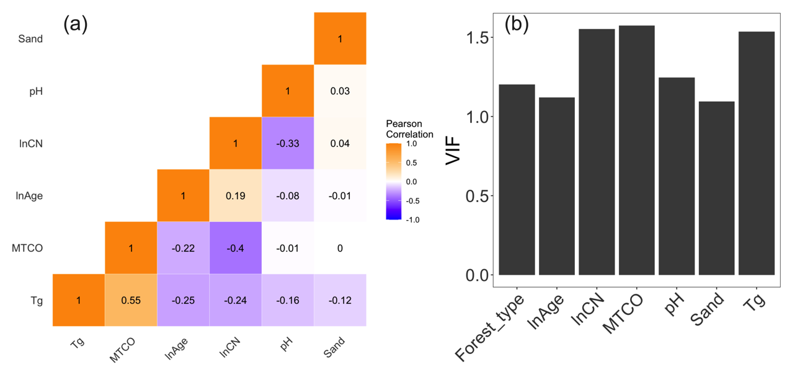
Fig. S2 Pearson correlation coefficients and Variance Inflation Factors (VIF) for different predictors. a: The coefficients are shown by numerical values and the gradient of colors for different environmental variables. b: VIFs for the model with predictors in the multiple linear regression model. The variables are growing-season mean temperature (T_{g}, ˚C), mean temperature of the coldest month (MTCO, ˚C), stand age (ln age, year), soil C:N ratio (ln CN), soil pH (pH, unitless), soil sand content (Sand, % of weight).

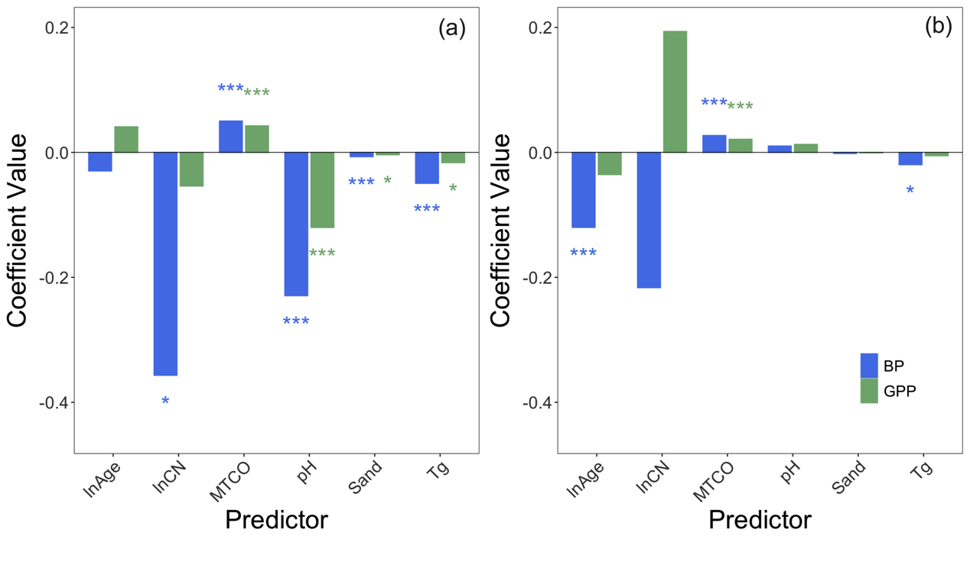
Fig. S3 Comparison of the coefficient values for the predictors in the models for biomass production (BP) and gross primary productivity (GPP) in (a) evergreen and (b) deciduous species. Bars represent the coefficients of the predictors, with positive and negative values indicating the direction of the relationship. The colour of the bars corresponds to the response variable (BP in blue and GPP in green). Significance levels are indicated by stars above each bar (p < 0.001: ***, p < 0.01: **, p < 0.05: *, p < 0.1: .). Environmental factors are growing-season mean temperature (T_{g}, ˚C), mean temperature of the coldest month (MTCO, ˚C) , natural log-transformed stand age (ln Age, year), natural log-transformed soil C:N ratio (ln CN), soil pH (pH, unitless) and soil sand content (Sand, % of weight).

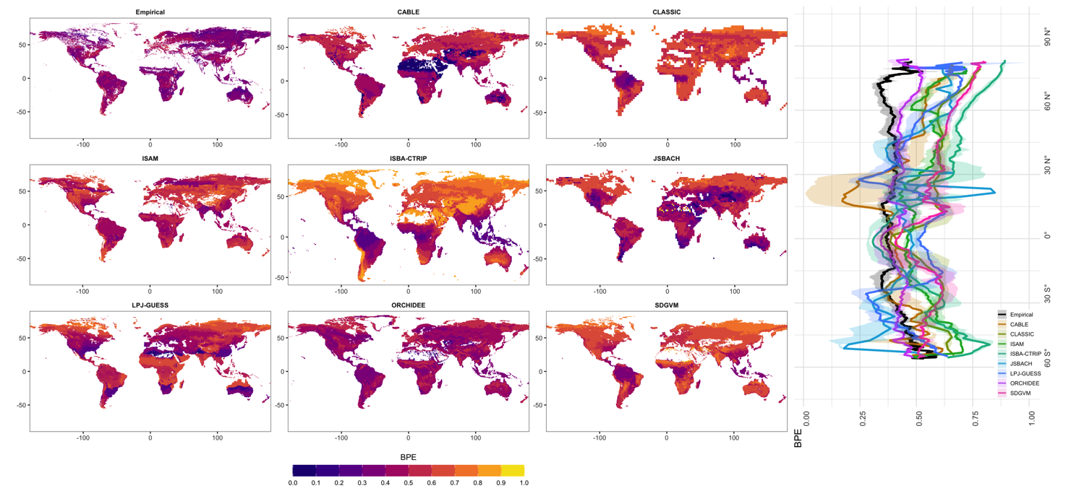
Fig. S4 The global distribution of biomass production efficiency (BPE) estimated by the multiple linear regression model and eight Dynamic Global Vegetation Models (DGVMs) in the TRENDY project, with their latitudinal variations.

