TITLE: ECO-EVOLUTIONARY DYNAMICS OF A THERMOCONFORMING ANOLE RECOLONIZING SECONDARY FOREST.

AUTHORS:
Fankhauser, Carly^{1,*}, 0000-0002-7584-3788
Miró-Herrans, Aida T.^{1,2}; 0009-0007-1902-1396
Papa, Riccardo³; 0000-0002-7986-9993
Acevedo, Miguel A.¹; 0000-0002-8289-1497
- Department of Wildlife Ecology and Conservation, University of Florida, Gainesville, FL, USA
- Academic Research Consulting and Services Department, George A. Smathers Libraries, University of Florida, Gainesville, FL, USA
- Department of Biology, University of Puerto Rico, Rio Piedras, Puerto Rico
*corresponding author. Carly Fankhauser (carlyfankhauser@gmail.com)

Table S1. Data sets used for analysis.

Data Set Name | Forest Age | PopID | N
El Yunque |  |  | 39
 | Old | EY-O | 16
 | Mid | EY-M | 14
 | Young | EY-Y | 9
Carite 1 |  |  | 16
 | Old | CA1-O | 5
 | Mid | CA1-M | 5
 | Young | CA1-Y | 6
Carite 2 |  |  | 19
 | Old | CA2-O | 3
 | Mid | CA2-M | 6
 | Young | CA2-Y | 10
Carite 1 & 2 |  |  | 35
 | Old | CA1-O | 5
 |  | CA2-O | 3
 | Mid | CA1-M | 5
 |  | CA2-M | 6
 | Young | CA1-Y | 6
 |  | CA2-Y | 10
Carite & El Yunque |  |  | 74
 | Old | CA1-O | 5
 |  | CA2-O | 3
 |  | EY-O | 16
 | Mid | CA1-M | 5
 |  | CA2-M | 6
 |  | EY-M | 14
 | Young | CA1-Y | 6
 |  | CA2-Y | 10
 |  | EY-Y | 9

Figure captions

Figure S1: Barplots of observed (dark blue) and expected (light blue) heterozygosity in populations within each forest chronosequence. Excess heterozygosity was only observed in the old-forest population in Carite 2.
Figure S2: PCA plots displaying individual genotypes as points grouped into similar clusters. The color of the data points represents the age of the forest inhabited by each population. The PCA plots incorporate individuals from a) El Yunque National Forest in 2019 (N = 39, EY); b) Carite State Forest in 2019 (N = 16, CA1); and c) Carite State Forest in 2021 (N = 19, CA2).

Figure S1
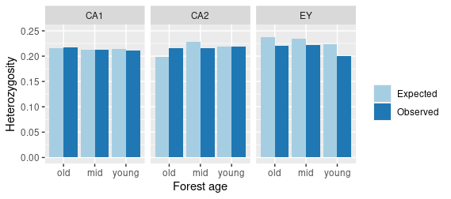

Figure S2
