Table of Contents of the Supplementary materials
Tables 2
Table 1: Search Strategy. 2
Table 2: Quality assessment of the included studies using Newcastle Ottawa scale (NOS) for cross-sectional and cohort studies. 3
Figures 5
Figure 1: Funnel plot asymmetry assessing publication bias 5
Figure 2: Forest plot of the prevalence of Impostor phenomenon (IP) by sex using a random-effects model……………………………………………………….…………….... 6
Figure 3: Forest plot of the prevalence of Impostor phenomenon (IP) by academic year using a random-effects model……………………………………………………….. 7
Figure 4: Forest plot of the prevalence of Impostor phenomenon (IP) by region using a random-effects model…………………………………………………………………….. 8
Figure 5: Forest plot of the prevalence of Impostor phenomenon (IP) by tool using a random-effects model………………………………………………………………………. 9
Figure 6: Forest plot of the prevalence of Impostor phenomenon (IP) by quality using a random-effects model…………………………………………………………………….10
Figure 7: Baujat plot identifying influential studies…………..………………………… 11
Figure 8: Influence diagnostics plot……………………………...……………………… 12
Figure 9: Forest plot of the sensitivity analysis after removing outliers...…………….. 13
Figure 10: Leave-one-out sensitivity analysis...……………………………………….. 14

Tables

Table 1 Search Strategy.
Database | Search strategy
PubMed &  CINHAL | ("impostor phenomenon" OR "imposter phenomenon" OR "impostor syndrome" OR "imposter syndrome" OR impostorism OR imposterism) AND ("medical student*" OR "medical education" OR "medical trainee*" OR "medical school" OR "medical undergraduate*" OR "clinical student*" OR "future physician*" OR "physician trainee*" OR "health profession student*" OR "medical learner*")
Web of Science | (TS= ("impostor phenomenon" OR "imposter phenomenon" OR "impostor syndrome" OR "imposter syndrome" OR impostorism OR imposterism) OR AB=("impostor phenomenon" OR "imposter phenomenon" OR "impostor syndrome" OR "imposter syndrome" OR impostorism OR imposterism) OR KP=("impostor phenomenon" OR "imposter phenomenon" OR "impostor syndrome" OR "imposter syndrome" OR impostorism OR imposterism)) AND (TS= ("medical student*" OR "medical education" OR "medical trainee*" OR "medical school" OR "medical undergraduate*" OR "clinical student*" OR "future physician*" OR "physician trainee*" OR "health profession student*" OR "medical learner*") OR AB=("medical student*" OR "medical education" OR "medical trainee*" OR "medical school" OR "medical undergraduate*" OR "clinical student*" OR "future physician*" OR "physician trainee*" OR "health profession student*" OR "medical learner*") OR KP=("medical student*" OR "medical education" OR "medical trainee*" OR "medical school" OR "medical undergraduate*" OR "clinical student*" OR "future physician*" OR "physician trainee*" OR "health profession student*" OR "medical learner*"))
Scopus | TITLE-ABS-KEY("Impostor" OR "Imposter" OR "Impostor's" OR "Imposter's" OR "Impostorism" OR "Imposterism")  AND  TITLE-ABS-KEY("Medical student" OR "Medical students" OR "Medical education" OR "Medical trainee" OR "Medical trainees" OR "Medical school" OR "Medical undergraduate*" OR "Clinical student*" OR "Future physician*" OR "Physician trainee*" OR "Health profession student*" OR "Medical learner*")

Table 2 Quality assessment of the included studies using Newcastle Ottawa scale (NOS) for cross-sectional and cohort studies.
Study ID  Domain | Selection | Comparability | Outcome | Overall | Overall decision
Houseknecht et al.; 2019* | 3 | 1 | 3 | 7 | Good
Rosenthal et a.; 2021* | 3 | 1 | 3 | 7 | Good
Tran et al.; 2024* | 2 | 1 | 2 | 5 | Moderate
Choron et al.; 2022* | 3 | 1 | 2 | 6 | Moderate-Good
Addae-Konadu et al.; 2021 | 3 | 1 | 2 | 6 | Satisfactory quality
Al Lawati et al.; 2023 | 4 | 1 | 2 | 7 | Good quality
Alok et al.; 2024 | 3 | 0 | 1 | 4 | Poor quality
Alsaleemet al.; 2021 | 4 | 1 | 2 | 7 | Good quality
Alzufari et al.; 2024 | 5 | 1 | 2 | 8 | Good quality
Brennan-Wydra et al.; 2021 | 4 | 1 | 2 | 7 | Good quality
Buathong et al.; 2024 | 3 | 1 | 2 | 6 | Satisfactory quality
Camara et al.; 2022 | 2 | 1 | 2 | 5 | Satisfactory quality
Clark et al.; 2024 | 2 | 1 | 1 | 4 | Poor quality
De et al.; 2024 | 4 | 1 | 2 | 7 | Good quality
Diaconescu et al.; 2024 | 5 | 1 | 2 | 8 | Good quality
El-Setouhy et al.; 2024 | 4 | 1 | 2 | 7 | Good quality
Elnaggar et al.; 2023 | 3 | 1 | 2 | 6 | Satisfactory quality
Franchi et al.; 2022 | 3 | 1 | 2 | 6 | Satisfactory quality
Henning et al.; 1998 | 3 | 1 | 2 | 6 | Satisfactory quality
Herța et al.; 2024 | 2 | 0 | 1 | 3 | Poor quality
Holliday et al.; 2019 | 3 | 1 | 1 | 5 | Satisfactory quality
Hu et al.; 2019 | 2 | 1 | 2 | 5 | Satisfactory quality
Khalil et al.; 2024 | 4 | 1 | 2 | 7 | Good quality
Kim et al.; 2024 | 2 | 1 | 2 | 5 | Satisfactory quality
Klen et al.; 2023 | 3 | 1 | 2 | 6 | Satisfactory quality
Kristofferson et al.; 2024 | 3 | 1 | 2 | 6 | Satisfactory quality
Levant et al.; 2020 | 3 | 1 | 2 | 6 | Satisfactory quality
Levant et al.; 2020 | 3 | 1 | 2 | 6 | Satisfactory quality
Mashhadi et al.; 2022 | 2 | 1 | 2 | 5 | Satisfactory quality
Naser et al.; 2022 | 2 | 1 | 2 | 5 | Satisfactory quality
Neufeld et al.; 2022 | 4 | 1 | 2 | 7 | Good quality
Neufeld et al.; 2024 | 3 | 1 | 2 | 6 | Satisfactory quality
Ogunyemi et al.; 2022 | 4 | 1 | 2 | 7 | Good quality
Priya et al.; 2024 | 3 | 1 | 2 | 6 | Satisfactory quality
Qureshi et al.; 2017 | 3 | 0 | 2 | 5 | Satisfactory quality
Rice et al.; 2023 | 3 | 1 | 2 | 6 | Satisfactory quality
Sawant et al.; 2023 | 2 | 1 | 2 | 5 | Satisfactory quality
Shill-Russell et al.; 2022 | 2 | 1 | 2 | 5 | Satisfactory quality
Shinawatra et al.; 2023 | 3 | 1 | 2 | 6 | Satisfactory quality
Shreffler et al.; 2020 | 3 | 1 | 2 | 6 | Satisfactory quality
Sivananthajothy et al.; 2024 | 3 | 1 | 2 | 6 | Satisfactory quality
Vilchez-Cornejo et al.; 2023 | 3 | 1 | 2 | 6 | Satisfactory quality
Vilwok et al.; 2016 | 3 | 1 | 3 | 7 | Good quality
Wang et al.; 2023 | 3 | 1 | 2 | 6 | Satisfactory quality
Wrench et al.; 2024 | 3 | 1 | 3 | 7 | Good quality
Gupta el al.; 2025 | 4 | 1 | 2 | 7 | Good quality

Figures
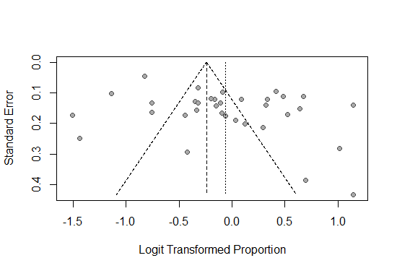
Figure S1. Funnel plot assessing publication bias

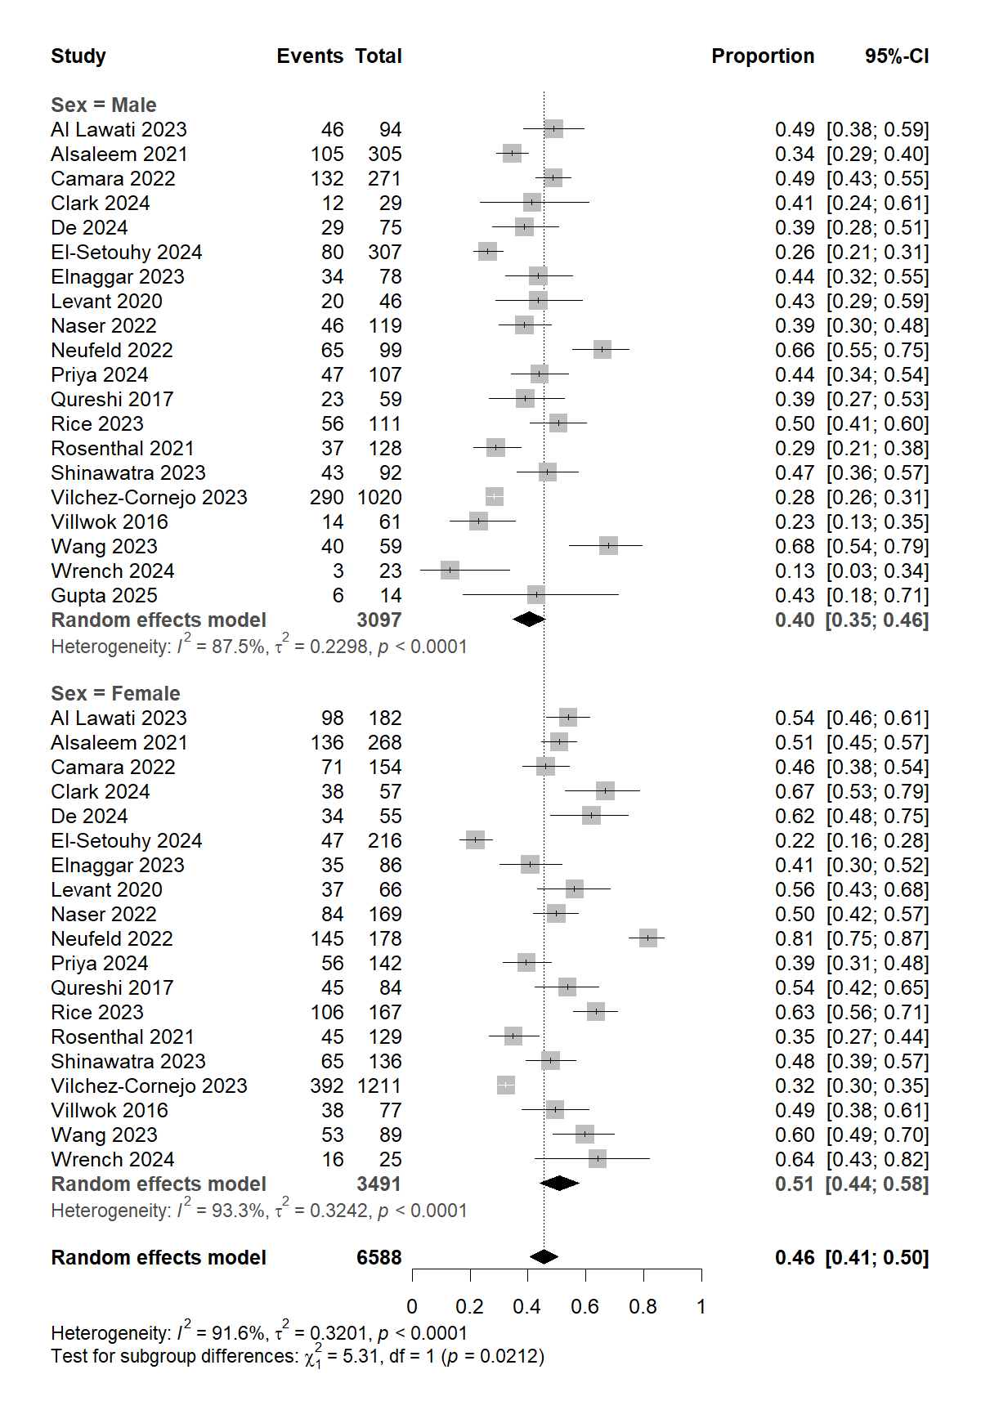
Figure S2. Forest plot of the prevalence of Impostor phenomenon (IP) by sex using a random-effects model

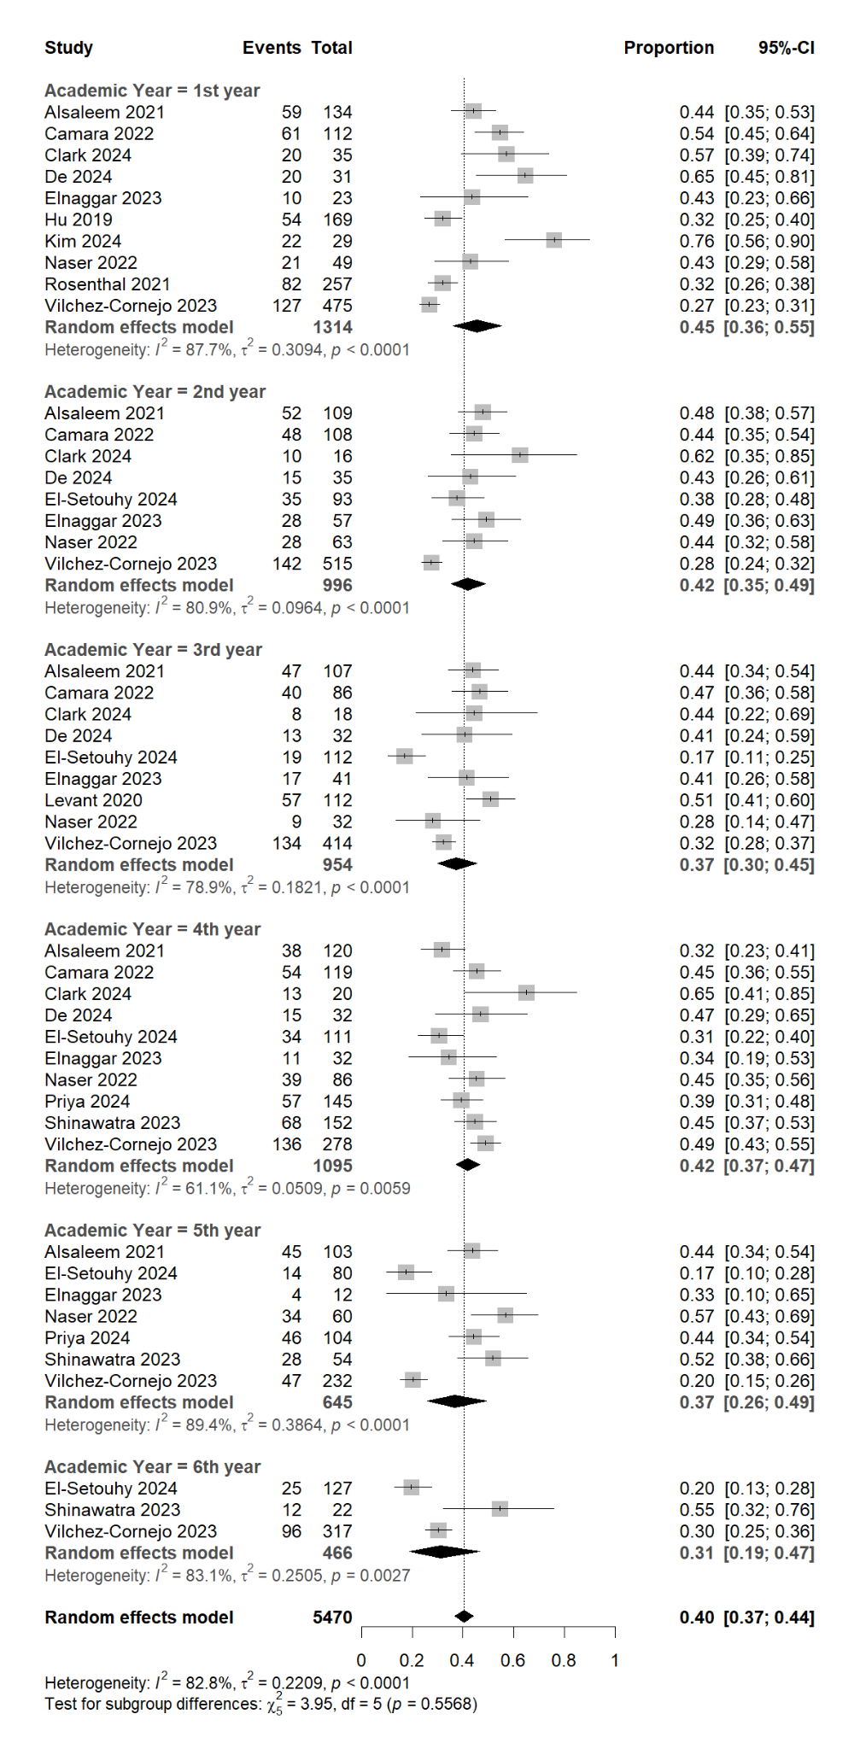
Figure S3. Forest plot of the prevalence of Impostor phenomenon (IP) by academic year using a random-effects model
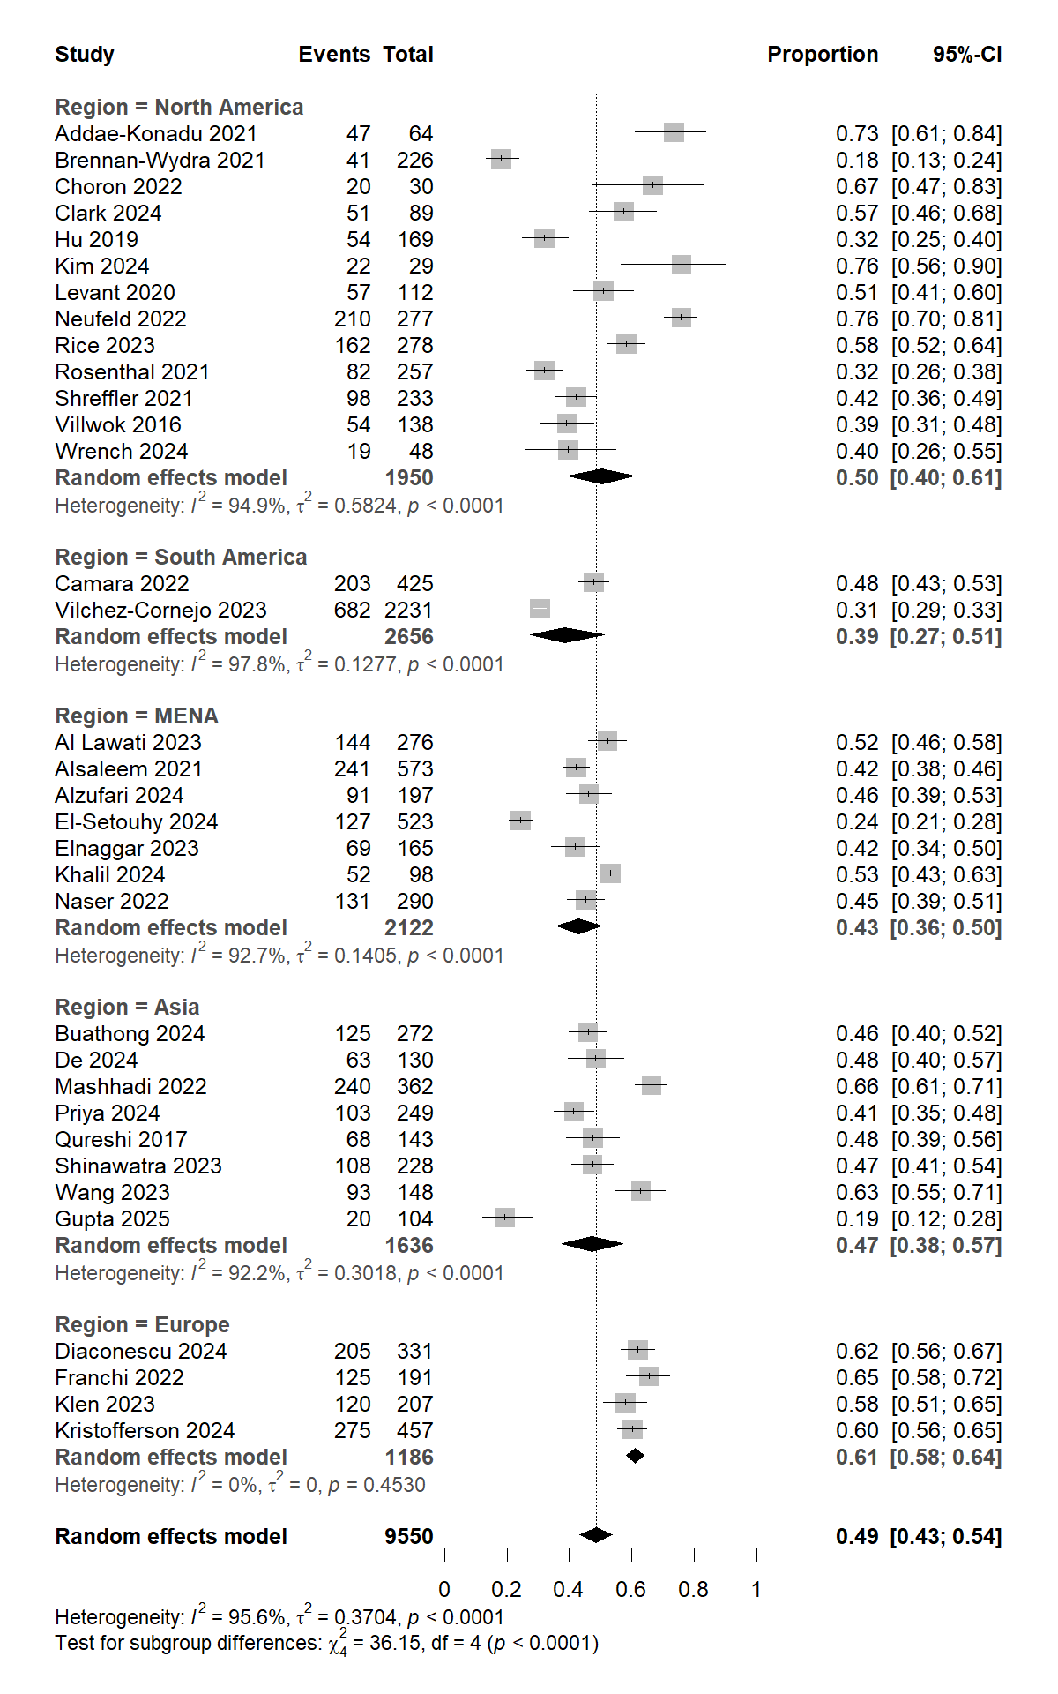
Figure S4. Forest plot of the prevalence of Impostor phenomenon (IP) by region using a random-effects model
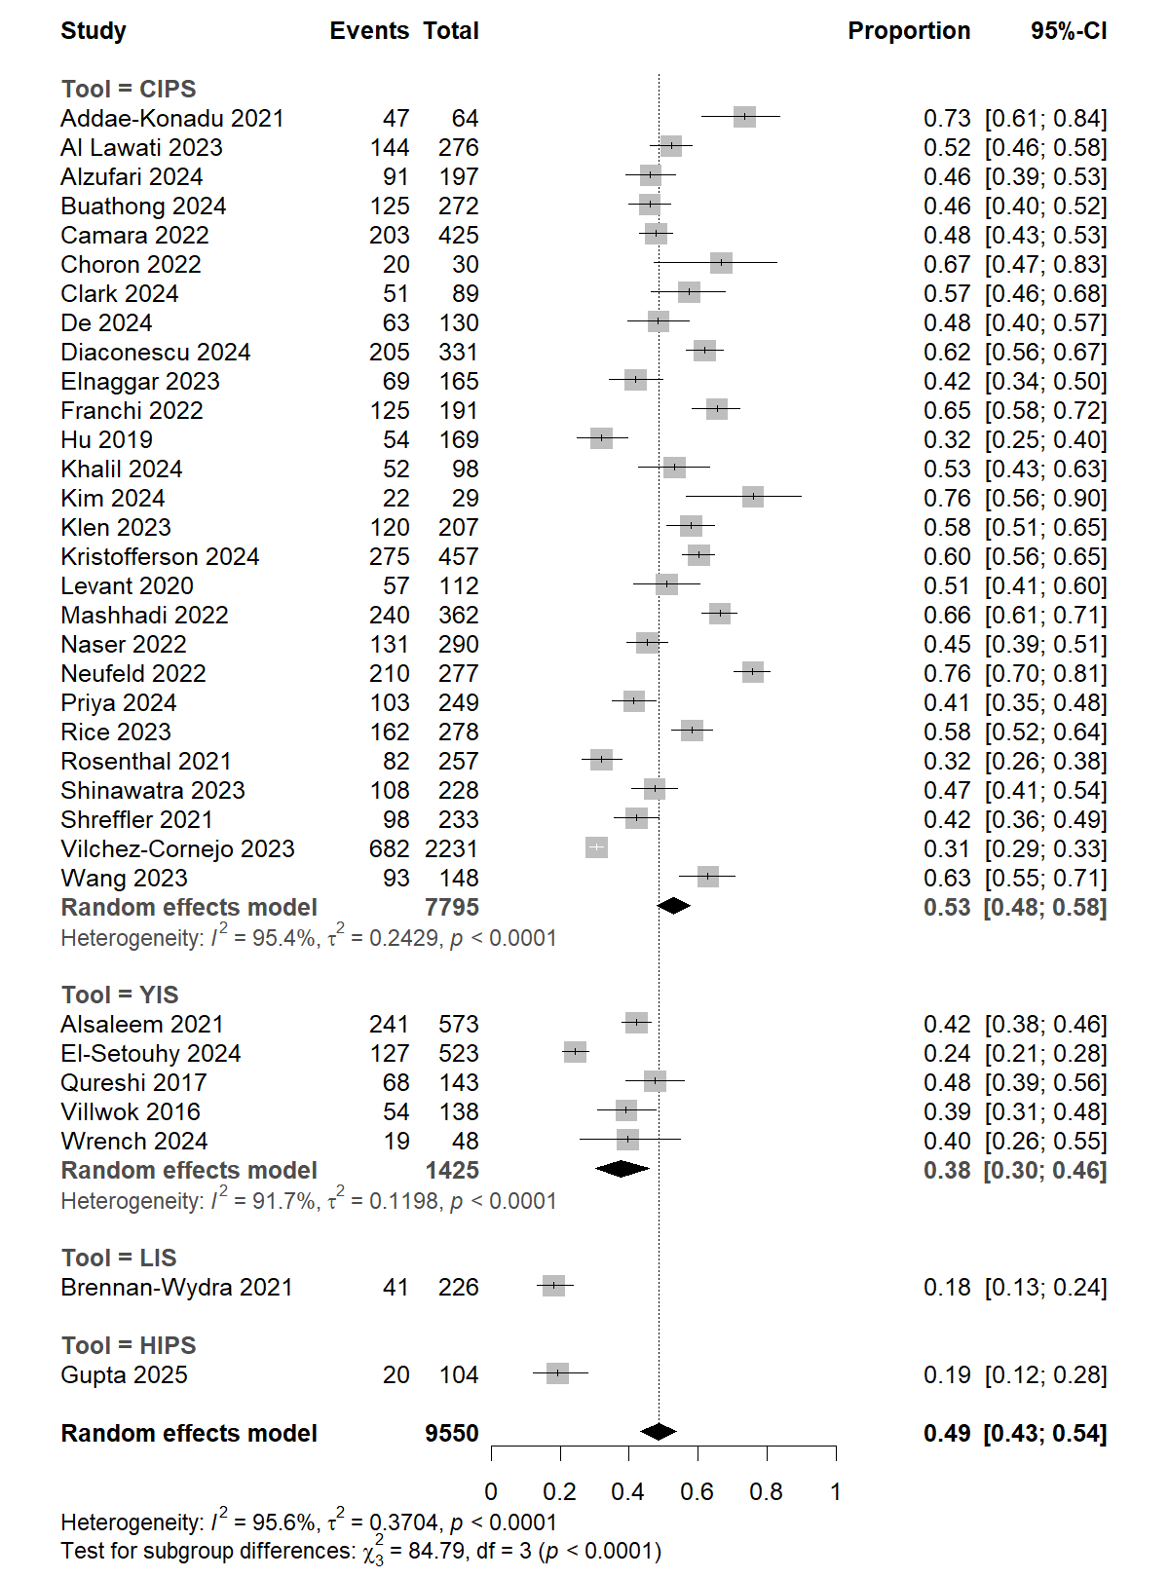
Figure S5. Forest plot of the prevalence of Impostor phenomenon (IP) by tool using a random-effects model
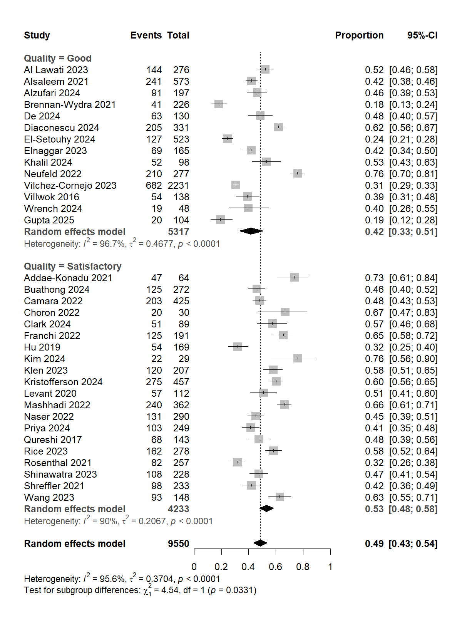
Figure S6. Forest plot of the prevalence of Impostor phenomenon (IP) by quality using a random-effects model
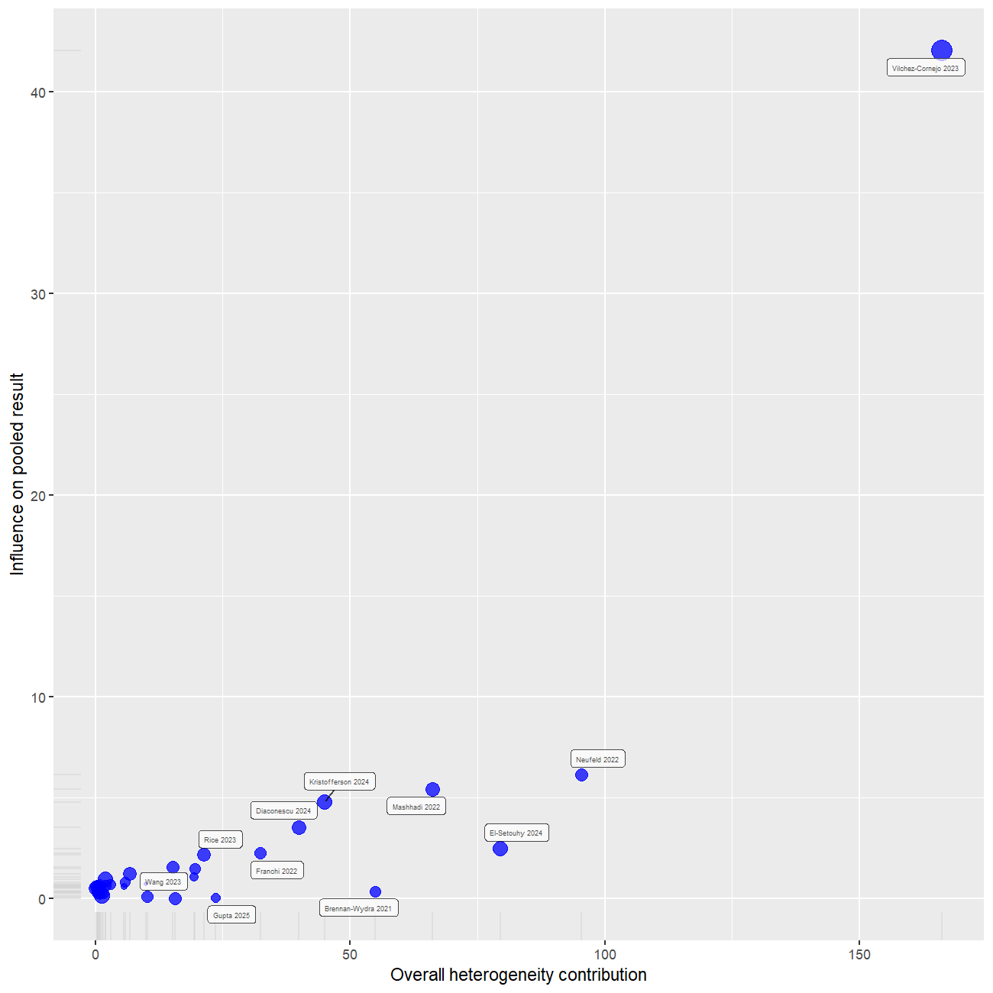
Figure S7. Baujat plot identifying influential studies

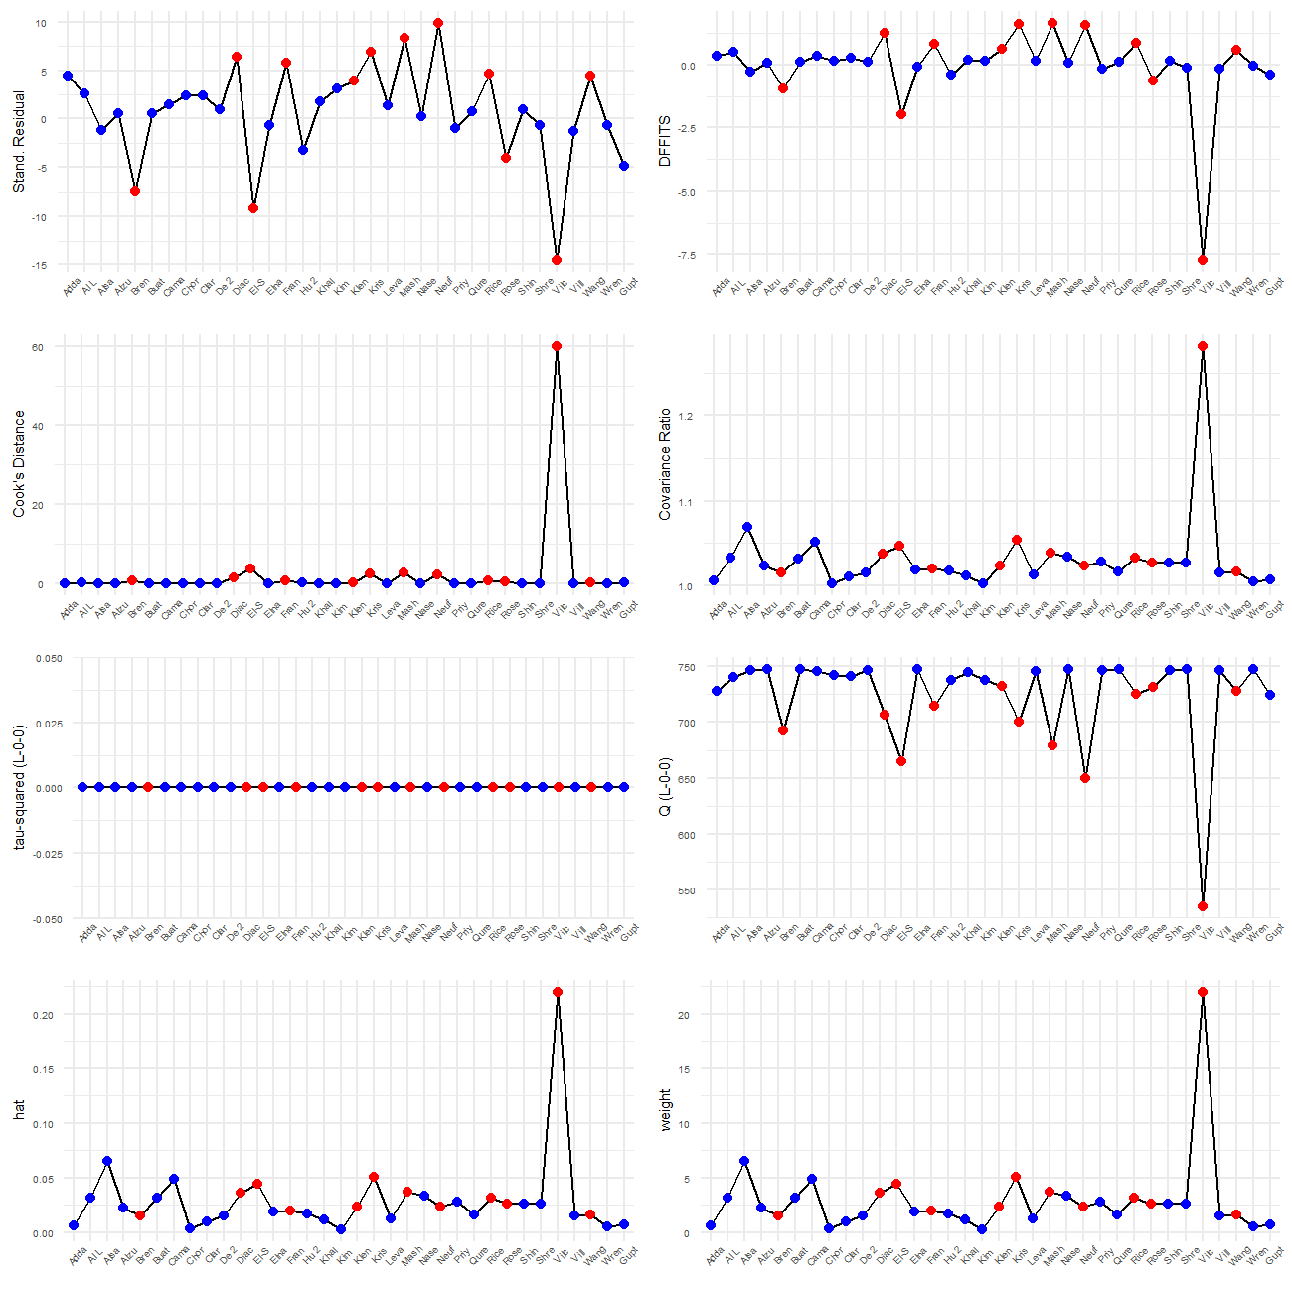
Figure S8. Influence diagnostics plot
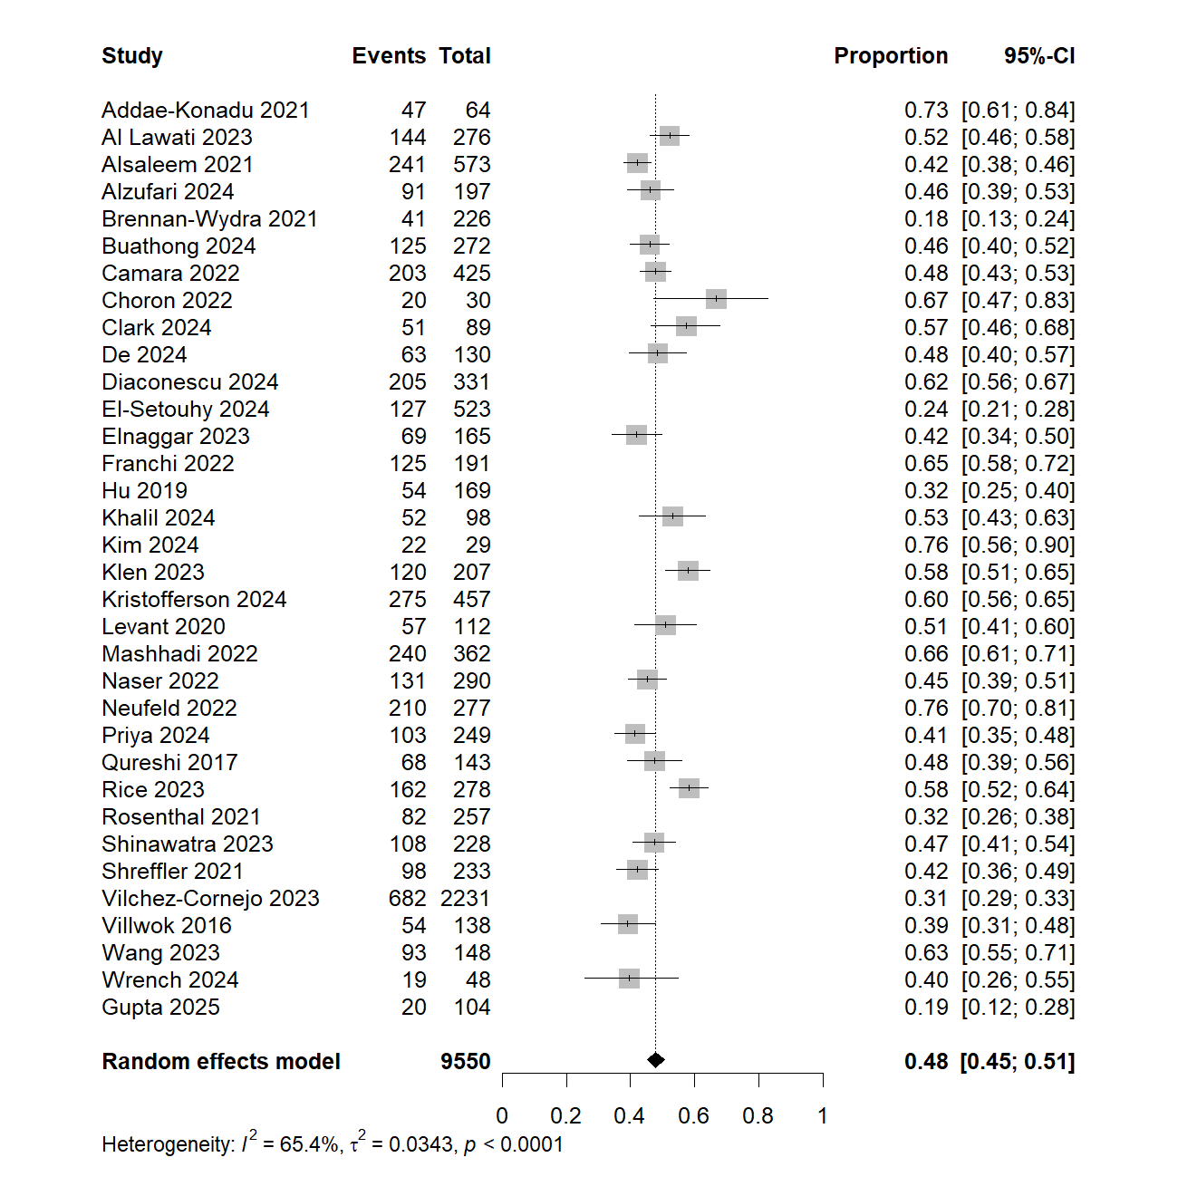
Figure S9. Forest plot of the sensitivity analysis after removing outliers
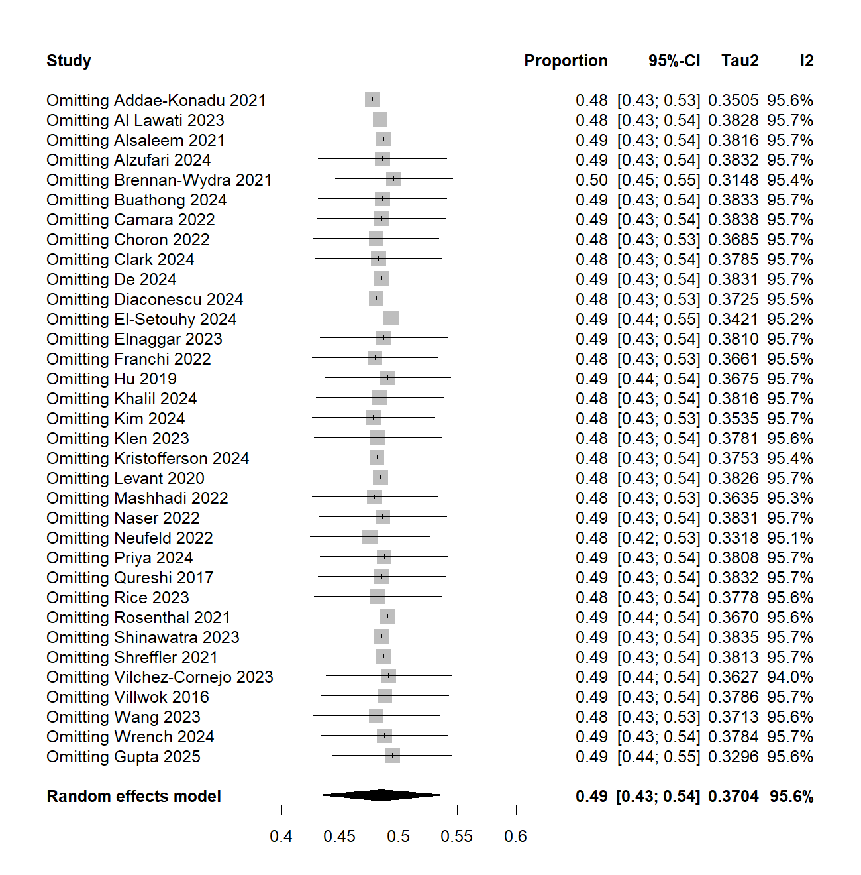
Figure S10. Leave-one-out sensitivity analysis

