Supplementary Materials for
Efficiency boosting of silicon solar cell via radiative cooling
Zhuning Wang^{1,3}, Sijie Pian^{2,3}, Chengtao Lu¹, Peixuan Wu¹, Maowei Liang¹, Qikai Chen¹, Zijun Zhang¹, Rengmao Wu¹, Yang (Michael) Yang¹, Xu Liu¹, Yaoguang Ma¹*
¹ State Key Laboratory of Extreme Photonics and Instrumentation, College of Optical Science and Engineering, ZJU–Hangzhou Global Scientific and Technological Innovation Center, Zhejiang University; Hangzhou 310027, China
² Institute of Applied Electronics, China Academy of Engineer Physics, Mianyang 621900, China
³These authors contributed equally to this work: Zhuning Wang and Sijie Pian

*Corresponding author. Email: mayaoguang@zju.edu.cn

The PDF file includes:
Supplementary Text
Figs. S1 to S10
Tables S1 to S6
References

Supplementary Text
Definition of average solar reflectance and average mid-infrared emittance
Based on the spectral data, the average solar reflectance ${\overline{R}}_{solar}$ and average mid-infrared emittance ${\overline{ε}}_{IR}$ can be calculated as follows.
$\begin{aligned}{\overline{R}}_{\text{solar}}\text{=}\frac{\int_{\text{0.3 μm}}^{\text{2.5 μm}}{R\left(λ\right)\text{·}{\text{I}}_{\text{AM 1.5}}\left(λ\right)\text{d}\text{λ}}}{\int_{\text{0.3 μm}}^{\text{2.5 μm}}{{\text{I}}_{\text{AM 1.5}}\left(λ\right)\text{d}\text{λ}}}\#\left(S1\right)\end{aligned}$
Where $λ$ is the wavelength, $R\left(λ\right)$ is the sample’s spectral reflectance at wavelength $λ$, ${\text{I}}_{\text{AM 1.5}}\left(λ\right)$ is the $\text{AM 1.5}$ global solar spectral irradiance.
In below-ambient cooling, a broad-spectrum infrared emissivity becomes paramount.
$$\begin{aligned}{\overline{ε}}_{\text{IR}}\text{=}\frac{\int_{\text{2.5μm}}^{∞}{ε\left(λ\right)\text{·}{\text{I}}_{\text{BB}}\left(λ,T\right)\text{d}\text{λ}}}{\int_{\text{2.5 μm}}^{∞}{{\text{I}}_{\text{BB}}\left(λ,T\right)\text{d}\text{λ}}}\#\left(S2\right)\end{aligned}$$
Where λ is the wavelength, $ε\left(λ\right)$ is the sample’s emittance at wavelength $λ$, ${\text{I}}_{\text{BB}}\left(λ,T\right)$ is the spectral emittance of a black body at temperature $T$, it can be calculated as shown in the following equation.
$$\begin{aligned} I_{BB}\left(λ,T\right)=\frac{2hc^{2}}{λ^{5}}⋅\frac{1}{e^{\frac{hc}{λk_{B}T}}-1}\#(S3)\end{aligned}$$
Where $h$ is the Plank’s constant, $c$ is the speed of light, $λ$ is the wavelength, and $k_{B}$ is the Boltzmann constant.

Utilization and conversion of solar energy by solar cells
Absorption and reflection
The solar spectrum spans a broad range of wavelengths from 0.3 to 2.5 micrometers (μm). We conducted spectral characterization of a commercial solar cell using a UV-Vis-NIR spectrophotometer (Cary 5000, Agilent Technologies). The results revealed that approximately 13.3% of the incident solar energy is reflected by the cell, with the remainder being absorbed (Fig. 3b).
The Shockley−Queisser limit and the conversion efficiency of solar cells
In ideal conditions, disregarding energy losses due to reflection, photothermal effects, and other factors, and assuming a perfect external quantum efficiency of 100%, the Shockley-Queisser (SQ) model can be used to calculate the energy conversion efficiency of a solar cell. In its simplest and most commonly used form, the SQ model assumes that: (1) the solar cell is composed of a single semiconductor material with a p-n junction, (2) the sunlight is not concentrated (i.e., it originates from a "one-sun" source), (3) the mobility of charge carriers is infinite, allowing for unrestricted charge collection spatially, and (4) all photons with energy equal to or greater than the semiconductor's optical bandgap ($E_{gap}$) are absorbed by the solar cell.
The photon flux onto the solar cell (optical bandgap $E_{gap}$) is determined by:
$$\begin{aligned}Φ_{sun}\left(E_{gap},T_{sun}\right)=K\frac{2π}{h^{3}c^{2}}\int_{E_{gap}}^{∞}{\frac{E^{2}}{e^{\frac{E}{k_{B}T_{sun}}}-1}dE}\#\left(S4\right)\end{aligned}$$
Where $h$ is the Plank’s constant, $c$ is the speed of light, $E$ is the photon energy, and $k_{B}$ is the Boltzmann constant. Both the sun and the solar cell are treated as black bodies, with their Kelvin temperatures denoted as $T_{sun}$ and $T_{cell}$, respectively. $K$ is a constant related to the view factor of the solar cell towards the sun and the solar incident angle:
$$\begin{aligned}K=\frac{\int_{\text{Ω}\text{∈}{\text{Ω}}_{\text{sun}}}{d\text{Ω}\cos{θ}}}{\int{d\text{Ω}\cos{θ}}}≈\frac{2π\cos{θ_{sun}}\int_{0}^{\frac{θ_{SE}}{2}}{\sin{θ}\cos{θ}dθ}}{2π\int_{0}^{\frac{π}{2}}{\sin{θ}\cos{θ}dθ}}≈\frac{\cos{θ_{sun}}r_{solar}^{2}}{d_{SE}^{2}}\#\left(S5\right)\end{aligned}$$
Where ${\text{Ω}}_{\text{sun}}$​ represents the solid angle subtended by the sun in spherical coordinates with earth as the origin. $θ_{SE}$​ denotes the zenith angle occupied by the sun. $θ_{sun}$​ is the solar incidence angle, which is the angle between the sunlight and the normal to earth's surface. $r_{solar}$ is the radius of the Sun, and $d_{SE}$ is the average distance between the sun and earth.
The photon emission from the solar cell depends on the quasi-Fermi level separation ($E_{femi}$) corresponding to:
$$\begin{aligned}Φ_{Emis}\left(E_{gap},E_{femi},T_{cell}\right)=\frac{2π}{h^{3}c^{2}}\int_{E_{gap}}^{∞}{\frac{E^{2}}{e^{\frac{E-E_{femi}}{k_{B}T_{cell}}}-1}dE}\#\left(S6\right)\end{aligned}$$
Since the difference between $Φ_{Abs}$ and $Φ_{Emis}$, multiplied by the electron charge $q$, represents the electric current generated in the solar cell, the power output ($P_{sc}$) of the solar cell depends on the optical bandgap ($E_{gap}$) and the quasi-Fermi level separation $E_{femi}$. For a given semiconductor material ($E_{gap}$), we need to vary the parameter $E_{femi}$ to find the condition that maximizes the power $P_{sc}=[q⋅\left(Φ_{sun}-Φ_{Emis}\right)]⋅{(E}_{femi}/q)$. This is typically done by varying the value of $E_{femi}$, starting from 0 and approaching the open-circuit condition (i.e., when $Φ_{Abs}=Φ_{Emis}$). Then, the efficiency $η_{SQ}$ of the solar cell can be defined as:
$$\begin{aligned}η_{SQ}=\frac{P_{sc}}{P_{sun}}=\frac{\left(Φ_{sun}-Φ_{Emis}\right)⋅E_{femi}}{K⋅σT_{sun}^{4}}\#\left(S7\right)\end{aligned}$$
where $σ$ is the Stefan-Boltzmann constant. Reference¹ presents the ideal efficiencies of solar cells calculated by various theoretical models, including the original SQ model. The maximum efficiency does not exceed 33.7%, as illustrated in Fig. S1a.
External quantum efficiency (EQE)
Even among the sunlight absorbed by a solar cell, not all incident photons effectively participate in the photoelectric effect. The external quantum efficiency (EQE) represents the ratio of the number of photogenerated carriers to the number of incident photons (Fig. S1c). According to Reference², as illustrated in Fig. S1d, only about 48.3% of the solar energy can be involved in photoelectric conversion, with the remaining energy being reflected or converted into waste heat.

Theoretical calculations of cooling power in different cases
Given the concentrated distribution of PV stations in mid-latitude regions (Fig. 5b and 5c) and installation requirements (Fig. 5a), all solar cell models are set at a 30° tilt angle. Furthermore, the top surface emissivity of the cells is based on measured data from commercial cells (Fig. 3b), while the bottom surface is modeled as an ideal blackbody emitter with zero solar spectral absorption and unit emissivity in other bands.
Case I: Top surface radiation
To evaluate the cooling performance of the emitter with a tilt angle of $θ_{t}$, as depicted in the left panel of Fig. 1d, we utilized a simplified model to analyze the energy balance of the emitter in Case I. In this scenario, heat exchange occurs exclusively on the top surface. The net cooling power $P_{cool}\left(T\right)$ can be calculated by the following thermal equilibrium equation (S8-S17).
$$\begin{aligned}P_{cool}\left(T\right)=P_{rad}\left(T\right)-P_{sun}-P_{c,top}\#\left(S8\right)\end{aligned}$$
Where $P_{rad}\left(T\right)$ denotes the radiative heat exchange between the emitter and the ground, as well as the atmosphere.
$$\begin{aligned}P_{rad}\left(T\right)=P_{emi}\left(T\right)-P_{ground}\left(T_{amb}, θ_{t}\right)-P_{atm}\left(T_{amb}, θ_{t}\right)\#\left(S9\right)\end{aligned}$$
Where $P_{emi}\left(T\right)$ defined by the following equation denotes the emitted thermal radiation from the surface of the radiative cooler.
$$\begin{aligned}P_{emi}\left(T\right)=A\int{dΩ\cos{θ\int_{0}^{∞}{I_{BB}\left(λ,T\right)ε_{top}\left(λ,θ\right)dλ}}}\#\left(S10\right)\end{aligned}$$
Here, $A$ is the area of the emitter’s top surface. $\int{dΩ\cos{θ}}$ is the hemispherical angular integral that can also be expressed as $2π\int_{0}^{\frac{π}{2}}{\sin{θ}dθ}$. The $I_{BB}\left(λ,T\right)$ in the equation indicates the spectral emittance of a black body at temperature $T$, it can be calculated as shown in equation (S11). $ε_{top}\left(λ,θ\right)$ is the spectral emissivity of the top surface.
$$\begin{aligned}I_{BB}\left(λ,T\right)=\frac{2hc^{2}}{λ^{5}}⋅\frac{1}{e^{\frac{hc}{λk_{B}T}}-1}\#\left(S11\right)\end{aligned}$$
Where $h$ is the Plank’s constant, $c$ is the speed of light, $λ$ is the wavelength, and $k_{B}$ is the Boltzmann constant.
The ground is considered a blackbody at ambient temperature. Due to the emitter’s tilt, it receives a portion of the radiation from the ground.
$$\begin{aligned}P_{ground}\left(T_{amb}, θ_{t}\right)=A\int_{0}^{∞}{\int_{{\frac{π}{2} -θ}_{t}}^{\frac{π}{2}}{\sin{θ}\cos{θ\left[2*\cos^{-1}\left(cotθ*cotθ_{t}\right)\right]}}I_{BB}\left(λ,T_{amb}\right)ε_{top}\left(λ,θ\right)dθdλ}\#\left(S12\right)\end{aligned}$$
The $P_{atm}\left(T_{amb}, θ_{t}\right)$ in equation (S9) is the absorbed thermal radiation from the atmosphere which can be expressed as equation (S12).
$$\begin{aligned}P_{atm}\left(T_{amb}, θ_{t}\right)=A\int_{0}^{∞}{\int_{0}^{2π}{\int_{0}^{\frac{π}{2}}{\sin{θ}\cos{θ}ε_{atm}\left(λ,θ_{n}\right)}}I_{BB}\left(λ,T_{amb}\right)ε_{top}\left(λ,θ\right)dθdψdλ}\#\left(S13\right)\end{aligned}$$
Here, ψ represents the azimuthal angle in the hemispherical coordinate system. $θ_{n}$ is the angle with respect to the zenith direction, which is given by equation (S14). $ε_{atm}\left(λ,θ_{n}\right)$ is the emissivity of the atmosphere which is given by equation (S15). Where $t\left(λ\right)$ is the atmospheric transmittance in the zenith direction.
$$\begin{aligned}θ_{n}\left({θ,ψ,θ}_{t}\right)=cos^{-1}\left(sinθcosψsinθ_{t}+cosθcosθ_{t}\right)\#\left(S14\right)\end{aligned}$$
$$\begin{aligned}ε_{atm}\left(λ,θ_{n}\right)=\left\{\begin{aligned}1-t{\left(λ\right)}^{\frac{1}{\cos{θ_{n}}}}，θ_{n}<\frac{π}{2} \\ 0，θ_{n}>=\frac{π}{2}\end{aligned}\right.\#\left(S15\right)\end{aligned}$$
The $P_{sun}$ in equation (S8) indicates the radiation absorbed from the sun. It is expressed as equation (S16), where $I_{AM1.5}\left(λ\right)$ is the solar illumination spectra (air mass 1.5 global).
$$\begin{aligned}P_{sun}=A\cos{θ_{sun}}\int_{0}^{∞}{I_{AM1.5}\left(λ\right)ε_{top}\left(λ\right)dλ}\#\left(S16\right)\end{aligned}$$
The $P_{c,top}$ in equation (S8) indicates the nonradiative power gained from thermal conduction and thermal convection between the top surface and the ambient environment. It can be calculated by equation (S17), where $h_{top}$ is the non-radiative heat transfer coefficient, $T_{amb}$ is the ambient temperature and $T$ is the temperature of the emitter.
$$\begin{aligned}P_{c,top}=h_{top}\left(T_{amb}-T\right)\#\left(S17\right)\end{aligned}$$
Case II: Top and bottom surface radiation
Accounting for the radiative and non-radiative heat exchange between the bottom of the emitter and the ground, we developed another model depicted in the middle panel of Fig. 1d to analyze the energy balance of the emitter in Case II. In this scenario, heat exchange occurs on both the top and bottom surfaces. The net cooling power $P_{cool}\left(T\right)$ can be calculated by the following thermal equilibrium equation (S18-S26).
$$\begin{aligned}P_{cool}\left(T\right)=P_{rad}\left(T\right)-P_{sun}-P_{sun,bottom}-P_{c,top}-P_{c,bottom}\#\left(S18\right)\end{aligned}$$
Where $P_{rad}\left(T\right)$ denotes the radiative heat exchange between the emitter and the ground, as well as the atmosphere.
$$\begin{aligned}\begin{matrix}P_{rad}\left(T\right)= & P_{emi,top}\left(T\right)+P_{emi,bottom}\left(T\right) \\ & -P_{ground,top}\left(T_{amb}, θ_{t}\right)-P_{ground,bottom}\left(T_{amb}, θ_{t}\right) \\ & -P_{atm,top}\left(T_{amb}, θ_{t}\right)-P_{atm,bottom}\left(T_{amb}, θ_{t}\right) \end{matrix}\#(S19)\end{aligned}$$
Where $P_{emi,top}\left(T\right)$ and $P_{emi,bottom}\left(T\right)$ defined by the following equation denote the emitted thermal radiation from the top surface and the bottom surface of the emitter, respectively.

$$\begin{aligned}P_{emi,top}\left(T\right)=A\int{dΩ\cos{θ}}\int_{0}^{∞}{I_{BB}\left(λ,T\right)ε_{top}\left(λ,θ\right)dλ}\#\left(S20\right)\end{aligned}$$
$$\begin{aligned}P_{emi,bottom}\left(T\right)=A\int{dΩ\cos{θ\int_{0}^{∞}{I_{BB}\left(λ,T\right)ε_{bottom}\left(λ,θ\right)dλ}}}\#\left(S21\right)\end{aligned}$$
$ε_{top}\left(λ,θ\right)$ is the spectral emissivity of the top surface. $ε_{bottom}\left(λ,θ\right)$ is the spectral emissivity of the top surface.
The ground emits blackbody radiation at ambient temperature towards both the top and bottom surfaces of the emitter.
$$\begin{aligned}P_{ground,top}\left(T_{amb}, θ_{t}\right)=A\int_{0}^{∞}{\int_{{\frac{π}{2} -θ}_{t}}^{\frac{π}{2}}{\sin{θ}\cos{θ\left[2\cos^{-1}\left(cotθ*cotθ_{t}\right)\right]}}I_{BB}\left(λ,T_{amb}\right)ε_{top}\left(λ,θ\right)dθdλ}\#\left(S22\right)\end{aligned}$$
$$P_{ground,bottom}\left(T_{amb}, θ_{t}\right)=+A\int{dΩ\cos{θ}}\int_{0}^{∞}{I_{BB}\left(λ,T_{amb}\right)ε_{bottom}\left(λ,θ\right)dλ }$$
$$\begin{aligned}-A\int_{{\frac{π}{2} -θ}_{t}}^{\frac{π}{2}}{\sin{θ}\cos{θ\left[2π-2\cos^{-1}\left(cotθ*cotθ_{t}\right)\right]}dθ}\int_{0}^{∞}{I_{BB}\left(λ,T_{amb}\right)ε_{bottom}\left(λ,θ\right)dλ}\#\left(S23\right)\end{aligned}$$
The absorption of atmospheric radiation by the top and bottom surfaces of the emitter can be expressed as follows.
$$\begin{aligned}P_{atm,top}\left(T_{amb}, θ_{t}\right)=A\int_{0}^{∞}{\int_{0}^{2π}{\int_{0}^{\frac{π}{2}}{\sin{θ}\cos{θ}ε_{atm}\left[λ,θ_{n}\left({θ,ψ,θ}_{t}\right)\right]}}I_{BB}\left(λ,T_{amb}\right)ε_{top}\left(λ,θ\right)dθdψdλ}\#\left(S24\right)\end{aligned}$$
$$\begin{aligned}P_{atm,bottom}\left(T_{amb}, θ_{t}\right)=A\int_{0}^{∞}{\int_{0}^{2π}{\int_{0}^{\frac{π}{2}}{\sin{θ}\cos{θ}ε_{atm}\left[λ,θ_{n}\left({θ,ψ,π-θ}_{t}\right)\right]}}I_{BB}\left(λ,T_{amb}\right)ε_{bottom}\left(λ,θ\right)dθdψdλ}\#\left(S25\right)\end{aligned}$$
$θ_{n}$ is the angle with respect to the zenith direction, which is given by equation (S14). $ε_{atm}\left(λ,θ_{n}\right)$ is the emissivity of the atmosphere which is given by equation (S15). Where $t\left(λ\right)$ is the atmospheric transmittance in the zenith direction.
The $P_{sun}$ in equation (S18) indicates the radiation absorbed from the sun. It is expressed as equation (S16), where $I_{AM1.5}\left(λ\right)$ is the solar illumination spectra (air mass 1.5 global).
The $P_{c,bottom}$ in equation (S18) indicates the nonradiative power gained from thermal conduction and thermal convection between the bottom surface and the ambient environment. It can be calculated by equation (S26), where $h_{bottom}$ is the non-radiative heat transfer coefficient, $T_{amb}$ is the ambient temperature and $T$ is the temperature of the emitter.
$$\begin{aligned}P_{c,bottom}=h_{bottom}\left(T_{amb}-T\right)\#\left(S26\right)\end{aligned}$$
Case III: Top and directed bottom surface radiation
We developed the third model, depicted in the right panel of Fig. 1d, to simulate the thermodynamic processes in Case III when the bottom surface’s radiation is directed towards the sky. The net cooling power $P_{cool}\left(T\right)$ can be calculated by the following thermal equilibrium equation (S27-S29).
$$\begin{aligned}P_{cool}\left(T\right)=P_{rad}\left(T\right)-P_{sun}-P_{sun,bottom}-P_{c,top}-P_{c,bottom}\#\left(S27\right)\end{aligned}$$
Where $P_{rad}\left(T\right)$ denotes the radiative heat exchange between the emitter and the ground, as well as the atmosphere.
$$\begin{aligned}\begin{matrix}P_{rad}\left(T\right)= & P_{emi,top}\left(T\right)+P_{emi,bottom}\left(T\right) \\ & -P_{ground,top}\left(T_{amb}, θ_{t}\right) \\ & -P_{atm,top}\left(T_{amb}, θ_{t}\right)-P_{atm,bottom}\left(T_{amb}\right) \end{matrix} \#(S28)\end{aligned}$$
Compared to the model in Case II, the model in Case III improves cooling efficiency by preventing radiative heat exchange between the ground and the bottom surface. This is achieved through ideal directional control, which directs the thermal radiation from the bottom surface solely towards the sky.
$P_{atm,bottom}\left(T_{amb}\right)$ in equation (S28) can be expressed as equation (S29).
$$\begin{aligned}P_{atm,bottom}\left(T_{amb}\right)=A\int_{0}^{∞}{\int_{0}^{2π}{\int_{0}^{\frac{π}{2}}{\sin{θ}\cos{θ}ε_{atm}\left(λ,θ\right)}}I_{BB}\left(λ,T_{amb}\right)ε_{bottom}\left(λ,θ\right)dθdψdλ}\#\left(S29\right)\end{aligned}$$

Figure of Merit
To provide a clearer illustration of our design concept, we have specifically introduced a Figure of Merit (FOM) in Fig. 2a. The specific definition of this FOM is as follows:
$$\begin{aligned}Minimize FOM_{0}\left(z\right)=-c_{1}*\left(P_{emi,rad}\left(z\right)-P_{atm,abs}\left(z\right)\right)+c_{2}*{\text{Area}}_{add}\left(z\right)\#\left(S30\right)\end{aligned}$$
Here, $z$ denotes the vector comprising the coordinates of control points (Fig. S2a and Fig. S3). $P_{emi,rad}$ signifies the thermal radiation emitted to the external environment from the bottom of the solar cell via a reflector, while $P_{atm,abs}$ indicates the atmospheric radiation absorbed by the bottom of the solar cell through the reflector. The difference between these two values represents the net cooling gain obtained by the cell through the reflector. ${\text{Area}}_{add}$ refers to the additional shading area occupied by the reflector, with a smaller value indicating a more compact device. $c_{1}$ and $c_{2}$ are weighting coefficients that are utilized to adjust the significance of radiated power and shading area within the FOM based on practical requirements. It is noteworthy that the current design is primarily tailored for compact array configurations. In different application scenarios, the FOM need to be adjusted according to specific engineering requirements. This means that the design can be flexibly adjusted and optimized to meet the performance requirements in various scenarios.

The calculation of the thermal convection coefficient
Convective heat transfer coefficient in enclosed spaces
Within confined spaces, the convective heat transfer coefficient, $h$ is related to the Nusselt number, $N_{u}$, and the Rayleigh number, $R_{a}$.
The Nusselt number $N_{u}$ represents the ratio of convective heat transfer within the fluid boundary layer to the conductive heat transfer across that layer. It is defined as follows:
$$\begin{aligned}N_{u}=\frac{hL}{k}\#(S31)\end{aligned}$$
$h$ denotes the convective heat transfer coefficient (W·m⁻²·℃⁻¹). $L$ represents the characteristic length(m), such as the height of an enclosed room or the diameter of a pipe. $k$ is the thermal conductivity of the fluid (W·m⁻¹·℃⁻¹), with air having a value of approximately 0.026 W·m⁻¹·℃⁻¹.
The Rayleigh number, $R_{a}$ , is a dimensionless quantity that characterizes the ratio of the driving force for natural convection flow to the resistive force of viscosity. It is defined as follows:
$$\begin{aligned}R_{a}=\frac{gβ\left(T_{s}-T_{f}\right)L^{3}}{να}\#\left(S32\right)\end{aligned}$$
The gravitational acceleration is denoted as $g$=9.81 m/s². The volumetric expansion coefficient of air is $β$=3×10⁻³ ℃⁻¹. $T_{s}$​ and $T_{f}$​ represent the temperatures at the solid surface and in the fluid, respectively. At ambient conditions, the kinematic viscosity of air is $ν$ = 1.5×10⁻⁵ m²/s, and its thermal diffusivity is $α$ =2×10⁻⁵ m²/s.
The relationship for calculating the Nusselt number $N_{u}$ in relation to the Rayleigh number $R_{a}$ is provided by Reference³:
$$\begin{aligned}N_{u}=\frac{2}{π}{\left[{\left(1-\frac{1}{\sqrt{8}}\right)}^{\frac{1}{2}}+{\left(\frac{{\left(2/π\right)}^{1/3}}{4}R_{a}^{1/3}\right)}^{\frac{1}{2}}\right]}^{2}\#\left(S33\right)\end{aligned}$$
In the experimental setup illustrated in Fig. 3a, a sealed acrylic box with internal dimensions of 0.4 m × 0.4 m × 0.2 m (characteristic length, $L$ = 0.2 m) was employed. The PE film effectively prevented external convective heat transfer, resulting in a negligible temperature difference ($T_{s}-T_{f}$) between the solar cell surface and the surrounding air within the insulated box. Taking $T_{s}-T_{f}$ = 1℃ as an example, and incorporating Eq. (S30) to Eq. (S32) with the respective parameters, we calculated a convective heat transfer coefficient of h = 5.1 W·℃⁻¹·m⁻². This value falls within the $h_{total}$ range of 4 to 7 W·℃⁻¹·m⁻² depicted in Fig. 3e, demonstrating good agreement with the experimental data. The $h$ range provided in Ref⁴ is between 6.5-9.1 W·℃⁻¹·m⁻².
The convective heat transfer coefficient in an open environment
In an open environment, the convective heat transfer coefficient is significantly influenced by wind speed. Reference⁵ provides an empirical formula for the impact of wind speed on solar cells without polyethylene (PE) shield:
$$\begin{aligned}h=8.3+2.5V_{wind}\#(S34)\end{aligned}$$

Fundamental limits of energy propagation in optical systems
To investigate the maximum output power of optical systems across different output areas, we adopt an adiabatic optical theory model as shown in Fig. 2a and S9. A blackbody with temperature $T$ and area $A{rea}_{source}$ is considered an ideal Lambertian source, with a total radiation power：
$$\begin{aligned}P_{source}=A{rea}_{source}⋅σT^{4}\#\left(S35\right)\end{aligned}$$
After passing through an optical system with an output area $A{rea}_{out}$, the output power is $P_{out}$. Placing a blackbody cover with temperature $T$ and area $A{rea}_{out}$ over the output aperture absorbs all emitted light. In an adiabatic environment, the temperatures of the two blackbodies equalize due to the second law of thermodynamics. Conservation of energy dictates that the power $P_{emi,cover}$ emitted by the cover through the optical system towards the source equals the power $P_{out}$ emitted by the source towards the cover, i.e.,
$\begin{aligned}P_{emi,cover}=P_{out}\#\left(S36\right)\end{aligned}$
The power $P_{emi,cover}$ emitted by the cover through the optical system is less than or equal to the total blackbody radiation of an equivalent area, i.e.,
$\begin{aligned}P_{emi,cover}≤A{\text{rea}}_{out}⋅σT^{4}\#\left(S37\right)\end{aligned}$
Consequently, under spatial constraints ($\frac{A{\text{rea}}_{out}}{A{\text{rea}}_{source}}≤1$), the limited efficiency of a Lambertian source for different output areas is
$\begin{aligned}η=\frac{P_{out}}{P_{source}}=\frac{P_{emi,cover}}{P_{source}}≤\frac{A{\text{rea}}_{out}}{A{\text{rea}}_{source}}\#\left(S38\right)\end{aligned}$
Besides, due to energy conservation, even without spatial constraints, the maximum efficiency cannot exceed 100%, as illustrated in the line graph of Fig. 2a.
In other words, the technical solution of extracting the bottom-surface thermal radiation through optical means has the potential to achieve a cooling effect equivalent to increasing the radiative cooling area by the same area, which is unattainable by simple heat conduction solutions under the same area.

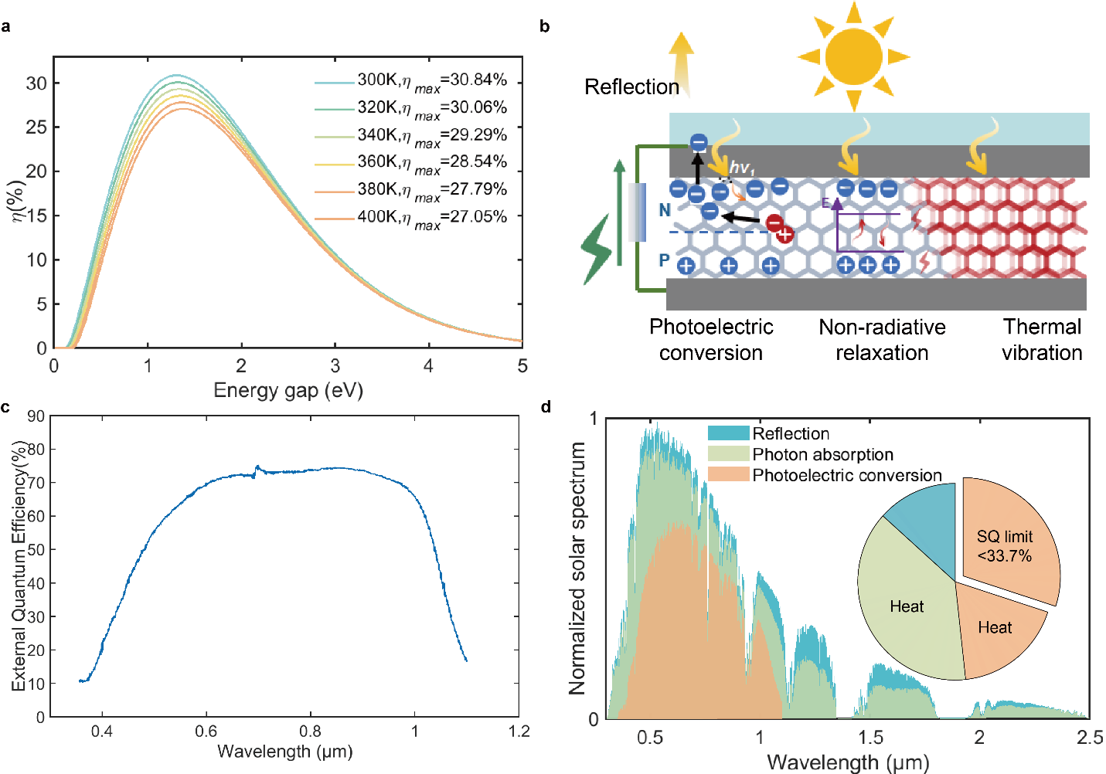

Fig. S1| Utilization and conversion of solar energy by solar cells. a, Shockley–Queisser(SQ) limit¹ for a single band-gap (p-n junction) solar cell. b, Schematic diagram of the conversion of solar energy into electrical and thermal energy. c, External quantum efficiency of a silicon solar cell². d, Spectral distribution of energy conversion in solar cells. The solar spectrum follows normalized ASTM G173 Global solar spectrum⁶.

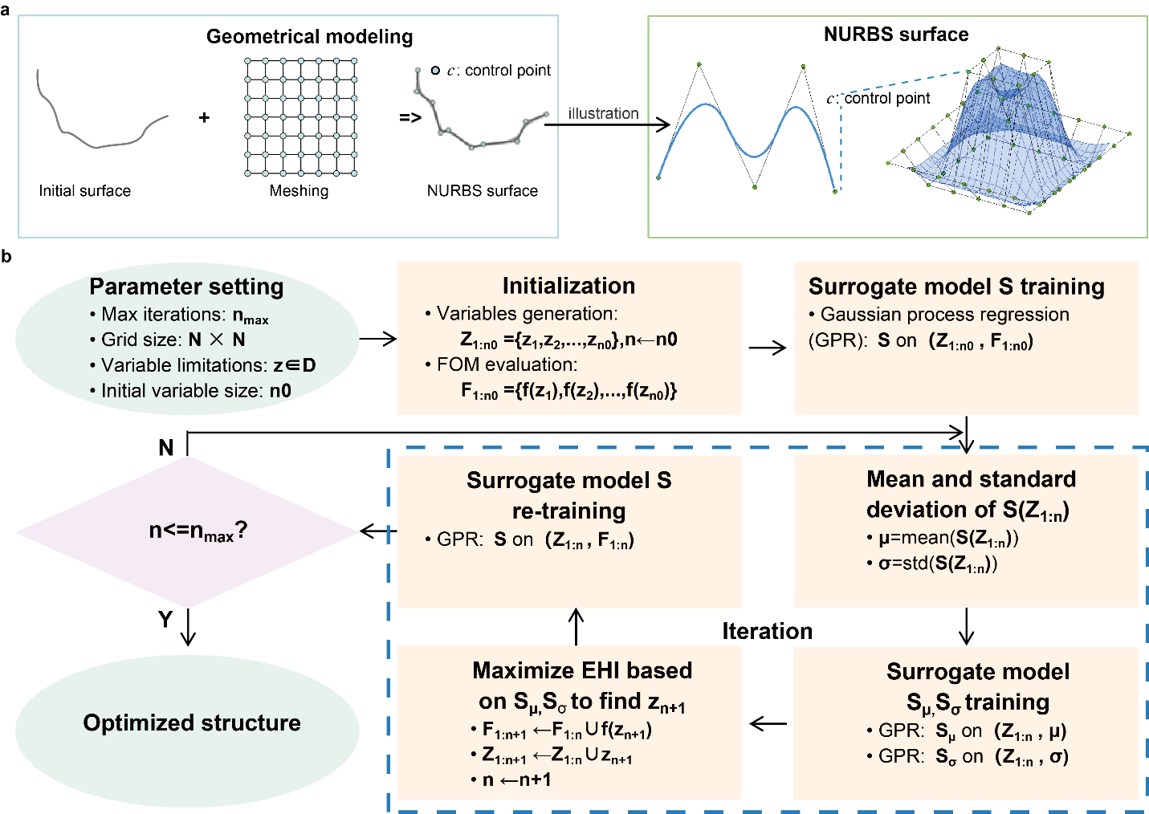

Fig. S2| Optimization of the freeform surface. a, Schematic of freeform surface construction using non-uniform rational B-splines (NURBS) ⁷. By optimizing the coordinates of control points within the mesh, an enhanced design for a thermal radiation reflector can be achieved. b, Flowchart of the robust inverse design algorithm based on Bayesian optimization process^{8,9}.
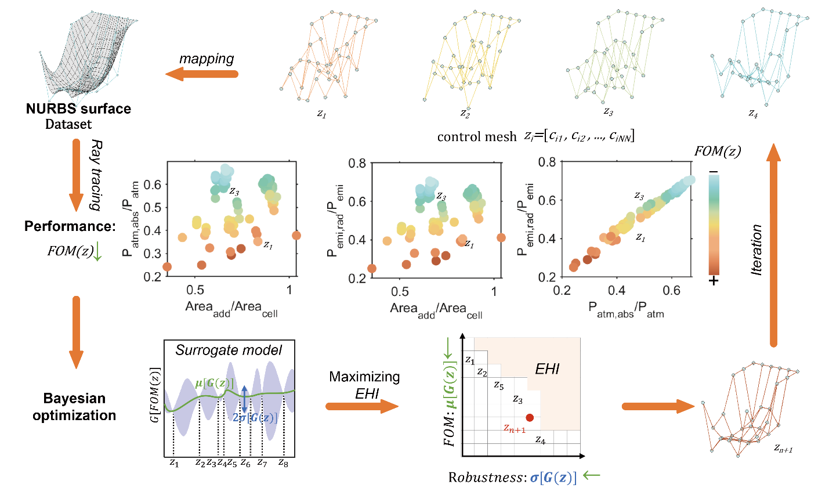

Fig. S3| Visualization of the freeform surface optimization procedure.
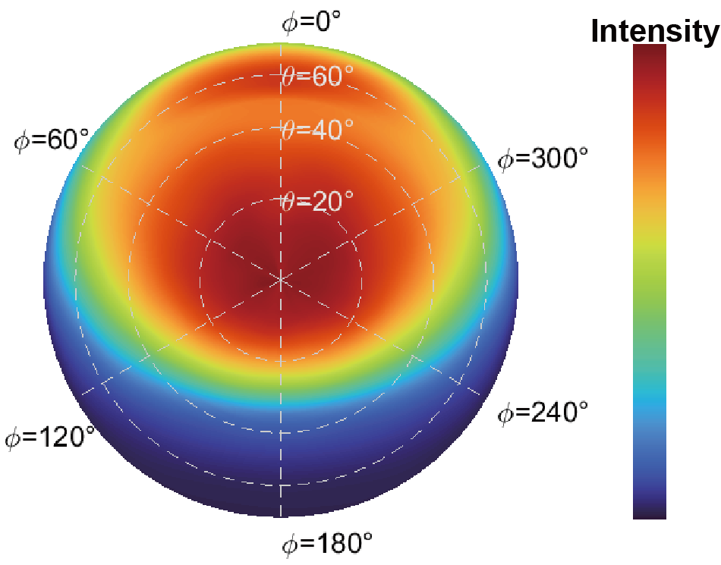

Fig. S4| Simulated far-field intensity distribution of the exit light from the BERC solar cell.

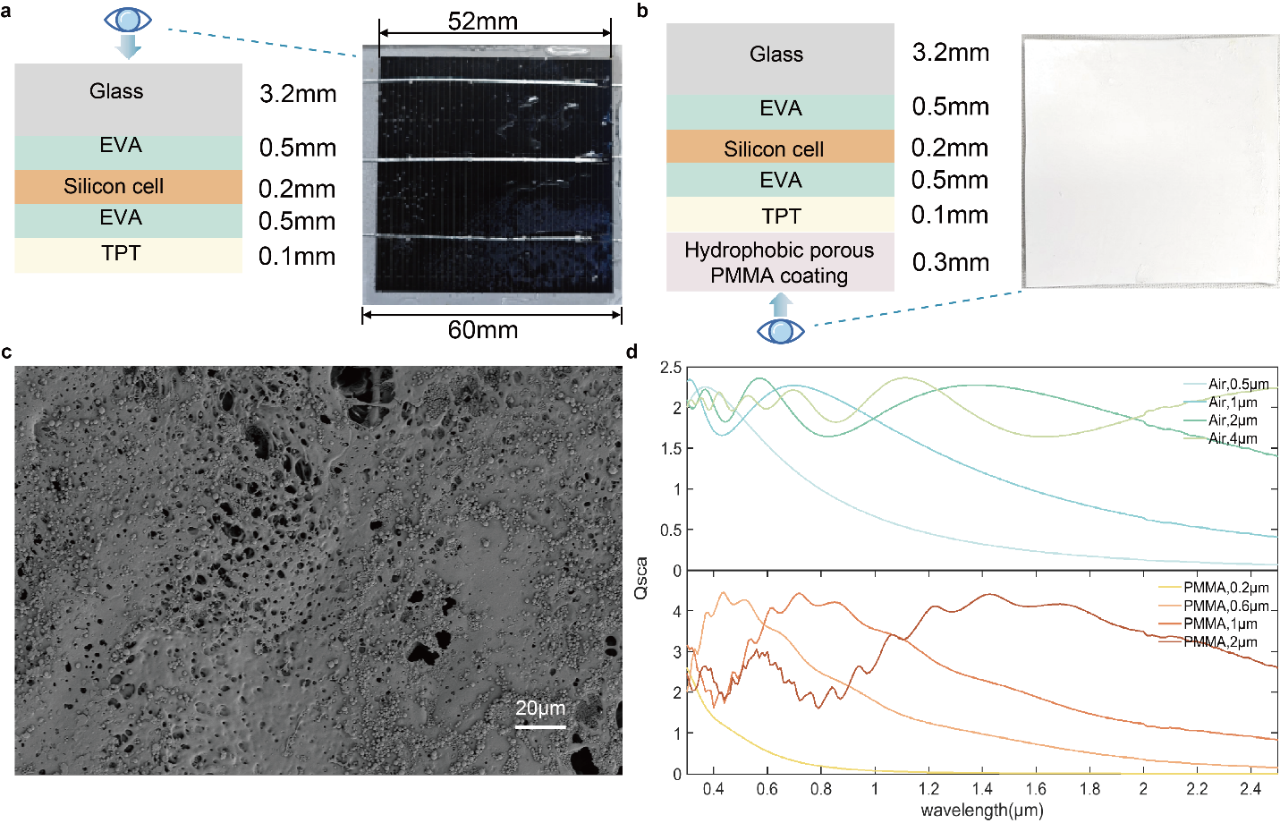

Fig. S5| Structure and optical characterization of the bottom-side enhanced radiative cooling of solar cell. a, Photograph and schematic of a commercially encapsulated solar cell. b, Photograph and schematic of a bottom-side enhanced radiative cooling of solar cell. c, SEM of the hydrophobic porous PMMA coating. d, Scattering efficiency ($Q_{sca}$) of air pores and PMMA at various scales across the solar spectrum range.

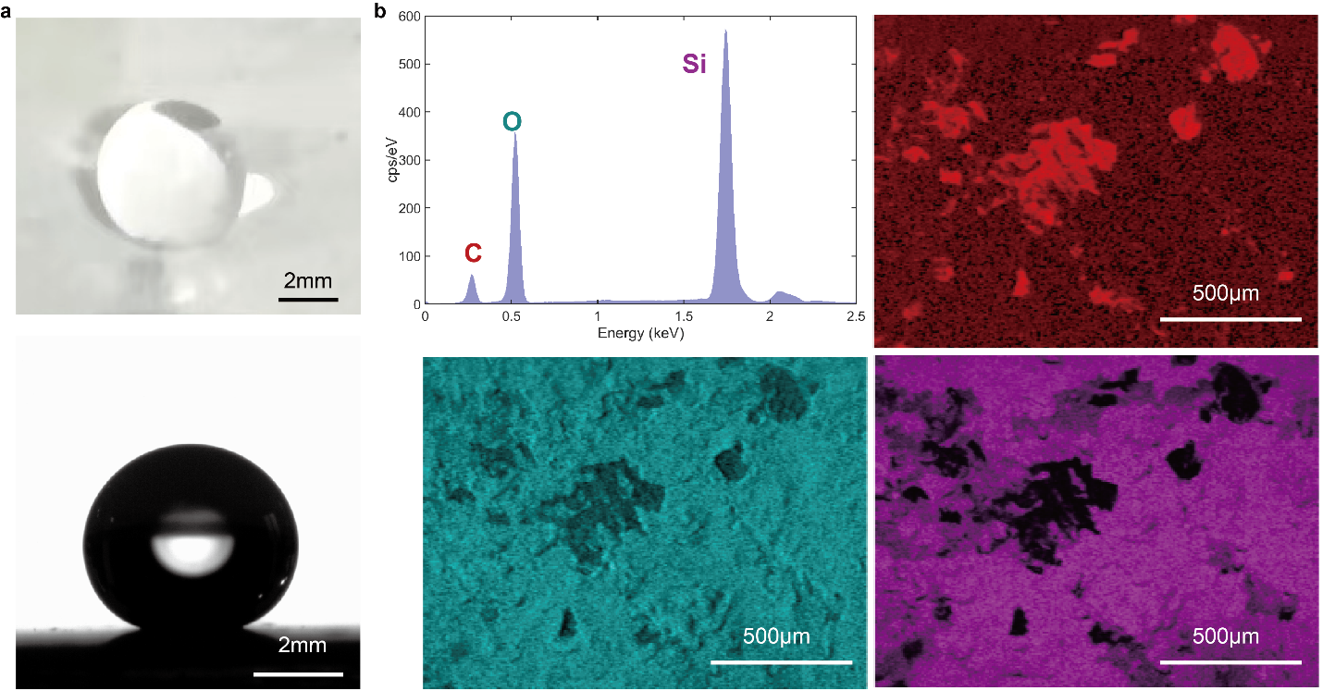

Fig. S6| Hydrophobic characterization of the BERC of solar cell. a, Optical and microscopic images of water droplets on a hydrophobic porous PMMA coating. The contact angle is approximately 152°, exhibiting superhydrophobicity. b, EDS spectrum of the hydrophobic porous PMMA coating. The elements Si and O are highly enriched.
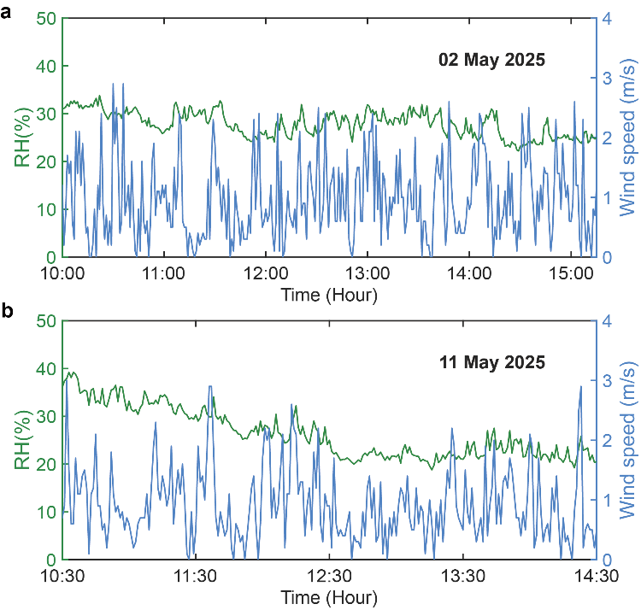

Fig. S7| Measured relative humidity and wind speed over time during outdoor testing in Hangzhou, China on a, 02 May, 2025 and b, 11 May, 2025.

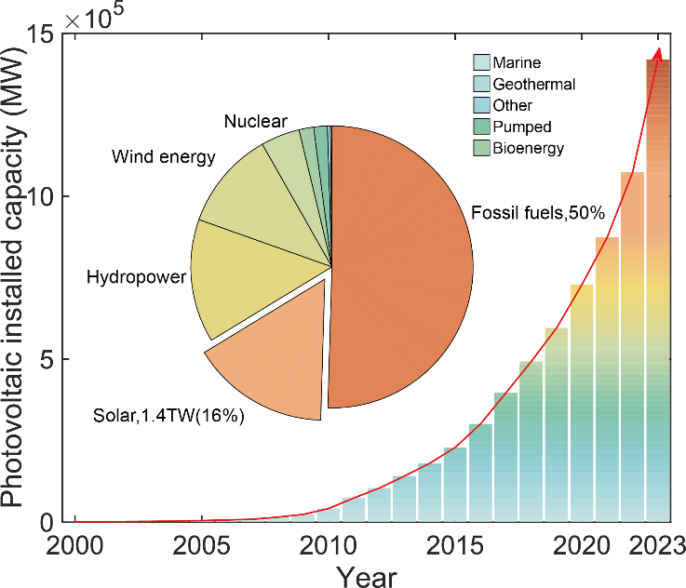

Fig. S8| Growth trend of PV and its significance in the energy mix¹⁰. The bar chart illustrates the continuous growth trend of PV installed and grid-connected capacity since the 21st century, while the pie chart shows the proportion of installed capacity by energy source in 2023, with PV accounting for 16% and ranking second only to fossil fuels as the second largest energy source.
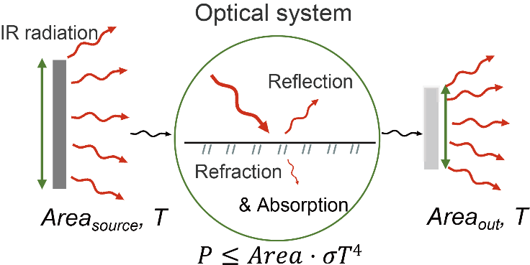

Fig. S9| Schematic of an optical system modulating blackbody radiation. Due to the brightness constancy principle, the maximum energy transmission efficiency depends on the output surface area.
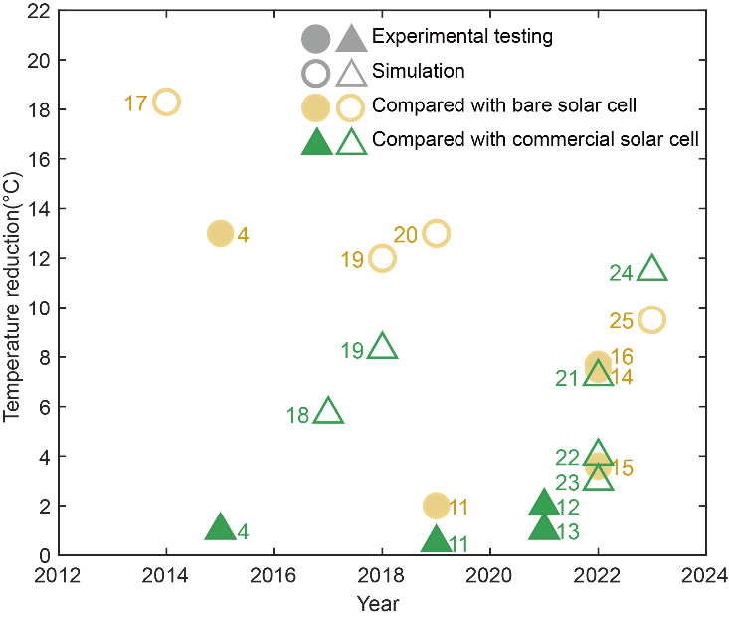

Fig. S10| Comparison of reported radiative cooling for solar cell cooling applications. Solid markers represent experimental data^{4,11–16}, while hollow markers represent simulation data^{17–25}. Yellow circles denote studies using bare Si^{11,12,14–17,19,20,25} as the reference sample, and green triangles denote those using a commercial solar cell^{4,11–13,18,19,21–24} as the reference.

Table S1| Comparison of the cooling temperatures of this work with other reported radiative cooling solar cells.
Methods | Comparison group |  |  | Type | Year
Methods | Bare silicon | Commercial encapsulation | Commercial encapsulation with natural convection | Type | Year
BERC solar cell | 19.3K(avg)  21.2K(max) | 13.1K(avg)  14.8K(max) | 5.6K(avg)  8.3K(max) | exp | This work
2D silica photonic crystal | 13K(avg) | 1K(avg) | 1.3K(avg) | exp | 2015⁴
PDMS | ~ | ~ | 1 K(avg) | exp | 2018²⁶
SiO₂ micro-grating | 2K(avg) | 0.5K(avg) | ~ | exp | 2019¹¹
Pyramid PDMS film | ~ | 2K(avg) | ~ | exp | 2021¹²
PDMS | ~ | 1 K(avg) | ~ | exp | 2021¹³
nanoporous anodic aluminum oxide | 7.5K(max) | ~ | ~ | exp | 2022¹⁴
micro-grating silica | 3.6K(avg) | ~ | ~ | exp | 2022¹⁵
silica aerogel microparticles in PDMS | 7.7K(avg) | ~ | ~ | exp | 2022¹⁶
3D crystalline silicon | 18.3K(sim) | ~ | ~ | sim | 2014¹⁷
multilayer dielectric photonic film | ~ | 5.7(sim) | ~ | sim | 2017¹⁸
1D multilayer stack and  2D photonic crystal | 12K(sim) | 8.3K(sim) | ~ | sim | 2018¹⁹
Pyramid PDMS film | 13K(sim) | ~ | ~ | sim | 2019²⁰
Submicron organic–inorganic hybrid film | ~ | 7.2K(sim) | ~ | sim | 2022²¹
Sodalime and PDMS hemisphere photonic structures | ~ | 4K(sim) | ~ | sim | 2022²²
Silica cylinder array | ~ | 3K(sim) | ~ | sim | 2022²³
Multilayer film and PDMS grating | ~ | 11.47(sim) | ~ | sim | 2023²⁴
SiO₂ particles in PDMS | 9.5K(sim) | ~ | ~ | sim | 2023²⁵
Note: (max): the maximum temperature difference; (avg): the average temperature difference; exp: experimental; sim: simulated

Table S2| Performance parameters of solar cells under different temperatures.
Temperature (℃) | V_{oc} (mV) | I_{sc} (mA) | P_{max} (mW) | FF (%) | Relative efficiency (%)
25 | 657.8465 | 901.7921 | 412.8265 | 69.5884 | 100.0000
48 | 620.6526 | 906.1639 | 386.3662 | 68.6979 | 93.5905
50 | 616.1080 | 904.9401 | 383.8720 | 68.8509 | 92.9863
52 | 612.4105 | 907.0649 | 380.4335 | 68.4854 | 92.1534
54 | 608.6978 | 908.5434 | 377.8613 | 68.3258 | 91.5303
56 | 604.7883 | 906.7301 | 374.4958 | 68.2913 | 90.7151
58 | 601.8235 | 908.9689 | 371.3085 | 67.8761 | 89.9430
60 | 597.1015 | 909.3442 | 367.8711 | 67.7515 | 89.1103
62 | 593.6928 | 908.9231 | 365.0887 | 67.6565 | 88.4364
64 | 591.6625 | 909.5121 | 361.1902 | 67.1202 | 87.4920
66 | 587.1925 | 909.3311 | 358.0397 | 67.0546 | 86.7289
68 | 583.5925 | 910.0646 | 354.6114 | 66.7684 | 85.8984
70 | 579.9695 | 909.0894 | 350.5447 | 66.4862 | 84.9133
72 | 577.1020 | 910.9936 | 347.0013 | 66.0029 | 84.0550
74 | 573.5778 | 911.3272 | 343.8464 | 65.7806 | 83.2908

Table S3| Selected geographical locations of solar power stations with capacities exceeding 500 MW
PV plants | Location | Installed capacity (MW) | Latitude | Longitude
Bhadla Solar Park | Bhadla, Rajasthan, India | 2245 | 27.0992 | 73.079
Pavagada Solar Park | Pavagada, Karnataka, India | 2050 | 14.03 | 77.324
Yanchi Solar Park | Ningxia Hui Autonomous Region, China | 2000 | 38.5747 | 106.2565
Al Dhafra PV2 Solar Power Plant | Al Dhafra, Abu Dhabi, United Arab Emirates | 2000 | 24.418 | 54.563
Jinchang Solar Park | Jinchang, Gansu Province, China | 2000 | 38.5 | 102
Wuhai Photovoltaic Leader Technology Base | Wuhai, Inner Mongolia, China | 2000 | 39.673 | 106.823
Ningxia Solar Park | Ningxia Hui Autonomous Region, China | 2000 | 38.36 | 106.28
Shanxi Yangquan National Advanced Technology Photovoltaic Power Generation Base | Yangquan, Shanxi Province, China | 2000 | 38.366 | 113.58
Gansu Longdong | Gansu Province, China | 2000 | 37.8 | 101.5
Hebei Zhangjiakou Olympic Corridor Leader Project | Zhangjiakou, Hebei Province, China | 2000 | 40.81 | 114.88
Tengger Desert Solar Park | Zhongwei, Ningxia, China | 1547 | 37.6128 | 105.1441
Benban Solar Park | Benban, Aswan Governorate, Egypt | 1650 | 23.75 | 32.75
Noor Abu Dhabi Solar Plant | Sweihan, Abu Dhabi, United Arab Emirates | 1177 | 24.246 | 54.6743
Mohammed bin Rashid Al Maktoum Solar Park | Sweihan, Abu Dhabi, United Arab Emirates | 1013 | 25.0797 | 55.3006
Xinyi Solar Energy | Xinyi, Jiangsu Province, China | 1000 | 34.116 | 118.481
Hainan Solar Park | Hainan, China | 1000 | 20.17 | 110.32
Datong Solar Power Top Runner Base | Datong, Shanxi, China | 1000 | 40.0972 | 113.2853
Kurnool Ultra Mega Solar Park | Kurnool, Andhra Pradesh, India | 1000 | 15.756 | 78.1266
Tantou Solar Park | Linyi, Shandong, China | 1000 | 35.0703 | 118.3572
Ananthapuram Solar Power Plant | Anantapur, Andhra Pradesh | 1000 | 14.684 | 77.639
Gujarat Solar Park (Palanpur) | Palanpur, Gujarat, India | 1000 | 24.0865 | 72.5264
Longyangxia Dam Solar Park | Qinghai, China | 850 | 36.5 | 98.3833
Villanueva Solar Power Plant | Villanueva, Misamis Oriental, Mindanao, Philippines | 828 | 8.436 | 124.721
Copper Mountain Solar Facility | Boulder City, Nevada, USA | 802 | 35.469 | -113.464
Muga Muga Solar Park | Sidi Harazem, Fès-Meknès, Morocco | 800 | 33.2294 | -5.6725
San Gonzalo Solar Power Project | Northern Mexico | 765 | 28 | -111
Escatrón-Chiprana-Samper Solar Power Complex | Zaragoza, Aragon, Spain | 730 | 41.167 | -0.35
Jaisalmer Solar Park | Jaisalmer, Rajasthan, India | 700 | 26.9196 | 70.9221
Tamarugal Solar Plant | Antofagasta Region, Chile | 700 | -23.85 | -69.42
Kamuthi Solar Power Plant | Kamuthi, Ramanathapuram District, Tamil Nadu, India | 648 | 9.301 | 78.169
Tucumán Solar Park | Tucumán, Argentina | 600 | -26.8242 | -65.2225
Solar Star Solar Power Project | San Bernardino County and Los Angeles County, California, USA | 579 | 34.9 | -116.5
Topaz Solar Farm | California, USA | 550 | 35.35 | -120.4
Shajiao C Solar Park | Guangdong Province, China | 500 | 22.7053 | 113.3082
Ceará Solar Park | Crateús, Ceará, Brazil | 500 | -5.0733 | -40.5564
Bokpoort Solar Park | Northern Cape, South Africa | 500 | -28.364 | 20.922
Note: Data collected online, as of October 2024.

Table S4| Material costs.
Material | Prices  ($/kg) | Density(g/cm³) | Process (Precision) | Thickness  (mm) | Typical price details ($/m²)
PLA (Fuzhong Plastic) | 2.455 | 1.31 | FDM (0.1mm) | 2 | Materials:  15% loss:  Other: | 6.43  0.965  0.3
 |  |  |  |  | Total: | 7.7
PETG (Jiangyin Huahong) | 1.31 | 1.28 | FDM (0.1mm) | 2 | Materials:  15% loss:  Other: | 3.35  0.503  0.3
 |  |  |  |  | Total: | 4.15
ABS (CHIMEI) | 1.62 | 1.05 | FDM (0.1mm) | 2 | Materials:  15% loss:  Other: | 3.40  0.51  0.3
 |  |  |  |  | Total: | 4.21
ASA (LG) | 2.138 | 1.08 | FDM (0.1mm) | 2 | Materials:  15% loss:  Other: | 6.62  0.993  0.3
 |  |  |  |  | Total: | 7.913
Photosensitive Resin  (Anycubic)` | 12.14 | 1.13 | SLA (0.05mm) | 2 | Materials:  15% loss:  Other: | 27.43  4.115  0.3
 |  |  |  |  | Total: | 31.84
ABS-Like Photosensitive Resin  (ELEGOO) | 14.865 | 1.13 | SLA (0.05mm) | 2 | Materials:  15% loss:  Other: | 33.59  5.039  0.3
 |  |  |  |  | Total | 38.93
Ag plating  (Beichen) |  | 10.49 | Plating | 0.01 | Plating solution  Pre/post processing  Other | 178  3.5  2.2
 |  |  |  |  | Total (two-side) | 367.4
Ni plating (Beichen) |  | 8.902 | Plating | 0.01 | Plating solution  Pre/post processing  Other | 6.47  3.5  2.2
 |  |  |  |  | Total (two-side) | 24.34
Cr plating  (BIGELY) |  | 7.19 | Plating | 0.01 | Plating solution  Pre/post processing  Other | 5.46  3.5  2.2
 |  |  |  |  | Total (two-side) | 22.32
A00 aluminum ingot | 2.885 | 2.7103 | Casting | 0.5 | Materials:  15% loss:  Other: | 3.91  0.586  0.3
 |  |  |  |  | Total: | 4.796
3003 aluminum sheet | 3.288 | 2.73 | Stamping | 0.5 | Materials:  15% loss:  Other: | 4.488  0.673  0.3
 |  |  |  |  | Total: | 5.461

Table S5| Electricity tariff in ten cities (in U.S. dollar)²⁷.
City | Electricity tariff ($/kWh)
Hotan | 0.07
Turpan | 0.064
Kunming | 0.069
Beijing | 0.079
Lanzhou | 0.083
Shanghai | 0.099
Changsha | 0.095
Chongqing | 0.084
Wuhan | 0.09
Hong Kong | 0.16

Table S6| BERC economic benefit calculation. (PETG 1mm+Al 0.5mm, 7$/m²)
1MW generation (kWh/year) | Electricity tariff ($/kWh) | Relative efficiency gain | Additional revenue ($/year) | PV panel area (1.7 × 1m², 350 W) | $$\frac{Area_{BERC}}{Area_{panel}}$$ | BERCcost | Cost recovery period (year)
~1000000 | ~0.1 | 6.33% | 6330 | 4867m² | 1.837 | 62585$ | 9.9

Reference
1. Zanatta, A. R. The Shockley–Queisser limit and the conversion efficiency of silicon-based solar cells. Results in Optics 9, 100320 (2022).
2. Ananda, W. External quantum efficiency measurement of solar cell. in 2017 15th International Conference on Quality in Research (QiR) : International Symposium on Electrical and Computer Engineering 450–456 (2017).
3. Jaffer, A. Natural Convection Heat Transfer from an Isothermal Plate. Thermo 3, 148–175 (2023).
4. Zhu, L., Raman, A. P. & Fan, S. Radiative cooling of solar absorbers using a visibly transparent photonic crystal thermal blackbody. Proceedings of the National Academy of Sciences 112, 12282–12287 (2015).
5. Zhao, D. et al. Radiative sky cooling: Fundamental principles, materials, and applications. Applied Physics Reviews 6, 021306 (2019).
6. Gueymard, C. A., Myers, D. & Emery, K. Proposed reference irradiance spectra for solar energy systems testing. Solar Energy 73, 443–467 (2002).
7. Zhuang, Z., Surman, P. & Yu, F. A freeform optics design with limited data for extended LED light sources. Journal of Modern Optics 63, 2151–2158 (2016).
8. Garnett, R. Bayesian Optimization. (Cambridge University Press, 2023).
9. Daulton, S., Eriksson, D., Balandat, M. & Bakshy, E. Multi-objective Bayesian optimization over high-dimensional search spaces. in 38th Conference on Uncertainty in Artificial Intelligence (eds. Cussens, J. & Zhang, K.) vol. 180 507–517 (PMLR, 2022).
10. Dhabi, A. Renewable Capacity Statistics 2024. (International Renewable Energy Agency, 2024).
11. Long, L., Yang, Y. & Wang, L. Simultaneously enhanced solar absorption and radiative cooling with thin silica micro-grating coatings for silicon solar cells. Solar Energy Materials and Solar Cells 197, 19–24 (2019).
12. Wang, K. et al. Radiative cooling of commercial silicon solar cells using a pyramid-textured PDMS film. Solar Energy 225, 245–251 (2021).
13. Li, Z., Ahmed, S. & Ma, T. Investigating the Effect of Radiative Cooling on the Operating Temperature of Photovoltaic Modules. Solar RRL 5, 2000735 (2021).
14. Tang, H. et al. Radiative cooling of solar cells with scalable and high-performance nanoporous anodic aluminum oxide. Solar Energy Materials and Solar Cells 235, 111498 (2022).
15. Zhao, B. et al. Radiative cooling of solar cells with micro-grating photonic cooler. Renewable Energy 191, 662–668 (2022).
16. Lee, K. W. et al. Visibly clear radiative cooling metamaterials for enhanced thermal management in solar cells and windows. Advanced Functional Materials 32, 2105882 (2022).
17. Zhu, L., Raman, A., Wang, K. X., Anoma, M. A. & Fan, S. Radiative cooling of solar cells. Optica 1, 32–38 (2014).
18. Li, W., Shi, Y., Chen, K., Zhu, L. & Fan, S. A Comprehensive Photonic Approach for Solar Cell Cooling. ACS Photonics 4, 774–782 (2017).
19. Zhao, B., Hu, M., Ao, X., Xuan, Q. & Pei, G. Comprehensive photonic approach for diurnal photovoltaic and nocturnal radiative cooling. Solar Energy Materials and Solar Cells 178, 266–272 (2018).
20. Lee, E. & Luo, T. Black body-like radiative cooling for flexible thin-film solar cells. Solar Energy Materials and Solar Cells 194, 222–228 (2019).
21. Perrakis, G. et al. Submicron Organic–Inorganic Hybrid Radiative Cooling Coatings for Stable, Ultrathin, and Lightweight Solar Cells. ACS Photonics 9, 1327–1337 (2022).
22. Silva-Oelker, G. & Jaramillo-Fernandez, J. Numerical study of sodalime and PDMS hemisphere photonic structures for radiative cooling of silicon solar cells. Optics Express 30, 32965–32977 (2022).
23. Akerboom, E., Veeken, T., Hecker, C., Van De Groep, J. & Polman, A. Passive radiative cooling of silicon solar modules with photonic silica microcylinders. ACS Photonics 9, 3831–3840 (2022).
24. Zhan, Y., Yin, H., Wang, J. & Fan, C. Enhanced performance of diurnal radiative cooling for solar cells based on a grating-textured PDMS photonic structure. Materials Today Communications 35, 106117 (2023).
25. Tu, Y. et al. Antireflection and radiative cooling difunctional coating design for silicon solar cells. Optics Express 31, 22296–22307 (2023).
26. Zhao, B., Hu, M., Ao, X. & Pei, G. Performance analysis of enhanced radiative cooling of solar cells based on a commercial silicon photovoltaic module. Solar Energy 176, 248–255 (2018).
27. Chen, J., Lu, L., Gong, Q., Lau, W. Y. & Cheung, K. H. Techno-economic and environmental performance assessment of radiative sky cooling-based super-cool roof applications in China. Energy Conversion and Management 245, 114621 (2021).

