Supplementary Materials for

Lymph node tissue homeostasis and adaptation to immune challenge resolved by fibroblast network mechanics
Harry L. Horsnell¹, Robert J. Tetley², Henry De Belly³, Spyridon Makris¹, Lindsey J. Millward¹, Agnesska C. Benjamin¹, Ewa K. Paluch³, Yanlan Mao^{2,4}, Sophie E. Acton^{1#}

Correspondence to: s.acton@ucl.ac.uk

This file includes:

Figs. S1 to S5
Tables S1
References (1 to 14)
Captions for Movies S1 to S4

Figs. S1 to S5
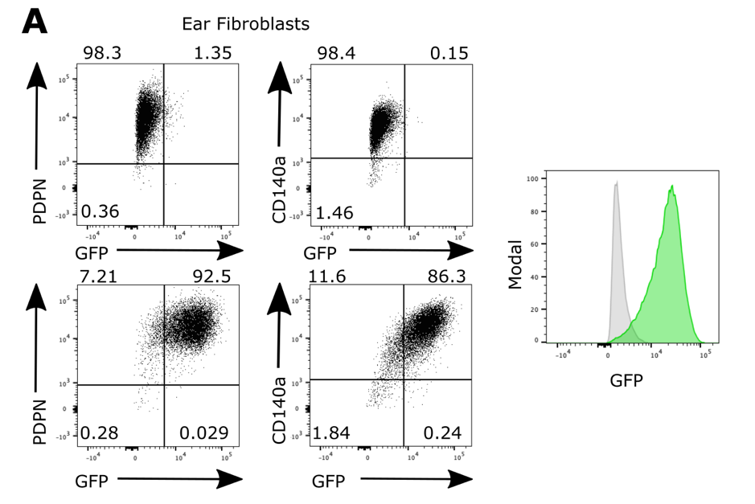

Fig. S1 - Flow cytometry of PDGFR$α$-mGFP fibroblasts

A) Flow cytometry panel of PDPN⁺ and CD140$α$⁺ skin fibroblasts expressing GFP. Top two panels show GFP- control fibroblasts. Bottom two panels show PDPN+, GFP+ and CD140a+ GFP+ fibroblasts. Right panel shows control fibroblasts (grey) to PDGFR$α$-mGFP fibroblasts (green).
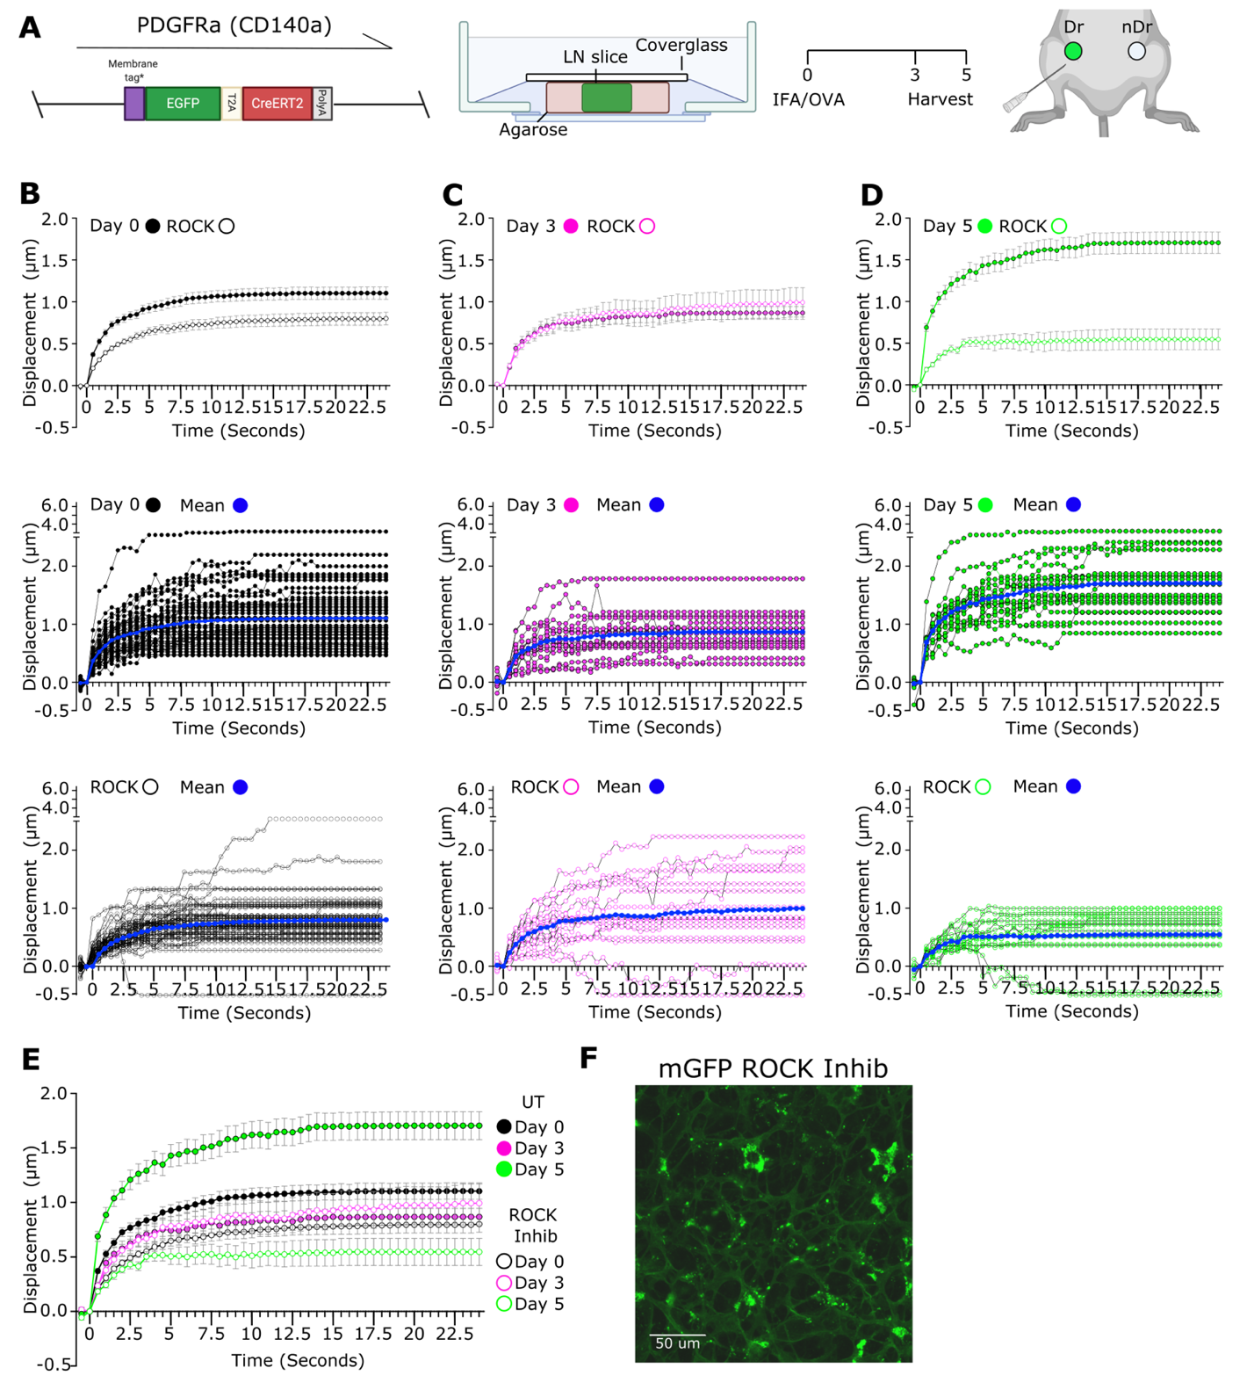
Fig. S2 – Y27 treatment of lymph node slices reduce tension in the FRC network

A) Schematic of immunisation and animal models. A membrane targeted GFP molecule is driven under the (PDGFR$α$) promoter (left). LN nodes were embedded in low melt agarose and sliced at 200$μ$m thickness before being secured by cover glass for imaging (middle). IFA/OVA is used as model immunisation with inguinal draining (dr) and non-draining (nDr) lymph nodes (LN’s) harvested day 3 or day 5 post immunisation (right). B-D) Recoil curves show displacement over time (mean ±SEM) (top panel). Individual recoil curves of control (middle) and Y27 treated LNs (bottom). N>5 animals per condition. E) Recoil curves show displacement over time (mean ±SEM), comparing untreated and Y27 treated LNs. Blue shading indicates initial recoil phase. N>5 animals per condition. F) Membrane GFP visualises the FRC network in the ex vivo lymph node slice. Y27 treatment has no effect on the FRC network connectivity. Scale bar 50$μ$m.
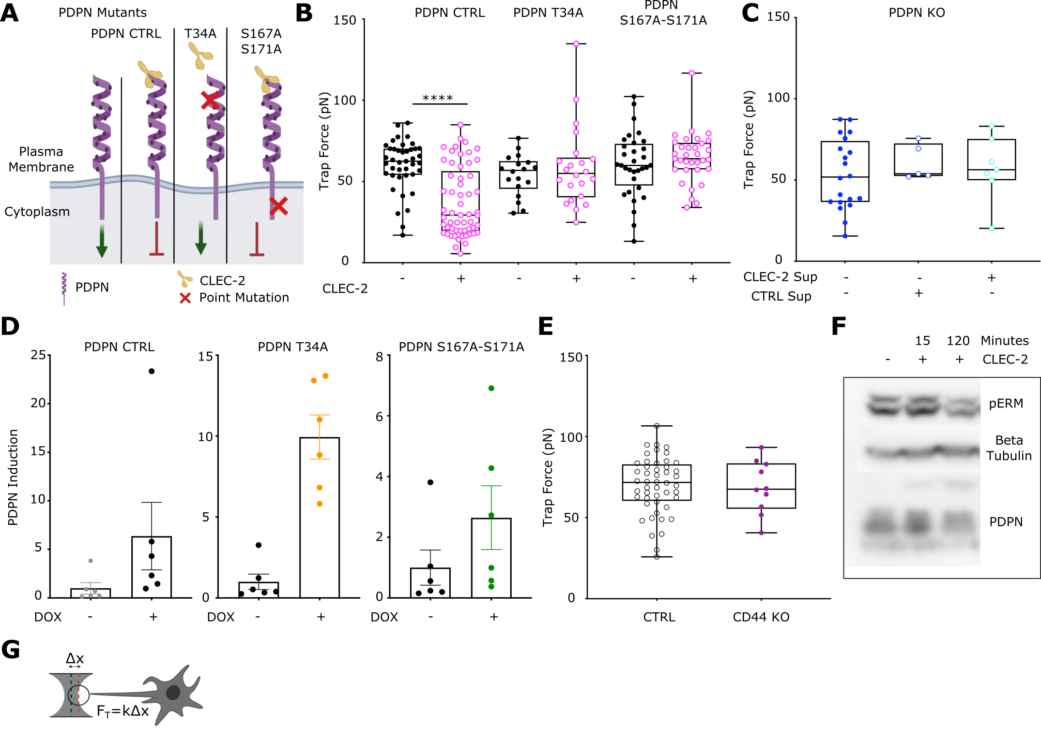
Fig. S3 - Induction of PDPN mutants in PDPN KO fibroblastic reticular cell line

A) Schema of exogenous PDPN mutants and interaction with CLEC2. Green arrow denotes active signalling by PDPN leading to actomyosin contractility, red arrow indicates inhibition of PDPN signalling and reduction in actomyosin contractility. B) Trap force measurements of FRCs expressing PDPN mutants after pre-treatment of CLEC2. Box plots indicates median and interquartile range. Two-way ANOVA with Tukeys multiple comparisons, p<0.001. N>18. C) Trap force measurements of PDPN CRISPR KO FRCs treated with CTRL or CLEC2 supernatant. One-way ANOVA with Tukeys multiple comparisons. N>5. D) Fold induction of exogenous PDPN, based on PDPN staining geometric mean, for each PDPN mutant cell line treated with or without doxycycline. PDPN CTRL (left), PDPN T34A (middle) and PDPN DSS (right). N=6. E) Trap force measurements of CTRL and CD44 (purple) KO FRCs. Mann-Whitney test, p<0.001. Each point represents one cell. N>10. F) Representative western blot of pERM in CTRL FRCs after treatment with CLEC2. G) Schema and equation to calculate trap force (F_{t}) from displacement.

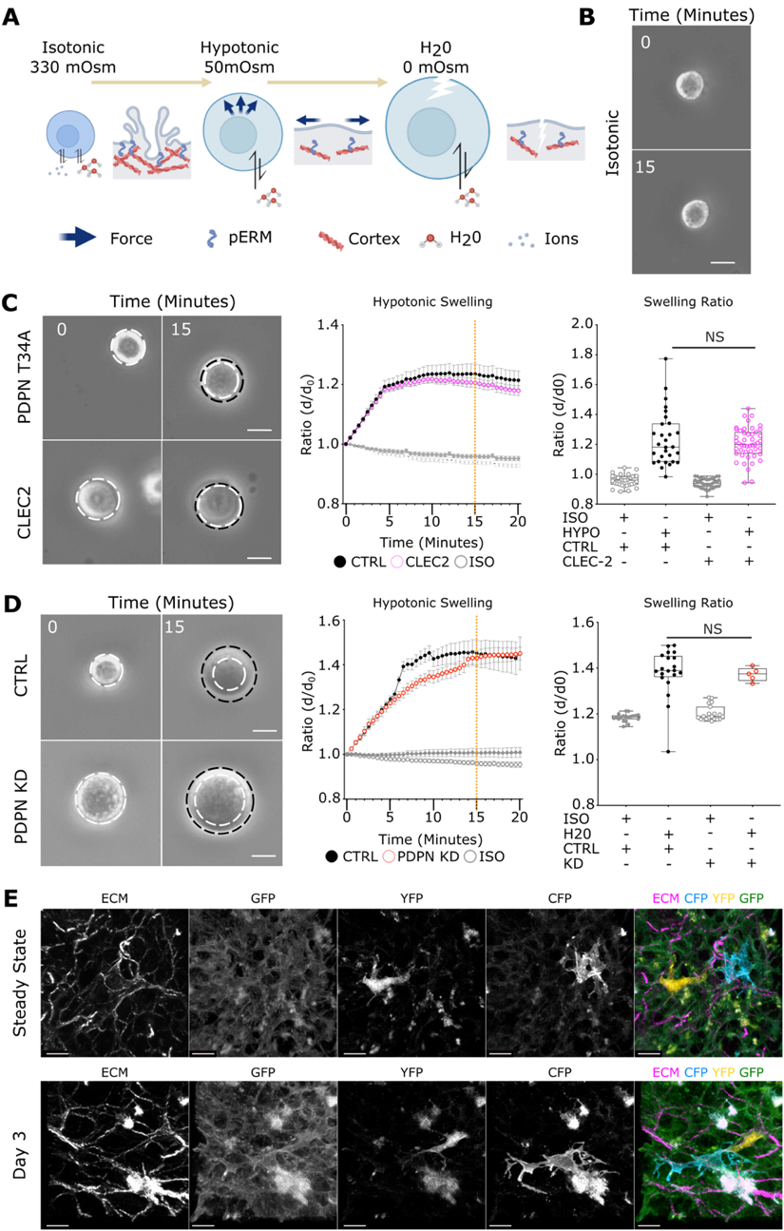
Fig. S4 - Membrane access of fibroblastic reticular cells is increased through the CLEC2/PDPN signalling axis

A) Schematic of osmotic shock experiment, inducing swelling by altering osmolarity. B) Representative stills of FRC in isotonic control media. Scale bar 25$μ$m. C) Time course of PDPN T34A FRCs with or without CLEC2 treatment in hypotonic conditions. Stills (top) show swelling of cells in hypotonic media. White dotted circle marks initial size before swelling and is compared to swelling at t=20 (black dotted circle). Scale bar 25$μ$m. Change in diameter ratio over time (bottom left, mean ±SEM). Swelling ratio comparisons between control and CLEC2 treatment at 15 minutes post swelling (orange dotted line, bottom right). Box plots indicates median and interquartile range. One-way ANOVA with Tukeys multiple comparisons. N>29. D) Time course of PDPN CTRL vs PDPN shRNA KD FRCs in extreme hypotonic conditions (H₂0). Stills (top) show swelling of cells in hypotonic media. White dotted circle marks initial size before swelling and is compared to swelling at t=20 (black dotted circle). Scale bar 25$μ$m. Change in diameter ratio over time (bottom left, mean ±SEM). Swelling ratio between control and PDPN shRNA KD FRCs at 15 minutes post swelling (orange dotted line, bottom right). Box plots indicates median and interquartile range. One-way ANOVA with Tukeys multiple comparisons. N>16. E) Single channel stills of PDGFR$α$-mGFP confetti FRC network in the steady state and day 3 post immunisation. Scale bar 10$μ$m.
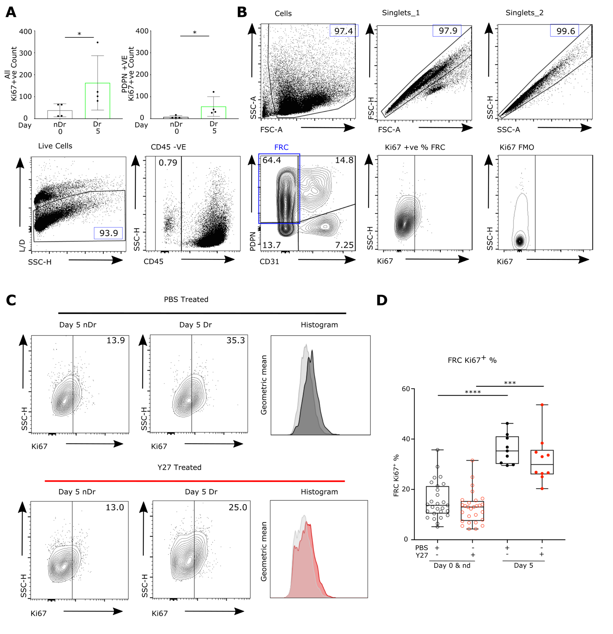
Fig. S5 - Flow cytometry gating strategy and Ki67 measurements

A) Quantification of Ki67⁺ cells (top) and PDPN⁺ Ki67⁺ cells (bottom) per LN region. Box plots indicates median and interquartile range. Mann-Whitney test, p<0.05. N=2. B) Schema of flow cytometry gating strategy for measurement of stromal cell populations. C) Example of Ki67⁺ FRCs cell plots and histogram of Ki67 geometric mean, comparing immunisation and Y27 treatments. D) Quantification of Ki67⁺ FRCs. Box plots indicates median and interquartile range. Two-way ANOVA with Tukey’s multiple comparisons. ****p<0.0001, ***p<0.001. N>9 animals per condition

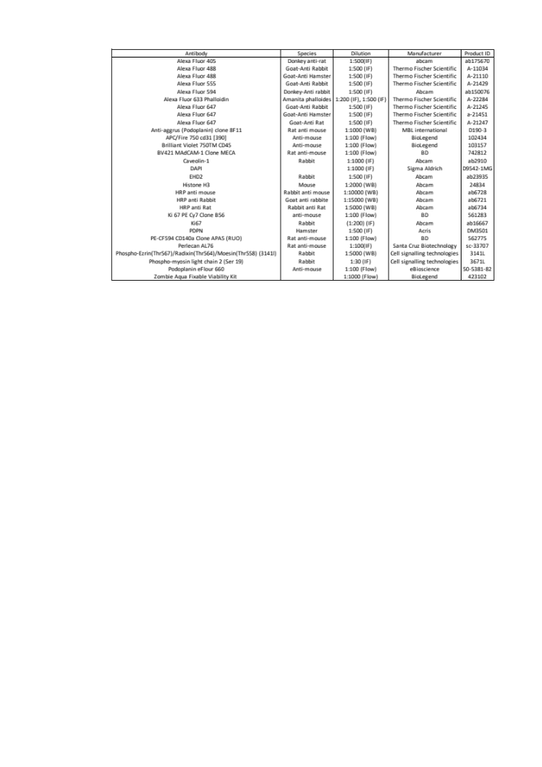
Tables S1
Table S1 – Antibody reagents and dilutions
References

1. Liu, Z. et al. Systematic comparison of 2A peptides for cloning multi-genes in a polycistronic vector. Sci. Rep. 7, (2017).
2. Snippert, H. J. et al. Intestinal crypt homeostasis results from neutral competition between symmetrically dividing Lgr5 stem cells. Cell 143, 134–144 (2010).
3. Bajénoff, M. et al. Stromal Cell Networks Regulate Lymphocyte Entry, Migration, and Territoriality in Lymph Nodes. Immunity 25, 989–1001 (2006).
4. Bozdag, E. Intravital Imaging of Dynamic Bone and Immune Systems. Ethics and Information Technology vol. 1763 (2018).
5. Groff, B. D., Kinman, A. W. L., Woodroof, J. F. & Pompano, R. R. Immunofluorescence staining of live lymph node tissue slices. J. Immunol. Methods 464, 119–125 (2019).
6. Belanger, M. C. et al. Acute lymph node slices are a functional model system to study immunity ex vivo. doi:10.1101/865543.
7. Mao, Y. et al. Differential proliferation rates generate patterns of mechanical tension that orient tissue growth. EMBO J. 32, 2790–2803 (2013).
8. Duda, M. et al. Polarization of Myosin II Refines Tissue Material Properties to Buffer Mechanical Stress. Dev. Cell 48, 245-260.e7 (2019).
9. Fletcher, A. L. et al. Reproducible isolation of lymph node stromal cells reveals site-dependent differences in fibroblastic reticular cells. Front. Immunol. 2, (2011).
10. Acton, S. E. et al. Dendritic cells control fibroblastic reticular network tension and lymph node expansion. Nature 514, 498–502 (2014).
11. De Winde, C. M. et al. Fibroblastic Reticular Cell Response to Dendritic Cells Requires Coordinated Activity of Podoplanin, CD44 and CD9. doi:10.1101/793141.
12. Diz-Muñoz, A. et al. Membrane Tension Acts Through PLD2 and mTORC2 to Limit Actin Network Assembly During Neutrophil Migration. PLoS Biol. 14, (2016).
13. De Belly, H. et al. Membrane Tension Gates ERK-Mediated Regulation of Pluripotent Cell Fate. Cell Stem Cell 28, 273-284.e6 (2021).
14. Compan, V. et al. Cell Volume Regulation Modulates NLRP3 Inflammasome Activation. Immunity 37, 487–500 (2012).

Movies S1 to S4

S1A – The paracortical T-cell FRC network, showing 3D localisation of actomyosin structures in homeostasis.

Staining of the conduit (perlecan, magenta), FRC network (PDPN, yellow), F-actin (phalloidin, cyan) and pMLC (red). PDPN and perlecan surface renders show the location of actomyosin in relation to these structures.

S1B – Laser ablation of homeostatic FRC network.

Movies captured over 25 seconds. Yellow line marks site of cut one second after imaging began.

S2A – Laser ablation of FRC network day 3 post immunisations.

Movies captured over 25 seconds. Yellow line marks site of cut one second after imaging began.

S2B – Laser ablation of FRC network day 5 post immunisations.

Movies captured over 25 seconds. Yellow line marks site of cut one second after imaging began.

S2C – The paracortical T-cell FRC network, showing 3D localisation of actomyosin structures day 3 post immunisations.

Staining of the conduit (perlecan, magenta), FRC network (PDPN, yellow), F-actin (phalloidin, cyan) and pMLC (red). PDPN and perlecan surface renders show the location of actomyosin in relation to these structures.

S2D – The paracortical T-cell FRC network, showing 3D localisation of actomyosin structures day 5 post immunisation.

Staining of the conduit (perlecan, magenta), FRC network (PDPN, yellow), F-actin (phalloidin, cyan) and pMLC (red). PDPN and perlecan surface renders show the location of actomyosin in relation to these structures.

S3A – Optical tweezers generate membrane tethers used to determine membrane tension

S4A – Osmotic swelling of PDPN CTRL fibroblastic reticular cells
PDPN CTRL + CLEC2 (left), PDPN CTRL – CLEC2 (middle), PDPN CTRL ISO control (right). Captured over 60 minutes with one frame every 30 seconds.

S4B – Osmotic swelling of PDPN CTRL fibroblastic reticular cells
B) PDPN T34A + CLEC2 (left), PDPN T34A – CLEC2 (middle), PDPN T34A ISO control (right). Captured over 60 minutes with one frame every 30 seconds.

S4C – Osmotic swelling of PDPN CTRL fibroblastic reticular cells
C) CTRL + HYPO (left), PDPN KD + HYPO (middle), CTRL ISO control (right). Captured over 60 minutes with one frame every 30 seconds.

S4D – Osmotic swelling of PDPN CTRL fibroblastic reticular cells
D) CTRL + H₂0 (left), PDPN KD + H₂0 (right). Captured over 60 minutes with one frame every 30 seconds.

