Supplementary Information

Table S1
Polynomial regression coefficients for all models
 | Model | CE | EE | CE² | CE × EE | EE²
Study 1 | EDE-Q | –0.06 [–0.23, 0.11] | 0.41 [0.23, 0.59] *** | 0.10 [–0.04, 0.23] | 0.03 [–0.15, 0.22] | 0.05 [–0.06, 0.16]
Study 1 | EDE-Q with covariates | –0.08 [–0.23, 0.07] | 0.22 [0.05, 0.39] ** | 0.03 [–0.09, 0.15] | 0.01 [–0.16, 0.17] | 0.02 [–0.08, 0.12]
Study 1 | CES-D | 0.09 [–0.31, 0.50] | 0.84 [0.41, 1.28] *** | 0.39 [0.06, 0.71] * | 0.04 [–0.41, 0.48] | 0.15 [–0.11, 0.41]
Study 1 | GAD-7 | 0.08 [–0.54, 0.69] | 1.93 [1.27, 2.59] *** | 0.39 [–0.10, 0.88] | 0.56 [–0.12, 1.23] | 0.25 [–0.15, 0.64]
Study 2 | Eating disorder diagnosis† | 0.83 [0.73, 0.95]** | 1.21 [1.07, 1.37]** | 0.99 [0.88, 1.10] | 0.99 [0.86, 1.13] | 1.08 [1.00, 1.18]
Study 2 | EDE-Q | –0.07 [–0.19, 0.04] | 0.20 [0.08, 0.32] ** | 0.03 [–0.07, 0.12] | 0.07 [–0.06, 0.20] | 0.001 [–0.09, 0.09]
Study 2 | EDE-Q with ERS | –0.00 [–0.11, 0.11] | –0.06 [–0.18, 0.06] | 0.00 [–0.09, 0.09] | 0.06 [–0.06, 0.18] | –0.02 [–0.10, 0.07]
Study 2 | ERS | –2.42 [–4.03, –0.82] ** | 9.15 [7.52, 10.79] *** | 0.79 [–0.51, 2.09] | 0.50 [–1.26, 2.25] | 0.57 [–0.63, 1.76]
Note. * p < 0.05, ** p < 0.01, *** p < 0.001; † reported in OR

Figure S1
Polynomial response surface predicting emotional reactivity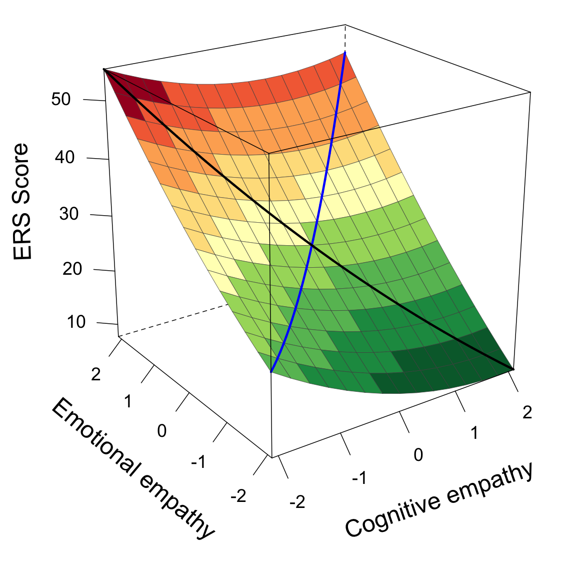
Note. The black line represents empathic disequilibrium, with movement toward the left corner indicating emotional empathy dominance and movement toward the right corner indicating cognitive empathy dominance. The blue line represents overall empathy, with movement along this line reflecting increasing levels of combined emotional and cognitive empathy. Emotional reactivity is colour-coded for interpretability.

Figure S2
Sensitivity analysis plot for the indirect effect by autoregressive and cross-lagged correlations
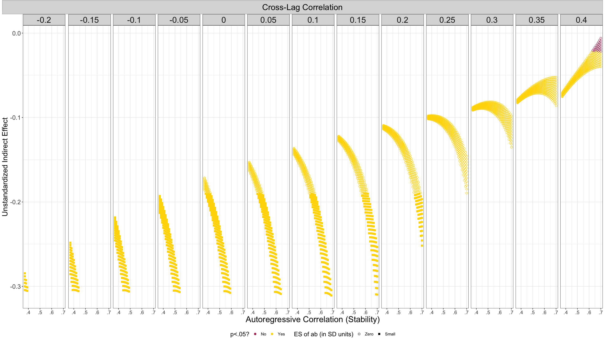
Note. Sensitivity analysis for the indirect effect from a cross-sectional mediation model, based on the approach of Georgeson et al. (2023). Indirect effect estimates (vertical axis) are shown across a grid of possible autoregressive correlations (horizontal axis) and cross-lag correlations (facets) reflecting hypothesised longitudinal stability and temporal associations. Each point represents the indirect effect computed under a given parameter combination; yellow indicates p < 0.05 and purple indicates p > 0.05.

