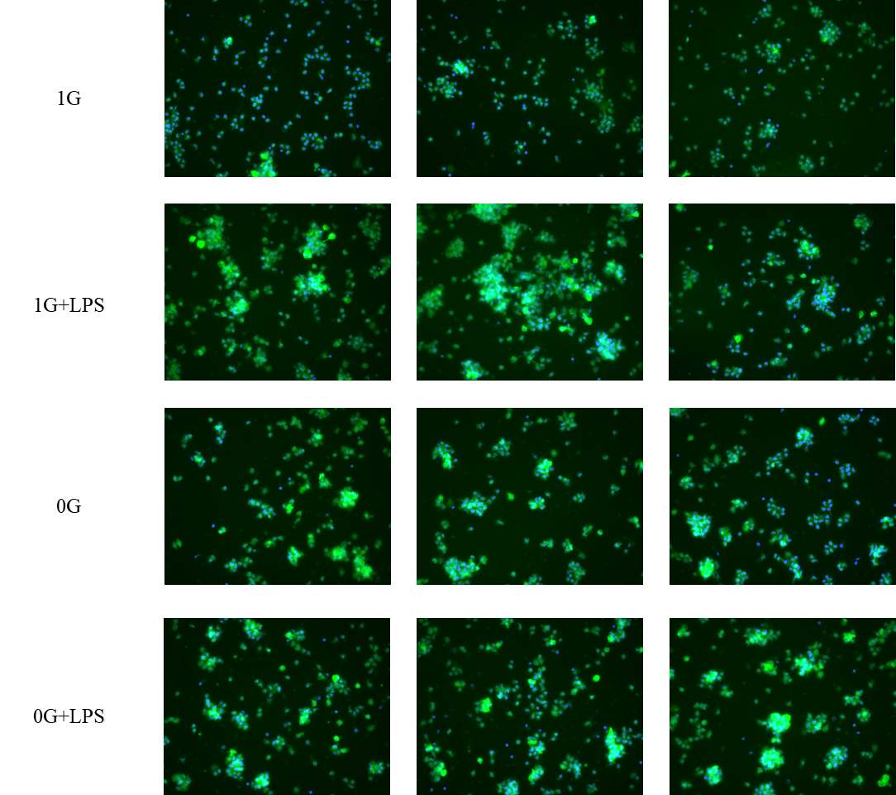
Supplementary Figure 1. Fluorescence microscopy of monocytes under different conditions.
4 × 3 grid shows experimental conditions (rows: 1G, 1G + LPS, 0G, 0G + LPS) across three donors (columns A–C). Green clusters indicate activation and aggregation. In 0G, fluorescence is heterogeneous; in 0G + LPS, clustering is less pronounced, reflecting reduced LPS responsiveness under simulated microgravity.

