Supporting Information

Mono V-substituted phosphomolybdic acid with intrinsic oxidase-like activity and near-instantaneous response

QingHui Zhao^{1,2†}, Ning Sheng^{2†}, Zhouzhou Yin³, Bohui Cui^{1,2}, JinHang Guo^{1,2},Ke Ma², Hong Zhao¹*, Jingquan Sha^{1,2}*
¹ School of Pharmacy, Jiamusi University, HeilongJiang, Jiamusi, 154007, P.R. China
² Laboratory of Functional materials in Universities of Shandong, Department of Chemistry and Chemical Engineering, Jining University, Qufu, Shandong, 273155, P.R China.
³ School of Pharmacy, Jinzhou Medical University, Jinzhou 121001, P. R. China.
Experimental section
1.1 Materials and methods
The materials and reagents used in this study were all of analytical grade. Ether, Na₂HPO₄·12H₂O, Na₂MoO₄·2H₂O, V₂O₅, Na₂CO₃, CaCO₃, NaCl, MgSO₄, tyrosine (Tyr), alanine (Ala), glutathione (GSH), cysteine (Cys), uric acid (UA), histidine (His) and glutamic acid (Glu) were acquired from Aladdin Reagent Co., Ltd. (Shanghai, China). Glucose and sucrose were purchased from Macklin. Deionized water was used throughout the whole experimental process.
Ultraviolet (UV) absorption spectra were obtained in the range of 350-750 nm using a TU-1900 double-beam UV-visible spectrophotometer. Fourier transform infrared (FT-IR) spectra were obtained in the range of 4000-400 cm⁻¹ using a NicoletiS10 FT/IR spectrometer with KBr pellets. Powder X-ray diffraction (PXRD) patterns were collected using a MiniFlex 600 X-ray diffractometer, with graphite-monochromatized Cu-Kα radiation (λ = 0.154 nm) and 2θ ranging from 5 to 40°. X-ray photoelectron spectroscopy (XPS) measurements were carried out on a scanning X-ray microprobe (K-Alpha, Thermo Scientific) with Al kα radiation.
1.2 Synthesis of PMo₁₁V₁
Na₂HPO₄·12H₂O (1.79 g, 5 mmol) and Na₂MoO₄·2H₂O (10.65 g, 44 mmol) were dissolved in 50.0 mL of distilled water, and then the mixture was heated to 110 °C for 30 minutes, by which a solution was obtained and designated as “A”. V₂O₅ (0.7 g, 4 mmol) was dissolved in 10.0 mL of Na₂CO₃ solution (1.0 M), and thus solution “B” was formed. Solution “B” was added into solution “A” under magnetic stirring, and then the mixture was heated at 90℃for 30 minutes. After the reaction, the resulting solution was treated with H₂SO₄ solution (9.0 M, added dropwise with stirring) until the pH value reached 2.0, and then it was cooled to room temperature. Subsequently, 30 mL of diethyl ether was introduced into this step, and then H₂SO₄ (9.0 M) was slowly added dropwise until the dark red solution turned pale yellow. The deep red oil at the bottom of the separation funnel was evaporated under vacuum so that the diethyl ether could be removed. Finally, the crude product PMo₁₁V₁ was dissolved in an appropriate amount of water and then it was recrystallized into a crystalline deep red solid (with a yield higher than 80%).
1.3 Colorimetric detection of PMo₁₁V₁
100 μL PMo₁₁V₁ (0.6 mg mL⁻¹) and 2 mL TMB (1 mM) were successively added into 3 ml acetate buffer solution (pH = 3), Then the mixed solution was heated at 25℃ for 6 minutes, and the absorbance at 661 nm was recorded by UV-visible absorption.
$$\frac{1}{v}=（\frac{Km}{Vmax}）*（\frac{1}{S}）+\frac{1}{Vmax}$$
where V was the initial velocity, S was the concentration of the substrate, Km was the Michaelis–Menten constant and Vmax was the maximal reaction velocity.
1.4 Determination of TA in tea samples
In order to determine the TA in tea, three tea samples were selected from the local supermarket. 0.2 g of each tea sample was taken and added to 50 mL of ultrapure water. The extractant was boiled for 10 minutes and then naturally cooled to room temperature. Next, the solution was filtered through a 0.22 μm filter membrane, and the filtrate was collected and diluted to 50 mL with ultrapure water. The solution was further diluted for analysis. Under the optimal conditions, 0.5 mL of the diluted filtrate was mixed with TMB (1 mM) and a buffer solution with pH = 2.5. The mixture was then allowed to react at 25℃ for 6 minutes. Finally, the ultraviolet-visible absorbance at 661 nm was measured. The relationship between the reduction value of absorbance at 661 nm (ΔA = A₀-A_{i}) (where A₀ and A_{i} were the absorbance without TA and the absorbance when the TA concentration was i, respectively) and different TA concentrations was used for the calibration curve of TA. The content of TA in the sample was determined by the standard curve method.

2. Characterization of H₅[PMo₁₁VO₄₀]
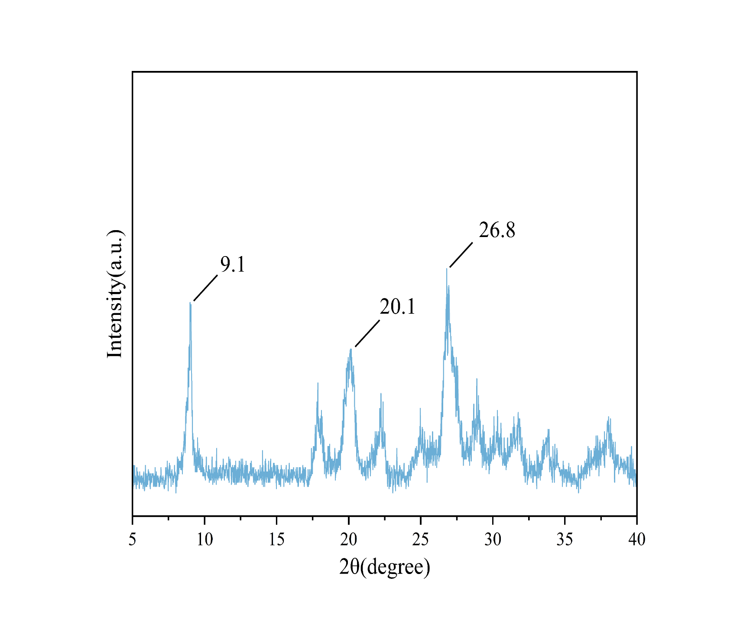
Figure .S1 FT-IR spectra of PMo₁₁V₁.
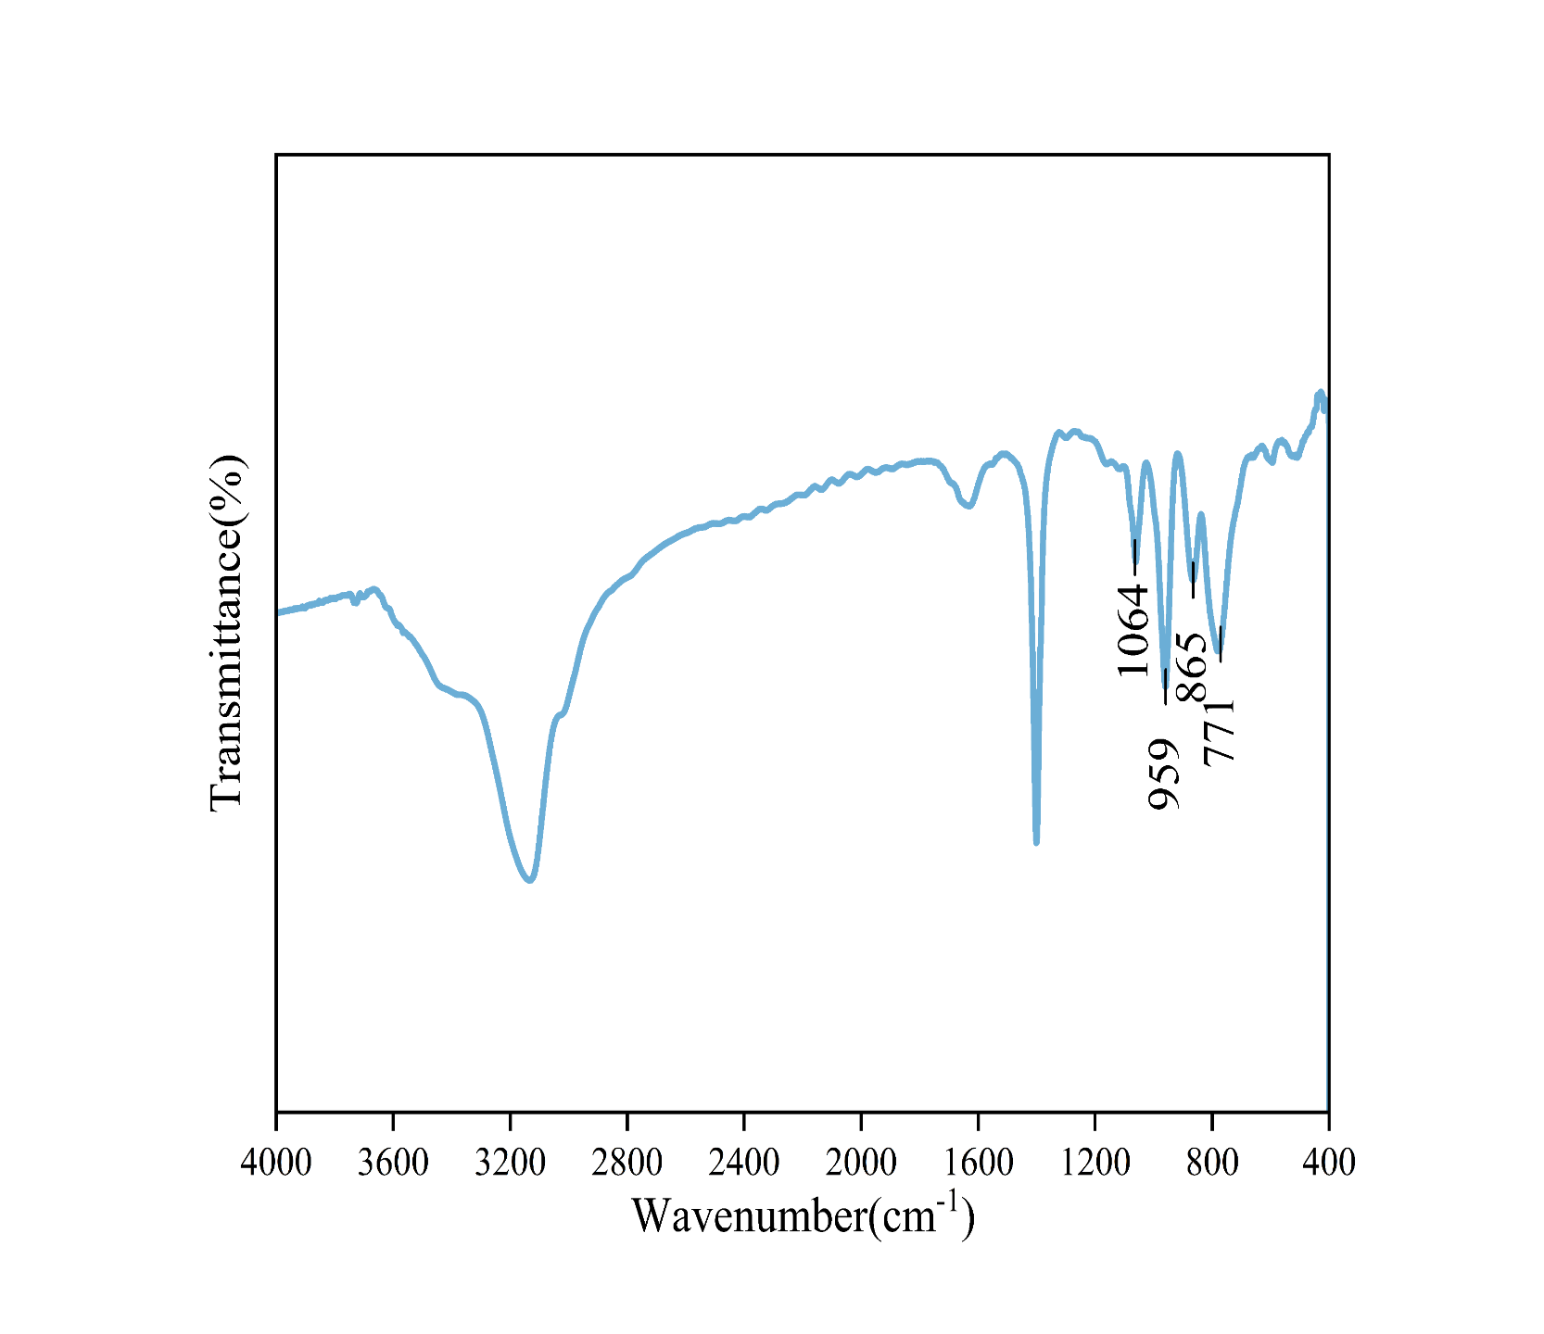
Figure .S2 PXRD (left) spectra of PMo₁₁V₁.

3. Oxidase-like performance of H₅[PMo₁₁VO₄₀]

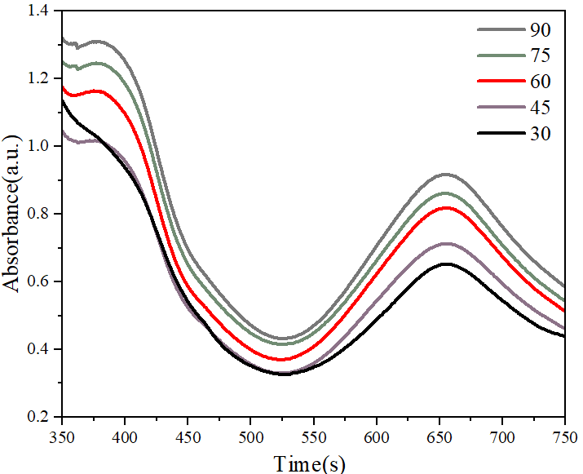
Figure .S3 The optimal Time of PMO₁₁V₁

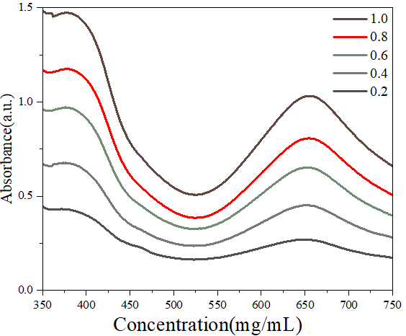
Figure .S4 The optimal concentration of PMO₁₁V₁

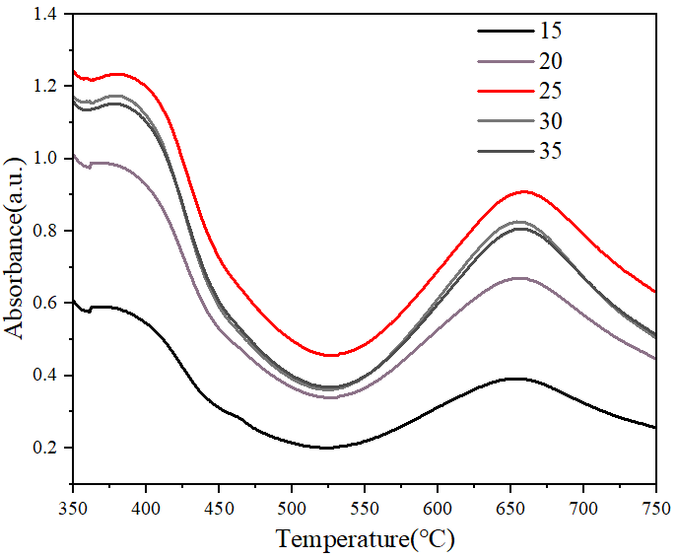
Figure.S5 The optimal Temperature of PMO₁₁V₁

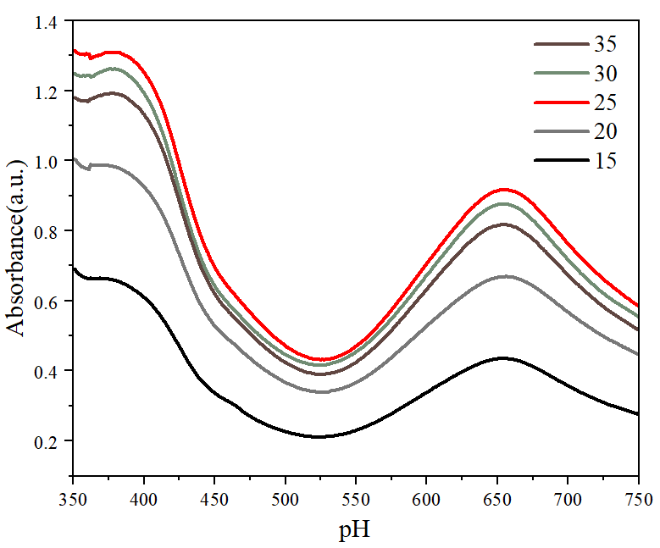
Figure.S6 The optimal pH of PMO₁₁V₁

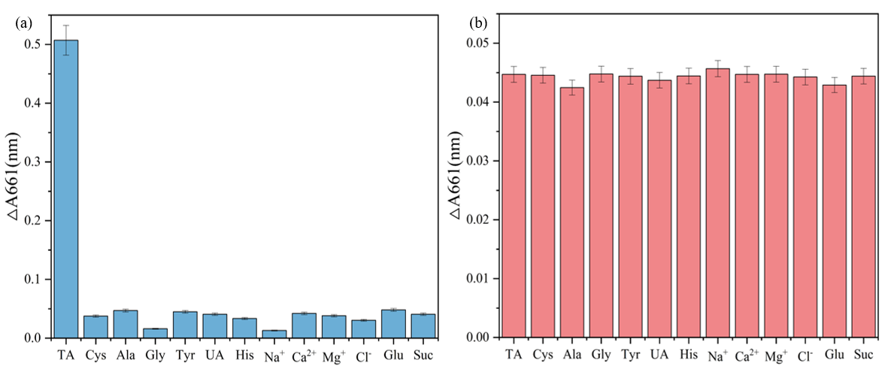
Figure. S7 (a) Effects of different interfering substances on the activity of PMo₁₁V₁; (b) Selectivity of PMo₁₁V₁ to TA sensing

