Supplementary Figure
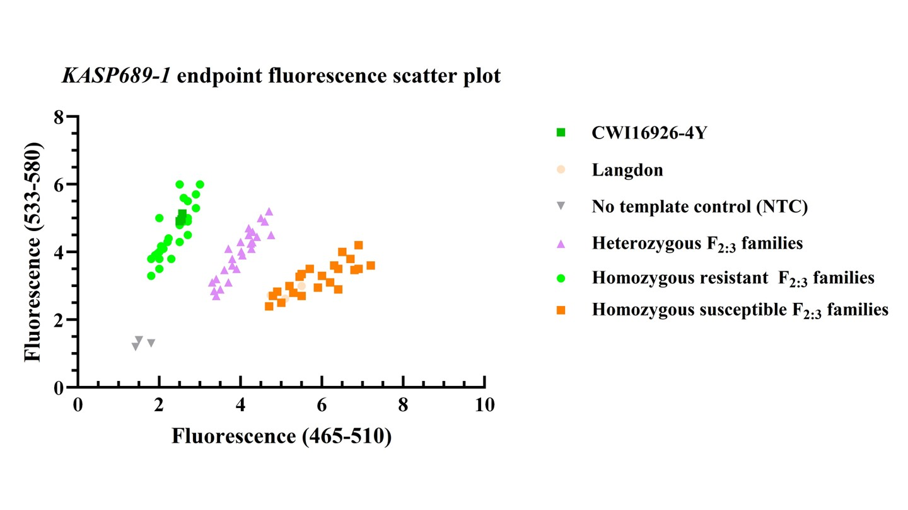
Figure S1 Genotyping pattern of the specific marker KASP689-1 for TRITD2Bv1G010140 in the F_{2:3} families of cross CWI16926-4Y×Langdon (LDN).

