Supplementary file:
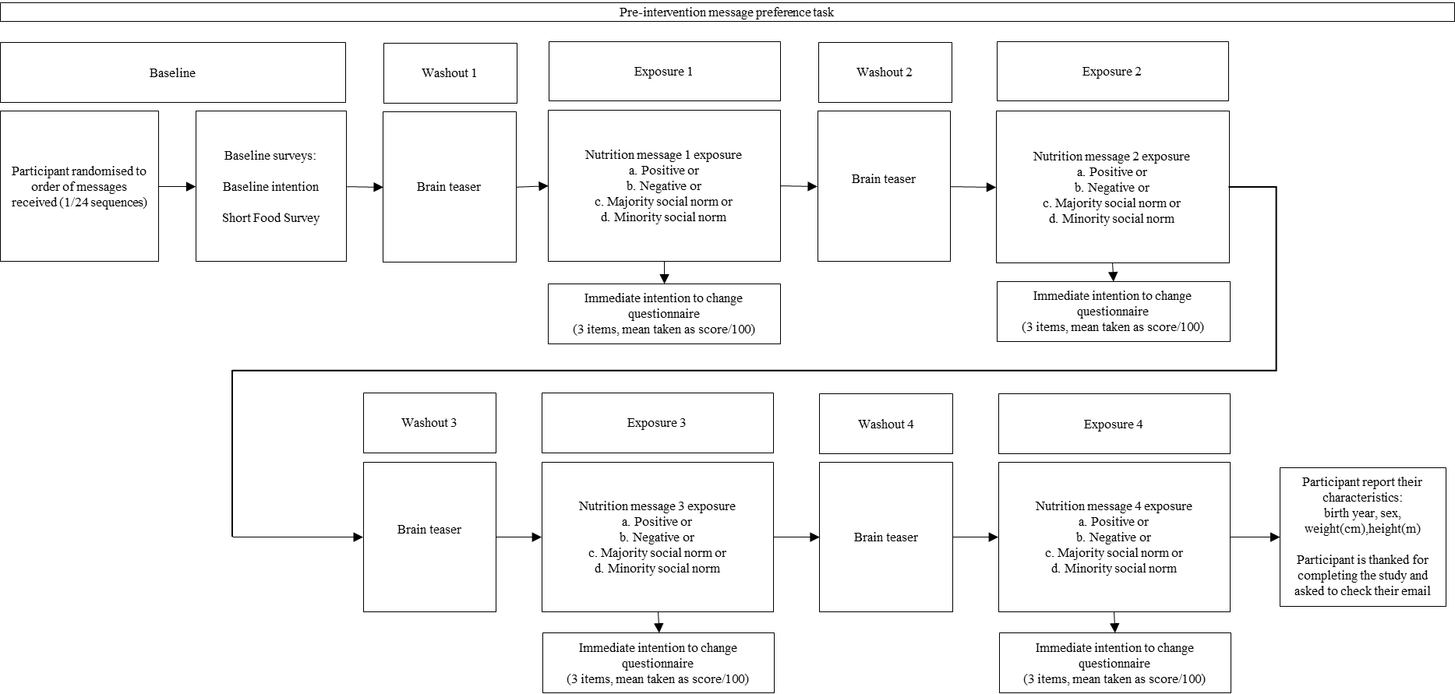Supplementary Figure 1: Process of the pre-intervention message preference task, in which participants were exposed to four nutrition message frames in a random order, with washout activities. This was conducted in one sitting.

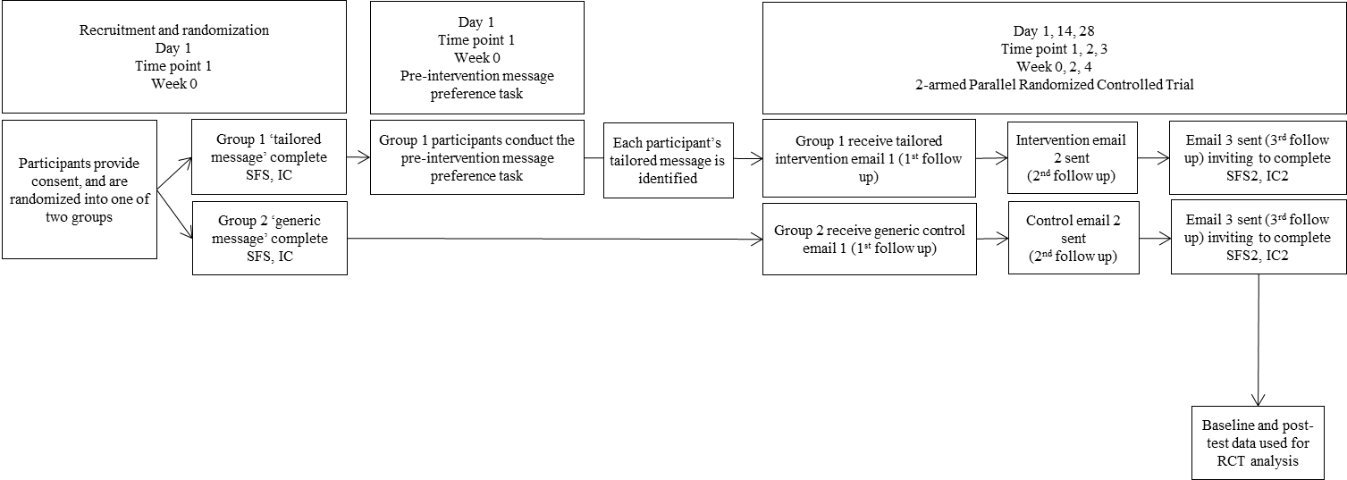
Supplementary Figure 2: Overview of the process pre-intervention message preference task and the two-armed parallel randomised controlled trial

Supplementary Table 1: Comparative description of the different elements provided in the brief online 28-day intervention, by type of intervention group
Type of intervention group | Tailored intervention group | Control group
Intervention name | Shifting My Nutrition Score in 28 Days
Method | Online, via email
Timeframe | 28 days
Email description | Brief but longer email (words approximately = 650) encouraging the new behaviour to eat less discretionary choices, using a tailored message, and supported by BCTs to reduce discretionary choices, guided by the Behaviour Change Wheel framework (173). | Brief but shorter email (words approximately = 150) encouraging the new behaviour to eat less discretionary choices, using only a generic message.
Personalisation | Sent addressing participant by first name
Intensity and dose | Two emails on two separate occasions (14 days apart)
Message type | Message tailored on participant-reported baseline intention score after message exposure. | Non-tailored generic message as per CSIRO Healthy Diet Score:  ‘Eat fewer discretionary foods. Your diet could be improved if you ate fewer discretionary foods also known as “extra foods”. Extra foods include cakes, biscuits, pastry, chips, lollies, ice-cream, processed meats, regular sausages, sugar-sweetened beverages, alcohol and similar foods. It is recommended that you eat these foods only sometimes and in small amounts.’
Behaviour change techniques (BCTs) applied | Nine BCTs (173) based on best available evidence (171):  - Goal-setting (behaviour) ‘implementation intention’ (BCT 1.1)  - Self-monitoring of behaviour (BCT 2.3)  - Social support (practical) (BCT 3.2)  - Instruction on how to perform a behaviour (BCT 4.1)  - Information about emotional consequences (BCT5.1)  - Monitoring of emotional consequences (BCT 5.4)  - Prompts/cues (BCT 7.1)  - Behavioural substitution (BCT 8.2)  - Avoidance/reducing exposure to cues for the behaviour (BCT 12.3) | Three BCTs (173) inherently found in the construction of the intervention:  - Goal-setting (behaviour) ‘implementation intention’ with intention score assessment (BCT 1.1)  - Self-monitoring of behaviour (BCT 2.3) with Short Food Survey  - Prompts/cues (BCT 7.1)
Priority dietary target | Discretionary choices

Supplementary Table 2: Type, definition and outline of the message frames
Type | Definition | Message
Positive/  Negative framing | Positive message:  Presentation of the desirable (positive) outcome by following the message: | 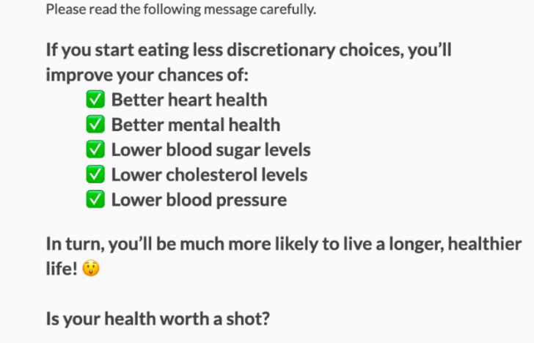
Positive/  Negative framing | Negative message:  Presentation of undesirable (negative) outcome by following the message: | 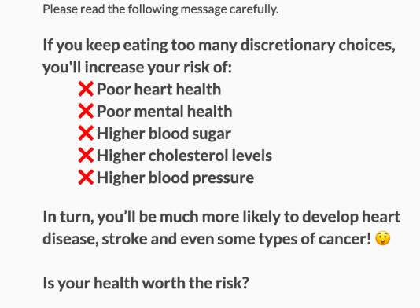
Descriptive social norm messages | Majority norm message:  Presentation of the dietary habits of the majority of people: | 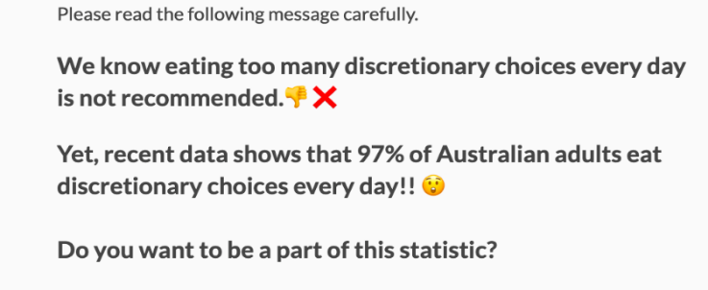
Descriptive social norm messages | Minority norm message:  Presentation of the dietary habits of the minority of people: | 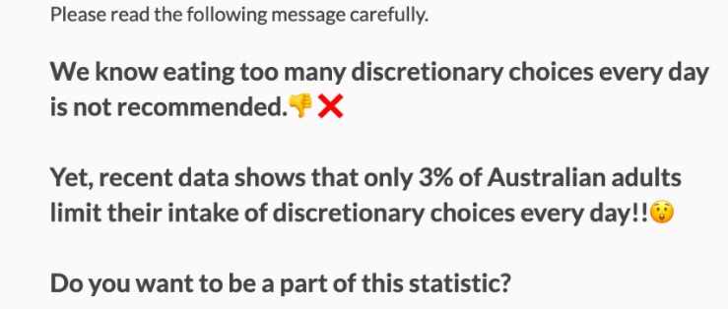

Intervention (tailored group) email :
Tailored message email 1:
Subject: Day 1 of 28 of Shifting My Nutrition Score!
Hi [participant name]!
Thank you for joining Shifting My Nutrition Score in 28 Days
You can improve your nutrition score by eating less discretionary choices. For the next month, please keep the following message in mind:
[Tailored message: positively framed]
Doing the following tips for the next 14 days will help you cut down on eating discretionary choices AND you’ll improve your health:
- Remind yourself how positive you are going to feel
- Be proactive! Seek fresh meal and snack ideas
- Be organised! Plan your snacks
- Act smart! Think before you drink
- Bring your social network on board
Let’s expand on these…
💪 Remind yourself how positive you are going to feel when you avoid discretionary choices
Remember how great you felt when you’ve previously eaten healthier. Now, write down how you’re going to feel every time you eat a healthier alternative to discretionary choices (i.e. “I know eating a healthier option will make me feel much more energetic”)
📱 Seek healthy meal and snack ideas
If you have meal ideas, you’ll find it easier to avoid take-away food! Click here (https://my.totalwellbeingdiet.com/resources/recipes.aspx?id=recipes_index_dinner) for quick & easy meals and snack ideas. You can also search for meal, cooking and recipe inspiration from Dietitians on any social media forum by searching the term or hashtag #Dietitian. Accounts run by dietitians are trustworthy and a great way to develop and practice your skillset in the kitchen!
✍ Plan your snacks
Make sure you keep a piece of fruit, yoghurt, nuts (or roasted beans or chickpeas), or whole-grain crackers and cheese in your bag or the fridge (at home or work), and you will be less likely to grab something less healthy on the run. These snacks are higher in fibre and protein, and lower in sugar and salt.
💦 Think before you drink
Keep a filled water bottle in front of you! This will help you drink fewer soft drinks, fruit juice, sports drinks or energy drinks. If you don’t like water from the tap, then try it sparkling, with fruit slices, or fruit-flavoured tea-bags. Try having 1 or 2 glasses of water before each meal or snack. If you plan on drinking alcohol, make sure you break up each drink with a glass of water.
👫 Bring your friends, colleagues and family on board
Everything is more fun when done with others. Extend this 28 day challenge onto your family, friends, colleagues and/or house-mates. Do the activity (below) with them and discuss your progress frequently so you can keep each other on track.
📌Stay motivated and on track by printing off or taking a screen shot of the table and tips below. For the next 14 days, see how many of the above tips you can do and cross off each day that you were able to eat less discretionary choices by doing one or more of the tips.

Day 1 | Day 2 | Day 3 | Day 4 | Day 5 | Day 6 | Day 7
Day 8 | Day 9 | Day 10 | Day 11 | Day 12 | Day 13 | Day 14

Your tips:
💪Remind yourself how positive you are going to feel
📱Be proactive! Seek fresh meal and snack ideas
✍Be organised! Plan your snacks
💦Act smart! Think before you drink
👫Bring your social network on board

You can also write the tips down on post-it notes to stick on your computer screen, or you can even save them as the screen-lock image on your phone! The more you read the information in this email, the more likely you’ll stay motivated and on track.
Let’s see what you can achieve in the next 14 days! You’ve got this!
We will be in touch soon, please remember to check your emails in 14 days’ time. This will keep you in the running to win one of $100 gift vouchers.
--------------------------------------------------------------------------------------------------------------

Generic message (control group) email 1:
Hi [participant name]!
Thank you for joining Shifting My Nutrition Score in 28 Days
For the next month, please keep the following message in mind:
Eat fewer discretionary choices
Your diet could be improved if you ate fewer discretionary choices also known as "extra foods".
Extra foods include cakes, biscuits, pastry, chips, lollies, ice-cream, processed meats, regular sausages, sugar sweetened beverages, alcohol and similar foods.
It is recommended that you eat these foods only sometimes and in small amounts.
We will be in touch in 14 days to see how you’re going, please remember to check your email then!
Don’t forget, by completing the final survey (which you will receive access to in 28 days), you’ll be in the running to win a $100 gift card to use at a retailer of your choice! 🛍️ You’ll also be helping us find ways to improve Australia’s eating habits.

Follow-up email to both groups:
Subject: The last step to Shifting My Nutrition Score in 28 Days!
Hi [participant name]!
You’ve made it to the 28 day mark of Shifting My Nutrition Score in 28 Days! 🎉
But before we let you go… We would like some extra information from you.
Remember, if you complete this final survey, you will go in the draw to win a $100 gift card to use at a retailer of your choice! 🛍️ You’ll also be helping us find ways to improve the population’s eating habits.
The following survey will only take 10-15 minutes of your time. Click on the following link and you will be directed to the last survey.
[invite(survey_link]
Thank you so much for participating in this study.
Supplementary Table 3: Baseline demographic, anthropometric, behavioral and psychosocial characteristics of the pooled sample of participants (N = 1,441) randomised to the brief online 28-day interventionby participants who did and did not reduce discretionary choice (DC) intake by one serving or more. Results presented as n (%) unless otherwise indicated.
 | Total  N = 1,441 (%) |  | Reduced DC intake by one serving or more  n = 576 (%) |  | Did not reduce DC intake by one serving or more  n = 865 (%)
Baseline DC intakeª | 4.2 ± 3.9 |  | 6.3 ± 4.8 |  | 2.8 ± 2.3
Intervention group
Control | 784 | (54.4) | 313 | (54.3) | 471 | (54.4)
Tailored | 657 | (45.6) | 263 | (45.7) | 394 | 45.5)
Sex
Male | 327 | (22.7) | 133 | (23.1) | 194 | (22.4)
Female | 1114 | (77.3) | 443 | (76.9) | 671 | (77.6)
Age group (years)
18–30 | 187 | (13.0) | 113 | (12.8) | 74 | (13.1)
31–50 | 484 | (33.6) | 275 | (36.3) | 209 | (31.8)
51–70 | 628 | (43.6) | 386 | (42.0) | 242 | (44.6)
71+ | 142 | (9.9) | 91 | (8.9) | 51 | (10.5)
Weight status category
Underweight | - | - | - | - | - | -
Healthy weight | 480 | (34.4) | 166 | (28.8) | 314 | (36.6)
Overweight | 485 | (33.7) | 194 | (33.6) | 291 | (33.7)
Obesity | 460 | (31.9) | 212 | (36.9) | 248 | (28.4)
Socio-economic status
1 (most disadvantaged) | 170 | (11.8) | 77 | (13.4) | 93 | (10.8)
2 | 189 | (13.1) | 77 | (13.4) | 112 | (12.9)
3 | 313 | (21.7) | 119 | (20.7) | 194 | (22.4)
4 | 350 | (24.3) | 161 | (28.0) | 189 | (21.8)
5 (least disadvantaged) | 419 | (29.1) | 142 | (24.7) | 277 | (32.0)

Supplementary Table 3 (continued): Baseline demographic, anthropometric, behavioral and psychosocial characteristics of the pooled sample of participants (N = 1,441) randomised to the brief online 28-day intervention; by participants who did and did not reduce discretionary choice (DC) intake by 1 serving or more; and by participants who did and did not comply with dietary guidelines for DC after the intervention. Results presented as n (%) unless otherwise indicated.
 | Total  N = 1,441 (%) |  | Reduced DC intake by one serving or more  n = 576 (%) |  | Did not reduce DC intake by one serving or more  n = 865 (%)
Intention tertiles (out of 100; range)
Low (1.0–71.7) | 481 | (33.4) | 173 | (31.8) | 308 | (35.6)
Med (71.8–88.3) | 486 | (33.7) | 220 | (38.2) | 266 | (30.8)
High (88.4–100.0) | 474 | (32.9) | 183 | (30.0) | 291 | (33.6)
Diet score quintiles (out of 100; range)
1 (21.1–45.5) | 288 | (20.0) | 158 | (27.4) | 130 | (15.0)
2 (45.6–51.4) | 288 | (20.0) | 125 | (21.7) | 163 | (18.8)
3 (51.5–56.6) | 289 | (20.1) | 119 | (20.7) | 170 | (19.7)
4 (56.7–63.2) | 288 | (20.0) | 115 | (20.0) | 173 | (20.0)
5 (63.3–90.6) | 288 | (20.0) | 59 | (10.2) | 229 | (26.5)
Note:
Data include the characteristics of the pooled sample, including participants randomised both to the intervention and control arms.
ªReported as mean and standard deviation. DC: discretionary choices.
Age group categories consistent with nutrient reference values ⁷⁸.
Weight status categories are according to Body Mass Index (BMI) (kg/m²); Underweight: <18.5 kg/m²; Healthy weight: 18.5–24.9 kg/m²; Overweight: 25–29.9 kg/m²; Obesity: >30 kg/m². Values for underweight sample (n = 16) not shown.
Socio-Economic Status is indicated by national Socio-Economic Indexes for Areas (SEIFA) of relative advantage and disadvantage represented by matching participant-reported postcode ⁴⁹.

