Figure S1: Funnel Plot for indoor (A), and outdoor (B) prevalence of Ae. aegypti
A:

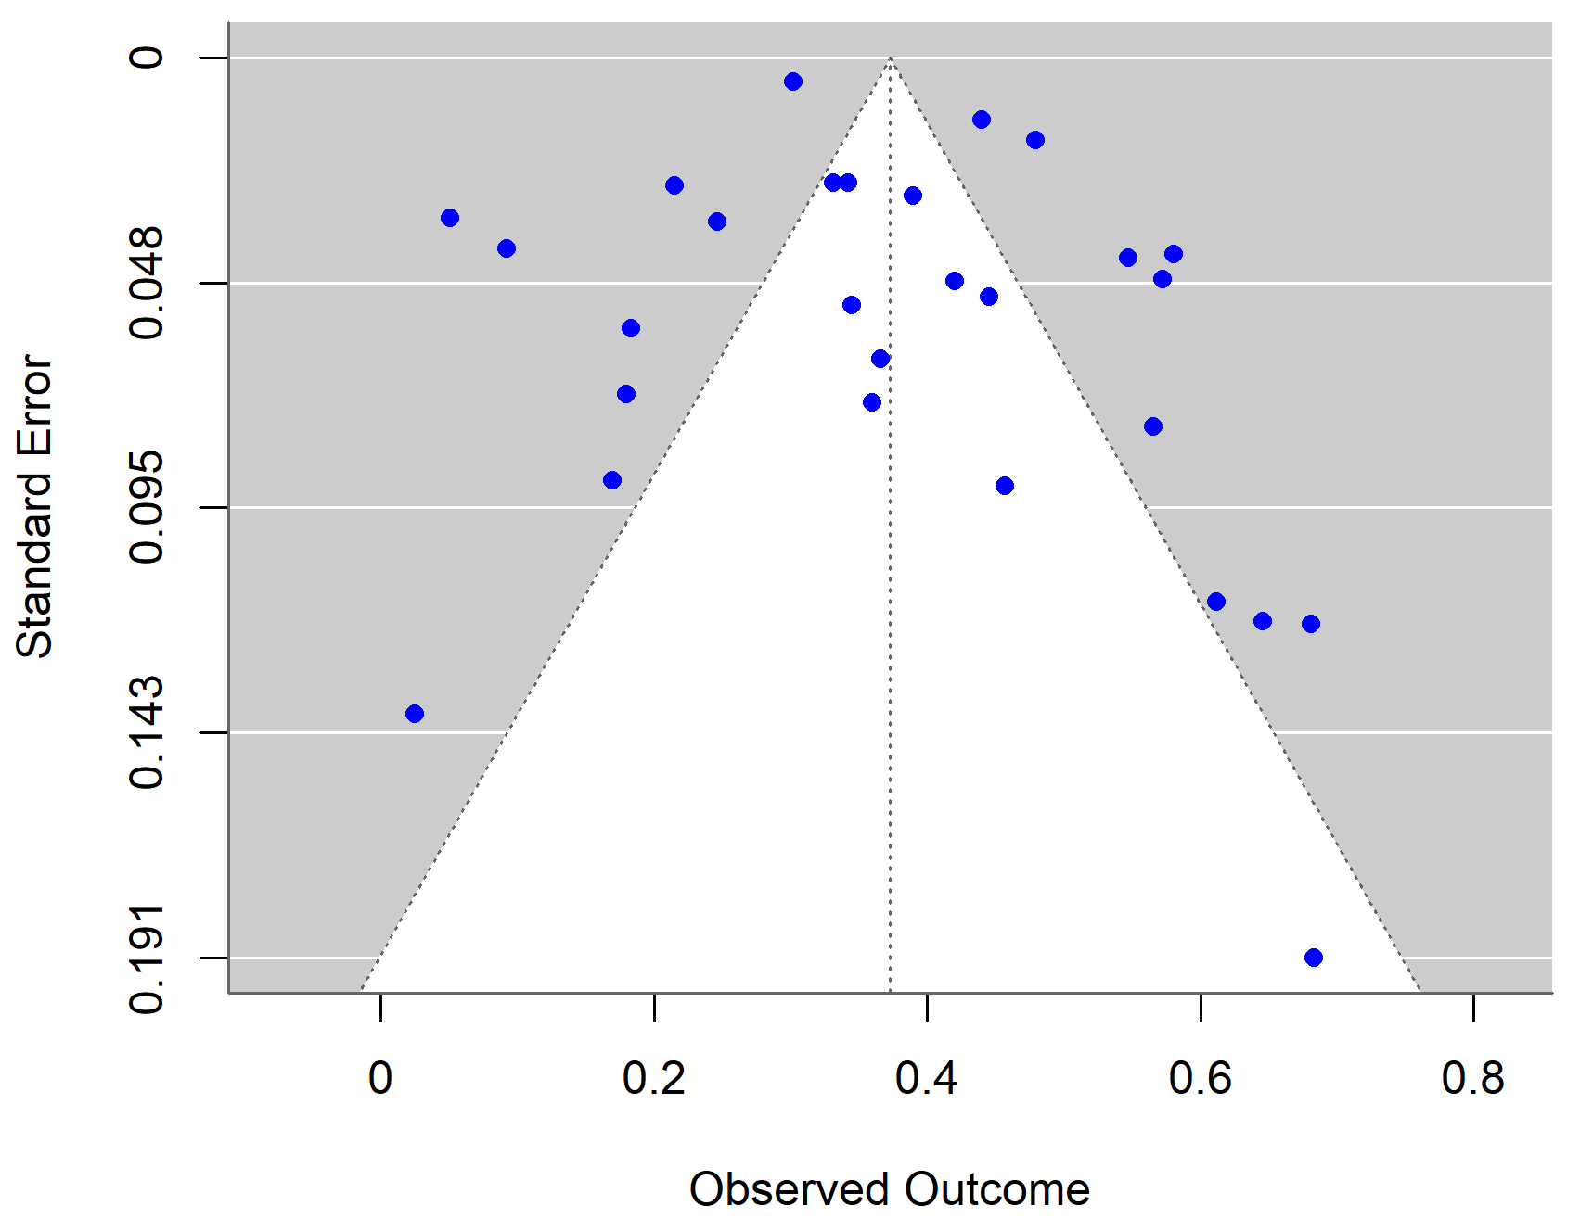

B:
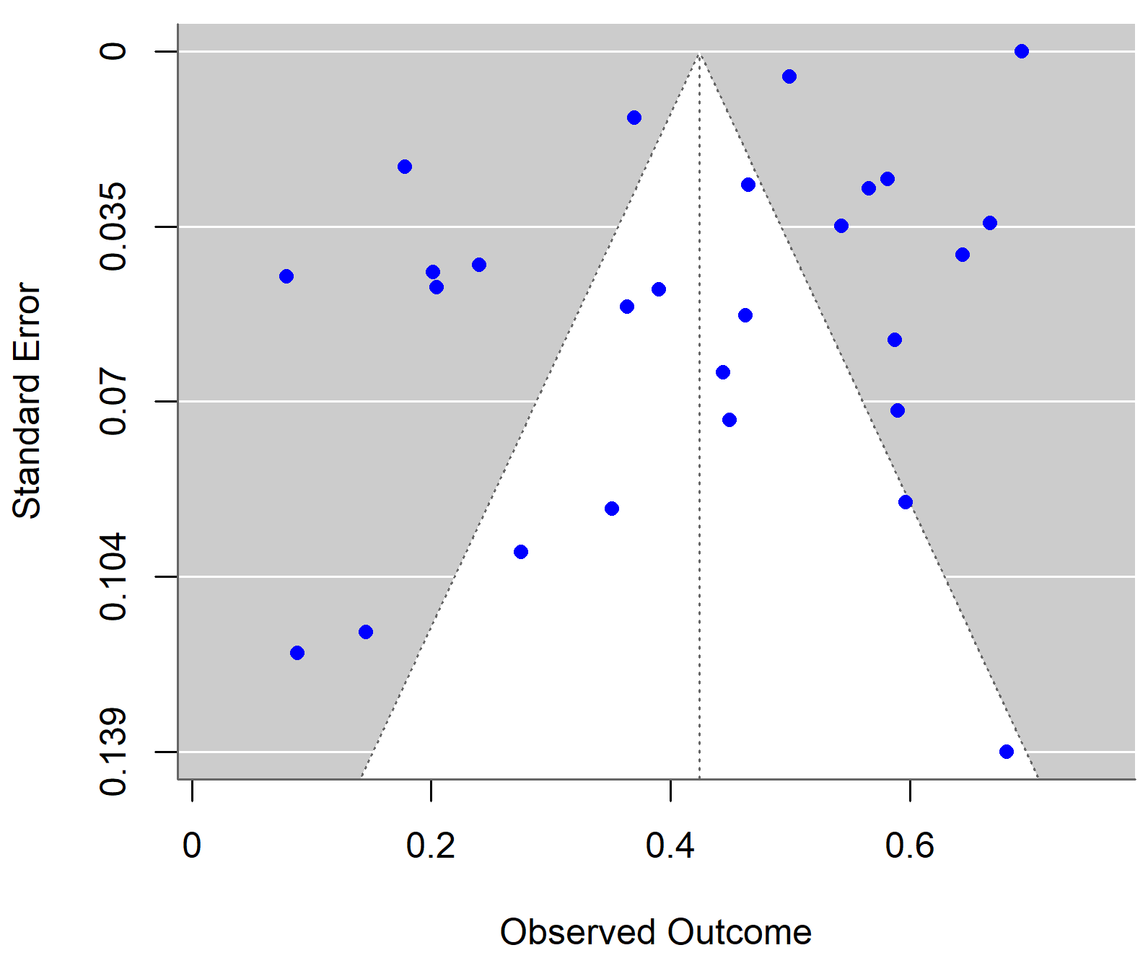

Figure S2: Funnel Plot for Indoor (A), and outdoor (B) prevalence of Ae. albopictus.
A:

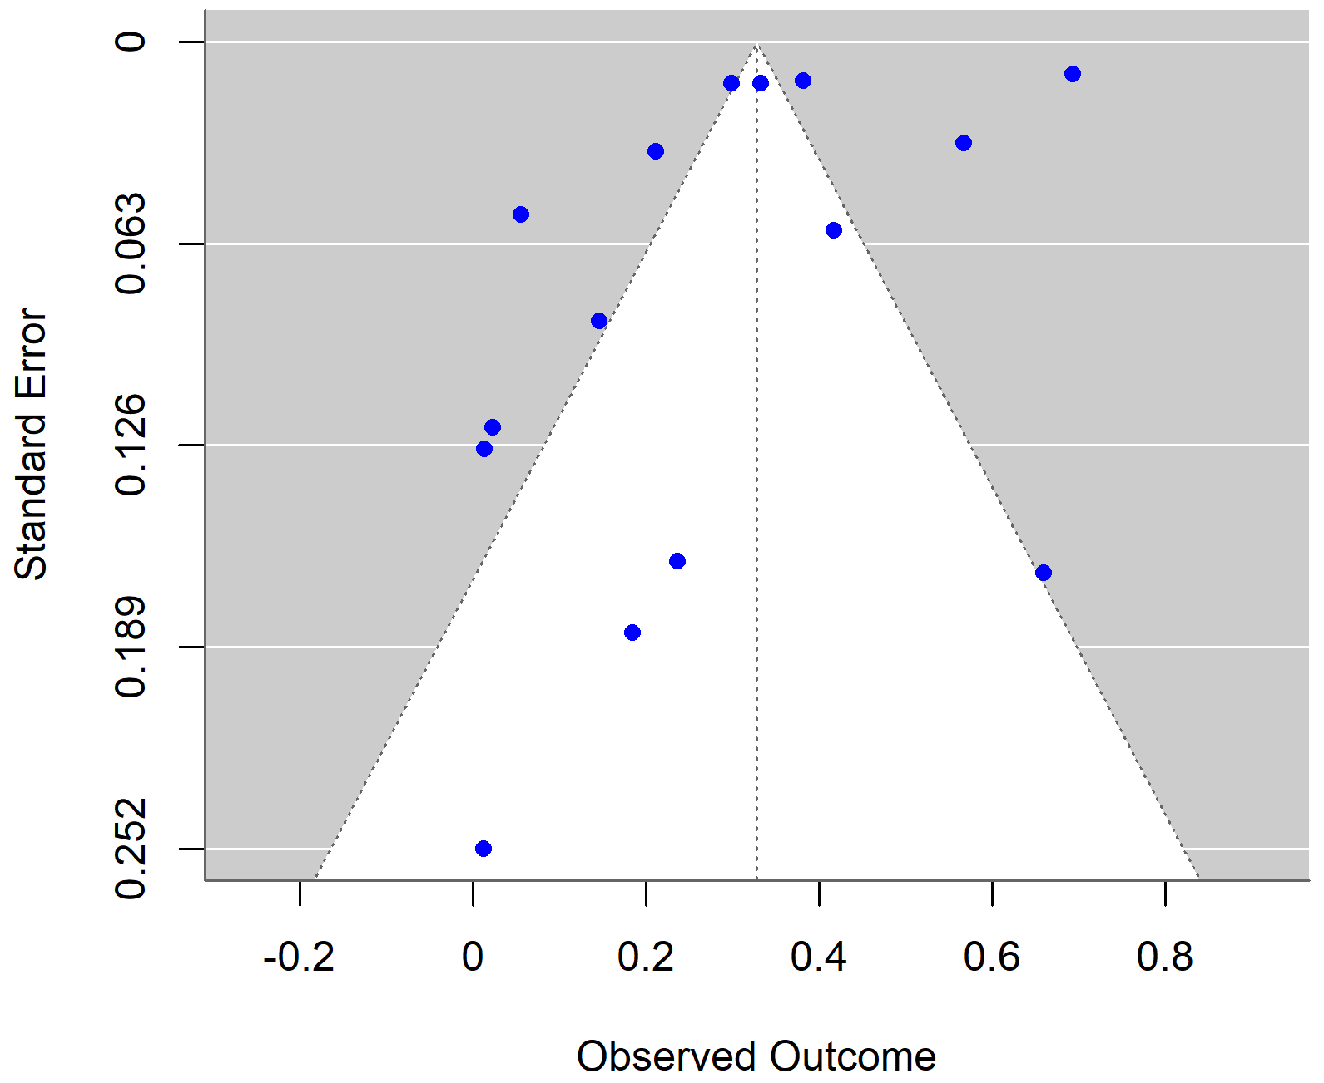

B:

