Molecular characteristics of the isolates
High quality DNA was extracted from the bacterial isolates. PCR amplification of the bacterial DNA resulted in complete amplification of the 16S rRNA genes. The gDNA bands from the isolates are shown in Fig. 3. Phylogenetic analysis of the 16S gene sequences from the bacterial isolates classified them as Bacillus cereus, Bacillus cereus, Bacillus fungorum and Bacillus paramycoides with accession numbers OR105044, OR105045, OR105046 and OR105047 respectively. The phylogenetic tree construct of the bacterial isolates are given in Fig. 4-5.

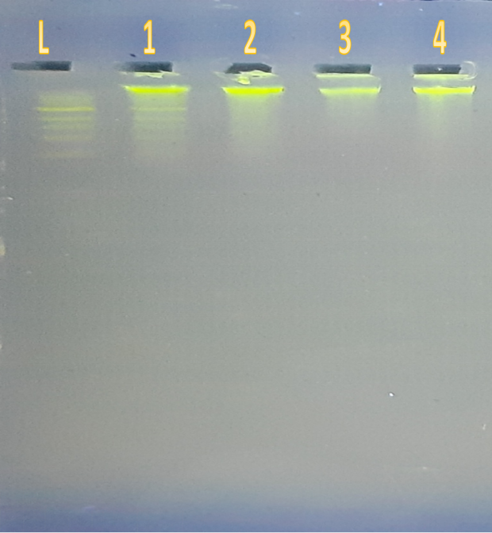
Fig. 3 gDNA bands from the isolates (1: PA4; Lane 2: PA6; Lane 3: PA7; Lane 4:PA11).
Fig. 4 Phylogenetic tree construct for Bacillus cereus strain PA4
Bacillus wiedmannii strain FSL W8-0169 (NR 152692.1)
Bacillus fungorum strain 17-SMS-01 (NR 170494.1)
Bacillus proteolyticus strain MCCC 1A00365 (NR 157735.1)
Bacillus tropicus strain MCCC 1A01406 (NR 157736.1)
Bacillus paramycoides strain MCCC 1A04098 (NR 157734.1)
Bacillus nitratireducens strain MCCC 1A00732 (NR 157732.1)
Bacillus luti strain MCCC 1A00359 (NR 157730.1)
Bacillus albus strain MCCC 1A02146 (NR 157729.1)
Bacillus cereus strain IAM 12605 (NR 115526.1)
Bacillus cereus strain JCM 2152 (NR 113266.1)
Bacillus cereus strain PA4
0.10

Bacillus cereus strain NBRC 15305 (NR 112630.1)
Bacillus cereus ATCC 14579 (NR 114582.1)
Bacillus cereus strain CCM 2010 (NR 115714.1)
Bacillus cereus strain JCM 2152 (NR 113266.1)
Bacillus cereus strain IAM 12605 (NR 115526.1)
Bacillus albus strain MCCC 1A02146 (NR 157729.1)
Bacillus luti strain MCCC 1A00359 (NR 157730.1)
Bacillus nitratireducens strain MCCC 1A00732 (NR 157732.1)
Bacillus tropicus strain MCCC 1A01406 (NR 157736.1)
Bacillus paramycoides strain MCCC 1A04098 (NR 157734.1)
Bacillus cereus strain PA6
0.10
Fig. 5 Phylogenetic tree construct for Bacillus cereus strainPA6

Bacillus paramycoides strain NH24A2(T) (MZ489421.1)
Bacillus paramycoides strain MCCC 1A04098 (MW065486.1)
Bacillus cereus ATCC 14579 (MN326684.1)
Bacillus paramycoides strain MCCC 1A04098 (MT159579.1)
Bacillus paramycoides strain MCCC 1A04098 (MT176483.1)
Bacillus paramycoides strain NH24A2(T) (MT256266.1)
Bacillus wiedmannii strain FSL W8-0169 (MT421925.1)
Bacillus sanguinis strain BML-BC004 (MW674727.1)
Bacillus fungorum strain 17-SMS-01 (NR 170494.1)
Bacillus fungorum strain PA7
0.10
Fig. 6 Phylogenetic tree construct for Bacillus fungorum strain PA7

Fig. 7 Phylogenetic Tree Construct forBacillus Paramycoides Strain PA11
Bacillus paramycoides strain MCCC 1A04098 (MT176483.1)
Bacillus cereus ATCC 14579 (MN326684.1)
Bacillus paramycoides strain NH24A2(T) (MT256266.1)
Bacillus wiedmannii strain FSL W8-0169 (MT421925.1)
Bacillus sanguinis strain BML-BC004 (MW674727.1)
Bacillus paramycoides strain MCCC 1A04098 (NR 170494.1)
Bacllus paramycoides strain PA11
0.10

