Supplementary Material Info

PepPharmaHub: A Cloud-Based Platform Integrating Multimodel Language Architectures with Curated Data Resources for Therapeutic Peptide Discovery

Dongya Qin¹, Hai Fang^{2*}, Zheng Wang^{1,3,4*}
¹ Jinfeng Laboratory, Chongqing, 401329, China.
² Shanghai Institute of Hematology, State Key Laboratory of Medical Genomics, National Research Center for Translational Medicine at Shanghai, Ruijin Hospital, Shanghai Jiao Tong University School of Medicine, Shanghai 200025, China
³ Medical Center of Hematology, Xinqiao Hospital of Army Medical University; State Key Laboratory of Trauma and Chemical Poisoning; Chongqing Key Laboratory of Hematology and Microenvironment, Chongqing 400037, China.
⁴ Bio-Med Informatics Research Center & Clinical Research Center, The Second Affiliated Hospital, Army Medical University, Chongqing 400037, China.
*Correspondence:
Hai Fang, fh12355@rjh.com.cn
Zheng Wang, biowz@mail.ustc.edu.cn

Supplementary Table 1 | The list of 22 AAD encodings and their parameter meanings collected from literature.
No. | Feature descriptor | Dimension | Explanation | Reference
1 | One hot | 20 | One-hot encoding represents each amino acid with a 20×1 vector with a single position (corresponding to the specific amino acid) set to one, and all 19 other positions set to zero. Each peptide was therefore represented by a 2D array created by concatenating the 20 × 1 vectors of the amino acids. | [1]
2 | DPPS | 10 | The DPPS descriptors for 20 amino acids are derived by PCA. The electronic properties of the amino acid are characterized by V₁-V₄, steric properties by V₅ and V₆, hydrophobic properties by V₇ and V₈, and hydrogen bond contributions by V₉ and V₁₀. | [2]
3 | BLOSUM62 | 10 | The BLOSUM matrix-derived descriptors (BLOSUM) including 10 indices, representing hydrophobicity, alpha-helix propensity, beta-sheet propensity, bulkiness, charge, and composition, are based on both physicochemical properties that have been subjected to a ARIMAX analyses and an alignment matrix of 20 coded amino acids, the BLOSUM62 matrix. | [3, 4]
4 | FASGAI | 6 | Through factor analysis, the FASGAI descriptors cluster 335 physicochemical properties of each of 20 coded amino acids into 6 factors, which are related to hydrophobicity, alpha and turn propensities, bulky properties, compositional characteristics, local flexibility and electronic properties, respectively. | [5]
5 | GRID | 7 | The 7 principal properties of the GRID scales are derived from PCA on interaction energies of 20 coded amino acids, with six different probes mimicking various functional groups which can be involved in peptide-peptide interactions. | [6]
6 | HESH | 12 | These 12 vectors of HESH for 20 amino acids were obtained by PCA. The v₁–v₄ were hydrophobic properties, v₅–v₆ were steric properties, v₇–v₁₀ were electronic properties, and v₁₁–v₁₂ were hydrogen bond contribution properties. | [7]
7 | ISA-ECI | 2 | The isotropic surface area (ISA) approximates the hydrophobic character of the side chain substituent; ^{b} the electronic charge index (ECI) is a measure of the charge concentration of the amino acid. Each residue was described by a combination of ISA and ECI descriptors. | [8]
8 | Lin’s scales | 3 | Three kinds of physicochemical parameters selected from properties of 20 coded amino acids, namely Van Der Waal’s volume, net charge index and hydrophobic parameter, construct the vectors to characterize the structures of peptides. | [9]
9 | MS-WHIM | 3 | MS-WHIM indexes, which are three principal components derived from PCA, are a collection of 36 statistical indexes aimed at extracting and condensing steric and electrostatic 3D-properties of a molecule. | [10]
10 | NNAAIndex | 6 | The NNAAIndex scales characterize a total of 155 physiochemical properties of 22 natural and 593 non-natural amino acids, followed by clustering the structural matrix into 6 representative property patterns by factor analysis. The six factors are geometric characteristics, H-bond, connectivity, accessible surface area, integy moments index, and volume and shape, respectively. | [11]
11 | ProtFP | 8 | The 8 principal component scores based on a PCA analysis of 58 amino acids properties explain 92% of the variances. For these predominant components, the first one is related to hydrophobicity and the second one is related to the size of amino acids. | [12]
12 | QTMS (ADFQ) indices | 7 | The amino acids indices of QTMS are obtained by application of PCA on the unfolded loadings of a data matrix of QTMS of all bonds of amino acids. | [13]
13 | ST-scales | 8 | ST-scales, the 8 principal component scores of ST-scales are derived from 827 structural variables of 167 amino acids by PCA, and these parameters are mainly related to constitutional, topological, geometrical, hydrophobic, electronic, and steric properties of the amino acids | [14]
14 | SVRG | 16 | The 16 principal component scores are derived from PCA of 150 radial distribution function and 74 geometrical descriptors. | [15]
15 | SVWG | 10 | The 10 principal component scores are obtained by PCA on 99 WHIM and 197 GETWAY descriptors. | [16]
16 | SZOTT | 13 | The SZOTT descriptors are derived from PCA of a matrix of 1369 structural variables including 0D, 1D, 2D and 3D information for 20 coded amino acids. | [17]
17 | T-scales | 5 | The 5 principal component scores of T-scales are derived from PCA on the collected 67 kinds of structural and topological variables of 135 amino acids. | [18]
18 | VHSE | 8 | The VHSE descriptors are derived from the PCA on independent families of 18 hydrophobic properties, 17 steric properties, and 15 electronic properties, respectively. Among them, VHSE₁ and VHSE₂ are related to hydrophobic properties, VHSE₃ and VHSE₄ to steric properties, and VHSE₅–VHSE₈ to electronic properties. | [19]
19 | VSTV | 3 | The 3 principal component scores as VSTV descriptors are derived from PCA on a matrix of 25 structural and topological variables of 20 coded amino acids. | [20]
20 | VSW | 9 | VSW was derived from the principal component analysis of a matrix of 99 weighted holistic invariant molecular indices of amino acids, and contained information about the whole molecular structure in terms of size, shape, symmetry, and atom distribution. | [21]
21 | Z-scales | 3 | The 3 principal component scores are derived from PCA of a matrix of 29 physicochemical variables for 20 coded amino acid are related to hydrophilicity (z₁), bulk (z₂), and electronic properties (z₃). | [22]
22 | P-scales | 10 | P-scale was recruited as a novel set of physicochemical descriptors derived from component analysis on four short of physicochemical properties variables (hydrophobic, electronic, steric and hydrogen bond contribution) of 20 coded amino acids. | [23]
23 | SDPZ27 | 27 | SDPZ27 is a 20 × 27 amino acid descriptor matrix optimized through forward feature selection, integrating steric, hydrophobic, electronic, and hydrogen bonding properties. It enables accurate and interpretable characterization of antioxidant peptides, and effectively improves model performance by reducing feature redundancy. | [24]
24 | VVSFZL37 | 37 | VVSFZL37 is a 37-dimensional descriptor set integrating six amino acid indices (FASGAI, Lin’s scales, ST-scales, VHSE, VSW, and Z-scales), capturing key physicochemical features. It offers low redundancy and high efficiency, enabling the LSTM model to achieve superior accuracy in ACE inhibitory peptide prediction. | [25]

Supplementary Table 2 | Cross-validation results of the RNN-Trainer module on 24 publicly available datasets.
No. | Bioactivity | Data sources | Cross-Validation (Average)
No. | Bioactivity | Data sources | nFolds | ACC | PRE | SEN | SPE | MCC | AUC
1 | Anti-coronavirus activity | FEOpti-ACVP | 5 | 0.8944 | 0.9155 | 0.8784 | 0.9118 | 0.7894 | 0.9423
2 | Anti-MRSA strains activity | SCMRSA | 10 | 0.8684 | 0.5000 | 0.3000 | 0.9545 | 0.3191 | 0.8000
3 | Antibacterial activity | starPep_AB | 10 | 0.9336 | 0.9561 | 0.9101 | 0.9580 | 0.8697 | 0.9756
4 | Anticancer activity | AntiCP 2.0 Main dataset | 5 | 0.6993 | 0.7007 | 0.6957 | 0.7029 | 0.3986 | 0.7852
4 | Anticancer activity | AntiCP 2.0 Alternative dataset | 10 | 0.9167 | 0.9452 | 0.8846 | 0.9487 | 0.8351 | 0.9596
5 | Antifungal activity | starPep_AF | 10 | 0.9295 | 0.9718 | 0.8846 | 0.9744 | 0.8625 | 0.9839
6 | Antihypertensive activity | mAHTPred | 10 | 0.7802 | 0.7525 | 0.8352 | 0.7253 | 0.5639 | 0.8555
6 | Antihypertensive activity | ACEiPP | 10 | 0.9452 | 0.9333 | 0.9589 | 0.9315 | 0.8907 | 0.9889
7 | Antimalarial activity | iAMAP-SCM Main dataset | 10 | 0.9890 | 1.0000 | 0.8182 | 1.0000 | 0.8993 | 0.9942
7 | Antimalarial activity | iAMAP-SCM Alternative dataset | 10 | 0.9692 | 0.9091 | 0.9091 | 0.9815 | 0.8906 | 0.9848
8 | Antimicrobial activity | TransImbAMP | 5 | 0.8662 | 0.8451 | 0.8824 | 0.8514 | 0.7330 | 0.9256
9 | Antioxidant activity | AnOxPePred-FRS | 5 | 0.7834 | 0.7500 | 0.8108 | 0.7590 | 0.5690 | 0.8091
9 | Antioxidant activity | AnOxPP | 5 | 0.9559 | 0.9697 | 0.9412 | 0.9706 | 0.9122 | 0.9864
10 | Antiparasitic activity | PredAPP | 10 | 0.9026 | 0.7530 | 0.8008 | 0.9182 | 0.7141 | 0.8918
11 | Antiviral activity | starPep_AV | 10 | 0.6810 | 0.7211 | 0.5905 | 0.7716 | 0.3682 | 0.7211
12 | Bitter | BERT4Bitter | 10 | 0.7692 | 0.7692 | 0.7692 | 0.7692 | 0.5385 | 0.8447
13 | Blood-Brain Barrier | BBPpred | 10 | 0.7500 | 0.6667 | 1.0000 | 0.5000 | 0.5774 | 0.8000
14 | DPP IV-inhibitory activity | iDPPIV-SCM | 10 | 0.8868 | 0.9184 | 0.8491 | 0.9245 | 0.7758 | 0.9405
15 | Neuropeptide | NeuroPred-CLQ | 10 | 0.8015 | 0.8634 | 0.7165 | 0.8866 | 0.6120 | 0.8446
16 | Quorum sensing activity | QSPred-FL | 10 | 0.9500 | 0.9091 | 1.0000 | 0.9000 | 0.9045 | 0.9975
17 | Toxicity | ATSE | 10 | 0.9085 | 0.8908 | 0.9337 | 0.8827 | 0.8179 | 0.9678
18 | Tumor T cell antigens | iTTCA-Hybrid | 10 | 0.6709 | 0.6438 | 1.0000 | 0.1875 | 0.3474 | 0.6363
19 | Umami | iUMAMI-SCM | 10 | 0.8571 | 0.7727 | 0.7727 | 0.8958 | 0.6686 | 0.9110
20 | Interleukin-6 inducing activity | StackIL6 | 10 | 0.9854 | 0.9788 | 0.9942 | 0.9788 | 0.9729 | 0.9967

Supplementary Table 3 | Cross-validation results of the BERT-Trainer module on 24 publicly available datasets.
No. | Bioactivity | Data sources | Cross-Validation (Average)
No. | Bioactivity | Data sources | nFolds | ACC | PRE | SEN | SPE | MCC | AUC
1 | Anti-coronavirus activity | FEOpti-ACVP | 5 | 0.9792 | 1.0000 | 0.6800 | 1.0000 | 0.8156 | 0.8997
2 | Anti-MRSA strains activity | SCMRSA | 10 | 1.0000 | 1.0000 | 1.0000 | 1.0000 | 1.0000 | 1.0000
3 | Antibacterial activity | starPep_AB | 10 | 0.5246 | 0.5421 | 0.1906 | 0.8454 | 0.0476 | 0.5210
4 | Anticancer activity | AntiCP 2.0 Main dataset | 5 | 0.8406 | 0.8446 | 0.8170 | 0.8623 | 0.6805 | 0.8958
4 | Anticancer activity | AntiCP 2.0 Alternative dataset | 10 | 0.9656 | 0.9737 | 0.9548 | 0.9758 | 0.9313 | 0.9833
5 | Antifungal activity | starPep_AF | 10 | 0.9594 | 0.9623 | 0.9563 | 0.9625 | 0.9188 | 0.9776
6 | Antihypertensive activity | mAHTPred | 10 | 0.8411 | 0.8743 | 0.7849 | 0.8939 | 0.6844 | 0.8892
6 | Antihypertensive activity | ACEiPP | 10 | 0.9719 | 0.9645 | 0.9819 | 0.9610 | 0.9438 | 0.9962
7 | Antimalarial activity | iAMAP-SCM Main dataset | 10 | 0.9974 | 1.0000 | 0.9565 | 1.0000 | 0.9767 | 0.9929
7 | Antimalarial activity | iAMAP-SCM Alternative dataset | 10 | 1.0000 | 1.0000 | 1.0000 | 1.0000 | 1.0000 | 1.0000
8 | Antimicrobial activity | TransImbAMP | 5 | 0.9209 | 0.9695 | 0.8693 | 0.9726 | 0.8465 | 0.9771
9 | Antioxidant activity | AnOxPePred-FRS | 5 | 0.8242 | 0.7963 | 0.7890 | 0.8503 | 0.6401 | 0.8741
9 | Antioxidant activity | AnOxPP | 5 | 0.9635 | 0.9609 | 0.9609 | 0.9659 | 0.9267 | 0.9916
10 | Antiparasitic activity | PredAPP | 10 | 0.9583 | 0.9694 | 0.9500 | 0.9674 | 0.9168 | 0.9823
11 | Antiviral activity | starPep_AV | 10 | 0.8362 | 0.8786 | 0.7802 | 0.8922 | 0.6767 | 0.9101
12 | Bitter | BERT4Bitter | 10 | 0.9844 | 0.9697 | 1.0000 | 0.9688 | 0.9692 | 0.9932
13 | Blood-Brain Barrier | BBPpred | 10 | 0.9219 | 0.8649 | 1.0000 | 0.8438 | 0.8542 | 0.9307
14 | DPP IV-inhibitory activity | iDPPIV-SCM | 10 | 0.9102 | 0.8889 | 0.9256 | 0.8963 | 0.8208 | 0.9732
15 | Neuropeptide | NeuroPred-CLQ | 10 | 0.9063 | 0.8878 | 0.9192 | 0.8945 | 0.8128 | 0.9515
16 | Quorum sensing activity | QSPred-FL | 10 | 1.0000 | 1.0000 | 1.0000 | 1.0000 | 1.0000 | 1.0000
17 | Toxicity | ATSE | 10 | 0.9453 | 0.9427 | 0.9476 | 0.9430 | 0.8906 | 0.9669
18 | Tumor T cell antigens | iTTCA-Hybrid | 10 | 0.7969 | 0.7767 | 0.9639 | 0.4889 | 0.5453 | 0.8142
19 | Umami | iUMAMI-SCM | 10 | 0.9688 | 1.0000 | 0.8571 | 1.0000 | 0.9078 | 0.9914
20 | Interleukin-6 inducing activity | StackIL6 | 10 | 0.8747 | 0.8980 | 0.8455 | 0.9040 | 0.7508 | 0.9493

Supplementary Table 4 | Performance comparison of RNN and BERT models trained on 24 sets of amino acid descriptors and 3 sets of k-mers encoding on the validation and independent test sets.
AADs | Mission ID | Validation set |  |  |  |  |  | Independent test set
AADs | Mission ID | ACC | PRE | SPE | SEN | MCC | auROC | ACC | PRE | SPE | SEN | MCC
One hot | RNN20241129093904 | 0.8091 | 0.9250 | 0.9455 | 0.6727 | 0.6425 | 0.8506 | 0.8099 | 0.9015 | 0.9239 | 0.6958 | 0.6365
BLOSUM62 | RNN20241128142059 | 0.8333 | 0.8873 | 0.9030 | 0.7636 | 0.6732 | 0.8995 | 0.8563 | 0.8916 | 0.9014 | 0.8113 | 0.7156
DPPS | RNN20241129105213 | 0.8606 | 0.8839 | 0.8909 | 0.8303 | 0.7225 | 0.9387 | 0.8761 | 0.9133 | 0.9211 | 0.8310 | 0.7552
FASGAI | RNN20241129114337 | 0.8818 | 0.8795 | 0.8788 | 0.8848 | 0.7637 | 0.9438 | 0.9042 | 0.9233 | 0.9268 | 0.8817 | 0.8093
GRID | RNN20241129151512 | 0.8455 | 0.8519 | 0.8545 | 0.8364 | 0.6910 | 0.9050 | 0.8704 | 0.9201 | 0.9296 | 0.8113 | 0.7461
HESH | RNN20241129190048 | 0.8758 | 0.8780 | 0.8788 | 0.8727 | 0.7515 | 0.9322 | 0.8958 | 0.8936 | 0.8930 | 0.8986 | 0.7916
ISAECI | RNN20241201131736 | 0.6455 | 0.6290 | 0.5818 | 0.7091 | 0.2933 | 0.6966 | 0.6338 | 0.6260 | 0.6028 | 0.6648 | 0.2681
Lin's scales | RNN20241202093649 | 0.6333 | 0.6146 | 0.5515 | 0.7152 | 0.2703 | 0.6858 | 0.5845 | 0.5661 | 0.4451 | 0.7239 | 0.1760
MSWHIM | RNN20241202141744 | 0.6121 | 0.6034 | 0.5697 | 0.6545 | 0.2251 | 0.6259 | 0.6211 | 0.6156 | 0.5972 | 0.6451 | 0.2425
NNAAINDEX | RNN20241202151215 | 0.5030 | 0.6000 | 0.9879 | 0.0182 | 0.0248 | 0.5344 | 0.5014 | 1.0000 | 1.0000 | 0.0028 | 0.0376
PROTFP | RNN20241203091934 | 0.8545 | 0.8162 | 0.7939 | 0.9152 | 0.7144 | 0.9220 | 0.8887 | 0.8632 | 0.8535 | 0.9239 | 0.7794
QTMSADFQ | RNN20241203100839 | 0.7879 | 0.7987 | 0.8061 | 0.7697 | 0.5761 | 0.8644 | 0.8028 | 0.8620 | 0.8845 | 0.7211 | 0.6139
ST-scales | RNN20241203105911 | 0.8152 | 0.7796 | 0.7515 | 0.8788 | 0.6355 | 0.8994 | 0.8268 | 0.8005 | 0.7831 | 0.8704 | 0.6560
SVRG | RNN20241203114707 | 0.8485 | 0.8571 | 0.8606 | 0.8364 | 0.6972 | 0.9212 | 0.8887 | 0.9035 | 0.9070 | 0.8704 | 0.7780
SVWG | RNN20241203144041 | 0.9152 | 0.9152 | 0.9152 | 0.9152 | 0.8303 | 0.9463 | 0.9099 | 0.9053 | 0.9042 | 0.9155 | 0.8198
SZOTT | RNN20241203152356 | 0.8697 | 0.8813 | 0.8848 | 0.8545 | 0.7397 | 0.9345 | 0.8789 | 0.9190 | 0.9268 | 0.8310 | 0.7612
T-scales | RNN20241203155423 | 0.8364 | 0.8101 | 0.7939 | 0.8788 | 0.6752 | 0.9079 | 0.8197 | 0.8179 | 0.8169 | 0.8225 | 0.6394
VHSE | RNN20241203162759 | 0.8606 | 0.8940 | 0.9030 | 0.8182 | 0.7238 | 0.9474 | 0.8634 | 0.9082 | 0.9183 | 0.8085 | 0.7312
VSTV | RNN20241203172913 | 0.5485 | 0.5274 | 0.1636 | 0.9333 | 0.1519 | 0.5435 | 0.5521 | 0.5300 | 0.1831 | 0.9211 | 0.1545
VSW | RNN20241203181841 | 0.8606 | 0.8115 | 0.7818 | 0.9394 | 0.7303 | 0.8940 | 0.8930 | 0.8720 | 0.8648 | 0.9211 | 0.7872
Z-scales | RNN20241203210328 | 0.8061 | 0.8024 | 0.8000 | 0.8121 | 0.6122 | 0.8727 | 0.8225 | 0.8378 | 0.8451 | 0.8000 | 0.6457
P-scales | RNN20241204095053 | 0.8606 | 0.8148 | 0.7879 | 0.9333 | 0.7290 | 0.9365 | 0.8873 | 0.8628 | 0.8535 | 0.9211 | 0.7764
SDPZ27 | RNN20241204102642 | 0.8788 | 0.8931 | 0.8970 | 0.8606 | 0.7581 | 0.9501 | 0.8648 | 0.8912 | 0.8986 | 0.8310 | 0.7313
VVSFZL37 | RNN20250624111715 | 0.8909 | 0.9103 | 0.9067 | 0.8879 | 0.7970 | 0.9463 | 0.9169 | 0.9088 | 0.9070 | 0.9268 | 0.8340
BERT (kmer = 1) | BERT20241120155324 | 0.8984 | 0.9242 | 0.9153 | 0.8841 | 0.7973 | 0.9484 | 0.9028 | 0.8817 | 0.8865 | 0.9206 | 0.8064
BERT (kmer = 2) | BERT20241204164252 | 0.9010 | 0.8883 | 0.9034 | 0.8983 | 0.8011 | 0.9253 | 0.7592 | 0.8507 | 0.8172 | 0.7190 | 0.5272
BERT (kmer = 3) | BERT20241204164317 | 0.9427 | 0.9436 | 0.9418 | 0.9436 | 0.8854 | 0.9600 | 0.5930 | 0.6310 | 0.6006 | 0.5864 | 0.1865

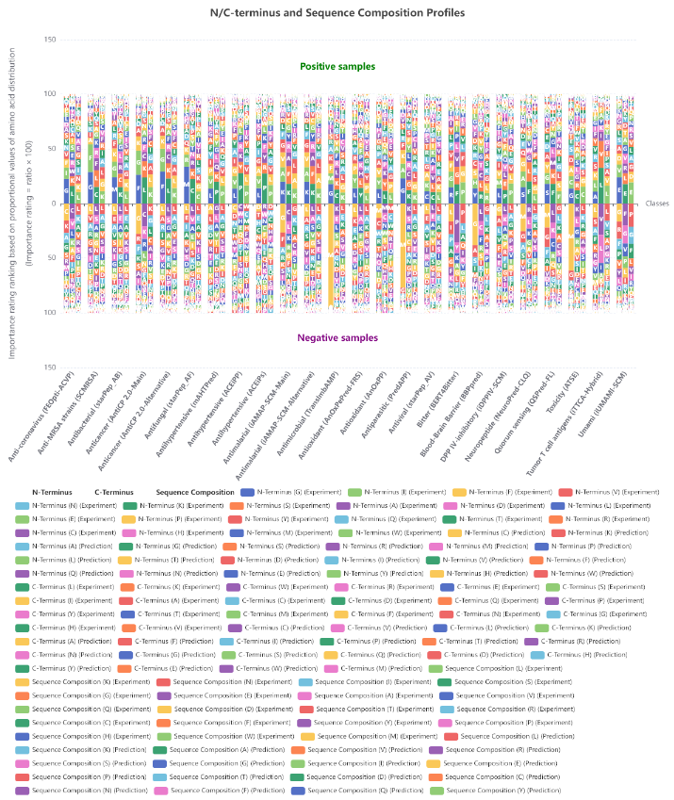
Supplementary Fig. 1 | N- and C-terminal sequence profiles and composition patterns across functional classes. Stacked bar plots illustrate the relative importance of sequence features derived from the N-terminus, C-terminus, and overall sequence composition for both positive (top, green) and negative (bottom, purple) samples across multiple protein classes. Feature importance is ranked based on amino acid distributions, with all contributions derived from experimental data. Each color corresponds to a specific feature type, as indicated in the legend.
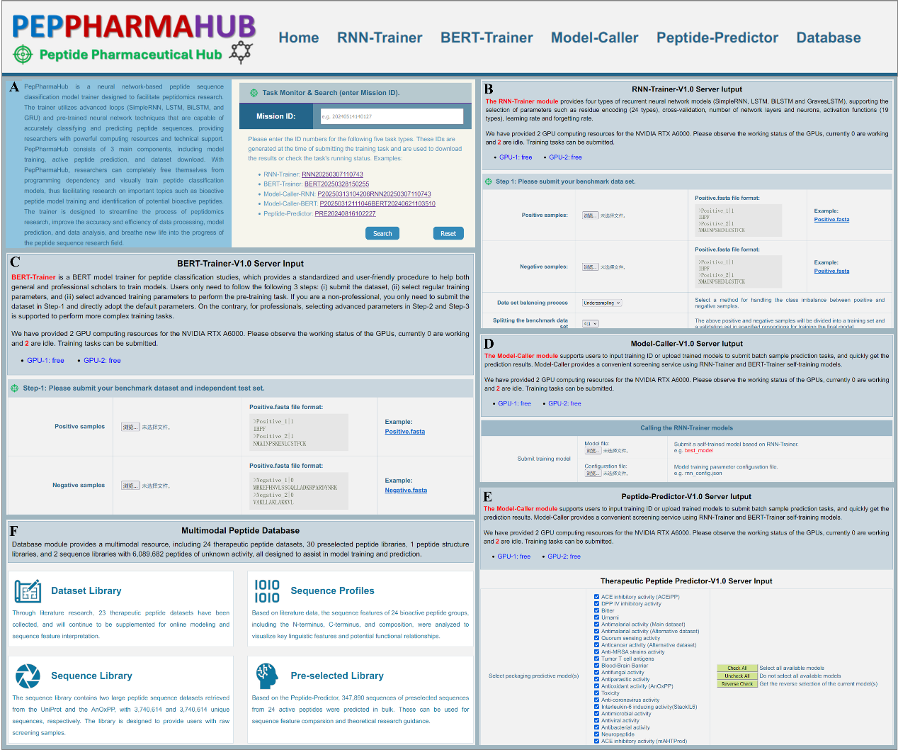
Supplementary Fig. 2 | Homepage, search, training, prediction and database interface of PepPharmaHub. a The homepage includes a description of the platform and ‘Mission Search’ access. b The RNN model training input interface. c The BERT model fine-turning input interface. d Self-training model calling input interface. e Therapeutic peptide screening input interface. f Database resource preview interface, including peptide datasets, pre-selected libraries and 3D structure libraries.

References
1. Jurtz, V.I., et al., An introduction to deep learning on biological sequence data: examples and solutions. Bioinformatics, 2017. 33(22): p. 3685-3690.
2. Tian, F., et al., In silico quantitative prediction of peptides binding affinity to human MHC molecule: an intuitive quantitative structure-activity relationship approach. Amino Acids, 2009. 36(3): p. 535-554.
3. Georgiev, A.G., Interpretable numerical descriptors of amino acid space. J Comput Biol, 2009. 16(5): p. 703-23.
4. Henikoff, S. and J.G. Henikoff, Amino acid substitution matrices from protein blocks. Proceedings of the National Academy of Sciences, 1992. 89(22): p. 10915-10919.
5. Liang, G. and Z. Li, Factor analysis scale of generalized amino acid Information as the source of a new set of descriptors for elucidating the structure and activity relationships of cationic antimicrobial peptides. QSAR & Combinatorial Science, 2007. 26(6): p. 754-763.
6. Cocchi, M. and E. Johansson, Amino Acids Characterization by GRID and Multivariate Data Analysis. Quantitative Structure-Activity Relationships, 1993. 12(1): p. 1-8.
7. Shu, M., et al., Structural parameter characterization and bioactivity simulation based on peptide sequence. QSAR & Combinatorial Science, 2009. 28(1): p. 27-35.
8. Collantes, E.R. and W.J. Dunn, 3rd, Amino acid side chain descriptors for quantitative structure-activity relationship studies of peptide analogues. J Med Chem, 1995. 38(14): p. 2705-13.
9. Lin, Z.H., et al., New descriptors of amino acids and their application to peptide QSAR study. Peptides, 2008. 29(10): p. 1798-805.
10. Zaliani, A. and E. Gancia, MS-WHIM scores for amino acids: A new 3D-description for peptide QSAR and QSPR studies. Journal of Chemical Information and Computer Sciences, 1999. 39(3): p. 525-533.
11. Liang, G., et al., An index for characterization of natural and non-natural amino acids for peptidomimetics. PLoS One, 2013. 8(7): p. e67844.
12. van Westen, G.J., et al., Benchmarking of protein descriptor sets in proteochemometric modeling (part 1): comparative study of 13 amino acid descriptor sets. J Cheminform, 2013. 5(1): p. 41.
13. Hemmateenejad, B., S. Yousefinejad, and A.R. Mehdipour, Novel amino acids indices based on quantum topological molecular similarity and their application to QSAR study of peptides. Amino Acids, 2011. 40(4): p. 1169-83.
14. Yang, L., et al., ST-scale as a novel amino acid descriptor and its application in QSAM of peptides and analogues. Amino Acids, 2010. 38(3): p. 805-16.
15. Tong, J., et al., A descriptor of amino acids: SVRG and its application to peptide quantitative structure-activity relationship. SAR QSAR Environ Res, 2011. 22(5-6): p. 611-20.
16. Tong, J., et al., A descriptor of amino acids SVWG and its applications in peptide QSAR. J CHEMOMETR, 2012. 26(10): p. 549-555.
17. Liang, G.-Z., M. Shu, and S.-S.Z. Li, A new set of amino acid descriptors for the development of quantitative sequence-activity modelings of HLA-A*0201 restrictive CTL epitopes. J CHIN CHEM SOC-TAIP, 2008. 55(5): p. 1178-1185.
18. Tian, F., P. Zhou, and Z. Li, T-scale as a novel vector of topological descriptors for amino acids and its application in QSARs of peptides. Journal of Molecular Structure, 2007. 830(1-3): p. 106-115.
19. Mei, H., et al., A new set of amino acid descriptors and its application in peptide QSARs. Biopolymers, 2005. 80(6): p. 775-86.
20. Tong, J., et al., A new descriptor of amino acids-SVGER and its applications in peptide QSAR. Molecular Informatics, 2017. 36(5-6): p. 1501023.
21. Tong, J., et al., A novel descriptor of amino acids and its application in peptide QSAR. J Theor Biol, 2008. 253(1): p. 90-7.
22. Hellberg, S., et al., Peptide quantitative structure-activity relationships, a multivariate approach. J Med Chem, 1987. 30(7): p. 1126-35.
23. Shu, M., et al., Predicting the activity of ACE inhibitory peptides with a novel mode of pseudo amino acid composition. Protein Pept Lett, 2011. 18(12): p. 1233-43.
24. Qin D, Jiao L, Wang R, Zhao Y, Hao Y, Liang G. Prediction of antioxidant peptides using a quantitative structure-activity relationship predictor (AnOxPP) based on bidirectional long short-term memory neural network and interpretable amino acid descriptors. Comput Biol Med. 2023;154:106591.
25. Qin D, Liang X, Jiao L, et al. Sequence-Activity Relationship of Angiotensin-Converting Enzyme Inhibitory Peptides Derived from Food Proteins, Based on a New Deep Learning Model. Foods. 2024;13(22):3550.

