eTable1 Baseline characteristics of participants according to median of atherogenic index of plasma
variable | Total  (n=2200) | Low  (n=1099) | High  (n=1101) | P value
Age (years) | 64.36 ± 11.16 | 66.47 ± 10.70 | 62.26 ± 11.21 | <0.001
Height (cm) | 164.42 ± 6.10 | 164.05 ± 5.99 | 164.79 ± 6.19 | <0.01
Weight (kg) | 65.22 ± 8.83 | 63.62 ± 8.63 | 66.81 ± 8.73 | <0.001
BMI (kg/m²) | 24.24 ± 7.21 | 23.73 ± 2.74 | 24.74 ± 9.80 | <0.001
SBP (mmHg) | 129.88 ± 22.60 | 129.82 ± 22.13 | 129.94 ± 23.07 | 0.91
DBP (mmHg) | 76.58 ± 13.29 | 75.96 ± 13.09 | 77.19 ± 13.48 | 0.03
HR (beats/min) | 75.84 ± 15.70 | 75.93 ± 15.23 | 75.74 ± 16.16 | 0.78
RBC | 4.35 ± 0.63 | 4.30 ± 0.62 | 4.39 ± 0.64 | <0.01
HGB (g/L) | 133.21 ± 19.00 | 131.79 ± 18.22 | 134.62 ± 19.65 | <0.001
WBC | 8.11 ± 3.60 | 8.06 ± 3.59 | 8.16 ± 3.62 | 0.54
PLT | 163.91 ± 62.86 | 160.09 ± 61.27 | 167.73 ± 64.20 | <0.01
TBIL (μmol/L) | 13.57 ± 7.59 | 14.20 ± 8.08 | 12.94 ± 7.01 | <0.001
ALT (U/L) | 46.84 ± 98.86 | 47.35 ± 116.29 | 46.32 ± 77.70 | 0.81
AST (U/L) | 74.33 ± 144.12 | 83.45 ± 169.39 | 65.21 ± 112.77 | <0.01
GLU (mmol/L) | 7.42 ± 3.26 | 7.23 ± 3.28 | 7.62 ± 3.23 | <0.01
UREA (mmol/L) | 6.63 ± 3.23 | 6.64 ± 3.11 | 6.62 ± 3.34 | 0.91
CERA (μmol/L) | 95.21 ± 55.51 | 92.49 ± 48.40 | 97.93 ± 61.69 | 0.02
eGFR (mL/min/1.73m²) | 78.02 ± 23.95 | 77.82 ± 22.85 | 78.23 ± 25.01 | 0.69
URIC (μmol/L) | 358.16 ± 101.22 | 345.04 ± 97.23 | 371.25 ± 103.45 | <0.01
CK (U/L) | 438.89 ± 944.15 | 471.30 ± 916.13 | 406.55 ± 970.65 | 0.11
LDH (U/L) | 315.25 ± 302.60 | 335.39 ± 336.59 | 295.14 ± 262.96 | <0.01
Na (mmol/L) | 140.12 ± 3.78 | 140.09 ± 3.96 | 140.15 ± 3.60 | 0.72
K (mmol/L) | 3.94 ± 0.49 | 3.94 ± 0.48 | 3.94 ± 0.50 | 0.73
Cl (mmol/L) | 105.30 ± 4.12 | 105.41 ± 4.31 | 105.20 ± 3.92 | 0.23
Ca (mmol/L) | 2.20 ± 0.15 | 2.19 ± 0.15 | 2.21 ± 0.15 | <0.001
AIP | 0.12 ± 0.29 | -0.10 ± 0.16 | 0.35 ± 0.20 | <0.001
Sex,No(%) |  |  |  | 0.06
Female | 475(21.59) | 256(23.29) | 219(19.89)
Male | 1725(78.41) | 843(76.71) | 882(80.11)
Diagnosis,No(%) |  |  |  | 0.99
NSTEMI | 402(18.27) | 202(18.38) | 200(18.17)
STEMI | 867(39.41) | 432(39.31) | 435(39.51)
UA | 931(42.32) | 465(42.31) | 466(42.33)
Smoking,No(%) |  |  |  | <0.01
Unclear | 13( 0.59) | 5( 0.45) | 8( 0.73)
Yes | 880(40.00) | 477(43.40) | 403(36.60)
No | 1307(59.41) | 617(56.14) | 690(62.67)
drinking,No(%) |  |  |  | 0.06
Unclear | 41( 1.86) | 24( 2.18) | 17( 1.54)
No | 1272(57.82) | 657(59.78) | 615(55.86)
Yes | 887(40.32) | 418(38.03) | 469(42.60)
Age group, No(%) |  |  |  | <0.001
>65 | 1196(54.36) | 685(62.33) | 511(46.41)
18-44 | 123( 5.59) | 34( 3.09) | 89( 8.08)
45-64 | 881(40.05) | 380(34.58) | 501(45.50)
stent, No(%) | 1695(77.05) | 848(77.16) | 847(76.93) | 0.94
COPD, No(%) | 23( 1.05) | 14( 1.27) | 9( 0.82) | 0.40
Stork, No(%) | 43( 1.95) | 24( 2.18) | 19( 1.73) | 0.53
DM, No(%) | 553(25.14) | 251(22.84) | 302(27.43) | 0.01
Hypertension, No(%) | 1308(59.45) | 647(58.87) | 661(60.04) | 0.61
CKD, No(%) | 122( 5.55) | 59( 5.37) | 63( 5.72) | 0.79
Hyperlipidemia, No(%) | 192( 8.73) | 41( 3.73) | 151(13.71) | <0.001
Peripheral , No(%) | 27( 1.23) | 16( 1.46) | 11( 1.00) | 0.44
Hyperuricemia , No(%) | 78( 3.55) | 22( 2.00) | 56( 5.09) | <0.001
Aspirin , No(%) | 2017(91.68) | 1001(91.08) | 1016(92.28) | 0.35
Clopidogrel , No(%) | 2041(92.77) | 1003(91.26) | 1038(94.28) | <0.01
Statin , No(%) | 2010(91.36) | 1003(91.26) | 1007(91.46) | 0.93
β-blocker, No(%) | 1434(65.18) | 684(62.24) | 750(68.12) | <0.01
ACEI, No(%) | 644(29.27) | 307(27.93) | 337(30.61) | 0.18
ARB, No(%) | 644(29.27) | 322(29.30) | 322(29.25) | 1.00
CCB, No(%) | 455(20.68) | 213(19.38) | 242(21.98) | 0.15
BMI , Body Mass Index; SBP , Systolic Blood Pressure; DBP , Diastolic Blood Pressure; HR , Heart Rate; RBC , Red Blood Cell Count; HGB , Hemoglobin; WBC , White Blood Cell Count; PLT , Platelet Count; TBIL , Total Bilirubin; DBIL , Direct Bilirubin; IBIL , Indirect Bilirubin; ALT , Alanine Aminotransferase; AST , Aspartate Aminotransferase; ALP , Alkaline Phosphatase; GGT , Gamma-Glutamyl Transferase; TP , Total Protein; ALB , Albumin; GBL , Globulin; GLU , Glucose; UREA , Urea; CERA , Creatinine; eGFR , Estimated Glomerular Filtration Rate; URIC , Uric Acid; CK , Creatine Kinase; LDH , Lactate Dehydrogenase; Na , Sodium; K , Potassium; Cl , Chloride; Ca , Calcium; Mg , Magnesium; Myo , Myoglobin; CK_MB , Creatine Kinase-MB; NT_proBNP , N-terminal Pro B-type Natriuretic Peptide; TPN_T , Troponin T; PT , Prothrombin Time; APTT , Activated Partial Thromboplastin Time; TT , Thrombin Time; FIB , Fibrinogen; AIP , Atherogenic Index of Plasma; NSTEMI , Non-ST-Elevation Myocardial Infarction; STEMI , ST-Elevation Myocardial Infarction; UA , Unstable Angina; COPD , Chronic Obstructive Pulmonary Disease; DM , Diabetes Mellitus; CKD , Chronic Kidney Disease; ACEI , Angiotensin-Converting Enzyme Inhibitors; ARB , Angiotensin Receptor Blockers; CCB , Calcium Channel Blockers; and β-blocker , Beta-Blocker

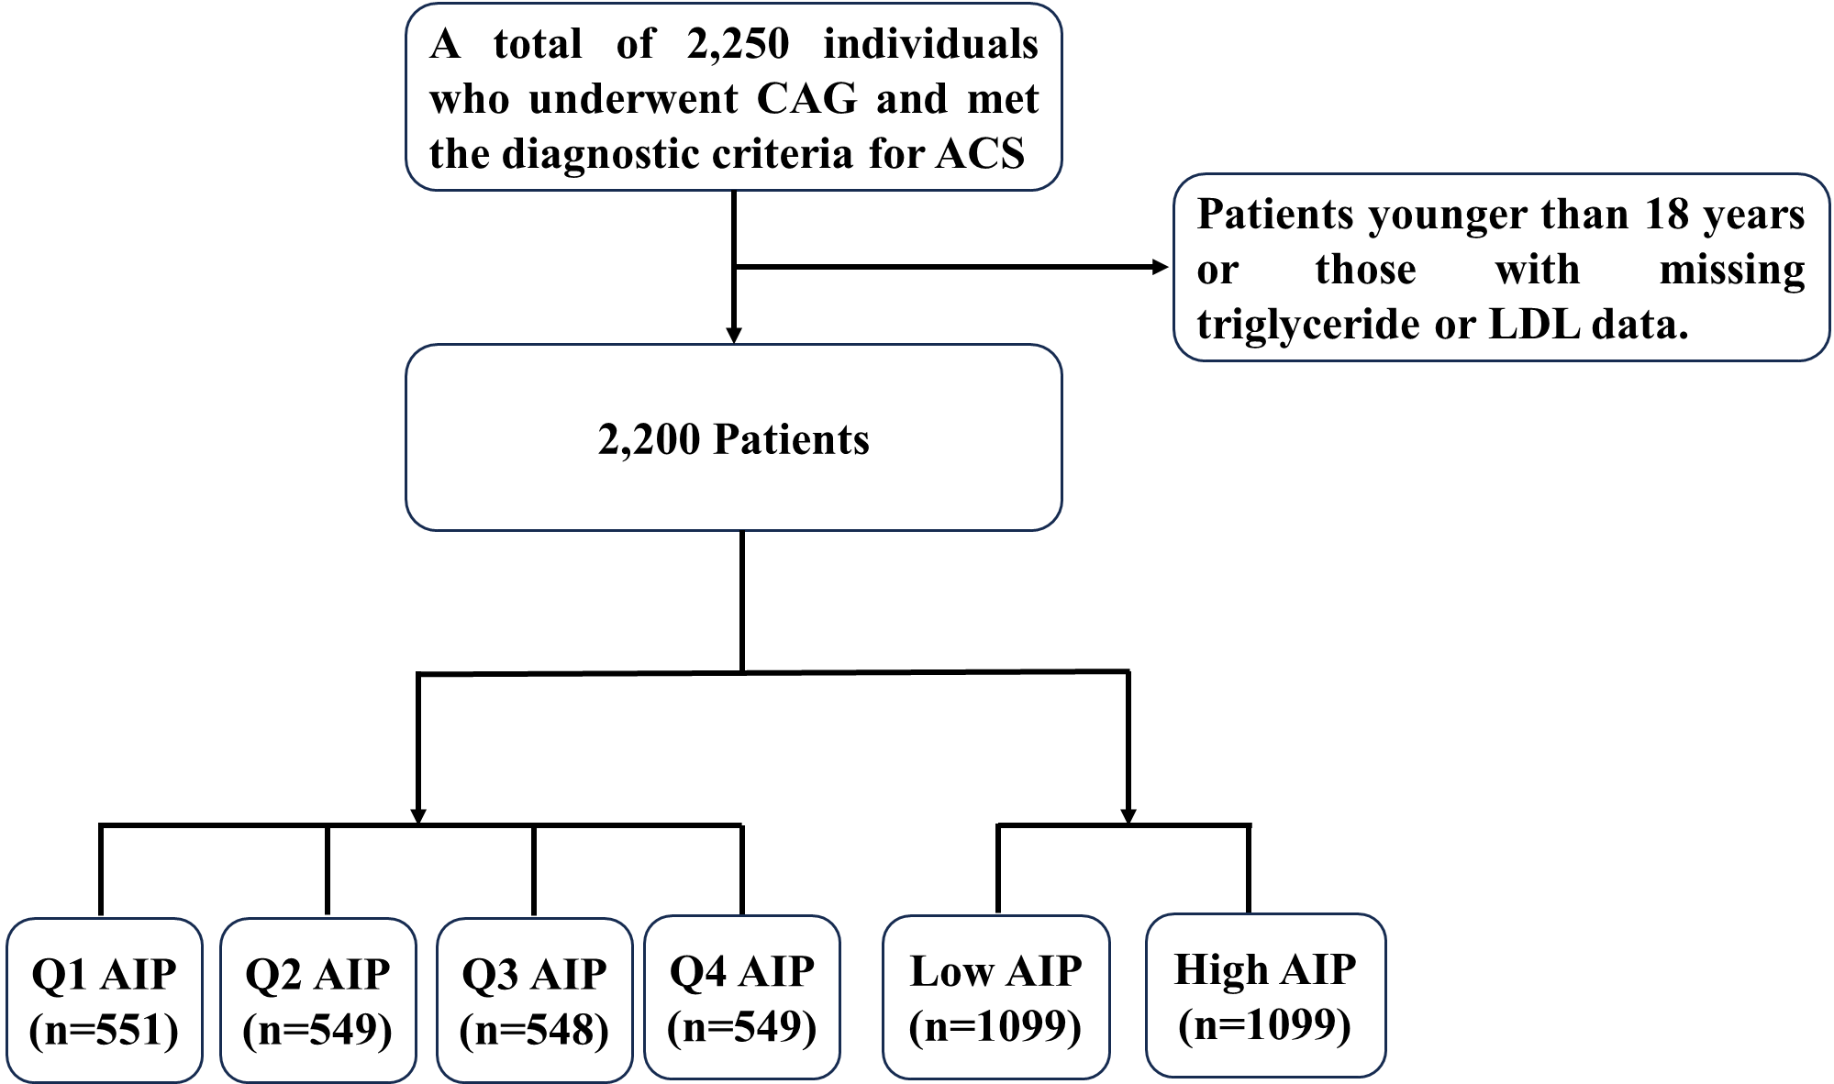
eFigure 1 Flow diagram of study population
CAG coronary angiography, ACS acute coronary syndrome, AIP atherogenic index of plasma, Q quartile.

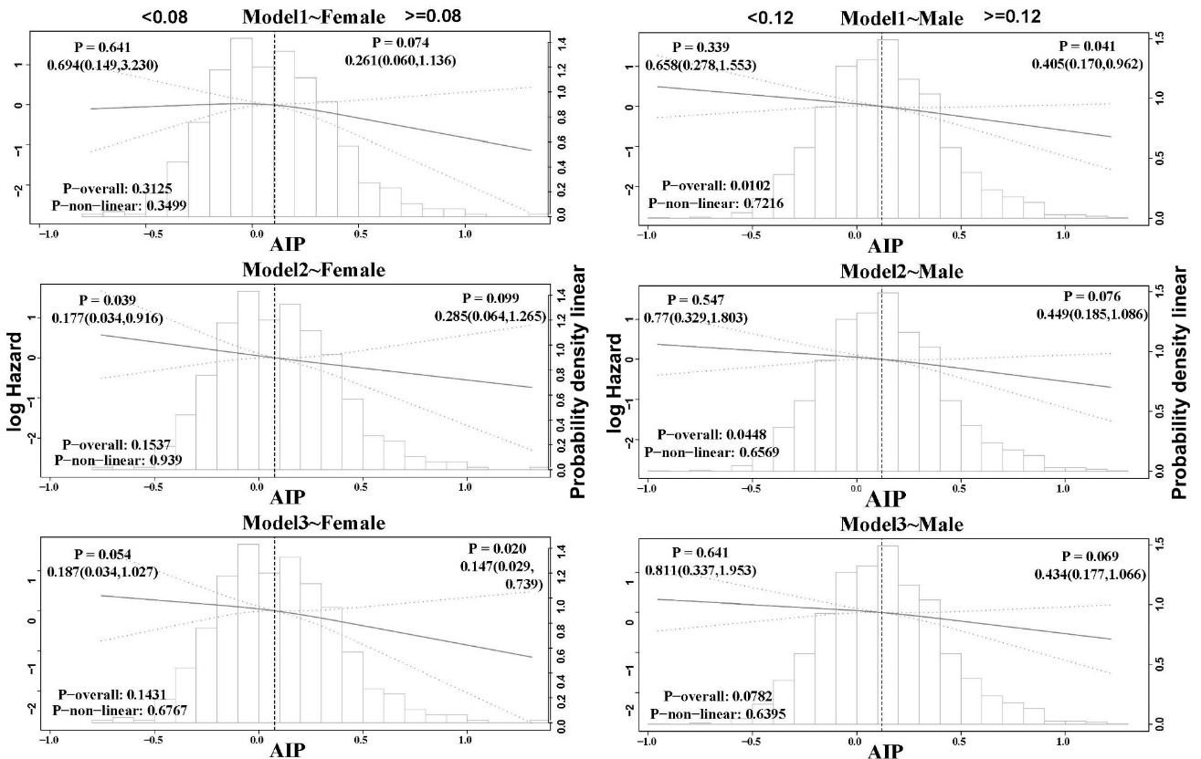
A
B
eFigure 2 Restricted cubic spline (RCS) curve of atherogenic index of plasma and HR in patients with acute myocardial infarction.
Model 1 is unadjusted. Model 2 is adjusted for age, sex, body mass index (BMI), smoking status, alcohol consumption, systolic blood pressure (SBP), diastolic blood pressure (DBP), and estimated glomerular filtration rate (eGFR). Model 3 includes additional adjustments based on Model 2, incorporating variables such as stroke, diabetes mellitus (DM), hypertension, chronic kidney disease (CKD), hyperlipidemia, peripheral vascular disease, hyperuricemia, and the use of medications including aspirin, clopidogrel, statins, β-blockers, angiotensin-converting enzyme inhibitors (ACEI), angiotensin II receptor blockers (ARB), as well as platelet count (PLT), alanine aminotransferase (ALT), aspartate aminotransferase (AST), potassium (K), and glucose (GLU)

eTable2 Stratified Analysis of Plasma Atherogenic Index and Mortality Risk in Acute Coronary Syndrome Patients by Quartiles
character | Q1 | Q2 | P | Q3 | P | Q4 | P
Age Group
45-64 | ref | 1.005(0.596,1.696) | 0.985 | 1.042(0.629,1.727) | 0.872 | 0.853(0.507,1.434) | 0.548
>65 | ref | 1.084(0.828,1.418) | 0.558 | 1.015(0.761,1.352) | 0.921 | 0.831(0.607,1.139) | 0.250
18-44 | ref | 1.882(0.171,20.753) | 0.606 | 2.809(0.328,24.046) | 0.346 | 1.094(0.122, 9.791) | 0.936
sex
No | ref | 1.175(0.747,1.848) | 0.486 | 1.033(0.643,1.660) | 0.895 | 0.778(0.464,1.306) | 0.343
Yes | ref | 0.964(0.730,1.274) | 0.799 | 0.893(0.672,1.186) | 0.434 | 0.670(0.496,0.907) | 0.009
Strok
No | ref | 0.970(0.763,1.234) | 0.807 | 0.907(0.710,1.158) | 0.432 | 0.655(0.503,0.854) | 0.002
Yes | ref | 6.072(0.730,50.518) | 0.095 | 1.968(0.123,31.479) | 0.632 | 5.353(0.625,45.840) | 0.126
Smoking
No | ref | 1.205(0.847,1.713) | 0.300 | 0.976(0.667,1.428) | 0.901 | 0.721(0.476,1.092) | 0.123
Yes | ref | 0.869(0.629,1.200) | 0.393 | 0.856(0.621,1.180) | 0.342 | 0.660(0.470,0.926) | 0.016
Drinking
No | ref | 1.079(0.801,1.452) | 0.617 | 0.944(0.696,1.281) | 0.711 | 0.765(0.551,1.063) | 0.111
Yes | ref | 1.033(0.685,1.559) | 0.876 | 0.937(0.614,1.431) | 0.765 | 0.650(0.415,1.017) | 0.059
DM
No | ref | 1.140(0.755,1.721) | 0.533 | 0.902(0.584,1.391) | 0.639 | 0.787(0.514,1.206) | 0.271
Yes | ref | 0.903(0.674,1.211) | 0.496 | 0.888(0.661,1.193) | 0.430 | 0.567(0.404,0.795) | 0.001
Hypertension
No | ref | 1.058(0.787,1.423) | 0.707 | 0.890(0.652,1.215) | 0.463 | 0.707(0.510,0.980) | 0.037
Yes | ref | 0.873(0.583,1.309) | 0.511 | 0.940(0.636,1.391) | 0.758 | 0.631(0.408,0.976) | 0.039
CKD
No | ref | 1.157(0.631,2.121) | 0.637 | 0.629(0.315,1.257) | 0.189 | 0.568(0.303,1.068) | 0.079
Yes | ref | 1.003(0.775,1.298) | 0.980 | 0.971(0.748,1.260) | 0.822 | 0.673(0.506,0.897) | 0.007
Hyperlipidemia
No | ref | 1.005(0.790,1.279) | 0.965 | 0.954(0.745,1.221) | 0.708 | 0.732(0.557,0.962) | 0.025
Yes | ref | 1.214(0.290,5.082) | 0.790 | 0.622(0.149,2.605) | 0.516 | 0.681(0.194,2.390) | 0.548
Peripheral
No | ref | 1.001(0.787,1.273) | 0.991 | 0.925(0.724,1.182) | 0.532 | 0.685(0.526,0.891) | 0.005
Yes | ref | 1.236(0.270,5.663) | 0.785 | 0.616(0.064,5.957) | 0.676 | 1.123(0.186,6.772) | 0.899
Hyperuricemia
No | ref | 1.003(0.789,1.274) | 0.981 | 0.903(0.705,1.156) | 0.418 | 0.681(0.522,0.888) | 0.005
Yes | ref | 1.553(0.174,13.899) | 0.694 | 1.557(0.191,12.694) | 0.679 | 1.032(0.124, 8.596) | 0.977
Diabetes mellitus (DM), hypertension, chronic kidney disease (CKD).

