Title
Material-specific three-dimensional printing of electrostatic chuck components via digital light processing: Integration of Al₂O₃ and BaTiO₃ as dual materials for performance optimization
Author Information
Yujin Kim¹, Jae-Hyuk Park^{2,3}, Jongwoo Lim^{2,3,}*, Sukeun Yoon ^{1,}*, Jihoon Kim ^{1,4,}*

¹ Division of Advanced Materials Engineering, Kongju National University, Cheonan, 32588, Republic of Korea
² School of Advanced Materials Science & Engineering, Sungkyunkwan University, Suwon, 16419, Republic of Korea
³ Electro Static Technology, Inc., Osan, 18102, Republic of Korea
⁴ Regional Industrial Application Lab, Kongju National University, Cheonan, 32588, Republic of Korea

*Corresponding author: jwlim80@skku.edu (J. Lim), skyoon@kongju.ac.kr (S. Yoon), Jihoon.kim@kongju.ac.kr (J. Kim)

Description
- Mechanical analysis of Al₂O₃- and BaTiO₃-resin dielectric layers: tensile properties, and force tolerance (Section S1-2)
- Surface profilometry-based air gap determination using 3D and 2D roughness measurements of the Al₂O₃-coated ESC (Section S3-S4)
- Surface profilometry-based air gap determination using 3D and 2D roughness measurements of the BaTiO₃-coated ESC (Section S5-S6)
- FEA-based chucking force simulations with varying dielectric layer thickness and material compositions (Section S7)

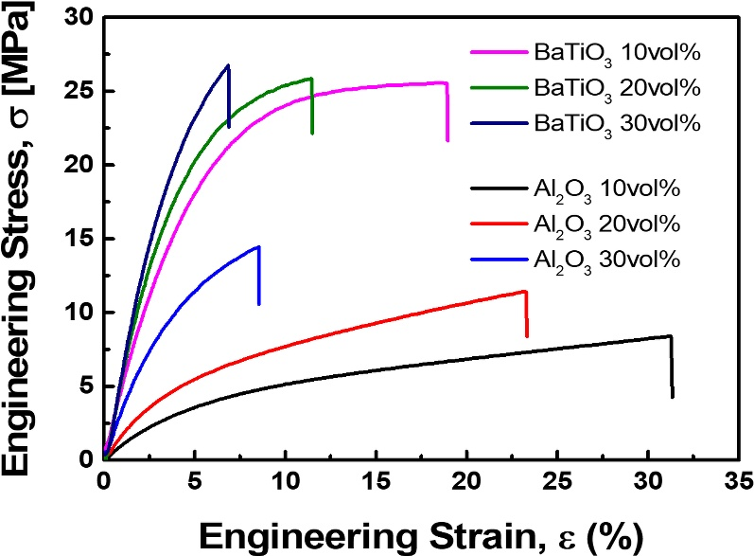
Section S1. Tensile stress-strain behavior of Al₂O₃- and BaTiO₃-resin composites with varying ceramic contents.
Figure S1. Tensile stress–strain curves of Al₂O₃- and BaTiO₃-resin composites with varying ceramic contents (10, 20, and 30 vol%), used to assess the mechanical performance of the dielectric layer materials.

Section S2. Maximum tolerable forces calculated from ultimate tensile strength (UTS) values of Al₂O₃- and BaTiO₃-resin composites.

 | $$σ_{UTS}$$ | Thickness = 70um | Thickness = 200um
Al₂O₃ 10vol% | 8.40 MPa | 0.588 N | 1.680 N
Al₂O₃ 20vol% | 11.41 MPa | 0.799 N | 2.282 N
Al₂O₃ 30vol% | 14.45 MPa | 1.012 N | 2.890 N
BaTiO₃ 10vol% | 25.55 MPa | 1.789 N | -
BaTiO₃ 20vol% | 25.84 MPa | 1.809 N | -
BaTiO₃ 30vol% | 26.74 MPa | 1.872 N | -
Table S1. Maximum tolerable forces for each Al₂O₃- and BaTiO₃-resin composite, calculated from their UTS values as a function of dielectric layer thickness.

Section S3. 3D profilometry-based air gap determination using surface roughness of the Al₂O₃-coated ESC.
Figure S2. 3D surface profiler measurement of the Al₂O₃-coated ESC (a) measurement areas (5×5mm²) on the ESC surface and (b-f) surface profile results with a total average roughness of 5.035 $μ$m.

Section S4. 2D profilometry-based air gap determination using surface roughness of the Al₂O₃-coated ESC.
Figure S3. 2D surface profile of the Al₂O₃-coated ESC, indicating a total average roughness of 4510.08 nm.

Section S5. 3D profilometry-based air gap determination using surface roughness of the BaTiO₃-coated ESC.
Figure S4. 3D surface profiler measurement of the BaTiO₃-coated ESC (a) measurement areas (5×5mm²) on the ESC surface and (b-f) surface profile results with a total average roughness of 1.819 $μ$m.

Section S6. 2D profilometry-based air gap determination using surface roughness of the BaTiO₃-coated ESC.
Figure S5. 2D surface profile of the BaTiO₃-coated ESC, indicating a total average roughness of 1645.37 nm.

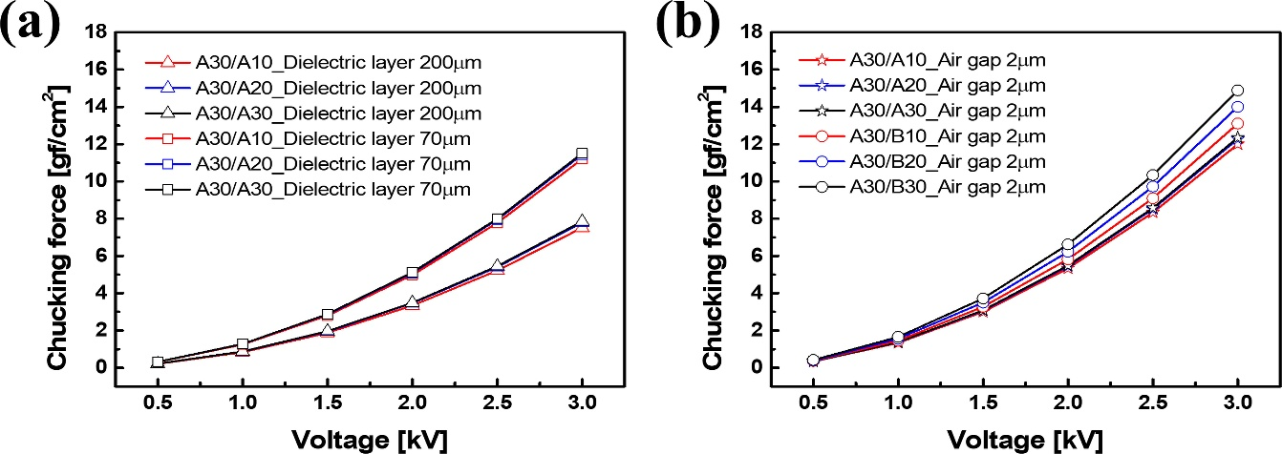
Section 7. FEA-based chucking force simulations with varying dielectric layer thickness and material compositions.
Figure S6. Simulated chucking force as a function of applied voltage. (a) Comparison of dielectric-layer thicknesses (70 $μ$m vs. 200 $μ$m) using Al₂O₃-resin composites. (b) Comparison between Al₂O₃- and BaTiO₃-resin based dielectric layers with the same thickness (70 $μ$m) and air gap (2 $μ$m).

