Soil pH and moisture drive depth-specific patterns of SOC, TN, and TP along elevational gradients in Chinese montane forests.
Author: Shihan Fu^{1,#}, Shijie Guo^{1,#}, Jing Wang^{1*}, Ziqiong Yuan¹, Xinzhe Wu¹, Shengyao Mu¹, Ruiqiang, Liu¹, Hua Chai¹, Zhenggang Du¹, Yang Qiao², Xuhui Zhou¹
¹Institute of Carbon Neutrality, Key Laboratory of Sustainable Forest Ecosystem Management-Ministry of Education, School of Ecology, Northeast Forestry University, Harbin 150040, China
²Tiantong National Station of Forest Ecosystem, School of Ecological and Environmental Sciences, East China Normal University, Shanghai 200241, China;

#These authors contributed equally.
*To whom correspondence should be addressed: Jing Wang.
School of Ecology, Northeast Forestry University, Harbin, 150040, China
Email: jingwang@nefu.edu.cn;

Table S1. The geographical attributes of 34 mountains across China. These geographical attributes are Longitude (º), Latitude (º), Altitude (m), and soil depth in each island. Climatic variables include average annual temperature (Temp, ^{°C) and} average precipitation (Prep, mm).
No. | Mountain | Altitude  (m) | Range  (m) | Longitude  (º) | Latitude  (º) | Temp.  (ºC) | Prep.  (mm) | Vegetation  type | Refs
1 | Ailao | 3100 | 1538 | 100.73 | 23.6 | 18.7 | 1102.8 | AM, EBF, NF | 1,2
2 | Altai | 2050 | 800 | 87.22~87.45 | 48.39 ~48.55​ | -2~3 | 500~800 | CBMF, CMF | 3
3 | Changbai | 1280 | 730 | 125.3~130.3 | 40.68~44.5 | -7.3~4.8 | 700~1400 | CMF, CF | 4
4 | Dabie | 1700 | 1200 | 116.05 | 30.67 | 12 | 1300 | EBF, DEBF, DBF, DNF, NF | 5
5 | Daiyun | 1501 | 698 | 118.18 | 25.66 | 15.6~19.5 | 1700~2000 | CEBF, CF | 6
6 | Dongling |  | 1613 | 115.4~115.5 | 40~40.05 | 6~10 | 600~800 | DBF | 7
7 | Fanjing | 2500 | 1980 | 108.60 | 27.78 | 12.1 | 2600 | AM | 8
8 | Fengyang | 1700 | 800 | 119.1 | 27.76 | 11.8 | 2000 | BMF, CBMF, FF, BF | 9
9 | Helan | 2664 | 1615 | 105.81~106.68 | 38.31~39.36 | 8.6 | 209.2 | DS, PCF, SM | 10
10 | Leigong | 2170 | 1470 | 108.20 | 26.38 | 9.2 | 1300~1600 | Shrub, DBF, EBF, MF | 11
11 | Lianhua | 1000 | 500 | 115.22 | 23.06 | 22 | 1935.7 | EBF | 12
12 | Maoer | 2100 | 1650 | 110.49 | 25.88 | 12.8 | 2100 | EBF, BF, MF | 13
13 | Mount Huang | 1864 | 1400 | 118.01~118.28 | 30.01~30.3 | 8.3 | 2400 | EBF、EDF、AM | 14
14 | Qilian | 3300 | 600 | 101.95 | 37.28 | 4 | 400 | CF, AM | 15
15 | Qinling | 2400 | 900 | 108.35 | 33.3 | 8~10 | 900~1200 | CF, MF | 16
16 | Taibai | 3767 | 2112 | 107.37 | 33.82 | 13 | 694.2 | AM、NF、DBF、BDF | 17,18
17 | Tianmu | 1474 | 1107 | 119.38 | 30.3 | 8.8~14.8 | 1390~1870 | EBF, DBF | 19
18 | Tian | 3550 | 1350 | 82.1~87.9 | 42~43.5 | 7 | 150~350 | SH | 20
19 | Wuyi | 2100 | 1600 | 117.45 | 27.55 | 17.6 | 1864 | EBF, CBF, CF | 21,22
20 | Xiaowutai | 3061 | 1400 | 115.3~115.5 | 39.83~41.17 | 6.4 | 400-700 | DBF, CBMF, CF, AM | 23
21 | Zheduo | 4200 | 800 | 100.73 | 23.6 | 8 | 1600 | MSES, ASM | 24
22 | Zhegu | 4000 | 3558 | 103.3 | 31.23 | 11.2 | 493 | AF, AM | 25

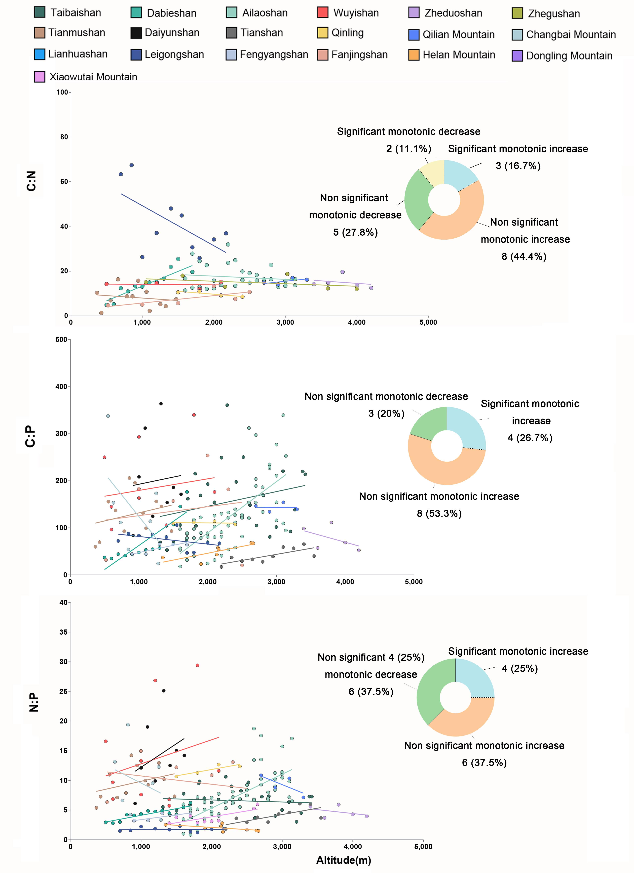
Figure S1. Altitudinal patterns of log-transformed stoichiometric ratios (C:N , C:P , N:P) at topsoil. Pie charts illustrate the proportion of significant positive or negative responses (p < 0.05) relative to the total observations.

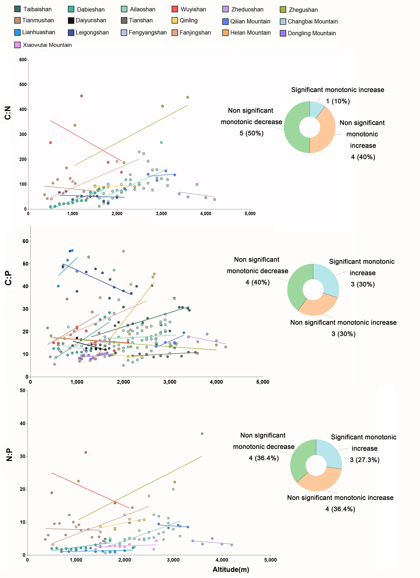
Figure S2. Altitudinal patterns of log-transformed stoichiometric ratios (C:N , C:P , N:P) at subsoil. Pie charts illustrate the proportion of significant positive or negative responses (p < 0.05) relative to the total observations.

Figure S3. Distribution of carbon, nitrogen, and phosphorus contents of topsoil and subsoil under different soil moisture and pH values.

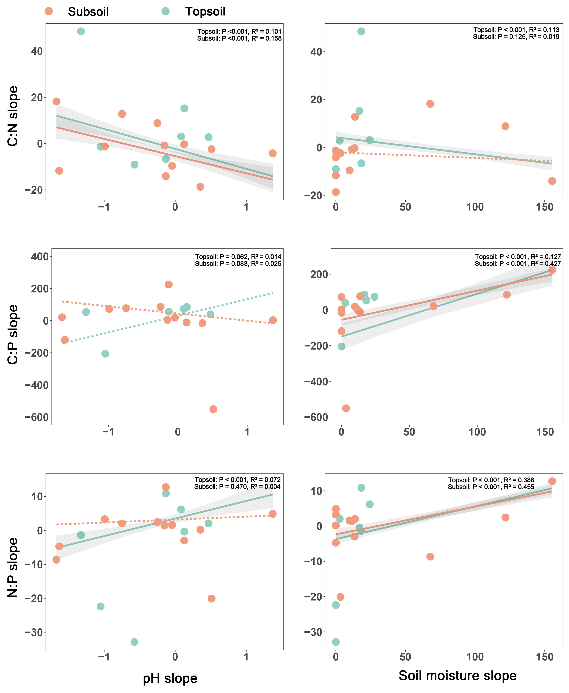
Figure S4. Correlation between the slopes of C:N, C:P and N:P in topsoil and subsoil and the slopes of soil pH and soil moisture. The coefficient of determination (R²) and corrected P value are reported.

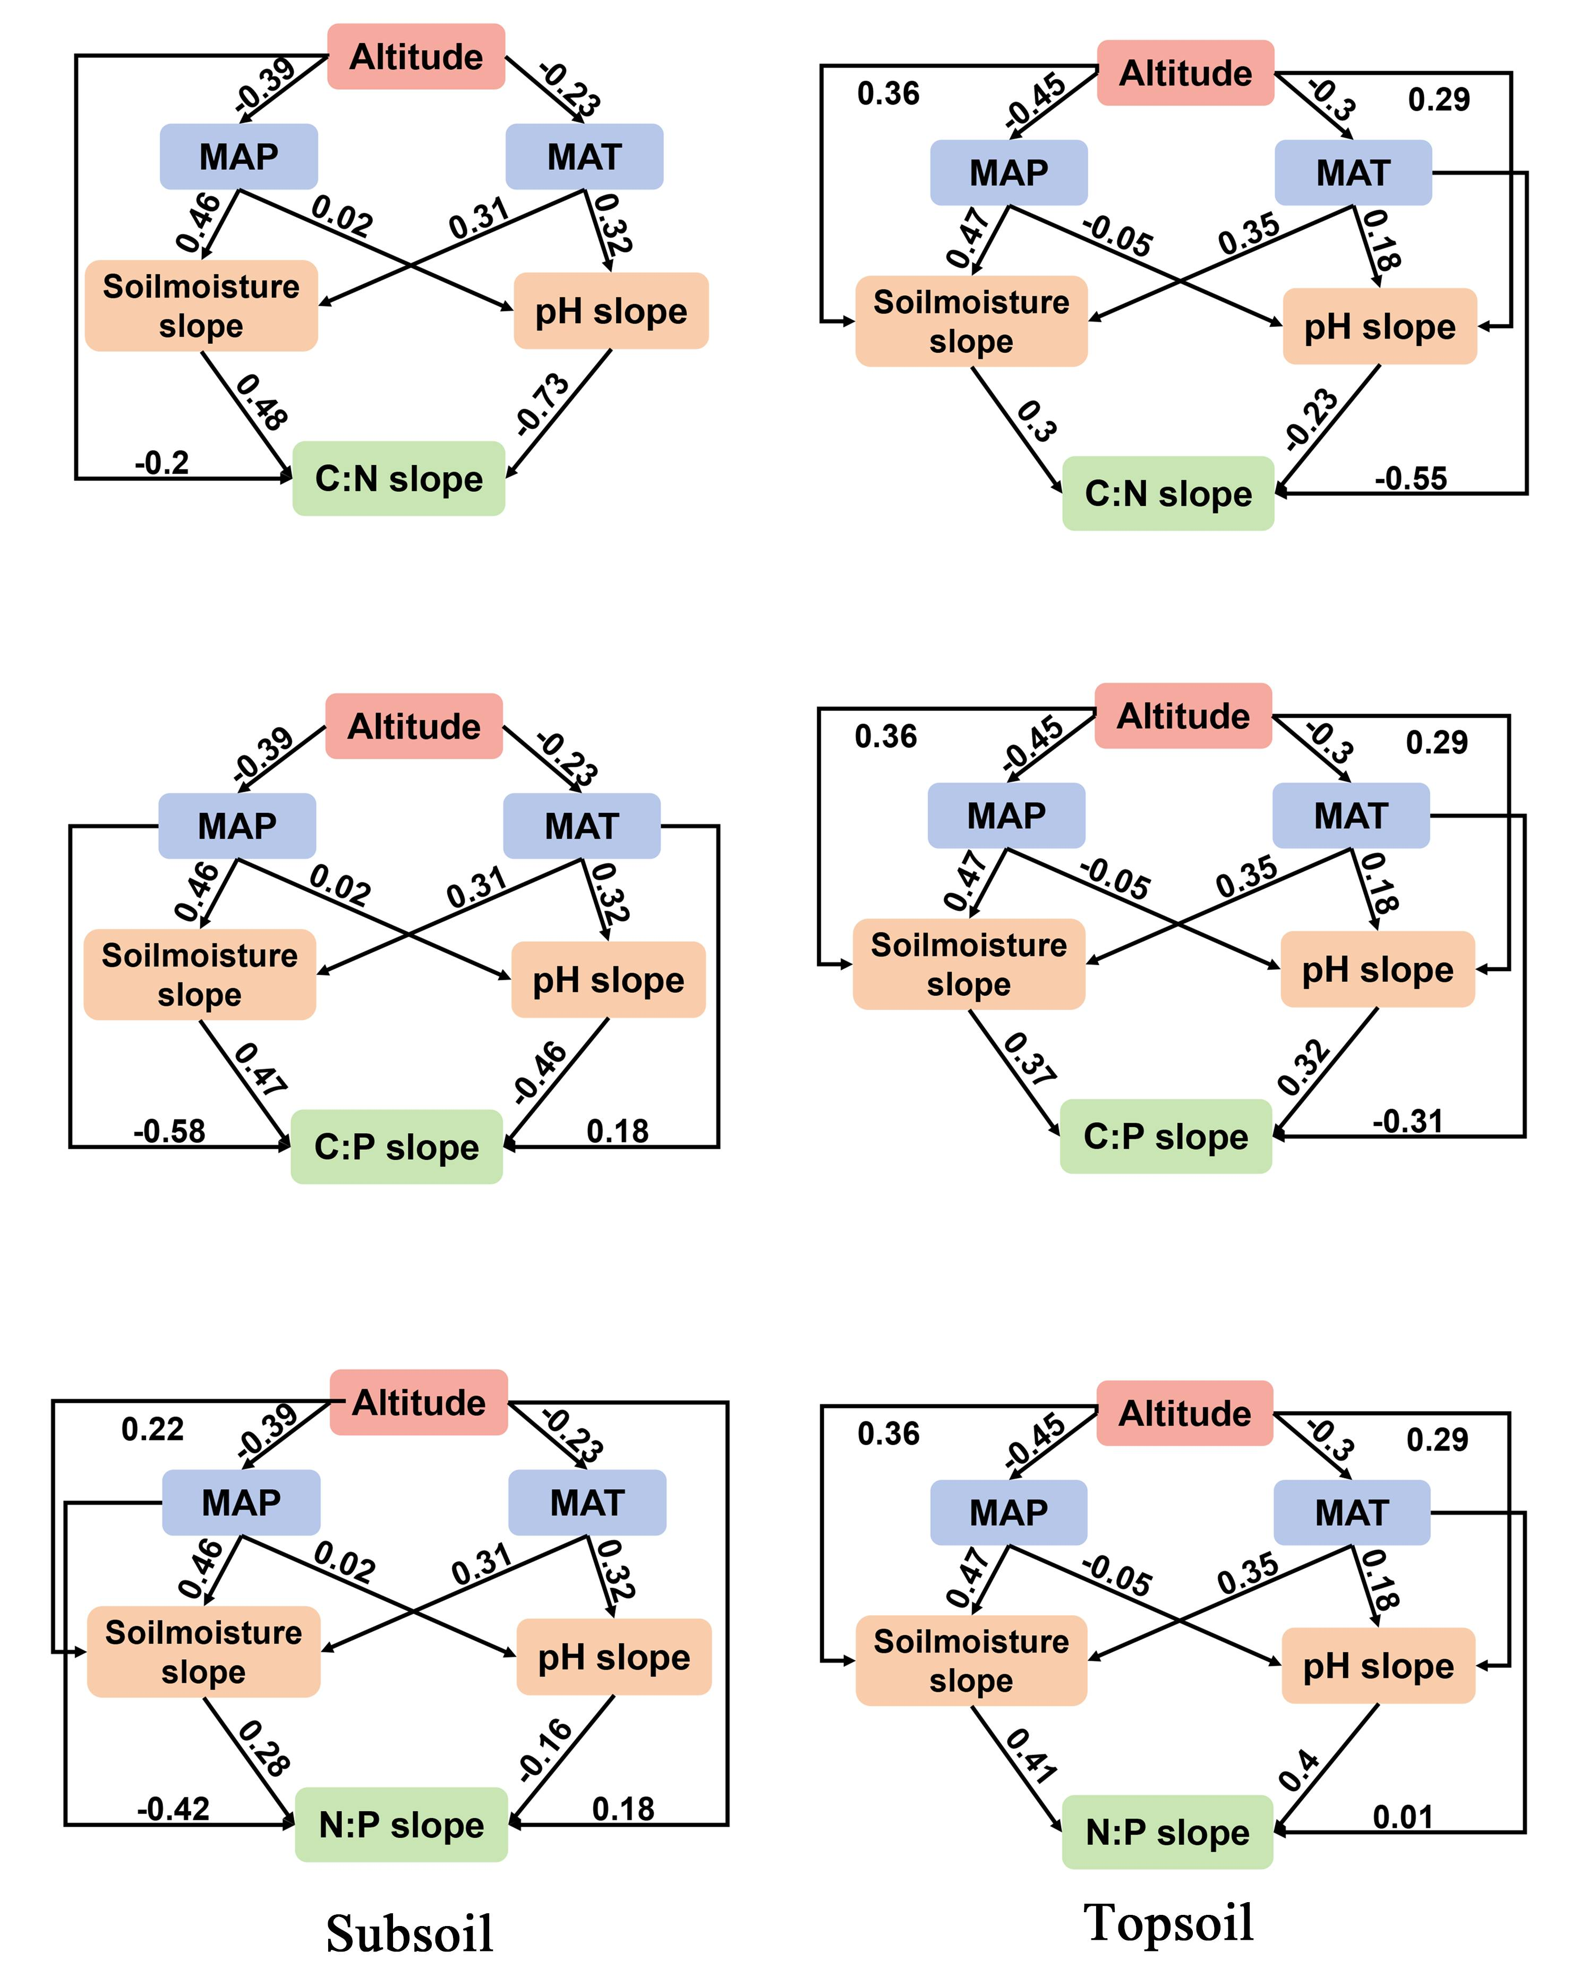
Figure S5. A structural equation model describing the influence of the mean annual temperature (MAT), mean annual precipitation (MAP), and the slopes of soil pH and soil moisture on the altitude trends of C:N, C:P and N:P in topsoil and subsoil. Numbers on arrows are standardized path coefficients (equivalent to correlation coefficients), in bold if significant at P< 0.05. Line widths are positively related to path coefficients. The percentage near boxes indicates the variance explained by the model (R²).

References used for data collection:

- Yang, X. (2019). Vertical Differentiation of Ecological Stoichiometric Characteristics in Ailao Mountain Nature Reserve.(Master's thesis). Yunnan Normal University.
- Gao, D. (2020). Analysis on the characteristics of soil physical and chemical properties and soil quality along the altitude gradient in the East and West slopes of Ailao Mountains National Nature Reserve.(Doctoral dissertation). Yunnan Normal University.
- Ma, Z., et al. (2016). Soil Characteristics and Fertility Evaluation of Abies sibirica Forest at Different Altitude Gradients in Altai Mountain.Research of Soil and Water Conservation, 23(5):134–140.
- Liu, X., Zhu, J., Guan, S., et al. (2023). Ecological stoichiometric characteristics of soil carbon, nitrogen, and phosphorus in forest wetlands at different elevations in the Changbai Mountain region. Journal of Tonghua Normal University, 44(4):21–28.
- Ge, P. (2014). Dynamics of forest soil carbon and nitrogen along an altitudinal gradient on Dabie Mountain, Anhui Province (Doctoral dissertation). East China Normal University.
- Li, M., He, Z., Jiang, L., et al. (2021). Distribution pattern and driving factors of species diversity and phylogenetic diversity along altitudinal gradient on the south slope of Daiyun Mountain.Acta Ecologica Sinica, 41(3): 1148–1157.
- Zhang, D., Zhang, Y., Qu, L., et al. (2012). Effects of altitude on soil microbial community in Quercus liaotungensis forest.
- Yan, Q., et al. (2015). Nutrient Characteristics of Forest Soil at Different Elevation in Fanjingshan Nature Reserve. Guizhou Agricultural Sciences, 43(8):146–150.
- Zhao, Y., Meng, M., Zhang, J., et al. (2018). Study on the composition and stability of soil aggregates of the main forest stands in Fengyang Mountain, Zhejiang Province. Journal of Nanjing Forestry University (Natural Science Edition), 42(5): 84–90.
- Yang J., et al. (2024). Characteristics of soil physicochemical properties and enzyme activities in different vegetation types on the western slope of Helan Mountain. Journal of Zhejiang A&F University, 4(4): 787–796.
- Jiang, X., et al. (2018). Vertical zonality of forest soil carbon, nitrogen, and phosphorus stoichiometric characteristics in Leigong Mountain Nature Reserve. Jiangsu Agricultural Sciences, 4(14): 292–295.
- Gou, X., Zhang, M., & Li, H. (2019). Soil Nutrients and Stoichiometric Characteristics along Altitude of Lianhua Mountain in Guangdong Province. Forestry and Environmental Science, 35(3): 82–86.
- Qin, H., et al. (2019). Soil C:N:P stoichiometry at different altitudes in Mao' er Mountain, Guangxi, China. Chinese Journal of Applied Ecology, 30(3).
- Yao, L., Zhang, H., Hu, L., Wang, G., & Fang, Y. (2019). Soil labile organic carbon and nitrogen and their relationship with enzyme activities in different vegetation zones along an altitudinal gradient on Mount Huangshan. Journal of Zhejiang A&F University, 36(6): 1069–1076.
- Bai, L., et al. (2024). Vertical variations in soil carbon, nitrogen, phosphorus content, and ecological stoichiometric characteristics under typical vegetation in Qilian Mountains. Arid Zone Research, 41(3).
- Wei, X., Zheng, X., & Zhang, S. (2014). Forest Soil Physicochemical Properties along Different Altitudinal Gradients at Huoditang in the Qinling Mountains. Journal of Northwest Forestry University, 29(3): 9–14.
- Li, D., Wang, Z., Tian, H., He, W., & Geng, Z. (2017). Soil carbon, nitrogen, phosphorus content, and stoichiometric characteristics at different elevations in Taibai Mountain. Acta Pedologica Sinica, 54(1): 160–170.
- Ma, H., Xie, M., Hu, H., et al. [Year]. Effects of stoichiometric characteristics of soil-plant-litter on soil nitrogen components in different forests along an elevational gradient of Qinling Mountains. Chinese Journal of Ecology.
- Yang, S., Ma, Y., Jiang, P., et al. (2009). Soil physical and chemical properties along altitudes of Western Tianmushan, Zhejiang. Journal of East China Normal University (Natural Science), (6): 101–107.
- Yu, G., et al. (2023).Altitude and plant community jointly regulate soil stoichiometry characteristics of natural grassland in the Baluntai area on the southern slope of the middle Tianshan Mountains, China. Acta Prataculturae Sinica, 32(9).
- Y. (2012). Variations of Soil Microbial Diversity along an Elevation Gradient in the Wuyi Mountains (Doctoral dissertation). Nanjing Forestry University.
- Nie, Y., et al. (2018). Characteristics of soil organic carbon mineralization in low altitude and high altitude forests in Wuyi Mountains，southeastern China．Chinese Journal of Applied Ecology, 29(3): 748.
- Ren, Q., Wang, X., Li, L., et al. (2019). Vertical Variation of Soil Physical and Chemical Properties at Different Altitudes in Xiaowutai Mountain. Journal of Soil and Water Conservation, 33(1): 241–247.
- Liu, Y. (2018). Soil nutrient distribution characteristics at different altitudinal gradients in the high and cold mountainous region of Western Sichuan (Master's thesis). Sichuan Agricultural University.
- Cao, R., Wu, F., Yang, W., et al. (2016). Effects of altitudes on soil microbial biomass and enzyme activity in alpine-gorge regions. Chinese Journal of Applied Ecology, 27(4): 1257–1264.

