Supplementary Information

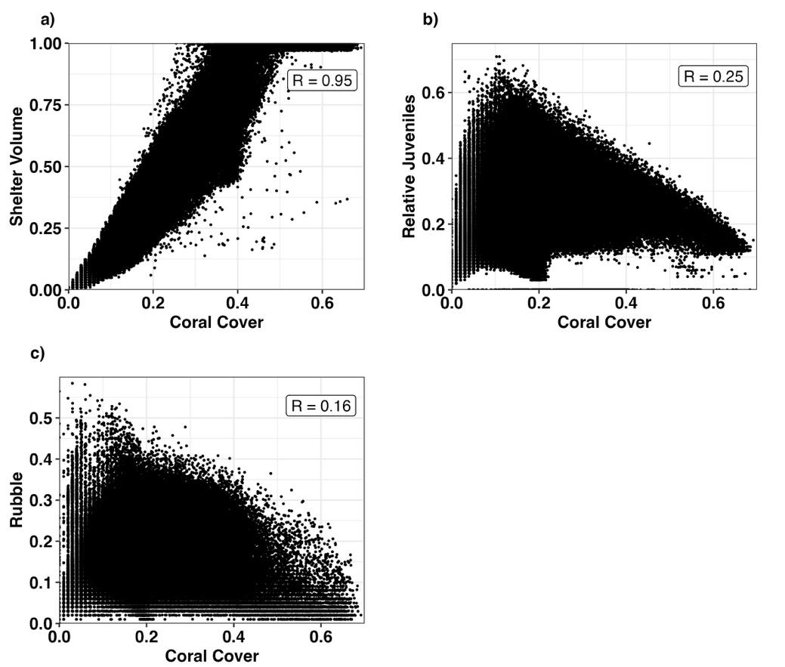
Supplementary Figure 1: Scatter plots of a) Shelter Volume, b) Relative Recruits and c) Rubble against Coral Cover. Each point is an annual observation from one the 3,806 reefs on the GBR, from 2007-2100. See Table 1 for information on how these values were obtained form ReefMod-GBR. In each subplot, Pearson correlation coefficient’s (R) are shown for each variable combination.

