FINE SEDIMENT PRODUCTION DURING URBAN DEVELOPMENT: THE DAMAGE IS DONE EARLY
Paulo V. R. M. Silva^{a,b,c,}*, Kathryn L. Russell^{b}, Tim D. Fletcher^{b}, Oldrich Navratil^{c}, Frederic Cherqui^{a,b,d}, Etienne Cossart^{c}, and Maria F. S. Gisi^{a,b,c}.
ª University of Lyon, INSA Lyon, DEEP, EA7429, 69621 Villeurbanne, France.
^{b} WERG, SAFES, The University of Melbourne, Burnley, VIC 3121, Australia.
^{c} University of Lyon, CNRS UMR 5600 Environment Ville et Société, Lyon, France.
^{d} University of Lyon, Université Claude Bernard Lyon-1, F-69622 Villeurbanne, France.
*Corresponding author email: pribeiromarq@student.unimelb.edu.au – ORCID: 0000-0002-9953-3450
Co-authors' email:
Kathryn L. Russell: kathryn.russell@unimelb.edu.au
Tim D. Fletcher: timf@unimelb.edu.au
Oldrich Navratil: oldrich.navratil@univ-lyon2.fr
Frederic Cherqui: frederic.cherqui@insa-lyon.fr
Etienne Cossart: etienne.cossart@univ-lyon3.fr
Maria F. S. Gisi: mfsgisi@gmail.com

SUPPLEMENTARY MATERIAL

- Land use and land cover
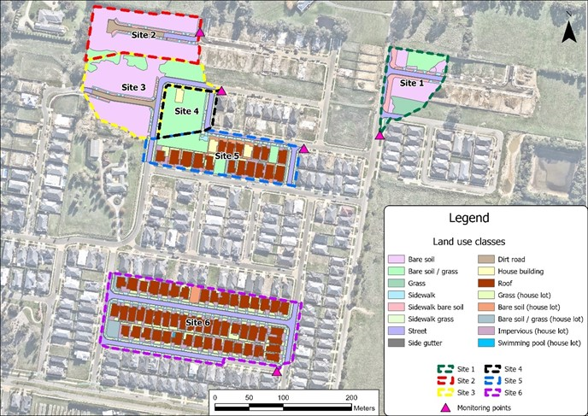
Figure S1 - Land use classification for all monitoring sites. This classification was done using the aerial imagery from 26/04/23, obtained on NearMap website.
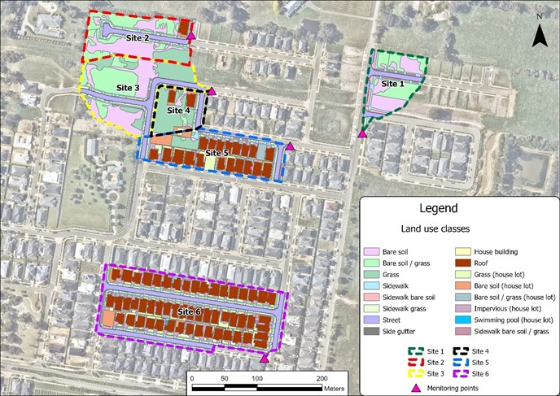
Figure S2 - Land use classification for all monitoring sites. This classification was done using the aerial imagery from 29/10/23, obtained on NearMap website.
- Monitoring Sites
Field inspections were conducted to identify and map recent drainage pipe assets not yet reflected in the official records from local authorities. These inspections were also used to locate stormwater pits suitable for accommodating the monitoring equipment. The selection of these pits considered technical factors such as depth, accessibility, and structural conditions, ensuring their capacity to support the necessary equipment for accurate data collection.
2.1) Monitoring stations
The monitoring of the impact of different construction phases of a greenfield residential urbanization on sediment production and surface runoff was carried out using a low-cost automated station developed by Silva et al., (2024) for monitoring suspended sediments and water level.
The operating principle of this station is based on the flow cell system, where water samples are pumped through the turbidity sensor for measurements. The monitoring station is equipped with turbidity sensor, temperature sensors (at two points), and a water level sensor, in addition to a peristaltic pump whose performance in terms of flow rate and velocity is comparable to that of the Hach Sigma 900 Max autosampler pump.
The station includes a configuration file (.txt) on the micro-SD card that enables the operator to adjust various measurement parameters, including the trigger level for pump activation, the intervals between measurements, the duration of pump operation (in both forward and reverse modes), number of turbidity measurements, and many other settings. Its open-source code (https://osf.io/cxbpf/files/osfstorage?view_only=378951f7e25949189b9773dd6cacd628) allows these measurement characteristics to be easily changed, which facilitates adaptation to suit the desired monitoring situation.
The station operates in two modes: basic and complete. The basic mode is activated when there is no water flow in the drainage pipes or when the water level is below the minimum required (preset trigger level) for turbidity readings. In this mode, only the water level and temperatures are monitored, saving energy since the peristaltic pump, the component with the highest energy consumption, remains deactivated. In the complete mode, in addition to the measurements from the basic mode, turbidity is measured in both dry and wet conditions.
Given that the station operates as a flow cell system, drawing water for turbidity readings, there is also the option to attach a container to the outlet of the sampling tube, after the turbidity measurement. This allows for the collection of water samples for subsequent laboratory analysis.
This operational flexibility allows for efficient and adjustable monitoring, particularly useful in stormwater drainage systems where water levels vary significantly depending on the occurrence of precipitation. In this way, the station can operate intermittently without unnecessary energy consumption, which is crucial in field environments where frequent maintenance may be impractical.
More detailed information about the automatic monitoring station and its operation can be found in Silva et al., (2024).
2.1.1) Field installation
The monitoring station cabinet was installed securely mounted to a wall within a stormwater pit (Figure S3), positioned in a location protected from flooding. The cabinet is water-resistant, ensuring that exposure to water droplets does not compromise its functionality.
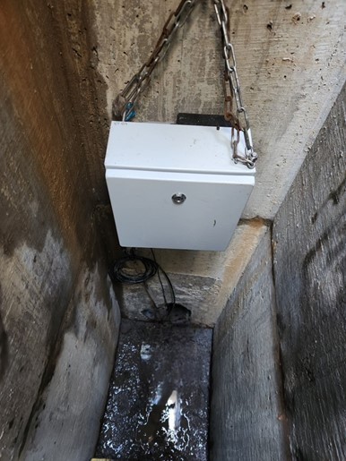
Figure S3 - Fixed monitoring station by chains on a wall inside a stormwater pit.
The water level sensor was fixed in the middle of the pipe, along with the inlet sampling tube (Figure S4). The sensor was securely fixed, as any change in orientation or positioning may lead to an incorrect measurement. The water level sensor was installed vertically oriented (consequently, perpendicular to flow direction), thus avoiding overpressure caused by the flow speed. The vertical position corresponds also to a horizontal position of the sensor membrane, thus reducing measurement error.
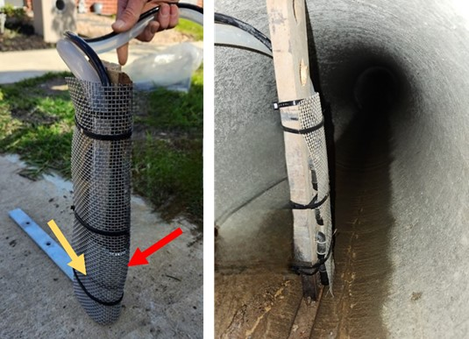
Figure S4 - Fixing the inlet sampling tube and the water level pressure sensor. In the picture on the left, the yellow and red arrows indicate the inlet tube and the water level sensor, respectively. On the right side, the figure illustrates both fixed in the middle of the drainage pipe.
The inlet sampling tube was fixed close to the invert to maximise data collected (around 10 mm from the bottom). A protective stainless steel mesh net with a 4x4 mm grid was installed around the entrance of the inlet tube to safeguard the sampling system (especially the pump) from coarse sediment. The orientation of the tube was approximately vertical, from the cabinet to the monitored point, to avoid both sedimentation and air accumulation inside the tube. The latter is particularly important, as microbubbles can mimic sediment, causing the turbidity sensor to measure incorrectly. The monitoring station outlet tube was placed into a 1 L bottle to collect samples during the monitored flow (Figure S5).
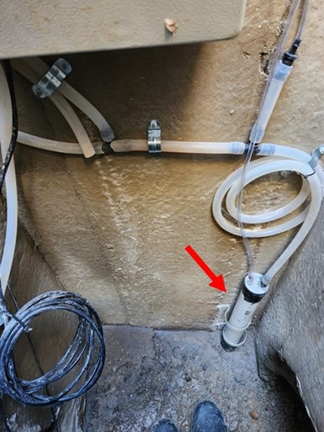
Figure S5 - Sampling system. The red arrow indicates the 1-liter bottle used to grab the water samples.
2.1.2) Operational specifications
The operational specifications of the monitoring station are illustrated in the flowchart presented in Figure S6.
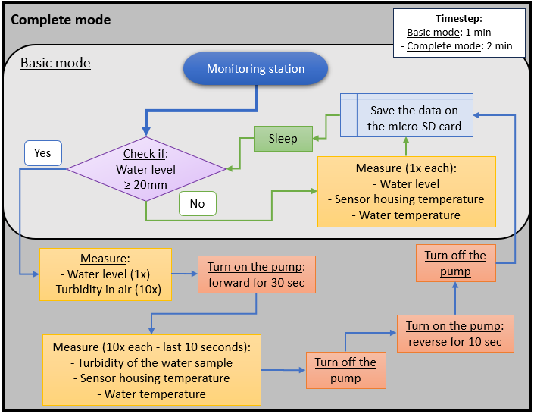
Figure S6 – Flowchart of the two modes (basic and complete) of the monitoring station operation. The duration of the sleep function is always calculated using information from the updated RTC and the period between each measurement cycle defined in the configuration file.
  - Sensor calibration
Calibration of the water level sensor was performed under controlled laboratory conditions. A linear equation was employed for this purpose, and the use of at least two reference points with varying water levels was sufficient to establish the calibration curve.
The calibration of the turbidity sensor involved two distinct steps. The first step entailed the development of a linear model to account for temperature compensation by correlating the sensor housing temperature with turbidity measurements (expressed in millivolts, mV).
For this, a laboratory experiment was conducted using four samples (mix of bentonite crushed and sieved to < 63 μm and reverse osmosis water) with known concentrations of 0, 0.1, 0.5, 1.0 g/L. During the experiment, the temperature of the sensor housing was gradually varied from 13°C to 23°C, allowing the turbidity readings of each sample to be observed across the temperature range. On average, 50 to 60 measurements were recorded for each sample (Figure S7). All data collected during the experiments for each station were randomly divided into training (90%) and testing (10%) datasets. Turbidity values (mV) were adjusted for temperature using the following equation (eq. 1).
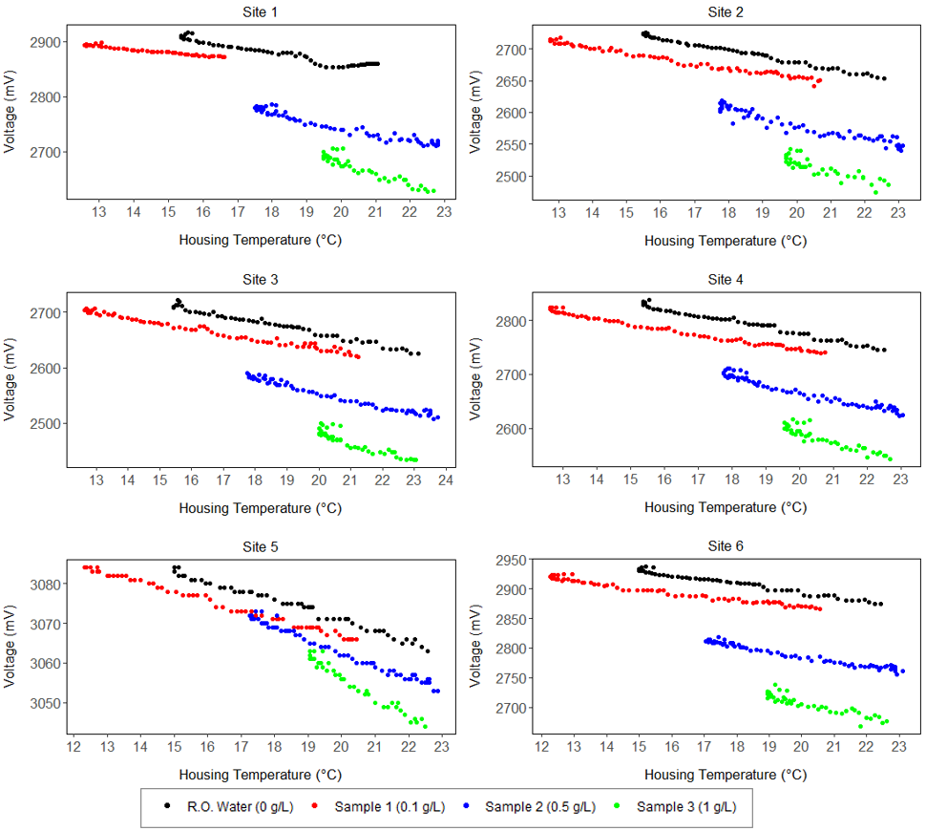
Figure S7 - Laboratory experiment performed with samples of known concentration. The experiment began with the samples at an initial temperature of approximately 13°C and continued until the samples reached a temperature of around 23°C.
$${Turb}_{Adjusted}=Turbidity-\left[{Slope}_{average}*\left({Temp}_{Housing}-{Temp}_{Reference}\right)\right] eq.1$$
Where: ${Turb}_{Adjusted}$ is the turbidity adjusted by the housing temperature (mV), $Turbidity$ is the turbidity (mV) measured by the turbidity sensor, ${Slope}_{average}$ is the average slope of the four linear regression lines for each concentration (mV/°C) between the turbidity measurements (mV) and the housing temperature (C). ${Temp}_{Housing}$ is the temperature measured inside the turbidity sensor housing, ${Temp}_{Reference}$ is the reference temperature. For this case, a temperature of 20 °C was chosen as this temperature is common in all concentrations and stations tested here.
The second step involved calibrating the sensor for the specific parameter of interest, such as suspended sediment concentration (SSC, g/L), which was performed using samples collected from the field during the monitoring period. A total of 106 water samples were collected during the monitored period and their total suspended solids (TSS) concentration analysed in a NATA-accredited (National Association of Testing Authorities) laboratory.
Therefore, after adjusting the raw turbidity values based on the sensor housing's temperature, the adjusted turbidity values were plotted (Figure S8) against the TSS of all samples during the monitoring period to establish a second-order polynomial regression model (Eq. 2) for each station.
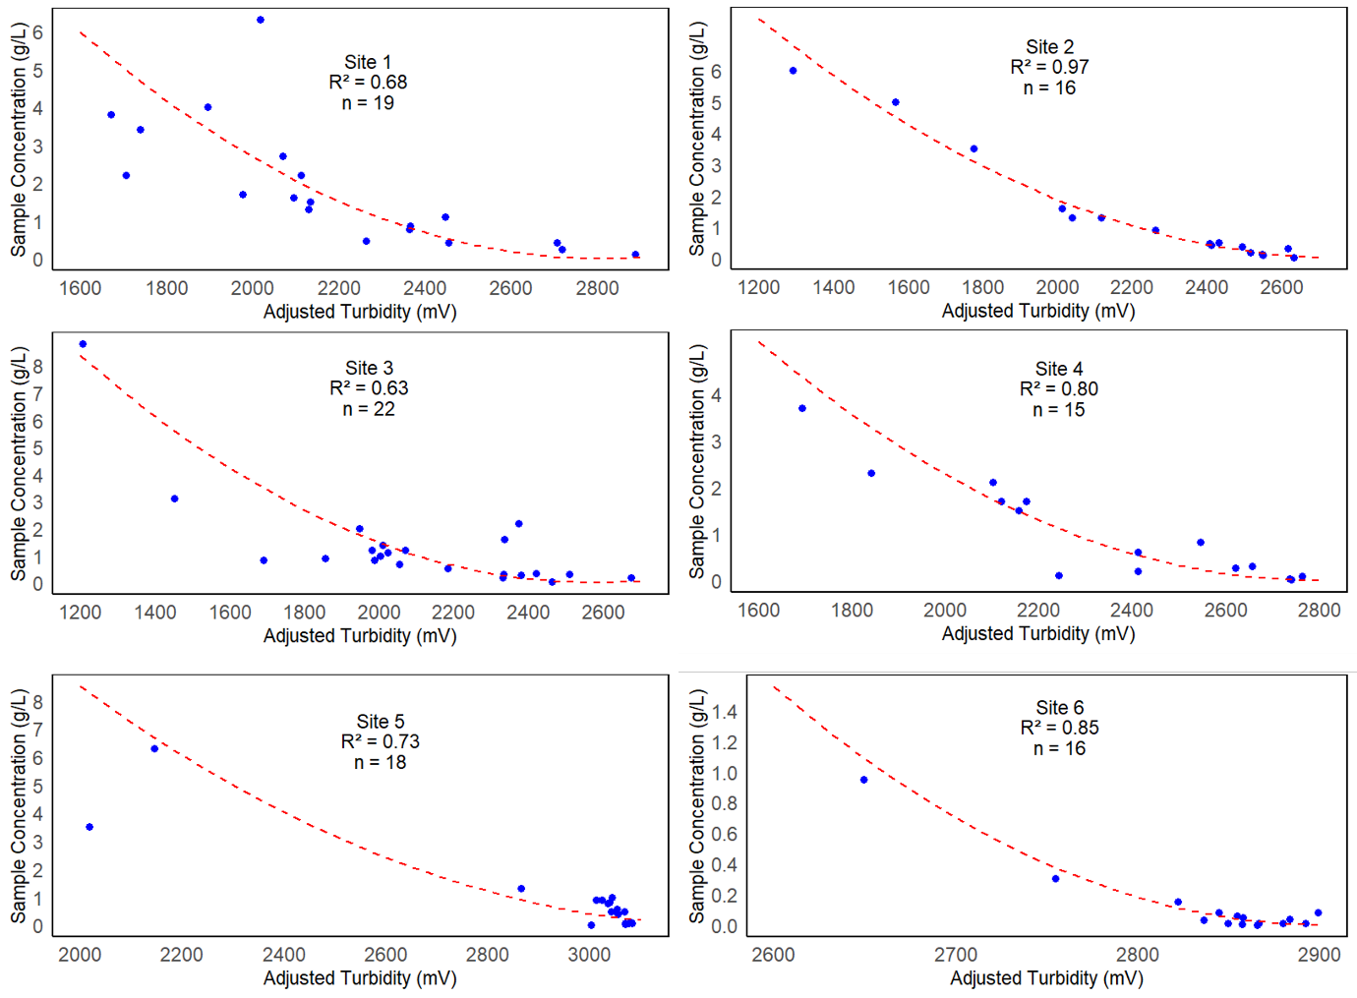
Figure S8 - Rating curves for all sites. Sample concentration (g/L) on y-axis and adjusted turbidity (mV) on the x-axis.
$$Concentration (g/L)={\left(\frac{{Turb}_{Adjusted}-Intercept}{Slope}\right)}^{2} eq.2$$
Where: $Concentration (g/L)$ is the suspended solids concentration (g/L), ${Turb}_{Adjusted}$ is the turbidity adjusted by the housing temperature (mV), and $Intercept$ and $Slope$ are respectively the intercept and slope of the regression model obtained from the sensor calibration between turbidity and TSS.
To validate the model, the Leave-One-Out Cross-Validation (LOOCV) method was employed. In this approach, the dataset for each station was iteratively divided into training and testing subsets. Specifically, each individual sample was used once as the testing set, while the remaining samples were utilized to train the model. This process was repeated for all samples within the dataset, resulting in “n” models for each station (where “n” corresponds to the total number of samples). The final Root Mean Square Error (RMSE) for each station was calculated as the average of the RMSE values obtained across all “n” iterations. Figure S9 shows a scatter plot comparing the estimated concentrations to the sample concentrations across all stations. More details on the sensors calibration can be found in Silva et al., (2024).

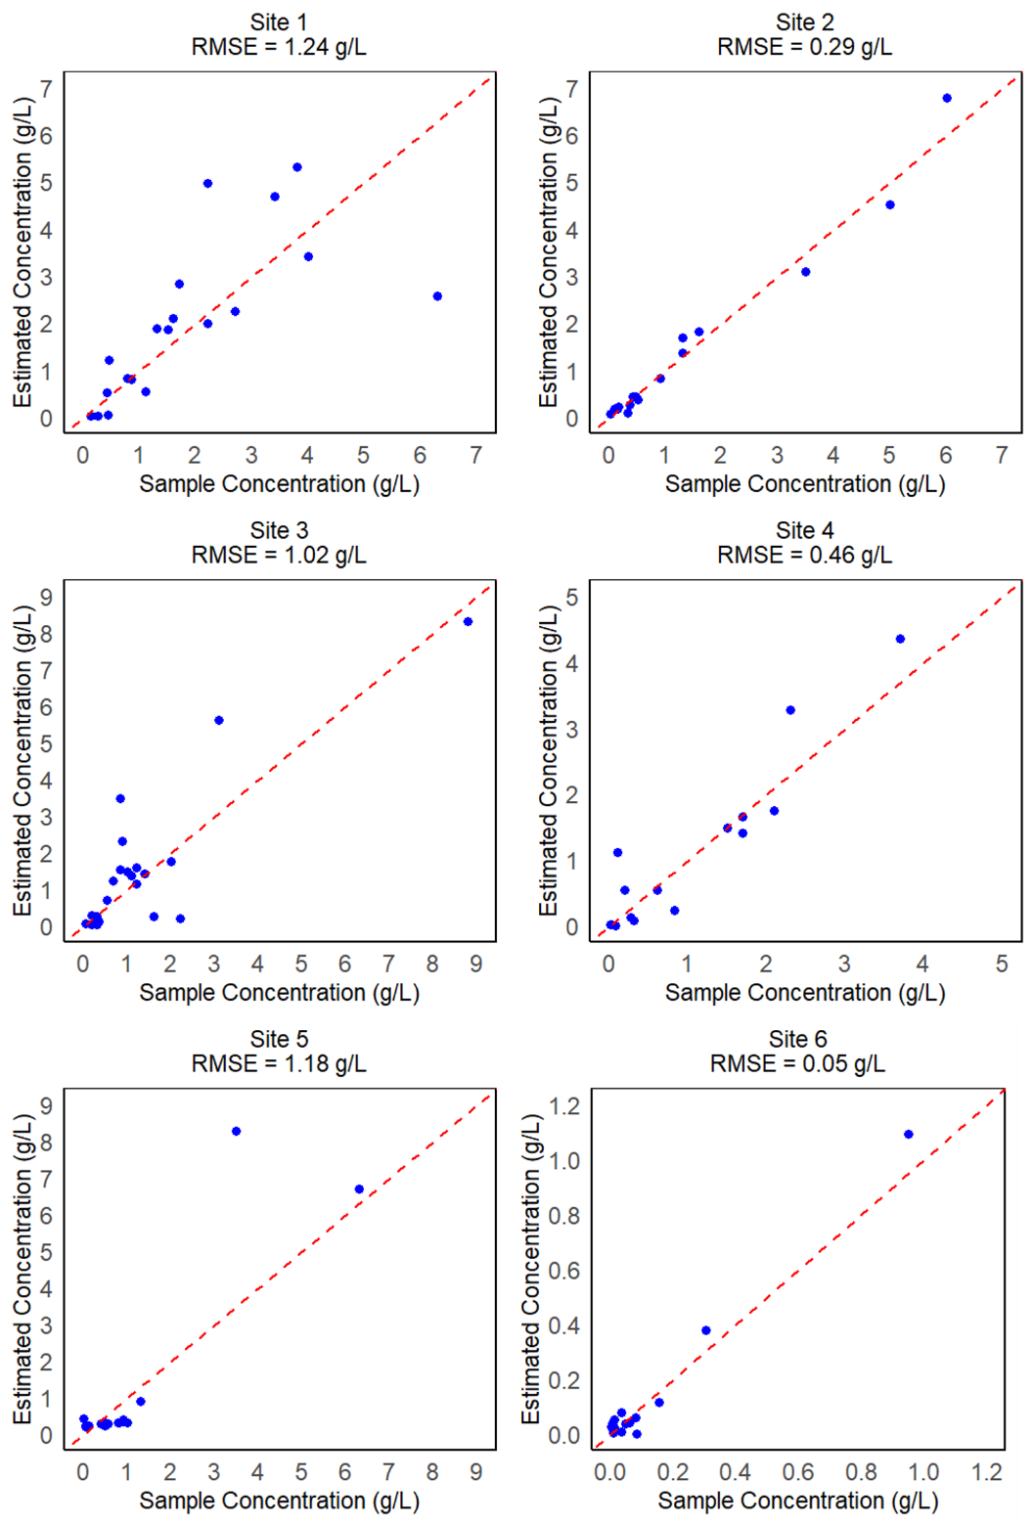
Figure S9 - Estimating concentrations. The red line indicates the 1:1 line between estimated concentration and sample concentration.
  - Turbidity
Figure S10 illustrates the raw data collected from the station at Site 2, as well as the validated data after the application of this algorithm.
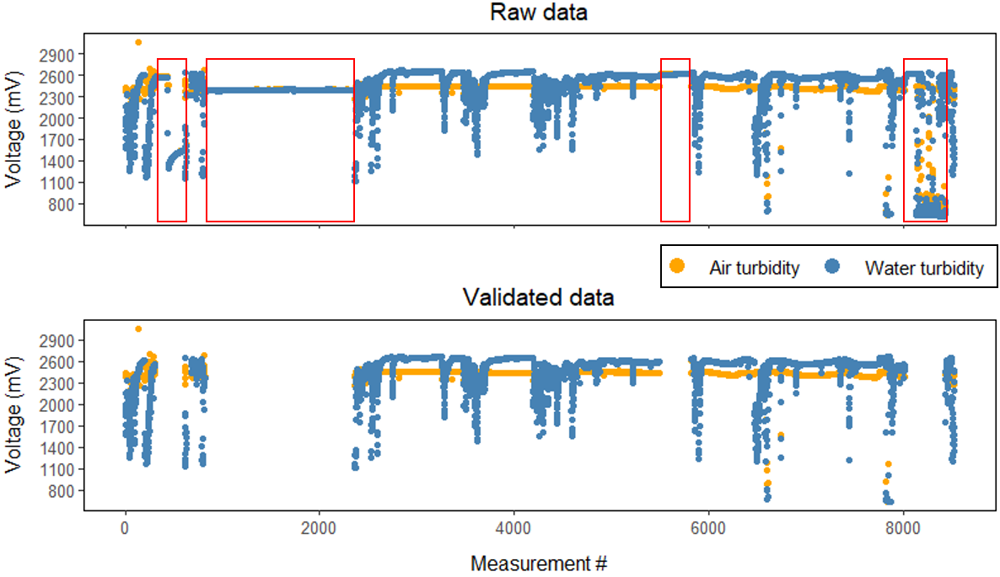
Figure S10 - Turbidity data collected at Site 2. The red squares represent periods where the air turbidity had the same value as water turbidity, therefore they were filtered out.
- Station installations dates and rainfall data along the monitored period.
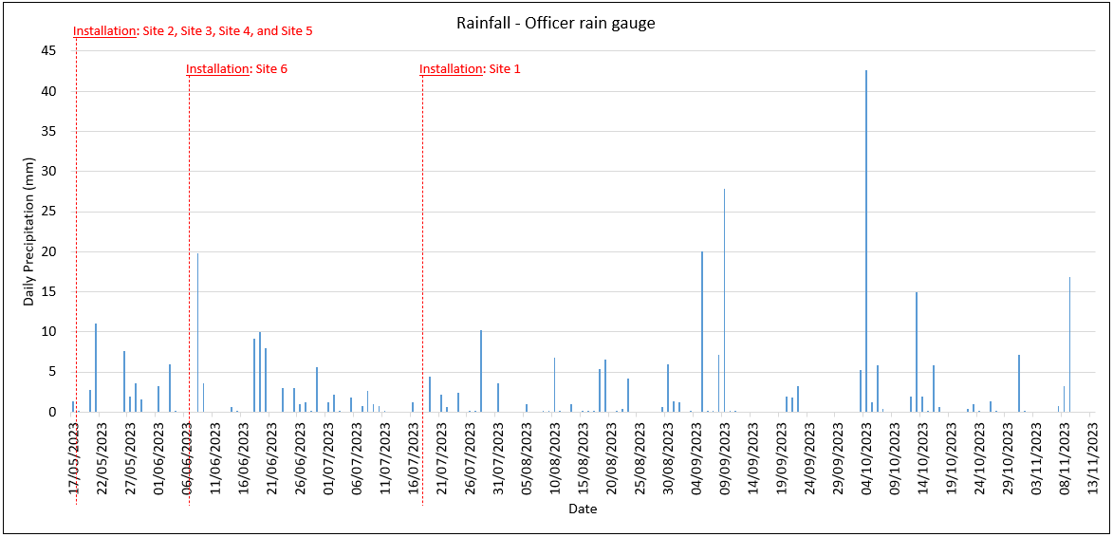
Figure S11 - Rainfall data from the 6-months monitoring period and the dates when the stations were installed.

- Flow blockage

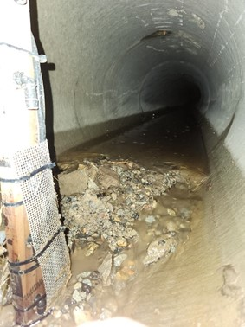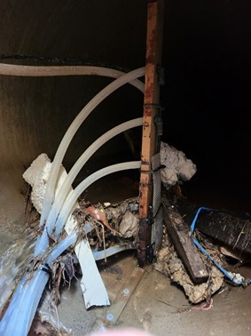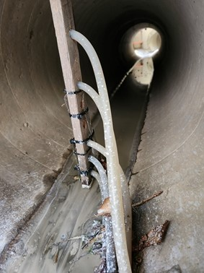
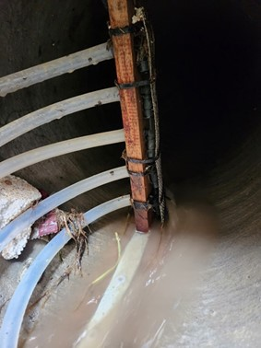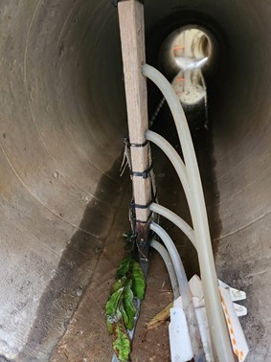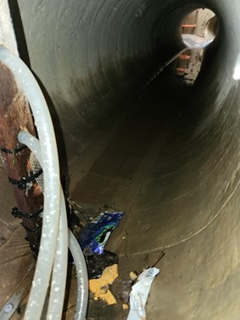
Figure S12 - Examples of flow blockages observed during the monitoring period.
- Statistics Results
Table S1 - Reference for all statistical results (graphs and tables).
Reference | Graph | Data
Figure S13 | EMC x all explanatory variables | All sites
Figure S14 | SSY x all explanatory variables | All sites
Figure S15 | d₅₀ x all explanatory variables | All sites
Figure S16 | Runoff volume x all explanatory variables | All sites
Figure S17 | EMC x TIMESTAMP | Each site
Figure S18 | EMC x Bare Soil (%) | Each site
Figure S19 | EMC x Impervious surface (%) | Each site
Figure S20 | EMC x Maximum flow (L/s) | Each site
Figure S21 | EMC x Daily rainfall (mm) | Each site
Figure S22 | EMC x Antecedent Dry Period (min) | Each site
Figure S23 | SSY x TIMESTAMP | Each site
Figure S24 | SSY x Bare Soil (%) | Each site
Figure S25 | SSY x Impervious surface (%) | Each site
Figure S26 | SSY x Maximum flow (L/s) | Each site
Figure S27 | SSY x Daily rainfall (mm) | Each site
Figure S28 | SSY x Antecedent Dry Period (min) | Each site
Figure S29 | d₅₀ x TIMESTAMP | Each site
Figure S30 | d₅₀ x Bare Soil (%) | Each site
Figure S31 | d₅₀ x Impervious surface (%) | Each site
Figure S32 | d₅₀ x Maximum flow (L/s) | Each site
Figure S33 | d₅₀ x Daily rainfall (mm) | Each site
Figure S34 | d₅₀ x Antecedent Dry Period (min) | Each site
Figure S35 | Runoff volume x TIMESTAMP | Each site
Figure S36 | Runoff volume x Bare Soil (%) | Each site
Figure S37 | Runoff volume x Impervious surface (%) | Each site
Figure S38 | Runoff volume x Maximum flow (L/s) | Each site
Figure S39 | Runoff volume x Daily rainfall (mm) | Each site
Figure S40 | Runoff volume x Antecedent Dry Period (min) | Each site
Figure S41 | EMC - Tukey's paired test | All sites
Figure S42 | SSY - Tukey's paired test | All sites
Figure S43 | PSD - Tukey's paired test | All sites
Figure S44 | Runoff - Tukey's paired test | All sites
Table S2 | EMC x all explanatory variables | Each site
Table S3 | SSY x all explanatory variables | Each site
Table S4 | d₅₀ x all explanatory variables | Each site
Table S5 | Runoff volume x all explanatory variables | Each site
Table S6 | Response variables x Explanatory variables | All sites

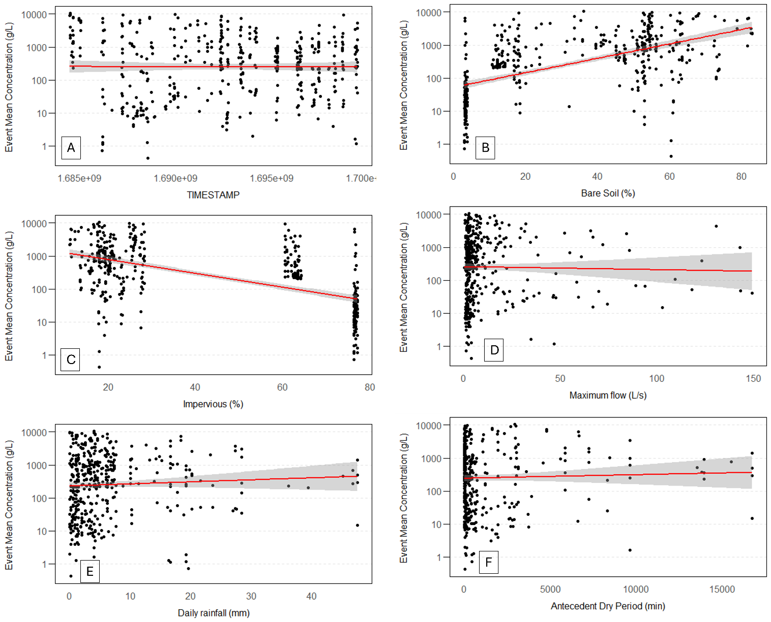
Figure S13 - Event Mean Concentration (EMC) of all monitored events from all sites. Y-axis is plotted in log. A) EMC x Timestamp. B) EMC x Bare soil percentage. C) EMC x Impervious surface percentage. D) EMC x Maximum flow (L/s). E) EMC x Daily rainfall (mm). F) EMC x Antecedent Dry Period (min).
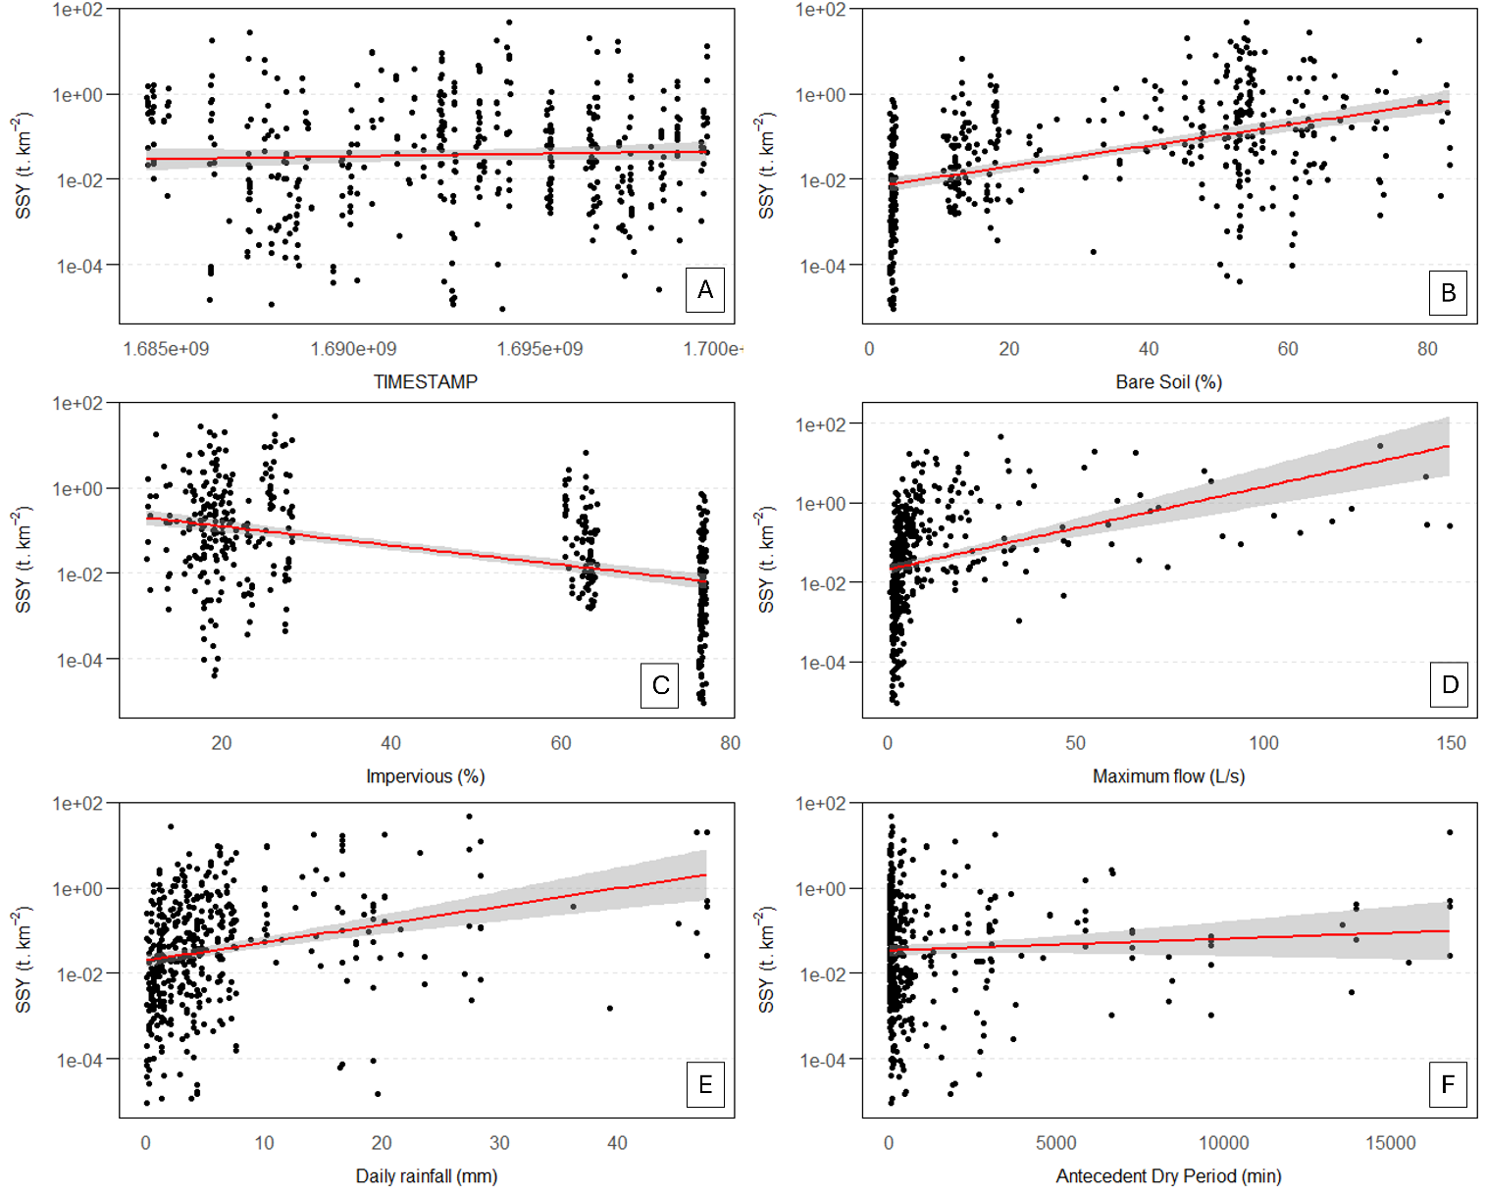
Figure S14 - Suspended Solids Yield (SSY) of all monitored events from all sites. Y-axis is plotted in log. A) SSY x Timestamp. B) SSY x Bare soil percentage. C) SSY x Impervious surface percentage. D) SSY x Maximum flow (L/s). E) SSY x Daily rainfall (mm). F) SSY x Antecedent Dry Period (min).

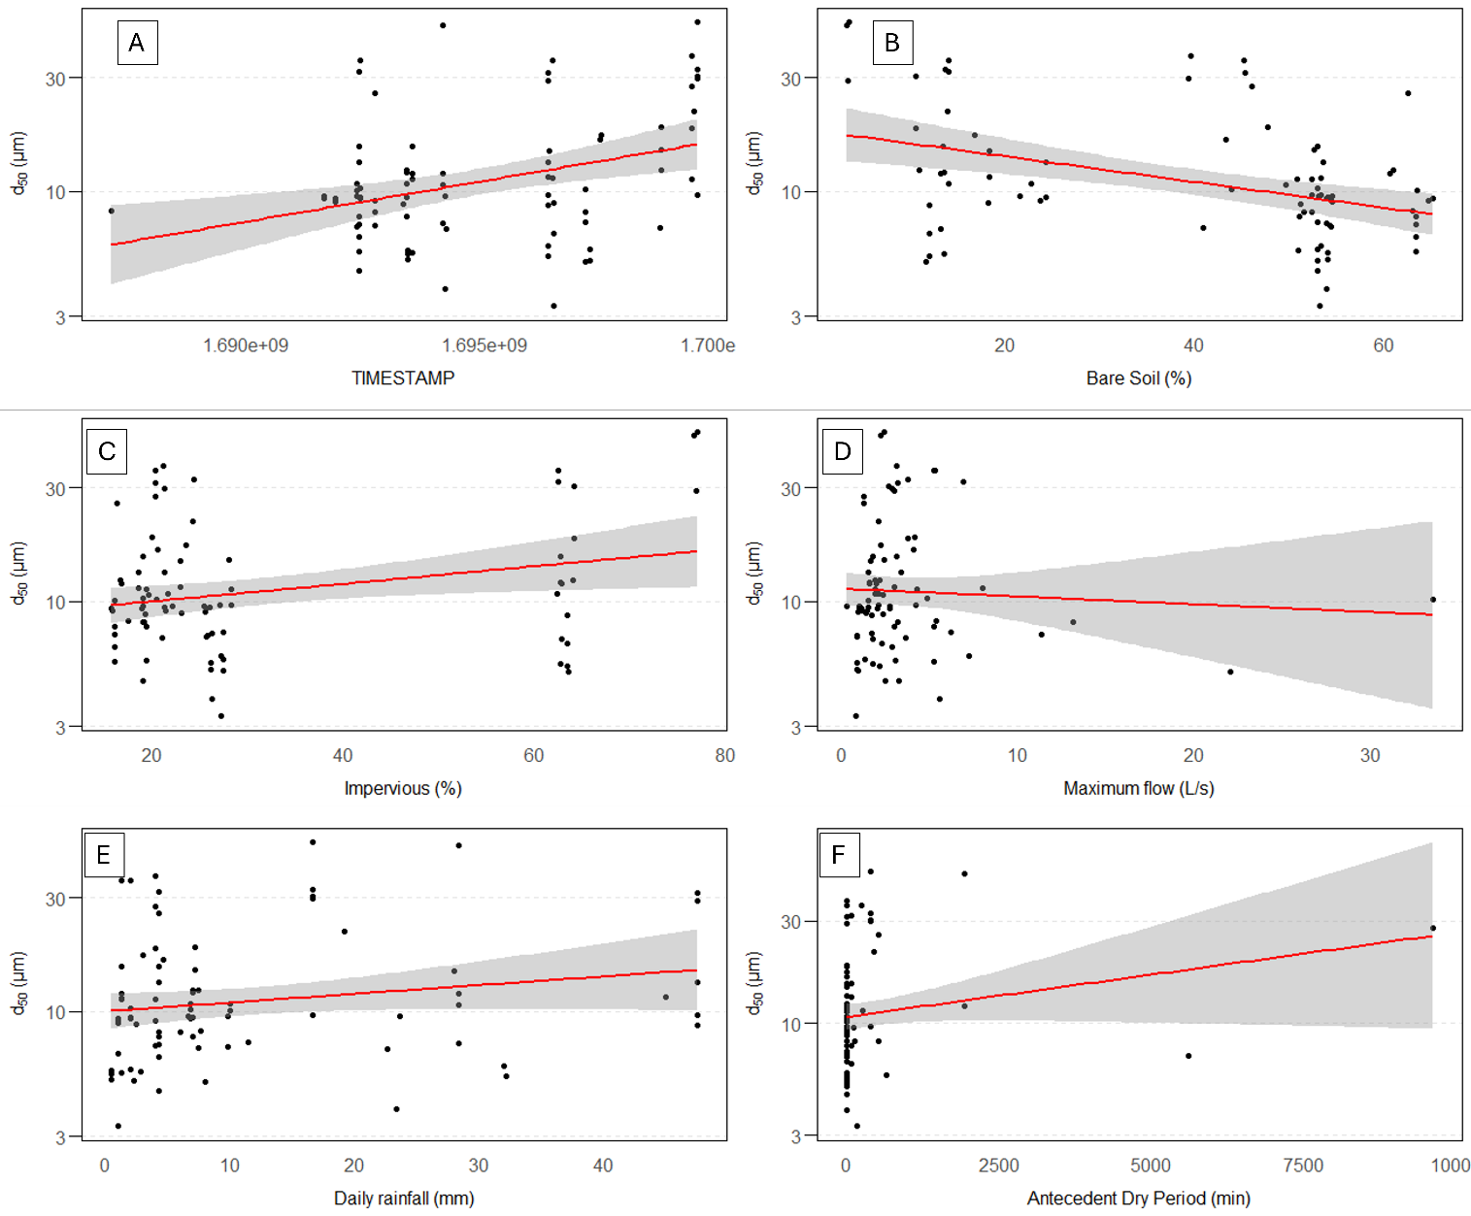
Figure S15 - Median Particle Size (d₅₀) of all monitored events from all sites. Y-axis is plotted in log. A) d₅₀ x Timestamp. B) d₅₀ x Bare soil percentage. C) d₅₀ x Impervious surface percentage. D) d₅₀ x Maximum flow (L/s). E) d₅₀ x Daily rainfall (mm). F) d₅₀ x Antecedent Dry Period (min).

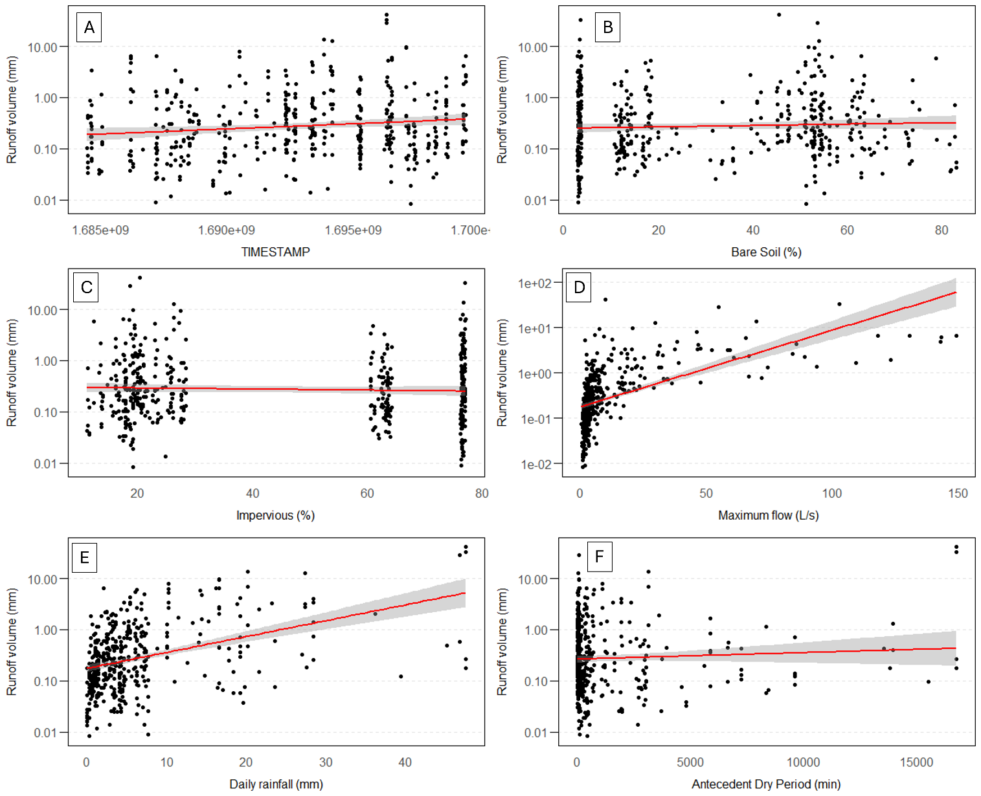
Figure S16 - Runoff volume of all monitored events from all sites. Y-axis is plotted in log. A) Runoff volume x Timestamp. B) Runoff volume x Bare soil percentage. C) Runoff volume x Impervious surface percentage. D) Runoff volume x Maximum flow (L/s). E) Runoff volume x Daily rainfall (mm). F) Runoff volume x Antecedent Dry Period (min).

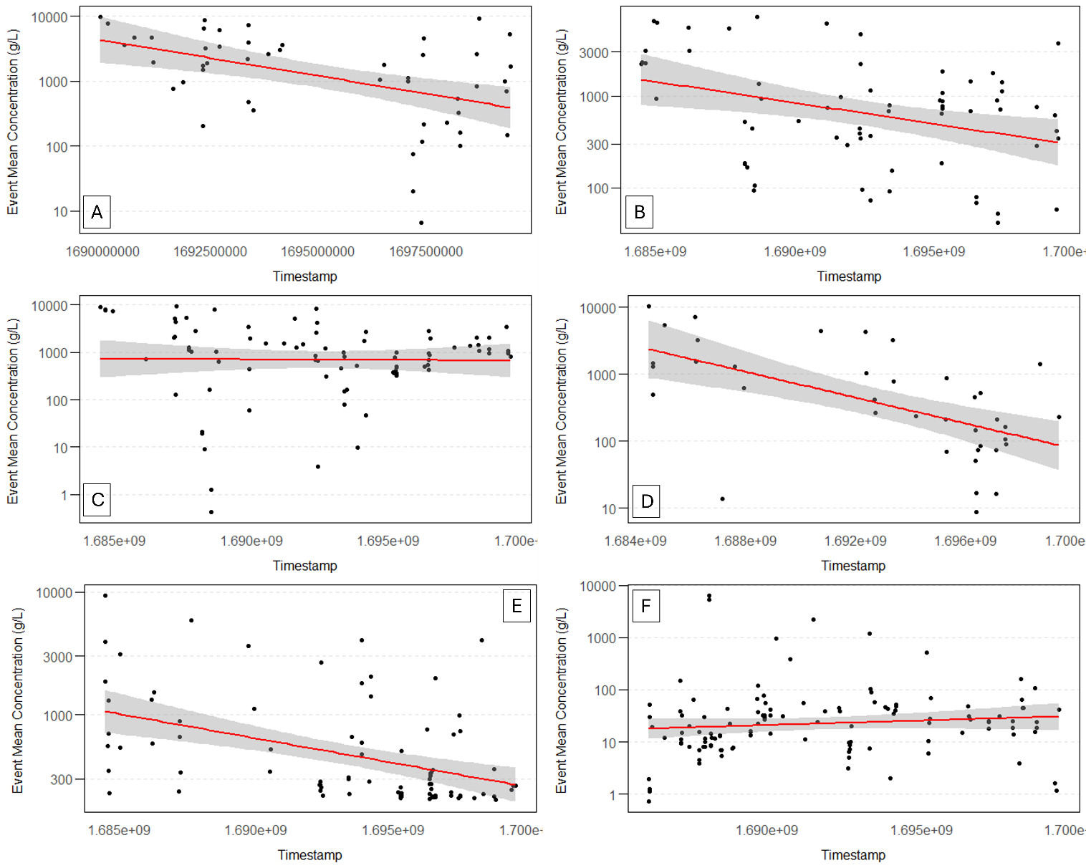
Figure S17 - Event Mean Concentration (EMC) x TIMESTAMP for each site. Y-axis is plotted in log. A) Site 1. B) Site 2. C) Site 3. D) Site 4. E) Site 5. F) Site 6.

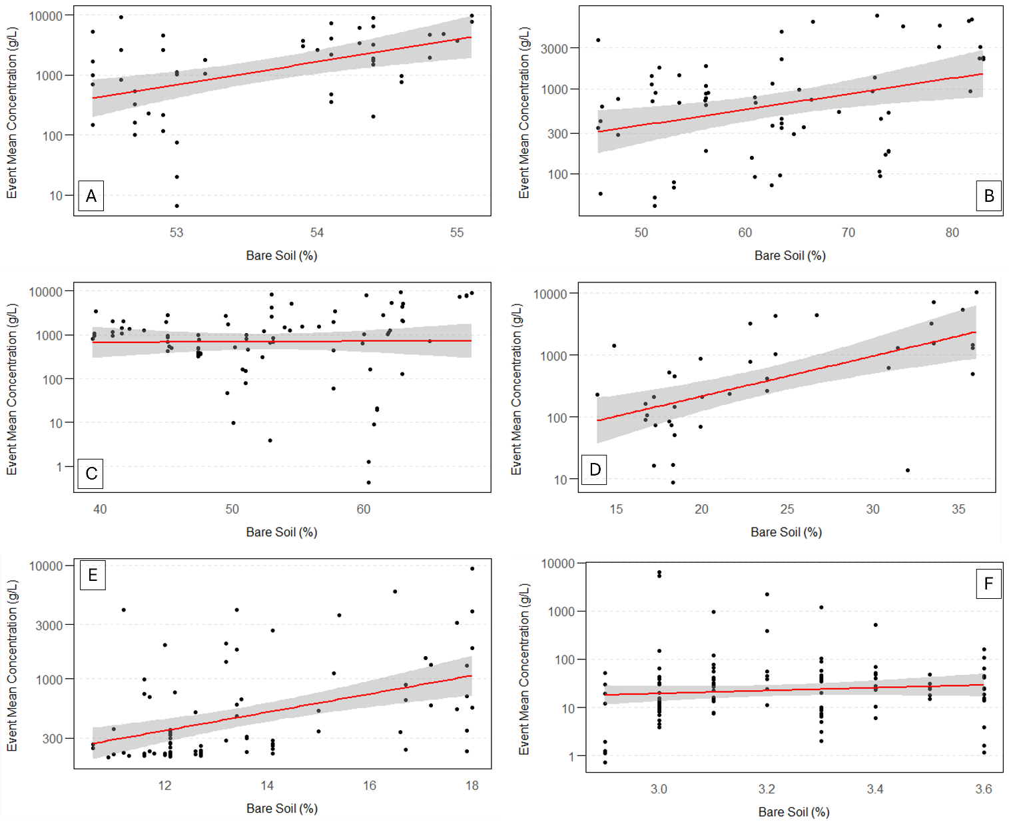
Figure S18 - Event Mean Concentration (EMC) x Bare soil (%) for each site. Y-axis is plotted in log. A) Site 1. B) Site 2. C) Site 3. D) Site 4. E) Site 5. F) Site 6.
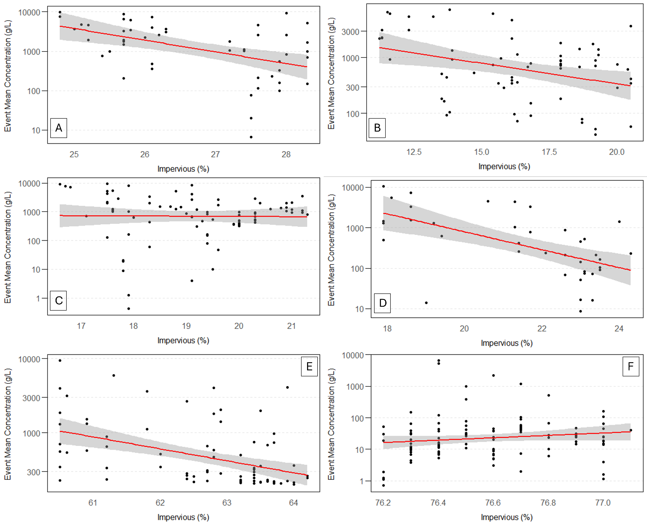
Figure S19 - Event Mean Concentration (EMC) x Impervious surface (%) for each site. Y-axis is plotted in log. A) Site 1. B) Site 2. C) Site 3. D) Site 4. E) Site 5. F) Site 6.

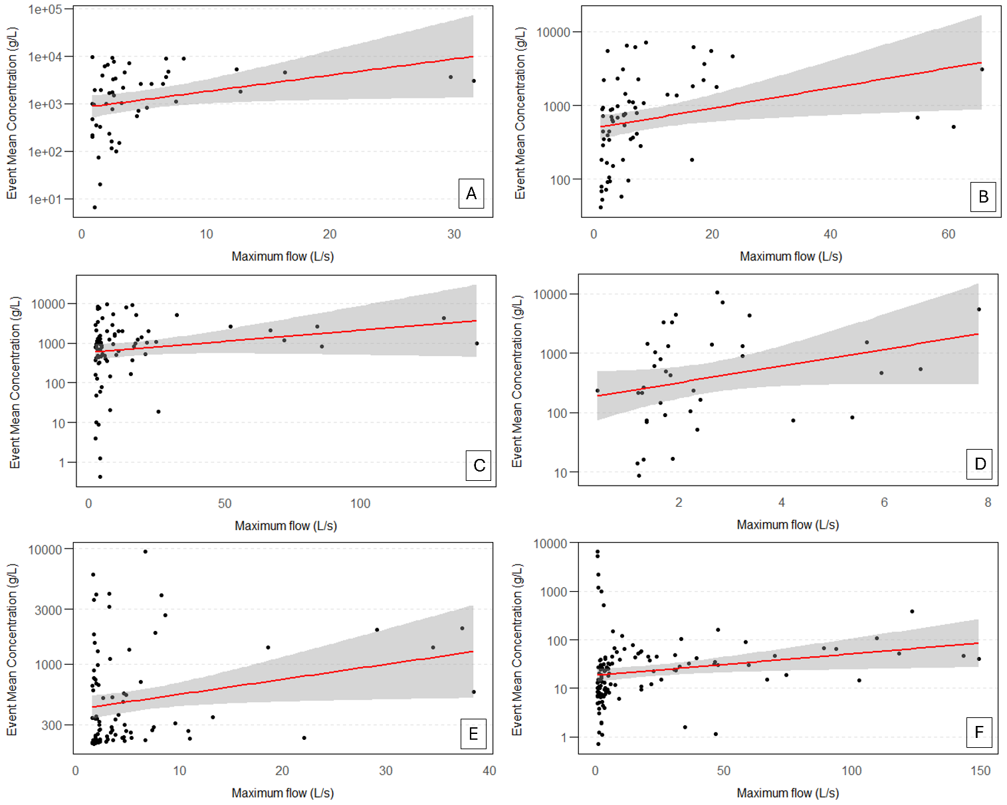
Figure S20 - Event Mean Concentration (EMC) x Maximum flow (L/s) for each site. Y-axis is plotted in log. A) Site 1. B) Site 2. C) Site 3. D) Site 4. E) Site 5. F) Site 6.

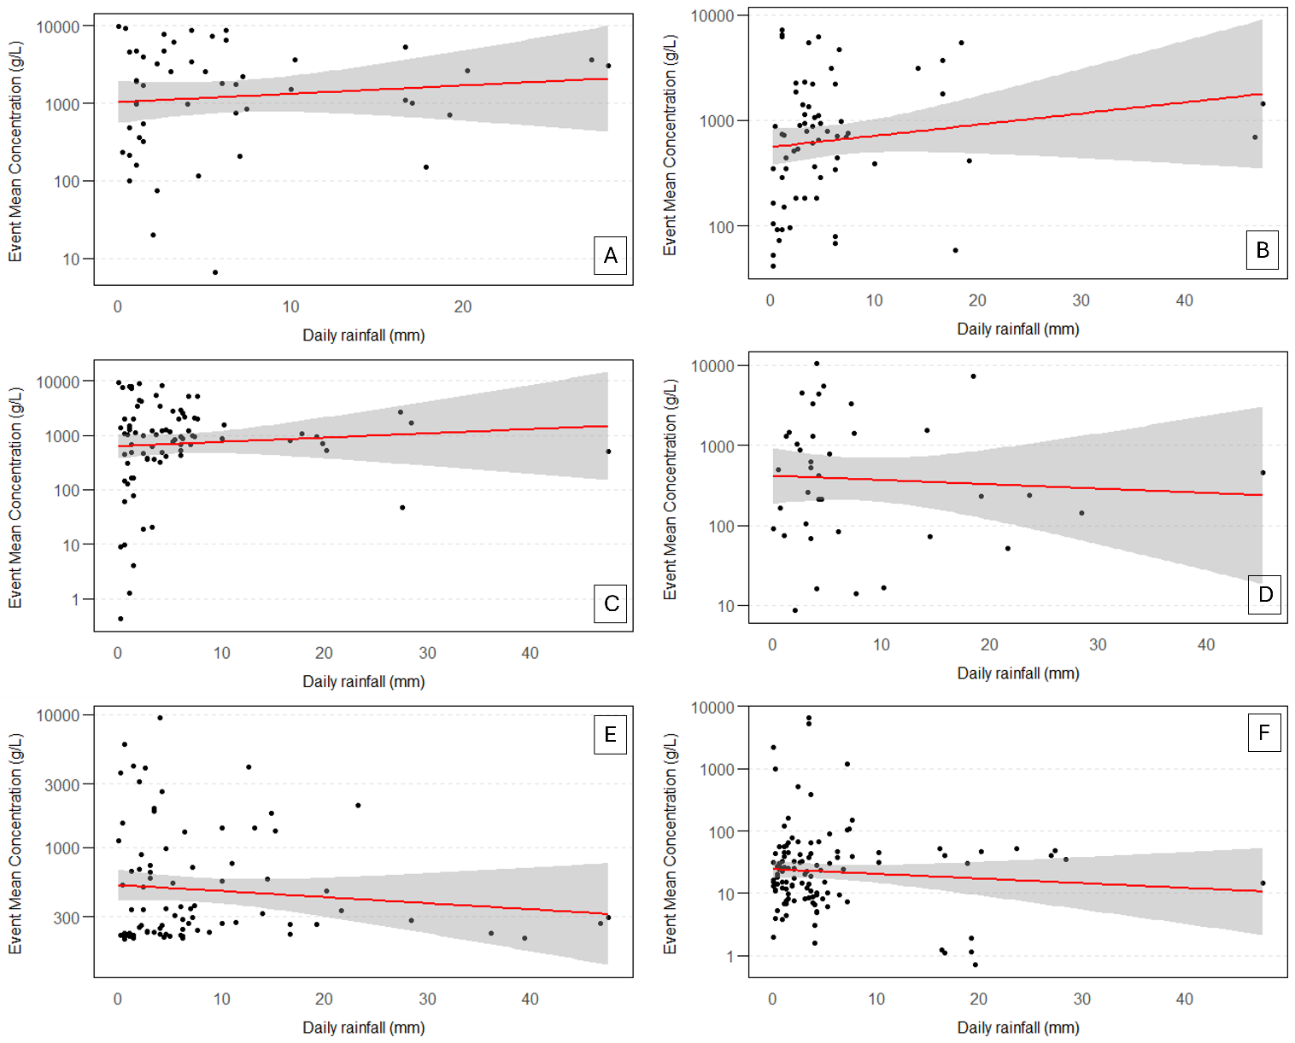
Figure S21 - Event Mean Concentration (EMC) x Daily rainfall (mm) for each site. Y-axis is plotted in log. A) Site 1. B) Site 2. C) Site 3. D) Site 4. E) Site 5. F) Site 6.

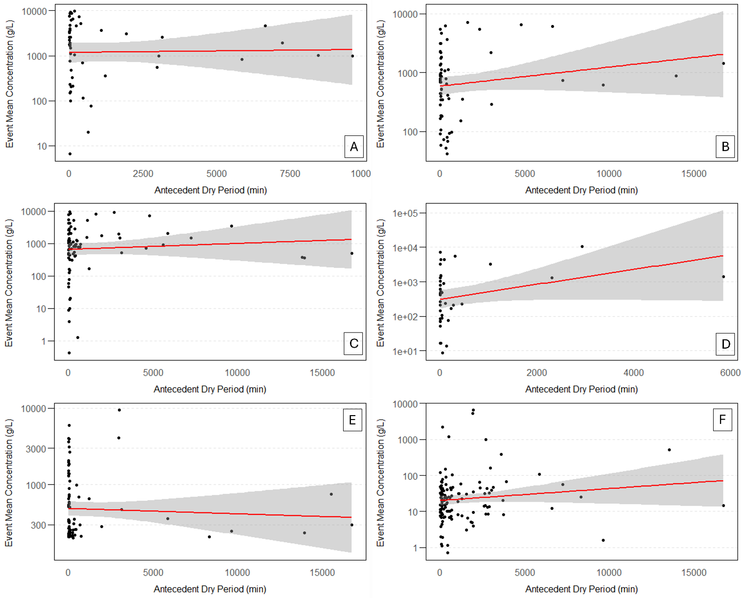
Figure S22 - Event Mean Concentration (EMC) x Antecedent Dry Period (min) for each site. Y-axis is plotted in log. A) Site 1. B) Site 2. C) Site 3. D) Site 4. E) Site 5. F) Site 6.

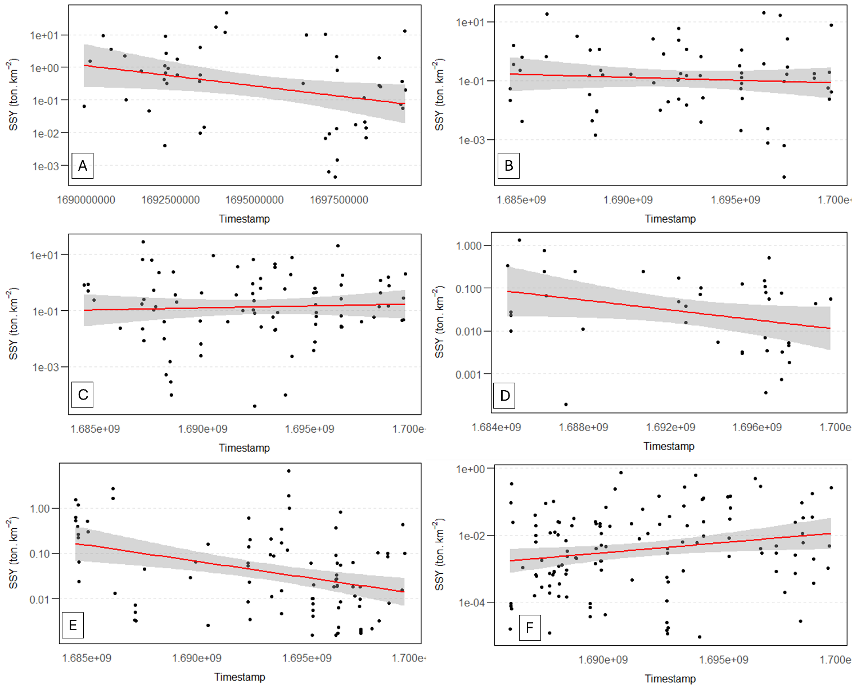
Figure S23 - Suspended Solids Yield (SSY) x TIMESTAMP for each site. Y-axis is plotted in log. A) Site 1. B) Site 2. C) Site 3. D) Site 4. E) Site 5. F) Site 6.

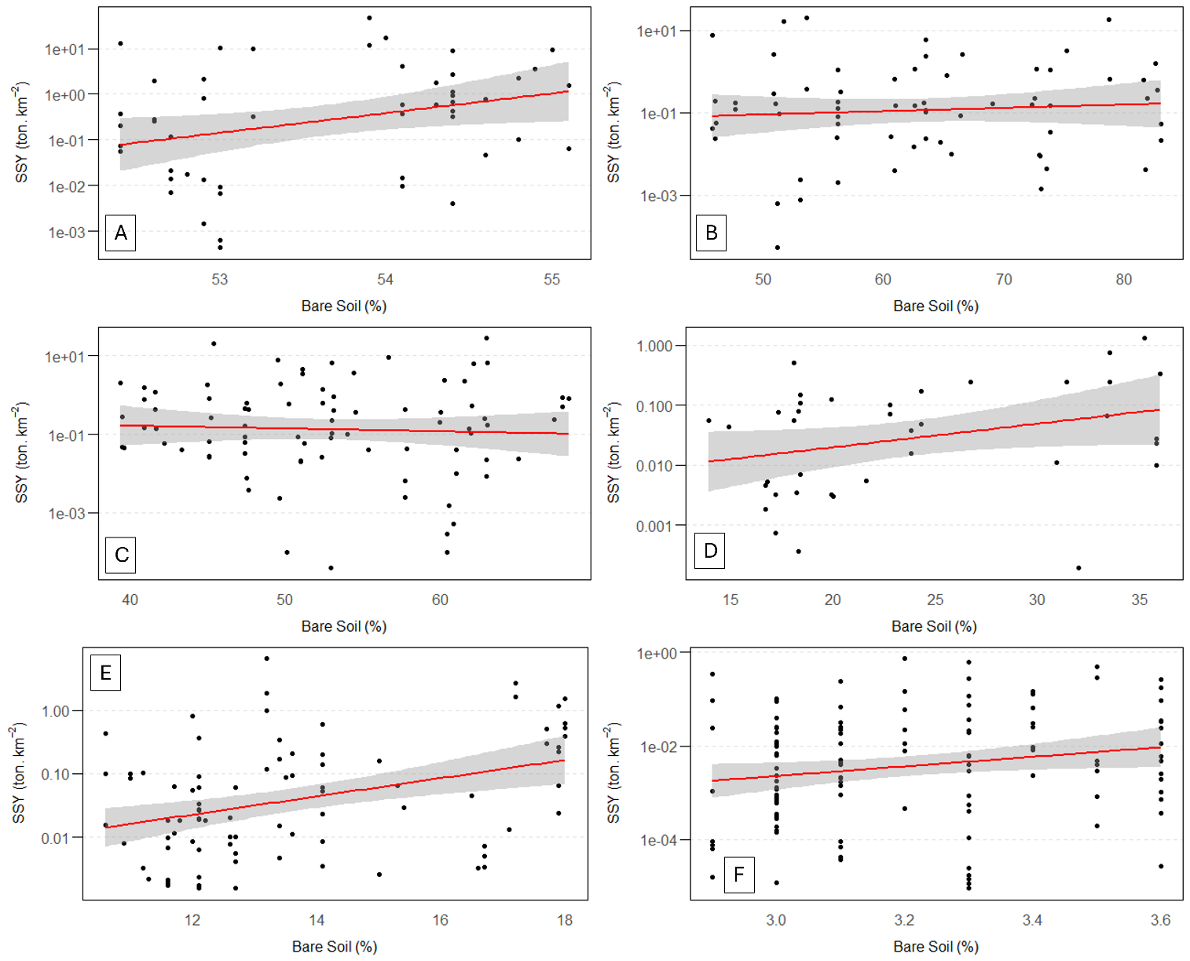
Figure S24 - Suspended Solids Yield (SSY) x Bare soil (%) for each site. Y-axis is plotted in log. A) Site 1. B) Site 2. C) Site 3. D) Site 4. E) Site 5. F) Site 6.

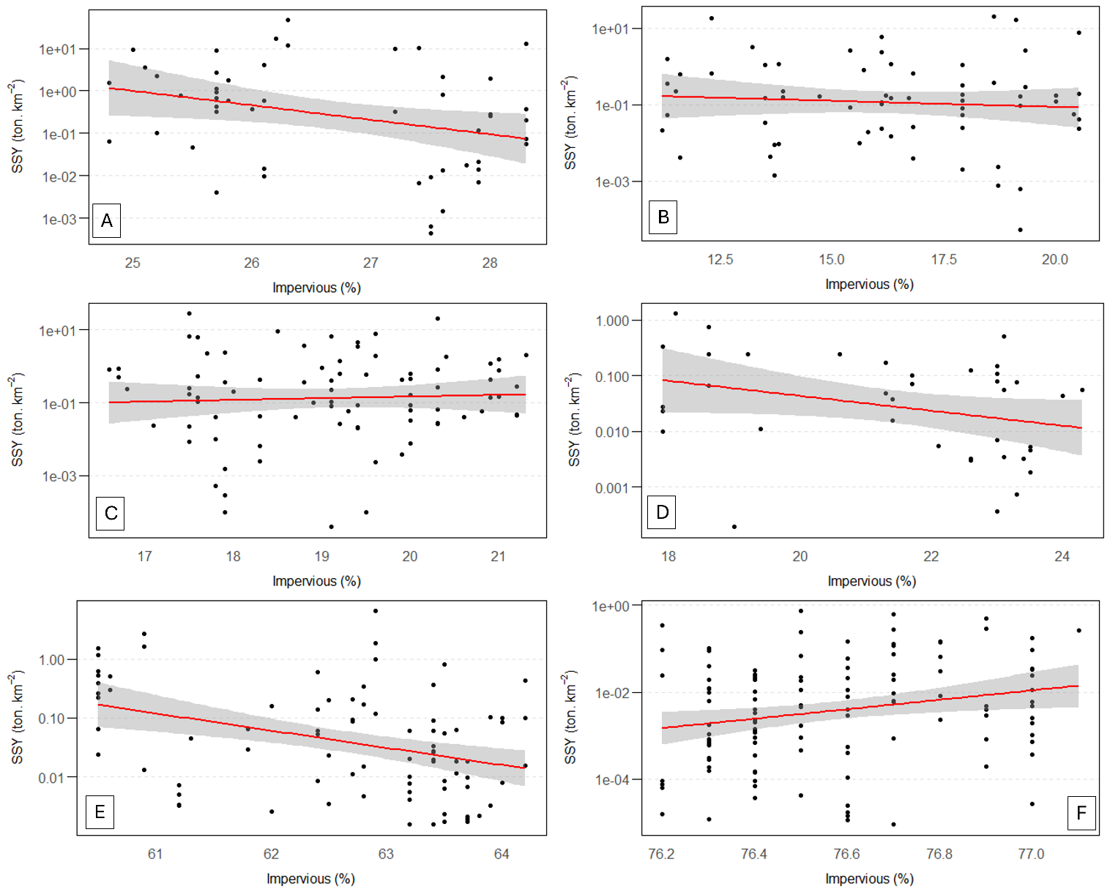
Figure S25 - Suspended Solids Yield (SSY) x Impervious surface (%) for each site. Y-axis is plotted in log. A) Site 1. B) Site 2. C) Site 3. D) Site 4. E) Site 5. F) Site 6.

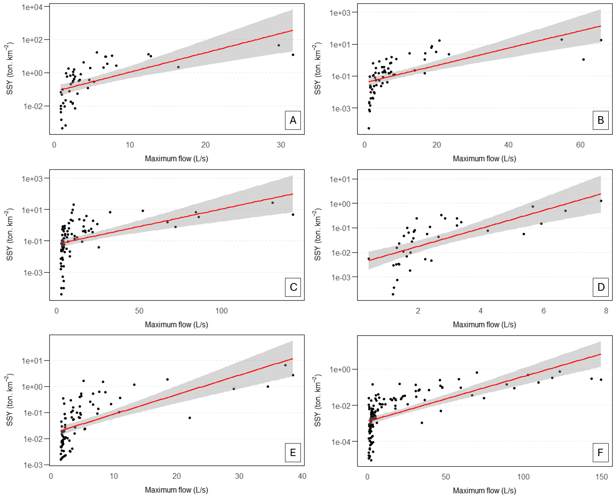
Figure S26 - Suspended Solids Yield (SSY) x Maximum flow (L/s) for each site. Y-axis is plotted in log. A) Site 1. B) Site 2. C) Site 3. D) Site 4. E) Site 5. F) Site 6.

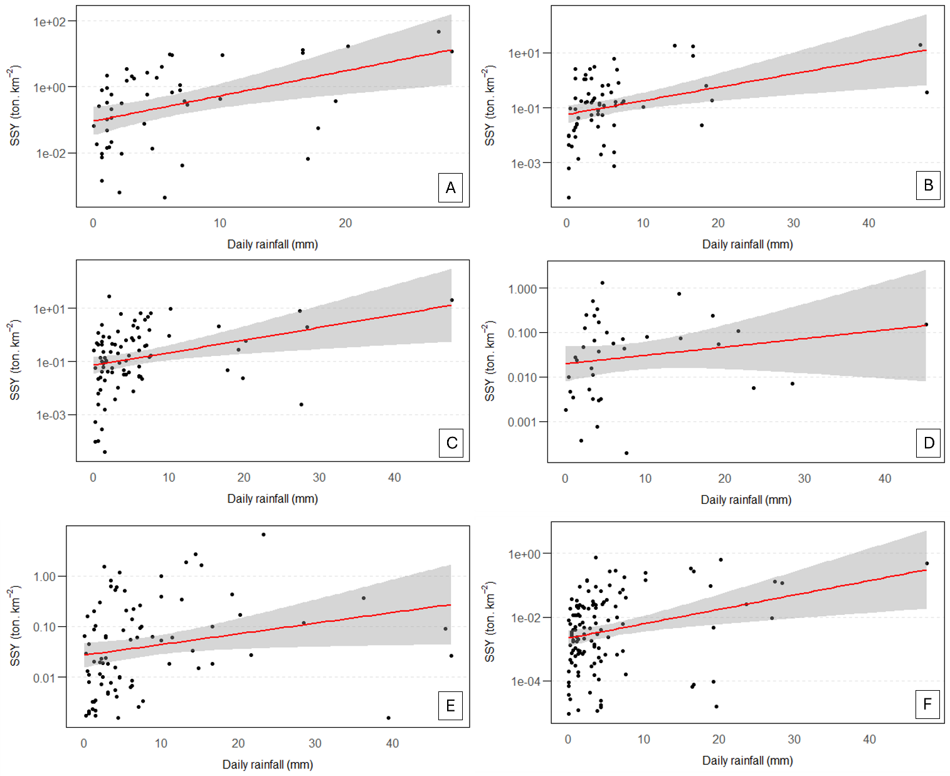
Figure S27 - Suspended Solids Yield (SSY) x Daily rainfall (mm) for each site. Y-axis is plotted in log. A) Site 1. B) Site 2. C) Site 3. D) Site 4. E) Site 5. F) Site 6.

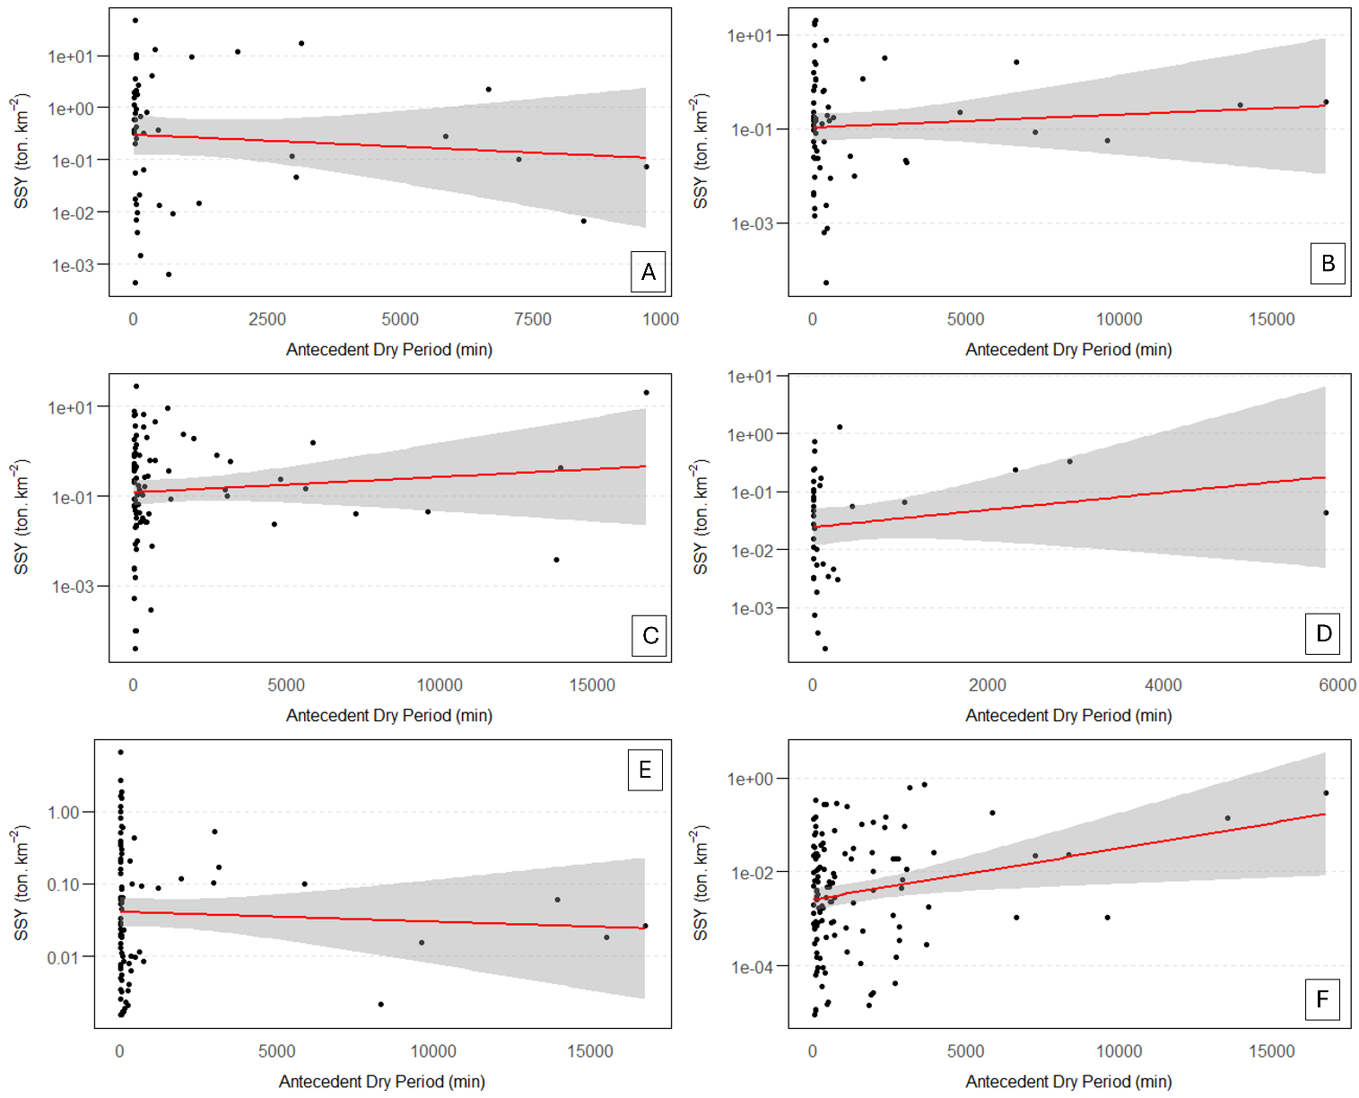
Figure S28 - Suspended Solids Yield (SSY) x Antecedent dry period (min) for each site. Y-axis is plotted in log. A) Site 1. B) Site 2. C) Site 3. D) Site 4. E) Site 5. F) Site 6.

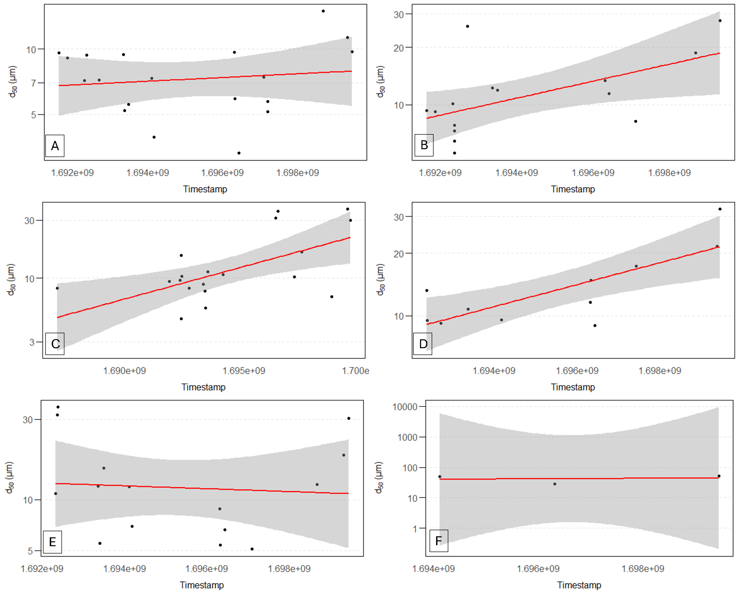
Figure S29 - Median Particle Size (d₅₀) x TIMESTAMP for each site. Y-axis is plotted in log. A) Site 1. B) Site 2. C) Site 3. D) Site 4. E) Site 5. F) Site 6.

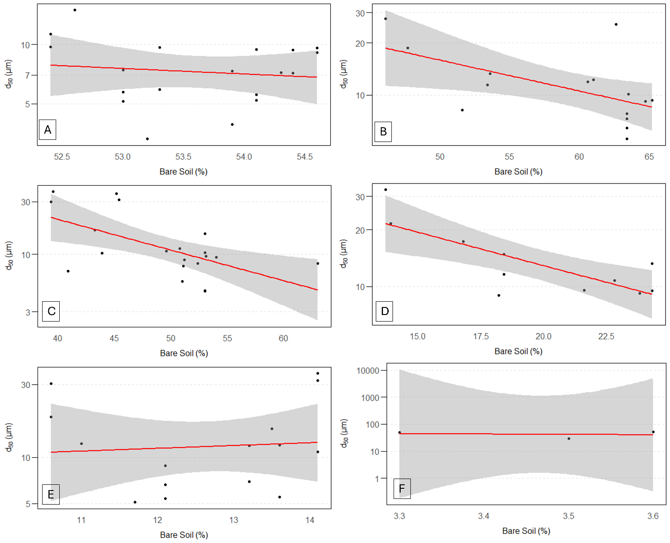
Figure S30 - Median Particle Size (d₅₀) x Bare soil (%) for each site. Y-axis is plotted in log. A) Site 1. B) Site 2. C) Site 3. D) Site 4. E) Site 5. F) Site 6.
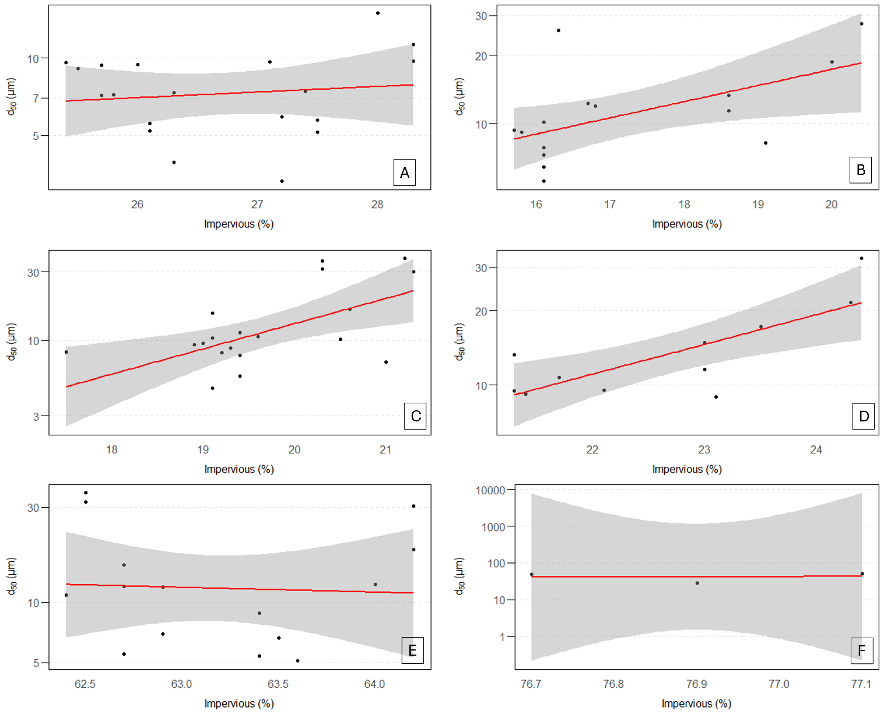
Figure S31 - Median Particle Size (d₅₀) x Impervious surface (%) for each site. Y-axis is plotted in log. A) Site 1. B) Site 2. C) Site 3. D) Site 4. E) Site 5. F) Site 6.
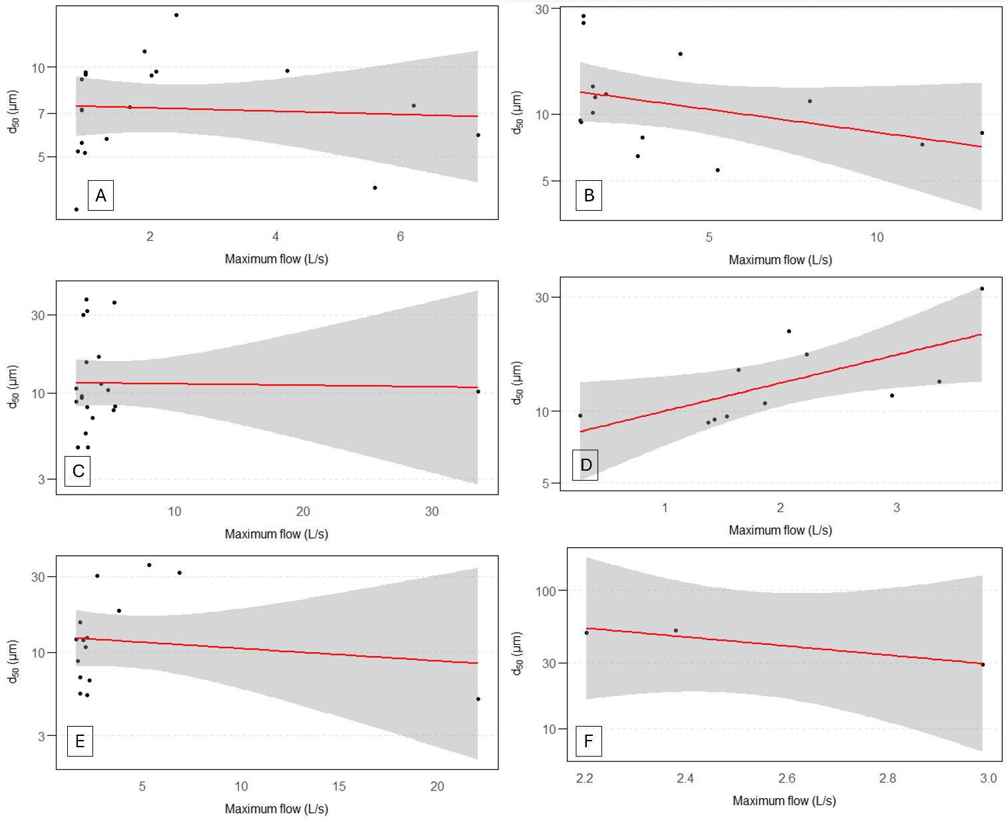
Figure S32 - Median Particle Size (d₅₀) x Maximum flow (L/s) for each site. Y-axis is plotted in log. A) Site 1. B) Site 2. C) Site 3. D) Site 4. E) Site 5. F) Site 6.
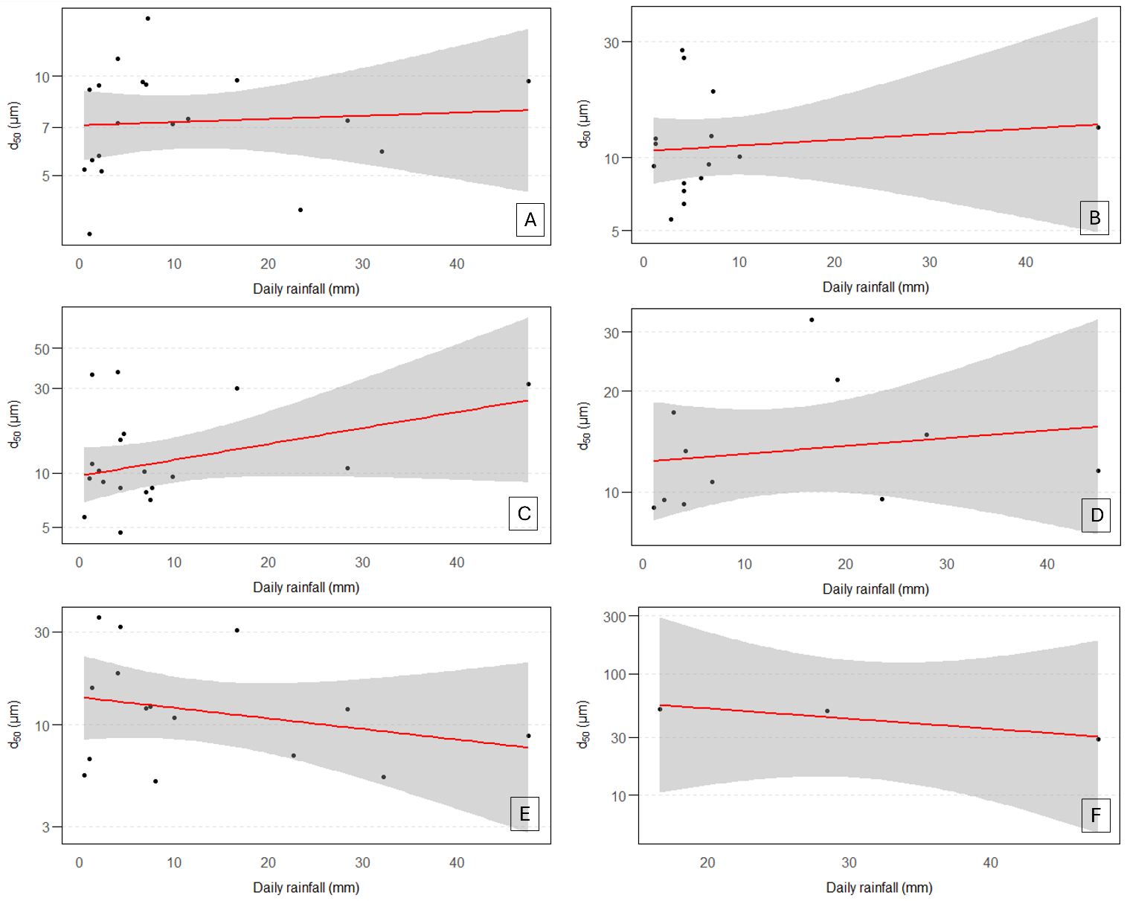
Figure S33 - Median Particle Size (d₅₀) x Daily rainfall (mm) for each site. Y-axis is plotted in log. A) Site 1. B) Site 2. C) Site 3. D) Site 4. E) Site 5. F) Site 6.

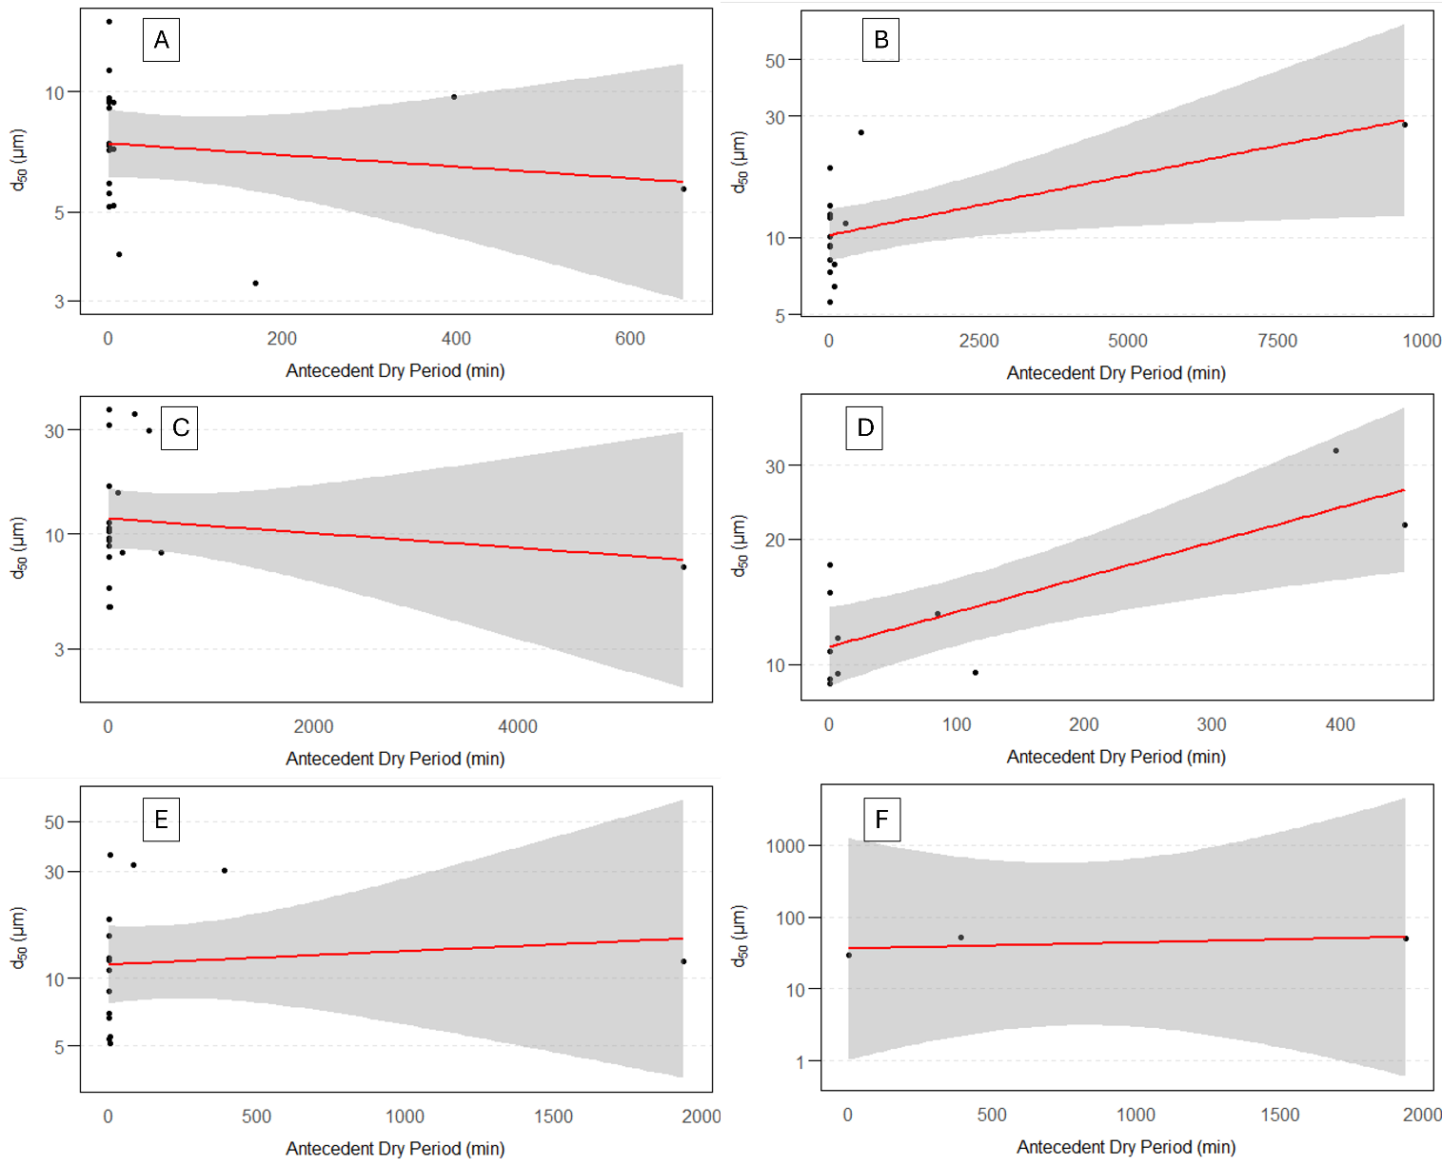
Figure S34 - Median Particle Size (d₅₀) x Antecedent Dry Period (min) for each site. Y-axis is plotted in log. A) Site 1. B) Site 2. C) Site 3. D) Site 4. E) Site 5. F) Site 6.

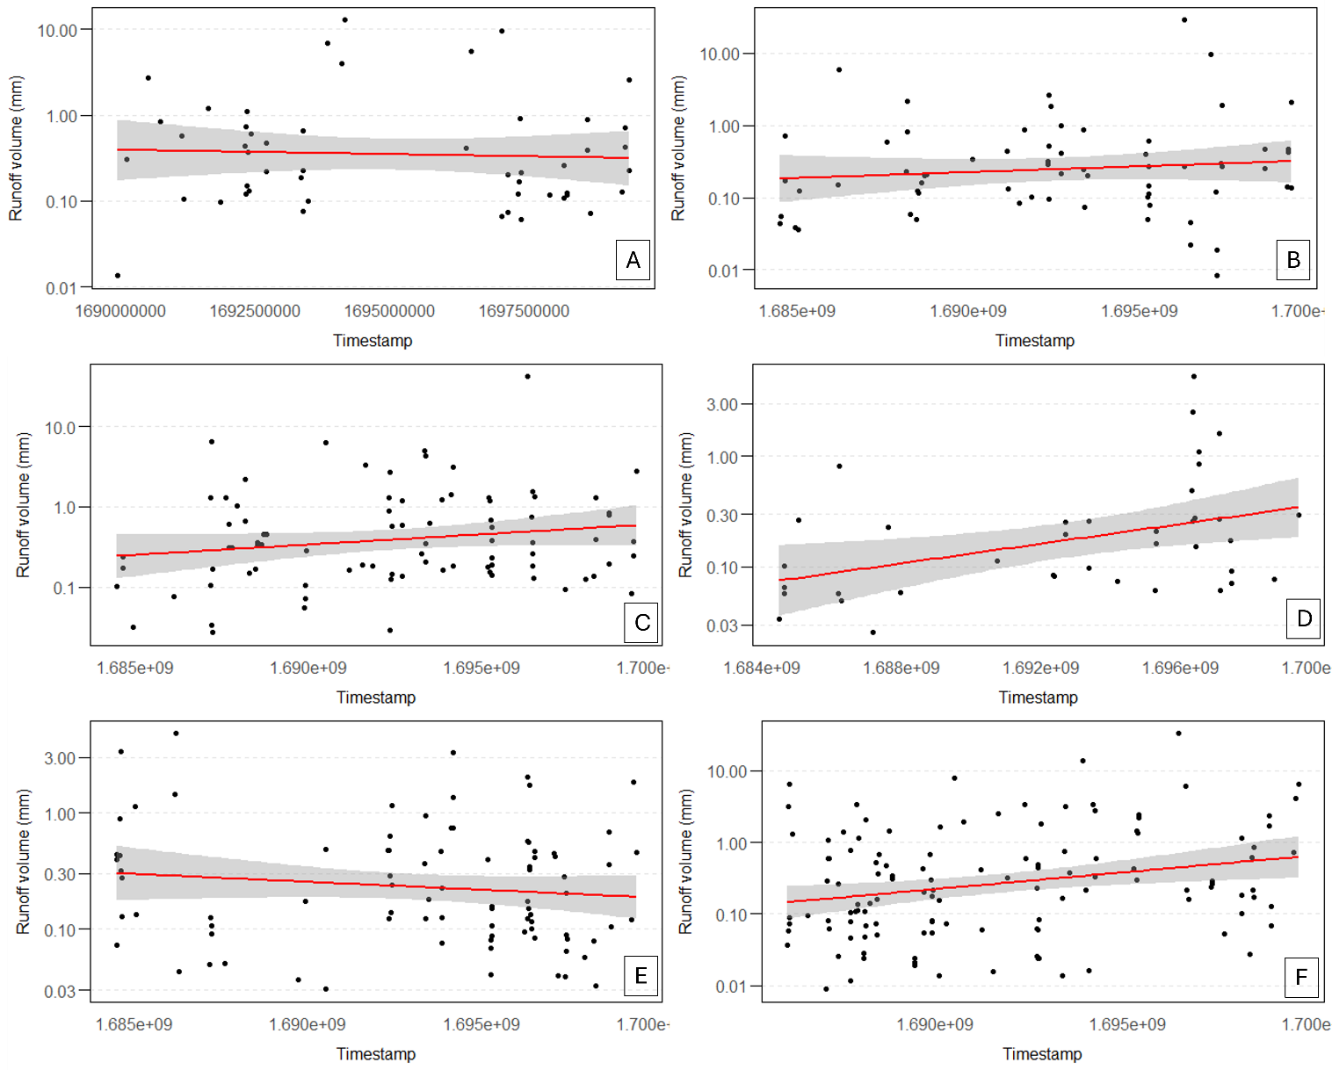
Figure S35 - Runoff Volume (mm) x TIMESTAMP for each site. Y-axis is plotted in log. A) Site 1. B) Site 2. C) Site 3. D) Site 4. E) Site 5. F) Site 6.
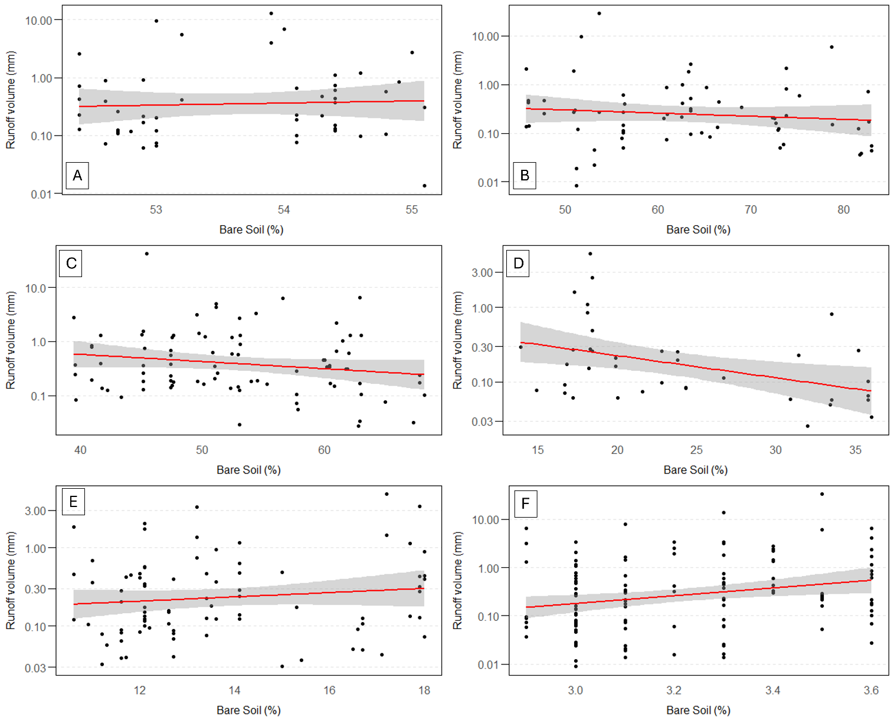
Figure S36 - Runoff Volume (mm) x Bare soil (%) for each site. Y-axis is plotted in log. A) Site 1. B) Site 2. C) Site 3. D) Site 4. E) Site 5. F) Site 6.
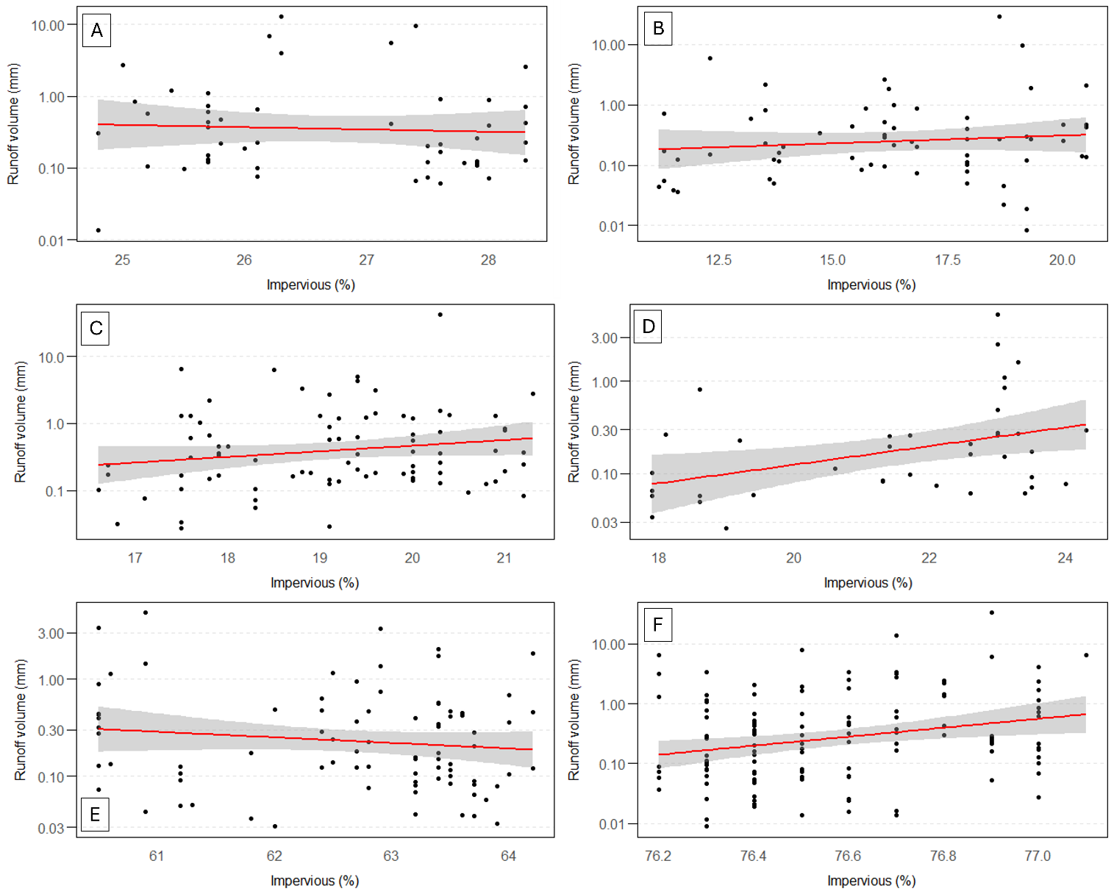
Figure S37 - Runoff Volume (mm) x Impervious surface (%) for each site. Y-axis is plotted in log. A) Site 1. B) Site 2. C) Site 3. D) Site 4. E) Site 5. F) Site 6.
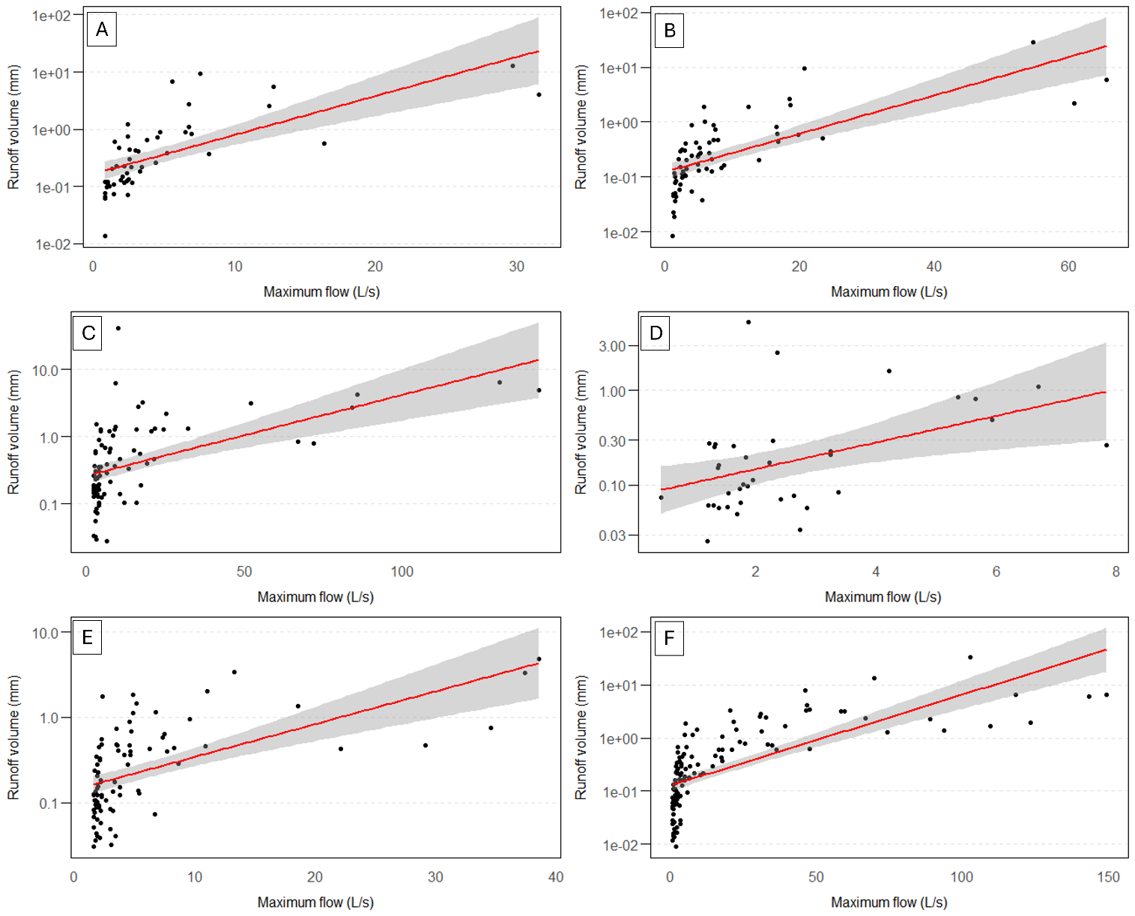
Figure S38 - Runoff Volume (mm) x Maximum flow (L/s) for each site. Y-axis is plotted in log. A) Site 1. B) Site 2. C) Site 3. D) Site 4. E) Site 5. F) Site 6.
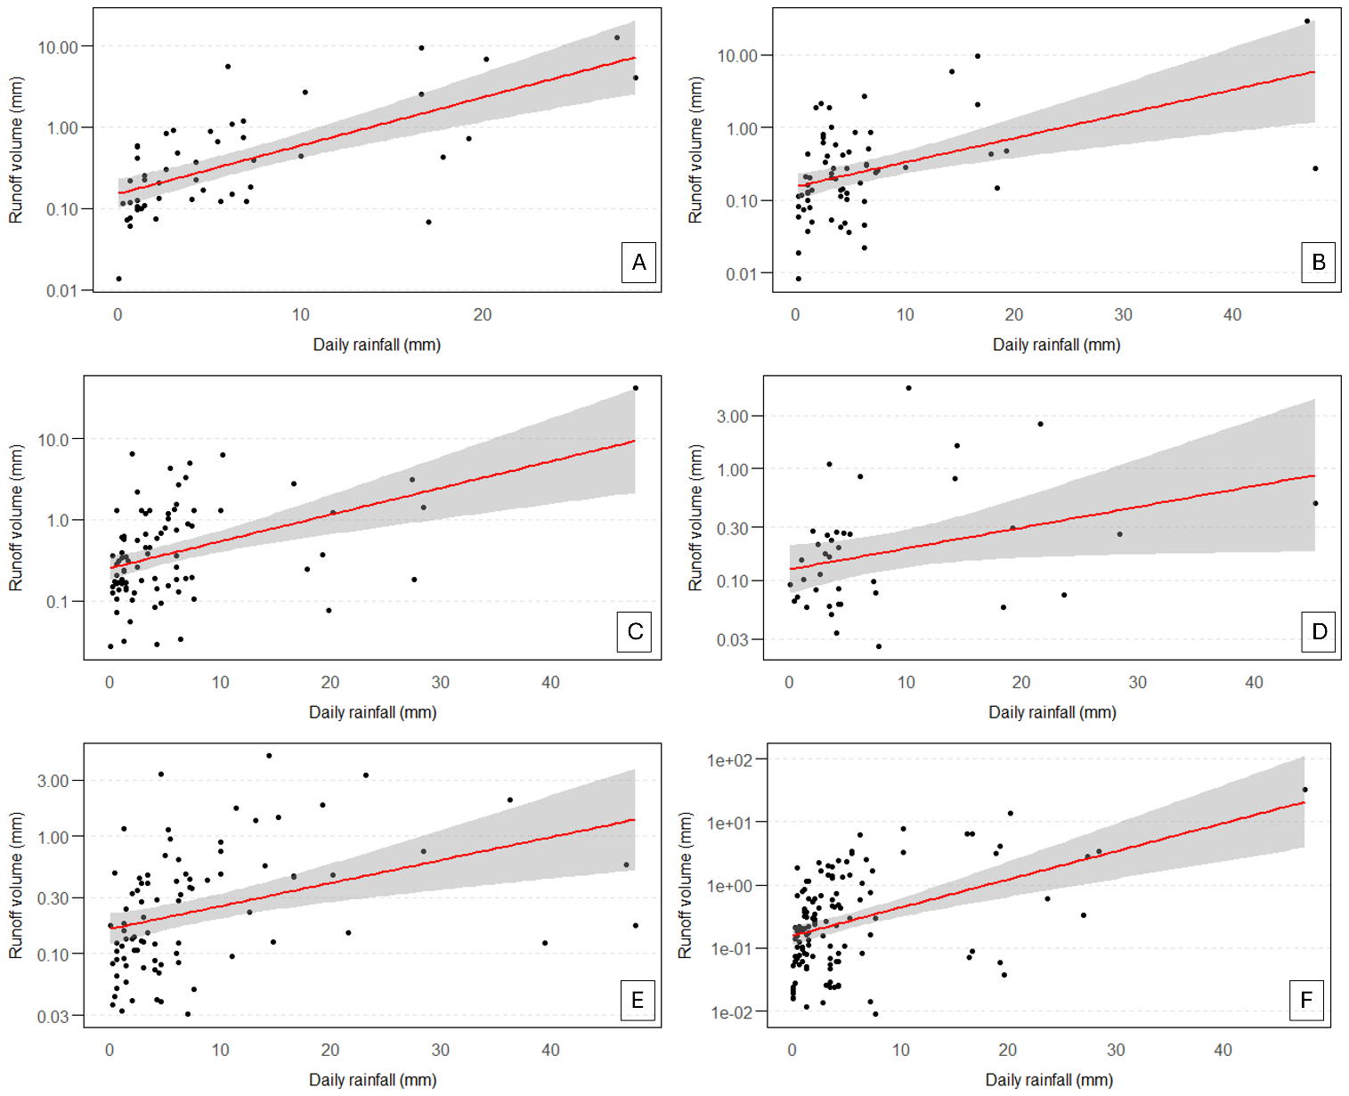
Figure S39 - Runoff Volume (mm) x Daily rainfall (mm) for each site. Y-axis is plotted in log. A) Site 1. B) Site 2. C) Site 3. D) Site 4. E) Site 5. F) Site 6.

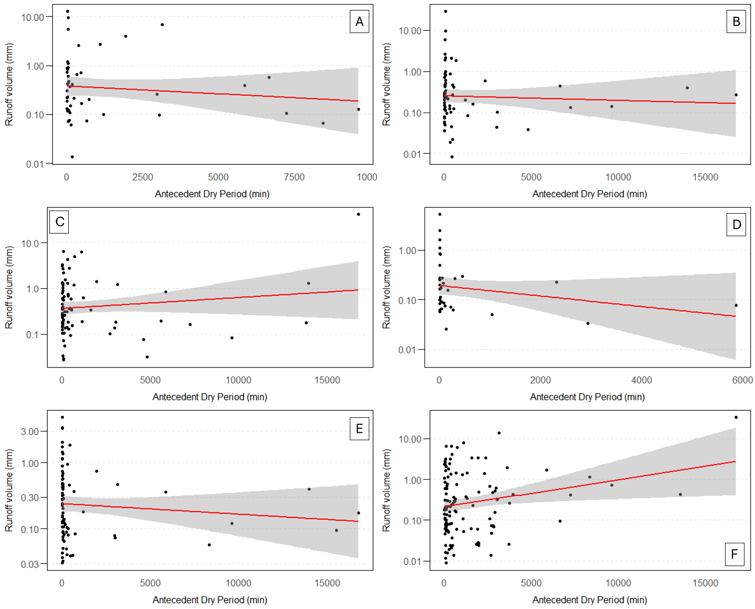
Figure S40 - Runoff Volume (mm) x Antecedent Dry Period (min) for each site. Y-axis is plotted in log. A) Site 1. B) Site 2. C) Site 3. D) Site 4. E) Site 5. F) Site 6.
Figure S41 - Event Mean Concentration - Tukey’s paired test.
Figure S42 - Suspended Solids Yield - Tukey’s paired test.
Figure S43 - Particle Size Distribution - Tukey’s paired test.
Figure S44 - Rainfall runoff - Tukey’s paired test.

Table S2 - Linear regression model results between Log(Event Mean Concentration (EMC)) and Timestamp, Bare soil (%), Impervious (%), maximum flow (L/s), daily rainfall (mm), antecedent dry period (min).
Site | Log (EMC) x Timestamp |  | Log (EMC) x Bare soil (%) |  | Log (EMC) x Impervious (%) |  | Log (EMC) x Q max (L/s) |  | Log (EMC) x Daily rainfall (mm) |  | Log (EMC) x ADP (min)
Site | p-value | R² | p-value | R² | p-value | R² | p-value | R² | p-value | R² | p-value | R²
Site 1 | 0.000544 | 0.22 | 0.000539 | 0.22 | 0.000485 | 0.23 | 0.0335 | 0.09 | 0.4644 | 0.01 | 0.8823 | 0.00
Site 2 | 0.003716 | 0.13 | 0.003634 | 0.13 | 0.003705 | 0.13 | 0.0156 | 0.09 | 0.2081 | 0.02 | 0.1663 | 0.03
Site 3 | 0.9132 | 0.00 | 0.9128 | 0.00 | 0.9069 | 0.00 | 0.1123 | 0.03 | 0.5048 | 0.00 | 0.5281 | 0.00
Site 4 | 0.000109 | 0.34 | 0.000108 | 0.34 | 0.000122 | 0.34 | 0.0704 | 0.09 | 0.707 | 0.00 | 0.07158 | 0.09
Site 5 | 0.000025 | 0.19 | 0.000023 | 0.19 | 0.000024 | 0.19 | 0.0326 | 0.05 | 0.3319 | 0.01 | 0.6341 | 0.00
Site 6 | 0.2469 | 0.01 | 0.2673 | 0.01 | 0.1106 | 0.02 | 0.0181 | 0.04 | 0.3566 | 0.01 | 0.1646 | 0.01

Table S3 - Linear regression model results between Log(Suspended solids yield (SSY)) and Timestamp, Bare soil (%), Impervious (%), maximum flow (L/s), daily rainfall (mm), antecedent dry period (min).
Site | Log (SSY) x Timestamp |  | Log (SSY) x Bare soil (%) |  | Log (SSY) x Impervious (%) |  | Log (SSY) x Q max (L/s) |  | Log (SSY) x Daily rainfall (mm) |  | Log (SSY) x ADP (min)
Site | p-value | R² | p-value | R² | p-value | R² | p-value | R² | p-value | R² | p-value | R²
Site 1 | 0.0288 | 0.10 | 0.02758 | 0.10 | 0.0255 | 0.10 | 5.348e-06 | 0.35 | 0.0015 | 0.19 | 0.5475 | 0.01
Site 2 | 0.5335 | 0.01 | 0.5297 | 0.01 | 0.5328 | 0.01 | 6.849e-08 | 0.37 | 0.0019 | 0.14 | 0.5525 | 0.01
Site 3 | 0.6611 | 0.00 | 0.6632 | 0.00 | 0.6522 | 0.00 | 3.962e-06 | 0.23 | 0.0043 | 0.09 | 0.4118 | 0.01
Site 4 | 0.0607 | 0.09 | 0.0599 | 0.09 | 0.0609 | 0.09 | 3.729e-06 | 0.45 | 0.2446 | 0.04 | 0.2922 | 0.03
Site 5 | 0.0005 | 0.14 | 0.0005 | 0.14 | 0.0004 | 0.14 | 1.103e-10 | 0.40 | 0.0331 | 0.05 | 0.6575 | 0.00
Site 6 | 0.0238 | 0.04 | 0.0344 | 0.04 | 0.0116 | 0.05 | 3.636e-16 | 0.42 | 0.0020 | 0.08 | 0.0123 | 0.05

Table S4 - Linear regression model results between Log(Rainfall runoff) and Timestamp, Bare soil (%), Impervious (%), maximum flow (L/s), daily rainfall (mm), antecedent dry period (min).
Site | Log (Runoff) x Timestamp |  | Log (Runoff) x Bare soil (%) |  | Log (Runoff) x Impervious (%) |  | Log (Runoff) x Q max (L/s) |  | Log (Runoff) x Daily rainfall (mm) |  | Log (Runoff) x ADP (min)
Site | p-value | R² | p-value | R² | p-value | R² | p-value | R² | p-value | R² | p-value | R²
Site 1 | 0.7347 | 0.00 | 0.7247 | 0.00 | 0.6913 | 0.00 | 5.39e-08 | 0.46 | 1.45e-07 | 0.44 | 0.4133 | 0.01
Site 2 | 0.3681 | 0.01 | 0.3701 | 0.01 | 0.3676 | 0.01 | 1.05e-10 | 0.49 | 1.56e-04 | 0.20 | 0.6655 | 0.00
Site 3 | 0.1012 | 0.03 | 0.102 | 0.03 | 0.0975 | 0.03 | 2.75e-07 | 0.27 | 3.69e-05 | 0.19 | 0.2419 | 0.02
Site 4 | 0.0102 | 0.17 | 0.0103 | 0.17 | 0.0111 | 0.17 | 4.26e-03 | 0.21 | 0.04027 | 0.11 | 0.1786 | 0.05
Site 5 | 0.2583 | 0.01 | 0.2645 | 0.01 | 0.2388 | 0.02 | 1.66e-08 | 0.32 | 3.88e-04 | 0.14 | 0.3647 | 0.01
Site 6 | 0.0052 | 0.06 | 0.0083 | 0.06 | 0.0055 | 0.06 | 2.2e-16 | 0.50 | 6.78e-07 | 0.18 | 0.0151 | 0.05

Table S5 - Linear regression model results between Log(d₅₀) and Timestamp, Bare soil (%), Impervious (%), maximum flow (L/s), daily rainfall (mm), antecedent dry period (min).
Site | Log (d₅₀) x Timestamp |  | Log (d₅₀) x Bare soil (%) |  | Log (d₅₀) x Impervious (%) |  | Log (d₅₀) x Q max (L/s) |  | Log (d₅₀) x Daily rainfall (mm) |  | Log (d₅₀) x ADP (min)
Site | p-value | R² | p-value | R² | p-value | R² | p-value | R² | p-value | R² | p-value | R²
Site 1 | 0.5784 | 0.02 | 0.6038 | 0.02 | 0.5986 | 0.02 | 0.7826 | 0.00 | 1.45e-07 | 0.44 | 0.4133 | 0.01
Site 2 | 0.0253 | 0.33 | 0.0257 | 0.33 | 0.0267 | 0.32 | 0.1492 | 0.15 | 1.56e-04 | 0.20 | 0.6655 | 0.00
Site 3 | 0.0057 | 0.35 | 0.0057 | 0.35 | 0.0057 | 0.35 | 0.9265 | 0.00 | 3.69e-05 | 0.19 | 0.2419 | 0.02
Site 4 | 0.0045 | 0.61 | 0.0046 | 0.61 | 0.0047 | 0.61 | 0.0290 | 0.43 | 0.04027 | 0.11 | 0.1786 | 0.05
Site 5 | 0.787 | 0.00 | 0.7739 | 0.01 | 0.8501 | 0.00 | 0.6103 | 0.02 | 3.88e-04 | 0.14 | 0.3647 | 0.01
Site 6 | 0.9059 | 0.02 | 0.9086 | 0.02 | 0.9703 | 0.00 | 0.1664 | 0.93 | 6.78e-07 | 0.18 | 0.0151 | 0.05

Table S6 - Statistics of all the response and explanatory variables for all monitored events from all sites.
Response Variables / Explanatory Variables | Timestamp |  | Bare soil (%) |  | Impervious surface (%) |  | Q max (L/s) |  | Daily rainfall (mm) |  | ADP (min)
Response Variables / Explanatory Variables | p-value | R² | p-value | R² | p-value | R² | p-value | R² | p-value | R² |  | p-value | R²
Log (EMC) | 0.9102 | 0.00 | 2.2e-16 | 0.33 | 2.2e-16 | 0.34 | 0.6558 | 0.00 | 0.2497 | 0.00 |  | 0.5096 | 0.00
Log (SSY) | 0.3918 | 0.00 | 2.2e-16 | 0.22 | 2.2e-16 | 0.20 | 8.527e-14 | 0.12 | 7.39e-09 | 0.07 |  | 0.2189 | 0.00
Log (d50) | 1.11e-03 | 0.12 | 1.66e-04 | 0.16 | 0.0179 | 0.07 | 0.6204 | 0.00 | 0.8022 | 0.00 |  | 0.0944 | 0.03
Log (Runoff volume) | 0.00387 | 0.02 | 0.2709 | 0.00 | 0.3658 | 0.00 | 2.2e-16 | 0.33 | 2.2e-16 | 0.16 |  | 0.2466 | 0.00

